Adult Consumer Survey

2015-16 Final Report



|  |  |
| --- | --- |
|  | **Human Services Research Institute (HSRI)**  2336 Massachusetts Avenue Cambridge, MA 02140 |
|  | **National Association of State Directors of Developmental Disabilities Services (NASDDDS)**  301 N Fairfax Street Suite 101 Alexandria, VA 22314-2633 |

March 2017

****List of Abbreviations Used in This Report****

CIP – Core Indicators Project

CMS – Centers for Medicare & Medicaid Services

HCBS – Home and Community-Based Services

HSRI – Human Services Research Institute

N – Number of respondents

NASDDDS – National Association of State Directors of Developmental Disabilities Services

## **Table of Contents**

Adult Consumer Survey 1

2015-16 Final Report 1

Table of Contents iv

Important Note on 2015-16 Changes to the Survey Tool, Analysis and Reporting x

Adult Consumer Survey Highlights xii

I. Results 1

Survey Development 2

Organization of the Survey 2

Presentation of Data 3

Demographic Characteristics of Respondents 4

Profile of Sample 5

Table 1. Age ¥ 6

Table 2. Age group º 7

Table 3. Gender 8

Table 4. Marital status º 9

Table 5. Race ± 10

Table 6. Residential designation (metropolitan, micropolitan, rural, small town) * º 11

Table 7. Type of residence –intermediate care facility for Individuals with I/DD (ICF/IID) or other institutional setting 12

Table 8. Type of residence – Group residential setting (e.g., group home) 13

Table 9. Type of residence, continued 14

Table 10. Length of time at current residence º 15

Table 11. Person's residence owned or controlled by provider agency º 16

Table 12. Person is named on the lease º 17

Table 13. Person owns home º 18

Table 14. Has ID diagnosis 19

Table 15. Level of ID (if the person has an ID diagnosis) ± ¥ 20

Table 16. Mood, anxiety, behavior, psychotic, and other mental illness ∞ 21

Table 17. Other diagnoses ∞ 23

Table 18. Other diagnoses, continued ∞ 25

Table 19. Health conditions ∞ 26

Table 20. Preferred means of communication ± 27

Table 21. Primary language 28

Table 22. Mobility ¥ 29

Table 23. Level of support needed to manage self-injurious behavior ¥ 30

Table 24. Level of support to manage disruptive behavior ¥ 31

Table 25. Level of support to manage destructive behavior ¥ 32

Table 26. Guardianship ± 33

Table 27. Guardian’s relationship to person º 34

Core Indicator Outcomes and Comparisons Across States 35

Table 28. Number of people in each type of residence 37

How to Read the Tables in This Report 38

Choice and Decision-Making 39

People make choices about their lives and are actively engaged in planning their services and supports. 39

Table 29. Chose or had some input in choosing where they live if not in the family home (adjusted variable, proxy responses allowed) * 42

Table 30. Chose or had some input in choosing people they live with, or chose to live alone if not in the family home (adjusted variable, proxy responses allowed) * 43

Table 31. Chose or had some input in choosing where they work (among those with a job in the community; adjusted variable, proxy responses allowed) ˇ * 44

Table 32. Chose or had some input in choosing where they go during the day (adjusted variable, proxy responses allowed) * 45

Table 33. Chose or were aware they could request to change the staff who help them at their home, job, or day program or activity (adjusted variable, proxy responses allowed) * 46

Table 34. Choose or help decide their daily schedule (adjusted variable, proxy responses allowed) * 47

Table 35. Choose or help decide how to spend free time (adjusted variable, proxy responses allowed) * 48

Table 36. Choose or help decide what to buy with their money (adjusted variable, proxy responses allowed) * 49

Table 37. Life decisions scale (adjusted variable) *,** 50

Table 38. Everyday choices scale (adjusted variable) *,** 51

Table 39. Chose or were aware they could request to change their case manager/service coordinator (‘person chose’ and ‘did not choose, but can request to change’ responses, proxy responses allowed) 53

Work 54

People have support to find and maintain community integrated employment. 54

Table 40. Has paid job in the community (information comes from Background Information section) ± 56

Table 41. Type of employment among those reported to have a paid job in the community (information comes from Background Information section) ± * 58

Table 42. Average number of biweekly hours by type of community employment among those reported to have a paid job in the community (information comes from Background Information section) ± ˇ 60

Table 43. Average biweekly gross wages by type of community employment among those reported to have a paid job in the community (information comes from Background Information section) ± 62

Table 44. Average biweekly hourly wage by type of community employment among those reported to have a paid job in the community (information comes from Background Information section) ± 64

Table 45. Length of employment in current job among those reported to have a paid job in the community (information comes from Background Information section) 66

Table 46. Receives paid vacation and/or sick time at their job (among those reported to have a job in the community; information comes from Background Information section) ± 68

Table 47. Four most common job types among those reported to have a paid job in the community (information comes from Background Information section) ± 70

Table 48. Would like a job in the community (among those reported not to have a paid community job from Background section; ‘yes’ responses only) ± 72

Table 49. Have community employment as a goal in their service plan (information comes from Background Information section) 74

Table 50. Takes classes, training, or does something to help get a job or a better job º 76

Table 51. Attends a day program or workshop± 78

Table 52. Volunteers 80

Self-Determination 81

People have authority and are supported to direct and manage their own services. 81

Table 53. Uses a self-directed supports option (information comes from Background Information section) ± 83

Table 54. People who decide how budget for services is used (among those using a self-direction option and who participate in making decisions about how to use budget, hire staff, or manage services; proxy responses allowed) º ˇ 85

Table 55. Hires or manages staff (among those using a self-direction option and who participate in making decisions about how to use budget, hire staff, or manage services; proxy responses allowed) º ˇ 87

Table 56. Can make changes to individual budget/services if needed (among those using a self-direction option and who participate in making decisions about how to use budget, hire staff, or manage services; proxy responses allowed) ˇ 89

Table 57. Has enough help deciding how to use their individual budget/services (among those using a self-direction option and who participate in making decisions about how to use budget, hire staff, or manage services; proxy responses allowed) ˇ 91

Table 58. Gets information about how much money is left in budget/services (among those using a self-direction option and who participate in making decisions about how to use budget, hire staff, or manage services; proxy responses allowed) ˇ 93

Table 59. Information about budget/services is easy to understand (among those using a self-direction option and who participate in making decisions about how to use budget, hire staff, or manage services; proxy responses allowed) ˇ 95

Community Inclusion, Participation, and Leisure 96

People have support to participate in everyday community activities. 96

Table 60. Went out shopping at least once in the past month (proxy responses allowed) ± 98

Table 61. Went out on errands at least once in the past month (proxy responses allowed) ± 100

Table 62. Went out for entertainment at least once in the past month (proxy responses allowed) ± 102

Table 63. Went out to eat at least once in the past month (proxy responses allowed) ± 104

Table 64. Went out to religious service or spiritual practice at least once in the past month (proxy responses allowed) ± 106

Table 65. Participated in a community group in the past month (proxy responses allowed) º 108

Table 66. Went on vacation in the past year (proxy responses allowed) ± 110

Table 67. Community Inclusion scale score 111

Table 68. Able to go out and do the things like to do in the community º 113

Table 69. Able to go out and do the things likes to do in the community as often as wants to º 115

Table 70. Has enough things they like to do when at home º 117

Relationships 118

People have friends and relationships. 118

Table 71. Has friends who are not staff or family members (‘yes’ responses only) 120

Table 72. Wants help to make or keep in contact with friends (‘yes’ and ‘maybe, not sure’ responses) º 122

Table 73. Has friends (may be staff or family) and the support needed to see friends when they want (‘yes’ responses only) 124

Table 74. Reasons cannot always see friends º 126

Table 75. Has other ways to communicate with friends when cannot see them (‘yes’ responses only) º 128

Table 76. Can see and communicate with their family whenever they want (‘yes’ responses only) ± 130

Table 77. Feels lonely (‘yes, often’ responses only) ± 132

Table 78. Can go on a date if they want or can date with some restriction (‘yes, can date’ or ‘is married or living with partner’ responses only) 134

Satisfaction 135

People are satisfied with the services and supports they receive. 135

Table 79. Like their home (‘yes’ responses only) 137

Table 80A. Reasons why person does not like home (categories are not mutually exclusive) º 139

Table 80B. Reasons why person does not like home (continued, categories are not mutually exclusive) º 140

Table 81. Want to live somewhere else (‘yes’ responses only) 142

Table 82. Has a paid job in the community and likes where they work (‘yes’ responses only) ˇ 144

Table 83. Has a paid job in the community and wants to work somewhere elseˇ (‘yes’ responses only) ˇ 146

Table 84. Attends a day program or workshop and wants to go more, less, or the same amount of time º 148

Table 85. Services and supports help person live a good life (‘yes’ responses only) º 150

Service Coordination 151

Service coordinators are accessible, responsive, and support the person’s participation in service planning. 151

Table 86. Met their case manager/service coordinator (‘yes’ responses only) 153

Table 87. Case manager/service coordinator asks person what s/he want (‘yes’ responses only) 155

Table 88. Able to contact case manager/service coordinator when wants (‘yes’ responses only) ± 157

Table 89. Took part in last service planning meeting (‘yes’ and ‘had the option but chose not to’ responses) º 159

Table 90. Knew what was talked about at last service planning meeting (yes responses only) º 161

Table 91. Last service planning meeting included people person wanted to be there (yes responses only) º 163

Table 92. Person was able to choose services they get as part of service plan (yes responses only) º 165

Table 93. Staff show up and leave when they are supposed to (‘yes’ responses only) 167

Access 168

Publicly funded services are readily available to individuals who need and qualify for them. 168

Table 94. Has a way to get places needs to go (‘yes almost always’ responses only) º 170

Table 95. Has a way to get places when wants to go outside of home—like going out to see friends, for entertainment, or to do something fun (‘yes almost always’ responses only) º 172

Table 96. Staff have adequate training to meet the person’s needs (‘yes’ responses only; proxy responses allowed but not asked if proxy is staff) 174

Table 97. Additional services needed (categories are not mutually exclusive; proxy responses allowed) ± 176

Table 98. Additional services needed, continued (categories are not mutually exclusive; proxy responses allowed) ± 177

Health 178

People secure needed health services. 178

Table 99. Has a primary care doctor or primary care practitioner (information comes from Background Information section) 180

Table 100. In poor health (‘poor health’ response only; proxy responses allowed) 182

Table 101. Had a complete physical exam in the past year (‘within the last year or less’ responses; information comes from Background Information section) 184

Table 102. Had a dental exam in the past year (within the last year or less responses; information comes from Background Information section) 186

Table 103. Had an eye exam in the past year (within the last year or less responses; information comes from Background Information section) 188

Table 104. Had a hearing test in the past five years (‘within five years or less’ responses; information comes from Background Information section) 190

Table 105. Had a Pap test in the past three years (among women; ‘within the past three years or less’ responses; information comes from Background Information section) 192

Table 106. Had a mammogram in the past two years (among women age 40 and over; ‘within the past two years or less’ responses; information comes from Background Information section) 194

Table 107. Had a colorectal cancer screening in the past year (among people age 50 and over; ‘within the last year or less’ responses; information comes from Background Information section) 196

Table 108. Had a flu vaccine in the past year (within the last year or less responses; information comes from Background Information section) 198

Medications 199

Medications are managed effectively and appropriately. 199

Table 109. Takes at least one medication for mood disorders, anxiety, psychotic disorders, and/or behavior (information comes from Background Information section) 201

Table 110. Takes medication for at least one of the following: mood disorders, anxiety, or psychotic disorders (information comes from Background Information section 203

Table 111. Number of medications taken for at least one of the following: mood disorders, anxiety, or psychotic disorders (information comes from Background Information section) 205

Table 112. Takes medication for behavior challenges (information comes from Background Information section) 207

Table 113. Number of medications taken for behavior challenges (information comes from Background Information section) 209

Table 114. Has a behavior plan (information comes from Background Information section) º 211

Table 115. Has a behavior (of those who take medication for a behavior challenge; information comes from Background Information section) 213

Wellness 214

People are supported to maintain healthy habits. 214

Table 116. Engages in physical activity (‘yes, regularly at least 3 times per week’ and ‘sometimes, 1 or 2 times per week’ responses; proxy responses allowed) ± 216

Table 117. BMI category (BMI calculated using data on weight and height; information comes from Background Information section) 218

Table 118. Uses nicotine or tobacco products (information comes from Background Information section) 220

Respect and Rights 221

People receive the same respect and protections as others in the community. 221

Table 119. Has a key to the home (‘yes’ responses only; proxy responses allowed) º 223

Table 120. Others let person know before entering home (‘yes’ responses only) 225

Table 121. Can lock bedroom if they want (‘yes’ responses only; proxy responses allowed) º 227

Table 122. Others let person know before entering bedroom (‘yes’ responses only) 229

Table 123. Others read mail or email without asking first ± 231

Table 124. Can use phone and internet whenever they want ± 233

Table 125. Can be alone wth visitors at home ± 235

Table 126. There are rules to having friends or visitors at home º 237

Table 127. Has a place to be alone at home ± 239

Table 128. Staff (at home, work, and/or day activity or program) are respectful (‘yes, all staff’ responses only) ± 241

Table 129. Have attended a self-advocacy event or had opportunity but chose not to (‘yes’ and ‘had opportunity but chose not to’ responses; proxy responses allowed) 243

Table 130. Has ever voted in local, state, or federal election, or had the opportunity and chose not to (‘yes’ and ‘had opportunity to register to vote but chose not to’ responses; proxy responses allowed) º 245

Safety 246

People are safe from abuse, neglect, and injury. 246

Table 131. There is at least one place where the person feels afraid or scared º 248

Table 132. Have someone to go to for help if they ever feel scared (‘yes’ responses only) 250

II. NCI History and Activities 251

Overview of National Core Indicators 252

State Participation 253

Figure 1. NCI State Participation 253

The Core Indicators 253

Figure 2 Adult Consumer Survey Indicators: Domains and Sub-Domains 254

How NCI Data Are Used 255

Caution and Limitations 255

III. Methodology 257

Administration 258

Proxy Respondents 258

Surveyor Training 259

Criteria for Exclusion of Responses 259

Responses for Section II 260

Sampling 260

Figure 3. Valid Surveys and Response Rates by State: 2015-16 263

IV. Data Analysis 264

Data Management and Analysis 265

Outcome Adjustment 265

Scale Development 266

Significance Testing 266

V. Appendices 268

Appendix A 269

Survey Changes 2014-15 to 2015-16 269

Appendix B 284

Rules for Recoding and Combining Variables to Compute Core Indicators 284

Appendix C Sampling Procedures 317

Appendix D 338

Un-collapsed and unadjusted data by state 338

Choice and Decision-Making (unadjusted and un-collapsed) 339

Table 133. Level of choice in where they live if not in the family home (proxy responses allowed) 339

Table 134. Level of choice in choosing their roommates if not in the family home (proxy responses allowed) 340

Table 135. Level of choice in choosing where they work (among those with a job in the community; proxy responses allowed) 341

Table 136. Level of choice in choosing where they go during the day (among those with a day program or activity; proxy responses allowed) 342

Table 137. Level of choice of staff who help them at their home, job, or day program or activity (proxy responses allowed) 343

Table 138. Level of choice in deciding their daily schedule (proxy responses allowed) 344

Table 139. Level of choice in deciding how to spend free time (proxy responses allowed) 345

Table 140. Level of choice in deciding what to buy with their money (proxy responses allowed) 346

Table 141. Level of choice in their case manager/service coordinator (proxy responses allowed) 347

Work (un-collapsed) 348

Table 142. Have a paid job in the community (among those with an individual and/or group supported; information comes from Background Information section) 348

Table 143. Receives paid vacation and/or sick time at their job (among those with a paid job in the community; information comes from Background Information section) 349

Table 144. Job industry (among those with a paid job in the community; information comes from Background Information section) 350

Table 145. Job industry, continued (among those with a paid job in the community; information comes from Background Information section) 351

Table 146. Would like a job in the community (among those without a paid job in the community) 352

Table 147. Have community employment as a goal in their service plan (among those with a paid job in the community; information comes from Background Information section) 353

Table 148. Takes classes to help get a job or get a better job 354

Table 149. Attend a day program or regular activity 355

Table 150. Volunteer 356

Self-Directed Supports (un-collapsed) 357

Table 151. Using a self-directed supports option (information comes from Background Information section) 357

Table 152. People who decide or have input in making decisions for how budget for services is used (among those using a self-direction option and who participate in deciding how to use budget, hire staff or manage services; proxy responses allowed) 358

Table 153. Hires or manages staff (among those using a self-direction option and who participate in deciding how to use budget, hire staff, or manage services; proxy responses allowed) 359

Table 154. Can make changes to individual budget/services if needed (among those using a self-direction option and who participate in deciding how to use budget, hire staff, or manage services; proxy responses allowed) 360

Table 155. Has enough help deciding how to use their individual budget/services (among those using a self-direction option and who participate in deciding how to use budget, hire staff, or manage services; proxy responses allowed) 361

Table 156. Gets enough information about how much money is left in budget/services (among those using a self-direction option and who participate in deciding how to use budget, hire staff, or manage services; proxy responses allowed) 362

Table 157. Information received about budget/services is easy to understand (among those using a self-direction option and who participate in making decisions about how to use budget, hire staff, or manage services; proxy responses allowed) 363

Community Inclusion, Participation and Leisure (un-collapsed) 364

Table 158. Went out shopping at least once in the past month (proxy responses allowed) 364

Table 159. Who person typically went out shopping with in the past month (proxy responses allowed) 365

Table 160. Went out on errands at least once in the past month (proxy responses allowed) 366

Table 161. Who person typically went on errands with in the past month (proxy responses allowed) 367

Table 162. Went out for entertainment at least once in the past month (proxy responses allowed) 368

Table 163. Who person typically went out for entertainment with in the past month (proxy responses allowed) 369

Table 164. Went out to eat at least once in the past month (proxy responses allowed) 370

Table 165. Who person typically went out to eat with in the past month (proxy responses allowed) 371

Table 166. Went out to religious service or spiritual practice at least once in the past month (proxy responses allowed) 372

Table 167. Who person typically went to religious service or spiritual practice with in the past month (proxy responses allowed) 373

Table 168. Participated in a community group in the past month (proxy responses allowed) 374

Table 169. Who person typically participated in a community group with in the past month (proxy responses allowed) 375

Table 170. Went on vacation in the past year (proxy responses allowed) 376

Table 171. Who person typically went on vacation with in the past year (proxy responses allowed) 377

Table 172. Able to go out and do the things like to do in the community 378

Table 173. Able to go out and do the things likes to do in the community as often as wants to 379

Table 174. Has enough things to do when at home 380

Relationships (un-collapsed) 381

Table 175. Have friends who are not staff or family members 381

Table 176. Wants more help to meet or keep in contact with friends 382

Table 177. Have friends (may be staff or family) and the support needed to see their friends when they want 383

Table 178. Reasons cannot always see friends 384

Table 179. Has other ways to communicate with friends when cannot see them 385

Table 180. Can see and communicate with their family when they want 386

Table 181. Feel lonely at least half the time 387

Table 182. Can go on a date if they want or can date with some restriction 388

Satisfaction (un-collapsed) 389

Table 183. Like their home 389

Table 184. Reasons why person does not like home (categories are not mutually exclusive) 390

Table 185. Reasons why person does not like home, continued (categories are not mutually exclusive) 391

Table 186. Want to live somewhere else 392

Table 187. Have a paid job in the community and like where they work 393

Table 188. Have a paid job in the community and want to work somewhere else 394

Table 189. Attend a day program or workshop and wants to go less often 395

Table 190. Services and Supports help person live a good life 396

Service Coordination (un-collapsed) 397

Table 191. Met their case manager/service coordinator 397

Table 192. Case manager/service coordinator asks person what s/he want 398

Table 193. Able to contact case manager/service coordinator when wants 399

Table 194. Took part in last service planning meeting, or had the opportunity and chose not to 400

Table 195. Understood what was talked about at last service planning meeting 401

Table 196. Last service planning meeting included people person wanted to be there 402

Table 197. Person was able to choose services they get as part of service plan 403

Table 198. Staff show up and leave when they are supposed to 404

Access (un-collapsed) 405

Table 199. Has a way to get places needs to go 405

Table 200. Has a way to get places when wants to go outside of home 406

Table 201. Staff have adequate training to meet the person’s needs (proxy responses allowed) 407

Table 202. Additional services needed (categories are not mutually exclusive; proxy responses allowed) 408

Table 203. Additional services needed, continued (categories are not mutually exclusive; proxy responses allowed) 409

Health (un-collapsed) 410

Table 204. Have a primary care doctor or primary care practitioner (information comes from Background Information section) 410

Table 205. Overall health (proxy responses allowed) 411

Table 206. Had a complete physical exam in the past year (information comes from Background Information section) 412

Table 207. Had a dental exam in the past year (information comes from Background Information section) 413

Table 208. Had an eye exam in the past year (information comes from Background Information section) 414

Table 209. Had a hearing test in the past five years (information comes from Background Information section) 415

Table 210. Had a Pap test in the past three years (among women; information comes from Background Information section) 416

Table 211. Had a mammogram test in the past two years (among women age 40 and over; (information comes from Background Information section) 417

Table 212 Had a colorectal cancer screening in past year (among people age 50 and over; comes from Background Information section) 418

Table 213. Had a flu vaccine in the past year (information comes from Background Information section) 419

Medications (un-collapsed) 420

Table 214. Takes at least one medication for behavior, mood disorders, anxiety, and/or psychotic disorders (information comes from Background Information section) 420

Table 215. Take medication for at least one of the following: mood disorders, anxiety, or psychotic disorders (information comes from Background Information section) 421

Table 216. Number of medications taken for at least one of the following: mood disorders, anxiety, or psychotic disorders (information comes from Background Information section) 422

Table 217. Take medication for behavior challenges (information comes from Background Information section) 423

Table 218. Number of medications taken for at least one of the following behavior challenges (information comes from Background Information section) 424

Table 219. Has a behavior plan (information comes from Background Information section) 425

Table 220. Has a behavior plan (of those who take medication for a behavior challeng; information comes from Background Information section) 426

Wellness (un-collapsed) 427

Table 221. Engage in physical activity (proxy respondents were allowed) 427

Table 222. BMI category (BMI is calculated using person’s height and weight; information comes from Background Information section) 428

Table 223. Chew or smoke tobacco (information comes from Background Information section) 429

Respect and Rights (un-collapsed) 430

Table 224. Has a key to the home (proxy responses allowed) 430

Table 225. People always ask before entering home 431

Table 226. Can lock bedroom (proxy responses allowed) 432

Table 227. People always ask before entering bedroom 433

Table 228. Others read mail or email without asking 434

Table 229. Can use phone and internet whenever wants 435

Table 230. Can be alone with friends and visitors at home 436

Table 231. There are rules against having friends and visitors at home 437

Table 232. Has a place to be alone 438

Table 233. Staff (at home, work, and/or day activity or program) are respectful 439

Table 234. Have attended a self-advocacy event or chose not to (proxy responses allowed) 440

Table 235. Has ever voted in local, state, or federal election, or had the opportunity and chose not (proxy responses allowed) 441

Safety (un-collapsed) 442

Table 236. There is at least one place where the person feels afraid or scared 442

Table 237. Have someone to go to for help if they ever feel scared 443

# Important Note on 2015-16 Changes to the Survey Tool, Analysis and Reporting

NCI strives to present data in a way that is both accurate and actionable. To this end, we modified several questions in the Adult Consumer Survey for the 2015-16 cycle, and we analyzed several of the survey items differently than in years past. These changes are noted throughout the report.

Below, we describe the more substantial changes to the 2015-16 survey tool.

**Community Inclusion, Participation and Leisure**

Questions around frequency of participation in community activities (shopping, errands, entertainment, etc.) changed from having a continuous response option (where the surveyor indicated the number of times a person did a certain activity) to having a categorical response option (where the respondent picks from a pre-set range of frequencies in a multiple choice-style option). As a result, frequency of participation in community activities is now reported as the proportion of people who performed the activity *at least once*. The calculation of the community inclusion scale also changed—from a simple sum of the number of times the activities were performed to an average of the proportions of respondents who performed the activities at least once.

**Employment**

Prior to 2015-16, NCI data on paid community job bi-weekly wages, bi-weekly hours, and hourly wage were reported based on three types of community work: (1) competitive—an individual job in which the person *does not receive* state or other funded supports; (2) individually supported—an individual job in which the person *receives* state or other funded supports; or (3) group-supported—a job that takes part in an integrated setting but is done with a group of individuals with disabilities (e.g., work crew).

For 2015-16 and going forward, the questions about paid community job in the background information section changed slightly: the survey now asks separately whether the person participates in a paid individual job in the community and/or whether he/she participates in a paid group job in the community. This allows us to report on cases in which the individual does both an individual job and a group job. As a result, the two categories are no longer mutually exclusive.

In addition, we have changed the names and types of community work by which we report wages and hours. The three categories are now: (1) individual job without publicly funded supports—an individual job in which the person *does not receive* state or other funded supports; (2) individual job with publicly funded supports—an individual job in which the person *receives* state or other funded supports; and (3) group-supported—a job that takes part in an integrated setting but is done with a group of individuals with disabilities (e.g., work crew). Group-supported jobs may or may not receive publicly funded supports.

**Self-direction**

Previously, the item on self-directed supports included only those people participating in specific self-direction programs or waivers. For 2015-16, this item now includes those who are using self-directed supports or participant direction for any part of their services. It is phrased as:

*"Self-directed" or "participant-directed" supports options offer individuals (and their representatives, including family members) the opportunity to manage some or all of their services. They may hire and fire their own support workers and/or control how their budget is spent.*

Additionally, questions on self-direction were moved from Section I (where only the person receiving services may respond) to Section II, where proxy respondents may also respond when applicable.

**Items with high rates of missing data**

For several states, survey items in the Background Information section (including certain items related to demographics, Health, Medication, and Wellness) had a large amount of missing data or data recorded as “don’t know.” States for which 25% or more of their sample were missing data (or reported as “don’t know”) for specific questions are indicated with an asterisk.

The quantity of missing data can be a result of several factors. We do not know whether the data are missing systematically or randomly; for example, for a specific state, are the data missing across the board for those in a specific waiver? If so, the resulting data are not representative of the entire sample or population. We advise caution when examining data that are indicated as having high rates of “missing” or “don’t know” responses.

Adult Consumer Survey Highlights  
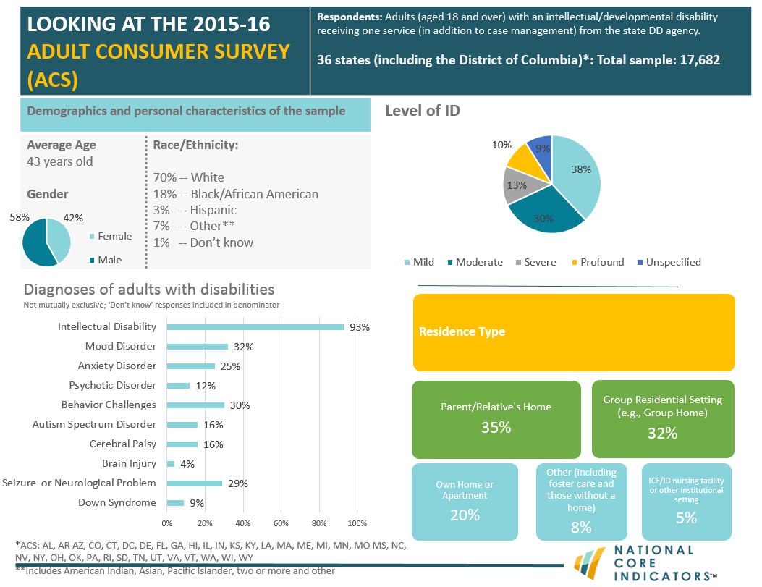

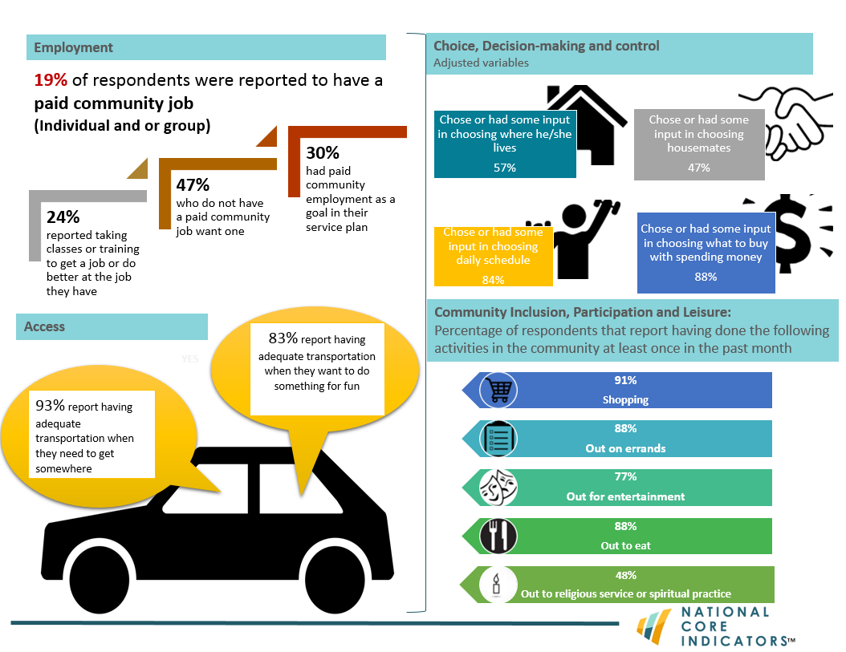

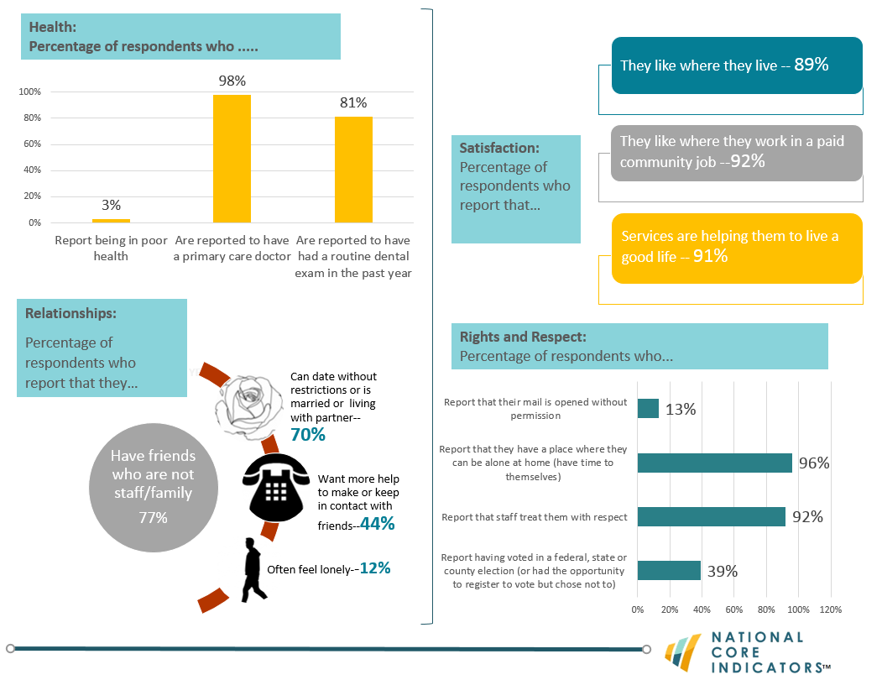

1. Results

This section briefly describes the structure of the survey instrument and presents the results of the most recent data collection cycle.

# Survey Development

The Adult Consumer Survey was initially developed by a technical advisory subcommittee for the purpose of collecting information directly from individuals with intellectual/developmental disabilities and their families or advocates. The survey is designed to measure more than half of the original 60 core indicators. Many questions were drawn from survey instruments already in use in the field; others were developed specifically for NCI.

Most participating states use the standard survey tool. However, some states opt to incorporate additional survey questions to look more deeply at specific issues. The analysis and presentation of these additional state-specific survey questions is not included in this report.

## Organization of the Survey

The Adult Consumer Survey consists of a pre-survey form, three distinct survey sections, and a surveyor feedback form. Each is described below.

**Pre-Survey Information:** This sectionhas questions that help the surveyor prepare for the meeting with the person being surveyed (the adult receiving services). Pre-Survey information is not included in the analysis by HSRI and is not included in this report; it is for surveyor use only.

**Background Information:** Thissectionconsists of questions about demographics, residence, health, employment status, and services and supports. Data are generally collected from state records, case managers, or a combination of both. If necessary, after consultation with NCI staff and if unavailable from other sources, certain information for the Background Information section may be collected during the face-to-face survey.

****Section I**:** This section asks subjective questions about, for example, the individual’s opinions and satisfaction with services. This section may *only* be completed through a face-to-face meeting with the individual.

****Section II:** This section** contains objective, fact-based questions. If the person receiving services is unwilling or unable to respond, a proxy who knows the person well may respond. Case managers or service coordinators are not allowed to respond to these questions on the individual’s behalf.

****Surveyor Feedback Sheet:** This form** is used to record information such as the length of the NCI meeting with the individual and any problematic questions encountered.

## Presentation of Data

The following two subsections of this report detail results from the 2015-16 data collection cycle. Demographic results are presented first. Tables display demographic results listed alphabetically by state. Outcomes are then displayed for the Adult Consumer Survey results. Items are grouped by domain and are presented in both chart and table form.

Notations are made throughout the report to indicate:

1. Items that were analyzed differently in the 2015-16 data collection cycle;
2. Items that were new additions to the survey in 2015-16;
3. Other important considerations.

**Note:** Survey question, reporting and analysis changes from year-to-year are important to consider when making year-to-year comparisons;

# Demographic Characteristics of Respondents

Thirty-five (35) states and the District of Columbia administered the Adult Consumer Survey in 2015-16 and submitted valid samples for analysis. Together, survey information was collected on a total of 17,682 individuals. The states represented are: Alabama (AL), Arkansas (AR), Arizona (AZ), Colorado (CO), Connecticut (CT), District of Columbia (DC), Delaware (DE), Florida (FL), Georgia (GA) Hawaii (HI), Illinois (IL), Indiana (IN), Kansas (KS), Kentucky (KY), Louisiana (LA), Massachusetts (MA), Maine (ME), Michigan (MI), Minnesota (MN), Missouri (MO), Mississippi (MS), North Carolina (NC), Nevada (NV), New York (NY), Ohio (OH), Oklahoma (OK), Pennsylvania (PA), Rhode Island (RI), South Dakota (SD), Tennessee (TN), Utah (UT), Virginia (VA), Vermont (VT), Washington (WA), Wisconsin (WI), and Wyoming (WY).

The tables on the following pages illustrate respondent characteristics by state and include the NCI Average (the average of all states’ means). Demographic information used for outcome adjustment is noted with “¥”.

## Profile of Sample

Table . Age ¥

|  |  |  |  |  |  |  |
| --- | --- | --- | --- | --- | --- | --- |
| State | Mean | Min | Max | Standard Deviation | Median | N |
| AL | 46 | 19 | 82 | 13 | 46 | 398 |
| AR | 41 | 19 | 81 | 14 | 40 | 395 |
| AZ | 35 | 18 | 76 | 14 | 31 | 476 |
| CO | 44 | 19 | 90 | 15 | 42 | 401 |
| CT | 43 | 18 | 90 | 17 | 42 | 347 |
| DC | 47 | 19 | 88 | 16 | 50 | 398 |
| DE | 46 | 18 | 93 | 17 | 47 | 434 |
| FL | 38 | 18 | 96 | 14 | 36 | 1,452 |
| GA | 42 | 19 | 91 | 14 | 41 | 473 |
| HI | 41 | 18 | 87 | 15 | 39 | 400 |
| IL | 44 | 20 | 86 | 15 | 43 | 397 |
| IN | 41 | 18 | 91 | 14 | 40 | 828 |
| KS | 40 | 18 | 84 | 15 | 37 | 379 |
| KY | 41 | 19 | 79 | 15 | 38 | 453 |
| LA | 42 | 18 | 86 | 14 | 40 | 437 |
| MA | 48 | 20 | 95 | 16 | 49 | 421 |
| ME | 47 | 22 | 87 | 16 | 47 | 401 |
| MI | 45 | 19 | 100 | 16 | 45 | 433 |
| MN | 41 | 18 | 91 | 16 | 39 | 427 |
| MO | 44 | 19 | 94 | 15 | 43 | 400 |
| MS | 42 | 21 | 74 | 12 | 40 | 414 |
| NC | 42 | 19 | 99 | 15 | 41 | 822 |
| NV | 41 | 19 | 81 | 13 | 39 | 403 |
| NY | 44 | 18 | 94 | 17 | 43 | 494 |
| OH | 41 | 18 | 87 | 16 | 38 | 611 |
| OK | 40 | 18 | 75 | 15 | 41 | 400 |
| PA | 42 | 19 | 92 | 16 | 40 | 671 |
| RI | 45 | 20 | 86 | 15 | 44 | 413 |
| SD | 43 | 21 | 87 | 16 | 40 | 364 |
| TN | 48 | 19 | 90 | 15 | 49 | 442 |
| UT | 39 | 18 | 87 | 15 | 36 | 407 |
| VA | 43 | 18 | 89 | 15 | 41 | 813 |
| VT | 42 | 20 | 80 | 16 | 40 | 326 |
| WA | 39 | 18 | 75 | 14 | 36 | 406 |
| WI | 47 | 18 | 91 | 16 | 48 | 413 |
| WY | 41 | 20 | 85 | 14 | 39 | 309 |
| NCI Average | 43 |  |  |  |  | 17,458 |

¥Item is used for risk adjustment

Table . Age group º

|  |  |  |  |  |  |  |  |
| --- | --- | --- | --- | --- | --- | --- | --- |
| State | 18-22 | 23-34 | 35-54 | 55-74 | 75 and Older | Unknown | N |
| AL | 1% | 22% | 48% | 28% | 1% | 0% | 399 |
| AR | 7% | 30% | 43% | 19% | 1% | 1% | 397 |
| AZ | 20% | 40% | 28% | 12% | 0% | 0% | 476 |
| CO | 6% | 26% | 42% | 20% | 3% | 2% | 411 |
| CT | 7% | 30% | 35% | 24% | 4% | 0% | 348 |
| DC | 5% | 23% | 34% | 35% | 2% | 1% | 401 |
| DE | 8% | 25% | 31% | 32% | 3% | 0% | 436 |
| FL | 12% | 33% | 40% | 13% | 1% | 0% | 1,457 |
| GA | 2% | 35% | 42% | 21% | 0% | 0% | 473 |
| HI | 6% | 35% | 39% | 17% | 3% | 0% | 401 |
| IL | 4% | 29% | 38% | 26% | 3% | 1% | 400 |
| IN | 11% | 25% | 44% | 18% | 1% | 0% | 830 |
| KS | 9% | 33% | 34% | 18% | 2% | 5% | 400 |
| KY | 9% | 33% | 36% | 21% | 1% | 1% | 456 |
| LA | 8% | 31% | 40% | 20% | 1% | 0% | 439 |
| MA | 0% | 23% | 42% | 27% | 7% | 0% | 422 |
| ME | 1% | 26% | 38% | 29% | 5% | 0% | 402 |
| MI | 6% | 25% | 38% | 28% | 3% | 0% | 435 |
| MN | 11% | 32% | 34% | 20% | 3% | 0% | 428 |
| MO | 5% | 24% | 45% | 23% | 2% | 0% | 400 |
| MS | 3% | 32% | 47% | 19% | 0% | 0% | 414 |
| NC | 9% | 29% | 37% | 23% | 1% | 0% | 823 |
| NV | 2% | 35% | 46% | 16% | 1% | 0% | 403 |
| NY | 9% | 26% | 36% | 25% | 4% | 1% | 497 |
| OH | 12% | 30% | 34% | 22% | 1% | 2% | 623 |
| OK | 24% | 15% | 40% | 21% | 1% | 0% | 400 |
| PA | 9% | 28% | 35% | 20% | 3% | 4% | 701 |
| RI | 3% | 23% | 31% | 23% | 1% | 18% | 506 |
| SD | 3% | 35% | 36% | 22% | 4% | 1% | 366 |
| TN | 3% | 21% | 38% | 34% | 3% | 1% | 447 |
| UT | 13% | 33% | 37% | 16% | 1% | 0% | 407 |
| VA | 5% | 31% | 39% | 22% | 3% | 1% | 818 |
| VT | 6% | 38% | 28% | 28% | 1% | 0% | 326 |
| WA | 5% | 41% | 35% | 18% | 0% | 0% | 406 |
| WI | 7% | 19% | 42% | 29% | 4% | 0% | 413 |
| WY | 7% | 32% | 36% | 21% | 1% | 4% | 321 |
| NCI Average | 7% | 29% | 38% | 22% | 2% | 1% | 17,682 |

ºNew variable to reporting

Table . Gender

|  |  |  |  |
| --- | --- | --- | --- |
| State | Male | Female | N |
| AL | 51% | 49% | 399 |
| AR | 55% | 45% | 386 |
| AZ | 62% | 38% | 471 |
| CO | 62% | 38% | 411 |
| CT | 54% | 46% | 345 |
| DC | 62% | 38% | 395 |
| DE | 56% | 44% | 429 |
| FL | 58% | 42% | 1,443 |
| GA | 61% | 39% | 470 |
| HI | 57% | 43% | 399 |
| IL | 58% | 42% | 397 |
| IN | 59% | 41% | 827 |
| KS | 60% | 40% | 373 |
| KY | 58% | 42% | 452 |
| LA | 61% | 39% | 437 |
| MA | 56% | 44% | 420 |
| ME | 55% | 45% | 399 |
| MI | 55% | 45% | 431 |
| MN | 59% | 41% | 427 |
| MO | 63% | 37% | 397 |
| MS | 52% | 48% | 414 |
| NC | 59% | 41% | 812 |
| NV | 57% | 43% | 403 |
| NY | 62% | 38% | 497 |
| OH | 61% | 39% | 615 |
| OK | 55% | 45% | 400 |
| PA | 56% | 44% | 666 |
| RI | 57% | 43% | 415 |
| SD | 56% | 44% | 362 |
| TN | 59% | 41% | 440 |
| UT | 60% | 40% | 407 |
| VA | 56% | 44% | 804 |
| VT | 59% | 41% | 326 |
| WA | 63% | 37% | 402 |
| WI | 60% | 40% | 413 |
| WY | 54% | 46% | 317 |
| NCI Average | 58% | 42% | 17,401 |

Table . Marital status º

|  |  |  |  |  |  |
| --- | --- | --- | --- | --- | --- |
| State | Single, Never Married | Married | Single, Married in the Past | Don't Know | N |
| AL | 97% | 1% | 2% | 0% | 398 |
| AR | 94% | 2% | 4% | 0% | 390 |
| AZ | 97% | 1% | 1% | 1% | 472 |
| CO | 93% | 4% | 3% | 0% | 401 |
| CT | 97% | 1% | 1% | 1% | 345 |
| DC ** | 85% | 1% | 0% | 14% | 293 |
| DE | 98% | 1% | 0% | 1% | 427 |
| FL | 97% | 1% | 2% | 0% | 1,446 |
| GA | 97% | 3% | 1% | 0% | 469 |
| HI | 99% | 0% | 1% | 0% | 400 |
| IL | 98% | 0% | 2% | 0% | 396 |
| IN | 95% | 1% | 3% | 2% | 826 |
| KS | 95% | 2% | 2% | 1% | 381 |
| KY | 96% | 2% | 2% | 0% | 453 |
| LA | 97% | 1% | 1% | 1% | 439 |
| MA | 94% | 2% | 4% | 0% | 418 |
| ME | 95% | 2% | 4% | 0% | 395 |
| MI | 97% | 1% | 2% | 0% | 434 |
| MN | 95% | 2% | 2% | 0% | 411 |
| MO | 96% | 1% | 2% | 0% | 400 |
| MS | 96% | 1% | 2% | 0% | 392 |
| NC | 97% | 1% | 2% | 0% | 818 |
| NV | 94% | 2% | 3% | 1% | 398 |
| NY | 94% | 3% | 3% | 0% | 490 |
| OH | 94% | 3% | 2% | 1% | 609 |
| OK | 97% | 2% | 2% | 0% | 400 |
| PA | 95% | 2% | 1% | 2% | 641 |
| RI | 96% | 0% | 2% | 1% | 404 |
| SD | 94% | 2% | 4% | 0% | 364 |
| TN | 96% | 2% | 2% | 1% | 445 |
| UT | 93% | 2% | 4% | 0% | 405 |
| VA | 94% | 0% | 2% | 4% | 816 |
| VT | 94% | 2% | 3% | 0% | 326 |
| WA | 97% | 1% | 2% | 0% | 399 |
| WI ** | 36% | 2% | 3% | 58% | 407 |
| WY | 88% | 4% | 7% | 1% | 314 |
| NCI Average | 94% | 2% | 2% | 3% | 17,222 |

ºNew variable to reporting

**State had a large number of “don’t know” responses and missing data (at least 25%)

Table . Race ±

|  |  |  |  |  |  |  |  |  |  |  |
| --- | --- | --- | --- | --- | --- | --- | --- | --- | --- | --- |
| State | American Indian or Alaska Native | Asian | Black or African American | Pacific Islander | White | Hispanic or Latino | Other | Two or More | Don't Know | N |
| AL | 0% | 0% | 38% | 0% | 62% | 0% | 0% | 1% | 0% | 399 |
| AR | 1% | 1% | 23% | 0% | 74% | 1% | 0% | 1% | 0% | 395 |
| AZ | 5% | 1% | 6% | 0% | 64% | 20% | 1% | 1% | 2% | 472 |
| CO | 0% | 0% | 2% | 0% | 38% | 7% | 38% | 0% | 13% | 401 |
| CT | 1% | 0% | 7% | 0% | 80% | 7% | 1% | 1% | 2% | 344 |
| DC | 0% | 1% | 87% | 0% | 7% | 2% | 1% | 0% | 2% | 397 |
| DE | 0% | 0% | 32% | 0% | 64% | 2% | 1% | 1% | 0% | 434 |
| FL | 0% | 1% | 26% | 0% | 56% | 13% | 2% | 1% | 0% | 1,439 |
| GA | 0% | 1% | 48% | 0% | 49% | 0% | 1% | 0% | 0% | 471 |
| HI | 0% | 40% | 1% | 16% | 14% | 2% | 5% | 20% | 1% | 401 |
| IL | 0% | 1% | 21% | 1% | 72% | 4% | 1% | 0% | 1% | 396 |
| IN | 0% | 0% | 11% | 0% | 86% | 1% | 0% | 1% | 0% | 828 |
| KS | 1% | 1% | 7% | 0% | 85% | 2% | 2% | 1% | 1% | 379 |
| KY | 1% | 0% | 13% | 0% | 85% | 0% | 0% | 0% | 0% | 453 |
| LA | 0% | 0% | 40% | 0% | 57% | 1% | 0% | 0% | 0% | 438 |
| MA | 0% | 0% | 8% | 0% | 84% | 6% | 1% | 0% | 0% | 416 |
| ME | 1% | 0% | 1% | 0% | 94% | 0% | 2% | 1% | 2% | 400 |
| MI | 1% | 0% | 18% | 0% | 78% | 1% | 2% | 0% | 0% | 433 |
| MN | 1% | 1% | 8% | 0% | 87% | 0% | 0% | 1% | 1% | 427 |
| MO | 0% | 1% | 14% | 0% | 81% | 1% | 1% | 1% | 2% | 399 |
| MS | 0% | 0% | 45% | 0% | 55% | 0% | 0% | 0% | 0% | 407 |
| NC | 1% | 0% | 34% | 0% | 63% | 1% | 1% | 0% | 0% | 819 |
| NV | 0% | 4% | 14% | 1% | 70% | 8% | 1% | 1% | 0% | 403 |
| NY | 0% | 1% | 20% | 0% | 63% | 9% | 4% | 2% | 1% | 497 |
| OH | 1% | 0% | 13% | 0% | 80% | 1% | 1% | 1% | 2% | 614 |
| OK | 10% | 0% | 11% | 0% | 75% | 2% | 0% | 2% | 0% | 400 |
| PA | 0% | 0% | 10% | 0% | 81% | 3% | 1% | 1% | 2% | 644 |
| RI | 0% | 2% | 6% | 0% | 79% | 9% | 2% | 1% | 1% | 413 |
| SD | 14% | 0% | 1% | 0% | 83% | 1% | 1% | 1% | 0% | 362 |
| TN | 0% | 0% | 27% | 0% | 69% | 0% | 2% | 0% | 0% | 446 |
| UT | 3% | 1% | 1% | 1% | 84% | 3% | 2% | 4% | 1% | 407 |
| VA | 1% | 3% | 28% | 0% | 61% | 2% | 2% | 1% | 3% | 817 |
| VT | 1% | 1% | 1% | 0% | 95% | 1% | 0% | 0% | 0% | 326 |
| WA | 3% | 4% | 3% | 0% | 83% | 4% | 0% | 2% | 0% | 405 |
| WI | 1% | 0% | 8% | 0% | 76% | 2% | 0% | 0% | 12% | 412 |
| WY | 3% | 0% | 2% | 1% | 91% | 3% | 0% | 1% | 0% | 318 |
| NCI Average | 1% | 2% | 18% | 1% | 70% | 3% | 2% | 1% | 1% | 17,412 |

±Item changed from previous years – race and ethnicity are combined

Table . Residential designation (metropolitan, micropolitan, rural, small town) * º

|  |  |  |  |  |  |  |
| --- | --- | --- | --- | --- | --- | --- |
| State | Metropolitan | Micropolitan | Rural | Small Town | Don't Know | N |
| AL | 68% | 15% | 4% | 10% | 3% | 399 |
| AR | 64% | 19% | 2% | 15% | 1% | 397 |
| AZ ** | 7% | 0% | 0% | 0% | 92% | 476 |
| CO | 84% | 8% | 1% | 6% | 1% | 411 |
| CT | 85% | 3% | 0% | 0% | 12% | 348 |
| DC ** | 72% | 0% | 0% | 0% | 28% | 401 |
| DE ** | 64% | 14% | 0% | 4% | 18% | 436 |
| FL | 83% | 1% | 0% | 2% | 14% | 1,457 |
| GA | 72% | 11% | 3% | 6% | 8% | 473 |
| HI ** | 26% | 2% | 0% | 0% | 72% | 401 |
| IL | 76% | 9% | 1% | 12% | 3% | 400 |
| IN | 73% | 16% | 3% | 7% | 1% | 830 |
| KS | 50% | 27% | 4% | 9% | 11% | 400 |
| KY ** | 36% | 30% | 5% | 9% | 21% | 456 |
| LA | 89% | 6% | 0% | 5% | 0% | 439 |
| MA | 96% | 1% | 0% | 1% | 2% | 422 |
| ME | 45% | 18% | 18% | 14% | 5% | 402 |
| MI | 79% | 11% | 5% | 5% | 0% | 435 |
| MN | 71% | 13% | 5% | 11% | 0% | 428 |
| MO | 60% | 18% | 5% | 18% | 0% | 400 |
| MS | 51% | 37% | 3% | 7% | 3% | 414 |
| NC | 69% | 23% | 3% | 5% | 1% | 823 |
| NV | 94% | 5% | 0% | 0% | 1% | 403 |
| NY | 72% | 8% | 3% | 6% | 10% | 497 |
| OH | 65% | 18% | 2% | 6% | 9% | 623 |
| OK | 54% | 31% | 2% | 13% | 1% | 400 |
| PA ** | 65% | 10% | 4% | 4% | 17% | 701 |
| RI ** | 61% | 0% | 0% | 0% | 39% | 506 |
| SD | 37% | 39% | 7% | 11% | 6% | 366 |
| TN ** | 0% | 2% | 0% | 0% | 97% | 447 |
| UT | 85% | 9% | 1% | 4% | 1% | 407 |
| VA | 81% | 6% | 4% | 7% | 1% | 818 |
| VT | 30% | 19% | 27% | 24% | 0% | 326 |
| WA | 85% | 11% | 1% | 2% | 1% | 406 |
| WI | 80% | 11% | 4% | 2% | 2% | 413 |
| WY ** | 29% | 28% | 5% | 13% | 25% | 321 |
| NCI Average | 63% | 13% | 3% | 7% | 14% | 17,682 |

*Residential designations were derived by transforming individuals’ zip codes into designations defined by the USDA

ºNew variable to reporting

**State had a large number of “don’t know” responses and missing data (at least 25%)

Table . Type of residence –intermediate care facility for Individuals with I/DD (ICF/IID) or other institutional setting

|  | ICF/IID, 4-6 Residents with Disabilities | ICF/IID, 7-15 Residents with Disabilities | ICF/IID, 16 or More Residents with Disabilities | Nursing Facility | Other Specialized Institutional Facility | N |
| --- | --- | --- | --- | --- | --- | --- |
| AL | 0% | 0% | 0% | 0% | 0% | 399 |
| AR | 26% | 1% | 0% | 0% | 0% | 393 |
| AZ | 0% | 1% | 1% | 0% | 0% | 476 |
| CO | 0% | 0% | 0% | 0% | 0% | 406 |
| CT | 0% | 0% | 5% | 1% | 0% | 346 |
| DC | 12% | 0% | 0% | 0% | 0% | 304 |
| DE | 0% | 0% | 0% | 0% | 0% | 435 |
| FL | 0% | 0% | 0% | 0% | 0% | 1,443 |
| GA | 0% | 0% | 0% | 0% | 0% | 473 |
| HI | 0% | 0% | 0% | 0% | 0% | 401 |
| IL | 0% | 0% | 0% | 0% | 0% | 400 |
| IN | 0% | 0% | 0% | 0% | 0% | 826 |
| KS | 0% | 0% | 0% | 0% | 0% | 382 |
| KY | 0% | 0% | 1% | 1% | 0% | 455 |
| LA | 16% | 3% | 10% | 0% | 0% | 439 |
| MA | 0% | 0% | 0% | 0% | 0% | 419 |
| ME | 0% | 0% | 0% | 1% | 2% | 398 |
| MI | 0% | 0% | 0% | 0% | 1% | 432 |
| MN | 4% | 2% | 1% | 0% | 0% | 428 |
| MO | 0% | 0% | 0% | 0% | 0% | 399 |
| MS | 0% | 0% | 0% | 0% | 0% | 379 |
| NC | 3% | 3% | 11% | 0% | 0% | 822 |
| NV | 0% | 0% | 0% | 0% | 0% | 403 |
| NY | 2% | 6% | 2% | 0% | 1% | 497 |
| OH | 1% | 3% | 9% | 1% | 0% | 616 |
| OK | 0% | 0% | 0% | 0% | 0% | 400 |
| PA | 1% | 1% | 3% | 2% | 1% | 647 |
| RI ** | 0% | 0% | 0% | 0% | 0% | 381 |
| SD | 0% | 0% | 3% | 0% | 0% | 365 |
| TN | 0% | 0% | 0% | 0% | 1% | 445 |
| UT | 1% | 0% | 5% | 0% | 0% | 406 |
| VA | 1% | 2% | 1% | 4% | 0% | 814 |
| VT | 0% | 0% | 0% | 0% | 0% | 326 |
| WA | 0% | 0% | 0% | 0% | 0% | 402 |
| WI* | 1%* | 0% | 8%* | 0% | 0% | 412 |
| WY | 0% | 0% | 0% | 0% | 0% | 314 |
| NCI Average | 2% | 1% | 2% | 0% | 0% | 17,283 |

**State had a large number of “don’t know” responses and missing data (at least 25%)

*A miscoding of residential types was identified by WI just prior to publication of this report. A portion of those in ICF categories should have been categorized in ‘Group Residential Setting’ in 2015-2016.

Table . Type of residence – Group residential setting (e.g., group home)

|  | Group Living Setting, 2-3 People w/ Disabilities | Group Living Setting, 4-6 People w/ Disabilities | Group Living Setting, 7-15 People w/ Disabilities | N |
| --- | --- | --- | --- | --- |
| AL | 33% | 11% | 9% | 399 |
| AR | 1% | 1% | 7% | 393 |
| AZ | 14% | 5% | 0% | 476 |
| CO | 4% | 8% | 5% | 406 |
| CT | 11% | 26% | 1% | 346 |
| DC | 40% | 1% | 0% | 304 |
| DE | 49% | 31% | 0% | 435 |
| FL | 1% | 22% | 5% | 1,443 |
| GA | 11% | 8% | 0% | 473 |
| HI | 2% | 9% | 0% | 401 |
| IL | 2% | 28% | 22% | 400 |
| IN | 2%*** | 0% | 0% | 826 |
| KS | 16% | 22% | 5% | 382 |
| KY | 30% | 2% | 2% | 455 |
| LA | 0% | 0% | 0% | 439 |
| MA | 8% | 44% | 3% | 419 |
| ME | 28% | 18% | 2% | 398 |
| MI | 5% | 28% | 7% | 432 |
| MN | 0% | 42% | 0% | 428 |
| MO | 7% | 11% | 9% | 399 |
| MS | 15% | 14% | 0% | 379 |
| NC | 7% | 14% | 2% | 822 |
| NV | 19% | 32% | 0% | 403 |
| NY | 5% | 20% | 19% | 497 |
| OH | 5% | 8% | 1% | 616 |
| OK | 31% | 12% | 2% | 400 |
| PA | 16% | 9% | 1% | 647 |
| RI ** | 6% | 28% | 5% | 381 |
| SD | 6% | 15% | 22% | 365 |
| TN | 26% | 2% | 4% | 445 |
| UT | 28% | 6% | 2% | 406 |
| VA | 6% | 35% | 6% | 814 |
| VT | 2% | 5% | 0% | 326 |
| WA | 3% | 4% | 1% | 402 |
| WI* | 8% | 4% | 0% | 412 |
| WY | 14% | 20% | 2% | 314 |
| NCI Average | 13% | 15% | 4% | 17,283 |

**State had a large number of “don’t know” responses and missing data (at least 25%)

***Due to the unique design of residential services in IN and the minor differences between the NCI descriptions of group home settings and independent home/apt settings, it is possible that the survey responses from IN categorized as living in group home settings may also be categorized as independent home/apartment. NCI will work with IN and other states to ensure that categorization is consistent in future years

*A miscoding of residential types was identified by WI just prior to publication of this report. A portion of those in ICF categories should have been categorized in ‘Group Residential Setting’ in 2015-2016.

Table . Type of residence, continued

|  |  |  |  |  |  |  |  |  |
| --- | --- | --- | --- | --- | --- | --- | --- | --- |
| State | Own Home or Apartment | Parent or Relative's Home | Foster Care or Host Home (2 or More People With a Disability) | Foster Care, Host Home, or Shared Living (1 Person With a Disability) | Homeless | Other | Don't Know | N |
| AL | 12% | 36% | 0% | 0% | 0% | 0% | 0% | 399 |
| AR | 34% | 25% | 1% | 2% | 0% | 2% | 0% | 393 |
| AZ | 10% | 61% | 6% | 1% | 0% | 1% | 0% | 476 |
| CO | 17% | 28% | 23% | 4% | 0% | 10% | 0% | 406 |
| CT | 16% | 36% | 1% | 2% | 0% | 0% | 0% | 346 |
| DC | 7% | 29% | 1% | 1% | 0% | 0% | 7% | 304 |
| DE | 7% | 2% | 3% | 8% | 0% | 0% | 0% | 435 |
| FL | 19% | 52% | 0% | 0% | 0% | 1% | 0% | 1,443 |
| GA | 20% | 51% | 7% | 2% | 0% | 0% | 0% | 473 |
| HI | 5% | 57% | 26% | 0% | 0% | 0% | 0% | 401 |
| IL | 8% | 39% | 1% | 0% | 0% | 0% | 0% | 400 |
| IN | 21% | 73% | 2% | 2% | 0% | 0% | 0% | 826 |
| KS | 26% | 27% | 1% | 1% | 0% | 1% | 1% | 382 |
| KY | 12% | 40% | 9% | 3% | 0% | 0% | 0% | 455 |
| LA | 25% | 46% | 0% | 0% | 0% | 0% | 0% | 439 |
| MA | 13% | 22% | 3% | 5% | 0% | 0% | 0% | 419 |
| ME | 14% | 17% | 4% | 10% | 0% | 5% | 1% | 398 |
| MI | 20% | 34% | 4% | 0% | 0% | 2% | 0% | 432 |
| MN | 12% | 30% | 7% | 0% | 0% | 0% | 2% | 428 |
| MO | 57% | 11% | 2% | 3% | 0% | 0% | 0% | 399 |
| MS | 25% | 46% | 0% | 0% | 0% | 0% | 0% | 379 |
| NC | 8% | 43% | 5% | 2% | 0% | 1% | 0% | 822 |
| NV | 33% | 13% | 1% | 2% | 0% | 0% | 1% | 403 |
| NY | 13% | 29% | 3% | 0% | 0% | 0% | 0% | 497 |
| OH | 23% | 46% | 0% | 1% | 0% | 0% | 0% | 616 |
| OK | 20% | 29% | 1% | 4% | 0% | 1% | 0% | 400 |
| PA | 13% | 47% | 0% | 1% | 0% | 4% | 1% | 647 |
| RI ** | 18% | 36% | 1% | 2% | 0% | 2% | 1% | 381 |
| SD | 39% | 14% | 1% | 0% | 0% | 0% | 0% | 365 |
| TN | 37% | 24% | 3% | 1% | 0% | 1% | 0% | 445 |
| UT | 13% | 38% | 3% | 3% | 0% | 1% | 0% | 406 |
| VA | 5% | 31% | 3% | 6% | 0% | 0% | 0% | 814 |
| VT | 15% | 25% | 15% | 38% | 0% | 0% | 0% | 326 |
| WA | 37% | 45% | 8% | 0% | 0% | 2% | 0% | 402 |
| WI | 30% | 37% | 0% | 0% | 0% | 7% | 5% | 412 |
| WY | 32% | 25% | 3% | 3% | 0% | 0% | 0% | 314 |
| NCI Average | 20% | 35% | 4% | 3% | 0% | 1% | 1% | 17,283 |

**State had a large number of “don’t know” responses and missing data (at least 25%)

Table . Length of time at current residence º

|  |  |  |  |  |  |  |
| --- | --- | --- | --- | --- | --- | --- |
| State | Less Than 1 Year | 1-3 Years | 3-5 Years | Over 5 Years | Don't Know | N |
| AL | 6% | 15% | 12% | 63% | 4% | 396 |
| AR | 13% | 19% | 12% | 54% | 3% | 386 |
| AZ ** | 11% | 14% | 7% | 44% | 24% | 472 |
| CO | 12% | 22% | 11% | 56% | 1% | 400 |
| CT | 6% | 17% | 12% | 61% | 4% | 340 |
| DC ** | 2% | 13% | 25% | 20% | 41% | 293 |
| DE | 16% | 23% | 15% | 37% | 9% | 426 |
| FL | 10% | 16% | 12% | 61% | 1% | 1,440 |
| GA | 6% | 15% | 11% | 64% | 4% | 464 |
| HI | 2% | 5% | 3% | 86% | 5% | 387 |
| IL | 7% | 18% | 9% | 60% | 7% | 396 |
| IN | 10% | 9% | 7% | 73% | 1% | 816 |
| KS | 15% | 22% | 13% | 47% | 3% | 379 |
| KY | 15% | 20% | 12% | 49% | 5% | 454 |
| LA | 5% | 15% | 11% | 58% | 11% | 437 |
| MA | 8% | 16% | 11% | 64% | 2% | 419 |
| ME | 14% | 18% | 12% | 55% | 1% | 391 |
| MI | 11% | 16% | 10% | 60% | 3% | 430 |
| MN | 7% | 15% | 10% | 66% | 2% | 411 |
| MO | 13% | 22% | 13% | 50% | 3% | 399 |
| MS | 9% | 20% | 8% | 59% | 4% | 400 |
| NC | 9% | 14% | 8% | 65% | 4% | 811 |
| NV | 14% | 25% | 16% | 42% | 3% | 400 |
| NY | 6% | 13% | 12% | 68% | 1% | 496 |
| OH | 10% | 12% | 10% | 61% | 7% | 610 |
| OK | 13% | 22% | 15% | 50% | 0% | 400 |
| PA | 8% | 15% | 10% | 58% | 9% | 623 |
| RI ** | 6% | 12% | 9% | 61% | 12% | 372 |
| SD | 12% | 22% | 15% | 49% | 2% | 358 |
| TN | 12% | 23% | 16% | 43% | 6% | 439 |
| UT | 11% | 20% | 11% | 54% | 3% | 401 |
| VA | 7% | 16% | 15% | 56% | 5% | 803 |
| VT | 17% | 18% | 12% | 52% | 2% | 326 |
| WA | 12% | 15% | 11% | 62% | 0% | 398 |
| WI ** | n/a | n/a | n/a | n/a | 100% | 413 |
| WY | 18% | 27% | 10% | 39% | 6% | 310 |
| NCI Average | 10% | 17% | 12% | 56% | 8% | 17,096 |

ºNew variable to reporting

**State had a large number of “don’t know” responses and missing data (at least 25%)

Table . Person's residence owned or controlled by provider agency º

|  |  |  |  |  |
| --- | --- | --- | --- | --- |
| State | Yes | No | Don't Know | N |
| AL | 93% | 6% | 1% | 215 |
| AR | 60% | 38% | 2% | 182 |
| AZ | 80% | 8% | 11% | 131 |
| CO | 78% | 20% | 1% | 202 |
| CT | 83% | 12% | 5% | 157 |
| DC | 91% | 7% | 2% | 247 |
| DE | 91% | 8% | 1% | 418 |
| FL | 37% | 63% | 0% | 1,065 |
| GA | 37% | 63% | 0% | 305 |
| HI | 64% | 35% | 1% | 174 |
| IL | 69% | 31% | 0% | 287 |
| IN | 7% | 92% | 1% | 492 |
| KS | 64% | 35% | 1% | 241 |
| KY | 44% | 54% | 2% | 412 |
| LA | 98% | 1% | 1% | 106 |
| MA | 73% | 22% | 5% | 318 |
| ME | 79% | 15% | 7% | 246 |
| MI | 75% | 18% | 8% | 177 |
| MN ^ | n/a | n/a | 100% | 245 |
| MO | 46% | 52% | 2% | 256 |
| MS | 92% | 0% | 8% | 106 |
| NC | 45% | 52% | 2% | 654 |
| NV | 69% | 28% | 3% | 301 |
| NY | 84% | 11% | 5% | 284 |
| OH | 42% | 52% | 6% | 309 |
| OK | 45% | 55% | 0% | 296 |
| PA | 67% | 28% | 5% | 317 |
| RI | 88% | 8% | 5% | 169 |
| SD | 46% | 53% | 0% | 360 |
| TN | 29% | 67% | 4% | 378 |
| UT | 39% | 59% | 2% | 392 |
| VA | 92% | 7% | 2% | 512 |
| VT | 29% | 71% | 0% | 208 |
| WA | 28% | 72% | 1% | 200 |
| WI ** | 10% | 0% | 90% | 125 |
| WY | 91% | 6% | 3% | 142 |
| NCI Average | 62% | 33% | 8% | 10,629 |

ºNew variable to reporting

**State had a large number of “don’t know” responses and missing data (at least 25%)

^ Based on residence type (Tables 7, 8 and 9) MN estimates that for those who are reported to be living in ICF/IID, Nursing Facility, or Group Living Situation (49%), the residence can be considered owned/controlled by a provider agency. For those living in an independent home or a parent/relative’s home (42%), the residence cannot be considered owned/controlled by a provider agency. For the remaining 9%, their result is unknown.

Table . Person is named on the lease º

|  |  |  |  |  |
| --- | --- | --- | --- | --- |
| State | Yes | No | Don't Know | N |
| AL ** | 28% | 53% | 19% | 204 |
| AR | 19% | 78% | 3% | 155 |
| AZ | 0% | 92% | 8% | 133 |
| CO | 3% | 88% | 10% | 208 |
| CT ** | 7% | 76% | 17% | 148 |
| DC | 0% | 96% | 4% | 233 |
| DE | 4% | 87% | 10% | 399 |
| FL | 5% | 91% | 3% | 410 |
| GA | 22% | 66% | 12% | 134 |
| HI ** | 1% | 63% | 36% | 113 |
| IL | 9% | 86% | 5% | 191 |
| IN | 31% | 55% | 14% | 51 |
| KS | 40% | 49% | 10% | 174 |
| KY | 5% | 91% | 5% | 199 |
| LA | 3% | 95% | 2% | 129 |
| MA | 2% | 91% | 7% | 261 |
| ME | 8% | 80% | 12% | 240 |
| MI | 9% | 78% | 13% | 191 |
| MN ** | 8% | 83% | 9% | 233 |
| MO | 14% | 77% | 9% | 128 |
| MS | 23% | 64% | 13% | 133 |
| NC | 6% | 88% | 6% | 366 |
| NV | 31% | 56% | 13% | 216 |
| NY | 2% | 93% | 5% | 276 |
| OH | 20% | 65% | 15% | 187 |
| OK | 76% | 21% | 3% | 194 |
| PA | 4% | 83% | 14% | 229 |
| RI | 5% | 84% | 10% | 167 |
| SD | 46% | 51% | 3% | 173 |
| TN | 78% | 17% | 5% | 162 |
| UT ** | 9% | 69% | 22% | 195 |
| VA | 8% | 90% | 1% | 502 |
| VT | 2% | 96% | 2% | 173 |
| WA | 23% | 73% | 4% | 77 |
| WI ** | 0% | 8% | 92% | 124 |
| WY ** | 44% | 35% | 20% | 133 |
| NCI Average | 16% | 71% | 12% | 7,241 |

ºNew variable to reporting

**State had a large number of “don’t know” responses and missing data (at least 25%)

Table . Person owns home º

|  |  |  |  |  |
| --- | --- | --- | --- | --- |
| State | Yes | No | Don't Know | N |
| AL | 1% | 97% | 2% | 393 |
| AR | 3% | 96% | 0% | 386 |
| AZ | 1% | 91% | 8% | 470 |
| CO | 4% | 95% | 2% | 404 |
| CT | 2% | 96% | 2% | 334 |
| DC | 1% | 97% | 2% | 345 |
| DE | 0% | 99% | 1% | 429 |
| FL | 4% | 95% | 0% | 1,422 |
| GA | 4% | 95% | 2% | 465 |
| HI ** | 0% | 67% | 33% | 380 |
| IL | 2% | 96% | 3% | 393 |
| IN | 2% | 98% | 0% | 824 |
| KS | 3% | 95% | 2% | 375 |
| KY | 2% | 96% | 2% | 454 |
| LA | 3% | 96% | 0% | 435 |
| MA | 3% | 96% | 1% | 414 |
| ME | 2% | 96% | 2% | 389 |
| MI | 2% | 97% | 1% | 425 |
| MN | 2% | 96% | 2% | 411 |
| MO | 1% | 98% | 1% | 394 |
| MS | 3% | 93% | 4% | 385 |
| NC | 1% | 97% | 2% | 814 |
| NV | 3% | 95% | 2% | 400 |
| NY | 1% | 98% | 1% | 487 |
| OH | 3% | 94% | 3% | 607 |
| OK | 1% | 99% | 0% | 400 |
| PA | 1% | 93% | 5% | 622 |
| RI | 2% | 94% | 4% | 371 |
| SD | 2% | 98% | 0% | 360 |
| TN | 2% | 93% | 6% | 441 |
| UT | 1% | 99% | 0% | 403 |
| VA | 2% | 97% | 1% | 809 |
| VT | 3% | 96% | 1% | 325 |
| WA | 3% | 97% | 0% | 398 |
| WI ** | n/a | n/a | 100% | 413 |
| WY | 7% | 91% | 2% | 313 |
| NCI Average | 2% | 95% | 5% | 17,090 |

ºNew variable to reporting

**State had a large number of “don’t know” responses and missing data (at least 25%)

Table . Has ID diagnosis

|  |  |  |  |  |
| --- | --- | --- | --- | --- |
| State | Yes | No | Don't Know | Valid N |
| AL | 99% | 1% | 0% | 398 |
| AR | 95% | 5% | 0% | 390 |
| AZ | 83% | 15% | 2% | 475 |
| CO | 100% | 0% | 0% | 411 |
| CT | 98% | 2% | 0% | 343 |
| DC | 99% | 0% | 1% | 344 |
| DE | 95% | 2% | 3% | 425 |
| FL | 89% | 11% | 0% | 1,434 |
| GA | 99% | 1% | 0% | 465 |
| HI | 95% | 5% | 0% | 396 |
| IL | 100% | 0% | 0% | 398 |
| IN | 94% | 5% | 1% | 827 |
| KS | 96% | 3% | 1% | 379 |
| KY | 96% | 3% | 1% | 453 |
| LA | 92% | 8% | 0% | 439 |
| MA | 93% | 2% | 5% | 418 |
| ME | 97% | 2% | 1% | 398 |
| MI | 97% | 3% | 0% | 433 |
| MN | 100% | 0% | 0% | 428 |
| MO | 89% | 10% | 0% | 398 |
| MS | 98% | 2% | 0% | 393 |
| NC | 96% | 3% | 1% | 818 |
| NV | 90% | 10% | 0% | 402 |
| NY | 95% | 5% | 0% | 493 |
| OH | 89% | 8% | 2% | 602 |
| OK | 100% | 0% | 0% | 400 |
| PA | 98% | 1% | 1% | 642 |
| RI ** | 84% | 7% | 9% | 406 |
| SD | 89% | 11% | 0% | 360 |
| TN | 95% | 5% | 1% | 437 |
| UT | 85% | 14% | 0% | 405 |
| VA | 94% | 4% | 2% | 815 |
| VT | 90% | 8% | 2% | 326 |
| WA | 86% | 14% | 0% | 405 |
| WI | 87% | 11% | 2% | 413 |
| WY | 84% | 15% | 1% | 314 |
| NCI Average | 93% | 5% | 1% | 17,283 |

**State had a large number of “don’t know” responses and missing data (at least 25%)

Table . Level of ID (if the person has an ID diagnosis) ± ¥

|  |  |  |  |  |  |  |
| --- | --- | --- | --- | --- | --- | --- |
| State | Mild | Moderate | Severe | Profound | Unspecified | N |
| AL | 36% | 38% | 16% | 10% | 0% | 391 |
| AR | 30% | 25% | 17% | 25% | 3% | 359 |
| AZ | 37% | 41% | 12% | 4% | 6% | 388 |
| CO | 44% | 39% | 10% | 7% | 1% | 384 |
| CT | 46% | 29% | 14% | 11% | 1% | 334 |
| DC | 31% | 32% | 17% | 17% | 3% | 329 |
| DE | 44% | 28% | 14% | 10% | 5% | 398 |
| FL | 29% | 39% | 16% | 8% | 8% | 1258 |
| GA | 32% | 34% | 13% | 9% | 11% | 458 |
| HI | 17% | 48% | 18% | 15% | 2% | 373 |
| IL | 42% | 32% | 14% | 12% | 1% | 394 |
| IN | 56% | 23% | 9% | 7% | 5% | 773 |
| KS | 40% | 33% | 13% | 6% | 8% | 359 |
| KY | 44% | 32% | 10% | 5% | 9% | 432 |
| LA | 34% | 25% | 18% | 19% | 4% | 400 |
| MA | 43% | 19% | 11% | 3% | 25% | 382 |
| ME | 44% | 30% | 14% | 8% | 4% | 384 |
| MI | 34% | 32% | 15% | 10% | 8% | 414 |
| MN | 42% | 25% | 14% | 9% | 11% | 428 |
| MO | 40% | 26% | 18% | 8% | 8% | 353 |
| MS | 44% | 26% | 12% | 15% | 3% | 384 |
| NC | 26% | 35% | 18% | 17% | 4% | 780 |
| NV | 62% | 27% | 6% | 2% | 3% | 359 |
| NY | 41% | 32% | 12% | 12% | 2% | 466 |
| OH | 41% | 33% | 12% | 10% | 4% | 534 |
| OK | 38% | 23% | 14% | 23% | 2% | 400 |
| PA | 46% | 29% | 12% | 9% | 4% | 623 |
| RI | 34% | 26% | 13% | 6% | 21% | 337 |
| SD | 52% | 28% | 9% | 8% | 3% | 321 |
| TN | 38% | 32% | 14% | 8% | 9% | 397 |
| UT | 36% | 30% | 18% | 13% | 3% | 346 |
| VA | 28% | 38% | 21% | 10% | 3% | 738 |
| VT | 57% | 25% | 8% | 4% | 7% | 293 |
| WA | 23% | 23% | 6% | 6% | 42% | 348 |
| WI | 3% | 9% | 0% | 0% | 89% | 356 |
| WY | 54% | 31% | 9% | 3% | 3% | 258 |
| NCI Average | 38% | 30% | 13% | 10% | 9% | 15,931 |

±Item changed from previous years – level of ID is only reported for those reported to have an ID diagnosis

¥Item is used for risk adjustment

Table . Mood, anxiety, behavior, psychotic, and other mental illness ∞

|  |  |  |  |  |  |
| --- | --- | --- | --- | --- | --- |
| State | Mood Disorder | Anxiety Disorder | Behavior Challenges | Psychotic Disorder | Other Mental Illness or Psychiatric Diagnosis |
| AL | 32% | 18% | 17% | 17% | 6% |
| AR | 33% | 28% | 36% | 12% | 12% |
| AZ | 26% | 20% | 26% | 8% | 8% |
| CO | 3% | 2% | 17% | 0% | 0% |
| CT | 34% | 28% | 41% | 14% | 13% |
| DC ** | 24% | 18% | 26% | 25% | 5% ** |
| DE | 44% | 30% | 45% | 17% | 16% |
| FL | 25% | 23% | 26% | 12% | 4% |
| GA | 25% | 19% | 22% | 17% | 8% |
| HI | 10% | 8% | 18% | 8% | 4% |
| IL | 32% | 25% | 30% | 13% | 13% |
| IN | 22% | 23% | 27% | 3% | 1% |
| KS | 42% | 29% | 38% | 15% | 14% |
| KY | 34% | 26% | 34% | 13% | 14% |
| LA ** | 44% | 34% | 50% | 19% | 17% |
| MA | 44% | 51% | 26% | 16% | 10% |
| ME | 37% | 41% | 36% | 11% | 14% |
| MI | 37% | 23% | 27% | 15% | 16% |
| MN | 8% | 6% | 27% | 4% | 25% |
| MO | 45% | 25% | 26% | 18% | 10% |
| MS | 25% | 11% | 22% | 13% | 7% |
| NC | 26% | 20% | 33% | 12% | 10% |
| NV | 38% | 20% | 27% | 16% | 11% |
| NY | 26% | 23% | 35% | 10% | 9% |
| OH | 37% | 24% | 25% | 13% | 15% |
| OK | 30% | 20% | 23% | 13% | 6% |
| PA | 33% | 28% | 28% | 11% | 9% |
| RI ** | 35% | 35% | 38% | 7% | 11% |
| SD | 36% | 26% | 25% | 12% | 19% |
| TN | 50% | 37% | 49% | 26% | 23% |
| UT | 44% | 39% | 51% | 8% | 9% |
| VA | 33% | 23% | 35% | 12% | 9% |
| VT | 41% | 41% | 35% | 9% | 12% |
| WA | 23% | 24% | 9% | 7% | 5% |
| WI | 28% | 24% | 27% | 8% | 17% |
| WY | 42% | 26% | 18% | 7% | 13% |
| NCI Average | 32% | 25% | 30% | 12% | 11% |

∞Individuals may have been diagnosed with more than one other disability; ‘Don’t know’ responses included in denominator

**State had a large number of “don’t know” responses and missing data (at least 25%)

Table . Other diagnoses ∞

|  |  |  |  |  |  |
| --- | --- | --- | --- | --- | --- |
| State | Autism Spectrum Disorder | Cerebral Palsy | Brain Injury | Seizure Disorder | Chemical Dependency |
| AL | 8% | 12% | 2% | 24% | 1% |
| AR | 15% | 25% | 7% | 29% | 1% |
| AZ | 17% | 22% | 3% | 24% | 0% |
| CO | 7% | 14% | 1% | 22% | n/a ** |
| CT | 22% | 20% | 3% | 29% | 1% |
| DC ** | 11% | 15% | 0% | 26% | 1% |
| DE | 18% | 13% | 2% | 27% | 1% |
| FL | 18% | 21% | 3% | 29% | 1% |
| GA | 13% | 12% | 1% | 25% | 1% |
| HI | 14% | 16% | 1% | 35% | 1% |
| IL | 17% | 16% | 4% | 28% | 1% |
| IN | 21% | 16% | 3% | 27% | 0% |
| KS | 22% | 15% | 5% | 37% | 1% |
| KY | 16% | 16% | 3% | 27% | 1% |
| LA ** | 25% | 22% | 9% | 44% | 1% |
| MA | 16% | 16% | 3% | 30% | 1% |
| ME | 18% | 11% | 6% | 25% | 1% |
| MI | 19% | 17% | 4% | 28% | 2% |
| MN | 16% | 13% | 0% | 19% | 1% |
| MO | 21% | 16% | 5% | 31% | 1% |
| MS | 8% | 16% | 4% | 31% | 2% |
| NC | 23% | 17% | 6% | 33% | 1% |
| NV | 15% | 16% | 6% | 27% | 1% |
| NY | 18% | 11% | 4% | 25% | 1% |
| OH | 21% | 16% | 6% | 29% | 2% |
| OK | 15% | 21% | 2% | 38% | 0% |
| PA | 16% | 12% | 2% | 27% | 2% |
| RI ** | 12% | 18% | 5% | 28% | 1% |
| SD | 14% | 15% | 6% | 31% | 4% |
| TN | 15% | 19% | 5% | 34% | 3% |
| UT | 21% | 12% | 7% | 30% | 2% |
| VA | 17% | 16% | 4% | 32% | 1% |
| VT | 20% | 10% | 5% | 23% | 1% |
| WA | 19% | 16% | 4% | 26% | 1% |
| WI | 13% | 19% | 11% | 26% | 1% |
| WY | 11% | 13% | 13% | 29% | 5% |
| NCI Average | 16% | 16% | 4% | 29% | 1% |

∞Individuals may have been diagnosed with more than one other disability; ‘Don’t know’ responses included in denominator

**State had a large number of “don’t know” responses and missing data (at least 25%)

Table . Other diagnoses, continued ∞

|  |  |  |  |  |  |  |
| --- | --- | --- | --- | --- | --- | --- |
| State | Down Syndrome | Prader-Willi | Fetal Alcohol Syndrome | Limited or No Vision (legally blind) | Severe or Profound Hearing Loss | No Other Disabilities |
| AL | 7% | 1% | 1% | 5% | 3% | 16% |
| AR | 7% | 1% | 1% | 11% | 6% | 2% |
| AZ | 13% | 0% | 1% | 10% | 6% | 7% |
| CO | 11% | n/a ** | n/a ** | 7% | 6% | 0% |
| CT | 11% | 1% | 1% | 12% | 10% | 3% |
| DC ** | 6% | 0% | 2% | 18% | 9% | 0% |
| DE | 5% | 0% | 1% | 13% | 7% | 1% |
| FL | 8% | 0% | 1% | 9% | 5% | 4% |
| GA | 7% | 1% | 0% | 5% | 5% | 6% |
| HI | 11% | 1% | 0% | 10% | 7% | 12% |
| IL | 12% | 2% | 1% | 10% | 5% | 3% |
| IN | 11% | 0% | 1% | 14% | 9% | 0% |
| KS | 11% | 1% | 1% | 8% | 7% | 3% |
| KY | 10% | 0% | 1% | 7% | 3% | 4% |
| LA ** | 15% | 1% | 1% | 15% | 7% | 0% |
| MA | 10% | 1% | 1% | 13% | 10% | 4% |
| ME | 12% | 1% | 2% | 9% | 12% | 3% |
| MI | 8% | 1% | 1% | 9% | 8% | 9% |
| MN | 4% | 1% | 2% | 18% | 5% | 0%** |
| MO | 7% | 1% | 1% | 8% | 6% | 5% |
| MS | 10% | 1% | 1% | 12% | 10% | 33% |
| NC | 8% | 1% | 1% | 14% | 6% | 4% |
| NV | 8% | 0% | 3% | 11% | 8% | 2% |
| NY | 7% | 0% | 1% | 11% | 9% | 5% |
| OH | 9% | 1% | 2% | 10% | 9% | 5% |
| OK | 8% | 1% | 2% | 13% | 8% | 9% |
| PA | 12% | 1% | 1% | 9% | 6% | 7% |
| RI ** | 13% | 1% | 0% | 12% | 9% | 1% |
| SD | 12% | 0% | 3% | 9% | 5% | 6% |
| TN | 13% | 1% | 3% | 14% | 13% | 0% |
| UT | 10% | 1% | 2% | 11% | 7% | 4% |
| VA | 8% | 0% | 1% | 12% | 7% | 2% |
| VT | 11% | 0% | 1% | 7% | 10% | 10% |
| WA | 11% | 0% | 0% | 7% | 6% | 8% |
| WI | 7% | 1% | n/a ** | 22% | 2% | 3% |
| WY | 7% | 1% | 2% | 4% | 2% | 4% |
| NCI Average | 9% | 1% | 1% | 11% | 7% | 5% |

∞Individuals may have been diagnosed with more than one other disability; ‘Don’t know’ responses included in denominator

**State had a large number of “don’t know” responses and missing data (at least 25%)

Table . Health conditions ∞

|  |  |  |  |  |  |  |  |  |
| --- | --- | --- | --- | --- | --- | --- | --- | --- |
| State | Cardiovascular Disease | Diabetes | Cancer | High Blood Pressure | High Cholesterol | Dysphagia | Pressure Ulcers | Alzheimer’s |
| AL | 5% | 18% | 3% | 35% | 22% | 1% | 1% | 2% |
| AR | 4% | 13% | 2% | 21% | 14% | 11% | 1% | 3% |
| AZ | 5% | 7% | 2% | 10% | 14% | 6% | 2% | 2% |
| CO | 1% | 0% | 0% | 0% | 0% | 0% | n/a ** | n/a ** |
| CT | 11% | 9% | 5% | 21% | 25% | 13% | 1% | 4% |
| DC ** | 5% | 12% | 0% | 30% | 14% | 4% | 1% | 1% |
| DE | 9% | 14% | 3% | 22% | 18% | 11% | 2% | 6% |
| FL | 6% | 9% | 2% | 18% | 16% | 3% | 1% | 2% |
| GA | 3% | 11% | 1% | 31% | 20% | 1% | 0% | 1% |
| HI | 3% | 10% | 1% | 17% | 14% | 2% | 1% | 1% |
| IL | 7% | 10% | 3% | 21% | 16% | 6% | 1% | 3% |
| IN | 5% | 9% | 1% | 21% | 18% | 7% | 1% | 1% |
| KS | 10% | 13% | 3% | 22% | 23% | 6% | 2% | 6% |
| KY | 6% | 13% | 3% | 22% | 18% | 8% | 1% | 3% |
| LA ** | 13% | 18% | 3% | 39% | 29% | 13% | 2% | 4% |
| MA | 12% | 14% | 3% | 28% | 24% | 15% | 1% | 4% |
| ME | 8% | 13% | 3% | 21% | 20% | 10% | 1% | 7% |
| MI | 10% | 11% | 1% | 23% | 15% | 10% | 2% | 5% |
| MN | 7% | 9% | 3% | 16% | 17% | 11% | 2% | 3% |
| MO | 8% | 14% | 4% | 26% | 18% | 6% | 2% | 3% |
| MS | 8% | 12% | 2% | 29% | 16% | 3% | 2% | 1% |
| NC | 8% | 14% | 3% | 24% | 19% | 8% | 3% | 3% |
| NV | 5% | 13% | 1% | 22% | 18% | 2% | 0% | 2% |
| NY | 7% | 12% | 2% | 20% | 19% | 6% | 1% | 2% |
| OH | 10% | 12% | 3% | 23% | 19% | 9% | 2% | 5% |
| OK | 3% | 13% | 1% | 21% | 14% | 7% | 0% | 2% |
| PA ** | 8% | 11% | 1% | 18% | 20% | 9% | 2% | 3% |
| RI ** | 6% | 13% | 5% | 20% | 19% | 10% | 2% | 4% |
| SD | 8% | 14% | 1% | 18% | 16% | 6% | 1% | 5% |
| TN | 15% | 16% | 4% | 38% | 35% | 15% | 3% | 5% |
| UT | 5% | 9% | 2% | 14% | 13% | 8% | 3% | 1% |
| VA | 6% | 13% | 2% | 22% | 19% | 8% | 1% | 4% |
| VT | 6% | 10% | 3% | 16% | 18% | 7% | 2% | 6% |
| WA | 7% | 11% | 2% | 14% | 11% | 2% | 1% | 1% |
| WI | 7% | 15% | 4% | 31% | n/a ** | n/a ** | 2% | 3% |
| WY | 4% | 7% | 2% | 14% | 11% | 1% | 1% | 6% |
| NCI Average | 7% | 12% | 2% | 22% | 18% | 7% | 1% | 3% |

∞Individuals may have been diagnosed with more than one health condition; ‘Don’t know’ responses included in denominator

**State had a large number of “don’t know” responses and missing data (at least 25%)

Table . Preferred means of communication ±

|  |  |  |  |  |  |  |  |
| --- | --- | --- | --- | --- | --- | --- | --- |
| State | Spoken | Gestures | Sign Language | Communication Device | Other | Don't Know | N |
| AL | 88% | 11% | 0% | 0% | 1% | 0% | 396 |
| AR | 75% | 18% | 1% | 1% | 5% | 1% | 392 |
| AZ | 77% | 14% | 2% | 3% | 3% | 2% | 473 |
| CO | 85% | 13% | 0% | 0% | 1% | 0% | 407 |
| CT | 80% | 12% | 1% | 1% | 4% | 1% | 346 |
| DC ** | 79% | 13% | 0% | 2% | 4% | 1% | 312 |
| DE | 77% | 15% | 3% | 0% | 4% | 1% | 429 |
| FL | 74% | 23% | 2% | 1% | 1% | 0% | 1,440 |
| GA | 79% | 18% | 1% | 1% | 1% | 0% | 472 |
| HI | 66% | 30% | 2% | 1% | 1% | 0% | 400 |
| IL | 79% | 17% | 2% | 1% | 1% | 0% | 394 |
| IN | 81% | 15% | 2% | 1% | 0% | 0% | 827 |
| KS | 80% | 15% | 1% | 1% | 2% | 1% | 380 |
| KY | 82% | 15% | 1% | 0% | 1% | 0% | 455 |
| LA | 75% | 21% | 0% | 1% | 2% | 1% | 438 |
| MA | 82% | 15% | 1% | 1% | 1% | 0% | 418 |
| ME | 82% | 11% | 3% | 1% | 3% | 0% | 401 |
| MI | 79% | 16% | 2% | 0% | 2% | 0% | 432 |
| MN | 74% | 12% | 11% | 3% | 0% | 0% | 427 |
| MO | 82% | 14% | 2% | 1% | 2% | 0% | 398 |
| MS | 80% | 16% | 1% | 0% | 2% | 1% | 391 |
| NC | 73% | 22% | 2% | 1% | 3% | 0% | 819 |
| NV | 92% | 4% | 1% | 1% | 2% | 0% | 401 |
| NY | 75% | 21% | 1% | 1% | 2% | 0% | 497 |
| OH | 84% | 12% | 1% | 0% | 2% | 1% | 614 |
| OK | 69% | 27% | 3% | 0% | 1% | 0% | 400 |
| PA | 80% | 16% | 1% | 1% | 1% | 1% | 668 |
| RI ** | 80% | 12% | 2% | 1% | 5% | 0% | 417 |
| SD | 82% | 13% | 1% | 2% | 2% | 0% | 365 |
| TN | 81% | 15% | 1% | 0% | 2% | 0% | 439 |
| UT | 74% | 17% | 2% | 1% | 5% | 0% | 406 |
| VA | 70% | 22% | 1% | 1% | 2% | 4% | 809 |
| VT | 87% | 8% | 2% | 1% | 1% | 0% | 326 |
| WA | 80% | 16% | 2% | 0% | 1% | 0% | 405 |
| WI | 69% | 8% | 0% | 0% | 11% | 11% | 411 |
| WY | 89% | 8% | 1% | 1% | 1% | 0% | 317 |
| NCI Average | 79% | 15% | 2% | 1% | 2% | 1% | 17,322 |

±Item changed from previous years – changed wording from “primary” to “preferred” means of communication

**State had a large number of “don’t know” responses and missing data (at least 25%)

Table . Primary language

|  |  |  |  |
| --- | --- | --- | --- |
| State | English | Other | N |
| AL | 100% | 0% | 398 |
| AR | 98% | 2% | 387 |
| AZ | 91% | 9% | 464 |
| CO | 100% | 0% | 399 |
| CT | 97% | 3% | 341 |
| DC | 98% | 2% | 331 |
| DE | 98% | 2% | 425 |
| FL | 92% | 8% | 1,417 |
| GA | 100% | 0% | 467 |
| HI | 96% | 4% | 397 |
| IL | 95% | 5% | 394 |
| IN | 100% | 0% | 816 |
| KS | 99% | 1% | 377 |
| KY | 99% | 1% | 453 |
| LA | 99% | 1% | 438 |
| MA | 94% | 6% | 419 |
| ME | 97% | 3% | 393 |
| MI | 96% | 4% | 432 |
| MN | 99% | 1% | 426 |
| MO | 99% | 1% | 393 |
| MS | 100% | 0% | 382 |
| NC | 99% | 1% | 814 |
| NV | 98% | 2% | 398 |
| NY | 96% | 4% | 493 |
| OH | 98% | 2% | 603 |
| OK | 100% | 0% | 400 |
| PA | 98% | 2% | 630 |
| RI ** | 95% | 5% | 388 |
| SD | 99% | 1% | 361 |
| TN | 99% | 1% | 437 |
| UT | 98% | 2% | 405 |
| VA | 99% | 1% | 807 |
| VT | 98% | 2% | 326 |
| WA | 98% | 2% | 404 |
| WI ** | 99% | 1% | 172 |
| WY | 98% | 2% | 317 |
| NCI Average | 98% | 2% | 16,904 |

**State had a large number of “don’t know” responses and missing data (at least 25%)

Table . Mobility ¥

|  |  |  |  |  |  |
| --- | --- | --- | --- | --- | --- |
| State | **Moves Self Around Environment *Without* Aids** | **Moves Self Around Environment *With* Aids or Uses Wheelchair Independently** | Non-Ambulatory; Always Needs Assistance to Move Around Environment | Don't Know | N |
| AL | 83% | 12% | 5% | 0% | 399 |
| AR | 76% | 12% | 12% | 0% | 392 |
| AZ | 73% | 14% | 10% | 2% | 472 |
| CO | 83% | 10% | 8% | 0% | 407 |
| CT | 73% | 16% | 11% | 1% | 344 |
| DC ** | 73% | 18% | 3% | 6% | 295 |
| DE | 76% | 17% | 7% | 0% | 430 |
| FL | 73% | 16% | 11% | 0% | 1,441 |
| GA | 85% | 11% | 4% | 0% | 473 |
| HI | 70% | 14% | 16% | 1% | 400 |
| IL | 78% | 15% | 7% | 0% | 396 |
| IN | 86% | 11% | 4% | 0% | 828 |
| KS | 77% | 14% | 8% | 1% | 381 |
| KY | 81% | 13% | 6% | 0% | 456 |
| LA | 72% | 15% | 12% | 1% | 439 |
| MA | 74% | 16% | 10% | 0% | 418 |
| ME | 79% | 14% | 7% | 0% | 400 |
| MI | 76% | 15% | 8% | 0% | 434 |
| MN | 77% | 12% | 10% | 0% | 410 |
| MO | 74% | 19% | 7% | 0% | 398 |
| MS | 80% | 12% | 8% | 0% | 387 |
| NC | 70% | 15% | 14% | 0% | 821 |
| NV | 85% | 13% | 2% | 0% | 402 |
| NY | 79% | 13% | 7% | 0% | 497 |
| OH | 77% | 14% | 8% | 0% | 613 |
| OK | 70% | 15% | 15% | 0% | 400 |
| PA | 75% | 14% | 7% | 4% | 664 |
| RI ** | 75% | 14% | 10% | 1% | 417 |
| SD | 75% | 19% | 6% | 0% | 365 |
| TN | 73% | 17% | 9% | 0% | 445 |
| UT | 76% | 15% | 9% | 0% | 405 |
| VA | 68% | 17% | 11% | 4% | 816 |
| VT | 86% | 11% | 4% | 0% | 326 |
| WA | 81% | 11% | 8% | 0% | 405 |
| WI | 82% | 12% | 3% | 3% | 413 |
| WY | 80% | 15% | 5% | 0% | 315 |
| NCI Average | 77% | 14% | 8% | 1% | 17,304 |

¥Item is used for risk adjustment

**State had a large number of “don’t know” responses and missing data (at least 25%)

Table . Level of support needed to manage self-injurious behavior ¥

|  |  |  |  |  |  |
| --- | --- | --- | --- | --- | --- |
| State | None | Some | Extensive | Don't Know | N |
| AL | 86% | 11% | 2% | 2% | 398 |
| AR | 66% | 26% | 7% | 1% | 383 |
| AZ | 76% | 12% | 6% | 6% | 465 |
| CO | 72% | 20% | 8% | 0% | 401 |
| CT | 67% | 20% | 12% | 1% | 340 |
| DC ** | 79% | 10% | 1% | 10% | 294 |
| DE | 63% | 24% | 8% | 5% | 426 |
| FL | 85% | 12% | 3% | 0% | 1,428 |
| GA | 86% | 12% | 2% | 0% | 467 |
| HI | 76% | 14% | 9% | 1% | 399 |
| IL | 77% | 17% | 4% | 2% | 392 |
| IN | 86% | 12% | 1% | 1% | 825 |
| KS | 54% | 33% | 11% | 2% | 380 |
| KY | 76% | 18% | 5% | 2% | 453 |
| LA | 71% | 21% | 7% | 1% | 438 |
| MA | 84% | 14% | 2% | 0% | 416 |
| ME | 68% | 24% | 6% | 2% | 395 |
| MI | 74% | 17% | 8% | 1% | 430 |
| MN | 59% | 31% | 10% | 0% | 427 |
| MO | 81% | 13% | 6% | 1% | 397 |
| MS | 85% | 10% | 2% | 2% | 392 |
| NC | 69% | 24% | 5% | 1% | 805 |
| NV | 81% | 13% | 4% | 2% | 402 |
| NY | 73% | 21% | 6% | 0% | 495 |
| OH | 80% | 16% | 3% | 2% | 611 |
| OK | 76% | 17% | 7% | 0% | 400 |
| PA | 75% | 13% | 5% | 7% | 648 |
| RI ** | 64% | 23% | 9% | 5% | 399 |
| SD | 81% | 16% | 3% | 0% | 362 |
| TN | 66% | 23% | 11% | 1% | 444 |
| UT | 61% | 30% | 9% | 1% | 396 |
| VA | 65% | 23% | 6% | 5% | 812 |
| VT | 74% | 21% | 4% | 0% | 325 |
| WA | 70% | 20% | 10% | 0% | 400 |
| WI ** | n/a | n/a | n/a | 100% | 413 |
| WY | 87% | 9% | 4% | 0% | 313 |
| NCI Average | 74% | 18% | 6% | 5% | 17,171 |

¥Item is used for risk adjustment

**State had a large number of “don’t know” responses and missing data (at least 25%)

Table . Level of support to manage disruptive behavior ¥

|  |  |  |  |  |  |
| --- | --- | --- | --- | --- | --- |
| State | None | Some | Extensive | Don't Know | N |
| AL | 74% | 22% | 3% | 1% | 397 |
| AR | 52% | 36% | 12% | 1% | 380 |
| AZ | 65% | 22% | 8% | 5% | 470 |
| CO | 47% | 39% | 13% | 1% | 402 |
| CT | 45% | 40% | 14% | 1% | 346 |
| DC ** | 48% | 40% | 1% | 11% | 292 |
| DE | 38% | 45% | 14% | 3% | 423 |
| FL | 73% | 21% | 6% | 0% | 1,427 |
| GA | 78% | 18% | 4% | 0% | 472 |
| HI | 71% | 19% | 10% | 0% | 401 |
| IL | 56% | 36% | 7% | 1% | 390 |
| IN | 73% | 22% | 4% | 1% | 826 |
| KS | 27% | 46% | 26% | 2% | 379 |
| KY | 62% | 29% | 8% | 2% | 453 |
| LA | 54% | 37% | 8% | 1% | 438 |
| MA | 73% | 23% | 4% | 0% | 417 |
| ME | 45% | 44% | 10% | 0% | 393 |
| MI | 59% | 31% | 9% | 1% | 430 |
| MN | 43% | 43% | 14% | 0% | 428 |
| MO | 59% | 30% | 10% | 1% | 397 |
| MS | 78% | 16% | 3% | 3% | 393 |
| NC | 51% | 40% | 8% | 1% | 803 |
| NV | 62% | 25% | 10% | 2% | 398 |
| NY | 60% | 32% | 8% | 0% | 496 |
| OH | 67% | 25% | 6% | 2% | 611 |
| OK | 64% | 26% | 10% | 0% | 400 |
| PA | 62% | 24% | 7% | 7% | 648 |
| RI ** | 46% | 36% | 11% | 7% | 401 |
| SD | 68% | 27% | 4% | 0% | 361 |
| TN | 45% | 36% | 19% | 0% | 442 |
| UT | 38% | 46% | 16% | 0% | 399 |
| VA | 44% | 41% | 10% | 5% | 812 |
| VT | 57% | 34% | 8% | 0% | 325 |
| WA | 40% | 39% | 21% | 0% | 403 |
| WI ** | n/a | n/a | n/a | 100% | 413 |
| WY | 67% | 24% | 9% | 0% | 316 |
| NCI Average | 57% | 32% | 10% | 4% | 17,182 |

¥Item is used for risk adjustment

**State had a large number of “don’t know” responses and missing data (at least 25%)

Table . Level of support to manage destructive behavior ¥

|  |  |  |  |  |  |
| --- | --- | --- | --- | --- | --- |
| State | None | Some | Extensive | Don't Know | N |
| AL | 81% | 16% | 2% | 1% | 396 |
| AR | 64% | 28% | 8% | 1% | 380 |
| AZ | 70% | 14% | 7% | 9% | 469 |
| CO | 63% | 27% | 9% | 1% | 397 |
| CT | 64% | 26% | 9% | 1% | 342 |
| DC ** | 79% | 10% | 1% | 11% | 291 |
| DE | 51% | 33% | 11% | 5% | 426 |
| FL | 82% | 13% | 5% | 0% | 1,435 |
| GA | 85% | 12% | 3% | 0% | 469 |
| HI | 76% | 16% | 7% | 0% | 399 |
| IL | 68% | 27% | 4% | 1% | 390 |
| IN | 85% | 12% | 2% | 1% | 822 |
| KS | 51% | 35% | 13% | 2% | 379 |
| KY | 71% | 22% | 5% | 3% | 451 |
| LA | 64% | 28% | 7% | 1% | 438 |
| MA | 80% | 16% | 4% | 0% | 418 |
| ME | 62% | 30% | 7% | 1% | 397 |
| MI | 72% | 20% | 6% | 1% | 433 |
| MN | 49% | 39% | 13% | 0% | 428 |
| MO | 71% | 20% | 8% | 1% | 396 |
| MS | 84% | 10% | 4% | 3% | 392 |
| NC | 71% | 21% | 7% | 1% | 803 |
| NV | 73% | 19% | 6% | 3% | 400 |
| NY | 72% | 22% | 6% | 0% | 496 |
| OH | 76% | 17% | 5% | 2% | 609 |
| OK | 74% | 21% | 5% | 0% | 400 |
| PA | 70% | 18% | 5% | 7% | 650 |
| RI ** | 58% | 24% | 11% | 7% | 395 |
| SD | 80% | 15% | 4% | 0% | 360 |
| TN | 55% | 27% | 17% | 0% | 441 |
| UT | 54% | 32% | 14% | 1% | 396 |
| VA | 60% | 27% | 8% | 5% | 810 |
| VT | 73% | 20% | 7% | 0% | 325 |
| WA | 62% | 24% | 14% | 0% | 403 |
| WI ** | n/a | n/a | n/a | 100% | 413 |
| WY | 79% | 14% | 6% | 0% | 316 |
| NCI Average | 69% | 22% | 7% | 5% | 17,165 |

¥Item is used for risk adjustment

**State had a large number of “don’t know” responses and missing data (at least 25%)

Table . Guardianship ±

|  |  |  |  |  |  |  |
| --- | --- | --- | --- | --- | --- | --- |
| State | No | Limited Guardianship (Person Has Authority Over Certain Decisions, e.g., Entering Into Contracts) | Full Guardian | Has Guardian, but Unable to Distinguish Level | Don't Know | N |
| AL | 78% | 2% | 19% | 1% | 1% | 398 |
| AR | 36% | 18% | 44% | 1% | 1% | 392 |
| AZ | 40% | 4% | 53% | 2% | 1% | 470 |
| CO | 52% | 4% | 41% | 2% | 0% | 407 |
| CT | 15% | 8% | 75% | 0% | 1% | 343 |
| DC | 35% | 31% | 17% | 6% | 11% | 361 |
| DE | 73% | 12% | 11% | 1% | 3% | 429 |
| FL | 69% | 9% | 20% | 1% | 1% | 1,438 |
| GA | 83% | 1% | 15% | 0% | 0% | 467 |
| HI | 33% | 1% | 64% | 1% | 0% | 401 |
| IL | 29% | 3% | 68% | 0% | 0% | 398 |
| IN | 48% | 4% | 47% | 1% | 1% | 829 |
| KS | 33% | 2% | 64% | 0% | 1% | 382 |
| KY | 35% | 1% | 62% | 1% | 0% | 455 |
| LA | 87% | 3% | 8% | 2% | 2% | 438 |
| MA | 38% | 3% | 56% | 1% | 0% | 419 |
| ME | 23% | 6% | 71% | 0% | 0% | 400 |
| MI | 25% | 19% | 54% | 2% | 0% | 431 |
| MN ** | 17% | 0% | 0% | 54% | 29% | 426 |
| MO | 20% | 2% | 76% | 2% | 0% | 400 |
| MS | 81% | 0% | 4% | 16% | 0% | 394 |
| NC | 31% | 9% | 58% | 2% | 0% | 823 |
| NV | 68% | 2% | 29% | 2% | 0% | 400 |
| NY | 58% | 5% | 26% | 4% | 6% | 495 |
| OH | 49% | 16% | 30% | 3% | 1% | 614 |
| OK | 32% | 5% | 63% | 0% | 0% | 400 |
| PA | 77% | 4% | 13% | 1% | 6% | 642 |
| RI ** | 69% | 2% | 22% | 2% | 5% | 394 |
| SD | 32% | 4% | 64% | 0% | 0% | 364 |
| TN | 39% | 14% | 43% | 3% | 1% | 441 |
| UT | 45% | 16% | 36% | 3% | 0% | 401 |
| VA | 59% | 7% | 30% | 2% | 2% | 816 |
| VT | 24% | 6% | 70% | 1% | 0% | 326 |
| WA | 48% | 1% | 49% | 2% | 0% | 400 |
| WI ** | 5% | 4% | 14% | 30% | 48% | 413 |
| WY | 34% | 3% | 62% | 1% | 0% | 318 |
| NCI Average | 45% | 6% | 41% | 4% | 3% | 17,325 |

±Item changed from previous years – response categories changed

**State had a large number of “don’t know” responses and missing data (at least 25%)

Table . Guardian’s relationship to person º

|  |  |  |  |  |  |  |
| --- | --- | --- | --- | --- | --- | --- |
| State | Family | Friend | Employee of State or Guardianship Agency | Other | Don't Know | N |
| AL | 75% | 2% | 7% | 10% | 6% | 87 |
| AR | 84% | 5% | 5% | 4% | 2% | 242 |
| AZ | 86% | 1% | 7% | 3% | 3% | 282 |
| CO | 85% | 4% | 9% | 1% | 2% | 190 |
| CT | 81% | 7% | 3% | 7% | 2% | 289 |
| DC ** | 25% | 0% | 21% | 33% | 20% | 220 |
| DE | 51% | 0% | 32% | 2% | 15% | 114 |
| FL | 86% | 2% | 7% | 2% | 3% | 443 |
| GA | 82% | 1% | 10% | 5% | 1% | 78 |
| HI | 69% | 2% | 27% | 1% | 2% | 266 |
| IL | 76% | 3% | 20% | 1% | 1% | 271 |
| IN | 94% | 1% | 2% | 1% | 2% | 430 |
| KS | 77% | 5% | 6% | 2% | 10% | 253 |
| KY | 65% | 2% | 31% | 1% | 2% | 294 |
| LA ** | 73% | 2% | 4% | 2% | 18% | 49 |
| MA | 72% | 4% | 13% | 9% | 2% | 253 |
| ME | 58% | 3% | 29% | 1% | 9% | 303 |
| MI | 65% | 2% | 25% | 7% | 0% | 308 |
| MN ** | n/a | n/a | n/a | n/a | 100% | 353 |
| MO | 61% | 2% | 28% | 9% | 1% | 316 |
| MS | 94% | 1% | 3% | 1% | 0% | 71 |
| NC | 80% | 4% | 9% | 4% | 4% | 562 |
| NV | 83% | 0% | 15% | 2% | 1% | 126 |
| NY | 76% | 0% | 6% | 1% | 16% | 206 |
| OH | 67% | 2% | 21% | 9% | 2% | 310 |
| OK | 85% | 5% | 3% | 7% | 0% | 274 |
| PA ** | 57% | 4% | 4% | 3% | 31% | 143 |
| RI ** | 78% | 2% | 0% | 2% | 19% | 118 |
| SD | 88% | 2% | 9% | 1% | 0% | 248 |
| TN | 75% | 4% | 15% | 4% | 2% | 255 |
| UT | 88% | 0% | 9% | 1% | 2% | 220 |
| VA | 73% | 1% | 9% | 6% | 10% | 323 |
| VT | 64% | 3% | 31% | 2% | 0% | 249 |
| WA | 79% | 0% | 10% | 0% | 10% | 227 |
| WI ** | 26% | 0% | 0% | 6% | 68% | 391 |
| WY | 77% | 6% | 8% | 5% | 4% | 211 |
| **NCI Average** | **73%** | **2%** | **13%** | **4%** | **10%** | **8,975** |

ºNew variable to reporting

**State had a large number of “don’t know” responses and missing data (at least 25%)

# Core Indicator Outcomes and Comparisons Across States

Outcome results are presented in subsections that correspond with the Adult Consumer Survey sub-domains. Results are shown in chart and table form. Charts illustrate un-collapsed averages for all unadjusted indicators (for state un-collapsed averages, see Appendix D). Corresponding tables show collapsed data broken out by state and include the NCI Average as well as the number of respondents by state and in total[1].

Tables are formatted so that all states are listed in descending order of percentage and are categorized as statistically significantly above the NCI Average, within the range of the NCI Average, and significantly below the NCI Average. Risk-adjusted indicators are noted in text with the table. Notably, significance testing was not performed for risk-adjusted indicators and state results are simply presented in descending order.

**Please Note:** Statistical significance is influenced by the size of the state’s sample. Therefore, it is possible that a state with a lower percentage but a larger sample will be classified as significantly above average while a state with a somewhat higher percentage but a smaller sample will not.

**Outcome break-outs by residence type**: The tables also break out average results for each state by the type of residence: institution, community-based group residence, independent home/apartment, and parent/relative’s home. Significance testing was not performed on the break-outs by residence and the number of people in each residential setting is often too small to allow for valid state-to-state comparisons. For the same reason, **in many cases statistically valid conclusions cannot be drawn about differences between residence types**. This information is provided for states’ internal purposes and should not be used to compare one state with another. If a state had fewer than 20 people in a residence type with valid responses to a given indicator, the outcome break-out by that residence type for that particular indicator is not reported.

Table 28 below presents, by state, the number of people surveyed in each residence type. The ‘ICF/IID or Other Institutional Setting’ category encompasses ICF/IID residences with 4-6 people with disabilities, ICF/IID residences with 7-15 people with disabilities, ICF/IID residences with 16+ people with disabilities, and nursing facilities or other specialized institutional facilities[2]. The residential settings included in the ‘Community-Based Group Residential Setting’ category (“Community-based Group Residential Settings”) are: group living settings with 2-3 people with disabilities; group living settings with 4-6 people with disabilities; and group living settings with 7-15 people with disabilities. Table 28 also shows the number of people in foster care/host home settings; however, this residence type is not included in the break-outs that follow.

**Important Notes on Residential Settings**

“Foster care/Host home” is not included in the outcomes residence breakouts. This break-out shown below since a notable number of individuals live in these residential settings in some states.

Due to the unique design of residential services in IN and the minor differences between the NCI descriptions of group home settings and independent home/apt settings, it is possible that the survey responses from IN categorized as *living in group home settings* may also be categorized as *independent home/apartment.* NCI will work with IN and other states to ensure that categorization is consistent in future years.

A miscoding of residential types for was identified by WI just prior to publication of this report. A portion of those in ICF categories should have been categorized as Group Residential Settings in 2015-2016.

Table . Number of people in each type of residence

|  |  |  |  |  |  |
| --- | --- | --- | --- | --- | --- |
| State | **ICF/IID and Other Institutional Settings** | **Community-based Group Residential Settings** | **Own Home or Apartment** | **Parent's or Relative's Home** | **Foster Care or Host Home\*** |
| AL | 0 | 208 | 49 | 142 | *0* |
| AR | 103 | 36 | 133 | 99 | *12* |
| AZ | 6 | 93 | 46 | 291 | *34* |
| CO | 0 | 70 | 71 | 115 | *109* |
| CT | 21 | 134 | 56 | 123 | *11* |
| DC | 37 | 127 | 22 | 88 | *8* |
| DE | 0 | 346 | 30 | 9 | *48* |
| FL | 0 | 409 | 270 | 751 | *5* |
| GA | 1 | 90 | 95 | 241 | *44* |
| HI | 0 | 45 | 19 | 227 | *108* |
| IL | 0 | 206 | 33 | 157 | *3* |
| IN | 0 | 20** | 175 | 601 | *29* |
| KS | 0 | 165 | 100 | 103 | *7* |
| KY | 10 | 151 | 53 | 184 | *57* |
| LA | 129 | 0 | 108 | 201 | *1* |
| MA | 3 | 232 | 55 | 92 | *35* |
| ME | 9 | 191 | 57 | 67 | *52* |
| MI | 4 | 170 | 85 | 148 | *18* |
| MN | 30 | 179 | 51 | 130 | *28* |
| MO | 1 | 109 | 228 | 43 | *18* |
| MS | 0 | 110 | 94 | 173 | *0* |
| NC | 141 | 190 | 69 | 357 | *58* |
| NV | 0 | 203 | 131 | 54 | *10* |
| NY | 52 | 220 | 64 | 145 | *14* |
| OH | 90 | 87 | 140 | 285 | *10* |
| OK | 0 | 182 | 81 | 114 | *20* |
| PA | 51 | 171 | 83 | 301 | *9* |
| RI | 1 | 149 | 67 | 139 | *14* |
| SD | 12 | 156 | 142 | 52 | *3* |
| TN | 4 | 142 | 165 | 109 | *21* |
| UT | 25 | 148 | 52 | 155 | *23* |
| VA | 64 | 380 | 41 | 252 | *73* |
| VT | 0 | 21 | 49 | 80 | *175* |
| WA | 0 | 31 | 147 | 179 | *34* |
| WI | 38*** | 50 | 124 | 152 | *1* |
| WY | 1 | 116 | 99 | 77 | *20* |
| **Total** | **833** | **5337** | **3284** | **6436** | *1,112* |

*“Foster care/Host home” is not included in the outcomes residence breakouts  
**Due to the unique design of residential services in IN and the minor differences between the NCI descriptions of group home settings and independent home/apt settings, it is possible that the survey responses from IN categorized as living in group home settings may also be categorized as independent home/apartment. NCI will work with IN and other states to ensure that categorization is consistent in future years.

***A miscoding of residential types for was identified by WI just prior to publication of this report. A portion of those in ICF categories should have been categorized as Group Residential Settings in 2015-2016.

## How to Read the Tables in This Report

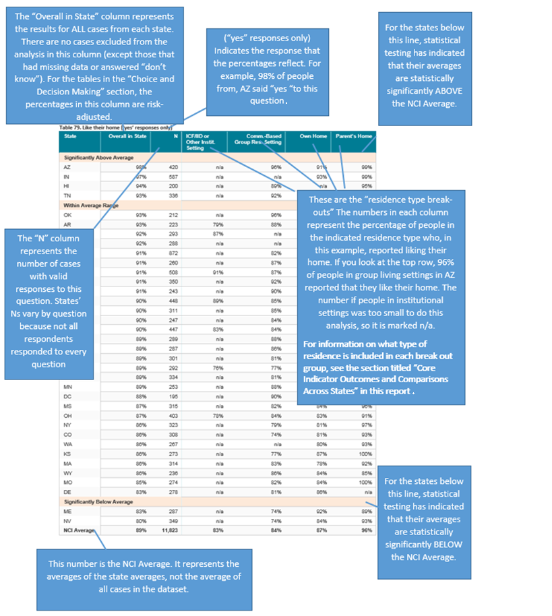

## Choice and Decision-Making

### People make choices about their lives and are actively engaged in planning their services and supports.

The Choice and Decision-Making indicator is:

1. The proportion of people who make choices about their everyday lives, including: housing, roommates, daily routines, jobs, support staff or providers, social activities, and what to spend money on

The Adult Consumer Survey includes nine choice items that correspond to the Choice indicator; all but one item, “Chose Case Manager” (

Table 39), were **risk-adjusted**.[3] Variables used as risk adjusters are: level of mobility, support needed for behavior problems, level of ID, and age. These are all found in the background information section. **WI is not included in risk-adjusted results due to lack of availability of data used for risk-adjustment.** To see WI’s results for the choice variables, please refer to Appendix D.

Two Choice composite scale scores were produced by adding and averaging Choice items. The Life Decisions scale (Table 37) refers to choice of: residence, roommates, work, day activity, and staff. The Everyday Choices scale (Table 38) refers to choice of: daily schedule, how to spend money, and free time activities. Both scales were risk-adjusted.

Tables 29 through

Table 39 present the results for these items.

All un-collapsed and unadjusted data frequencies for these survey questions are displayed in Appendix D.

Table . Chose or had some input in choosing where they live *if not in the family home* (adjusted variable, proxy responses allowed) *

|  |  |  |  |  |  |  |
| --- | --- | --- | --- | --- | --- | --- |
| State | Adjusted Average | N (observed) | ICF/IID and Other Institutional Settings | Community-based Group Residential Settings | Own Home or Apartment | Parent's or Relative's Home |
| KS | 74% | 271 | n/a | 74% | 73% | n/a |
| AZ | 74% | 160 | n/a | 71% | 84% | n/a |
| GA | 73% | 199 | n/a | 67% | 85% | n/a |
| IN | 69% | 197 | n/a | n/a | 69% | n/a |
| WA | 68% | 200 | n/a | 47% | 74% | n/a |
| CO | 66% | 281 | n/a | 57% | 70% | n/a |
| FL | 63% | 611 | n/a | 54% | 85% | n/a |
| SD | 63% | 293 | n/a | 56% | 77% | n/a |
| TN | 62% | 299 | n/a | 60% | 62% | n/a |
| UT | 62% | 223 | 50% | 65% | 74% | n/a |
| WY | 62% | 234 | n/a | 56% | 72% | n/a |
| VA | 61% | 522 | 49% | 60% | 82% | n/a |
| IL | 60% | 208 | n/a | 58% | 79% | n/a |
| MN | 59% | 245 | 53% | 52% | 88% | n/a |
| LA | 58% | 209 | 46% | n/a | 74% | n/a |
| RI | 57% | 294 | n/a | 57% | 66% | n/a |
| AR | 57% | 267 | 37% | 73% | 61% | n/a |
| ME | 57% | 277 | n/a | 53% | 76% | n/a |
| KY | 56% | 254 | n/a | 49% | 80% | n/a |
| NC | 55% | 423 | 33% | 52% | 87% | n/a |
| MI | 55% | 259 | n/a | 46% | 69% | n/a |
| OH | 54% | 306 | 45% | 59% | 57% | n/a |
| PA | 54% | 321 | 34% | 47% | 82% | n/a |
| MA | 53% | 290 | n/a | 48% | 62% | n/a |
| NV | 53% | 320 | n/a | 49% | 60% | n/a |
| DE | 50% | 307 | n/a | 48% | 50% | n/a |
| AL | 50% | 233 | n/a | 45% | 73% | n/a |
| MS | 48% | 196 | n/a | 44% | 47% | n/a |
| CT | 48% | 191 | n/a | 44% | 64% | n/a |
| VT | 47% | 236 | n/a | 25% | 73% | n/a |
| NY | 47% | 314 | 24% | 42% | 96% | n/a |
| MO | 46% | 335 | n/a | 39% | 49% | n/a |
| OK | 45% | 263 | n/a | 39% | 60% | n/a |
| HI | 41% | 140 | n/a | 33% | n/a | n/a |
| DC | 37% | 255 | 26% | 34% | n/a | n/a |
| NCI Average | 57% | 9,633 | 40% | 51% | 72% | n/a |

*WI is not included in risk-adjusted results due to lack of availability of data used for risk-adjustment. To see WI’s results for the choice variables, please refer to Appendix D.

Table . Chose or had some input in choosing people they live with, or chose to live alone *if not in the family home* (adjusted variable, proxy responses allowed) *

|  |  |  |  |  |  |  |
| --- | --- | --- | --- | --- | --- | --- |
| State | Adjusted Average | N (observed) | ICF/IID and Other Institutional Settings | Community-based Group Residential Settings | Own Home or Apartment | Parent's or Relative's Home |
| AZ | 71% | 166 | n/a | 63% | 88% | n/a |
| WA | 68% | 207 | n/a | 34% | 80% | n/a |
| IN | 67% | 195 | n/a | n/a | 70% | n/a |
| KS | 66% | 256 | n/a | 59% | 83% | n/a |
| GA | 65% | 195 | n/a | 49% | 92% | n/a |
| CO | 60% | 276 | n/a | 37% | 88% | n/a |
| LA | 59% | 206 | 41% | n/a | 84% | n/a |
| TN | 58% | 296 | n/a | 54% | 60% | n/a |
| FL | 57% | 611 | n/a | 43% | 86% | n/a |
| UT | 56% | 226 | 74% | 47% | 84% | n/a |
| WY | 52% | 209 | n/a | 40% | 68% | n/a |
| AR | 51% | 262 | 31% | 24% | 69% | n/a |
| MS | 48% | 197 | n/a | 38% | 57% | n/a |
| OH | 48% | 313 | 31% | 39% | 65% | n/a |
| SD | 47% | 277 | n/a | 29% | 74% | n/a |
| RI | 47% | 288 | n/a | 39% | 66% | n/a |
| OK | 47% | 263 | n/a | 37% | 69% | n/a |
| PA | 45% | 305 | 30% | 33% | 84% | n/a |
| IL | 44% | 213 | n/a | 41% | n/a | n/a |
| ME | 43% | 282 | n/a | 29% | 73% | n/a |
| MO | 43% | 329 | n/a | 27% | 50% | n/a |
| CT | 42% | 179 | n/a | 31% | 80% | n/a |
| AL | 40% | 234 | n/a | 30% | 88% | n/a |
| NV | 39% | 327 | n/a | 26% | 59% | n/a |
| MN | 38% | 244 | 43% | 25% | 85% | n/a |
| MI | 38% | 251 | n/a | 28% | 58% | n/a |
| NC | 36% | 419 | 29% | 18% | 93% | n/a |
| MA | 35% | 283 | n/a | 27% | 68% | n/a |
| DE | 35% | 302 | n/a | 30% | 68% | n/a |
| VA | 35% | 515 | 25% | 26% | 70% | n/a |
| NY | 34% | 313 | 27% | 21% | 96% | n/a |
| VT | 34% | 233 | n/a | n/a | 77% | n/a |
| KY | 31% | 249 | n/a | 19% | 59% | n/a |
| DC | 29% | 250 | 8% | 28% | n/a | n/a |
| HI | 27% | 116 | n/a | 31% | n/a | n/a |
| NCI Average | 47% | 9,487 | 34% | 34% | 75% | n/a |

*WI is not included in risk-adjusted results due to lack of availability of data used for risk-adjustment. To see WI’s results for the choice variables, please refer to Appendix D.

Table . Chose or had some input in choosing where they work (among those with a job in the community; adjusted variable, proxy responses allowed) ˇ *

|  |  |  |  |  |  |  |
| --- | --- | --- | --- | --- | --- | --- |
| State | Adjusted Average | N (observed) | ICF/IID and Other Institutional Settings | Community-based Group Residential Settings | Own Home or Apartment | Parent's or Relative's Home |
| KS | 100% | 45 | n/a | n/a | 100% | n/a |
| FL | 100% | 126 | n/a | n/a | 100% | 100% |
| MO | 97% | 36 | n/a | n/a | 96% | n/a |
| TN | 96% | 46 | n/a | n/a | n/a | n/a |
| AR | 96% | 21 | n/a | n/a | n/a | n/a |
| PA | 94% | 68 | n/a | n/a | 100% | 92% |
| WA | 93% | 158 | n/a | n/a | 98% | 90% |
| GA | 93% | 71 | n/a | n/a | 92% | 93% |
| KY | 92% | 25 | n/a | n/a | n/a | n/a |
| IN | 92% | 134 | n/a | n/a | 93% | 91% |
| UT | 92% | 64 | n/a | 93% | 95% | n/a |
| SD | 91% | 114 | n/a | 84% | 94% | n/a |
| OH | 91% | 100 | n/a | n/a | 90% | 93% |
| LA | 90% | 49 | n/a | n/a | 96% | n/a |
| AL | 90% | 26 | n/a | n/a | n/a | n/a |
| IL | 89% | 29 | n/a | n/a | n/a | n/a |
| VA | 88% | 55 | n/a | 91% | n/a | n/a |
| AZ | 87% | 61 | n/a | n/a | n/a | 87% |
| ME | 85% | 71 | n/a | 82% | 86% | n/a |
| MI | 85% | 43 | n/a | n/a | n/a | n/a |
| CO | 85% | 49 | n/a | n/a | n/a | n/a |
| NV | 84% | 58 | n/a | 84% | 87% | n/a |
| VT | 83% | 129 | n/a | n/a | n/a | 77% |
| WY | 83% | 97 | n/a | 92% | n/a | 76% |
| NC | 83% | 82 | n/a | 82% | n/a | 80% |
| MN | 81% | 160 | n/a | 76% | 94% | 80% |
| MA | 80% | 95 | n/a | 82% | 82% | 75% |
| NY | 80% | 47 | n/a | n/a | n/a | n/a |
| RI | 77% | 66 | n/a | n/a | 76% | 63% |
| CT | 77% | 116 | n/a | 73% | 93% | 76% |
| MS | 75% | 58 | n/a | n/a | 92% | n/a |
| DE | 71% | 51 | n/a | 71% | n/a | n/a |
| OK | 67% | 56 | n/a | 66% | n/a | n/a |
| DC | n/a | n/a | n/a | n/a | n/a | n/a |
| HI | n/a | n/a | n/a | n/a | n/a | n/a |
| NCI Average | 87% | 2,406 | n/a | 81% | 92% | 84% |

ˇReported for those who were reported to have a paid community job from Background section

*WI is not included in risk-adjusted results due to lack of availability of data used for risk-adjustment. To see WI’s results for the choice variables, please refer to Appendix D.

Table . Chose or had some input in choosing where they go during the day (adjusted variable, proxy responses allowed) *

|  |  |  |  |  |  |  |
| --- | --- | --- | --- | --- | --- | --- |
| State | Adjusted Average | N (observed) | ICF/IID and Other Institutional Settings | Community-based Group Residential Settings | Own Home or Apartment | Parent's or Relative's Home |
| WA | 85% | 236 | n/a | 80% | 96% | 80% |
| GA | 82% | 381 | n/a | 79% | 96% | 80% |
| FL | 80% | 999 | n/a | 75% | 92% | 81% |
| KS | 80% | 328 | n/a | 79% | 81% | 79% |
| AZ | 79% | 276 | n/a | 75% | 86% | 80% |
| TN | 74% | 271 | n/a | 67% | 78% | 70% |
| SD | 71% | 274 | n/a | 67% | 83% | 74% |
| RI | 71% | 418 | n/a | 71% | 89% | 68% |
| VT | 71% | 125 | n/a | n/a | 79% | 63% |
| AR | 69% | 254 | 71% | 79% | 64% | 69% |
| MO | 68% | 247 | n/a | 58% | 77% | 67% |
| PA | 68% | 453 | 56% | 62% | 89% | 68% |
| UT | 68% | 283 | 94% | 67% | 77% | 59% |
| WY | 66% | 269 | n/a | 54% | 80% | 76% |
| HI | 65% | 365 | n/a | 58% | n/a | 69% |
| VA | 65% | 577 | 62% | 64% | 79% | 61% |
| NV | 65% | 301 | n/a | 63% | 75% | 53% |
| KY | 64% | 380 | n/a | n/a | 80% | 76% |
| NC | 64% | 558 | 81% | 55% | 76% | 54% |
| OH | 64% | 401 | 53% | 73% | 64% | 65% |
| MI | 64% | 292 | n/a | 62% | 66% | 63% |
| MN | 63% | 275 | 61% | 55% | 93% | 69% |
| LA | 63% | 231 | 55% | 50% | 78% | 66% |
| CO | 62% | 301 | n/a | 54% | 87% | 55% |
| ME | 62% | 235 | n/a | 58% | 73% | 70% |
| IL | 61% | 321 | n/a | 60% | 60% | 63% |
| AL | 61% | 350 | n/a | 55% | 85% | 62% |
| IN | 58% | 527 | n/a | n/a | 66% | 56% |
| CT | 58% | 263 | n/a | 58% | 76% | 58% |
| MA | 56% | 325 | n/a | 56% | 58% | 58% |
| NY | 56% | 397 | 48% | 51% | 94% | 61% |
| DE | 51% | 238 | n/a | 51% | n/a | n/a |
| MS | 50% | 310 | n/a | 47% | 55% | 50% |
| OK | 49% | 152 | n/a | 37% | 70% | 51% |
| DC | 45% | 338 | 33% | 51% | n/a | 38% |
| NCI Average | 65% | 11,951 | 61% | 61% | 78% | 65% |

*WI is not included in risk-adjusted results due to lack of availability of data used for risk-adjustment. To see WI’s results for the choice variables, please refer to Appendix D.

Table . Chose or were aware they could request to change the staff who help them at their home, job, or day program or activity (adjusted variable, proxy responses allowed) *

|  |  |  |  |  |  |  |
| --- | --- | --- | --- | --- | --- | --- |
| State | Adjusted Average | N (observed) | ICF/IID and Other Institutional Settings | Community-based Group Residential Settings | Own Home or Apartment | Parent's or Relative's Home |
| AL | 97% | 372 | n/a | 95% | 100% | 100% |
| TN | 96% | 425 | n/a | 97% | 94% | 97% |
| KS | 91% | 349 | n/a | 93% | 90% | 88% |
| ME | 88% | 370 | n/a | 89% | 95% | 89% |
| AZ | 83% | 370 | n/a | 81% | 71% | 86% |
| IN | 83% | 739 | n/a | n/a | 86% | 82% |
| WA | 81% | 375 | n/a | 89% | 91% | 73% |
| LA | 79% | 383 | 73% | n/a | 87% | 79% |
| FL | 79% | 1,283 | n/a | 79% | 90% | 75% |
| UT | 78% | 381 | 82% | 87% | 85% | 68% |
| CO | 78% | 361 | n/a | 78% | 93% | 78% |
| NV | 77% | 372 | n/a | 73% | 85% | 81% |
| AR | 76% | 370 | 63% | 94% | 91% | 61% |
| GA | 76% | 433 | n/a | 76% | 81% | 77% |
| OK | 73% | 363 | n/a | 83% | 86% | 48% |
| MS | 71% | 370 | n/a | 65% | 67% | 76% |
| SD | 70% | 316 | n/a | 72% | 71% | 74% |
| OH | 70% | 446 | 57% | 76% | 78% | 72% |
| MO | 70% | 383 | n/a | 56% | 77% | 73% |
| RI | 70% | 424 | n/a | 71% | 75% | 72% |
| NY | 67% | 422 | 66% | 61% | 91% | 72% |
| VT | 63% | 261 | n/a | n/a | 86% | 64% |
| HI | 63% | 363 | n/a | 67% | n/a | 64% |
| NC | 62% | 693 | 42% | 55% | 77% | 70% |
| IL | 61% | 360 | n/a | 55% | 75% | 68% |
| MN | 60% | 362 | 70% | 49% | 78% | 68% |
| MA | 59% | 377 | n/a | 63% | 70% | 43% |
| MI | 59% | 349 | n/a | 54% | 63% | 68% |
| WY | 59% | 291 | n/a | 53% | 68% | 61% |
| CT | 58% | 295 | 53% | 52% | 68% | 63% |
| VA | 58% | 760 | 57% | 56% | 68% | 59% |
| PA | 54% | 549 | 58% | 46% | 73% | 53% |
| DE | 51% | 353 | n/a | 52% | 53% | n/a |
| DC | 48% | 363 | 55% | 50% | 46% | 44% |
| KY | 23% | 419 | n/a | 19% | 18% | 30% |
| NCI Average | 69% | 15,102 | 61% | 68% | 77% | 70% |

*WI is not included in risk-adjusted results due to lack of availability of data used for risk-adjustment. To see WI’s results for the choice variables, please refer to Appendix D.

Table . Choose or help decide their daily schedule (adjusted variable, proxy responses allowed) *

|  |  |  |  |  |  |  |
| --- | --- | --- | --- | --- | --- | --- |
| State | Adjusted Average | N (observed) | ICF/IID and Other Institutional Settings | Community-based Group Residential Settings | Own Home or Apartment | Parent's or Relative's Home |
| GA | 96% | 443 | n/a | 99% | 98% | 93% |
| WA | 94% | 392 | n/a | 93% | 100% | 91% |
| ME | 92% | 375 | n/a | 93% | 100% | 88% |
| FL | 92% | 1,396 | n/a | 89% | 96% | 93% |
| MO | 91% | 388 | n/a | 90% | 93% | 81% |
| UT | 91% | 382 | 89% | 93% | 100% | 88% |
| KY | 90% | 441 | n/a | 91% | 94% | 88% |
| MA | 90% | 406 | n/a | 91% | 96% | 86% |
| AL | 89% | 379 | n/a | 87% | 100% | 90% |
| KS | 89% | 353 | n/a | 87% | 92% | 88% |
| MI | 88% | 432 | n/a | 88% | 91% | 85% |
| AZ | 87% | 468 | n/a | 78% | 93% | 90% |
| NV | 87% | 390 | n/a | 82% | 95% | 90% |
| CO | 87% | 405 | n/a | 80% | 100% | 85% |
| PA | 86% | 658 | 83% | 87% | 98% | 84% |
| VT | 84% | 320 | n/a | 74% | 92% | 79% |
| RI | 84% | 442 | n/a | 83% | 91% | 81% |
| TN | 84% | 424 | n/a | 80% | 86% | 85% |
| MN | 83% | 402 | 82% | 85% | 96% | 82% |
| AR | 83% | 382 | 73% | 88% | 93% | 84% |
| WY | 83% | 309 | n/a | 79% | 90% | 85% |
| SD | 83% | 333 | n/a | 78% | 96% | 86% |
| IN | 83% | 810 | n/a | n/a | 96% | 80% |
| OH | 82% | 538 | 80% | 84% | 89% | 79% |
| VA | 82% | 800 | 82% | 83% | 85% | 79% |
| IL | 82% | 375 | n/a | 79% | 82% | 84% |
| NC | 81% | 744 | 86% | 74% | 91% | 78% |
| LA | 81% | 424 | 67% | n/a | 91% | 85% |
| CT | 78% | 319 | 74% | 76% | 96% | 76% |
| OK | 77% | 398 | n/a | 68% | 88% | 86% |
| MS | 77% | 399 | n/a | 64% | 85% | 81% |
| NY | 77% | 478 | 64% | 75% | 100% | 77% |
| DE | 77% | 364 | n/a | 78% | 87% | n/a |
| HI | 71% | 379 | n/a | 58% | n/a | 71% |
| DC | 65% | 383 | 46% | 65% | 67% | 64% |
| NCI Average | 84% | 16,331 | 75% | 82% | 93% | 84% |

*WI is not included in risk-adjusted results due to lack of availability of data used for risk-adjustment. To see WI’s results for the choice variables, please refer to Appendix D.

Table . Choose or help decide how to spend free time (adjusted variable, proxy responses allowed) *

|  |  |  |  |  |  |  |
| --- | --- | --- | --- | --- | --- | --- |
| State | Adjusted Average | N (observed) | ICF/IID and Other Institutional Settings | Community-based Group Residential Settings | Own Home or Apartment | Parent's or Relative's Home |
| GA | 98% | 445 | n/a | 100% | 98% | 98% |
| MO | 96% | 389 | n/a | 97% | 97% | 93% |
| TN | 96% | 432 | n/a | 96% | 95% | 98% |
| ME | 96% | 388 | n/a | 97% | 100% | 91% |
| AL | 96% | 379 | n/a | 95% | 96% | 97% |
| WA | 96% | 392 | n/a | 94% | 100% | 94% |
| UT | 95% | 382 | 98% | 97% | 100% | 93% |
| FL | 95% | 1,405 | n/a | 93% | 99% | 95% |
| SD | 95% | 333 | n/a | 94% | 100% | 90% |
| CO | 94% | 404 | n/a | 89% | 100% | 96% |
| PA | 94% | 668 | 96% | 95% | 97% | 94% |
| LA | 94% | 406 | 95% | n/a | 97% | 92% |
| AZ | 94% | 468 | n/a | 89% | 100% | 95% |
| MI | 94% | 426 | n/a | 94% | 95% | 93% |
| IL | 93% | 375 | n/a | 94% | 84% | 94% |
| MA | 93% | 409 | n/a | 94% | 95% | 90% |
| VT | 93% | 319 | n/a | 89% | 100% | 92% |
| OK | 93% | 397 | n/a | 91% | 93% | 95% |
| VA | 93% | 799 | 95% | 93% | 100% | 91% |
| MN | 93% | 406 | 95% | 94% | 100% | 93% |
| NC | 93% | 743 | 95% | 92% | 97% | 90% |
| KY | 92% | 434 | n/a | 93% | 96% | 92% |
| KS | 92% | 359 | n/a | 91% | 94% | 92% |
| RI | 92% | 446 | n/a | 92% | 100% | 90% |
| IN | 91% | 809 | n/a | n/a | 98% | 91% |
| AR | 91% | 377 | 91% | 97% | 97% | 87% |
| WY | 91% | 311 | n/a | 87% | 95% | 95% |
| NV | 91% | 389 | n/a | 89% | 94% | 95% |
| OH | 90% | 535 | 92% | 93% | 90% | 88% |
| MS | 88% | 394 | n/a | 89% | 92% | 88% |
| CT | 88% | 320 | 76% | 90% | 95% | 86% |
| DE | 87% | 356 | n/a | 87% | 91% | n/a |
| NY | 84% | 481 | 77% | 84% | 100% | 81% |
| HI | 83% | 368 | n/a | 76% | n/a | 87% |
| DC | 77% | 375 | 76% | 80% | 69% | 75% |
| NCI Average | 92% | 16,319 | 90% | 92% | 96% | 91% |

*WI is not included in risk-adjusted results due to lack of availability of data used for risk-adjustment. To see WI’s results for the choice variables, please refer to Appendix D.

Table . Choose or help decide what to buy with their money (adjusted variable, proxy responses allowed) *

|  |  |  |  |  |  |  |
| --- | --- | --- | --- | --- | --- | --- |
| State | Adjusted Average | N (observed) | ICF/IID and Other Institutional Settings | Community-based Group Residential Settings | Own Home or Apartment | Parent's or Relative's Home |
| GA | 96% | 440 | n/a | 96% | 98% | 94% |
| ME | 94% | 379 | n/a | 93% | 100% | 94% |
| KS | 93% | 344 | n/a | 93% | 95% | 90% |
| NC | 92% | 737 | 97% | 93% | 95% | 88% |
| AZ | 92% | 463 | n/a | 90% | 96% | 91% |
| MO | 91% | 390 | n/a | 89% | 95% | 84% |
| KY | 91% | 441 | n/a | 90% | 100% | 89% |
| AL | 91% | 377 | n/a | 90% | 96% | 91% |
| AR | 90% | 372 | 90% | 100% | 93% | 84% |
| RI | 90% | 446 | n/a | 92% | 100% | 87% |
| SD | 90% | 335 | n/a | 89% | 98% | 81% |
| VA | 89% | 799 | 86% | 91% | 95% | 85% |
| LA | 89% | 415 | 89% | n/a | 91% | 87% |
| WA | 88% | 390 | n/a | 88% | 99% | 86% |
| PA | 88% | 657 | 85% | 92% | 91% | 88% |
| UT | 88% | 385 | 97% | 90% | 95% | 84% |
| IL | 88% | 373 | n/a | 88% | 100% | 88% |
| MI | 88% | 426 | n/a | 87% | 90% | 86% |
| MS | 88% | 395 | n/a | 96% | 92% | 84% |
| MA | 88% | 404 | n/a | 90% | 94% | 82% |
| MN | 88% | 402 | 88% | 87% | 100% | 86% |
| FL | 87% | 1,398 | n/a | 90% | 92% | 85% |
| WY | 87% | 311 | n/a | 86% | 84% | 87% |
| NV | 87% | 386 | n/a | 85% | 90% | 87% |
| CO | 87% | 398 | n/a | 88% | 100% | 81% |
| HI | 87% | 332 | n/a | 84% | n/a | 89% |
| OH | 87% | 532 | 89% | 88% | 92% | 83% |
| OK | 86% | 394 | n/a | 85% | 84% | 89% |
| TN | 85% | 428 | n/a | 85% | 88% | 81% |
| IN | 85% | 806 | n/a | n/a | 93% | 84% |
| CT | 84% | 322 | n/a | 88% | 89% | 80% |
| VT | 83% | 320 | n/a | 68% | 81% | 84% |
| DE | 82% | 358 | n/a | 82% | 80% | n/a |
| NY | 79% | 484 | 79% | 77% | 95% | 75% |
| DC | 69% | 372 | 76% | 62% | 73% | 68% |
| NCI Average | 88% | 16,211 | 88% | 88% | 93% | 85% |

*WI is not included in risk-adjusted results due to lack of availability of data used for risk-adjustment. To see WI’s results for the choice variables, please refer to Appendix D.

Table . Life decisions scale (adjusted variable) *,**

|  |  |  |  |  |  |  |
| --- | --- | --- | --- | --- | --- | --- |
| State | Adjusted Average | N (observed) | ICF/IID and Other Institutional Settings | Community-based Group Residential Settings | Own Home or Apartment | Parent's or Relative's Home |
| KS | 84% | 363 | n/a | 81% | 86% | 92% |
| TN | 83% | 434 | n/a | 76% | 79% | 95% |
| AZ | 82% | 428 | n/a | 75% | 82% | 84% |
| IN | 80% | 786 | n/a | n/a | 75% | 82% |
| WA | 79% | 385 | n/a | 69% | 85% | 79% |
| GA | 79% | 445 | n/a | 69% | 86% | 81% |
| AL | 78% | 382 | n/a | 62% | 87% | 96% |
| FL | 76% | 1,367 | n/a | 65% | 83% | 79% |
| CO | 75% | 391 | n/a | 62% | 84% | 81% |
| LA | 74% | 408 | 58% | n/a | 83% | 80% |
| UT | 72% | 387 | 79% | 72% | 82% | 70% |
| ME | 72% | 389 | n/a | 65% | 81% | 85% |
| RI | 70% | 457 | n/a | 67% | 76% | 78% |
| MS | 69% | 386 | n/a | 54% | 63% | 81% |
| SD | 69% | 339 | n/a | 60% | 77% | 80% |
| AR | 68% | 383 | 53% | 72% | 77% | 67% |
| OH | 68% | 508 | 51% | 65% | 71% | 76% |
| IL | 66% | 373 | n/a | 58% | 80% | 75% |
| WY | 65% | 314 | n/a | 58% | 72% | 68% |
| NV | 65% | 392 | n/a | 56% | 73% | 78% |
| NC | 64% | 726 | 51% | 50% | 83% | 75% |
| HI | 64% | 383 | n/a | 56% | n/a | 71% |
| MN | 64% | 388 | 61% | 50% | 80% | 77% |
| MI | 64% | 397 | n/a | 51% | 69% | 78% |
| PA | 62% | 619 | 49% | 51% | 82% | 66% |
| CT | 61% | 321 | 43% | 51% | 75% | 71% |
| MO | 61% | 397 | n/a | 47% | 65% | 80% |
| NY | 61% | 462 | 47% | 50% | 87% | 74% |
| VA | 60% | 789 | 50% | 54% | 76% | 67% |
| MA | 59% | 407 | n/a | 55% | 71% | 57% |
| VT | 58% | 315 | n/a | 30% | 80% | 68% |
| OK | 58% | 375 | n/a | 56% | 75% | 53% |
| DE | 52% | 379 | n/a | 51% | 58% | n/a |
| DC | 49% | 379 | 48% | 46% | 49% | 52% |
| KY | 47% | 435 | n/a | 38% | 57% | 53% |
| NCI Average | 67% | 16,089 | 54% | 58% | 76% | 75% |

*WI is not included in risk-adjusted results due to lack of availability of data used for risk-adjustment. To see WI’s results for the choice variables, please refer to Appendix D.

**Includes choice of: residence, roommates, work, day activity, and staff

Table . Everyday choices scale (adjusted variable) *,**

|  |  |  |  |  |  |  |
| --- | --- | --- | --- | --- | --- | --- |
| State | Adjusted Average | N (observed) | ICF/IID and Other Institutional Settings | Community-based Group Residential Settings | Own Home or Apartment | Parent's or Relative's Home |
| GA | 96% | 449 | n/a | 100% | 94% | 95% |
| ME | 93% | 393 | n/a | 94% | 95% | 90% |
| MO | 93% | 397 | n/a | 92% | 94% | 87% |
| WA | 92% | 395 | n/a | 93% | 96% | 90% |
| UT | 92% | 389 | 100% | 94% | 93% | 89% |
| AL | 92% | 383 | n/a | 91% | 94% | 92% |
| FL | 91% | 1,425 | n/a | 91% | 93% | 91% |
| KS | 91% | 367 | n/a | 90% | 92% | 90% |
| KY | 91% | 448 | n/a | 91% | 93% | 89% |
| AZ | 91% | 473 | n/a | 85% | 92% | 92% |
| MI | 90% | 432 | n/a | 90% | 91% | 88% |
| MA | 90% | 414 | n/a | 91% | 91% | 87% |
| PA | 89% | 679 | 89% | 92% | 91% | 89% |
| CO | 89% | 405 | n/a | 84% | 94% | 87% |
| NC | 89% | 747 | 99% | 86% | 92% | 84% |
| TN | 88% | 435 | n/a | 87% | 89% | 88% |
| AR | 88% | 386 | 84% | 95% | 93% | 84% |
| SD | 88% | 340 | n/a | 87% | 92% | 86% |
| RI | 88% | 459 | n/a | 89% | 92% | 86% |
| VA | 88% | 812 | 88% | 89% | 91% | 84% |
| LA | 88% | 424 | 83% | n/a | 92% | 88% |
| IL | 88% | 381 | n/a | 87% | 87% | 89% |
| NV | 88% | 396 | n/a | 85% | 90% | 90% |
| MN | 87% | 408 | 88% | 89% | 92% | 86% |
| WY | 87% | 316 | n/a | 85% | 88% | 89% |
| VT | 87% | 324 | n/a | 79% | 89% | 86% |
| OH | 86% | 541 | 86% | 89% | 89% | 84% |
| IN | 86% | 818 | n/a | n/a | 92% | 85% |
| OK | 85% | 398 | n/a | 80% | 89% | 90% |
| MS | 84% | 400 | n/a | 83% | 89% | 83% |
| CT | 83% | 327 | 72% | 85% | 90% | 81% |
| DE | 82% | 384 | n/a | 82% | 87% | n/a |
| NY | 80% | 488 | 69% | 78% | 92% | 79% |
| HI | 77% | 394 | n/a | 70% | n/a | 81% |
| DC | 69% | 392 | 63% | 69% | 73% | 70% |
| NCI Average | 88% | 16,619 | 84% | 87% | 91% | 87% |

*WI is not included in risk-adjusted results due to lack of availability of data used for risk-adjustment. To see WI’s results for the choice variables, please refer to Appendix D.

**Includes choice of: daily schedule, how to spend money, and free time activities

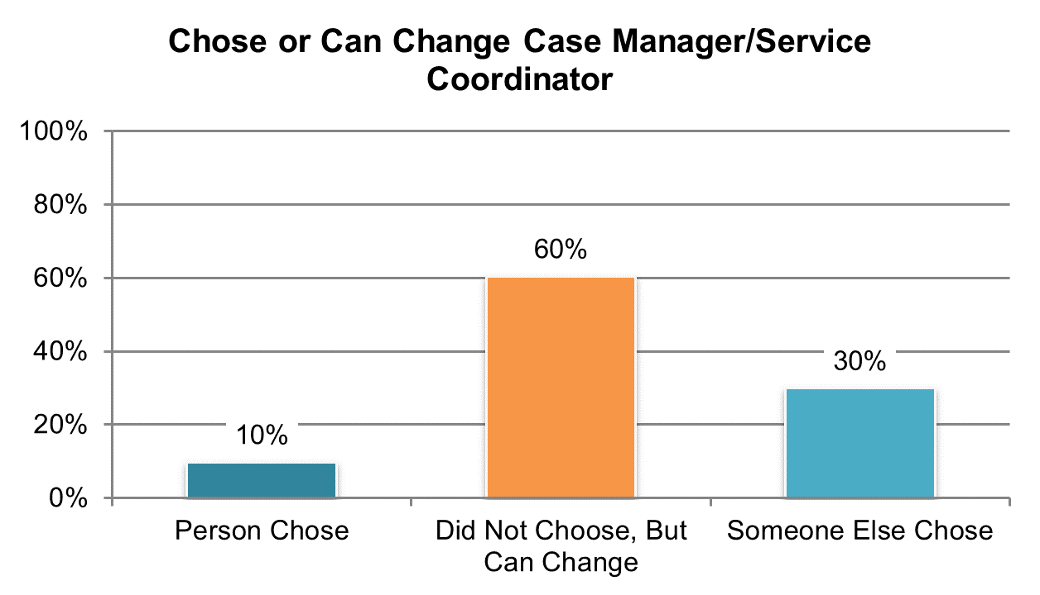

Table . Chose or were aware they could request to change their case manager/service coordinator (‘person chose’ and ‘did not choose, but can request to change’ responses, proxy responses allowed)

|  |  |  |  |  |  |  |
| --- | --- | --- | --- | --- | --- | --- |
| State | Overall in State | N | ICF/IID and Other Institutional Settings | Community-based Group Residential Settings | Own Home | Parent’s or Relative’s Home |
| **Significantly Above Average** | | |  | | | |
| AL | 98% | 380 | n/a | 96% | 100% | 100% |
| TN | 97% | 426 | n/a | 98% | 95% | 100% |
| NV | 90% | 374 | n/a | 86% | 93% | 98% |
| ME | 90% | 367 | n/a | 92% | 93% | 87% |
| KS | 88% | 356 | n/a | 91% | 86% | 92% |
| WI | 87% | 383 | 71% | 84% | 88% | 88% |
| IN | 86% | 777 | n/a | n/a | 93% | 84% |
| WA | 86% | 381 | n/a | 97% | 85% | 84% |
| AZ | 86% | 466 | n/a | 83% | 80% | 87% |
| OK | 84% | 388 | n/a | 84% | 82% | 83% |
| CO | 83% | 387 | n/a | 84% | 93% | 87% |
| AR | 83% | 366 | 63% | 97% | 91% | 83% |
| NY | 81% | 459 | 77% | 76% | 98% | 83% |
| SD | 80% | 324 | n/a | 78% | 83% | 85% |
| LA | 78% | 396 | 78% | n/a | 78% | 78% |
| OH | 78% | 513 | 51% | 78% | 84% | 84% |
| VT | 78% | 308 | n/a | 50% | 94% | 83% |
| FL | 76% | 1,303 | n/a | 73% | 91% | 72% |
| **Within Average Range** | | |  | | | |
| MI | 74% | 414 | n/a | 70% | 76% | 77% |
| UT | 73% | 358 | 60% | 79% | 91% | 64% |
| MS | 73% | 362 | n/a | 67% | 72% | 74% |
| NC | 67% | 602 | 29% | 62% | 80% | 78% |
| MO | 66% | 368 | n/a | 51% | 72% | 71% |
| IL | 65% | 369 | n/a | 58% | 72% | 73% |
| GA | 65% | 426 | n/a | 66% | 73% | 63% |
| WY | 63% | 300 | n/a | 58% | 77% | 55% |
| **Significantly Below Average** | | |  | | | |
| RI | 62% | 424 | n/a | 59% | 64% | 63% |
| MN | 62% | 372 | 63% | 57% | 70% | 66% |
| VA | 60% | 780 | 43% | 56% | 79% | 66% |
| CT | 52% | 296 | n/a | 43% | 66% | 60% |
| PA | 49% | 626 | 37% | 37% | 61% | 51% |
| MA | 47% | 386 | n/a | 48% | 57% | 39% |
| DC | 38% | 373 | 34% | 37% | 33% | 40% |
| HI | 30% | 365 | n/a | 21% | n/a | 37% |
| E | 28% | 305 | n/a | 26% | 44% | n/a |
| KY | 23% | 430 | n/a | 20% | 17% | 27% |
| NCI Average | 70% | 15,910 | 55% | 66% | 77% | 73% |

## 

## Work

### People have support to find and maintain community integrated employment.

There are 11 Work indicators measured by the Adult Consumer Survey:

1. The percentage of people with a paid job in the community
2. The average number of hours worked biweekly by people with jobs in the community
3. The average biweekly earnings of people with paid jobs in the community
4. The average biweekly hourly earnings of people with a paid job in the community
5. Of those with a paid job in the community, the percentage of people who were continuously employed throughout the previous year
6. Of those with a paid job in the community, the average length of time they have been working at their current job
7. Of those with a paid job in the community, the percentage of people who receive vacation and/or sick time benefits
8. The percentage of people who have a goal of integrated employment in their service plan
9. The percentage of people who do not have a paid job in the community but would like to have one
10. The percentage of people who go to a day program or have some other daily activity
11. The percentage of people who do volunteer work

A paid community job, either individual or group, takes place in an integrated setting.

A paid individual job takes place in a local business alongside peers who do not have disabilities—that is, the job is part of the typical labor market (e.g., competitive employment). A paid group job in a Community-based Group Residential Settings is done in an integrated setting, as part of a group of not more than eight people with disabilities (e.g., enclave, work crew).

**NCI reports on three types of community jobs: (1) individual job without publicly funded supports—an individual job in which the person *does not receive* state or other funded supports; (2) individual job with publicly funded supports—an individual job in which the person *receives* state or other funded supports; and (3) group-supported—a job that takes part in an integrated setting but is done with a group of individuals with disabilities (e.g., work crew). Group-supported jobs may or may not receive publicly funded supports.**

Tables 30 through 59 present items from the Work domain. All un-collapsed state data frequencies for these survey questions are displayed in Appendix D.

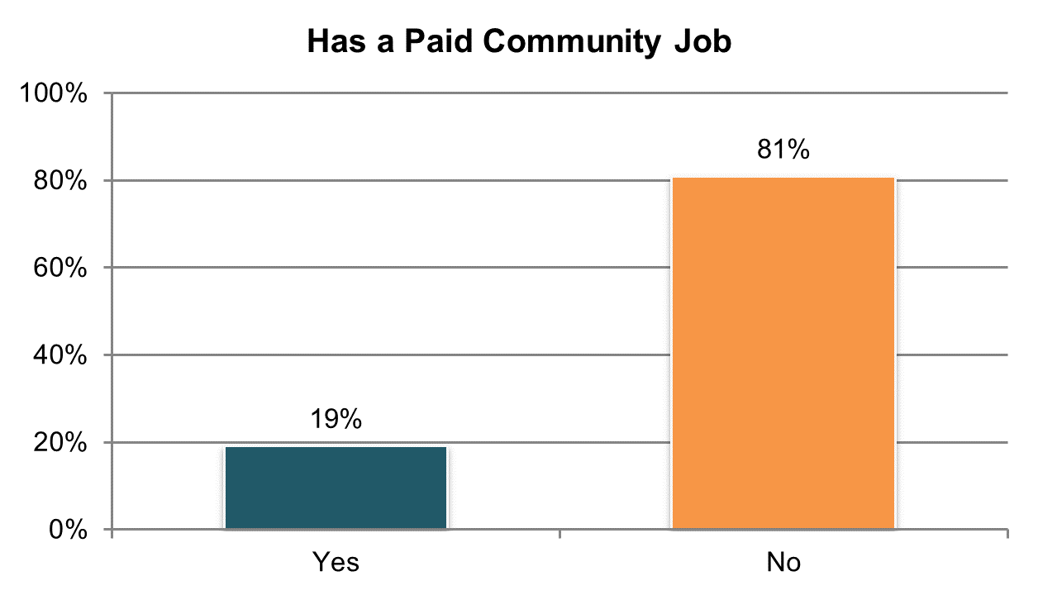

Table . Has paid job in the community (information comes from Background Information section) ±

|  |  |  |  |  |  |  |
| --- | --- | --- | --- | --- | --- | --- |
| State | Overall in State | N | ICF/IID and Other Institutional Settings | Community-based Group Residential Settings | Own Home | Parent’s or Relative’s Home |
| **Significantly Above Average** | | |  | | | |
| CT | 42% | 319 | n/a | 26% | 62% | 53% |
| VT | 42% | 325 | n/a | 24% | 35% | 58% |
| MN | 41% | 402 | 31% | 37% | 67% | 44% |
| WA | 41% | 402 | n/a | 19% | 37% | 49% |
| SD | 38% | 361 | n/a | 20% | 60% | 38% |
| WY | 37% | 293 | n/a | 25% | 45% | 43% |
| MA | 30% | 351 | n/a | 17% | 50% | 47% |
| RI ** | 26% | 349 | n/a | 14% | 33% | 36% |
| **Within Average Range** | | |  | | | |
| ME | 24% | 374 | n/a | 18% | 52% | 29% |
| OH | 24% | 556 | 5% | 11% | 32% | 31% |
| UT | 19% | 398 | 0% | 19% | 47% | 14% |
| GA | 18% | 461 | n/a | 5% | 33% | 20% |
| MS | 17% | 370 | n/a | 20% | 27% | 11% |
| IN | 17% | 821 | n/a | n/a | 27% | 15% |
| MI | 17% | 360 | n/a | 8% | 30% | 18% |
| OK | 17% | 400 | n/a | 21% | 26% | 4% |
| PA ** | 16% | 549 | 5% | 9% | 39% | 15% |
| DE | 16% | 401 | n/a | 16% | 32% | n/a |
| TN | 16% | 402 | n/a | 17% | 17% | 10% |
| NV | 15% | 399 | n/a | 11% | 23% | 11% |
| LA | 15% | 427 | 11% | n/a | 26% | 12% |
| CO | 15% | 407 | n/a | 11% | 28% | 8% |
| WI | 15% | 383 | 3% | 0% | 15% | 20% |
| AZ | 15% | 451 | n/a | 16% | 22% | 12% |
| KS | 15% | 368 | n/a | 8% | 22% | 16% |
| **Significantly Below Average** | | |  | | | |
| NC | 13% | 777 | 3% | 14% | 31% | 13% |
| VA | 11% | 765 | 2% | 14% | 16% | 7% |
| NY | 10% | 488 | 2% | 8% | 25% | 12% |
| FL | 9% | 1,429 | n/a | 4% | 19% | 9% |
| IL | 9% | 352 | n/a | 7% | 28% | 9% |
| MO | 9% | 395 | n/a | 8% | 10% | 7% |
| KY | 9% | 419 | n/a | 13% | 7% | 10% |
| AL | 9% | 394 | n/a | 9% | 9% | 9% |
| DC ** | 7% | 275 | 0% | 9% | 10% | 9% |
| AR | 7% | 354 | 2% | 0% | 16% | 4% |
| HI | 5% | 398 | n/a | 7% | n/a | 6% |
| NCI Average | 19% | 16,375 | 6% | 14% | 30% | 20% |

±Item changed from previous years – community employment categories were described differently for 2015-16 (see Appendix A)

**State had a large number of “don’t know” responses and missing data (at least 25%)

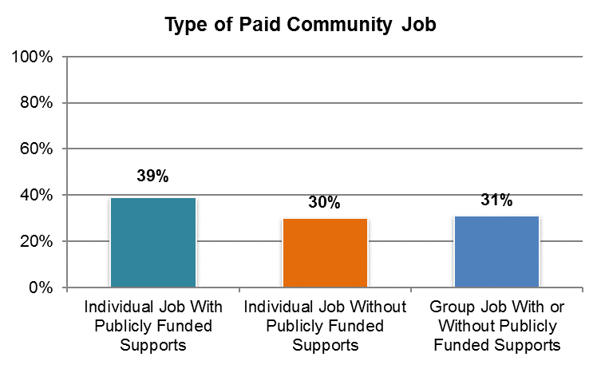

NCI reports on three types of community jobs: (1) individual job without publicly funded supports—an individual job in which the person does not receive state or other funded supports; (2) individual job with publicly funded supports—an individual job in which the person does receive state or other funded supports; and (3) group-supported—a job that takes part in an integrated setting but is done with a group of individuals with disabilities (e.g., work crew). Group-supported jobs may or may not receive publicly funded supports.

Table . Type of employment among those reported to have a paid job in the community (information comes from Background Information section) ± *

|  |  |  |  |  |
| --- | --- | --- | --- | --- |
| State | Individual Job With Publicly Funded Supports | Individual Job Without Publicly Funded Supports | Group Job With or Without Publicly Funded Supports | N |
| AL | 48% | 21% | 21% | 34 |
| AR | 37% | 53% | 19% | 24 |
| AZ | 12% | 15% | 71% | 67 |
| CO | 32% | 25% | 41% | 61 |
| CT | 22% | 8% | 76% | 135 |
| DC | 60% | 13% | 21% | 20 |
| DE | 67% | 10% | 26% | 65 |
| FL | 47% | 47% | 8% | 135 |
| GA | 54% | 24% | 23% | 83 |
| HI | 27% | 33% | 25% | 20 |
| IL | 35% | 41% | 26% | 33 |
| IN | 41% | 53% | 4% | 140 |
| KS | 48% | 40% | 16% | 54 |
| KY | 53% | 38% | 6% | 39 |
| LA | 7% | 20% | 52% | 65 |
| MA | 37% | 29% | 47% | 106 |
| ME | 63% | 30% | 11% | 91 |
| MI | 22% | 35% | 59% | 61 |
| MN | 33% | 50% | 32% | 166 |
| MO | 33% | 58% | 8% | 37 |
| MS | 56% | 39% | 10% | 64 |
| NC | 62% | 28% | 13% | 99 |
| NV | 17% | 22% | 31% | 61 |
| NY | 50% | 34% | 18% | 51 |
| OH | 43% | 25% | 38% | 131 |
| OK | 4% | 9% | 84% | 67 |
| PA | 37% | 38% | 33% | 89 |
| RI | 55% | 18% | 29% | 91 |
| SD | 17% | 47% | 40% | 136 |
| TN | 36% | 38% | 35% | 64 |
| UT | 49% | 25% | 22% | 77 |
| VA | 19% | 13% | 68% | 82 |
| VT | 80% | 20% | 0% | 137 |
| WA | 83% | 8% | 9% | 164 |
| WI | 4% | 2% | 84% | 57 |
| WY | 24% | 62% | 12% | 108 |
| NCI Average | 39% | 30% | 31% | 2,914 |

± Item changed from previous years – community employment categories were described differently for 2015-16 (see Appendix A)

*Percentages may not add up to 100% if type of employment was unknown; N represents the number of people who participated in at least one of these work types.

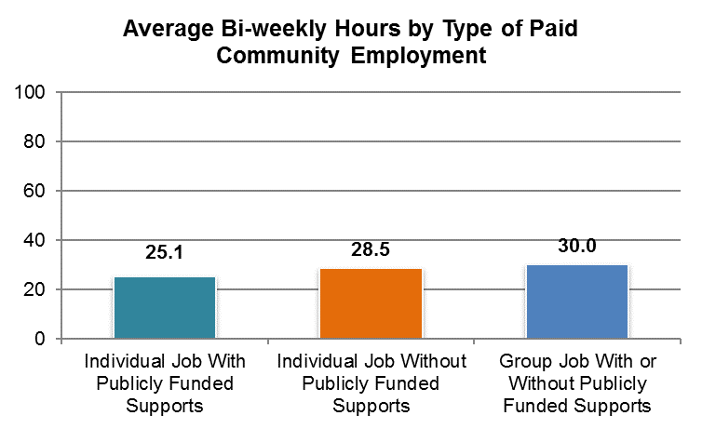

NCI reports on three types of community jobs: (1) individual job without publicly funded supports—an individual job in which the person does not receive state or other funded supports; (2) individual job with publicly funded supports—an individual job in which the person does receive state or other funded supports; and (3) group-supported—a job that takes part in an integrated setting but is done with a group of individuals with disabilities (e.g., work crew). Group-supported jobs may or may not receive publicly funded supports.

Table . Average number of biweekly hours by type of community employment among those reported to have a paid job in the community (information comes from Background Information section) ± ˇ

|  |  |  |  |
| --- | --- | --- | --- |
| State | Individual Job With Publicly Funded Supports | Individual Job Without Publicly Funded Supports | Group Job With or Without Publicly Funded Supports |
| AZ | n/a | n/a | 39.0 |
| CT | 28.6 | n/a | 28.0 |
| DE | 38.7 | n/a | n/a |
| FL | 32.0 | 31.4 | n/a |
| GA | 30.7 | n/a | n/a |
| IN | 25.7 | 31.8 | n/a |
| KS | 21.8 | n/a | n/a |
| LA | n/a | n/a | 34.2 |
| MA | 23.7 | 24.7 | 19.3 |
| ME | 13.6 | n/a | n/a |
| MI | n/a | n/a | 20.6 |
| MN | 27.6 | 37.3 | 28.0 |
| MS | 28.8 | 26.0 | n/a |
| NC | 26.4 | 17.9 | n/a |
| NY | 32.6 | n/a | n/a |
| OH | 31.0 | 33.7 | 32.5 |
| OK | n/a | n/a | 40.6 |
| PA | 22.0 | 28.7 | n/a |
| RI | 19.2 | n/a | 14.6 |
| SD | 20.2 | 28.2 | 22.6 |
| UT | 15.9 | n/a | n/a |
| VA | n/a | n/a | 39.2 |
| VT | 14.7 | 26.1 | n/a |
| WA | 24.7 | n/a | n/a |
| WI | n/a | n/a | 41.2 |
| WY | n/a | 27.8 | n/a |
| NCI Average | 25.1 | 28.5 | 30.0 |

± Item changed from previous years – community employment categories were described differently for 2015-16 (see Appendix A)

**Note:** The following states are not included in analysis due to low N (<20) for each employment type: AL, AR, CO, DC, HI, IL, KY, MO, NV, TN

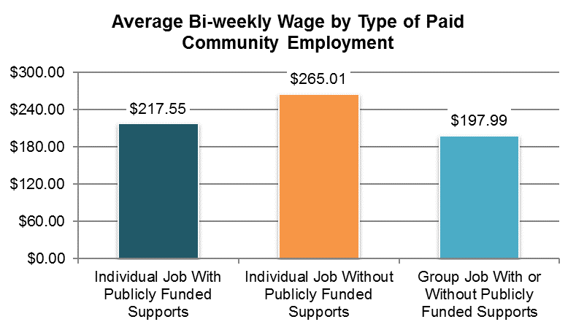

NCI reports on three types of community jobs: (1) individual job without publicly funded supports—an individual job in which the person does not receive state or other funded supports; (2) individual job with publicly funded supports—an individual job in which the person does receive state or other funded supports; and (3) group-supported—a job that takes part in an integrated setting but is done with a group of individuals with disabilities (e.g., work crew). Group-supported jobs may or may not receive publicly funded supports.

Table . Average biweekly gross wages by type of community employment among those reported to have a paid job in the community (information comes from Background Information section) ±

|  |  |  |  |
| --- | --- | --- | --- |
| State | Individual Job With Publicly Funded Supports | Individual Job Without Publicly Funded Supports | Group Job With or Without Publicly Funded Supports |
| AZ | n/a | n/a | $185.02 |
| CT | $267.83 | n/a | $193.31 |
| FL | $271.70 | $229.30 | n/a |
| GA | $305.87 | n/a | n/a |
| IN | $174.41 | $236.66 | n/a |
| LA | n/a | n/a | $111.44 |
| MA | $228.86 | $228.77 | $132.20 |
| ME | $116.94 | n/a | n/a |
| MI | n/a | n/a | $139.93 |
| MN | $118.81 | $317.57 | $154.73 |
| NC | $236.83 | n/a | n/a |
| OH | $313.24 | $312.41 | $239.13 |
| OK | n/a | n/a | $227.76 |
| RI | $169.87 | n/a | n/a |
| SD | $220.62 | $275.70 | $166.09 |
| VA | n/a | n/a | $187.46 |
| VT | $144.23 | $256.13 | n/a |
| WA | $258.97 | n/a | n/a |
| WI | n/a | n/a | $440.84 |
| WY | n/a | $263.54 | n/a |
| NCI Average | $217.55 | $265.01 | $197.99 |

± Item changed from previous years – community employment categories were described differently for 2015-16 (see Appendix A)

**Note:** The following states are not included in analysis due to low N (<20) for each employment type: AL, AR, CO, DC, DE, HI, IL, KS, KY, MO, MS, NV, NY, PA, TN, UT

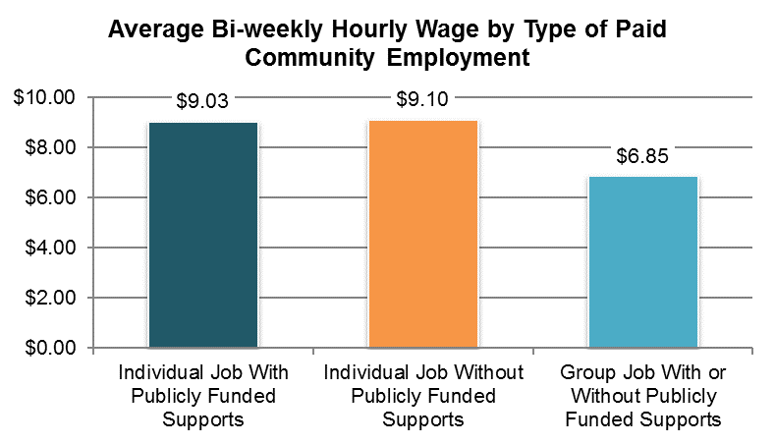

NCI reports on three types of community jobs: (1) individual job without publicly funded supports—an individual job in which the person does not receive state or other funded supports; (2) individual job with publicly funded supports—an individual job in which the person does receive state or other funded supports; and (3) group-supported—a job that takes part in an integrated setting but is done with a group of individuals with disabilities (e.g., work crew). Group-supported jobs may or may not receive publicly funded supports.

Table . Average biweekly hourly wage by type of community employment among those reported to have a paid job in the community (information comes from Background Information section) ±

|  |  |  |  |
| --- | --- | --- | --- |
| State | Individual Job With Publicly Funded Supports | Individual Job Without Publicly Funded Supports | Group Job With or Without Publicly Funded Supports |
| AZ | n/a | n/a | $5.38 |
| CT | $9.48 | n/a | $9.23 |
| FL | $8.53 | $8.97 | n/a |
| GA | $8.76 | n/a | n/a |
| IN | $7.14 | $7.57 | n/a |
| LA | n/a | n/a | $3.82 |
| MA | $9.64 | $9.56 | $8.17 |
| ME | $9.60 | n/a | n/a |
| MI | n/a | n/a | $7.60 |
| MN | $5.05 | $8.71 | $6.18 |
| NC | $8.52 | n/a | n/a |
| OH | $10.63 | $9.12 | $7.73 |
| OK | n/a | n/a | $5.70 |
| RI | $9.32 | n/a | n/a |
| SD | $9.99 | $9.53 | $6.93 |
| VA | n/a | n/a | $5.93 |
| VT | $9.88 | $10.20 | n/a |
| WA | $10.79 | n/a | n/a |
| WI | n/a | n/a | $8.64 |
| WY | n/a | $9.16 | n/a |
| NCI Average | $9.03 | $9.10 | $6.85 |

± Item changed from previous years – community employment categories were described differently for 2015-16 (see Appendix A)

**Note:** The following states are not included in analysis due to low N (<20) for each employment type: AL, AR, CO, DC, DE, HI, IL, KS, KY, MO, MS, NV, NY, PA, TN, UT

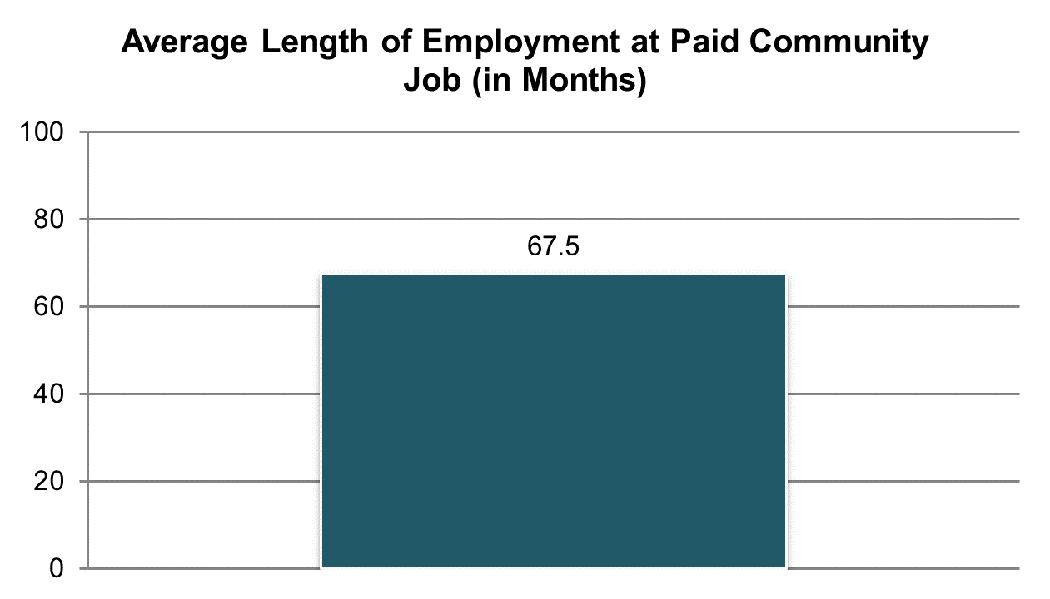

Table . Length of employment in current job among those reported to have a paid job in the community (information comes from Background Information section)

|  |  |  |
| --- | --- | --- |
| State | Average Months | N |
| AL | 41.4 | 28 |
| AR | 57.7 | 29 |
| AZ | 43.3 | 37 |
| CO | 76.5 | 44 |
| CT | 82.0 | 80 |
| DE | 46.7 | 33 |
| FL | 76.6 | 132 |
| GA | 72.0 | 71 |
| IL | 76.8 | 29 |
| IN | 111.8 | 133 |
| KS | 66.0 | 46 |
| KY | 65.3 | 50 |
| LA | 67.8 | 47 |
| MA | 76.7 | 92 |
| ME | 76.6 | 79 |
| MI | 56.1 | 46 |
| MN | 91.7 | 162 |
| MO | 84.5 | 33 |
| MS | 62.6 | 45 |
| NC | 68.4 | 72 |
| NV | 56.3 | 86 |
| NY | 79.9 | 47 |
| OH | 62.2 | 111 |
| OK | 64.1 | 67 |
| PA | 66.5 | 59 |
| RI | 54.0 | 79 |
| SD | 59.5 | 129 |
| TN | 57.8 | 50 |
| UT | 67.7 | 51 |
| VA | 70.8 | 61 |
| VT | 62.3 | 129 |
| WA | 72.0 | 150 |
| WY | 55.5 | 81 |
| NCI Average | 67.5 | 2,388 |

**Note:** The following states are not included in analysis due to low N (<20): DC, HI, WI

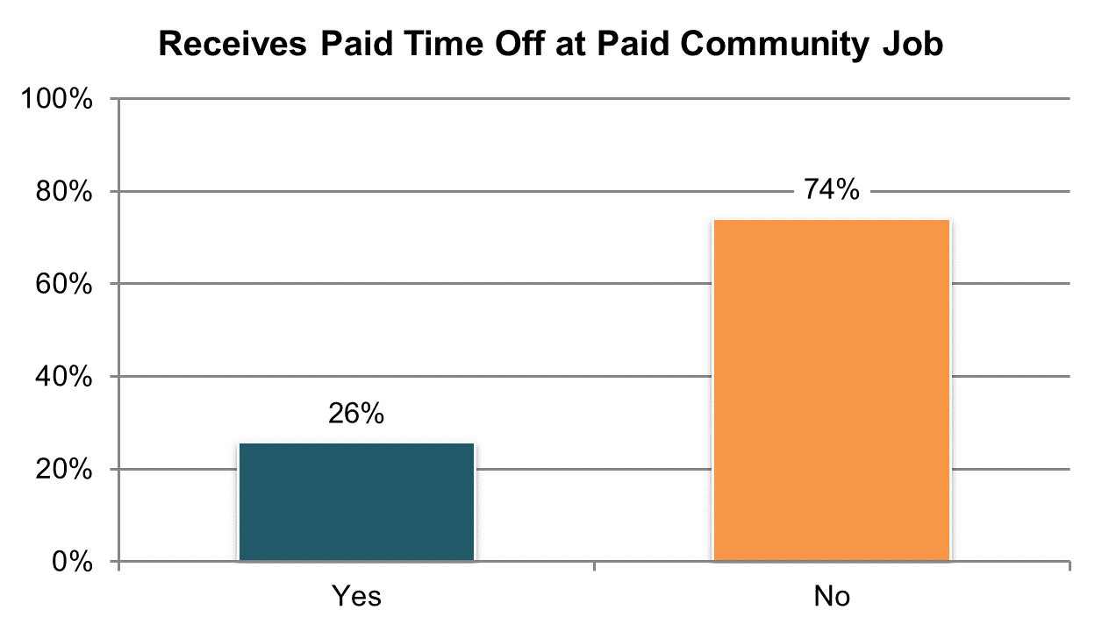

Table . Receives paid vacation and/or sick time at their job (among those reported to have a job in the community; information comes from Background Information section) ±

|  |  |  |  |  |  |  |
| --- | --- | --- | --- | --- | --- | --- |
| State | Overall in State | N | ICF/IID and Other Institutional Settings | Community-based Group Residential Settings | Own Home | Parent’s or Relative’s Home |
| **Significantly Above Average** | | |  | | | |
| CT | 57% | 77 | n/a | n/a | 57% | 56% |
| OH | 40% | 106 | n/a | n/a | 37% | 40% |
| **Within Average Range** | | |  | | | |
| IL | 44% | 25 | n/a | n/a | n/a | n/a |
| NY | 42% | 38 | n/a | n/a | n/a | n/a |
| MA | 40% | 90 | n/a | 33% | 43% | 45% |
| CO | 37% | 35 | n/a | n/a | n/a | n/a |
| MN | 34% | 156 | n/a | 30% | 47% | 34% |
| WY | 32% | 78 | n/a | n/a | 50% | 20% |
| NV | 31% | 75 | n/a | 35% | 35% | n/a |
| KS | 30% | 44 | n/a | n/a | n/a | n/a |
| MO | 29% | 34 | n/a | n/a | 38% | n/a |
| AZ | 29% | 49 | n/a | n/a | n/a | 12% |
| IN | 28% | 123 | n/a | n/a | 38% | 23% |
| KY | 28% | 43 | n/a | n/a | n/a | n/a |
| PA | 28% | 43 | n/a | n/a | n/a | n/a |
| FL | 26% | 125 | n/a | n/a | 31% | 22% |
| DE | 25% | 40 | n/a | 21% | n/a | n/a |
| GA | 25% | 76 | n/a | n/a | 22% | 25% |
| WA | 24% | 147 | n/a | n/a | 32% | 21% |
| RI | 24% | 79 | n/a | n/a | 33% | 21% |
| UT | 20% | 50 | n/a | n/a | n/a | n/a |
| SD | 20% | 126 | n/a | 10% | 27% | n/a |
| TN | 19% | 42 | n/a | n/a | n/a | n/a |
| AL | 17% | 29 | n/a | n/a | n/a | n/a |
| VA | 17% | 47 | n/a | 17% | n/a | n/a |
| ME | 16% | 73 | n/a | 17% | n/a | n/a |
| OK | 15% | 65 | n/a | 14% | 15% | n/a |
| MI | 15% | 46 | n/a | n/a | n/a | n/a |
| NC | 15% | 80 | n/a | 4% | n/a | 19% |
| AR | 12% | 25 | n/a | n/a | n/a | n/a |
| **Significantly Below Average** | | |  | | | |
| VT | 11% | 125 | n/a | n/a | n/a | 14% |
| MS | 11% | 47 | n/a | n/a | n/a | n/a |
| LA | 9% | 44 | n/a | n/a | n/a | n/a |
| NCI Average | 26% | 2,282 | n/a | 20% | 36% | 27% |

± Item changed from previous years – wording changed for 2015-16 (see Appendix A)

**Note:** The following states are not included in analysis due to low N (<20): DC, HI, WI

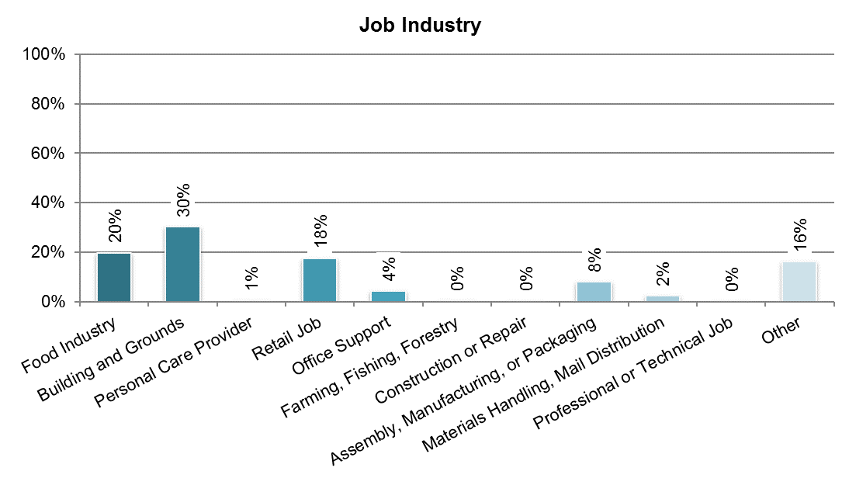

Table . Four most common job types among those reported to have a paid job in the community (information comes from Background Information section) ±

|  |  |  |  |  |  |
| --- | --- | --- | --- | --- | --- |
| State | Food Preparation and Food Service | Building and Grounds Cleaning or Maintenance | Retail Job | Assembly, Manufacturing, or Packaging | N |
| AL | 12% | 42% | 12% | 12% | 33 |
| AR | 38% | 31% | 0% | 0% | 29 |
| AZ | 14% | 29% | 14% | 8% | 65 |
| CO | 17% | 30% | 19% | 13% | 47 |
| CT | 10% | 29% | 15% | 16% | 98 |
| DE | 21% | 43% | 6% | 8% | 53 |
| FL | 20% | 21% | 30% | 4% | 140 |
| GA | 20% | 33% | 29% | 4% | 83 |
| HI | 35% | 40% | 15% | 5% | 20 |
| IL | 21% | 12% | 21% | 18% | 33 |
| IN | 28% | 19% | 28% | 8% | 137 |
| KS | 29% | 31% | 14% | 4% | 51 |
| KY | 25% | 20% | 32% | 7% | 56 |
| LA | 21% | 40% | 13% | 4% | 52 |
| MA | 18% | 27% | 19% | 13% | 99 |
| ME | 21% | 28% | 25% | 5% | 87 |
| MI | 22% | 33% | 10% | 12% | 51 |
| MN | 13% | 25% | 12% | 30% | 163 |
| MO | 11% | 34% | 18% | 3% | 38 |
| MS | 36% | 36% | 12% | 0% | 58 |
| NC | 21% | 23% | 20% | 2% | 94 |
| NV | 7% | 47% | 11% | 12% | 90 |
| NY | 16% | 22% | 26% | 12% | 50 |
| OH | 16% | 31% | 14% | 12% | 130 |
| OK | 3% | 46% | 15% | 7% | 67 |
| PA | 28% | 14% | 20% | 9% | 74 |
| RI | 22% | 29% | 8% | 4% | 85 |
| SD | 24% | 36% | 10% | 8% | 135 |
| TN | 23% | 42% | 11% | 4% | 53 |
| UT | 23% | 35% | 9% | 14% | 57 |
| VA | 15% | 32% | 18% | 10% | 68 |
| VT | 11% | 27% | 27% | 8% | 131 |
| WA | 20% | 29% | 19% | 6% | 163 |
| WI | 14% | 27% | 19% | 5% | 63 |
| WY | 22% | 24% | 25% | 3% | 92 |
| NCI Average | 20% | 30% | 17% | 8% | 2,745 |

± Item changed from previous years – community employment categories were described differently for 2015-16 (see Appendix A)

**Note:** DC excluded due to low N (<20)

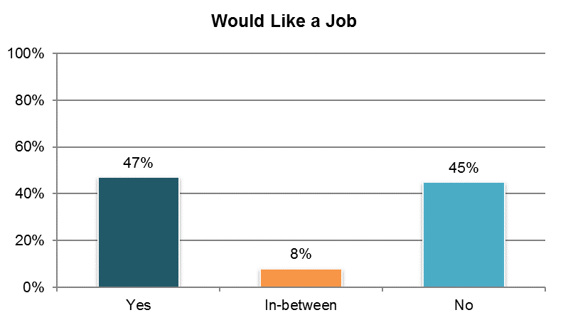

Table . Would like a job in the community (among those reported not to have a paid community job from Background section; ‘yes’ responses only) ±

|  |  |  |  |  |  |  |
| --- | --- | --- | --- | --- | --- | --- |
| State | Overall in State | N | ICF/IID and Other Institutional Settings | Community-based Group Residential Settings | Own Home | Parent’s or Relative’s Home |
| **Significantly Above Average** | | |  | | | |
| DE | 73% | 165 | n/a | 71% | n/a | n/a |
| DC | 66% | 80 | n/a | 61% | n/a | 78% |
| ME | 61% | 150 | n/a | 72% | n/a | 54% |
| NC | 59% | 250 | 58% | 65% | 45% | 57% |
| **Within Average Range** | | |  | | | |
| OK | 60% | 101 | n/a | 68% | n/a | 58% |
| AR | 59% | 108 | n/a | n/a | 64% | 50% |
| UT | 56% | 125 | n/a | 59% | 52% | 57% |
| HI | 54% | 122 | n/a | n/a | n/a | 56% |
| AL | 53% | 278 | n/a | 56% | 56% | 50% |
| WY | 53% | 100 | n/a | 66% | 36% | n/a |
| VA | 52% | 293 | 33% | 55% | 48% | 53% |
| VT | 52% | 140 | n/a | n/a | 48% | 83% |
| MN | 52% | 79 | n/a | 53% | n/a | 60% |
| SD | 51% | 109 | n/a | 61% | 34% | n/a |
| IL | 50% | 150 | n/a | 58% | n/a | 39% |
| MS | 50% | 161 | n/a | 53% | 47% | 49% |
| GA | 49% | 194 | n/a | 47% | 41% | 54% |
| WA | 48% | 117 | n/a | n/a | 39% | 61% |
| RI | 48% | 117 | n/a | 47% | 33% | 65% |
| NV | 46% | 241 | n/a | 43% | 51% | 43% |
| MA | 45% | 134 | n/a | 43% | n/a | 47% |
| OH | 42% | 177 | 35% | 38% | 55% | 34% |
| MI | 42% | 146 | n/a | 37% | 41% | 43% |
| WI | 41% | 141 | n/a | n/a | 39% | 36% |
| IN | 40% | 389 | n/a | n/a | 47% | 38% |
| LA | 40% | 142 | 55% | n/a | 55% | 26% |
| CO | 40% | 145 | n/a | n/a | 48% | 40% |
| KS | 39% | 159 | n/a | 36% | 44% | 36% |
| CT | 38% | 74 | n/a | 26% | n/a | 45% |
| NY | 38% | 208 | n/a | 34% | 41% | 43% |
| **Significantly Below Average** | | |  | | | |
| FL | 41% | 655 | n/a | 45% | 43% | 37% |
| TN | 36% | 222 | n/a | 43% | 44% | 22% |
| MO | 36% | 188 | n/a | 33% | 35% | n/a |
| PA | 35% | 215 | n/a | 35% | 23% | 43% |
| KY | 29% | 206 | n/a | 37% | 33% | 21% |
| AZ | 7% | 269 | n/a | 6% | 11% | 6% |
| NCI Average | 47% | 6,550 | 45% | 48% | 43% | 46% |

± Item changed from previous years – community employment categories were described differently for 2015-16 (see Appendix A)

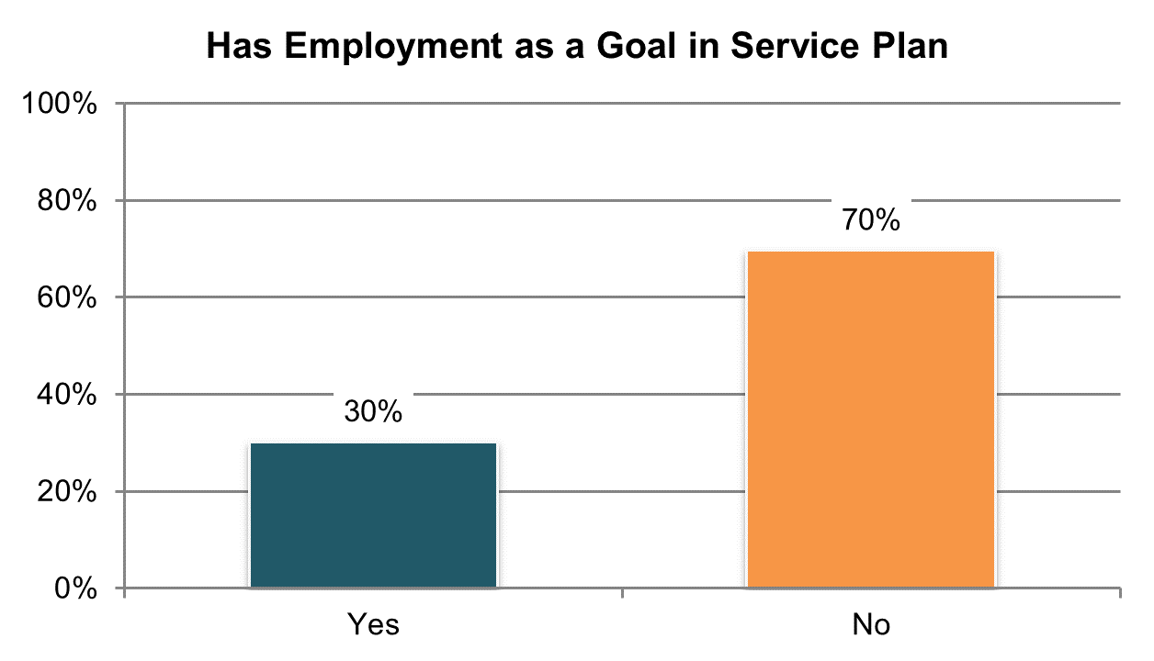

Table . Have community employment as a goal in their service plan (information comes from Background Information section)

|  |  |  |  |  |  |  |
| --- | --- | --- | --- | --- | --- | --- |
| State | Overall in State | N | ICF/IID and Other Institutional Settings | Community-based Group Residential Settings | Own Home | Parent’s or Relative’s Home |
| **Significantly Above Average** | | |  | | | |
| RI | 69% | 340 | n/a | 63% | 55% | 80% |
| WA | 59% | 398 | n/a | 55% | 55% | 64% |
| VT | 50% | 325 | n/a | 33% | 50% | 66% |
| DC | 48% | 183 | 11% | 51% | n/a | 61% |
| MN | 46% | 380 | 31% | 43% | 64% | 52% |
| MS | 44% | 374 | n/a | 56% | 51% | 32% |
| NV | 44% | 384 | n/a | 36% | 56% | 44% |
| OH | 39% | 591 | 22% | 31% | 44% | 42% |
| DE | 37% | 380 | n/a | 37% | 69% | n/a |
| **Within Average Range** | | |  | | | |
| WY | 36% | 304 | n/a | 33% | 35% | 40% |
| ME | 34% | 377 | n/a | 31% | 43% | 42% |
| OK | 33% | 400 | n/a | 35% | 40% | 25% |
| SD | 31% | 350 | n/a | 23% | 39% | 40% |
| CT | 31% | 332 | n/a | 17% | 48% | 44% |
| CO | 30% | 398 | n/a | 14% | 51% | 28% |
| TN | 29% | 417 | n/a | 29% | 35% | 23% |
| AL | 28% | 384 | n/a | 25% | 48% | 25% |
| MA | 27% | 403 | n/a | 17% | 38% | 51% |
| UT | 27% | 387 | 15% | 27% | 40% | 24% |
| MI | 26% | 417 | n/a | 21% | 31% | 27% |
| KS | 25% | 369 | n/a | 19% | 37% | 26% |
| **Significantly Below Average** | | |  | | | |
| PA | 24% | 604 | 6% | 16% | 43% | 27% |
| LA | 23% | 399 | 30% | n/a | 29% | 16% |
| VA | 23% | 763 | 4% | 28% | 26% | 19% |
| KY | 22% | 437 | n/a | 19% | 29% | 21% |
| IN | 21% | 796 | n/a | n/a | 32% | 19% |
| NY | 21% | 476 | 8% | 15% | 37% | 27% |
| GA | 20% | 461 | n/a | 10% | 31% | 21% |
| AZ | 20% | 441 | n/a | 15% | 24% | 19% |
| WI | 19% | 376 | 0% | 7% | 20% | 25% |
| NC | 19% | 797 | 3% | 23% | 37% | 19% |
| AR | 19% | 364 | 13% | 11% | 33% | 9% |
| FL | 19% | 1,408 | n/a | 12% | 33% | 17% |
| IL | 17% | 386 | n/a | 14% | 38% | 16% |
| HI | 16% | 392 | n/a | 14% | n/a | 19% |
| MO | 15% | 393 | n/a | 11% | 19% | 7% |
| NCI Average | 30% | 16,386 | 13% | 26% | 40% | 32% |

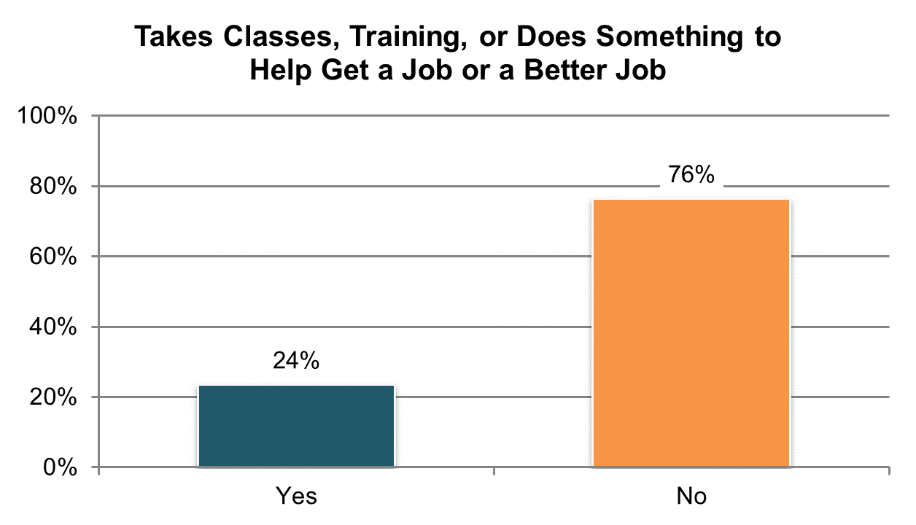

Table . Takes classes, training, or does something to help get a job or a better job º

|  |  |  |  |  |  |  |
| --- | --- | --- | --- | --- | --- | --- |
| State | Overall in State | N | ICF/IID and Other Institutional Settings | Community-based Group Residential Settings | Own Home | Parent’s or Relative’s Home |
| **Significantly Above Average** | | |  | | | |
| IL | 47% | 233 | n/a | 54% | 33% | 43% |
| GA | 40% | 284 | n/a | 42% | 37% | 43% |
| AL | 38% | 331 | n/a | 40% | 35% | 37% |
| AR | 34% | 215 | 50% | 38% | 36% | 27% |
| DC | 34% | 190 | n/a | 28% | n/a | 44% |
| FL | 29% | 827 | n/a | 31% | 22% | 32% |
| **Within Average Range** | | |  | | | |
| HI | 32% | 189 | n/a | 48% | n/a | 32% |
| UT | 32% | 230 | n/a | 32% | 29% | 29% |
| MI | 31% | 275 | n/a | 29% | 26% | 38% |
| MA | 29% | 296 | n/a | 27% | 12% | 45% |
| SD | 28% | 273 | n/a | 34% | 17% | 41% |
| NC | 27% | 423 | 21% | 31% | 19% | 30% |
| MS | 26% | 286 | n/a | 33% | 17% | 29% |
| ME | 25% | 278 | n/a | 24% | 18% | 28% |
| RI | 24% | 341 | n/a | 25% | 19% | 26% |
| CT | 23% | 227 | n/a | 20% | 27% | 24% |
| OH | 22% | 384 | 23% | 19% | 15% | 29% |
| MN | 22% | 248 | n/a | 21% | 17% | 26% |
| NV | 22% | 338 | n/a | 25% | 17% | 23% |
| OK | 22% | 195 | n/a | 22% | 14% | 25% |
| LA | 21% | 281 | 22% | n/a | 14% | 25% |
| IN | 21% | 558 | n/a | n/a | 14% | 24% |
| DE | 21% | 243 | n/a | 22% | 12% | n/a |
| CO | 20% | 295 | n/a | 11% | 16% | 19% |
| WI | 18% | 292 | 20% | 9% | 15% | 21% |
| WY | 18% | 234 | n/a | 17% | 14% | 24% |
| VT | 17% | 267 | n/a | n/a | 15% | 26% |
| **Significantly Below Average** | | |  | | | |
| VA | 18% | 462 | 3% | 20% | 18% | 20% |
| TN | 17% | 330 | n/a | 20% | 16% | 13% |
| NY | 17% | 296 | n/a | 11% | 18% | 20% |
| KS | 14% | 240 | n/a | 10% | 14% | 16% |
| PA | 14% | 419 | 0% | 12% | 11% | 18% |
| WA | 12% | 262 | n/a | n/a | 9% | 13% |
| KY | 12% | 288 | n/a | 12% | 2% | 16% |
| AZ | 12% | 416 | n/a | 7% | 17% | 12% |
| MO | 10% | 247 | n/a | 5% | 11% | n/a |
| NCI Average | 24% | 11,193 | 20% | 24% | 18% | 27% |

ºNew variable to reporting

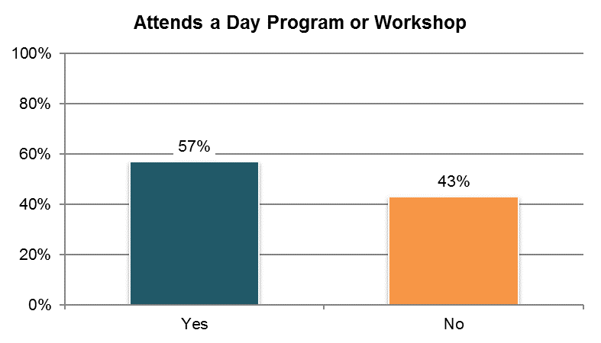

Table . Attends a day program or workshop±

|  |  |  |  |  |  |  |
| --- | --- | --- | --- | --- | --- | --- |
| State | Overall in State | N | ICF/IID and Other Institutional Settings | Community-based Group Residential Settings | Own Home | Parent’s or Relative’s Home |
| **Significantly Above Average** | | |  | | | |
| AL | 93% | 331 | n/a | 92% | 86% | 98% |
| IL | 82% | 258 | n/a | 97% | 55% | 73% |
| MS | 77% | 293 | n/a | 95% | 54% | 76% |
| DE | 75% | 274 | n/a | 75% | 66% | n/a |
| KY | 74% | 299 | n/a | 94% | 43% | 67% |
| ME | 73% | 289 | n/a | 71% | 58% | 87% |
| HI | 72% | 199 | n/a | 89% | n/a | 74% |
| KS | 72% | 266 | n/a | 89% | 67% | 48% |
| NV | 70% | 346 | n/a | 76% | 58% | 76% |
| RI | 70% | 344 | n/a | 70% | 51% | 80% |
| AR | 70% | 217 | 92% | 88% | 63% | 62% |
| MA | 70% | 310 | n/a | 78% | 43% | 72% |
| GA | 69% | 311 | n/a | 80% | 60% | 67% |
| VA | 69% | 502 | 33% | 77% | 61% | 67% |
| OH | 65% | 399 | 81% | 71% | 59% | 62% |
| **Within Average Range** | | |  |  |  |  |
| UT | 63% | 241 | n/a | 80% | 45% | 51% |
| NY | 63% | 309 | n/a | 80% | 26% | 59% |
| CO | 63% | 305 | n/a | 84% | 32% | 65% |
| SD | 62% | 279 | n/a | 85% | 38% | 68% |
| NC | 61% | 437 | 69% | 86% | 26% | 44% |
| MI | 56% | 286 | n/a | 65% | 41% | 57% |
| PA | 56% | 429 | 52% | 77% | 29% | 57% |
| IN | 56% | 578 | n/a | n/a | 49% | 58% |
| AZ | 54% | 421 | n/a | 74% | 43% | 51% |
| CT | 54% | 228 | n/a | 71% | 27% | 54% |
| MN | 51% | 251 | n/a | 72% | 23% | 39% |
| WY | 49% | 237 | n/a | 73% | 36% | 35% |
| **Within Average Range** | | |  |  |  |  |
| LA | 49% | 289 | 83% | n/a | 24% | 49% |
| MO | 45% | 273 | n/a | 55% | 42% | 59% |
| TN | 45% | 334 | n/a | 50% | 31% | 56% |
| FL | 44% | 852 | n/a | 64% | 30% | 41% |
| WI | 42% | 287 | 46% | 65% | 32% | 42% |
| OK | 32% | 210 | n/a | 40% | 20% | 25% |
| VT | 14% | 274 | n/a | n/a | 8% | 9% |
| WA | 10% | 266 | n/a | n/a | 8% | 9% |
| DC | 0% | 195 | n/a | 0% | n/a | 0% |
| NCI Average | 57% | 11,619 | 65% | 74% | 42% | 55% |

±Item changed from previous years – question rephrased (see Appendix A)

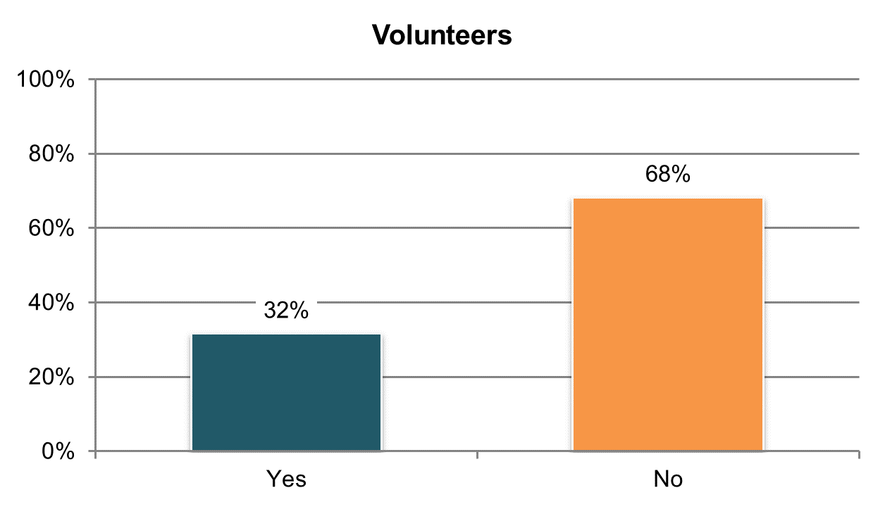

Table . Volunteers

|  |  |  |  |  |  |  |
| --- | --- | --- | --- | --- | --- | --- |
| State | Overall in State | N | ICF/IID and Other Institutional Settings | Community-based Group Residential Settings | Own Home | Parent’s or Relative’s Home |
| Significantly Above Average | | |  |  |  |  |
| HI | 49% | 196 | n/a | 57% | n/a | 50% |
| MN | 41% | 249 | n/a | 43% | 27% | 47% |
| VA | 40% | 479 | 36% | 43% | 17% | 33% |
| WI | 40% | 292 | 28% | 19% | 42% | 42% |
| IN | 38% | 576 | n/a | n/a | 27% | 41% |
| **With Average Range** | | |  |  |  |  |
| DC | 40% | 190 | n/a | 38% | n/a | 53% |
| SD | 39% | 282 | n/a | 45% | 37% | 33% |
| MA | 39% | 298 | n/a | 38% | 35% | 49% |
| ME | 39% | 286 | n/a | 33% | 35% | 54% |
| AL | 38% | 331 | n/a | 34% | 40% | 42% |
| CT | 37% | 239 | n/a | 34% | 39% | 40% |
| UT | 37% | 236 | n/a | 41% | 24% | 36% |
| AR | 34% | 218 | 23% | 36% | 39% | 33% |
| NC | 34% | 425 | 13% | 27% | 33% | 44% |
| CO | 33% | 299 | n/a | 31% | 25% | 36% |
| IL | 33% | 242 | n/a | 30% | 39% | 34% |
| RI | 33% | 347 | n/a | 31% | 24% | 44% |
| WY | 32% | 237 | n/a | 21% | 34% | 39% |
| LA | 32% | 284 | 29% | n/a | 31% | 34% |
| GA | 30% | 300 | n/a | 25% | 23% | 33% |
| DE | 30% | 250 | n/a | 26% | 48% | n/a |
| MI | 30% | 275 | n/a | 21% | 30% | 36% |
| KS | 29% | 259 | n/a | 22% | 31% | 38% |
| WA | 29% | 265 | n/a | n/a | 28% | 32% |
| NY | 29% | 309 | n/a | 31% | 14% | 38% |
| OH | 28% | 388 | 21% | 30% | 26% | 29% |
| OK | 28% | 210 | n/a | 19% | 28% | 40% |
| PA | 28% | 429 | 24% | 20% | 15% | 34% |
| MO | 27% | 267 | n/a | 28% | 25% | 23% |
| VT | 27% | 273 | n/a | n/a | 21% | 25% |
| MS | 26% | 288 | n/a | 28% | 25% | 24% |
| **Significantly Below Average** | | |  |  |  |  |
| NV | 25% | 342 | n/a | 31% | 18% | 23% |
| FL | 23% | 838 | n/a | 18% | 20% | 28% |
| TN | 23% | 332 | n/a | 29% | 14% | 24% |
| KY | 15% | 292 | n/a | 16% | 5% | 24% |
| AZ | 8% | 411 | n/a | 5% | 7% | 9% |
| NCI Average | 32% | 11,434 | 25% | 30% | 27% | 36% |

## Self-Determination

### People have authority and are supported to direct and manage their own services.

There are seven indicators measured by the Adult Consumer Survey:

1. Proportion of people who were reported to be using a self-directed supports option
2. Proportion of people self-directing who reported participating in decisions about using budget, hiring staff, or managing services
3. Proportion of people self-directing who reported they make decisions about how their budget for services is used
4. Proportion of people self-directing who reported they hire and manage their staff
5. Proportion of people self-directing who reported they have enough help deciding how to use their budget/services
6. Proportion of people self-directing who reported they receive information about money that’s left in their budget
7. Proportion of people self-directing who report they get enough information about their budget/services and that the information is easy to understand

Tables 53 through 59 present the results for these seven core indicators.

All un-collapsed state data frequencies for these survey questions are displayed in Appendix D.

.

Important note on changes to the survey tool and analysis. NCI broadened the description of self-directed supports from only including those participating in specific self-direction programs or waivers to include those who are using self-direction or participant direction for any part of their services. It is phrased as:

*"Self-directed" or "participant-directed" supports options offer individuals (and their representatives, including family members) the opportunity to manage some or all of their services. They may hire and fire their own support workers and/or control how their budget is spent.*

Additionally, questions on self-direction were moved from Section I (where only the person receiving services may respond) to Section II to allow for proxy responses when applicable.

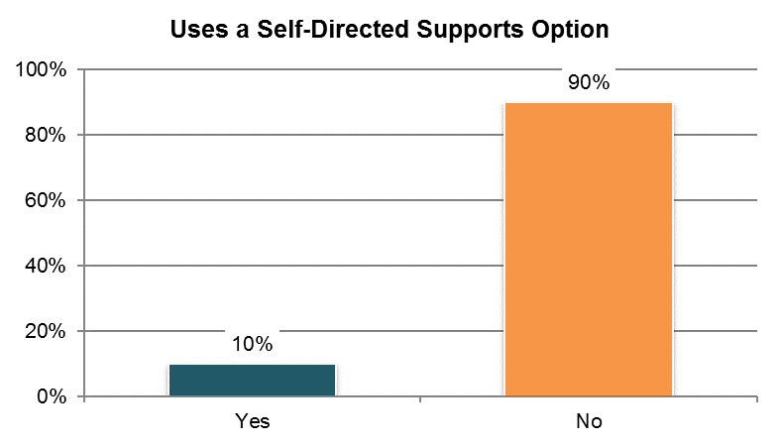

Table . Uses a self-directed supports option (information comes from Background Information section) ±

|  |  |  |  |  |  |  |
| --- | --- | --- | --- | --- | --- | --- |
| State | Overall in State | N | ICF/IID and Other Institutional Settings | Community-based Group Residential Settings | Own Home | Parent’s or Relative’s Home |
| Significantly Above Average | | |  |  |  |  |
| WA | 67% | 406 | n/a | 16% | 58% | 89% |
| WI | 33% | 304 | 8% | 12% | 35% | 44% |
| IL | 32% | 386 | n/a | 5% | 44% | 66% |
| KY | 27% | 450 | n/a | 1% | 30% | 57% |
| UT | 23% | 407 | 0% | 0% | 12% | 55% |
| MI | 22% | 420 | n/a | 2% | 40% | 40% |
| KS | 20% | 378 | n/a | 2% | 15% | 54% |
| FL | 20% | 1,433 | n/a | 0% | 14% | 33% |
| HI | 17% | 401 | n/a | 2% | n/a | 28% |
| VA | 17% | 747 | 6% | 2% | 27% | 44% |
| **Within Average Range** | | |  |  |  |  |
| PA | 14% | 611 | 4% | 1% | 10% | 25% |
| VT | 12% | 326 | n/a | 0% | 10% | 39% |
| RI | 10% | 358 | n/a | 2% | 13% | 17% |
| CT | 9% | 339 | n/a | 1% | 11% | 21% |
| MN | 7% | 428 | 0% | 0% | 2% | 21% |
| WY | 7% | 315 | n/a | 1% | 4% | 19% |
| **Significantly Below Average** | | |  |  |  |  |
| SD | 6% | 354 | n/a | 0% | 7% | 22% |
| NY | 4% | 484 | 0% | 3% | 8% | 7% |
| MO | 4% | 397 | n/a | 0% | 2% | 26% |
| TN | 4% | 425 | n/a | 0% | 4% | 10% |
| LA | 3% | 435 | 1% | n/a | 1% | 7% |
| GA | 3% | 468 | n/a | 0% | 2% | 5% |
| OK | 3% | 400 | n/a | 0% | 0% | 11% |
| OH | 3% | 574 | 1% | 1% | 3% | 3% |
| NC | 2% | 800 | 2% | 0% | 9% | 2% |
| MA | 2% | 416 | n/a | 0% | 2% | 7% |
| AL | 0% | 396 | n/a | 0% | 0% | 0% |
| AR | 0% | 363 | 0% | 0% | 0% | 0% |
| AZ | 0% | 471 | n/a | 0% | 0% | 0% |
| CO | 0% | 411 | n/a | 0% | 0% | 0% |
| DC | 0% | 341 | 0% | 0% | 0% | 0% |
| DE | 0% | 436 | n/a | 0% | 0% | n/a |
| IN | 0% | 825 | n/a | 0% | 0% | 0% |
| ME | 0% | 386 | n/a | 0% | 0% | 0% |
| MS | 0% | 414 | n/a | 0% | 0% | 0% |
| NV | 0% | 400 | n/a | 0% | 0% | 0% |
| NCI Average | 10% | 16,905 | 2% | 2% | 10% | 21% |

±Item changed from previous years – question rephrased (see Appendix A)

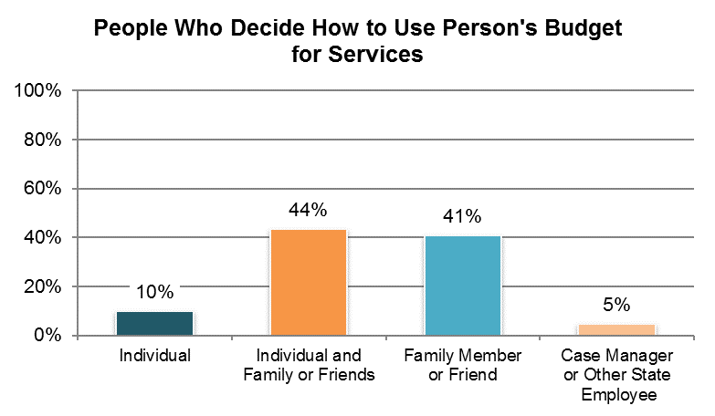

Table . People who decide how budget for services is used (among those using a self-direction option and who participate in making decisions about how to use budget, hire staff, or manage services; proxy responses allowed) º ˇ

|  |  |  |  |  |  |
| --- | --- | --- | --- | --- | --- |
| State | Individual | Individual and  Family or Friends | Family Member  or Friend | Case Manager  or Other State  Employee | N |
| FL | 12% | 48% | 40% | 0% | 231 |
| HI | 7% | 14% | 75% | 4% | 28 |
| IL | 4% | 55% | 38% | 2% | 47 |
| KS | 13% | 50% | 33% | 3% | 30 |
| KY | 15% | 62% | 23% | 0% | 26 |
| MI | 20% | 43% | 30% | 0% | 44 |
| PA | 5% | 36% | 45% | 14% | 22 |
| RI | 0% | 43% | 35% | 22% | 23 |
| UT | 5% | 35% | 60% | 0% | 60 |
| WA | 14% | 44% | 38% | 4% | 214 |
| WI | 14% | 48% | 34% | 4% | 77 |
| **NCI Average** | **10%** | **44%** | **41%** | **5%** | **802** |

ºNew variable to reporting

ˇReported for those who were reported to use a self-directed supports option from Background section

**Note:** The following states are not included in analysis due to low N (<20): AL, AR, AZ, CO, CT, DC, DE, GA, IN, LA, MA, ME, MN, MO, MS, NC, NV, NY, OH, OK, SD, TN, VA, VT, WY

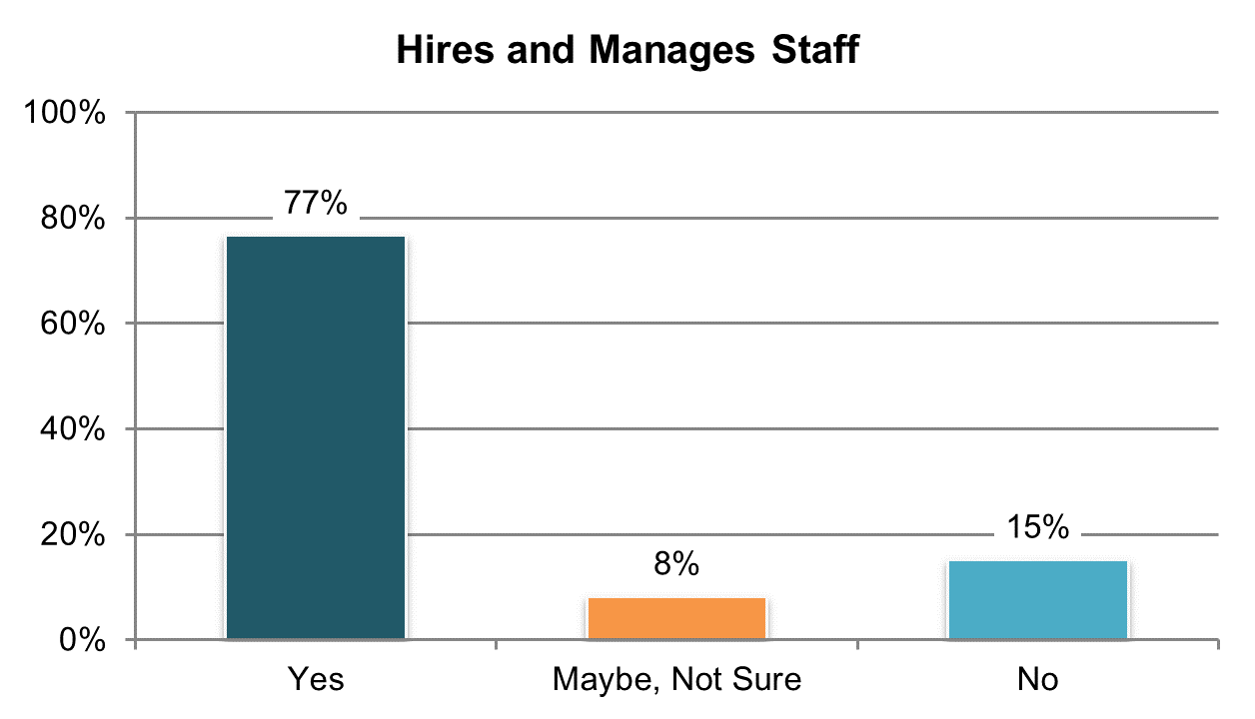

Table . Hires or manages staff (among those using a self-direction option and who participate in making decisions about how to use budget, hire staff, or manage services; proxy responses allowed) º ˇ

|  |  |  |  |  |  |  |
| --- | --- | --- | --- | --- | --- | --- |
| State | Overall in State | N | ICF/IID and Other Institutional Settings | Community-based Group Residential Settings | Own Home | Parent’s or Relative’s Home |
| Significantly Above Average | | |  |  |  |  |
| PA | 95% | 21 | n/a | n/a | n/a | 95% |
| HI | 93% | 28 | n/a | n/a | n/a | 92% |
| UT | 91% | 57 | n/a | n/a | n/a | 91% |
| FL | 85% | 229 | n/a | n/a | 91% | 84% |
| **Within Average Range** | | |  |  |  |  |
| KY | 83% | 23 | n/a | n/a | n/a | 80% |
| WA | 73% | 204 | n/a | n/a | 54% | 85% |
| MI | 71% | 42 | n/a | n/a | n/a | 74% |
| WI | 67% | 70 | n/a | n/a | 73% | 67% |
| KS | 67% | 27 | n/a | n/a | n/a | n/a |
| RI | 64% | 22 | n/a | n/a | n/a | n/a |
| IL | 55% | 44 | n/a | n/a | n/a | 57% |
| NCI Average | 77% | 767 | n/a | n/a | 73% | 80% |

ºNew variable to reporting

ˇReported for those who were reported to use a self-directed supports option from Background section

**Note:** The following states are not included in analysis due to low N (<20): AL, AR, AZ, CO, CT, DC, DE, GA, IN, LA, MA, ME, MN, MO, MS, NC, NV, NY, OH, OK, SD, TN, VA, VT, WY

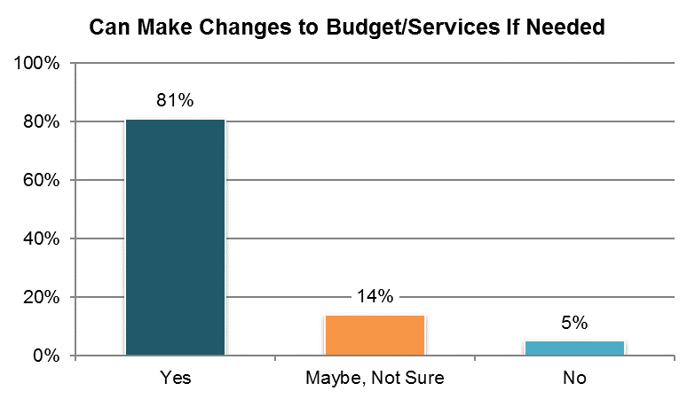

Table . Can make changes to individual budget/services if needed (among those using a self-direction option and who participate in making decisions about how to use budget, hire staff, or manage services; proxy responses allowed) ˇ

|  |  |  |  |  |  |  |
| --- | --- | --- | --- | --- | --- | --- |
| State | Overall in State | N | ICF/IID and Other Institutional Settings | Community-based Group Residential Settings | Own Home | Parent’s or Relative’s Home |
| Significantly Above Average | | |  |  |  |  |
| FL | 92% | 229 | n/a | n/a | 91% | 92% |
| WI | 91% | 77 | n/a | n/a | 85% | 93% |
| **Within Average Range** | | |  |  |  |  |
| UT | 91% | 56 | n/a | n/a | n/a | 90% |
| KY | 88% | 24 | n/a | n/a | n/a | 86% |
| WA | 87% | 200 | n/a | n/a | 91% | 83% |
| KS | 78% | 27 | n/a | n/a | n/a | n/a |
| HI | 74% | 27 | n/a | n/a | n/a | 74% |
| RI | 74% | 23 | n/a | n/a | n/a | n/a |
| MI | 71% | 42 | n/a | n/a | n/a | 67% |
| IL | 64% | 45 | n/a | n/a | n/a | 67% |
| **NCI Average** | **81%** | **750** | **n/a** | **n/a** | **89%** | **81%** |

ˇReported for those who were reported to use a self-directed supports option from Background section

**Note:** The following states are not included in analysis due to low N (<20): AL, AR, AZ, CO, CT, DC, DE, GA, IN, LA, MA, ME, MN, MO, MS, NC, NV, NY, OH, OK, PA, SD, TN, VA, VT, WY

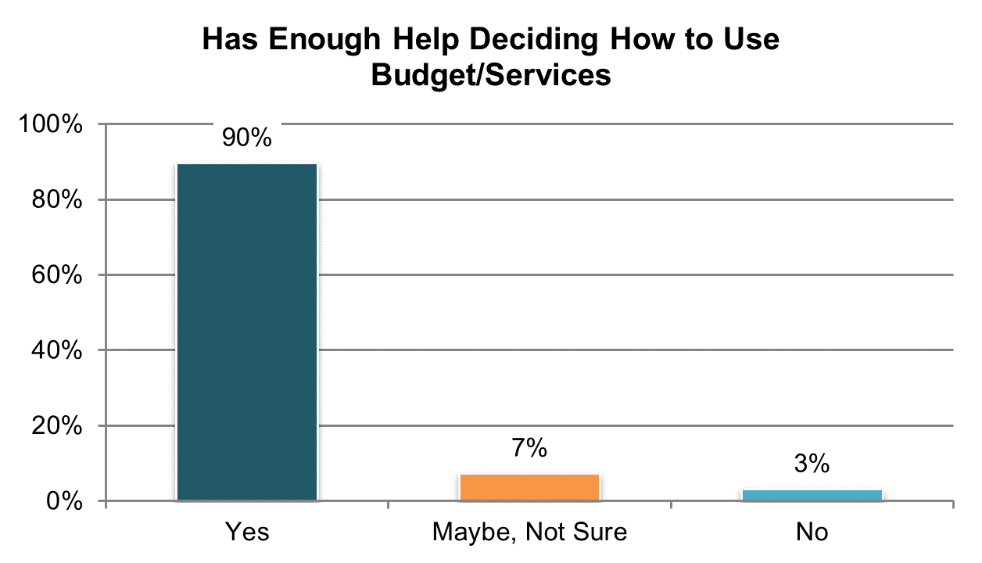

Table . Has enough help deciding how to use their individual budget/services (among those using a self-direction option and who participate in making decisions about how to use budget, hire staff, or manage services; proxy responses allowed) ˇ

|  |  |  |  |  |  |  |
| --- | --- | --- | --- | --- | --- | --- |
| State | Overall in State | N | ICF/IID and Other Institutional Settings | Community-based Group Residential Settings | Own Home | Parent’s or Relative’s Home |
| Significantly Above Average | | |  |  |  |  |
| FL | 96% | 231 | n/a | n/a | 94% | 96% |
| **Within Average Range** | | |  |  |  |  |
| HI | 96% | 27 | n/a | n/a | n/a | 96% |
| PA | 95% | 21 | n/a | n/a | n/a | 95% |
| WA | 93% | 208 | n/a | n/a | 97% | 92% |
| WI | 93% | 74 | n/a | n/a | 92% | 95% |
| UT | 91% | 58 | n/a | n/a | n/a | 91% |
| IL | 87% | 46 | n/a | n/a | n/a | 84% |
| RI | 87% | 23 | n/a | n/a | n/a | n/a |
| KY | 84% | 25 | n/a | n/a | n/a | 82% |
| MI | 83% | 42 | n/a | n/a | n/a | 78% |
| KS | 79% | 29 | n/a | n/a | n/a | n/a |
| NCI Average | 90% | 784 | n/a | n/a | 94% | 90% |

ˇReported for those who were reported to use a self-directed supports option from Background section

**Note:** The following states are not included in analysis due to low N (<20): AL, AR, AZ, CO, CT, DC, DE, GA, IN, LA, MA, ME, MN, MO, MS, NC, NV, NY, OH, OK, SD, TN, VA, VT, WY

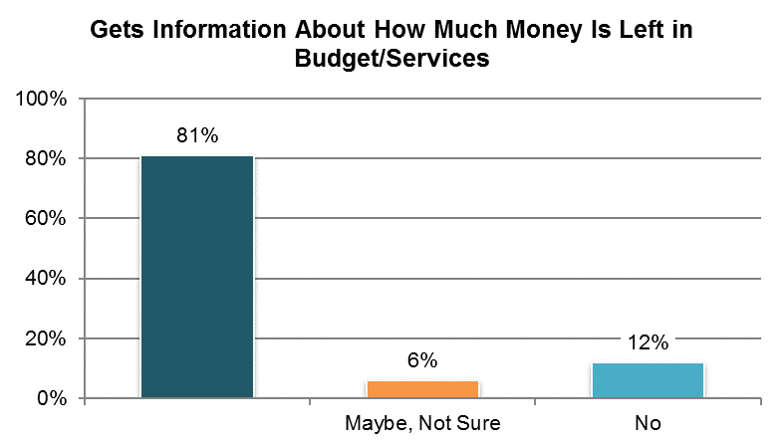

Table . Gets information about how much money is left in budget/services (among those using a self-direction option and who participate in making decisions about how to use budget, hire staff, or manage services; proxy responses allowed) ˇ

|  |  |  |  |  |  |  |
| --- | --- | --- | --- | --- | --- | --- |
| State | Overall in State | N | ICF/IID and Other Institutional Settings | Community-based Group Residential Settings | Own Home | Parent’s or Relative’s Home |
| **Significantly Above Average** | | |  |  |  |  |
| UT | 97% | 59 | n/a | n/a | n/a | 96% |
| KY | 96% | 25 | n/a | n/a | n/a | 95% |
| FL | 94% | 229 | n/a | n/a | 91% | 95% |
| **Within Average Range** | | |  |  |  |  |
| WI | 88% | 76 | n/a | n/a | 88% | 88% |
| PA | 86% | 21 | n/a | n/a | n/a | 85% |
| KS | 79% | 28 | n/a | n/a | n/a | n/a |
| RI | 78% | 23 | n/a | n/a | n/a | n/a |
| MI | 74% | 39 | n/a | n/a | n/a | 77% |
| IL | 74% | 46 | n/a | n/a | n/a | 70% |
| HI | 58% | 26 | n/a | n/a | n/a | 61% |
| **Significantly Below Average** | | |  |  |  |  |
| WA | 68% | 182 | n/a | n/a | 75% | 64% |
| NCI Average | 81% | 754 | n/a | n/a | 85% | 81% |

ˇReported for those who were reported to use a self-directed supports option from Background section

**Note:** The following states are not included in analysis due to low N (<20): AL, AR, AZ, CO, CT, DC, DE, GA, IN, LA, MA, ME, MN, MO, MS, NC, NV, NY, OH, OK, SD, TN, VA, VT, WY

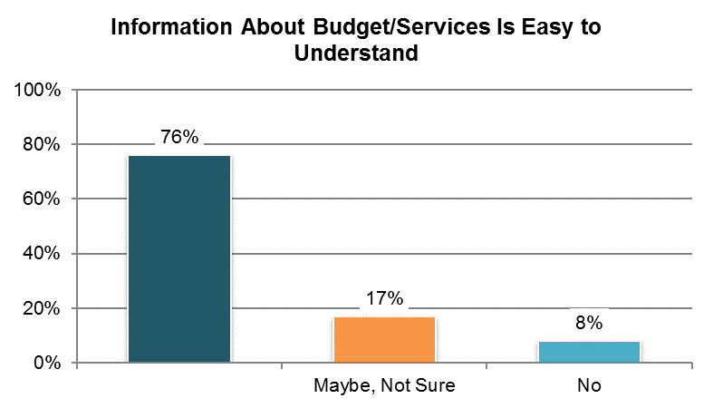

Table . Information about budget/services is easy to understand (among those using a self-direction option and who participate in making decisions about how to use budget, hire staff, or manage services; proxy responses allowed) ˇ

|  |  |  |  |  |  |  |
| --- | --- | --- | --- | --- | --- | --- |
| State | Overall in State | N | ICF/IID and Other Institutional Settings | Community-based Group Residential Settings | Own Home | Parent’s or Relative’s Home |
| **Within Average Range** | | |  |  |  |  |
| KY | 92% | 24 | n/a | n/a | n/a | 90% |
| FL | 82% | 215 | n/a | n/a | 66% | 85% |
| KS | 77% | 22 | n/a | n/a | n/a | n/a |
| WI | 75% | 68 | n/a | n/a | 55% | 87% |
| UT | 75% | 59 | n/a | n/a | n/a | 75% |
| IL | 70% | 37 | n/a | n/a | n/a | 71% |
| MI | 67% | 30 | n/a | n/a | n/a | 62% |
| WA | 67% | 153 | n/a | n/a | 86% | 58% |
| NCI Average | 76% | 608 | n/a | n/a | 69% | 76% |

ˇReported for those who were reported to use a self-directed supports option from Background section

**Note:** The following states are not included in analysis due to low N (<20): AL, AR, AZ, CO, CT, DC, DE, GA, IN, LA, MA, ME, MN, MO, MS, NC, NV, NY, OH, OK, PA, SD, TN, VA, VT, WY

## Community Inclusion, Participation, and Leisure

### People have support to participate in everyday community activities.

There are four Community Inclusion indicators:

1. The proportion of people who regularly participate in integrated activities in their communities (seven items within this indicator):
   1. Went shopping (in the past month)
   2. Went out on errands or appointments (in the past month)
   3. Went out for entertainment (in the past month)
   4. Went out to eat (in the past month)
   5. Went to religious services (in the past month)
   6. Took part in community groups or participated in other activities in the community (in the past month)
   7. Went on vacation (in the past year)
2. Proportion of people who report being able to go out and do the things they like to do
3. Proportion of people who report being able to go out and do the things they like to do enough
4. Proportion of people who report they have enough things to do at home

These items are depicted in Tables 60 through 70.

Results from the Community Inclusion composite scale score, shown in Table 67, were produced by adding four of the items: the number of times the person went shopping, on errands, for entertainment, and out to eat.

All un-collapsed data frequencies for these survey questions are displayed in Appendix D.

Important note on changes to the survey tool and analysis. Response options to questions around the frequency of participation in community activities changed from being continuous (number of times person did a certain activity) to being categorical (person did a particular activity 0 times, 1-2 times, etc). Consequently, the way that the individual community inclusion items are being reported in the tables has changed from the average number of times people performed the activity to the proportion of people who performed the activity at least once (the charts demonstrate the NCI Average for all response options). The calculation of the Community Inclusion scale also changed—from a simple sum of the number of times the activities were performed to an average of the proportions who performed the activities at least once. The calculation of the Community Inclusion scale is now similar to the calculation of choice and decision-making scales.

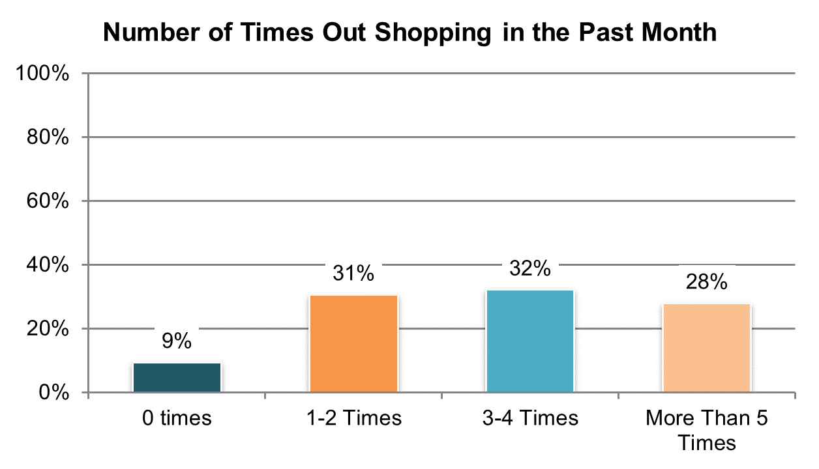

Table . Went out shopping at least once in the past month (proxy responses allowed) ±

|  |  |  |  |  |  |  |
| --- | --- | --- | --- | --- | --- | --- |
| State | Overall in State | N | ICF/IID and Other Institutional Settings | Community-based Group Residential Settings | Own Home | Parent’s or Relative’s Home |
| **Significantly Above Average** | | |  |  |  |  |
| WY | 97% | 306 | n/a | 96% | 99% | 95% |
| GA | 95% | 441 | n/a | 98% | 97% | 93% |
| ME | 95% | 391 | n/a | 94% | 100% | 98% |
| NV | 94% | 382 | n/a | 92% | 98% | 92% |
| AZ | 94% | 469 | n/a | 89% | 93% | 95% |
| **Within Average Range** | | |  |  |  |  |
| KY | 94% | 445 | n/a | 92% | 96% | 96% |
| TN | 94% | 429 | n/a | 94% | 95% | 90% |
| MO | 93% | 394 | n/a | 93% | 94% | 85% |
| SD | 93% | 326 | n/a | 91% | 98% | 87% |
| DC | 92% | 382 | 89% | 93% | 95% | 89% |
| MN | 92% | 401 | 88% | 93% | 98% | 90% |
| PA | 92% | 660 | 71% | 94% | 94% | 93% |
| KS | 92% | 362 | n/a | 89% | 97% | 92% |
| RI | 92% | 450 | n/a | 89% | 95% | 92% |
| VT | 92% | 319 | n/a | 70% | 92% | 99% |
| MS | 91% | 394 | n/a | 98% | 95% | 86% |
| IN | 91% | 812 | n/a | n/a | 96% | 90% |
| IL | 91% | 377 | n/a | 90% | 100% | 90% |
| MI | 91% | 429 | n/a | 85% | 94% | 95% |
| CO | 90% | 403 | n/a | 74% | 100% | 94% |
| NC | 90% | 733 | 78% | 91% | 100% | 93% |
| CT | 90% | 322 | 86% | 90% | 94% | 89% |
| FL | 90% | 1,416 | n/a | 89% | 97% | 87% |
| VA | 90% | 804 | 62% | 93% | 95% | 88% |
| OK | 90% | 397 | n/a | 89% | 96% | 85% |
| OH | 89% | 532 | 76% | 91% | 97% | 89% |
| NY | 89% | 483 | 90% | 87% | 97% | 89% |
| WA | 89% | 394 | n/a | 90% | 93% | 90% |
| AL | 89% | 380 | n/a | 85% | 96% | 92% |
| HI | 88% | 380 | n/a | 74% | n/a | 92% |
| UT | 88% | 380 | 44% | 91% | 98% | 88% |
| MA | 88% | 406 | n/a | 87% | 94% | 90% |
| DE | 86% | 354 | n/a | 84% | 96% | n/a |
| **Significantly Below Average** | | |  |  |  |  |
| LA | 84% | 421 | 65% | n/a | 96% | 89% |
| AR | 84% | 376 | 57% | 97% | 96% | 84% |
| WI | 83% | 405 | 68% | 88% | 84% | 85% |
| NCI Average | 91% | 16,755 | 73% | 89% | 96% | 91% |

±Item changed from previous years – response options changed (see Appendix A)

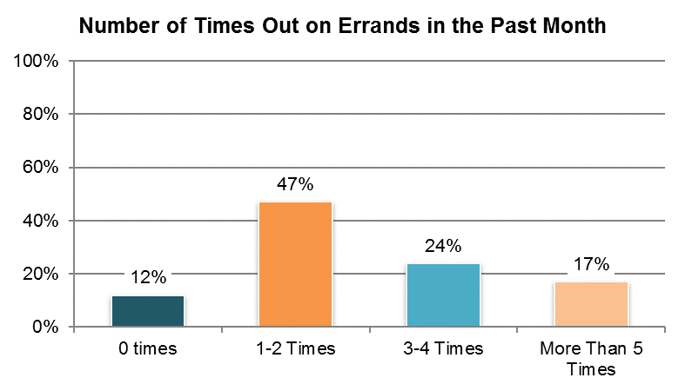

Table . Went out on errands at least once in the past month (proxy responses allowed) ±

|  |  |  |  |  |  |  |
| --- | --- | --- | --- | --- | --- | --- |
| State | Overall in State | N | ICF/IID and Other Institutional Settings | Community-based Group Residential Settings | Own Home | Parent’s or Relative’s Home |
| **Significantly Above Average** | | |  |  |  |  |
| DE | 94% | 329 | n/a | 93% | 100% | n/a |
| OK | 94% | 398 | n/a | 93% | 96% | 91% |
| SD | 94% | 312 | n/a | 96% | 95% | 89% |
| CO | 94% | 401 | n/a | 96% | 100% | 91% |
| VT | 94% | 308 | n/a | n/a | 94% | 90% |
| TN | 93% | 429 | n/a | 97% | 93% | 89% |
| RI | 93% | 441 | n/a | 99% | 91% | 91% |
| AZ | 93% | 467 | n/a | 87% | 98% | 94% |
| **Within Average Range** | | |  |  |  |  |
| CT | 92% | 317 | 80% | 94% | 98% | 91% |
| WA | 92% | 393 | n/a | 87% | 96% | 92% |
| KY | 92% | 447 | n/a | 91% | 98% | 94% |
| MA | 91% | 401 | n/a | 93% | 96% | 83% |
| WY | 91% | 299 | n/a | 88% | 90% | 94% |
| MN | 91% | 398 | 88% | 94% | 93% | 89% |
| PA | 91% | 649 | 72% | 96% | 95% | 90% |
| ME | 91% | 383 | n/a | 92% | 94% | 87% |
| IL | 90% | 378 | n/a | 93% | 91% | 85% |
| AL | 89% | 374 | n/a | 86% | 96% | 91% |
| NY | 89% | 484 | 87% | 91% | 92% | 86% |
| WI | 88% | 401 | 85% | 81% | 93% | 87% |
| NV | 88% | 371 | n/a | 87% | 91% | 87% |
| MI | 88% | 427 | n/a | 85% | 92% | 91% |
| MO | 88% | 392 | n/a | 83% | 90% | 77% |
| IN | 87% | 803 | n/a | n/a | 88% | 87% |
| DC | 86% | 367 | 82% | 84% | 86% | 86% |
| MS | 85% | 395 | n/a | 88% | 92% | 80% |
| GA | 85% | 420 | n/a | 89% | 89% | 82% |
| LA | 85% | 424 | 68% | n/a | 92% | 91% |
| OH | 84% | 522 | 65% | 82% | 89% | 89% |
| AR | 84% | 381 | 76% | 94% | 92% | 76% |
| **Significantly Below Average** | | |  |  |  |  |
| VA | 85% | 804 | 54% | 88% | 78% | 86% |
| NC | 85% | 725 | 69% | 87% | 89% | 89% |
| FL | 84% | 1,411 | n/a | 84% | 90% | 82% |
| KS | 83% | 360 | n/a | 84% | 81% | 82% |
| UT | 81% | 376 | 29% | 84% | 88% | 85% |
| HI | 75% | 323 | n/a | 72% | n/a | 77% |
| **NCI Average** | **88%** | **16,510** | **71%** | **89%** | **92%** | **87%** |

±Item changed from previous years – response options changed (see Appendix A)

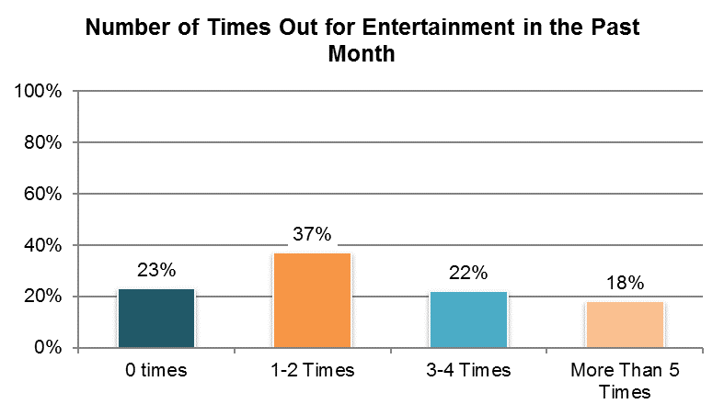

Table . Went out for entertainment at least once in the past month (proxy responses allowed) ±

|  |  |  |  |  |  |  |
| --- | --- | --- | --- | --- | --- | --- |
| State | Overall in State | N | ICF/IID and Other Institutional Settings | Community-based Group Residential Settings | Own Home | Parent’s or Relative’s Home |
| **Significantly Above Average** | | |  |  |  |  |
| DC | 89% | 385 | 100% | 84% | 81% | 90% |
| AZ | 87% | 470 | n/a | 76% | 89% | 91% |
| KY | 86% | 443 | n/a | 86% | 91% | 86% |
| CT | 86% | 321 | 90% | 87% | 82% | 85% |
| TN | 85% | 433 | n/a | 88% | 88% | 75% |
| NV | 85% | 379 | n/a | 89% | 80% | 81% |
| RI | 83% | 443 | n/a | 90% | 73% | 89% |
| MN | 83% | 403 | 82% | 86% | 72% | 87% |
| GA | 83% | 430 | n/a | 80% | 85% | 83% |
| **Within Average Range** | | |  |  |  |  |
| IL | 82% | 369 | n/a | 82% | 88% | 81% |
| OK | 82% | 394 | n/a | 78% | 89% | 82% |
| UT | 80% | 381 | 80% | 83% | 78% | 78% |
| OH | 79% | 532 | 73% | 86% | 76% | 83% |
| WY | 79% | 308 | n/a | 74% | 78% | 88% |
| SD | 78% | 319 | n/a | 80% | 78% | 79% |
| FL | 78% | 1,411 | n/a | 88% | 74% | 74% |
| VA | 78% | 797 | 49% | 85% | 78% | 72% |
| MA | 77% | 402 | n/a | 79% | 75% | 76% |
| AR | 77% | 379 | 71% | 86% | 78% | 75% |
| MI | 77% | 430 | n/a | 71% | 80% | 81% |
| CO | 76% | 404 | n/a | 74% | 77% | 75% |
| NC | 76% | 736 | 74% | 78% | 67% | 77% |
| MO | 76% | 394 | n/a | 76% | 78% | 59% |
| WA | 76% | 397 | n/a | 68% | 83% | 77% |
| WI | 75% | 404 | 76% | 79% | 70% | 79% |
| KS | 75% | 357 | n/a | 73% | 69% | 81% |
| LA | 74% | 419 | 61% | n/a | 85% | 75% |
| PA | 74% | 666 | 77% | 80% | 61% | 74% |
| AL | 72% | 373 | n/a | 72% | 82% | 68% |
| **Significantly Below Average** | | |  |  |  |  |
| IN | 71% | 814 | n/a | n/a | 71% | 71% |
| DE | 69% | 347 | n/a | 68% | 65% | n/a |
| HI | 69% | 372 | n/a | 60% | n/a | 74% |
| NY | 66% | 483 | 84% | 69% | 47% | 64% |
| MS | 64% | 396 | n/a | 73% | 63% | 60% |
| VT | 63% | 316 | n/a | 55% | 59% | 62% |
| ME | 62% | 381 | n/a | 61% | 70% | 60% |
| NCI Average | 77% | 16,688 | 76% | 78% | 76% | 77% |

±Item changed from previous years – response options changed (see Appendix A)

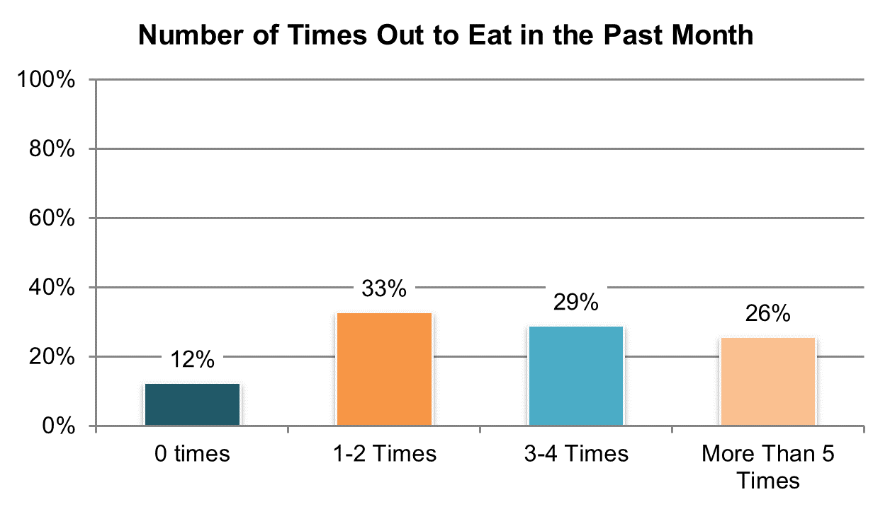

Table . Went out to eat at least once in the past month (proxy responses allowed) ±

|  |  |  |  |  |  |  |
| --- | --- | --- | --- | --- | --- | --- |
| State | Overall in State | N | ICF/IID and Other Institutional Settings | Community-based Group Residential Settings | Own Home | Parent’s or Relative’s Home |
| **Significantly Above Average** | | |  |  |  |  |
| GA | 96% | 445 | n/a | 97% | 97% | 96% |
| KY | 93% | 446 | n/a | 93% | 96% | 93% |
| WY | 93% | 304 | n/a | 93% | 92% | 95% |
| IL | 93% | 372 | n/a | 95% | 100% | 89% |
| AL | 93% | 376 | n/a | 93% | 92% | 92% |
| TN | 92% | 432 | n/a | 90% | 93% | 93% |
| MO | 92% | 393 | n/a | 83% | 96% | 90% |
| RI | 92% | 449 | n/a | 91% | 93% | 91% |
| **Within Average Range** | | |  |  |  |  |
| CO | 90% | 400 | n/a | 75% | 93% | 94% |
| MA | 89% | 404 | n/a | 90% | 91% | 86% |
| VT | 89% | 318 | n/a | 85% | 83% | 93% |
| SD | 89% | 326 | n/a | 88% | 90% | 89% |
| KS | 89% | 362 | n/a | 87% | 95% | 88% |
| CT | 89% | 322 | n/a | 88% | 92% | 91% |
| NC | 88% | 735 | 79% | 89% | 93% | 91% |
| WA | 88% | 397 | n/a | 81% | 89% | 90% |
| VA | 88% | 808 | 49% | 95% | 85% | 87% |
| OK | 88% | 396 | n/a | 88% | 94% | 82% |
| OH | 87% | 533 | 75% | 88% | 93% | 89% |
| PA | 87% | 658 | 63% | 93% | 87% | 87% |
| IN | 87% | 813 | n/a | n/a | 86% | 87% |
| UT | 87% | 382 | 64% | 89% | 88% | 87% |
| MI | 86% | 429 | n/a | 83% | 83% | 90% |
| FL | 86% | 1,412 | n/a | 90% | 89% | 84% |
| MN | 86% | 404 | 85% | 90% | 85% | 85% |
| MS | 86% | 395 | n/a | 94% | 84% | 85% |
| NV | 86% | 374 | n/a | 90% | 80% | 83% |
| ME | 85% | 390 | n/a | 84% | 84% | 91% |
| WI | 84% | 403 | 81% | 88% | 82% | 85% |
| LA | 83% | 405 | 69% | n/a | 90% | 88% |
| AZ | 83% | 468 | n/a | 64% | 84% | 91% |
| AR | 82% | 379 | 57% | 94% | 94% | 83% |
| DC | 82% | 372 | 61% | 83% | 65% | 89% |
| **Significantly Below Average** | | |  |  |  |  |
| DE | 82% | 347 | n/a | 81% | 75% | n/a |
| NY | 81% | 483 | 88% | 78% | 81% | 83% |
| HI | 79% | 373 | n/a | 63% | n/a | 85% |
| NCI Average | 88% | 16,705 | 70% | 87% | 88% | 89% |

±Item changed from previous years – response options changed (see Appendix A)

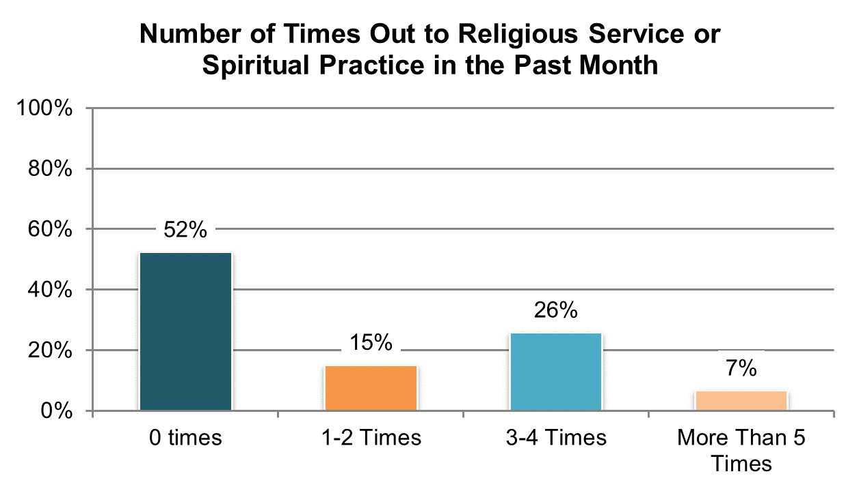

Table . Went out to religious service or spiritual practice at least once in the past month (proxy responses allowed) ±

|  |  |  |  |  |  |  |
| --- | --- | --- | --- | --- | --- | --- |
| State | Overall in State | N | ICF/IID and Other Institutional Settings | Community-based Group Residential Settings | Own Home | Parent’s or Relative’s Home |
| **Significantly Above Average** | | |  |  |  |  |
| GA | 71% | 418 | n/a | 64% | 61% | 78% |
| MS | 70% | 395 | n/a | 70% | 74% | 71% |
| AL | 70% | 372 | n/a | 68% | 51% | 80% |
| DC | 68% | 352 | 60% | 70% | 81% | 62% |
| NC | 66% | 727 | 62% | 69% | 58% | 67% |
| LA | 64% | 418 | 67% | n/a | 64% | 61% |
| AZ | 61% | 463 | n/a | 49% | 60% | 63% |
| TN | 59% | 424 | n/a | 48% | 61% | 70% |
| UT | 55% | 375 | 48% | 40% | 59% | 71% |
| **Within Average Range** | | |  |  |  |  |
| HI | 52% | 326 | n/a | 68% | n/a | 54% |
| VA | 52% | 800 | 38% | 49% | 41% | 54% |
| OK | 51% | 398 | n/a | 43% | 58% | 57% |
| IN | 50% | 819 | n/a | n/a | 48% | 48% |
| AR | 49% | 375 | 36% | 47% | 54% | 49% |
| MO | 48% | 387 | n/a | 46% | 45% | 53% |
| FL | 47% | 1,412 | n/a | 45% | 47% | 47% |
| SD | 47% | 321 | n/a | 50% | 43% | 51% |
| MN | 46% | 404 | 50% | 41% | 51% | 50% |
| KS | 45% | 339 | n/a | 38% | 51% | 51% |
| MI | 45% | 428 | n/a | 35% | 48% | 51% |
| KY | 44% | 434 | n/a | 34% | 47% | 50% |
| IL | 44% | 361 | n/a | 38% | 22% | 56% |
| OH | 44% | 530 | 31% | 42% | 40% | 52% |
| PA | 42% | 648 | 44% | 34% | 39% | 46% |
| WI | 42% | 406 | 37% | 40% | 44% | 45% |
| DE | 41% | 352 | n/a | 39% | 30% | n/a |
| **Significantly Below Average** | | |  |  |  |  |
| RI | 41% | 432 | n/a | 35% | 31% | 41% |
| CO | 39% | 403 | n/a | 37% | 34% | 41% |
| MA | 37% | 393 | n/a | 33% | 40% | 43% |
| WY | 37% | 311 | n/a | 21% | 42% | 43% |
| CT | 36% | 318 | n/a | 32% | 40% | 38% |
| WA | 36% | 395 | n/a | 35% | 32% | 38% |
| ME | 33% | 385 | n/a | 27% | 45% | 30% |
| NV | 32% | 376 | n/a | 30% | 29% | 43% |
| NY | 30% | 481 | 24% | 28% | 34% | 30% |
| VT | 23% | 317 | n/a | 38% | 33% | 26% |
| NCI Average | 48% | 16,495 | 45% | 44% | 47% | 52% |

±Item changed from previous years – response options changed (see Appendix A)

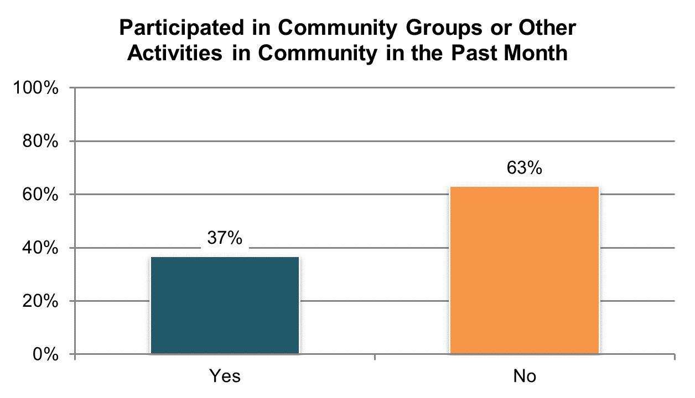

Table . Participated in a community group in the past month (proxy responses allowed) º

|  |  |  |  |  |  |  |
| --- | --- | --- | --- | --- | --- | --- |
| State | Overall in State | N | ICF/IID and Other Institutional Settings | Community-based Group Residential Settings | Own Home | Parent’s or Relative’s Home |
| **Significantly Above Average** | | |  |  |  |  |
| GA | 63% | 421 | n/a | 63% | 65% | 63% |
| HI | 62% | 356 | n/a | 70% | n/a | 59% |
| UT | 54% | 375 | 32% | 55% | 61% | 52% |
| WA | 49% | 395 | n/a | 42% | 49% | 52% |
| FL | 47% | 1,399 | n/a | 45% | 52% | 47% |
| NV | 47% | 381 | n/a | 47% | 44% | 53% |
| CT | 47% | 319 | n/a | 44% | 47% | 50% |
| MO | 45% | 385 | n/a | 40% | 45% | 58% |
| VA | 42% | 790 | 39% | 42% | 43% | 40% |
| **Within Average Range** | | |  |  |  |  |
| KS | 42% | 321 | n/a | 43% | 39% | 42% |
| NC | 41% | 722 | 19% | 48% | 45% | 44% |
| SD | 41% | 313 | n/a | 45% | 35% | 49% |
| IL | 40% | 352 | n/a | 37% | 36% | 44% |
| PA | 39% | 646 | 32% | 38% | 33% | 40% |
| WY | 38% | 305 | n/a | 32% | 38% | 42% |
| MA | 38% | 388 | n/a | 35% | 35% | 45% |
| TN | 37% | 428 | n/a | 34% | 33% | 41% |
| MN | 37% | 401 | 52% | 37% | 26% | 37% |
| MI | 36% | 423 | n/a | 33% | 43% | 37% |
| RI | 36% | 436 | n/a | 40% | 37% | 34% |
| WI | 36% | 403 | 27% | 23% | 34% | 40% |
| OK | 36% | 397 | n/a | 31% | 41% | 39% |
| IN | 34% | 807 | n/a | n/a | 31% | 34% |
| MS | 34% | 387 | n/a | 43% | 36% | 27% |
| AR | 33% | 368 | 19% | 34% | 44% | 34% |
| LA | 32% | 415 | 25% | n/a | 37% | 34% |
| **Significantly Below Average** | | |  |  |  |  |
| OH | 30% | 535 | 22% | 18% | 34% | 36% |
| CO | 29% | 402 | n/a | 21% | 30% | 32% |
| DC | 29% | 338 | 13% | 29% | 25% | 30% |
| ME | 28% | 381 | n/a | 24% | 33% | 30% |
| VT | 28% | 317 | n/a | 30% | 33% | 23% |
| NY | 23% | 478 | 10% | 22% | 29% | 26% |
| AL | 22% | 369 | n/a | 17% | 31% | 27% |
| AZ | 19% | 466 | n/a | 22% | 24% | 16% |
| DE | 17% | 338 | n/a | 16% | 22% | n/a |
| KY | 16% | 426 | n/a | 12% | 6% | 21% |
| NCI Average | 37% | 16,383 | 26% | 36% | 37% | 39% |

ºNew variable to reporting

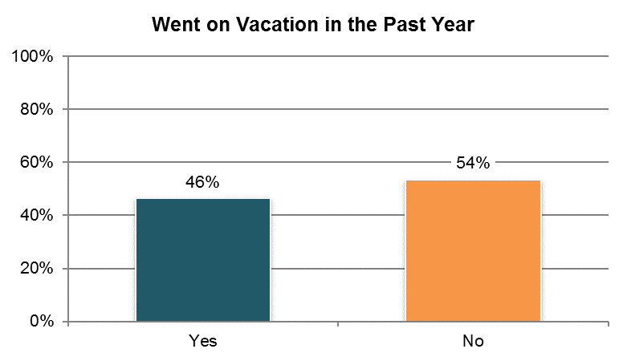

Table . Went on vacation in the past year (proxy responses allowed) ±

|  |  |  |  |  |  |  |
| --- | --- | --- | --- | --- | --- | --- |
| State | Overall in State | N | ICF/IID and Other Institutional Settings | Community-based Group Residential Settings | Own Home | Parent’s or Relative’s Home |
| **Significantly Above Average** | | |  |  |  |  |
| DC | 75% | 363 | 88% | 86% | n/a | 60% |
| WY | 59% | 306 | n/a | 45% | 60% | 74% |
| VT | 58% | 322 | n/a | 33% | 41% | 63% |
| MN | 58% | 403 | 48% | 62% | 51% | 57% |
| ME | 57% | 385 | n/a | 53% | 55% | 59% |
| CO | 55% | 403 | n/a | 42% | 46% | 65% |
| VA | 55% | 800 | 18% | 55% | 46% | 58% |
| UT | 55% | 377 | 16% | 41% | 55% | 71% |
| **Within Average Range** | | |  |  |  |  |
| WA | 53% | 390 | n/a | 40% | 50% | 62% |
| MA | 53% | 395 | n/a | 48% | 55% | 65% |
| CT | 53% | 319 | n/a | 44% | 52% | 63% |
| WI | 52% | 404 | 37% | 57% | 42% | 65% |
| NC | 51% | 728 | 34% | 45% | 46% | 63% |
| IN | 48% | 819 | n/a | n/a | 37% | 51% |
| SD | 48% | 319 | n/a | 41% | 51% | 68% |
| AR | 47% | 371 | 30% | 62% | 49% | 52% |
| KS | 46% | 345 | n/a | 36% | 45% | 64% |
| FL | 46% | 1,413 | n/a | 35% | 45% | 52% |
| IL | 45% | 365 | n/a | 34% | 39% | 63% |
| MS | 45% | 391 | n/a | 44% | 46% | 46% |
| PA | 44% | 657 | 19% | 36% | 32% | 55% |
| OH | 44% | 527 | 31% | 43% | 37% | 55% |
| RI | 43% | 440 | n/a | 39% | 37% | 51% |
| NY | 43% | 477 | 23% | 45% | 34% | 49% |
| LA | 42% | 417 | 29% | n/a | 39% | 51% |
| OK | 42% | 395 | n/a | 28% | 46% | 56% |
| NV | 42% | 371 | n/a | 36% | 44% | 49% |
| **Significantly Below Average** | | |  |  |  |  |
| MO | 39% | 393 | n/a | 37% | 39% | 48% |
| MI | 39% | 426 | n/a | 28% | 43% | 53% |
| AL | 39% | 373 | n/a | 30% | 40% | 53% |
| DE | 36% | 364 | n/a | 35% | 21% | n/a |
| GA | 36% | 419 | n/a | 26% | 28% | 40% |
| HI | 35% | 370 | n/a | 33% | n/a | 44% |
| TN | 33% | 424 | n/a | 31% | 28% | 39% |
| KY | 31% | 417 | n/a | 22% | 22% | 43% |
| AZ | 24% | 470 | n/a | 16% | 36% | 25% |
| NCI Average | 46% | 16,558 | 34% | 41% | 42% | 55% |

±Item changed from previous years – response options changed

Table . Community Inclusion scale score

|  |  |  |  |  |  |  |
| --- | --- | --- | --- | --- | --- | --- |
| State | Overall in State | N | ICF/IID and Other Institutional Settings | Community-based Group Residential Settings | Own Home | Parent’s or Relative’s Home |
| **Significantly Above Average** | | |  |  |  |  |
| KY | 91% | 451 | n/a | 90% | 95% | 92% |
| TN | 91% | 436 | n/a | 92% | 92% | 87% |
| WY | 90% | 315 | n/a | 88% | 90% | 93% |
| RI | 90% | 461 | n/a | 92% | 88% | 91% |
| GA | 90% | 452 | n/a | 90% | 92% | 89% |
| CT | 89% | 331 | 82% | 90% | 92% | 89% |
| IL | 89% | 380 | n/a | 90% | 95% | 86% |
| AZ | 89% | 474 | n/a | 79% | 90% | 93% |
| **Within Average Range** | | |  |  |  |  |
| SD | 89% | 333 | n/a | 89% | 90% | 86% |
| OK | 88% | 398 | n/a | 87% | 94% | 85% |
| MN | 88% | 409 | 85% | 91% | 87% | 88% |
| NV | 88% | 388 | n/a | 89% | 87% | 86% |
| CO | 87% | 405 | n/a | 80% | 93% | 88% |
| DC | 87% | 391 | 84% | 86% | 82% | 88% |
| MO | 87% | 396 | n/a | 84% | 90% | 77% |
| MA | 86% | 414 | n/a | 87% | 90% | 84% |
| WA | 86% | 398 | n/a | 81% | 90% | 87% |
| MI | 85% | 432 | n/a | 81% | 87% | 89% |
| PA | 85% | 678 | 70% | 90% | 84% | 85% |
| OH | 85% | 540 | 73% | 87% | 89% | 87% |
| AL | 85% | 383 | n/a | 84% | 91% | 85% |
| VA | 85% | 814 | 53% | 90% | 84% | 84% |
| NC | 85% | 746 | 75% | 86% | 87% | 88% |
| FL | 84% | 1,430 | n/a | 87% | 87% | 82% |
| VT | 84% | 324 | n/a | 73% | 82% | 86% |
| KS | 84% | 369 | n/a | 83% | 85% | 84% |
| IN | 84% | 821 | n/a | n/a | 84% | 84% |
| UT | 84% | 388 | 54% | 87% | 88% | 84% |
| ME | 83% | 393 | n/a | 83% | 87% | 84% |
| **Significantly Below Average** | | |  |  |  |  |
| WI | 82% | 408 | 75% | 84% | 82% | 84% |
| DE | 82% | 377 | n/a | 81% | 82% | n/a |
| MS | 82% | 400 | n/a | 88% | 84% | 78% |
| AR | 82% | 385 | 65% | 93% | 90% | 79% |
| NY | 82% | 487 | 88% | 81% | 79% | 80% |
| LA | 81% | 426 | 66% | n/a | 91% | 86% |
| HI | 78% | 395 | n/a | 68% | n/a | 83% |
| NCI Average | 86% | 17,028 | 72% | 86% | 88% | 86% |

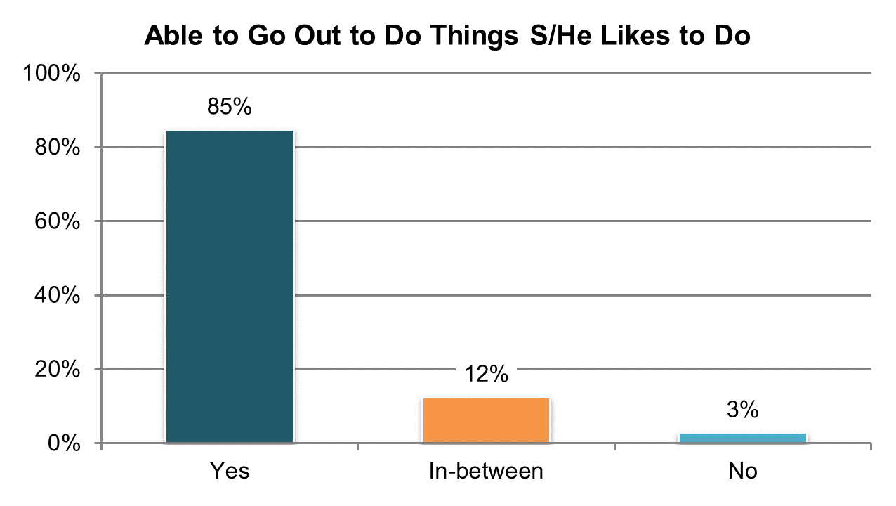

Table . Able to go out and do the things like to do in the community º

|  |  |  |  |  |  |  |
| --- | --- | --- | --- | --- | --- | --- |
| State | Overall in State | N | ICF/IID and Other Institutional Settings | Community-based Group Residential Settings | Own Home | Parent’s or Relative’s Home |
| **Significantly Above Average** | | |  |  |  |  |
| AZ | 93% | 412 | n/a | 87% | 93% | 96% |
| PA | 92% | 432 | 90% | 89% | 92% | 94% |
| IN | 92% | 571 | n/a | n/a | 92% | 92% |
| KY | 92% | 299 | n/a | 85% | 89% | 98% |
| WA | 91% | 257 | n/a | n/a | 90% | 93% |
| AR | 91% | 219 | 89% | 100% | 90% | 90% |
| GA | 90% | 299 | n/a | 91% | 94% | 88% |
| VA | 90% | 499 | 74% | 91% | 89% | 90% |
| **Within Average Range** | | |  |  |  |  |
| CT | 89% | 244 | n/a | 89% | 88% | 93% |
| MN | 89% | 251 | n/a | 90% | 90% | 88% |
| OH | 89% | 386 | 88% | 87% | 90% | 90% |
| TN | 89% | 330 | n/a | 89% | 92% | 86% |
| MA | 88% | 311 | n/a | 89% | 90% | 89% |
| UT | 88% | 243 | n/a | 85% | 93% | 88% |
| DC | 87% | 189 | n/a | 84% | n/a | 90% |
| OK | 86% | 207 | n/a | 85% | 84% | 89% |
| LA | 86% | 287 | 77% | n/a | 88% | 88% |
| HI | 86% | 188 | n/a | 71% | n/a | 90% |
| IL | 85% | 252 | n/a | 85% | 77% | 88% |
| MO | 85% | 265 | n/a | 77% | 88% | 87% |
| NC | 85% | 428 | 85% | 80% | 84% | 89% |
| KS | 84% | 255 | n/a | 79% | 87% | 92% |
| FL | 84% | 836 | n/a | 76% | 85% | 88% |
| NY | 83% | 303 | n/a | 79% | 90% | 83% |
| AL | 83% | 334 | n/a | 81% | 86% | 84% |
| RI | 82% | 340 | n/a | 82% | 83% | 84% |
| SD | 82% | 285 | n/a | 77% | 86% | 88% |
| NV | 81% | 339 | n/a | 78% | 90% | 73% |
| WY | 80% | 237 | n/a | 77% | 84% | 81% |
| ME | 80% | 280 | n/a | 80% | 82% | 78% |
| MS | 79% | 283 | n/a | 79% | 77% | 80% |
| **Significantly Below Average** | | |  |  |  |  |
| CO | 78% | 304 | n/a | 81% | 80% | 73% |
| WI | 78% | 285 | 68% | 77% | 78% | 78% |
| MI | 77% | 273 | n/a | 70% | 81% | 79% |
| DE | 70% | 232 | n/a | 68% | 79% | n/a |
| VT | 65% | 252 | n/a | n/a | 75% | 62% |
| NCI Average | 85% | 11,407 | 82% | 82% | 86% | 86% |

ºNew variable to reporting

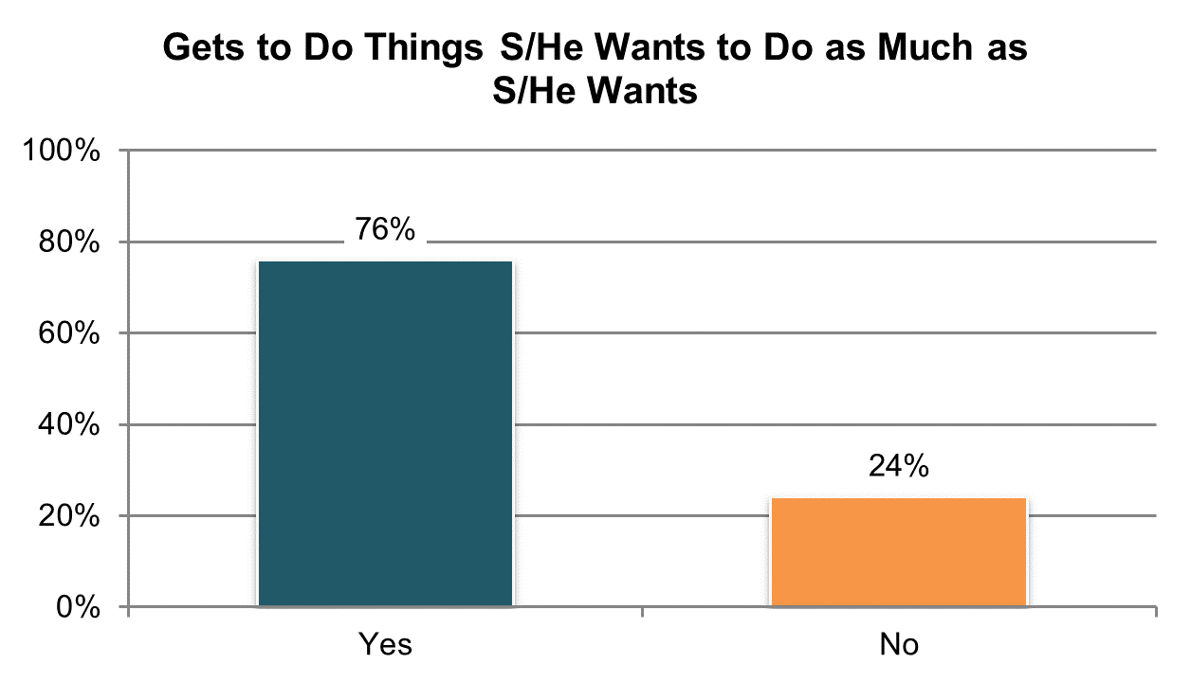

Table . Able to go out and do the things likes to do in the community as often as wants to º

|  |  |  |  |  |  |  |
| --- | --- | --- | --- | --- | --- | --- |
| State | Overall in State | N | ICF/IID and Other Institutional Settings | Community-based Group Residential Settings | Own Home | Parent’s or Relative’s Home |
| **Significantly Above Average** | | |  |  |  |  |
| AZ | 92% | 400 | n/a | 89% | 81% | 96% |
| KY | 91% | 287 | n/a | 83% | 90% | 96% |
| PA | 87% | 398 | n/a | 86% | 88% | 86% |
| GA | 86% | 277 | n/a | 75% | 95% | 87% |
| TN | 85% | 314 | n/a | 85% | 89% | 81% |
| WA | 85% | 248 | n/a | n/a | 83% | 86% |
| **Within Average Range** | | |  |  |  |  |
| KS | 83% | 233 | n/a | 84% | 77% | 95% |
| CT | 83% | 219 | n/a | 79% | 90% | 83% |
| UT | 81% | 224 | n/a | 80% | 79% | 83% |
| VA | 80% | 469 | 80% | 78% | 79% | 81% |
| MN | 80% | 241 | n/a | 77% | 87% | 86% |
| IL | 80% | 214 | n/a | 80% | 74% | 80% |
| MA | 79% | 279 | n/a | 77% | 87% | 78% |
| LA | 79% | 260 | 70% | n/a | 81% | 81% |
| FL | 79% | 791 | n/a | 72% | 75% | 83% |
| IN | 78% | 526 | n/a | n/a | 71% | 80% |
| OH | 77% | 364 | 83% | 81% | 72% | 76% |
| NY | 77% | 281 | n/a | 76% | 69% | 80% |
| MO | 76% | 250 | n/a | 74% | 75% | 90% |
| DC | 76% | 182 | n/a | 74% | n/a | 87% |
| RI | 76% | 309 | n/a | 79% | 70% | 81% |
| NC | 76% | 402 | 72% | 73% | 63% | 83% |
| OK | 76% | 192 | n/a | 74% | 79% | 76% |
| MS | 75% | 261 | n/a | 82% | 71% | 73% |
| NV | 74% | 310 | n/a | 74% | 77% | 64% |
| AR | 73% | 211 | 67% | 60% | 73% | 79% |
| WY | 73% | 201 | n/a | 74% | 78% | 71% |
| CO | 73% | 282 | n/a | 74% | 64% | 67% |
| HI | 72% | 148 | n/a | n/a | n/a | 83% |
| MI | 70% | 250 | n/a | 69% | 74% | 67% |
| SD | 69% | 267 | n/a | 63% | 71% | 71% |
| **Significantly Below Average** | | |  |  |  |  |
| WI | 63% | 257 | n/a | 69% | 69% | 54% |
| DE | 62% | 201 | n/a | 62% | 72% | n/a |
| AL | 59% | 319 | n/a | 66% | 36% | 59% |
| VT | 56% | 228 | n/a | n/a | 61% | 58% |
| ME | 54% | 258 | n/a | 56% | 60% | 51% |
| NCI Average | 76% | 10,553 | 74% | 75% | 75% | 78% |

ºNew variable to reporting

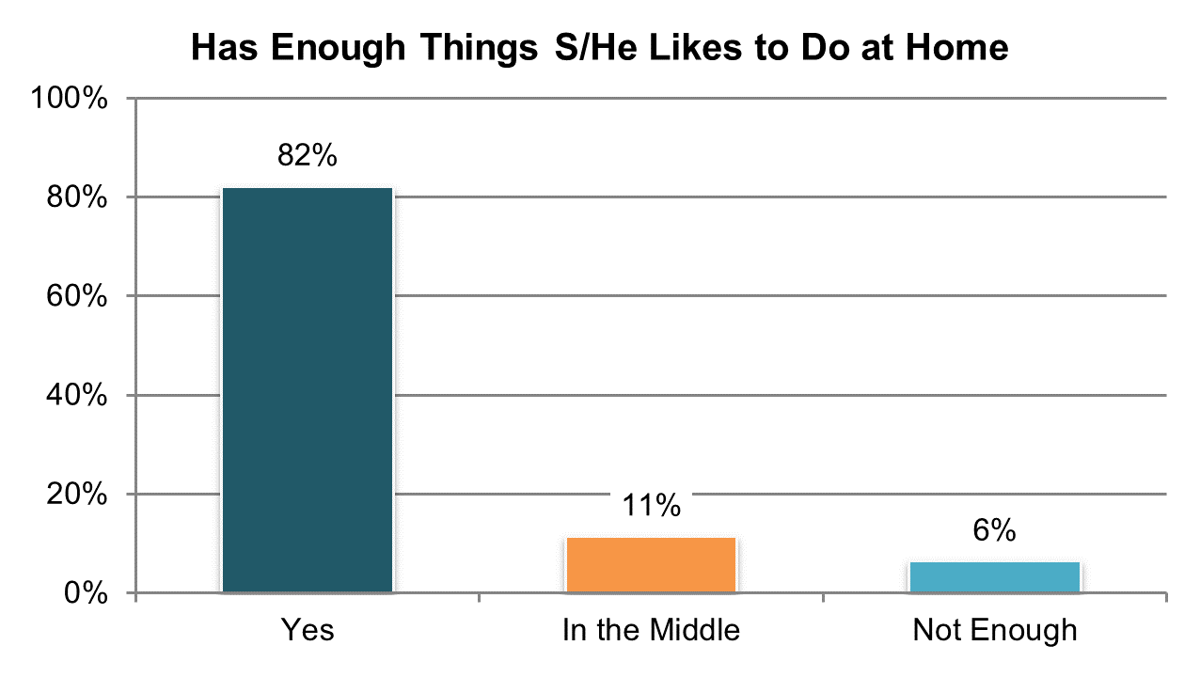

Table . Has enough things they like to do when at home º

|  |  |  |  |  |  |  |
| --- | --- | --- | --- | --- | --- | --- |
| State | Overall in State | N | ICF/IID and Other Institutional Settings | Community-based Group Residential Settings | Own Home | Parent’s or Relative’s Home |
| **Significantly Above Average** | | |  |  |  |  |
| AZ | 96% | 418 | n/a | 92% | 93% | 98% |
| IN | 92% | 574 | n/a | n/a | 89% | 93% |
| WA | 92% | 264 | n/a | n/a | 92% | 92% |
| TN | 91% | 333 | n/a | 92% | 88% | 93% |
| PA | 91% | 434 | 90% | 93% | 89% | 91% |
| WI | 90% | 290 | 84% | 84% | 92% | 92% |
| MN | 89% | 254 | n/a | 88% | 86% | 93% |
| KY | 89% | 299 | n/a | 78% | 91% | 95% |
| IL | 88% | 260 | n/a | 85% | 84% | 92% |
| VA | 87% | 501 | 78% | 87% | 89% | 89% |
| **Within Average Range** | | |  |  |  |  |
| CO | 87% | 307 | n/a | 92% | 84% | 88% |
| MO | 86% | 265 | n/a | 90% | 85% | 77% |
| GA | 85% | 303 | n/a | 77% | 93% | 83% |
| NC | 85% | 432 | 75% | 85% | 83% | 87% |
| CT | 84% | 244 | n/a | 86% | 84% | 82% |
| FL | 84% | 837 | n/a | 76% | 85% | 88% |
| OH | 84% | 391 | 81% | 76% | 82% | 89% |
| UT | 84% | 243 | n/a | 85% | 79% | 83% |
| SD | 83% | 284 | n/a | 82% | 85% | 77% |
| MA | 83% | 304 | n/a | 83% | 82% | 83% |
| AR | 83% | 223 | 75% | 88% | 84% | 81% |
| LA | 82% | 289 | 74% | n/a | 85% | 85% |
| NY | 81% | 307 | n/a | 80% | 81% | 81% |
| KS | 81% | 256 | n/a | 73% | 82% | 93% |
| RI | 80% | 349 | n/a | 90% | 75% | 75% |
| WY | 79% | 234 | n/a | 71% | 81% | 91% |
| OK | 79% | 210 | n/a | 81% | 76% | 78% |
| DC | 78% | 190 | n/a | 82% | n/a | 79% |
| MI | 78% | 278 | n/a | 73% | 79% | 81% |
| AL | 77% | 328 | n/a | 78% | 74% | 77% |
| **Significantly Below Average** | | |  |  |  |  |
| NV | 72% | 346 | n/a | 70% | 69% | 84% |
| MS | 71% | 290 | n/a | 63% | 68% | 80% |
| HI | 71% | 193 | n/a | 54% | n/a | 75% |
| VT | 69% | 262 | n/a | n/a | 65% | 67% |
| ME | 66% | 284 | n/a | 63% | 65% | 67% |
| DE | 62% | 238 | n/a | 60% | 63% | n/a |
| NCI Average | 82% | 11,514 | 80% | 80% | 82% | 85% |

ºNew variable to reporting

## Relationships

### People have friends and relationships.

There are seven Relationship indicators:

1. Proportion of people who reported they have friends who are not staff or family members
2. Proportion of people who reported they can see or communicate with their family when they want
3. Proportion of people who reported they have friends (may be staff or family) and the support needed to see their friends when they want
4. Proportion of people who want more help to keep in contact with friends
5. Proportion of people who reported they had other ways of communicating with friends (e.g., over the phone, via email)
6. Proportion of people who reported they can go on a date if they want or can date with some restriction
7. Proportion of people who reported they feel lonely at least half the time

In addition, NCI collects information as to why people cannot see their friends when they want. Tables 71 through 78 present the results for these seven core indicators. The corresponding charts show un-collapsed averages.

All un-collapsed state data frequencies for these survey questions are displayed in Appendix D.

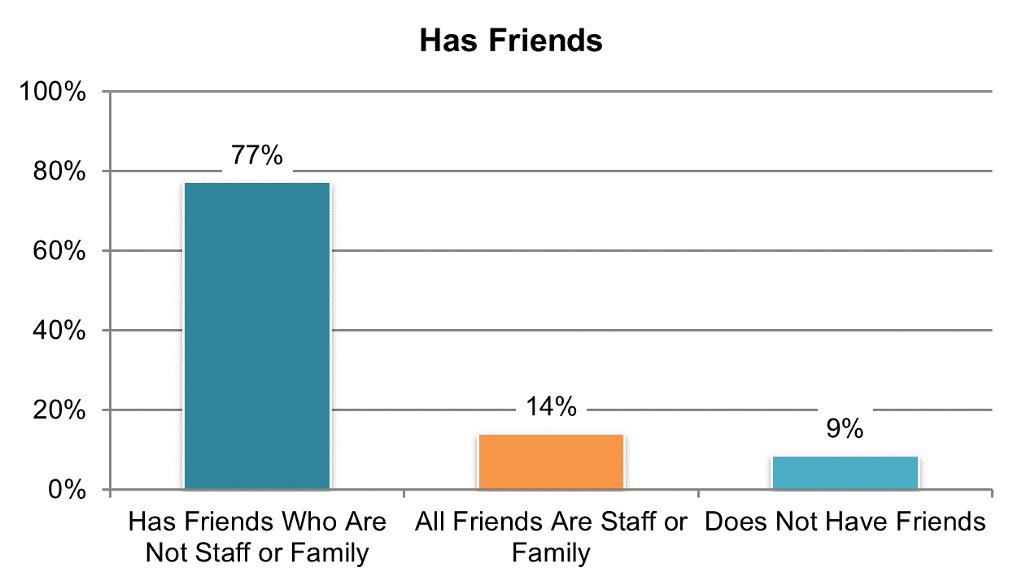

Table . Has friends who are not staff or family members (‘yes’ responses only)

|  |  |  |  |  |  |  |
| --- | --- | --- | --- | --- | --- | --- |
| State | Overall in State | N | ICF/IID and Other Institutional Settings | Community-based Group Residential Settings | Own Home | Parent’s or Relative’s Home |
| **Significantly Above Average** | | |  |  |  |  |
| AL | 89% | 331 | n/a | 90% | 90% | 88% |
| ME | 88% | 285 | n/a | 87% | 90% | 89% |
| TN | 87% | 331 | n/a | 91% | 89% | 80% |
| IN | 87% | 575 | n/a | n/a | 87% | 86% |
| GA | 84% | 307 | n/a | 74% | 88% | 85% |
| **Within Average Range** | | |  |  |  |  |
| MN | 83% | 246 | n/a | 82% | 87% | 88% |
| SD | 83% | 281 | n/a | 81% | 83% | 87% |
| WY | 83% | 233 | n/a | 84% | 83% | 81% |
| WA | 83% | 262 | n/a | n/a | 85% | 81% |
| IL | 82% | 260 | n/a | 79% | 97% | 80% |
| MA | 82% | 309 | n/a | 81% | 88% | 80% |
| VA | 82% | 500 | 76% | 82% | 83% | 83% |
| MS | 81% | 290 | n/a | 79% | 84% | 81% |
| LA | 81% | 292 | 79% | n/a | 86% | 78% |
| DC | 81% | 192 | n/a | 83% | n/a | 83% |
| MO | 81% | 267 | n/a | 79% | 82% | 74% |
| WI | 80% | 291 | 80% | 72% | 86% | 73% |
| OH | 79% | 392 | 74% | 82% | 82% | 77% |
| CO | 78% | 304 | n/a | 82% | 79% | 79% |
| AR | 78% | 221 | 70% | 88% | 78% | 72% |
| FL | 77% | 852 | n/a | 73% | 84% | 74% |
| RI | 75% | 352 | n/a | 71% | 85% | 84% |
| KS | 74% | 258 | n/a | 67% | 86% | 75% |
| CT | 74% | 245 | n/a | 74% | 82% | 72% |
| PA | 74% | 438 | 95% | 69% | 73% | 74% |
| OK | 73% | 212 | n/a | 72% | 68% | 82% |
| NY | 71% | 312 | n/a | 63% | 75% | 80% |
| NV | 71% | 345 | n/a | 73% | 65% | 76% |
| VT | 71% | 268 | n/a | n/a | 71% | 73% |
| MI | 70% | 282 | n/a | 57% | 79% | 74% |
| UT | 70% | 239 | n/a | 71% | 68% | 70% |
| **Significantly Below Average** | | |  |  |  |  |
| NC | 69% | 438 | 62% | 67% | 75% | 71% |
| DE | 68% | 253 | n/a | 68% | 79% | n/a |
| HI | 67% | 196 | n/a | 64% | n/a | 76% |
| AZ | 67% | 422 | n/a | 67% | 67% | 68% |
| KY | 60% | 300 | n/a | 46% | 77% | 70% |
| NCI Average | 77% | 11,581 | 77% | 75% | 81% | 78% |

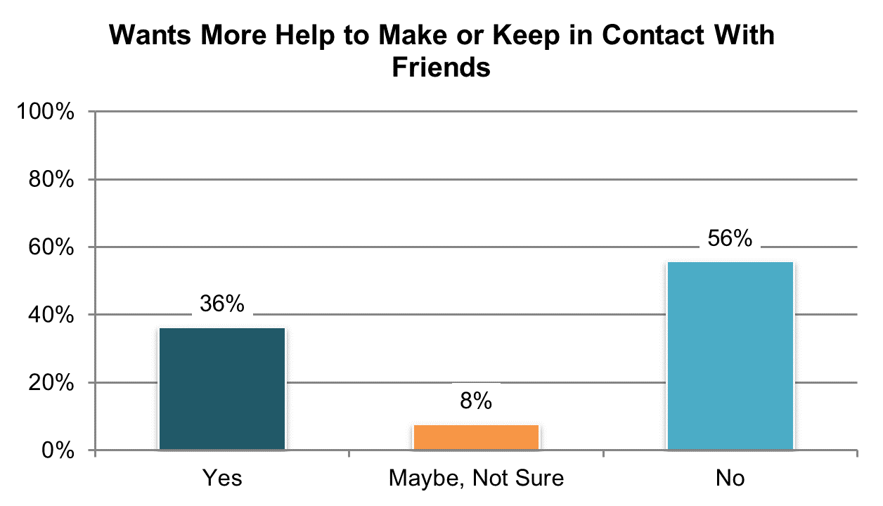

Table . Wants help to make or keep in contact with friends (‘yes’ and ‘maybe, not sure’ responses) º

|  |  |  |  |  |  |  |
| --- | --- | --- | --- | --- | --- | --- |
| State | Overall in State | N | ICF/IID and Other Institutional Settings | Community-based Group Residential Settings | Own Home | Parent’s or Relative’s Home |
| **Significantly Above Average** | | |  |  |  |  |
| OK | 72% | 195 | n/a | 78% | 66% | 67% |
| NV | 65% | 333 | n/a | 75% | 53% | 63% |
| AL | 61% | 327 | n/a | 58% | 67% | 63% |
| RI | 59% | 331 | n/a | 69% | 47% | 61% |
| UT | 57% | 220 | n/a | 63% | 38% | 59% |
| MA | 55% | 286 | n/a | 63% | 33% | 56% |
| SD | 53% | 270 | n/a | 56% | 46% | 63% |
| **Within Average Range** | | |  |  |  |  |
| CT | 53% | 239 | n/a | 57% | 50% | 52% |
| CO | 51% | 295 | n/a | 59% | 36% | 58% |
| DE | 49% | 220 | n/a | 53% | 32% | n/a |
| MN | 47% | 241 | n/a | 51% | 32% | 55% |
| HI | 47% | 185 | n/a | 54% | n/a | 49% |
| LA | 47% | 288 | 42% | n/a | 48% | 48% |
| MI | 47% | 271 | n/a | 63% | 33% | 42% |
| VT | 46% | 242 | n/a | n/a | 41% | 48% |
| VA | 46% | 470 | 45% | 52% | 26% | 47% |
| FL | 46% | 800 | n/a | 55% | 40% | 45% |
| DC | 46% | 180 | n/a | 45% | n/a | 46% |
| MO | 45% | 233 | n/a | 41% | 46% | n/a |
| AR | 45% | 216 | 65% | 52% | 34% | 50% |
| MS | 44% | 280 | n/a | 52% | 42% | 39% |
| GA | 43% | 282 | n/a | 66% | 35% | 38% |
| OH | 41% | 374 | 47% | 45% | 42% | 38% |
| NY | 41% | 296 | n/a | 47% | 22% | 47% |
| IN | 41% | 529 | n/a | n/a | 33% | 44% |
| ME | 41% | 270 | n/a | 46% | 27% | 33% |
| KS | 40% | 240 | n/a | 39% | 35% | 50% |
| NC | 39% | 413 | 34% | 41% | 32% | 38% |
| **Significantly Below Average** | | |  |  |  |  |
| WI | 34% | 274 | 52% | 50% | 26% | 32% |
| WA | 34% | 255 | n/a | n/a | 31% | 30% |
| IL | 31% | 251 | n/a | 33% | 17% | 33% |
| WY | 30% | 225 | n/a | 39% | 20% | 32% |
| PA | 28% | 388 | n/a | 34% | 22% | 25% |
| TN | 27% | 328 | n/a | 32% | 23% | 25% |
| KY | 24% | 293 | n/a | 31% | 14% | 25% |
| AZ | 16% | 418 | n/a | 17% | 23% | 13% |
| NCI Average | 44% | 10,958 | 48% | 50% | 36% | 45% |

ºNew variable to reporting

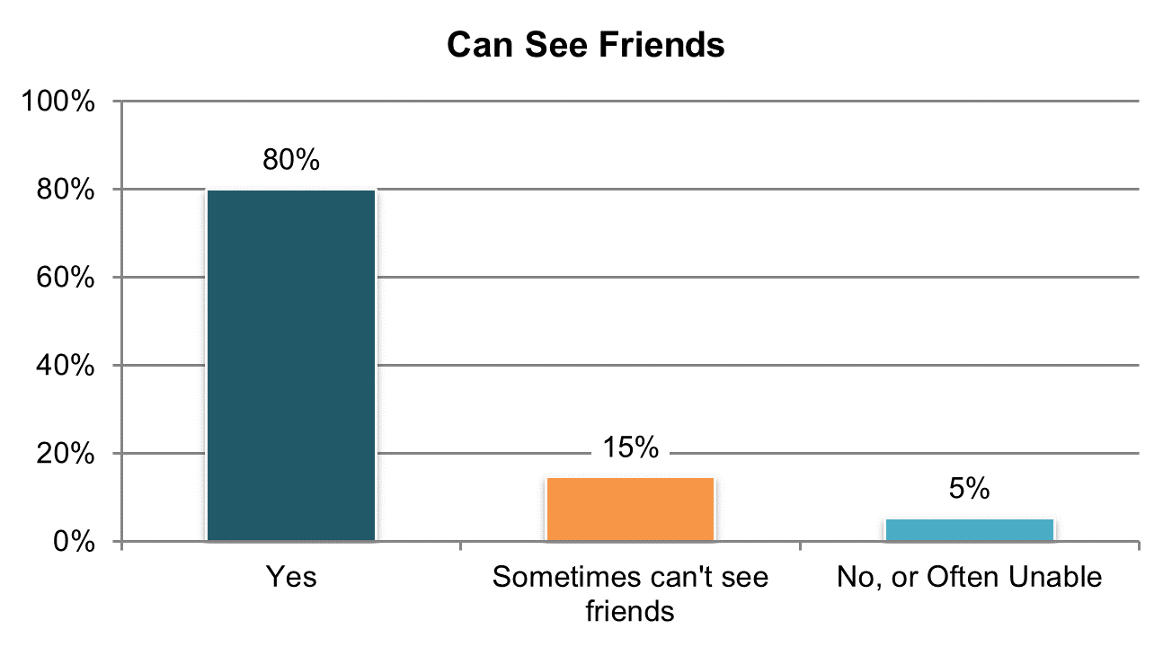

Table . Has friends (may be staff or family) and the support needed to see friends when they want (‘yes’ responses only)

|  |  |  |  |  |  |  |
| --- | --- | --- | --- | --- | --- | --- |
| State | Overall in State | N | ICF/IID and Other Institutional Settings | Community-based Group Residential Settings | Own Home | Parent’s or Relative’s Home |
| **Significantly Above Average** | | |  |  |  |  |
| KS | 90% | 242 | n/a | 92% | 89% | 89% |
| AZ | 90% | 397 | n/a | 88% | 86% | 91% |
| TN | 89% | 328 | n/a | 92% | 89% | 89% |
| AR | 89% | 196 | 91% | 96% | 88% | 89% |
| PA | 89% | 368 | n/a | 89% | 93% | 90% |
| KY | 88% | 285 | n/a | 79% | 93% | 92% |
| VA | 85% | 445 | 77% | 84% | 84% | 88% |
| **Within Average Range** | | |  |  |  |  |
| SD | 84% | 273 | n/a | 87% | 86% | 75% |
| MS | 84% | 269 | n/a | 81% | 81% | 88% |
| LA | 83% | 262 | 82% | n/a | 89% | 80% |
| UT | 83% | 220 | n/a | 78% | 93% | 80% |
| NY | 83% | 253 | n/a | 85% | 89% | 79% |
| IL | 82% | 221 | n/a | 81% | 90% | 82% |
| WA | 82% | 243 | n/a | n/a | 80% | 85% |
| MA | 82% | 282 | n/a | 79% | 92% | 80% |
| OH | 82% | 355 | 80% | 81% | 84% | 82% |
| MO | 82% | 233 | n/a | 82% | 81% | n/a |
| WY | 82% | 212 | n/a | 75% | 87% | 81% |
| NC | 81% | 372 | 97% | 81% | 78% | 79% |
| HI | 80% | 166 | n/a | 68% | n/a | 85% |
| IN | 80% | 523 | n/a | n/a | 81% | 79% |
| GA | 79% | 280 | n/a | 73% | 86% | 79% |
| WI | 79% | 250 | 70% | 93% | 81% | 74% |
| FL | 79% | 760 | n/a | 74% | 86% | 76% |
| RI | 78% | 317 | n/a | 82% | 75% | 88% |
| MI | 78% | 246 | n/a | 75% | 89% | 73% |
| DC | 77% | 168 | n/a | 81% | n/a | 80% |
| MN | 77% | 237 | n/a | 76% | 77% | 78% |
| OK | 77% | 188 | n/a | 80% | 79% | 69% |
| CT | 76% | 234 | n/a | 77% | 76% | 76% |
| NV | 76% | 303 | n/a | 72% | 84% | 67% |
| AL | 74% | 316 | n/a | 71% | 80% | 75% |
| CO | 72% | 259 | n/a | 73% | 81% | 63% |
| DE | 72% | 220 | n/a | 71% | 77% | n/a |
| **Significantly Below Average** | | |  |  |  |  |
| VT | 58% | 215 | n/a | n/a | 69% | 65% |
| ME | 57% | 236 | n/a | 63% | 52% | 52% |
| NCI Average | 80% | 10,374 | 83% | 80% | 83% | 79% |

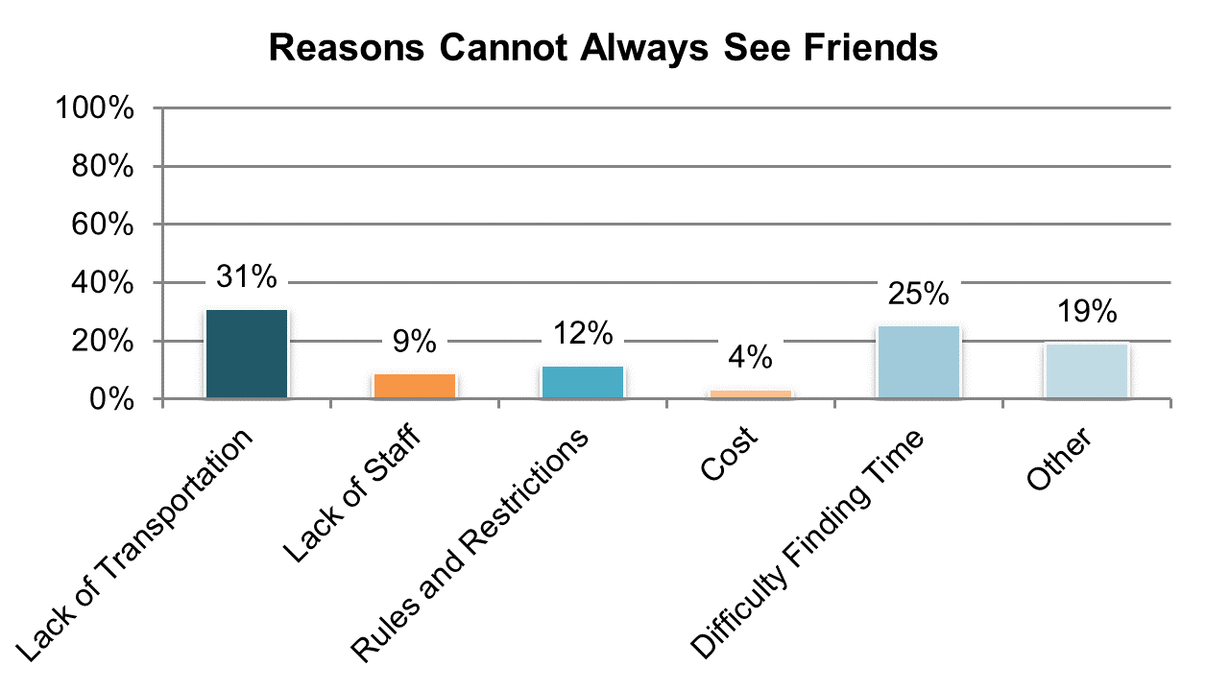

Table . Reasons cannot always see friends º

|  |  |  |  |  |  |  |
| --- | --- | --- | --- | --- | --- | --- |
| State | Lack of Transportation | Lack of Support Staff | Rules or Restrictions About Seeing Friends | Money/Cost of Going Out | Difficulty Finding a Good Time to Get Together | Other |
| AL | 55% | 1% | 7% | 3% | 32% | 3% |
| AZ | 32% | 6% | 32% | 3% | 6% | 21% |
| CO | 15% | 6% | 12% | 1% | 51% | 15% |
| CT | 27% | 24% | 16% | 2% | 9% | 22% |
| DC | 48% | 19% | 15% | 7% | 11% | 0% |
| DE | 20% | 12% | 27% | 2% | 31% | 8% |
| FL | 34% | 9% | 7% | 9% | 29% | 13% |
| GA | 58% | 13% | 6% | 4% | 15% | 4% |
| HI | 33% | n/a | 7% | n/a | 4% | 56% |
| IL | 39% | 13% | 9% | 9% | 9% | 22% |
| IN | 22% | 2% | 3% | n/a | 57% | 15% |
| KY | 45% | 7% | 31% | 3% | 10% | 3% |
| LA | 16% | 9% | 14% | n/a | 23% | 39% |
| MA | 24% | 16% | 11% | 2% | 27% | 20% |
| ME | 35% | 10% | 4% | 1% | 26% | 23% |
| MI | 49% | 2% | 15% | 5% | 12% | 17% |
| MN | 34% | 8% | 6% | 6% | 34% | 12% |
| MO | 11% | 17% | 25% | 11% | 19% | 17% |
| MS | 34% | 5% | 3% | 3% | 34% | 21% |
| NC | 42% | 6% | 8% | 3% | 12% | 29% |
| NV | 28% | 4% | 14% | 5% | 28% | 20% |
| NY | 32% | 14% | 11% | 3% | 27% | 14% |
| OH | 36% | 9% | 7% | 2% | 26% | 21% |
| OK | 18% | n/a | 15% | 3% | 21% | 44% |
| PA | 25% | 14% | 8% | 3% | 11% | 39% |
| RI | 23% | 13% | 8% | 2% | 34% | 20% |
| SD | 30% | 19% | 16% | 8% | 14% | 14% |
| TN | 12% | 6% | 9% | 3% | 48% | 21% |
| UT | 29% | 9% | 17% | 3% | 26% | 17% |
| VA | 41% | 8% | 6% | 4% | 31% | 10% |
| VT | 35% | 1% | 2% | 1% | 49% | 11% |
| WA | 19% | 7% | 9% | 2% | 47% | 16% |
| WI | 40% | 4% | n/a | 4% | 32% | 20% |
| WY | 19% | 13% | 19% | 3% | 16% | 31% |
| AR | n/a | n/a | n/a | n/a | n/a | n/a |
| KS | n/a | n/a | n/a | n/a | n/a | n/a |
| NCI Average | 31% | 9% | 12% | 4% | 25% | 19% |

ºNew variable to reporting

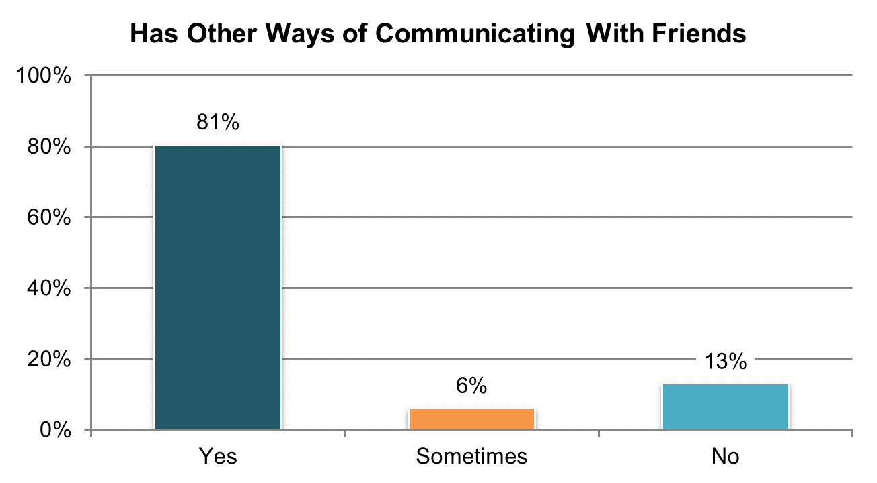

Table . Has other ways to communicate with friends when cannot see them (‘yes’ responses only) º

|  |  |  |  |  |  |  |
| --- | --- | --- | --- | --- | --- | --- |
| State | Overall in State | N | ICF/IID and Other Institutional Settings | Community-based Group Residential Settings | Own Home | Parent’s or Relative’s Home |
| **Significantly Above Average** | | |  |  |  |  |
| WA | 90% | 231 | n/a | n/a | 93% | 89% |
| LA | 89% | 235 | 83% | n/a | 92% | 90% |
| SD | 88% | 267 | n/a | 77% | 98% | 89% |
| WY | 88% | 208 | n/a | 83% | 91% | 88% |
| MO | 87% | 205 | n/a | 85% | 88% | n/a |
| **Within Average Range** | | |  |  |  |  |
| MA | 86% | 269 | n/a | 85% | 93% | 84% |
| AR | 85% | 196 | 78% | 91% | 88% | 78% |
| OK | 85% | 189 | n/a | 83% | 90% | 83% |
| MS | 85% | 270 | n/a | 88% | 88% | 76% |
| NV | 84% | 299 | n/a | 82% | 89% | 81% |
| DC | 84% | 169 | n/a | 83% | n/a | 88% |
| GA | 84% | 269 | n/a | 80% | 90% | 83% |
| WI | 84% | 243 | n/a | 84% | 91% | 82% |
| FL | 83% | 762 | n/a | 74% | 92% | 82% |
| TN | 82% | 316 | n/a | 93% | 83% | 67% |
| MN | 82% | 237 | n/a | 79% | 95% | 82% |
| OH | 82% | 355 | 79% | 81% | 83% | 80% |
| CT | 81% | 220 | n/a | 77% | 85% | 84% |
| KS | 81% | 233 | n/a | 81% | 83% | 79% |
| PA | 81% | 320 | n/a | 80% | 87% | 78% |
| IL | 81% | 211 | n/a | 79% | 92% | 78% |
| UT | 80% | 212 | n/a | 79% | 97% | 75% |
| DE | 80% | 219 | n/a | 80% | 88% | n/a |
| NC | 79% | 357 | 81% | 77% | 93% | 79% |
| VA | 79% | 441 | 87% | 78% | 85% | 77% |
| IN | 78% | 503 | n/a | n/a | 88% | 76% |
| ME | 78% | 247 | n/a | 72% | 87% | 89% |
| AL | 78% | 309 | n/a | 76% | 85% | 78% |
| AZ | 78% | 393 | n/a | 68% | 79% | 81% |
| RI | 78% | 308 | n/a | 81% | 85% | 79% |
| MI | 76% | 244 | n/a | 69% | 87% | 75% |
| NY | 75% | 236 | n/a | 68% | 88% | 78% |
| CO | 75% | 264 | n/a | 74% | 90% | 69% |
| **Significantly Below Average** | | |  |  |  |  |
| KY | 69% | 145 | n/a | 65% | n/a | 73% |
| VT | 67% | 208 | n/a | n/a | 80% | 73% |
| HI | 62% | 156 | n/a | 55% | n/a | 66% |
| NCI Average | 81% | 9,946 | 82% | 78% | 89% | 80% |

ºNew variable to reporting

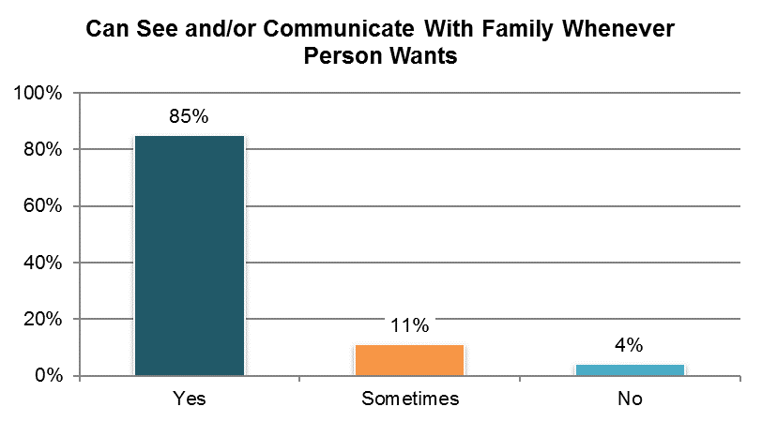

Table . Can see and communicate with their family whenever they want (‘yes’ responses only) ±

|  |  |  |  |  |  |  |
| --- | --- | --- | --- | --- | --- | --- |
| State | Overall in State | N | ICF/IID and Other Institutional Settings | Community-based Group Residential Settings | Own Home | Parent’s or Relative’s Home |
| **Significantly Above Average** | | |  |  |  |  |
| AZ | 96% | 413 | n/a | 89% | 93% | 98% |
| MN | 94% | 238 | n/a | 93% | 96% | 94% |
| PA | 93% | 353 | n/a | 90% | 95% | 96% |
| WA | 93% | 250 | n/a | n/a | 88% | 97% |
| KS | 93% | 244 | n/a | 92% | 90% | 100% |
| IN | 92% | 567 | n/a | n/a | 86% | 96% |
| OH | 91% | 367 | 89% | 79% | 88% | 97% |
| TN | 90% | 309 | n/a | 87% | 90% | 100% |
| **Within Average Range** | | |  |  |  |  |
| HI | 90% | 190 | n/a | 75% | n/a | 98% |
| CT | 90% | 229 | n/a | 89% | 89% | 93% |
| GA | 90% | 290 | n/a | 73% | 97% | 93% |
| MA | 89% | 288 | n/a | 86% | 94% | 93% |
| NV | 88% | 323 | n/a | 86% | 88% | 100% |
| AR | 88% | 212 | 83% | 96% | 84% | 90% |
| WI | 88% | 278 | 77% | 85% | 84% | 95% |
| MI | 87% | 268 | n/a | 74% | 85% | 97% |
| RI | 86% | 322 | n/a | 86% | 83% | 93% |
| MS | 86% | 278 | n/a | 80% | 86% | 91% |
| LA | 86% | 284 | 69% | n/a | 86% | 94% |
| UT | 86% | 237 | n/a | 81% | 82% | 92% |
| VA | 86% | 464 | 94% | 80% | 76% | 94% |
| IL | 85% | 241 | n/a | 79% | 84% | 94% |
| OK | 85% | 200 | n/a | 79% | 88% | 96% |
| SD | 85% | 280 | n/a | 86% | 86% | 88% |
| FL | 84% | 803 | n/a | 73% | 78% | 93% |
| WY | 84% | 231 | n/a | 74% | 89% | 93% |
| MO | 84% | 244 | n/a | 86% | 81% | 100% |
| CO | 83% | 277 | n/a | 85% | 82% | 91% |
| NC | 82% | 418 | 95% | 76% | 83% | 87% |
| DC | 80% | 168 | n/a | 72% | n/a | 90% |
| DE | 79% | 222 | n/a | 77% | 96% | n/a |
| NY | 79% | 282 | n/a | 69% | 81% | 90% |
| **Significantly Below Average** | | |  |  |  |  |
| KY | 75% | 298 | n/a | 59% | 82% | 95% |
| AL | 73% | 323 | n/a | 61% | 86% | 83% |
| VT | 70% | 246 | n/a | n/a | 84% | 84% |
| ME | 61% | 237 | n/a | 51% | 72% | 88% |
| NCI Average | 85% | 10,874 | 84% | 80% | 86% | 94% |

±Item changed from previous years – question rephrased see Appendix A

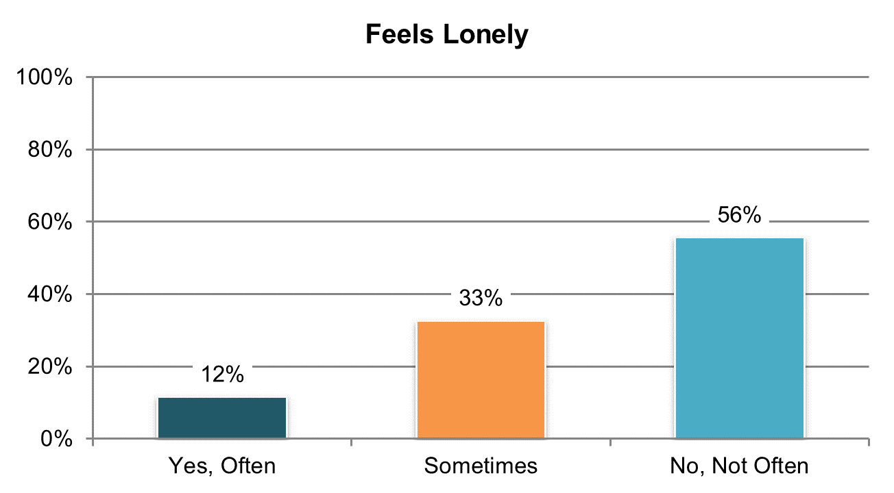

Table . Feels lonely (‘yes, often’ responses only) ±

|  |  |  |  |  |  |  |
| --- | --- | --- | --- | --- | --- | --- |
| State | Overall in State | N | ICF/IID and Other Institutional Settings | Community-based Group Residential Settings | Own Home | Parent’s or Relative’s Home |
| **Significantly Above Average** | | |  |  |  |  |
| DE | 19% | 243 | n/a | 19% | 25% | n/a |
| **Within Average Range** | | |  |  |  |  |
| KS | 18% | 262 | n/a | 17% | 16% | 17% |
| NV | 17% | 339 | n/a | 17% | 16% | 16% |
| UT | 16% | 231 | n/a | 19% | 20% | 11% |
| AR | 16% | 223 | 36% | 28% | 8% | 15% |
| CO | 16% | 302 | n/a | 11% | 23% | 16% |
| ME | 16% | 273 | n/a | 17% | 10% | 16% |
| HI | 15% | 188 | n/a | 16% | n/a | 16% |
| WI | 15% | 282 | 13% | 19% | 14% | 12% |
| AL | 14% | 326 | n/a | 15% | 10% | 14% |
| RI | 14% | 339 | n/a | 11% | 17% | 19% |
| WY | 14% | 233 | n/a | 14% | 14% | 17% |
| MS | 14% | 286 | n/a | 13% | 14% | 13% |
| MA | 13% | 293 | n/a | 16% | 16% | 9% |
| SD | 13% | 276 | n/a | 17% | 9% | 10% |
| IN | 12% | 563 | n/a | n/a | 13% | 12% |
| IL | 12% | 250 | n/a | 9% | 3% | 17% |
| MI | 12% | 277 | n/a | 14% | 10% | 9% |
| DC | 12% | 191 | n/a | 14% | n/a | 6% |
| MN | 11% | 252 | n/a | 14% | 10% | 9% |
| WA | 11% | 257 | n/a | n/a | 10% | 11% |
| OH | 11% | 382 | 27% | 9% | 16% | 5% |
| OK | 11% | 209 | n/a | 10% | 15% | 7% |
| VT | 10% | 259 | n/a | n/a | 19% | 8% |
| NC | 10% | 430 | 5% | 11% | 12% | 9% |
| NY | 9% | 307 | n/a | 8% | 16% | 6% |
| MO | 9% | 259 | n/a | 8% | 10% | n/a |
| CT | 9% | 244 | n/a | 11% | 2% | 7% |
| VA | 8% | 472 | 6% | 11% | 6% | 7% |
| **Significantly Below Average** | | |  |  |  |  |
| FL | 8% | 824 | n/a | 11% | 9% | 5% |
| LA | 7% | 285 | 9% | n/a | 7% | 5% |
| TN | 7% | 331 | n/a | 11% | 6% | 1% |
| GA | 6% | 297 | n/a | 10% | 9% | 3% |
| PA | 6% | 418 | 0% | 9% | 10% | 3% |
| KY | 5% | 298 | n/a | 4% | 0% | 7% |
| AZ | 5% | 415 | n/a | 10% | 2% | 4% |
| NCI Average | 12% | 11,316 | 14% | 13% | 12% | 10% |

±Item changed from previous years – analysis now only includes “often” response (see Appendix A)

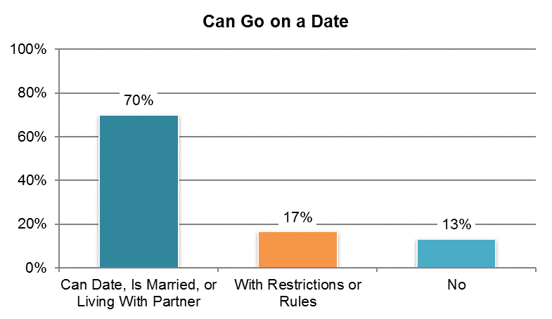

Table . Can go on a date if they want or can date with some restriction (‘yes, can date’ or ‘is married or living with partner’ responses only)

|  |  |  |  |  |  |  |
| --- | --- | --- | --- | --- | --- | --- |
| State | Overall in State | N | ICF/IID and Other Institutional Settings | Community-based Group Residential Settings | Own Home | Parent’s or Relative’s Home |
| **Significantly Above Average** | | |  |  |  |  |
| VT | 88% | 197 | n/a | n/a | 93% | 84% |
| WA | 87% | 184 | n/a | n/a | 85% | 88% |
| TN | 85% | 253 | n/a | 90% | 88% | 80% |
| KS | 85% | 235 | n/a | 83% | 92% | 84% |
| GA | 82% | 267 | n/a | 70% | 92% | 83% |
| WI | 82% | 208 | n/a | 70% | 89% | 83% |
| SD | 80% | 255 | n/a | 77% | 91% | 69% |
| AL | 79% | 312 | n/a | 81% | 85% | 74% |
| FL | 79% | 639 | n/a | 66% | 96% | 75% |
| OH | 79% | 328 | 63% | 86% | 89% | 71% |
| **Within Average Range** | | |  |  |  |  |
| MO | 77% | 202 | n/a | 74% | 79% | n/a |
| MA | 77% | 252 | n/a | 70% | 96% | 72% |
| MI | 76% | 230 | n/a | 69% | 91% | 72% |
| ME | 74% | 199 | n/a | 74% | 87% | 74% |
| UT | 74% | 210 | n/a | 72% | 88% | 68% |
| CO | 74% | 243 | n/a | 94% | 91% | 66% |
| AR | 73% | 182 | 78% | 77% | 80% | 53% |
| PA | 72% | 320 | n/a | 68% | 91% | 69% |
| WY | 72% | 213 | n/a | 71% | 80% | 70% |
| IN | 71% | 461 | n/a | n/a | 83% | 66% |
| NV | 71% | 312 | n/a | 70% | 78% | 56% |
| MN | 70% | 199 | n/a | 66% | 95% | 62% |
| MS | 70% | 198 | n/a | 67% | 72% | 64% |
| NY | 69% | 213 | n/a | 54% | 93% | 67% |
| RI | 68% | 302 | n/a | 71% | 77% | 57% |
| LA | 68% | 227 | 71% | n/a | 75% | 61% |
| OK | 68% | 192 | n/a | 70% | 75% | 55% |
| DC | 66% | 175 | n/a | 65% | n/a | 61% |
| **Significantly Below Average** | | |  |  |  |  |
| IL | 59% | 209 | n/a | 65% | 70% | 48% |
| VA | 58% | 398 | 71% | 56% | 66% | 52% |
| KY | 58% | 233 | n/a | 51% | 77% | 55% |
| DE | 57% | 202 | n/a | 57% | 60% | n/a |
| NC | 56% | 373 | 33% | 55% | 75% | 54% |
| HI | 52% | 146 | n/a | 45% | n/a | 52% |
| CT | 49% | 187 | n/a | 45% | 73% | 44% |
| AZ | 17% | 389 | n/a | 18% | 36% | 14% |
| NCI Average | 70% | 9,345 | 63% | 67% | 82% | 65% |

## Satisfaction

### People are satisfied with the services and supports they receive.

There are five Satisfaction indicators:

1. Proportion of people who reported they like their home
2. Proportion of people who reported they would like to live somewhere else
3. Proportion of people who were reported to have a job in the community and who reported they like where they work
4. Proportion of people who were reported to have a job in the community and who reported they want to work somewhere else
5. Proportion of people who reported that services and supports were helping them live a good life

In addition, NCI collects information as to why people do not like where they live and whether they want to spend more, less, or the same amount of time at their day program or workshop. Tables 79 through 85 present items that correspond to the Satisfaction domain. The corresponding charts show un-collapsed averages.

All un-collapsed state data frequencies for these survey questions are displayed in Appendix D.

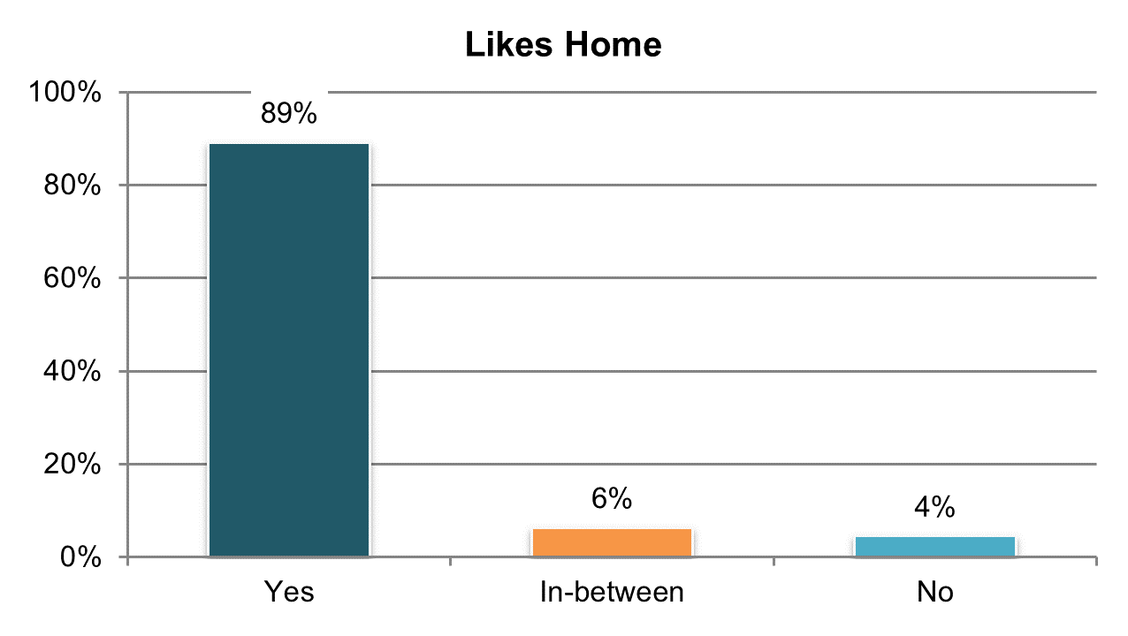

Table . Like their home (‘yes’ responses only)

|  |  |  |  |  |  |  |
| --- | --- | --- | --- | --- | --- | --- |
| State | Overall in State | N | ICF/IID and Other Institutional Settings | Community-based Group Residential Settings | Own Home | Parent’s or Relative’s Home |
| **Significantly Above Average** | | |  |  |  |  |
| AZ | 98% | 420 | n/a | 96% | 91% | 99% |
| IN | 97% | 587 | n/a | n/a | 93% | 99% |
| HI | 94% | 200 | n/a | 89% | n/a | 95% |
| TN | 93% | 336 | n/a | 92% | 91% | 97% |
| **Within Average Range** | | |  |  |  |  |
| OK | 93% | 212 | n/a | 96% | 87% | 94% |
| AR | 93% | 223 | 79% | 88% | 94% | 100% |
| LA | 92% | 293 | 87% | n/a | 89% | 98% |
| VT | 92% | 288 | n/a | n/a | 96% | 96% |
| FL | 91% | 872 | n/a | 82% | 90% | 98% |
| IL | 91% | 260 | n/a | 87% | 90% | 96% |
| VA | 91% | 508 | 91% | 87% | 86% | 98% |
| RI | 91% | 350 | n/a | 92% | 85% | 99% |
| UT | 91% | 243 | n/a | 90% | 83% | 96% |
| NC | 90% | 448 | 89% | 85% | 81% | 97% |
| GA | 90% | 311 | n/a | 85% | 85% | 93% |
| CT | 90% | 247 | n/a | 84% | 88% | 98% |
| PA | 90% | 447 | 83% | 84% | 82% | 96% |
| SD | 89% | 289 | n/a | 88% | 90% | 97% |
| MI | 89% | 287 | n/a | 86% | 87% | 94% |
| KY | 89% | 301 | n/a | 81% | 89% | 96% |
| WI | 89% | 292 | 76% | 77% | 90% | 96% |
| AL | 89% | 334 | n/a | 81% | 88% | 98% |
| MN | 89% | 253 | n/a | 88% | 85% | 93% |
| DC | 88% | 195 | n/a | 90% | n/a | 92% |
| MS | 87% | 315 | n/a | 82% | 84% | 96% |
| OH | 87% | 403 | 78% | 84% | 83% | 91% |
| NY | 86% | 323 | n/a | 79% | 81% | 97% |
| CO | 86% | 308 | n/a | 74% | 81% | 93% |
| WA | 86% | 267 | n/a | n/a | 80% | 93% |
| KS | 86% | 273 | n/a | 77% | 87% | 100% |
| MA | 86% | 314 | n/a | 83% | 78% | 92% |
| WY | 86% | 236 | n/a | 86% | 84% | 85% |
| MO | 85% | 274 | n/a | 82% | 84% | 100% |
| DE | 83% | 278 | n/a | 81% | 86% | n/a |
| **Significantly Below Average** | | |  |  |  |  |
| ME | 83% | 287 | n/a | 74% | 92% | 89% |
| NV | 80% | 349 | n/a | 74% | 84% | 93% |
| NCI Average | 89% | 11,823 | 83% | 84% | 87% | 96% |

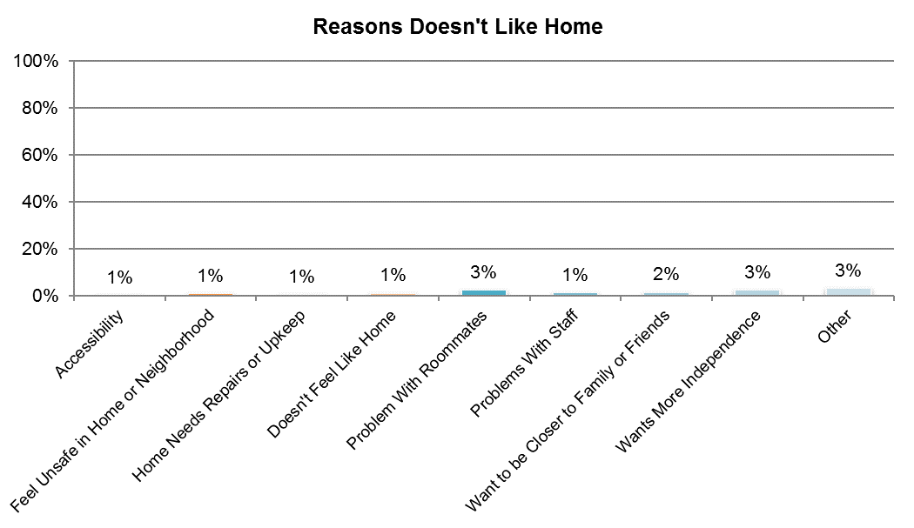

Table A. Reasons why person does not like home (categories are not mutually exclusive) º

|  |  |  |  |  |
| --- | --- | --- | --- | --- |
| State | Accessibility | Feel Unsafe in Home or Neighborhood | Home Needs Repair or Upkeep | Doesn't Feel Like Home |
| AL | 0% | 0% | 1% | 1% |
| AR | 0% | 0% | 1% | 1% |
| AZ | 1% | 0% | 0% | 0% |
| CO | 0% | 2% | 1% | 1% |
| CT | 0% | 0% | 0% | 0% |
| DC | 1% | 2% | 2% | 1% |
| DE | 1% | 3% | 1% | 4% |
| FL | 0% | 1% | 1% | 1% |
| GA | 0% | 1% | 0% | 0% |
| HI | 1% | 0% | 0% | 0% |
| IL | 0% | 2% | 0% | 1% |
| IN | 0% | 0% | 1% | 0% |
| KS | 0% | 0% | 0% | 1% |
| KY | 0% | 2% | 3% | 2% |
| LA | 0% | 2% | 1% | 2% |
| MA | 1% | 2% | 1% | 1% |
| ME | 0% | 1% | 1% | 2% |
| MI | 0% | 1% | 1% | 1% |
| MN | 0% | 1% | 1% | 3% |
| MO | 1% | 1% | 2% | 2% |
| MS | 1% | 2% | 1% | 3% |
| NC | 0% | 0% | 1% | 1% |
| NV | 2% | 1% | 0% | 3% |
| NY | 1% | 2% | 1% | 1% |
| OH | 1% | 1% | 1% | 1% |
| OK | 0% | 0% | 0% | 0% |
| PA | 1% | 1% | 1% | 0% |
| RI | 1% | 1% | 1% | 1% |
| SD | 0% | 1% | 1% | 2% |
| TN | 0% | 1% | 1% | 1% |
| UT | 1% | 2% | 2% | 2% |
| VA | 0% | 1% | 0% | 1% |
| VT | 0% | 0% | 0% | 1% |
| WA | 2% | 1% | 1% | 1% |
| WI | 1% | 0% | 1% | 1% |
| WY | 1% | 0% | 1% | 1% |
| NCI Average | 1% | 1% | 1% | 1% |

ºNew variable to reporting

Table B. Reasons why person does not like home (continued, categories are not mutually exclusive) º

|  |  |  |  |  |  |
| --- | --- | --- | --- | --- | --- |
| State | Problem With Roommates | Problems With Staff | Want to Be Closer to Family or Friends | Wants More Independence | Other |
| AL | 3% | 0% | 1% | 3% | 2% |
| AR | 1% | 0% | 2% | 1% | 3% |
| AZ | 0% | 1% | 0% | 0% | 1% |
| CO | 4% | 2% | 3% | 6% | 6% |
| CT | 1% | 1% | 2% | 3% | 4% |
| DC | 3% | 3% | 1% | 4% | 3% |
| DE | 8% | 6% | 3% | 4% | 1% |
| FL | 2% | 0% | 1% | 2% | 3% |
| GA | 0% | 1% | 2% | 2% | 4% |
| HI | 0% | 0% | 0% | 0% | 5% |
| IL | 3% | 0% | 2% | 2% | 2% |
| IN | 0% | 0% | 0% | 1% | 1% |
| KS | 2% | 1% | 2% | 4% | 5% |
| KY | 7% | 2% | 1% | 2% | 1% |
| LA | 1% | 1% | 3% | 2% | 1% |
| MA | 5% | 3% | 4% | 5% | 3% |
| ME | 5% | 2% | 5% | 4% | 5% |
| MI | 3% | 2% | 2% | 3% | 3% |
| MN | 5% | 4% | 2% | 4% | 4% |
| MO | 3% | 2% | 4% | 4% | 5% |
| MS | 3% | 2% | 4% | 2% | 3% |
| NC | 2% | 1% | 1% | 2% | 4% |
| NV | 5% | 3% | 2% | 7% | 10% |
| NY | 1% | 1% | 2% | 2% | 5% |
| OH | 2% | 1% | 2% | 2% | 6% |
| OK | 0% | 0% | 0% | 0% | 1% |
| PA | 1% | 1% | 1% | 2% | 3% |
| RI | 2% | 1% | 1% | 1% | 4% |
| SD | 3% | 2% | 3% | 2% | 3% |
| TN | 3% | 1% | 0% | 1% | 2% |
| UT | 2% | 1% | 2% | 1% | 2% |
| VA | 2% | 1% | 2% | 2% | 3% |
| VT | 1% | 1% | 1% | 2% | 2% |
| WA | 2% | 1% | 0% | 2% | 6% |
| WI | 2% | 1% | 2% | 4% | 5% |
| WY | 3% | 2% | 3% | 5% | 5% |
| NCI Average | 3% | 1% | 2% | 3% | 3% |

ºNew variable to reporting

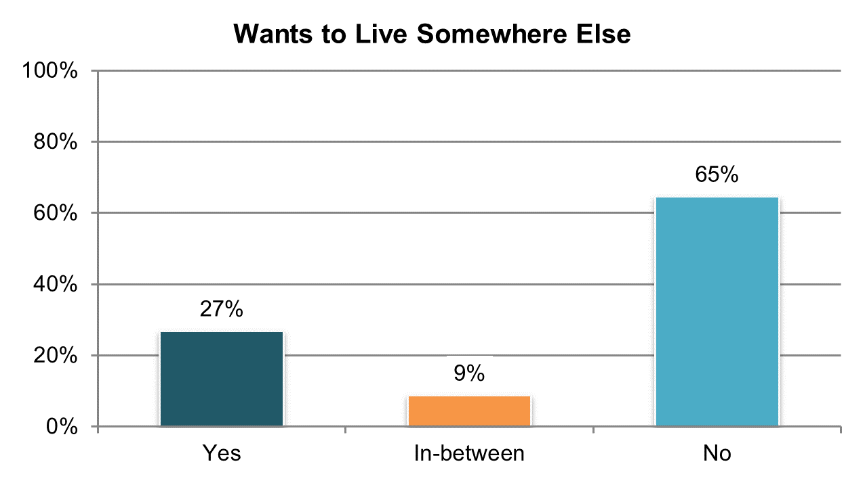

Table . Want to live somewhere else (‘yes’ responses only)

|  |  |  |  |  |  |  |
| --- | --- | --- | --- | --- | --- | --- |
| State | Overall in State | N | ICF/IID and Other Institutional Settings | Community-based Group Residential Settings | Own Home | Parent’s or Relative’s Home |
| **Significantly Above Average** | | |  |  |  |  |
| NV | 46% | 335 | n/a | 49% | 43% | 41% |
| DE | 43% | 263 | n/a | 45% | 46% | n/a |
| SD | 37% | 278 | n/a | 41% | 31% | 40% |
| **Within Average Range** | | |  |  |  |  |
| OH | 32% | 388 | 59% | 31% | 35% | 27% |
| DC | 32% | 189 | n/a | 28% | n/a | 34% |
| AR | 32% | 222 | 45% | 35% | 31% | 23% |
| OK | 31% | 206 | n/a | 33% | 33% | 27% |
| CT | 31% | 236 | n/a | 30% | 27% | 33% |
| LA | 29% | 275 | 50% | n/a | 25% | 22% |
| MI | 29% | 281 | n/a | 36% | 31% | 20% |
| MN | 29% | 250 | n/a | 41% | 20% | 23% |
| WI | 28% | 289 | 17% | 37% | 30% | 24% |
| AL | 28% | 329 | n/a | 34% | 21% | 23% |
| MO | 28% | 269 | n/a | 32% | 32% | 9% |
| NC | 28% | 433 | 50% | 23% | 41% | 24% |
| UT | 28% | 239 | n/a | 30% | 33% | 22% |
| RI | 27% | 338 | n/a | 32% | 25% | 27% |
| VT | 27% | 272 | n/a | n/a | 38% | 34% |
| ME | 27% | 282 | n/a | 33% | 17% | 25% |
| IL | 27% | 252 | n/a | 33% | 19% | 21% |
| WY | 26% | 237 | n/a | 36% | 25% | 20% |
| MA | 26% | 301 | n/a | 31% | 27% | 22% |
| VA | 25% | 482 | 38% | 31% | 19% | 15% |
| MS | 23% | 311 | n/a | 33% | 24% | 15% |
| HI | 23% | 196 | n/a | 44% | n/a | 21% |
| PA | 23% | 435 | 26% | 29% | 23% | 18% |
| KS | 23% | 260 | n/a | 28% | 19% | 12% |
| WA | 22% | 258 | n/a | n/a | 22% | 21% |
| GA | 21% | 302 | n/a | 24% | 20% | 22% |
| **Significantly Below Average** | | |  |  |  |  |
| FL | 23% | 856 | n/a | 30% | 26% | 17% |
| IN | 21% | 560 | n/a | n/a | 22% | 20% |
| NY | 20% | 317 | n/a | 23% | 30% | 13% |
| CO | 20% | 304 | n/a | 24% | 25% | 15% |
| KY | 19% | 297 | n/a | 25% | 12% | 15% |
| TN | 17% | 332 | n/a | 20% | 21% | 7% |
| AZ | 13% | 418 | n/a | 21% | 20% | 10% |
| NCI Average | 27% | 11,492 | 41% | 32% | 27% | 22% |

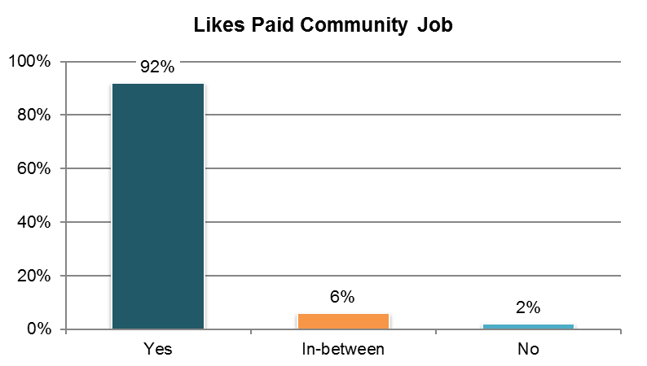

Table . Has a paid job in the community and likes where they work (‘yes’ responses only) ˇ

|  |  |  |  |  |  |  |
| --- | --- | --- | --- | --- | --- | --- |
| State | Overall in State | N | ICF/IID and Other Institutional Settings | Community-based Group Residential Settings | Own Home | Parent’s or Relative’s Home |
| **Within Average Range** | | |  |  |  |  |
| AL | 100% | 28 | n/a | n/a | n/a | n/a |
| AR | 100% | 20 | n/a | n/a | n/a | n/a |
| OH | 97% | 94 | n/a | n/a | 97% | 98% |
| PA | 97% | 60 | n/a | n/a | 95% | 96% |
| AZ | 97% | 58 | n/a | n/a | n/a | 97% |
| KY | 96% | 27 | n/a | n/a | n/a | n/a |
| OK | 96% | 50 | n/a | 96% | n/a | n/a |
| GA | 96% | 72 | n/a | n/a | 96% | 95% |
| NY | 96% | 48 | n/a | n/a | n/a | n/a |
| IN | 95% | 131 | n/a | n/a | 95% | 94% |
| VT | 95% | 128 | n/a | n/a | n/a | 95% |
| MO | 94% | 36 | n/a | n/a | 96% | n/a |
| NC | 93% | 76 | n/a | 100% | n/a | 93% |
| KS | 93% | 44 | n/a | n/a | n/a | n/a |
| ME | 93% | 72 | n/a | 100% | 92% | n/a |
| RI | 93% | 57 | n/a | n/a | n/a | 96% |
| IL | 93% | 27 | n/a | n/a | n/a | n/a |
| SD | 93% | 107 | n/a | 96% | 92% | n/a |
| MN | 92% | 124 | n/a | 90% | 87% | 97% |
| CO | 91% | 47 | n/a | n/a | n/a | n/a |
| WA | 91% | 138 | n/a | n/a | 88% | 94% |
| WY | 91% | 91 | n/a | 91% | 89% | 93% |
| MA | 91% | 89 | n/a | 92% | 92% | 88% |
| MS | 90% | 52 | n/a | n/a | 95% | n/a |
| CT | 90% | 108 | n/a | 76% | 93% | 98% |
| LA | 89% | 47 | n/a | n/a | 95% | n/a |
| TN | 89% | 47 | n/a | n/a | 86% | n/a |
| FL | 89% | 122 | n/a | n/a | 80% | 97% |
| WI | 89% | 36 | n/a | n/a | n/a | n/a |
| NV | 88% | 57 | n/a | 86% | 89% | n/a |
| MI | 87% | 31 | n/a | n/a | n/a | n/a |
| VA | 86% | 51 | n/a | 85% | n/a | n/a |
| UT | 84% | 64 | n/a | 75% | 95% | n/a |
| DE | 84% | 56 | n/a | 85% | n/a | n/a |
| NCI Average | 92% | 2,295 | n/a | 89% | 92% | 95% |

ˇReported for those who were reported to have a paid community job from Background section

**Note:** The following states are not included in analysis due to low N (<20): DC, HI

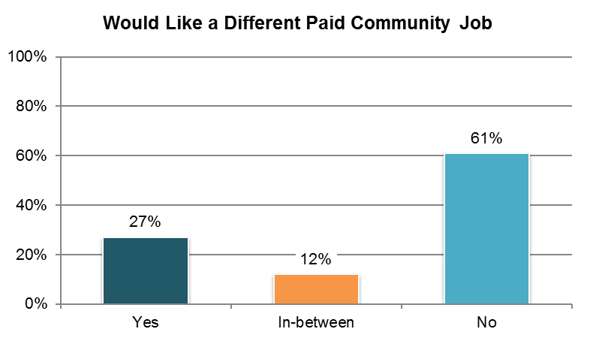

Table . Has a paid job in the community and wants to work somewhere elseˇ (‘yes’ responses only) ˇ

|  |  |  |  |  |  |  |
| --- | --- | --- | --- | --- | --- | --- |
| State | Overall in State | N | ICF/IID and Other Institutional Settings | Community-based Group Residential Settings | Own Home | Parent’s or Relative’s Home |
| **Within Average Range** | | |  |  |  |  |
| DE | 46% | 56 | n/a | 46% | n/a | n/a |
| AL | 41% | 27 | n/a | n/a | n/a | n/a |
| IL | 39% | 28 | n/a | n/a | n/a | n/a |
| UT | 37% | 63 | n/a | 46% | 29% | n/a |
| MA | 36% | 84 | n/a | 30% | 41% | 32% |
| MI | 35% | 31 | n/a | n/a | n/a | n/a |
| MN | 34% | 121 | n/a | 41% | 24% | 28% |
| VA | 33% | 49 | n/a | 29% | n/a | n/a |
| RI | 32% | 57 | n/a | n/a | n/a | 29% |
| NV | 31% | 55 | n/a | 29% | 32% | n/a |
| WI | 31% | 36 | n/a | n/a | n/a | n/a |
| CT | 29% | 106 | n/a | 42% | 37% | 18% |
| CO | 28% | 46 | n/a | n/a | n/a | n/a |
| VT | 28% | 124 | n/a | n/a | n/a | 29% |
| WY | 28% | 90 | n/a | 26% | 31% | 21% |
| SD | 28% | 108 | n/a | 42% | 23% | n/a |
| NY | 27% | 44 | n/a | n/a | n/a | n/a |
| MS | 27% | 52 | n/a | n/a | 14% | n/a |
| ME | 27% | 67 | n/a | 17% | 23% | n/a |
| AR | 25% | 20 | n/a | n/a | n/a | n/a |
| GA | 25% | 73 | n/a | n/a | 20% | 23% |
| PA | 25% | 57 | n/a | n/a | 24% | 25% |
| OH | 24% | 94 | n/a | n/a | 19% | 23% |
| NC | 24% | 74 | n/a | 13% | n/a | 31% |
| OK | 23% | 48 | n/a | 28% | n/a | n/a |
| TN | 22% | 45 | n/a | n/a | 30% | n/a |
| IN | 21% | 124 | n/a | n/a | 17% | 25% |
| WA | 20% | 136 | n/a | n/a | 22% | 16% |
| FL | 19% | 122 | n/a | n/a | 15% | 20% |
| AZ | 17% | 54 | n/a | n/a | n/a | 15% |
| KS | 14% | 44 | n/a | n/a | n/a | n/a |
| LA | 13% | 46 | n/a | n/a | 5% | n/a |
| MO | 12% | 34 | n/a | n/a | 14% | n/a |
| KY | 11% | 27 | n/a | n/a | n/a | n/a |
| NCI Average | 27% | 2,242 | n/a | 32% | 23% | 24% |

ˇReported for those who were reported to have a paid community job from Background section

**Note:** The following states are not included in analysis due to low N (<20): DC, HI

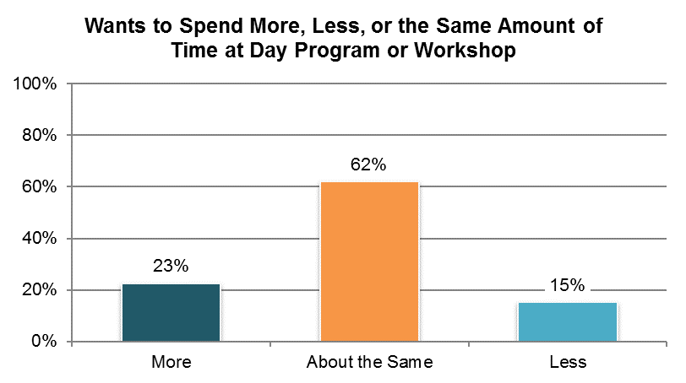

Table . Attends a day program or workshop and wants to go more, less, or the same amount of time º

|  |  |  |  |  |
| --- | --- | --- | --- | --- |
| State | More | About the Same Amount | Less | N |
| AL | 23% | 55% | 23% | 304 |
| AR | 28% | 53% | 19% | 134 |
| AZ | 8% | 88% | 4% | 218 |
| CO | 18% | 69% | 13% | 182 |
| CT | 38% | 51% | 11% | 99 |
| DE | 27% | 40% | 33% | 187 |
| FL | 12% | 74% | 14% | 354 |
| GA | 8% | 85% | 7% | 202 |
| HI | 27% | 60% | 13% | 128 |
| IL | 21% | 63% | 16% | 198 |
| IN | 22% | 66% | 11% | 303 |
| KS | 7% | 80% | 13% | 170 |
| KY | 5% | 75% | 20% | 215 |
| LA | 21% | 68% | 11% | 132 |
| MA | 22% | 60% | 18% | 194 |
| ME | 10% | 72% | 19% | 200 |
| MI | 27% | 62% | 11% | 140 |
| MN | 29% | 52% | 18% | 119 |
| MO | 18% | 70% | 12% | 108 |
| MS | 32% | 42% | 26% | 216 |
| NC | 24% | 67% | 9% | 243 |
| NV | 36% | 47% | 16% | 225 |
| NY | 19% | 75% | 5% | 166 |
| OH | 17% | 65% | 18% | 239 |
| OK | 24% | 54% | 22% | 63 |
| PA | 23% | 67% | 10% | 211 |
| RI | 25% | 55% | 20% | 222 |
| SD | 28% | 54% | 18% | 165 |
| TN | 21% | 66% | 13% | 148 |
| UT | 15% | 68% | 17% | 133 |
| VA | 14% | 71% | 14% | 312 |
| VT | 42% | 44% | 14% | 36 |
| WA | 52% | 39% | 9% | 23 |
| WI | 26% | 60% | 14% | 108 |
| WY | 24% | 55% | 22% | 102 |
| NCI Average | 23% | 62% | 15% | 6,199 |

ºNew variable to reporting

**Note:** DC is not included in analysis due to low N (<20)

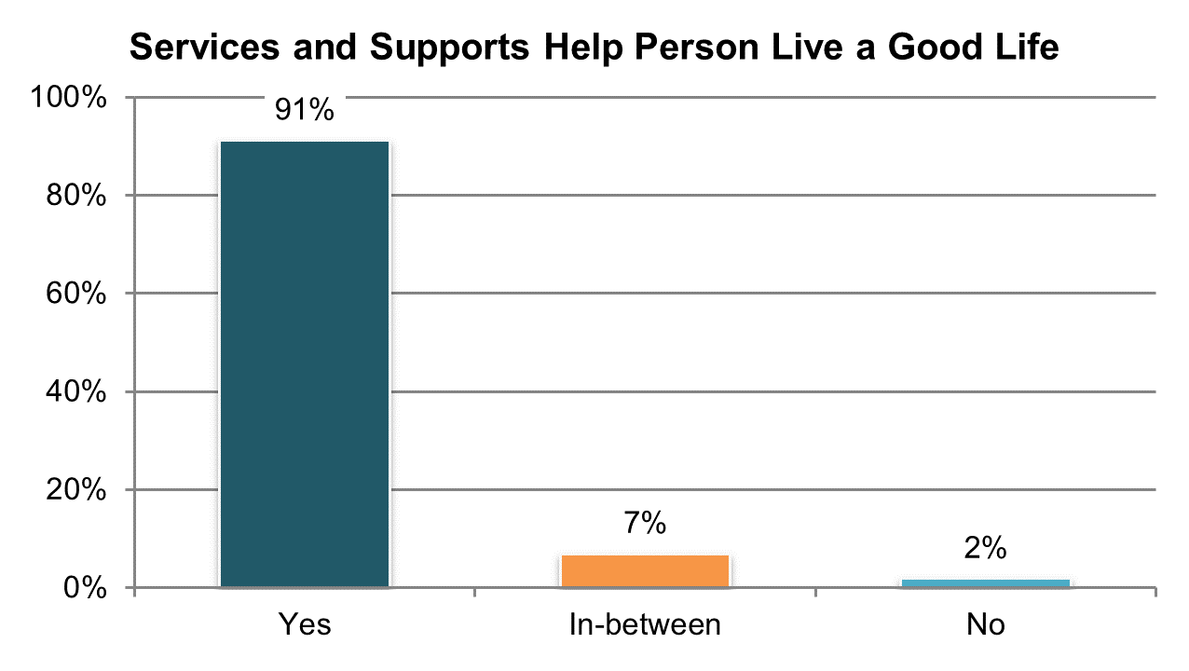

Table . Services and supports help person live a good life (‘yes’ responses only) º

|  |  |  |  |  |  |  |
| --- | --- | --- | --- | --- | --- | --- |
| State | Overall in State | N | ICF/IID and Other Institutional Settings | Community-based Group Residential Settings | Own Home | Parent’s or Relative’s Home |
| **Significantly Above Average** | | |  |  |  |  |
| AZ | 97% | 416 | n/a | 95% | 93% | 98% |
| TN | 97% | 328 | n/a | 94% | 98% | 99% |
| AL | 95% | 333 | n/a | 93% | 98% | 98% |
| IN | 95% | 566 | n/a | n/a | 92% | 96% |
| FL | 94% | 827 | n/a | 90% | 93% | 97% |
| **Within Average Range** | | |  |  |  |  |
| WA | 94% | 258 | n/a | n/a | 95% | 94% |
| VA | 94% | 494 | 84% | 95% | 97% | 93% |
| UT | 94% | 239 | n/a | 92% | 93% | 97% |
| IL | 94% | 254 | n/a | 91% | 97% | 95% |
| AR | 93% | 225 | 79% | 92% | 92% | 100% |
| HI | 93% | 195 | n/a | 93% | n/a | 93% |
| CT | 93% | 241 | n/a | 97% | 92% | 90% |
| RI | 92% | 335 | n/a | 96% | 91% | 95% |
| SD | 92% | 282 | n/a | 95% | 89% | 97% |
| NC | 92% | 418 | 91% | 91% | 86% | 95% |
| GA | 92% | 300 | n/a | 87% | 93% | 94% |
| PA | 92% | 423 | n/a | 92% | 86% | 93% |
| KY | 92% | 296 | n/a | 82% | 95% | 98% |
| MA | 91% | 309 | n/a | 92% | 88% | 91% |
| MN | 91% | 250 | n/a | 94% | 88% | 90% |
| MS | 91% | 292 | n/a | 89% | 93% | 91% |
| NV | 91% | 346 | n/a | 92% | 88% | 96% |
| LA | 91% | 283 | 92% | n/a | 93% | 89% |
| KS | 90% | 252 | n/a | 88% | 93% | 95% |
| OH | 90% | 384 | 86% | 93% | 88% | 90% |
| OK | 89% | 209 | n/a | 95% | 87% | 80% |
| CO | 89% | 307 | n/a | 92% | 87% | 86% |
| MO | 89% | 259 | n/a | 84% | 89% | 95% |
| DC | 88% | 168 | n/a | 95% | n/a | 83% |
| WI | 88% | 289 | 76% | 93% | 83% | 91% |
| VT | 87% | 254 | n/a | n/a | 85% | 91% |
| DE | 87% | 230 | n/a | 86% | 92% | n/a |
| NY | 87% | 307 | n/a | 90% | 78% | 89% |
| WY | 86% | 234 | n/a | 82% | 91% | 83% |
| MI | 86% | 267 | n/a | 83% | 89% | 84% |
| ME | 85% | 280 | n/a | 82% | 90% | 91% |
| NCI Average | 91% | 11,350 | 85% | 91% | 91% | 92% |

ºNew variable to reporting

## Service Coordination

### Service coordinators are accessible, responsive, and support the person’s participation in service planning.

There are eight Service Coordination indicators:

1. Proportion of people who reported they met their case manager/service coordinator
2. Proportion of people who reported their case manager/service coordinator asks them what they want
3. Proportion of people who reported their case manager/service coordinator gets back to them right away
4. Proportion of people who reported taking part in the last service planning meeting
5. Proportion of people who reported that they understood what was discussed in last service planning meeting
6. Proportion of people who reported that service planning meeting included people the person wanted to be there
7. Proportion of people who reported that they were able to choose the services that were received as part of service plan
8. Proportion of people who reported support workers come and leave when they are supposed to

Tables 86 through 93 present the results for these seven core indicators. The corresponding charts show un-collapsed averages.

All un-collapsed state data frequencies for these survey questions are displayed in Appendix D.

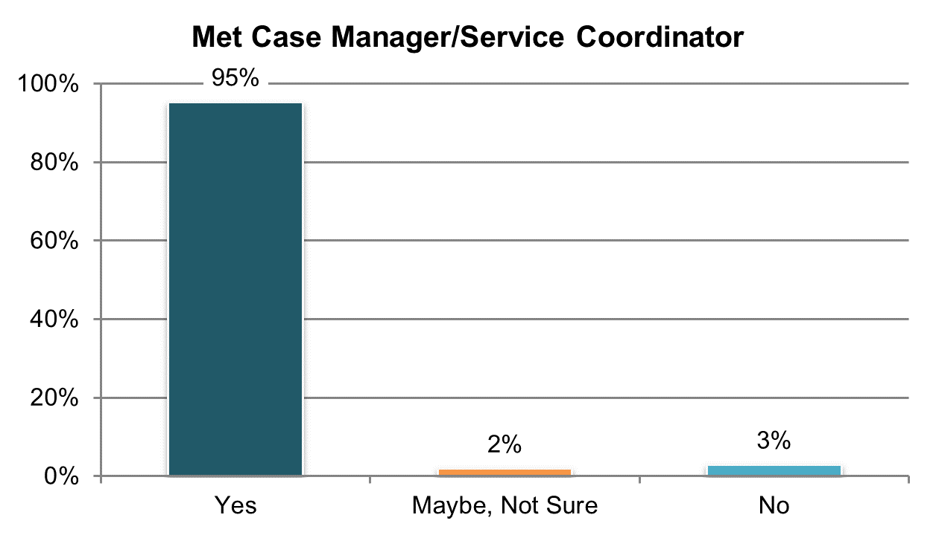

Table . Met their case manager/service coordinator (‘yes’ responses only)

|  |  |  |  |  |  |  |
| --- | --- | --- | --- | --- | --- | --- |
| State | Overall in State | N | ICF/IID and Other Institutional Settings | Community-based Group Residential Settings | Own Home | Parent’s or Relative’s Home |
| **Significantly Above Average** | | |  |  |  |  |
| WY | 100% | 234 | n/a | 100% | 100% | 100% |
| VT | 100% | 277 | n/a | n/a | 100% | 99% |
| FL | 99% | 857 | n/a | 99% | 100% | 99% |
| TN | 99% | 325 | n/a | 98% | 99% | 100% |
| ME | 98% | 283 | n/a | 96% | 100% | 100% |
| MO | 98% | 266 | n/a | 98% | 98% | 96% |
| AZ | 98% | 423 | n/a | 95% | 100% | 98% |
| **Within Average Range** | | |  |  |  |  |
| UT | 98% | 234 | n/a | 97% | 95% | 100% |
| NY | 97% | 313 | n/a | 98% | 98% | 96% |
| KY | 97% | 300 | n/a | 98% | 95% | 98% |
| AL | 97% | 334 | n/a | 98% | 100% | 96% |
| IL | 97% | 254 | n/a | 97% | 100% | 97% |
| SD | 97% | 285 | n/a | 96% | 98% | 100% |
| MI | 97% | 283 | n/a | 97% | 97% | 98% |
| WI | 97% | 289 | 100% | 94% | 97% | 97% |
| AR | 97% | 216 | 100% | 96% | 98% | 92% |
| KS | 97% | 269 | n/a | 98% | 96% | 93% |
| PA | 96% | 427 | n/a | 97% | 96% | 96% |
| NV | 96% | 344 | n/a | 95% | 99% | 93% |
| IN | 96% | 576 | n/a | n/a | 95% | 96% |
| OH | 96% | 387 | 88% | 93% | 98% | 98% |
| HI | 96% | 199 | n/a | 89% | n/a | 98% |
| NC | 96% | 353 | 95% | 93% | 98% | 98% |
| LA | 95% | 278 | 97% | n/a | 95% | 95% |
| VA | 95% | 493 | 86% | 95% | 94% | 96% |
| DC | 95% | 185 | n/a | 94% | n/a | 89% |
| MA | 94% | 309 | n/a | 99% | 94% | 87% |
| MS | 94% | 281 | n/a | 95% | 95% | 94% |
| CT | 94% | 242 | n/a | 89% | 94% | 97% |
| CO | 93% | 303 | n/a | 87% | 97% | 91% |
| RI | 91% | 336 | n/a | 91% | 86% | 92% |
| MN | 91% | 243 | n/a | 89% | 89% | 91% |
| GA | 91% | 295 | n/a | 89% | 97% | 89% |
| OK | 90% | 209 | n/a | 89% | 89% | 91% |
| **Significantly Below Average** | | |  |  |  |  |
| WA | 87% | 264 | n/a | n/a | 87% | 86% |
| DE | 81% | 223 | n/a | 80% | 88% | n/a |
| NCI Average | 95% | 11,389 | 94% | 94% | 96% | 95% |

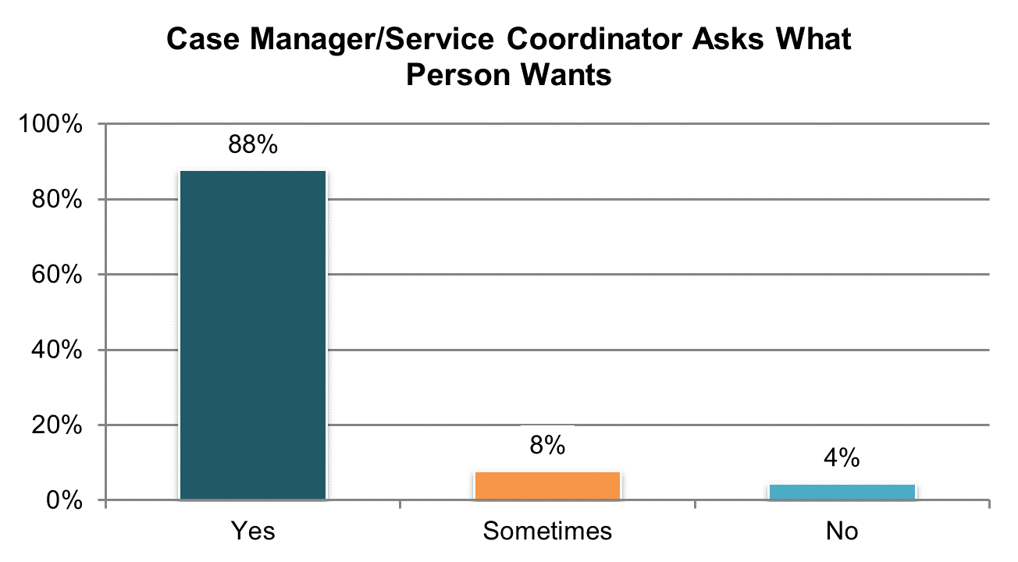

Table . Case manager/service coordinator asks person what s/he want (‘yes’ responses only)

|  |  |  |  |  |  |  |
| --- | --- | --- | --- | --- | --- | --- |
| State | Overall in State | N | ICF/IID and Other Institutional Settings | Community-based Group Residential Settings | Own Home | Parent’s or Relative’s Home |
| **Significantly Above Average** | | |  |  |  |  |
| TN | 98% | 319 | n/a | 98% | 98% | 98% |
| FL | 95% | 818 | n/a | 95% | 96% | 95% |
| AZ | 95% | 408 | n/a | 96% | 90% | 96% |
| IN | 95% | 533 | n/a | n/a | 94% | 96% |
| AL | 94% | 324 | n/a | 94% | 90% | 95% |
| WA | 93% | 222 | n/a | n/a | 95% | 95% |
| PA | 92% | 388 | n/a | 88% | 88% | 95% |
| **Within Average Range** | | |  |  |  |  |
| WY | 92% | 228 | n/a | 91% | 94% | 92% |
| KY | 92% | 291 | n/a | 86% | 95% | 95% |
| AR | 92% | 212 | 93% | 100% | 93% | 88% |
| KS | 91% | 250 | n/a | 91% | 88% | 94% |
| LA | 90% | 265 | 87% | n/a | 93% | 89% |
| IL | 90% | 239 | n/a | 93% | 90% | 86% |
| VA | 89% | 466 | 85% | 91% | 91% | 87% |
| OH | 89% | 354 | 93% | 78% | 85% | 93% |
| MN | 89% | 211 | n/a | 89% | 88% | 91% |
| UT | 88% | 223 | n/a | 87% | 85% | 93% |
| CT | 88% | 226 | n/a | 91% | 89% | 84% |
| CO | 87% | 280 | n/a | 84% | 88% | 86% |
| GA | 87% | 264 | n/a | 85% | 82% | 89% |
| NY | 87% | 303 | n/a | 85% | 85% | 88% |
| NC | 87% | 324 | 100% | 85% | 86% | 91% |
| MS | 87% | 260 | n/a | 85% | 86% | 86% |
| SD | 86% | 272 | n/a | 86% | 86% | 83% |
| HI | 86% | 180 | n/a | 78% | n/a | 89% |
| RI | 86% | 302 | n/a | 94% | 90% | 82% |
| MO | 86% | 247 | n/a | 89% | 85% | 95% |
| WI | 86% | 269 | 74% | 83% | 85% | 91% |
| OK | 85% | 179 | n/a | 90% | 85% | 78% |
| MA | 85% | 282 | n/a | 84% | 83% | 85% |
| NV | 84% | 315 | n/a | 80% | 83% | 97% |
| MI | 84% | 265 | n/a | 82% | 88% | 82% |
| DC | 82% | 167 | n/a | 89% | n/a | 84% |
| **Significantly Below Average** | | |  |  |  |  |
| ME | 78% | 262 | n/a | 74% | 91% | 71% |
| VT | 74% | 257 | n/a | n/a | 79% | 61% |
| DE | 70% | 171 | n/a | 68% | 71% | n/a |
| NCI Average | 88% | 10,576 | 89% | 87% | 88% | 89% |

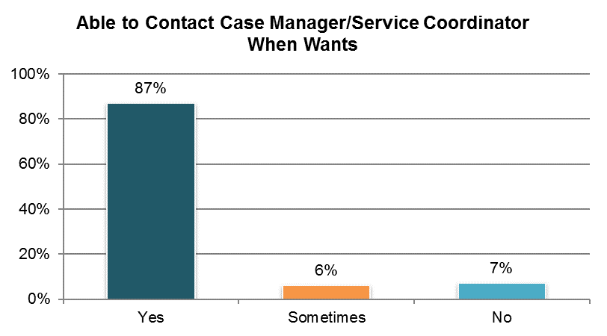

Table . Able to contact case manager/service coordinator when wants (‘yes’ responses only) ±

|  |  |  |  |  |  |  |
| --- | --- | --- | --- | --- | --- | --- |
| State | Overall in State | N | ICF/IID and Other Institutional Settings | Community-based Group Residential Settings | Own Home | Parent’s or Relative’s Home |
| **Significantly Above Average** | | |  |  |  |  |
| TN | 97% | 322 | n/a | 96% | 98% | 98% |
| IN | 96% | 472 | n/a | n/a | 97% | 97% |
| AZ | 96% | 410 | n/a | 95% | 98% | 96% |
| LA | 93% | 260 | 97% | n/a | 92% | 93% |
| FL | 93% | 773 | n/a | 90% | 93% | 94% |
| **Within Average Range** | | |  |  |  |  |
| WI | 91% | 278 | 91% | 90% | 91% | 93% |
| OH | 91% | 353 | 93% | 91% | 87% | 94% |
| KY | 91% | 293 | n/a | 82% | 95% | 94% |
| NY | 91% | 278 | n/a | 88% | 89% | 95% |
| AR | 90% | 214 | 96% | 85% | 95% | 86% |
| ME | 90% | 196 | n/a | 88% | 98% | 89% |
| CO | 90% | 292 | n/a | 94% | 93% | 84% |
| WY | 89% | 231 | n/a | 80% | 94% | 94% |
| MO | 89% | 212 | n/a | 88% | 89% | n/a |
| SD | 88% | 278 | n/a | 87% | 89% | 94% |
| UT | 88% | 217 | n/a | 87% | 88% | 93% |
| WA | 88% | 181 | n/a | n/a | 89% | 89% |
| MS | 88% | 265 | n/a | 87% | 89% | 91% |
| PA | 88% | 321 | n/a | 85% | 91% | 89% |
| RI | 88% | 308 | n/a | 91% | 82% | 86% |
| MN | 87% | 222 | n/a | 82% | 96% | 85% |
| NC | 87% | 315 | 95% | 81% | 98% | 91% |
| GA | 87% | 219 | n/a | 85% | 91% | 87% |
| IL | 86% | 235 | n/a | 84% | 90% | 87% |
| AL | 86% | 302 | n/a | 80% | 98% | 90% |
| MA | 86% | 271 | n/a | 88% | 89% | 83% |
| KS | 86% | 230 | n/a | 84% | 83% | 96% |
| OK | 85% | 195 | n/a | 82% | 90% | 87% |
| CT | 85% | 226 | n/a | 75% | 88% | 93% |
| MI | 84% | 276 | n/a | 79% | 87% | 86% |
| VA | 83% | 438 | 88% | 87% | 81% | 76% |
| HI | 82% | 181 | n/a | 76% | n/a | 83% |
| DC | 82% | 172 | n/a | 92% | n/a | 79% |
| **Significantly Below Average** | | |  |  |  |  |
| NV | 76% | 336 | n/a | 71% | 81% | 79% |
| VT | 73% | 203 | n/a | n/a | 71% | 62% |
| DE | 61% | 179 | n/a | 60% | 64% | n/a |
| NCI Average | 87% | 10,154 | 93% | 85% | 89% | 89% |

±Item changed from previous years – question rephrased (see Appendix A)

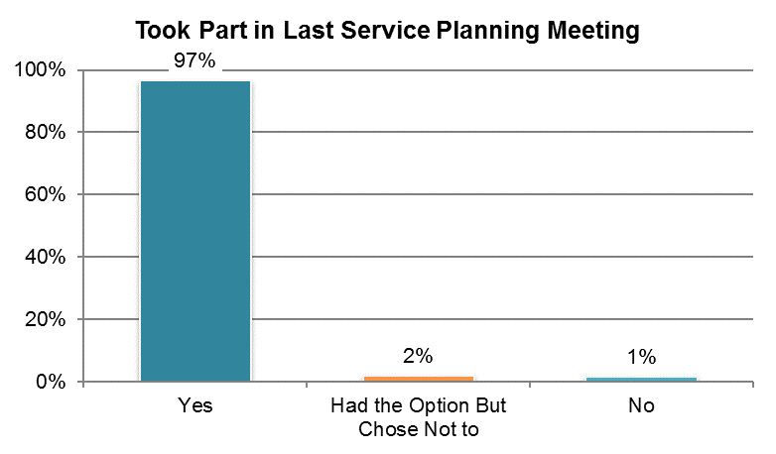

Table . Took part in last service planning meeting (‘yes’ and ‘had the option but chose not to’ responses) º

|  |  |  |  |  |  |  |
| --- | --- | --- | --- | --- | --- | --- |
| State | Overall in State | N | ICF/IID and Other Institutional Settings | Community-based Group Residential Settings | Own Home | Parent’s or Relative’s Home |
| **Significantly Above Average** | | |  |  |  |  |
| AL | 100% | 324 | n/a | 100% | 100% | 100% |
| GA | 100% | 292 | n/a | 100% | 100% | 100% |
| IN | 100% | 503 | n/a | n/a | 100% | 100% |
| WA | 100% | 250 | n/a | n/a | 100% | 100% |
| KY | 100% | 280 | n/a | 100% | 100% | 100% |
| VA | 100% | 434 | 100% | 100% | 100% | 100% |
| FL | 99% | 771 | n/a | 99% | 100% | 100% |
| **Within Average Range** | | |  |  |  |  |
| LA | 100% | 254 | 100% | n/a | 100% | 99% |
| SD | 100% | 235 | n/a | 100% | 99% | 100% |
| IL | 100% | 234 | n/a | 100% | 100% | 99% |
| OK | 99% | 181 | n/a | 100% | 100% | 98% |
| HI | 99% | 178 | n/a | 100% | n/a | 100% |
| AZ | 99% | 139 | n/a | 100% | 100% | 99% |
| MI | 99% | 229 | n/a | 97% | 100% | 100% |
| ME | 99% | 228 | n/a | 99% | 100% | 100% |
| PA | 99% | 334 | n/a | 99% | 100% | 100% |
| WY | 99% | 221 | n/a | 100% | 100% | 98% |
| RI | 99% | 299 | n/a | 100% | 96% | 99% |
| MA | 99% | 287 | n/a | 100% | 100% | 96% |
| NY | 99% | 286 | n/a | 99% | 100% | 98% |
| CO | 99% | 278 | n/a | 97% | 100% | 99% |
| MO | 99% | 238 | n/a | 100% | 98% | 100% |
| NV | 99% | 308 | n/a | 98% | 99% | 100% |
| CT | 99% | 206 | n/a | 100% | 100% | 96% |
| OH | 98% | 335 | 100% | 96% | 97% | 99% |
| UT | 98% | 214 | n/a | 99% | 95% | 100% |
| MN | 98% | 202 | n/a | 99% | 95% | 100% |
| KS | 98% | 246 | n/a | 96% | 100% | 100% |
| NC | 98% | 333 | 100% | 100% | 95% | 98% |
| DC | 98% | 174 | n/a | 98% | n/a | 100% |
| WI | 97% | 257 | 95% | 100% | 98% | 97% |
| AR | 97% | 181 | 100% | 100% | 98% | 93% |
| TN | 96% | 325 | n/a | 98% | 97% | 93% |
| VT | 96% | 168 | n/a | n/a | 100% | 98% |
| DE | 96% | 114 | n/a | 95% | n/a | n/a |
| **Significantly Below Average** | | |  |  |  |  |
| MS | 93% | 184 | n/a | 94% | 90% | 96% |
| NCI Average | 99% | 9,722 | 99% | 99% | 99% | 99% |

ºNew variable to reporting

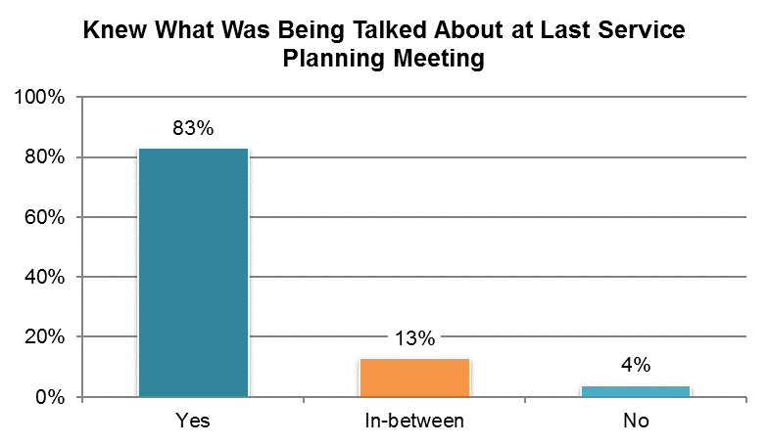

Table . Knew what was talked about at last service planning meeting (yes responses only) º

|  |  |  |  |  |  |  |
| --- | --- | --- | --- | --- | --- | --- |
| State | Overall in State | N | ICF/IID and Other Institutional Settings | Community-based Group Residential Settings | Own Home | Parent’s or Relative’s Home |
| **Significantly Above Average** | | |  |  |  |  |
| AL | 93% | 317 | n/a | 91% | 95% | 95% |
| KY | 93% | 268 | n/a | 92% | 98% | 93% |
| NY | 91% | 273 | n/a | 87% | 93% | 94% |
| KS | 91% | 233 | n/a | 90% | 90% | 91% |
| FL | 90% | 751 | n/a | 89% | 95% | 88% |
| TN | 89% | 302 | n/a | 90% | 88% | 87% |
| **Within Average Range** | | |  |  |  |  |
| LA | 89% | 244 | 83% | n/a | 93% | 89% |
| MA | 88% | 271 | n/a | 87% | 91% | 85% |
| IL | 88% | 225 | n/a | 86% | 93% | 88% |
| AR | 87% | 170 | 85% | n/a | 90% | 76% |
| IN | 86% | 484 | n/a | n/a | 92% | 84% |
| MN | 86% | 189 | n/a | 82% | 95% | 84% |
| AZ | 85% | 130 | n/a | 78% | 88% | 87% |
| WA | 85% | 240 | n/a | n/a | 86% | 84% |
| OH | 85% | 310 | 85% | 81% | 93% | 79% |
| UT | 85% | 200 | n/a | 86% | 87% | 81% |
| WY | 84% | 206 | n/a | 83% | 91% | 80% |
| NC | 84% | 311 | 85% | 89% | 85% | 84% |
| PA | 84% | 321 | n/a | 88% | 95% | 76% |
| MO | 83% | 213 | n/a | 86% | 85% | n/a |
| VA | 83% | 406 | 86% | 85% | 94% | 77% |
| GA | 83% | 283 | n/a | 76% | 88% | 81% |
| SD | 82% | 222 | n/a | 77% | 87% | 80% |
| NV | 81% | 286 | n/a | 82% | 82% | 76% |
| MS | 81% | 156 | n/a | 85% | 91% | 69% |
| HI | 80% | 169 | n/a | 80% | n/a | 80% |
| DC | 80% | 167 | n/a | 78% | n/a | 89% |
| CT | 79% | 192 | n/a | 83% | 87% | 70% |
| MI | 79% | 214 | n/a | 77% | 82% | 79% |
| DE | 78% | 101 | n/a | 82% | n/a | n/a |
| VT | 78% | 157 | n/a | n/a | 84% | 79% |
| RI | 77% | 273 | n/a | 80% | 80% | 76% |
| WI | 77% | 243 | n/a | 63% | 83% | 72% |
| **Significantly Below Average** | | |  |  |  |  |
| ME | 73% | 213 | n/a | 71% | 78% | 78% |
| OK | 71% | 161 | n/a | 80% | 61% | 62% |
| CO | 71% | 271 | n/a | 52% | 85% | 69% |
| NCI Average | 83% | 9,172 | 85% | 82% | 88% | 81% |

ºNew variable to reporting

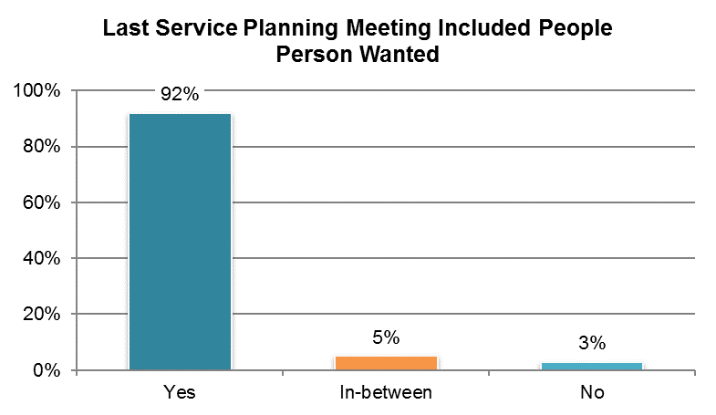

Table . Last service planning meeting included people person wanted to be there (yes responses only) º

|  |  |  |  |  |  |  |
| --- | --- | --- | --- | --- | --- | --- |
| State | Overall in State | N | ICF/IID and Other Institutional Settings | Community-based Group Residential Settings | Own Home | Parent’s or Relative’s Home |
| **Significantly Above Average** | | |  |  |  |  |
| KS | 97% | 239 | n/a | 97% | 97% | 100% |
| TN | 97% | 316 | n/a | 94% | 98% | 97% |
| GA | 97% | 282 | n/a | 90% | 98% | 99% |
| FL | 97% | 757 | n/a | 95% | 97% | 97% |
| CT | 96% | 204 | n/a | 96% | 100% | 94% |
| PA | 96% | 322 | n/a | 95% | 100% | 96% |
| IN | 96% | 495 | n/a | n/a | 97% | 95% |
| **Within Average Range** | | |  |  |  |  |
| HI | 95% | 167 | n/a | 95% | n/a | 94% |
| WI | 95% | 253 | 91% | 93% | 98% | 94% |
| WA | 94% | 246 | n/a | n/a | 93% | 94% |
| NC | 94% | 318 | 91% | 96% | 100% | 95% |
| MA | 94% | 284 | n/a | 96% | 87% | 92% |
| LA | 94% | 243 | 77% | n/a | 97% | 99% |
| AL | 94% | 318 | n/a | 93% | 93% | 95% |
| VA | 94% | 429 | 100% | 93% | 97% | 92% |
| KY | 93% | 281 | n/a | 88% | 98% | 95% |
| IL | 93% | 231 | n/a | 91% | 97% | 94% |
| MN | 93% | 202 | n/a | 95% | 100% | 82% |
| SD | 93% | 242 | n/a | 94% | 94% | 92% |
| OH | 93% | 324 | 93% | 91% | 90% | 95% |
| MO | 92% | 219 | n/a | 89% | 95% | n/a |
| NY | 92% | 270 | n/a | 88% | 93% | 97% |
| ME | 92% | 220 | n/a | 91% | 93% | 95% |
| RI | 92% | 285 | n/a | 95% | 89% | 94% |
| UT | 91% | 211 | n/a | 90% | 95% | 94% |
| WY | 91% | 215 | n/a | 88% | 94% | 90% |
| MI | 91% | 211 | n/a | 87% | 91% | 92% |
| AR | 91% | 172 | 80% | 90% | 92% | 94% |
| AZ | 89% | 133 | n/a | 92% | 88% | 91% |
| NV | 88% | 303 | n/a | 86% | 86% | 100% |
| CO | 88% | 274 | n/a | 76% | 88% | 90% |
| VT | 88% | 155 | n/a | n/a | 94% | 85% |
| DC | 88% | 161 | n/a | 87% | n/a | 89% |
| OK | 86% | 169 | n/a | 84% | 88% | 91% |
| MS | 86% | 168 | n/a | 87% | 84% | 89% |
| **Significantly Below Average** | | |  |  |  |  |
| DE | 79% | 106 | n/a | 81% | n/a | n/a |
| NCI Average | 92% | 9,425 | 89% | 91% | 94% | 94% |

ºNew variable to reporting

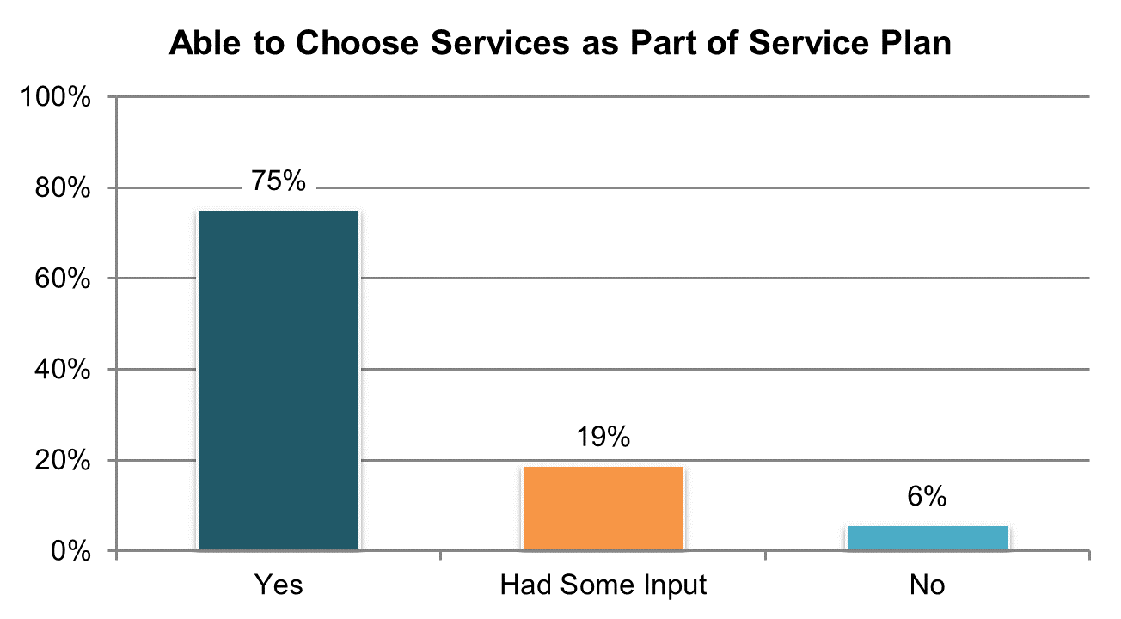

Table . Person was able to choose services they get as part of service plan (yes responses only) º

|  |  |  |  |  |  |  |
| --- | --- | --- | --- | --- | --- | --- |
| State | Overall in State | N | ICF/IID and Other Institutional Settings | Community-based Group Residential Settings | Own Home | Parent’s or Relative’s Home |
| **Significantly Above Average** | | |  |  |  |  |
| KY | 93% | 280 | n/a | 87% | 93% | 96% |
| UT | 91% | 204 | n/a | 87% | 98% | 91% |
| IN | 91% | 490 | n/a | n/a | 92% | 91% |
| FL | 89% | 759 | n/a | 84% | 93% | 90% |
| TN | 88% | 321 | n/a | 92% | 88% | 81% |
| VA | 86% | 430 | 67% | 87% | 88% | 88% |
| GA | 85% | 284 | n/a | 78% | 88% | 86% |
| LA | 84% | 251 | 78% | n/a | 87% | 86% |
| **Within Average Range** | | |  |  |  |  |
| HI | 82% | 168 | n/a | 81% | n/a | 80% |
| PA | 81% | 304 | n/a | 76% | 89% | 81% |
| KS | 81% | 243 | n/a | 77% | 82% | 86% |
| AR | 81% | 175 | n/a | 95% | 82% | 66% |
| ME | 79% | 217 | n/a | 77% | 91% | 85% |
| DC | 79% | 163 | n/a | 82% | n/a | 83% |
| NY | 78% | 271 | n/a | 75% | 88% | 74% |
| IL | 77% | 226 | n/a | 74% | 80% | 81% |
| OH | 77% | 319 | 65% | 83% | 78% | 75% |
| SD | 77% | 236 | n/a | 74% | 81% | 75% |
| WA | 74% | 231 | n/a | n/a | 79% | 74% |
| WY | 74% | 213 | n/a | 62% | 80% | 84% |
| RI | 73% | 288 | n/a | 73% | 74% | 71% |
| AL | 72% | 319 | n/a | 68% | 88% | 72% |
| MI | 72% | 219 | n/a | 65% | 75% | 72% |
| MO | 72% | 208 | n/a | 56% | 79% | n/a |
| NV | 72% | 301 | n/a | 71% | 73% | 76% |
| MA | 71% | 273 | n/a | 67% | 78% | 77% |
| NC | 70% | 308 | 52% | 68% | 74% | 82% |
| CT | 69% | 201 | n/a | 64% | 77% | 73% |
| OK | 67% | 167 | n/a | 69% | 75% | 56% |
| MN | 66% | 197 | n/a | 62% | 78% | 70% |
| AZ | 64% | 132 | n/a | 59% | 72% | 61% |
| **Significantly Below Average** | | |  |  |  |  |
| CO | 63% | 273 | n/a | 49% | 72% | 64% |
| WI | 62% | 250 | 62% | 42% | 65% | 69% |
| VT | 59% | 163 | n/a | n/a | 78% | 59% |
| DE | 56% | 95 | n/a | 56% | n/a | n/a |
| MS | 55% | 181 | n/a | 52% | 63% | 52% |
| NCI Average | 75% | 9,360 | 65% | 72% | 81% | 77% |

ºNew variable to reporting

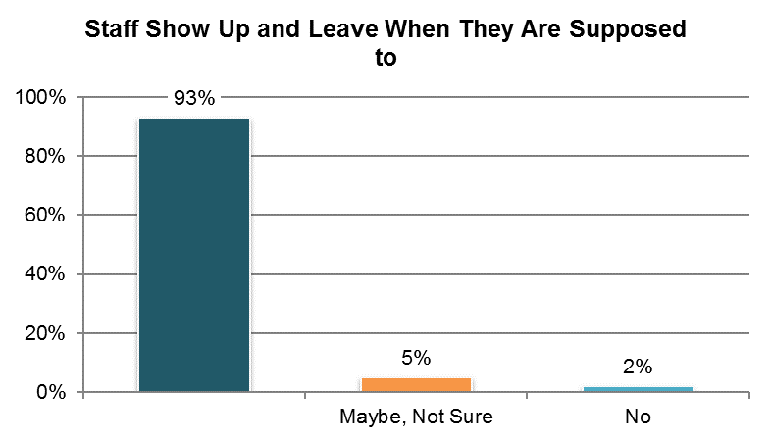

Table . Staff show up and leave when they are supposed to (‘yes’ responses only)

|  |  |  |  |  |  |  |
| --- | --- | --- | --- | --- | --- | --- |
| State | Overall in State | N | ICF/IID and Other Institutional Settings | Community-based Group Residential Settings | Own Home | Parent’s or Relative’s Home |
| **Significantly Above Average** | | |  |  |  |  |
| TN | 99% | 326 | n/a | 99% | 99% | 99% |
| AL | 98% | 313 | n/a | 97% | 98% | 99% |
| AR | 98% | 200 | 100% | 100% | 98% | 96% |
| AZ | 96% | 300 | n/a | 93% | 90% | 98% |
| IN | 96% | 500 | n/a | n/a | 97% | 96% |
| FL | 96% | 746 | n/a | 93% | 96% | 97% |
| **Within Average Range** | | |  |  |  |  |
| LA | 96% | 254 | 98% | n/a | 96% | 95% |
| IL | 96% | 225 | n/a | 95% | 100% | 95% |
| UT | 96% | 232 | n/a | 94% | 98% | 96% |
| OK | 95% | 185 | n/a | 96% | 91% | 97% |
| VA | 95% | 460 | 91% | 96% | 94% | 95% |
| MS | 95% | 278 | n/a | 95% | 95% | 95% |
| WA | 95% | 237 | n/a | n/a | 93% | 96% |
| OH | 95% | 312 | 97% | 88% | 96% | 96% |
| WI | 94% | 204 | 100% | 96% | 92% | 96% |
| KY | 94% | 283 | n/a | 87% | 98% | 98% |
| DC | 94% | 163 | n/a | 95% | n/a | 94% |
| NV | 93% | 323 | n/a | 94% | 91% | 95% |
| PA | 93% | 312 | n/a | 97% | 90% | 91% |
| CT | 93% | 222 | n/a | 90% | 94% | 95% |
| ME | 93% | 266 | n/a | 95% | 87% | 93% |
| NC | 92% | 380 | 84% | 95% | 96% | 90% |
| NY | 92% | 255 | n/a | 92% | 87% | 96% |
| SD | 91% | 253 | n/a | 94% | 90% | 92% |
| MO | 91% | 250 | n/a | 86% | 93% | n/a |
| MN | 91% | 226 | n/a | 91% | 89% | 93% |
| VT | 91% | 217 | n/a | n/a | 91% | 86% |
| MI | 90% | 218 | n/a | 86% | 91% | 93% |
| KS | 90% | 252 | n/a | 92% | 91% | 87% |
| CO | 89% | 267 | n/a | 83% | 89% | 87% |
| GA | 88% | 290 | n/a | 85% | 89% | 88% |
| WY | 88% | 215 | n/a | 84% | 90% | 96% |
| RI | 87% | 295 | n/a | 92% | 86% | 93% |
| HI | 87% | 178 | n/a | 86% | n/a | 86% |
| **Significantly Below Average** | | |  |  |  |  |
| MA | 87% | 263 | n/a | 83% | 93% | 93% |
| DE | 85% | 214 | n/a | 85% | 86% | n/a |
| NCI Average | 93% | 10,114 | 95% | 92% | 93% | 94% |

## Access

### Publicly funded services are readily available to individuals who need and qualify for them.

There are four Access indicators:

1. Proportion of people who reported they always have a way to get places when they need to go somewhere
2. Proportion of people who reported they always have a way to get places when they want to do something for fun
3. Proportion of people who reported their staff have adequate training to meet their needs
4. Proportion of people who report needing additional services

Tables 94 through 98 present the results from these indicators. The corresponding charts show un-collapsed averages.

All un-collapsed state data frequencies for these survey questions by state are displayed in Appendix D.

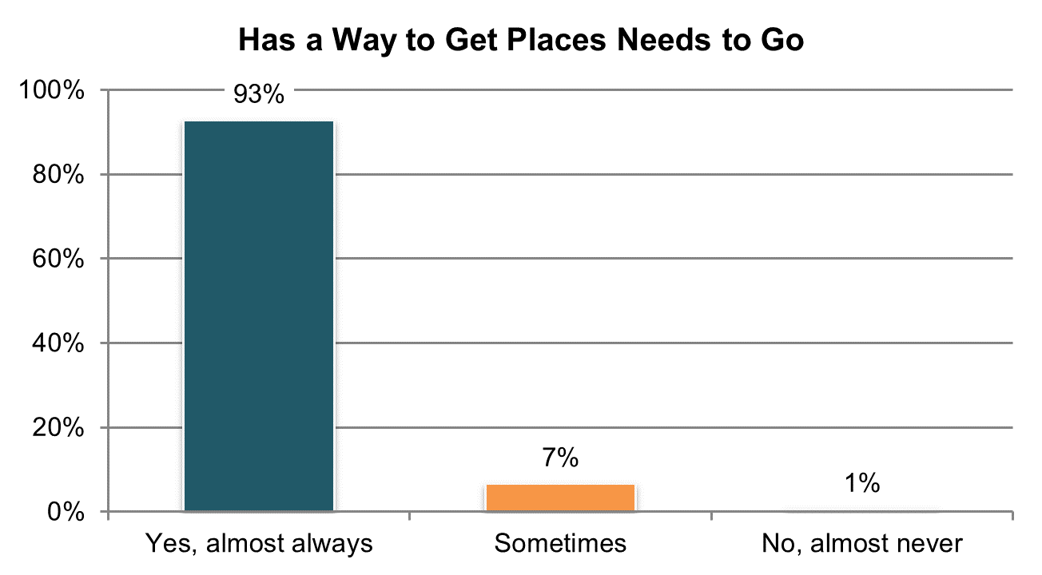

Table . Has a way to get places needs to go (‘yes almost always’ responses only) º

|  |  |  |  |  |  |  |
| --- | --- | --- | --- | --- | --- | --- |
| State | Overall in State | N | ICF/IID and Other Institutional Settings | Community-based Group Residential Settings | Own Home | Parent’s or Relative’s Home |
| **Significantly Above Average** | | |  |  |  |  |
| TN | 99% | 326 | n/a | 98% | 99% | 100% |
| AR | 98% | 226 | 96% | 100% | 97% | 98% |
| OK | 98% | 210 | n/a | 99% | 100% | 95% |
| MA | 97% | 311 | n/a | 97% | 96% | 97% |
| IN | 96% | 567 | n/a | n/a | 96% | 96% |
| **Within Average Range** | | |  |  |  |  |
| CT | 96% | 240 | n/a | 98% | 96% | 96% |
| MN | 96% | 253 | n/a | 97% | 94% | 96% |
| OH | 96% | 390 | 91% | 93% | 94% | 98% |
| AZ | 95% | 417 | n/a | 92% | 98% | 96% |
| WA | 95% | 261 | n/a | n/a | 93% | 97% |
| RI | 95% | 340 | n/a | 95% | 91% | 95% |
| MO | 95% | 264 | n/a | 94% | 95% | 91% |
| PA | 94% | 435 | n/a | 100% | 90% | 95% |
| LA | 94% | 289 | 94% | n/a | 94% | 95% |
| NC | 94% | 428 | 95% | 95% | 86% | 95% |
| ME | 94% | 280 | n/a | 97% | 98% | 87% |
| CO | 93% | 306 | n/a | 97% | 93% | 90% |
| HI | 93% | 198 | n/a | 89% | n/a | 95% |
| DE | 93% | 228 | n/a | 92% | 96% | n/a |
| WI | 93% | 294 | 96% | 97% | 89% | 95% |
| AL | 93% | 334 | n/a | 96% | 88% | 91% |
| VA | 93% | 496 | 88% | 95% | 83% | 92% |
| FL | 92% | 830 | n/a | 92% | 93% | 92% |
| SD | 92% | 277 | n/a | 92% | 94% | 83% |
| VT | 92% | 269 | n/a | n/a | 84% | 96% |
| IL | 92% | 255 | n/a | 91% | 94% | 92% |
| MS | 91% | 295 | n/a | 92% | 91% | 88% |
| KS | 90% | 266 | n/a | 88% | 87% | 98% |
| UT | 90% | 234 | n/a | 90% | 91% | 88% |
| WY | 90% | 235 | n/a | 89% | 90% | 89% |
| DC | 90% | 193 | n/a | 93% | n/a | 94% |
| NV | 89% | 344 | n/a | 90% | 85% | 93% |
| NY | 89% | 310 | n/a | 90% | 86% | 88% |
| MI | 88% | 284 | n/a | 80% | 93% | 90% |
| **Significantly Below Average** | | |  |  |  |  |
| KY | 85% | 293 | n/a | 76% | 84% | 91% |
| GA | 81% | 301 | n/a | 83% | 76% | 83% |
| NCI Average | 93% | 11,479 | 93% | 93% | 92% | 93% |

ºNew variable to reporting

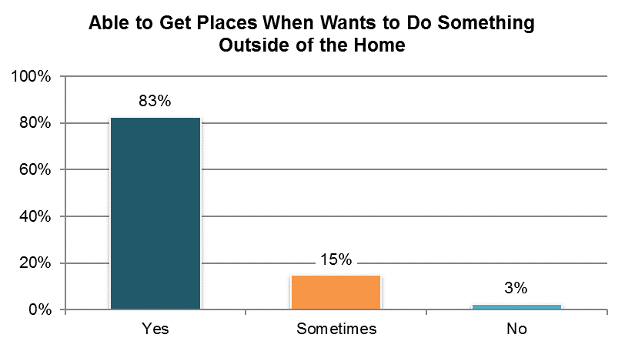

Table . Has a way to get places when wants to go outside of home—like going out to see friends, for entertainment, or to do something fun (‘yes almost always’ responses only) º

|  |  |  |  |  |  |  |
| --- | --- | --- | --- | --- | --- | --- |
| State | Overall in State | N | ICF/IID and Other Institutional Settings | Community-based Group Residential Settings | Own Home | Parent’s or Relative’s Home |
| **Significantly Above Average** | | |  |  |  |  |
| TN | 96% | 327 | n/a | 92% | 96% | 99% |
| PA | 93% | 432 | n/a | 95% | 90% | 94% |
| AR | 92% | 225 | 71% | 92% | 96% | 93% |
| MN | 91% | 253 | n/a | 95% | 92% | 88% |
| WA | 91% | 263 | n/a | n/a | 87% | 94% |
| AZ | 91% | 424 | n/a | 82% | 91% | 94% |
| VA | 88% | 494 | 73% | 88% | 83% | 95% |
| **Within Average Range** | | |  |  |  |  |
| OK | 88% | 206 | n/a | 86% | 98% | 89% |
| HI | 88% | 191 | n/a | 88% | n/a | 89% |
| OH | 87% | 388 | 83% | 87% | 87% | 90% |
| MA | 87% | 309 | n/a | 85% | 92% | 89% |
| LA | 86% | 289 | 82% | n/a | 88% | 87% |
| KY | 85% | 297 | n/a | 75% | 89% | 92% |
| CT | 85% | 241 | n/a | 90% | 82% | 85% |
| MO | 85% | 264 | n/a | 85% | 84% | 82% |
| IN | 84% | 563 | n/a | n/a | 81% | 86% |
| CO | 83% | 304 | n/a | 86% | 86% | 77% |
| KS | 82% | 264 | n/a | 77% | 81% | 93% |
| UT | 82% | 239 | n/a | 79% | 80% | 82% |
| NY | 81% | 301 | n/a | 80% | 76% | 84% |
| NC | 81% | 429 | 84% | 74% | 83% | 87% |
| FL | 81% | 832 | n/a | 74% | 84% | 83% |
| SD | 80% | 281 | n/a | 78% | 83% | 81% |
| IL | 80% | 250 | n/a | 78% | 77% | 82% |
| DC | 80% | 192 | n/a | 82% | n/a | 87% |
| WI | 80% | 289 | 79% | 76% | 78% | 82% |
| RI | 79% | 335 | n/a | 85% | 79% | 77% |
| MI | 79% | 278 | n/a | 73% | 77% | 84% |
| AL | 77% | 332 | n/a | 79% | 70% | 77% |
| WY | 77% | 235 | n/a | 69% | 81% | 79% |
| **Significantly Below Average** | | |  |  |  |  |
| MS | 75% | 291 | n/a | 73% | 75% | 76% |
| GA | 74% | 293 | n/a | 78% | 73% | 73% |
| NV | 74% | 339 | n/a | 73% | 73% | 77% |
| ME | 73% | 264 | n/a | 77% | 76% | 63% |
| DE | 71% | 219 | n/a | 67% | 86% | n/a |
| VT | 67% | 254 | n/a | n/a | 71% | 65% |
| NCI Average | 83% | 11,387 | 79% | 81% | 83% | 84% |

ºNew variable to reporting

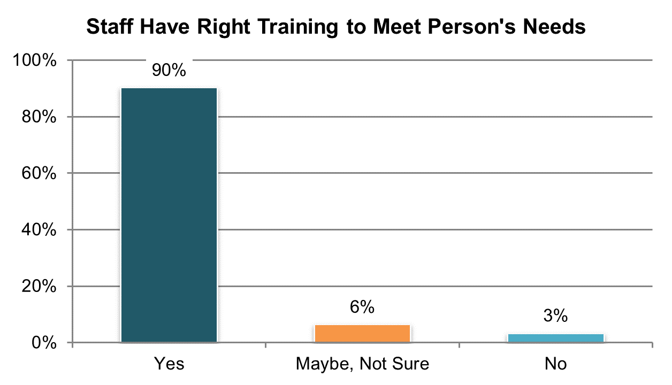

Table . Staff have adequate training to meet the person’s needs (‘yes’ responses only; proxy responses allowed but not asked if proxy is staff)

|  |  |  |  |  |  |  |
| --- | --- | --- | --- | --- | --- | --- |
| State | Overall in State | N | ICF/IID and Other Institutional Settings | Community-based Group Residential Settings | Own Home | Parent’s or Relative’s Home |
| **Significantly Above Average** | | |  |  |  |  |
| TN | 98% | 354 | n/a | 97% | 98% | 98% |
| AR | 96% | 246 | 96% | 100% | 96% | 93% |
| FL | 94% | 1,152 | n/a | 87% | 97% | 96% |
| **Within Average Range** | | |  |  |  |  |
| OK | 95% | 177 | n/a | 96% | 97% | 94% |
| UT | 94% | 273 | n/a | 96% | 96% | 92% |
| LA | 94% | 313 | 94% | n/a | 94% | 94% |
| AL | 93% | 332 | n/a | 93% | 93% | 94% |
| IL | 93% | 256 | n/a | 93% | 93% | 92% |
| PA | 93% | 424 | n/a | 91% | 92% | 93% |
| MO | 93% | 245 | n/a | 89% | 93% | 96% |
| KS | 92% | 270 | n/a | 89% | 93% | 100% |
| MN | 92% | 307 | n/a | 92% | 90% | 92% |
| CT | 92% | 234 | n/a | 86% | 92% | 96% |
| AZ | 92% | 355 | n/a | 92% | 85% | 93% |
| HI | 92% | 218 | n/a | 92% | n/a | 92% |
| WA | 92% | 311 | n/a | n/a | 90% | 93% |
| SD | 91% | 275 | n/a | 94% | 90% | 94% |
| KY | 91% | 317 | n/a | 82% | 93% | 97% |
| ME | 91% | 292 | n/a | 91% | 94% | 91% |
| DC | 91% | 161 | n/a | 91% | n/a | 100% |
| OH | 91% | 351 | 88% | 90% | 92% | 90% |
| NC | 90% | 508 | 95% | 87% | 93% | 90% |
| MS | 90% | 369 | n/a | 90% | 94% | 88% |
| VA | 89% | 566 | 89% | 93% | 88% | 84% |
| MA | 88% | 277 | n/a | 87% | 84% | 89% |
| RI | 88% | 337 | n/a | 94% | 77% | 89% |
| GA | 87% | 292 | n/a | 83% | 85% | 90% |
| VT | 87% | 219 | n/a | n/a | 89% | 84% |
| MI | 87% | 256 | n/a | 90% | 89% | 81% |
| WY | 87% | 261 | n/a | 87% | 85% | 88% |
| CO | 86% | 327 | n/a | 76% | 91% | 83% |
| WI | 86% | 266 | 73% | 95% | 84% | 92% |
| **Significantly Below Average** | | |  |  |  |  |
| IN | 87% | 735 | n/a | n/a | 87% | 88% |
| NY | 84% | 299 | n/a | 88% | 80% | 82% |
| NV | 83% | 350 | n/a | 77% | 88% | 87% |
| DE | 81% | 193 | n/a | 83% | 78% | n/a |
| NCI Average | 90% | 12,118 | 89% | 90% | 90% | 91% |

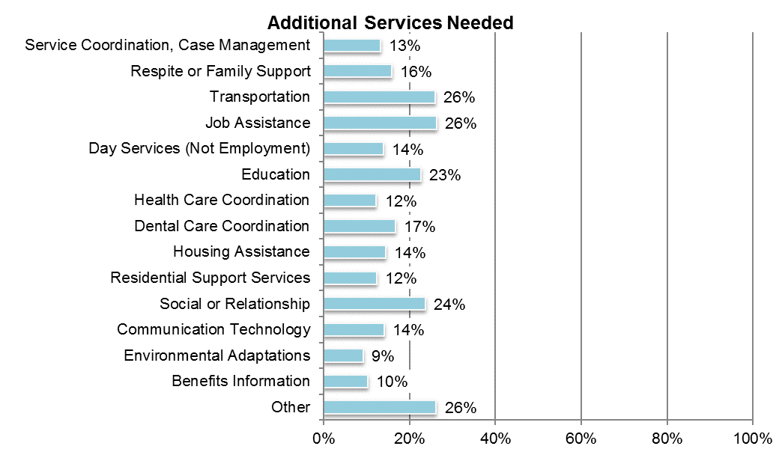

Table . Additional services needed (categories are not mutually exclusive; proxy responses allowed) ±

|  |  |  |  |  |  |  |  |
| --- | --- | --- | --- | --- | --- | --- | --- |
| State | Service Coordination, Case Management | Respite or Family Support | Transportation | Job Assistance | Day Services (Not Employment) | Education | Health Care Coordination |
| AL | 1% | 3% | 27% | 59% | 1% | 14% | 3% |
| AR | 2% | 7% | 6% | 13% | 3% | 13% | 3% |
| AZ | 5% | 20% | 26% | 20% | 9% | 26% | 11% |
| CO | 20% | 28% | 35% | 30% | 18% | 27% | 15% |
| CT | 15% | 24% | 37% | 24% | 21% | 28% | 16% |
| DC | 3% | 6% | 26% | 31% | 5% | 28% | 6% |
| DE | 38% | 22% | 24% | 50% | 20% | 42% | 18% |
| FL | 3% | 13% | 14% | 18% | 8% | 9% | 5% |
| GA | 11% | 12% | 26% | 21% | 3% | 14% | 11% |
| HI | 4% | 21% | 23% | 11% | 5% | 14% | 4% |
| IL | 5% | 5% | 12% | 16% | 4% | 9% | 5% |
| IN | 1% | 22% | 21% | 11% | 10% | 15% | 6% |
| KS | 45% | 7% | 33% | 21% | 36% | 14% | 44% |
| KY | 3% | 9% | 20% | 22% | 9% | 11% | 5% |
| LA | 2% | 8% | 11% | 25% | 4% | 19% | 7% |
| MA | 11% | 16% | 15% | 19% | 12% | 15% | 7% |
| ME | 3% | 11% | 15% | 34% | 5% | 20% | 2% |
| MI | 7% | 16% | 31% | 33% | 22% | 33% | 10% |
| MN | 26% | 23% | 44% | 36% | 23% | 35% | 17% |
| MO | 6% | 6% | 16% | 31% | 11% | 24% | 10% |
| MS | 13% | 28% | 34% | 25% | 15% | 40% | 18% |
| NC | 15% | 27% | 23% | 26% | 14% | 32% | 13% |
| NV | 28% | 26% | 49% | 37% | 30% | 35% | 33% |
| NY | 24% | 14% | 33% | 19% | 15% | 21% | 30% |
| OH | 20% | 14% | 31% | 32% | 23% | 36% | 15% |
| OK | 16% | 16% | 34% | 18% | 13% | 30% | 5% |
| PA | 6% | 18% | 22% | 16% | 12% | 18% | 6% |
| RI | 19% | 19% | 38% | 43% | 23% | 38% | 22% |
| SD | 29% | 14% | 51% | 33% | 19% | 25% | 25% |
| TN | 6% | 11% | 8% | 27% | 2% | 22% | 2% |
| UT | 6% | 10% | 13% | 16% | 8% | 19% | 7% |
| VA | 8% | 19% | 19% | 21% | 13% | 18% | 9% |
| VT | 13% | 23% | 22% | 29% | 35% | 11% | 3% |
| WA | 15% | 25% | 25% | 26% | 16% | 18% | 13% |
| WI | 17% | 17% | 42% | 20% | 14% | 27% | 14% |
| WY | 32% | 13% | 29% | 30% | 21% | 17% | 22% |
| NCI Average | 13% | 16% | 26% | 26% | 14% | 23% | 12% |

±Item changed from previous years – question and response options rephrased (see Appendix A)

Table . Additional services needed, continued (categories are not mutually exclusive; proxy responses allowed) ±

|  |  |  |  |  |  |  |  |  |
| --- | --- | --- | --- | --- | --- | --- | --- | --- |
| State | Dental Care Coordination | Housing Assistance | Residential Support Services | Social or Relationship | Communication Technology | Environmental Adaptations | Benefits Information | Other |
| AL | 2% | 29% | 8% | 37% | 4% | 5% | 2% | 9% |
| AR | 12% | 6% | 2% | 14% | 8% | 7% | 2% | 54% |
| AZ | 16% | 14% | 9% | 19% | 16% | 11% | 12% | 35% |
| CO | 13% | 12% | 13% | 32% | 16% | 11% | 17% | 14% |
| CT | 14% | 14% | 22% | 31% | 19% | 11% | 13% | 19% |
| DC | 9% | 16% | 5% | 18% | 17% | 5% | 1% | 22% |
| DE | 18% | 23% | 15% | 44% | 21% | 4% | 5% | 9% |
| FL | 17% | 4% | 5% | 19% | 7% | 8% | 2% | 32% |
| GA | 26% | 8% | 15% | 8% | 9% | 0% | 2% | 12% |
| HI | 14% | 11% | 2% | 6% | 9% | 4% | 7% | 50% |
| IL | 5% | 8% | 5% | 12% | 7% | 3% | 2% | 55% |
| IN | 5% | 7% | 17% | 16% | 9% | 6% | 4% | 33% |
| KS | 42% | 7% | 36% | 20% | 5% | 7% | 27% | 13% |
| KY | 3% | 22% | 5% | 17% | 8% | 5% | 7% | 14% |
| LA | 16% | 18% | 6% | 20% | 8% | 13% | 4% | 39% |
| MA | 8% | 10% | 12% | 20% | 11% | 5% | 9% | 39% |
| ME | 7% | 12% | 4% | 31% | 15% | 4% | 1% | 48% |
| MI | 21% | 17% | 21% | 33% | 17% | 7% | 7% | 8% |
| MN | 21% | 24% | 16% | 30% | 17% | 17% | 18% | 4% |
| MO | 19% | 14% | 8% | 23% | 14% | 11% | 8% | 20% |
| MS | 28% | 10% | 15% | 22% | 20% | 22% | 29% | 8% |
| NC | 16% | 11% | 13% | 26% | 21% | 15% | 7% | 36% |
| NV | 46% | 36% | 23% | 42% | 20% | 9% | 23% | 27% |
| NY | 27% | 18% | 9% | 36% | 12% | 5% | 30% | 18% |
| OH | 17% | 21% | 14% | 28% | 22% | 13% | 15% | 23% |
| OK | 6% | 10% | 10% | 15% | 18% | 18% | 10% | 45% |
| PA | 8% | 13% | 9% | 18% | 11% | 9% | 5% | 26% |
| RI | 19% | 23% | 21% | 42% | 27% | 18% | 21% | 22% |
| SD | 27% | 23% | 31% | 25% | 29% | 12% | 29% | 6% |
| TN | 1% | 12% | 4% | 21% | 18% | 8% | 3% | 53% |
| UT | 16% | 7% | 7% | 15% | 9% | 9% | 5% | 38% |
| VA | 36% | 7% | 10% | 18% | 22% | 14% | 4% | 20% |
| VT | 3% | 9% | 1% | 28% | 4% | 1% | 1% | 25% |
| WA | 18% | 11% | 9% | 21% | 12% | 10% | 8% | 17% |
| WI | 24% | 17% | 19% | 29% | 12% | 19% | 23% | 23% |
| WY | 20% | 16% | 24% | 18% | 13% | 5% | 8% | 25% |
| NCI Average | 17% | 14% | 12% | 24% | 14% | 9% | 10% | 26% |

±Item changed from previous years – question and response options rephrased (see Appendix A)

## Health

### People secure needed health services.

The Health indicators are collected in the Background Information section of the Adult Consumer Survey. The 10 core Health indicators are:

1. Proportion of people who were reported to have a primary care practioner
2. Proportion of people who were reported to be in poor health
3. Proportion of people who were reported to have had a complete physical exam in the past year
4. Proportion of people who were reported to have had a dental exam in the past year
5. Proportion of people who were reported to have had an eye exam in the past year
6. Proportion of people who were reported to have had a hearing test in the past five years
7. Proportion of women who were reported to have had a Pap test in the past three years
8. Proportion of women over 40 who were reported to have had a mammogram test in the past two years
9. Proportion of people 50 or over who were reported to have had a colorectal cancer screening in the past year
10. Proportion of people who were reported to have had a flu vaccine in the past year

Tables 99 through 108 present the results for these 10 core indicators. The corresponding charts show un-collapsed averages.

All un-collapsed state data frequencies for these survey questions are displayed in Appendix D.

Important note on changes to the survey tool and analysis. In examining the results included in the Health section, we found that a number of states had a large amount of missing data for these questions. States for which 25% or more of their sample were missing data for specific questions are indicated with an asterisk. The quantity of missing data can be a result of several factors. We do not know, however, whether the data are missing systematically or randomly; for example, for a specific state, are the data missing across the board for those in a specific waiver? If so, the resulting data are not representative of the entire sample or population. As a result, we advise caution when examining the health data.

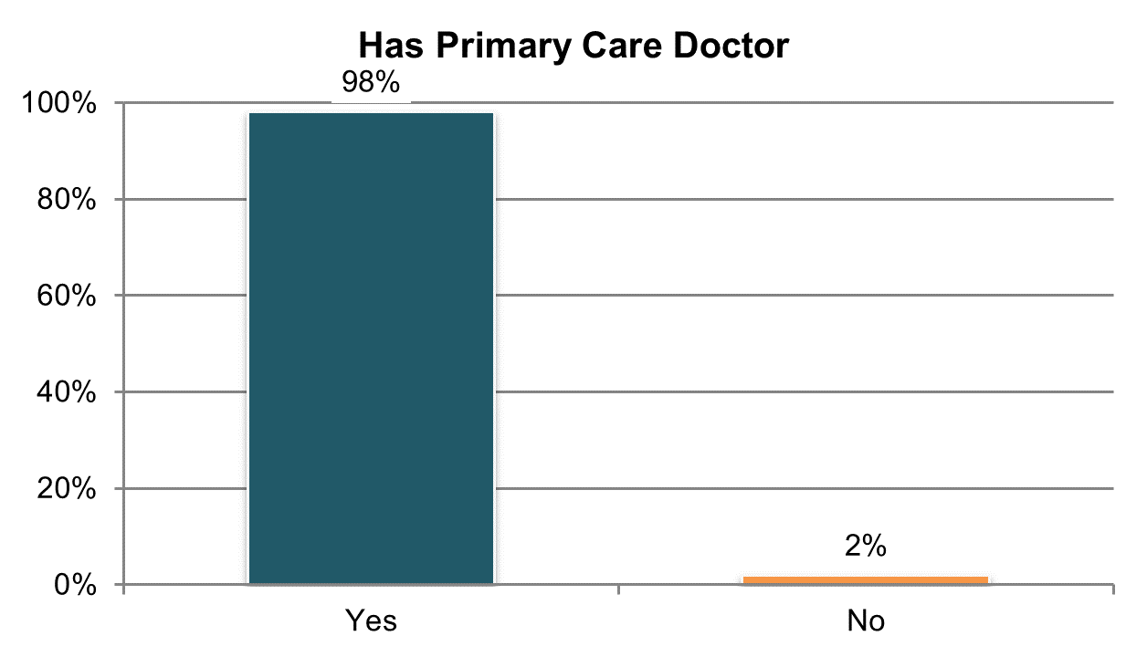

Table . Has a primary care doctor or primary care practitioner (information comes from Background Information section)

|  |  |  |  |  |  |  |
| --- | --- | --- | --- | --- | --- | --- |
| State | Overall in State | N | ICF/IID and Other Institutional Settings | Community-based Group Residential Settings | Own Home | Parent’s or Relative’s Home |
| **Significantly Above Average** | | |  |  |  |  |
| DC | 100% | 346 | 100% | 100% | 100% | 100% |
| WI | 100% | 391 | 100% | 100% | 99% | 100% |
| MO | 99% | 398 | n/a | 100% | 100% | 98% |
| AL | 99% | 393 | n/a | 99% | 100% | 100% |
| **Within Average Range** | | |  |  |  |  |
| MA | 99% | 417 | n/a | 99% | 100% | 100% |
| WA | 99% | 401 | n/a | 100% | 100% | 98% |
| NV | 99% | 393 | n/a | 99% | 98% | 100% |
| KS | 99% | 371 | n/a | 99% | 99% | 99% |
| SD | 99% | 362 | n/a | 100% | 97% | 100% |
| DE | 99% | 424 | n/a | 99% | 100% | n/a |
| OK | 99% | 400 | n/a | 99% | 99% | 98% |
| HI | 99% | 395 | n/a | 98% | n/a | 99% |
| RI ** | 99% | 375 | n/a | 100% | 98% | 99% |
| MN | 99% | 409 | 100% | 98% | 100% | 98% |
| CT | 98% | 341 | n/a | 99% | 100% | 98% |
| VA | 98% | 778 | 100% | 98% | 98% | 97% |
| WY | 98% | 313 | n/a | 98% | 99% | 96% |
| NC | 98% | 817 | 96% | 98% | 100% | 98% |
| NY | 98% | 497 | 98% | 98% | 97% | 98% |
| ME | 98% | 397 | n/a | 98% | 96% | 98% |
| VT | 98% | 326 | n/a | 100% | 98% | 98% |
| FL | 98% | 1,442 | n/a | 100% | 97% | 98% |
| GA | 98% | 462 | n/a | 99% | 98% | 97% |
| IN | 98% | 827 | n/a | 100% | 99% | 97% |
| KY | 98% | 450 | n/a | 96% | 96% | 99% |
| MI | 97% | 431 | n/a | 98% | 96% | 97% |
| AR | 97% | 390 | 98% | 97% | 98% | 97% |
| UT | 97% | 386 | 100% | 98% | 96% | 97% |
| OH | 97% | 593 | 98% | 97% | 99% | 96% |
| PA | 97% | 627 | 98% | 96% | 96% | 98% |
| LA | 97% | 433 | 94% | n/a | 97% | 99% |
| IL | 97% | 393 | n/a | 98% | 97% | 97% |
| AZ | 97% | 463 | n/a | 98% | 93% | 98% |
| MS | 97% | 395 | n/a | 97% | 97% | 97% |
| TN | 96% | 435 | n/a | 98% | 95% | 95% |
| CO | 96% | 405 | n/a | 99% | 96% | 94% |
| NCI Average | 98% | 17,076 | 98% | 99% | 98% | 98% |

**State had a large number of “don’t know” responses and missing data (at least 25%)

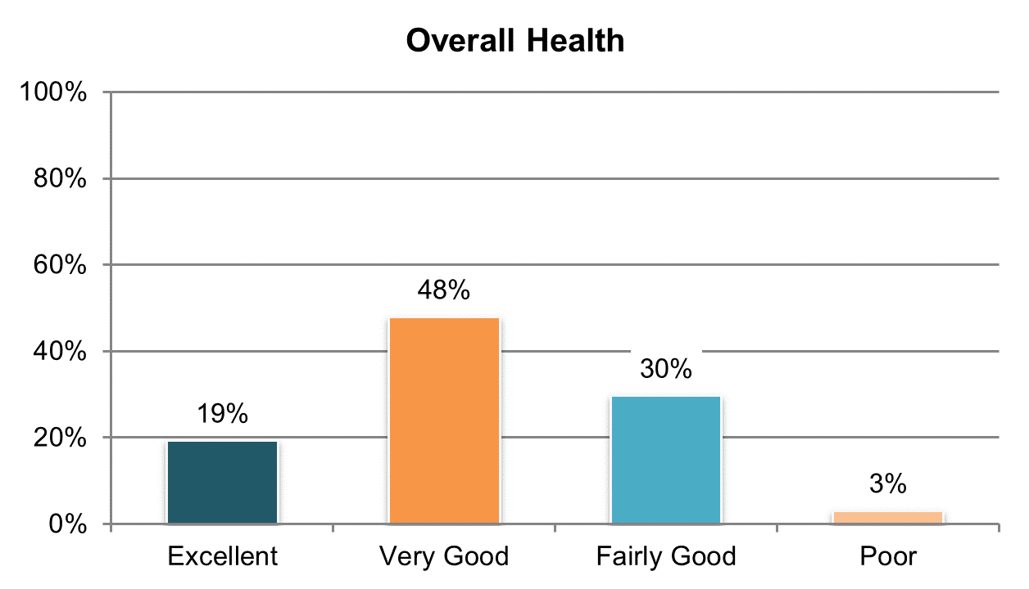

Table . In poor health (‘poor health’ response only; proxy responses allowed)

|  |  |  |  |  |  |  |
| --- | --- | --- | --- | --- | --- | --- |
| State | Overall in State | N | ICF/IID and Other Institutional Settings | Community-based Group Residential Settings | Own Home | Parent’s or Relative’s Home |
| **Significantly Above Average** | | |  |  |  |  |
| KY | 7% | 443 | n/a | 6% | 6% | 9% |
| **Within Average Range** | | |  |  |  |  |
| WY | 5% | 303 | n/a | 5% | 5% | 7% |
| MS | 5% | 397 | n/a | 6% | 2% | 6% |
| OH | 5% | 537 | 9% | 5% | 6% | 2% |
| MN | 4% | 403 | 7% | 4% | 2% | 4% |
| TN | 4% | 433 | n/a | 4% | 3% | 7% |
| WI | 4% | 403 | 5% | 2% | 7% | 2% |
| VT | 4% | 321 | n/a | 5% | 8% | 4% |
| KS | 4% | 353 | n/a | 5% | 3% | 2% |
| MO | 4% | 388 | n/a | 2% | 4% | 8% |
| SD | 4% | 334 | n/a | 6% | 2% | 3% |
| OK | 4% | 397 | n/a | 3% | 4% | 4% |
| DE | 3% | 372 | n/a | 3% | 4% | n/a |
| VA | 3% | 806 | 5% | 2% | 0% | 5% |
| IN | 3% | 815 | n/a | n/a | 2% | 3% |
| AR | 3% | 368 | 2% | 9% | 4% | 1% |
| ME | 3% | 376 | n/a | 2% | 2% | 5% |
| FL | 3% | 1,420 | n/a | 2% | 3% | 3% |
| UT | 3% | 387 | 4% | 3% | 4% | 3% |
| MI | 3% | 427 | n/a | 4% | 2% | 2% |
| AZ | 3% | 465 | n/a | 2% | 2% | 3% |
| CO | 3% | 404 | n/a | 3% | 3% | 3% |
| LA | 3% | 423 | 2% | n/a | 4% | 2% |
| NV | 3% | 393 | n/a | 3% | 2% | 0% |
| WA | 3% | 396 | n/a | 0% | 5% | 1% |
| MA | 2% | 408 | n/a | 4% | 0% | 1% |
| NC | 2% | 739 | 2% | 2% | 0% | 3% |
| PA | 2% | 660 | 6% | 3% | 4% | 2% |
| RI | 2% | 449 | n/a | 3% | 2% | 2% |
| IL | 2% | 368 | n/a | 1% | 3% | 3% |
| HI | 2% | 374 | n/a | 3% | n/a | 2% |
| DC | 2% | 390 | 3% | 2% | 0% | 1% |
| **Significantly Below Average** | | |  |  |  |  |
| NY | 1% | 483 | 2% | 2% | 0% | 1% |
| CT | 1% | 323 | n/a | 1% | 0% | 1% |
| GA | 1% | 447 | n/a | 1% | 1% | 1% |
| AL | 1% | 376 | n/a | 1% | 0% | 0% |
| NCI Average | 3% | 16,781 | 4% | 3% | 3% | 3% |

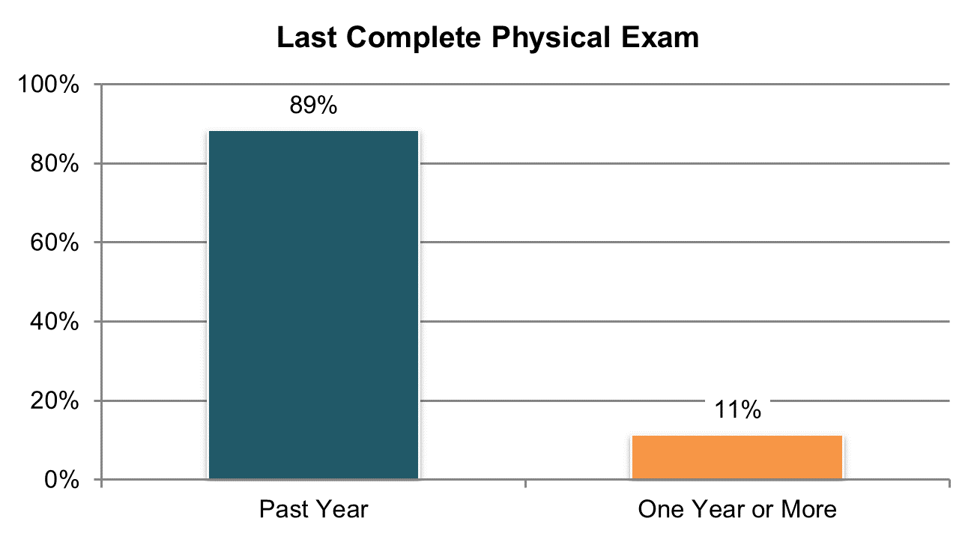

Table . Had a complete physical exam in the past year (‘within the last year or less’ responses; information comes from Background Information section)

|  |  |  |  |  |  |  |
| --- | --- | --- | --- | --- | --- | --- |
| State | Overall in State | N | ICF/IID and Other Institutional Settings | Community-based Group Residential Settings | Own Home | Parent’s or Relative’s Home |
| **Significantly Above Average** | | |  |  |  |  |
| OK | 97% | 400 | n/a | 97% | 98% | 96% |
| AR | 97% | 377 | 100% | 94% | 96% | 95% |
| MO | 96% | 391 | n/a | 98% | 96% | 88% |
| SD | 95% | 353 | n/a | 98% | 95% | 87% |
| ME | 95% | 388 | n/a | 95% | 91% | 95% |
| CT | 95% | 316 | n/a | 98% | 96% | 89% |
| LA | 94% | 409 | 95% | n/a | 94% | 95% |
| FL | 94% | 1,438 | n/a | 96% | 92% | 93% |
| AL | 93% | 392 | n/a | 96% | 100% | 85% |
| NC | 93% | 774 | 97% | 98% | 80% | 90% |
| MA | 93% | 406 | n/a | 95% | 81% | 90% |
| TN | 93% | 432 | n/a | 97% | 94% | 83% |
| PA | 92% | 604 | 91% | 99% | 84% | 89% |
| **Within Average Range** | | |  |  |  |  |
| NV | 91% | 383 | n/a | 94% | 91% | 78% |
| NY | 90% | 487 | 98% | 94% | 87% | 81% |
| MI | 90% | 397 | n/a | 96% | 91% | 81% |
| UT | 90% | 361 | 100% | 97% | 86% | 80% |
| IN | 90% | 809 | n/a | n/a | 94% | 89% |
| GA | 89% | 454 | n/a | 93% | 83% | 89% |
| CO | 89% | 387 | n/a | 93% | 81% | 86% |
| KY | 88% | 412 | n/a | 91% | 83% | 87% |
| RI ** | 88% | 319 | n/a | 95% | 88% | 80% |
| VT | 88% | 316 | n/a | 100% | 80% | 83% |
| VA | 86% | 749 | 94% | 90% | 80% | 79% |
| IL | 86% | 372 | n/a | 94% | 84% | 74% |
| WA | 86% | 395 | n/a | 90% | 83% | 86% |
| OH ** | 85% | 498 | 100% | 90% | 84% | 77% |
| DE | 84% | 398 | n/a | 83% | 85% | n/a |
| DC ** | 83% | 268 | 83% | 83% | 91% | 79% |
| **Significantly Below Average** | | |  |  |  |  |
| KS | 81% | 363 | n/a | 86% | 82% | 72% |
| AZ ** | 81% | 365 | n/a | 89% | 85% | 76% |
| WY | 80% | 314 | n/a | 80% | 82% | 79% |
| HI | 76% | 396 | n/a | 77% | n/a | 75% |
| MN | 64% | 386 | 72% | 80% | 43% | 40% |
| NCI Average | 89% | 15,509 | 93% | 92% | 87% | 83% |

**State had a large number of “don’t know” responses and missing data (at least 25%)

**Note:** The following states were not included in analysis due to low N (<20): MS and WI

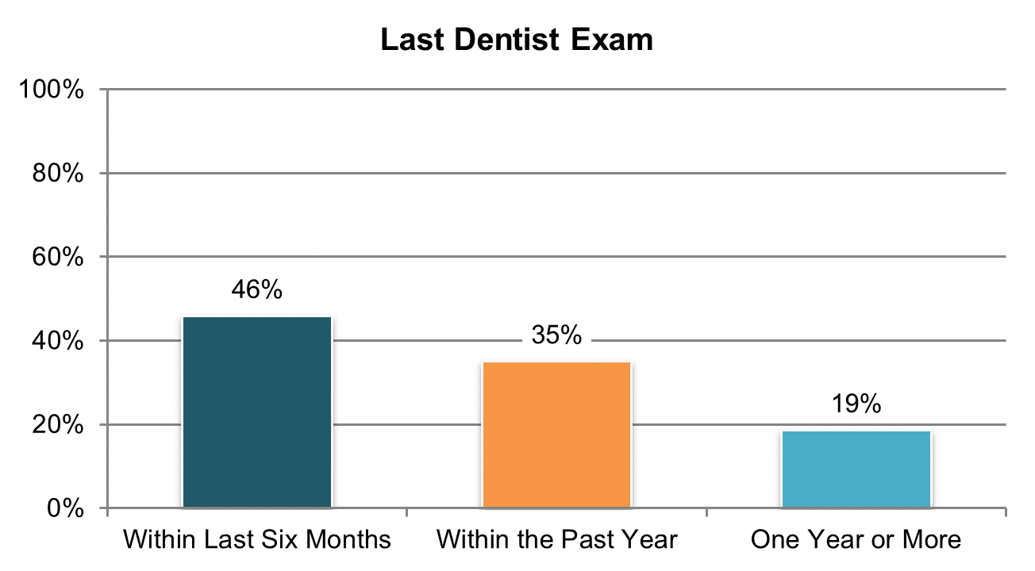

Table . Had a dental exam in the past year (within the last year or less responses; information comes from Background Information section)

|  |  |  |  |  |  |  |
| --- | --- | --- | --- | --- | --- | --- |
| State | Overall in State | N | ICF/IID and Other Institutional Settings | Community-based Group Residential Settings | Own Home | Parent’s or Relative’s Home |
| **Within Average Range** | | |  |  |  |  |
| SD | 97% | 346 | n/a | 96% | 98% | 96% |
| CT | 95% | 300 | n/a | 97% | 96% | 90% |
| MA | 93% | 401 | n/a | 95% | 82% | 93% |
| NY | 91% | 457 | 96% | 97% | 79% | 82% |
| TN | 89% | 409 | n/a | 95% | 94% | 74% |
| DE | 89% | 390 | n/a | 90% | 86% | n/a |
| RI ** | 88% | 247 | n/a | 94% | 83% | 79% |
| AR | 87% | 318 | 99% | 97% | 81% | 78% |
| OK | 86% | 388 | n/a | 89% | 83% | 86% |
| NC | 85% | 739 | 100% | 90% | 77% | 80% |
| **Significantly Above Average** | | |  |  |  |  |
| DC ** | 86% | 249 | 86% | 87% | 95% | 79% |
| VT | 86% | 295 | n/a | n/a | 81% | 86% |
| MO | 86% | 374 | n/a | 89% | 86% | 69% |
| IN | 85% | 795 | n/a | n/a | 81% | 85% |
| KY | 84% | 363 | n/a | 93% | 74% | 76% |
| PA ** | 83% | 528 | 90% | 95% | 59% | 79% |
| AL | 81% | 345 | n/a | 91% | 87% | 61% |
| KS | 80% | 312 | n/a | 84% | 75% | 81% |
| FL | 80% | 1,404 | n/a | 91% | 78% | 76% |
| OH ** | 80% | 419 | 92% | 91% | 79% | 68% |
| UT | 80% | 318 | 96% | 84% | 74% | 72% |
| IL | 80% | 327 | n/a | 91% | 69% | 63% |
| ME | 79% | 369 | n/a | 80% | 79% | 83% |
| NV | 79% | 345 | n/a | 85% | 75% | 62% |
| WA | 78% | 399 | n/a | 90% | 82% | 76% |
| GA | 77% | 402 | n/a | 89% | 69% | 74% |
| WY | 76% | 306 | n/a | 77% | 76% | 78% |
| AZ ** | 75% | 313 | n/a | 75% | 75% | 72% |
| LA | 75% | 357 | 98% | n/a | 69% | 57% |
| **Significantly Below Average** | | |  |  |  |  |
| MI | 74% | 341 | n/a | 77% | 75% | 67% |
| MN | 73% | 396 | 80% | 84% | 60% | 58% |
| VA ** | 72% | 645 | 90% | 76% | 72% | 63% |
| CO | 71% | 384 | n/a | 83% | 65% | 54% |
| MS ** | 64% | 258 | n/a | 68% | 66% | 61% |
| HI | 56% | 319 | n/a | 50% | n/a | 59% |
| NCI Average | 81% | 14,558 | 93% | 87% | 78% | 74% |

**State had a large number of “don’t know” responses and missing data (at least 25%)

**Note:** WI is not included in analysis due to low N (<20)

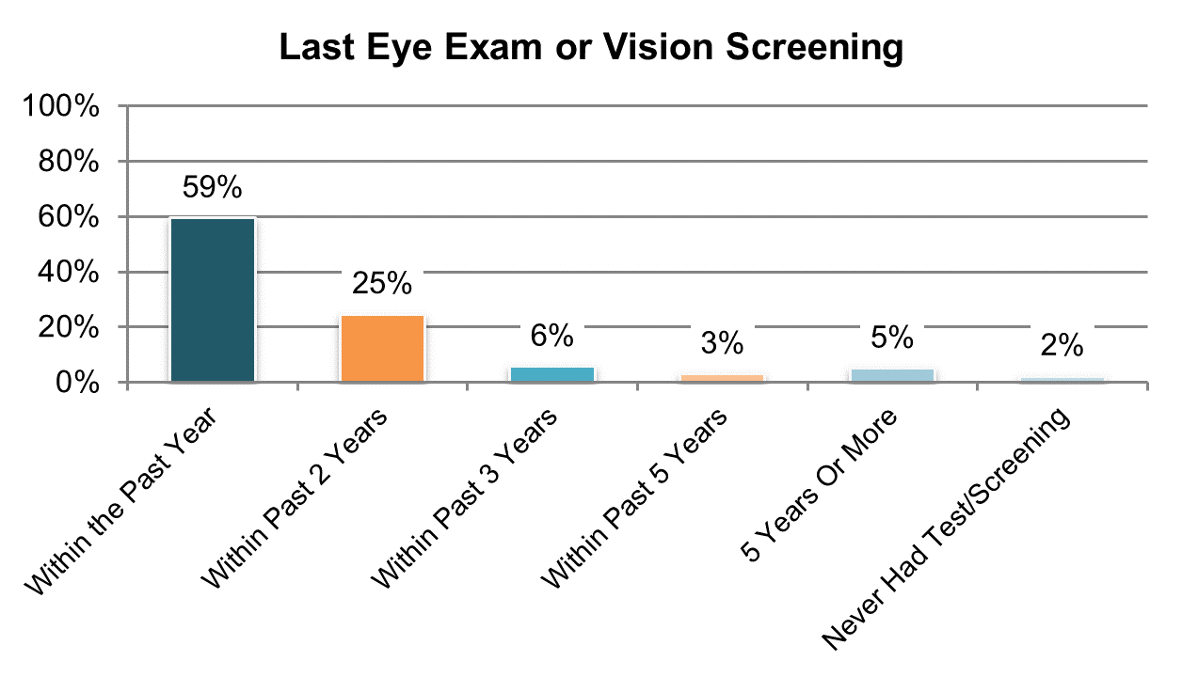

Table . Had an eye exam in the past year (within the last year or less responses; information comes from Background Information section)

|  |  |  |  |  |  |  |
| --- | --- | --- | --- | --- | --- | --- |
| State | Overall in State | N | ICF/IID and Other Institutional Settings | Community-based Group Residential Settings | Own Home | Parent’s or Relative’s Home |
| **Within Average Range** | | |  |  |  |  |
| TN | 80% | 396 | n/a | 87% | 86% | 55% |
| DC ** | 76% | 187 | 68% | 78% | n/a | 76% |
| IL ** | 73% | 298 | n/a | 83% | 67% | 49% |
| NV ** | 72% | 307 | n/a | 74% | 75% | 62% |
| SD | 71% | 346 | n/a | 77% | 73% | 40% |
| AR ** | 70% | 285 | 80% | 89% | 68% | 51% |
| KY ** | 69% | 304 | n/a | 86% | 52% | 53% |
| NY | 69% | 450 | 88% | 73% | 59% | 61% |
| PA ** | 69% | 454 | 70% | 84% | 52% | 60% |
| MO | 67% | 375 | n/a | 77% | 66% | 55% |
| OK | 66% | 385 | n/a | 69% | 75% | 56% |
| DE | 64% | 351 | n/a | 66% | 58% | n/a |
| GA ** | 64% | 306 | n/a | 77% | 66% | 57% |
| LA ** | 61% | 329 | 87% | n/a | 47% | 44% |
| MA | 61% | 376 | n/a | 64% | 60% | 54% |
| AZ ** | 61% | 226 | n/a | 72% | 73% | 52% |
| CT ** | 59% | 231 | n/a | 63% | 73% | 44% |
| KS ** | 59% | 282 | n/a | 60% | 62% | 51% |
| MS ** | 58% | 195 | n/a | 68% | 64% | 44% |
| RI ** | 58% | 235 | n/a | 54% | 65% | 59% |
| WY | 57% | 297 | n/a | 58% | 54% | 58% |
| MN | 56% | 351 | 63% | 64% | 52% | 39% |
| FL | 54% | 1,342 | n/a | 63% | 54% | 49% |
| VT | 54% | 250 | n/a | n/a | 53% | 45% |
| VA ** | 53% | 467 | 56% | 57% | 41% | 46% |
| OH ** | 53% | 393 | 83% | 57% | 46% | 37% |
| IN | 51% | 772 | n/a | n/a | 58% | 48% |
| HI ** | 50% | 282 | n/a | 45% | n/a | 48% |
| NC ** | 50% | 647 | 60% | 60% | 50% | 40% |
| WA | 49% | 346 | n/a | 48% | 61% | 41% |
| UT ** | 49% | 202 | 62% | 58% | 41% | 29% |
| AL | 49% | 313 | n/a | 57% | 48% | 32% |
| MI ** | 48% | 293 | n/a | 50% | 52% | 43% |
| CO | 41% | 335 | n/a | 44% | 51% | 36% |
| ME | 39% | 356 | n/a | 40% | 43% | 31% |
| NCI Average | 59% | 12,964 | 72% | 66% | 59% | 48% |

**State had a large number of “don’t know” responses and missing data (at least 25%)

**Note:** WI is not included in analysis due to low N (<20)

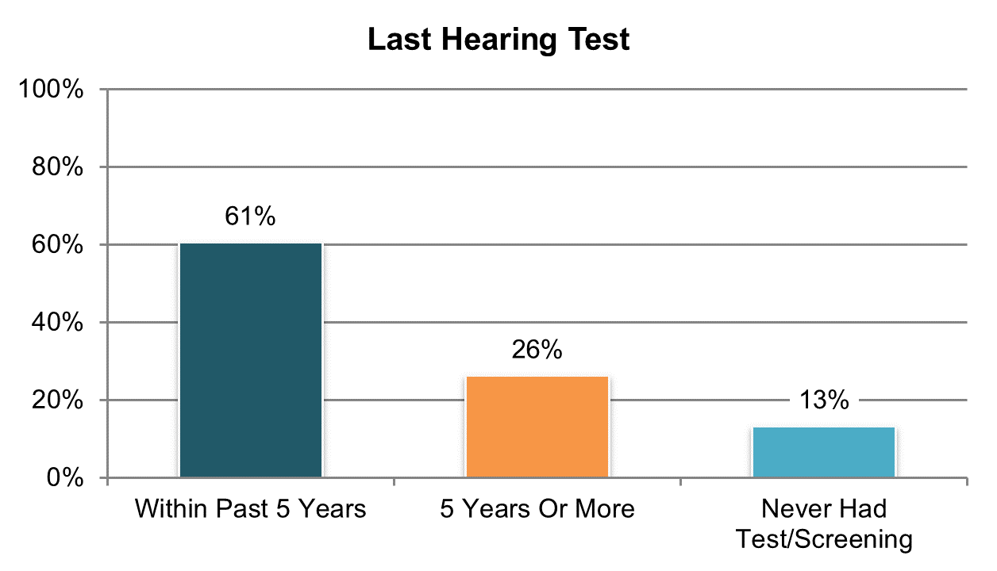

Table . Had a hearing test in the past five years (‘within five years or less’ responses; information comes from Background Information section)

|  |  |  |  |  |  |  |
| --- | --- | --- | --- | --- | --- | --- |
| State | Overall in State | N | ICF/IID and Other Institutional Settings | Community-based Group Residential Settings | Own Home | Parent’s or Relative’s Home |
| **Within Average Range** | | |  |  |  |  |
| CO ** | 99% | 77 | n/a | n/a | n/a | n/a |
| DC ** | 98% | 156 | 96% | 100% | n/a | 90% |
| TN | 91% | 354 | n/a | 95% | 94% | 80% |
| PA ** | 86% | 310 | 97% | 96% | 77% | 75% |
| IL ** | 78% | 210 | n/a | 81% | n/a | 69% |
| NY | 77% | 395 | 93% | 84% | 62% | 62% |
| CT ** | 76% | 152 | n/a | 81% | n/a | 59% |
| DE ** | 73% | 111 | n/a | 75% | n/a | n/a |
| HI ** | 71% | 231 | n/a | 59% | n/a | 75% |
| AZ ** | 70% | 162 | n/a | 86% | n/a | 64% |
| AR ** | 69% | 217 | 86% | n/a | 68% | 39% |
| AL ** | 65% | 168 | n/a | 74% | 72% | 45% |
| MN ** | 63% | 230 | n/a | 65% | n/a | 55% |
| MA ** | 61% | 318 | n/a | 71% | 59% | 39% |
| OH ** | 61% | 242 | 81% | 70% | 44% | 47% |
| GA ** | 61% | 218 | n/a | 66% | 55% | 57% |
| VT ** | 59% | 181 | n/a | n/a | 64% | 63% |
| RI ** | 58% | 150 | n/a | 73% | 45% | 44% |
| NV ** | 58% | 151 | n/a | 63% | 54% | n/a |
| LA ** | 56% | 251 | 81% | n/a | 38% | 34% |
| KY ** | 56% | 179 | n/a | 56% | 64% | 50% |
| UT ** | 56% | 133 | 96% | 49% | n/a | 35% |
| MO ** | 55% | 249 | n/a | 56% | 59% | 26% |
| NC ** | 50% | 485 | 76% | 54% | 36% | 36% |
| SD | 49% | 278 | n/a | 51% | 45% | 37% |
| FL | 48% | 1,125 | n/a | 53% | 42% | 48% |
| MI ** | 48% | 224 | n/a | 57% | 40% | 39% |
| ME ** | 47% | 190 | n/a | 53% | 45% | 40% |
| VA ** | 46% | 282 | 96% | 48% | 43% | 31% |
| MS ** | 46% | 144 | n/a | 58% | 41% | 43% |
| KS ** | 46% | 149 | n/a | 52% | 34% | 44% |
| OK ** | 42% | 375 | n/a | 40% | 45% | 45% |
| WY ** | 38% | 197 | n/a | 30% | 37% | 47% |
| IN | 32% | 698 | n/a | n/a | 42% | 29% |
| WA ** | 31% | 284 | n/a | n/a | 37% | 26% |
| NCI Average | 61% | 9,276 | 89% | 65% | 52% | 49% |

**State had a large number of “don’t know” responses and missing data (at least 25%)

**Note:** WI is not included in analysis due to low N (<20)

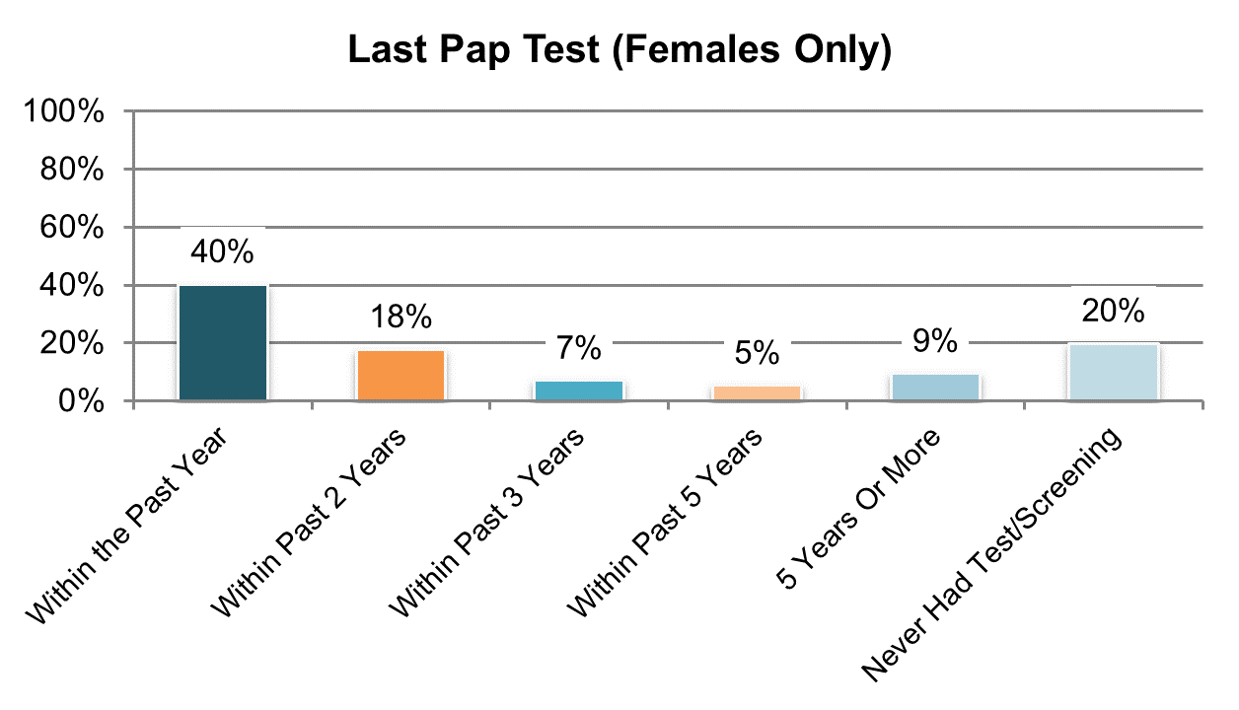

Table . Had a Pap test in the past three years (among women; ‘within the past three years or less’ responses; information comes from Background Information section)

|  |  |  |  |  |  |  |
| --- | --- | --- | --- | --- | --- | --- |
| State | Overall in State | N | ICF/IID and Other Institutional Settings | Community-based Group Residential Settings | Own Home | Parent’s or Relative’s Home |
| **Significantly Above Average** | | |  |  |  |  |
| DC ** | 100% | 34 | n/a | n/a | n/a | n/a |
| DE | 92% | 124 | n/a | 92% | n/a | n/a |
| GA | 83% | 116 | n/a | 79% | 82% | 89% |
| NV | 82% | 102 | n/a | 88% | 89% | n/a |
| MS | 81% | 145 | n/a | 81% | 87% | 76% |
| CT ** | 80% | 92 | n/a | 88% | 90% | 65% |
| NY | 79% | 158 | n/a | 83% | 82% | 62% |
| AL | 78% | 147 | n/a | 85% | 92% | 57% |
| PA | 76% | 135 | n/a | 85% | n/a | 58% |
| **Within Average Range** | | |  |  |  |  |
| KY ** | 74% | 97 | n/a | 83% | n/a | 58% |
| LA | 74% | 111 | 86% | n/a | 78% | 63% |
| AR | 72% | 115 | 78% | n/a | 79% | 44% |
| TN | 72% | 103 | n/a | 76% | 74% | n/a |
| AZ ** | 70% | 57 | n/a | n/a | n/a | 59% |
| IL ** | 68% | 85 | n/a | 71% | n/a | 52% |
| OH | 67% | 118 | 70% | 77% | 81% | 50% |
| WY | 63% | 105 | n/a | 75% | 63% | 48% |
| RI ** | 62% | 82 | n/a | 73% | 64% | n/a |
| SD | 60% | 128 | n/a | 46% | 75% | n/a |
| MO | 59% | 119 | n/a | 66% | 66% | n/a |
| VA | 59% | 182 | n/a | 61% | n/a | 51% |
| VT ** | 58% | 99 | n/a | n/a | n/a | 50% |
| MI | 58% | 120 | n/a | 59% | 64% | 44% |
| CO ** | 56% | 54 | n/a | n/a | n/a | n/a |
| KS ** | 52% | 77 | n/a | 50% | 78% | n/a |
| UT ** | 48% | 60 | n/a | 76% | n/a | 17% |
| **Significantly Below Average** | | |  |  |  |  |
| NC | 56% | 247 | 76% | 67% | 71% | 39% |
| FL | 56% | 541 | n/a | 65% | 79% | 41% |
| MA | 55% | 149 | n/a | 52% | 67% | 42% |
| ME | 55% | 108 | n/a | 38% | 82% | n/a |
| MN | 54% | 102 | n/a | 62% | 60% | n/a |
| WA | 50% | 114 | n/a | n/a | 63% | 37% |
| HI | 49% | 110 | n/a | n/a | n/a | 30% |
| OK | 46% | 170 | n/a | 56% | 72% | 23% |
| IN | 40% | 308 | n/a | n/a | 56% | 34% |
| NCI Average | 65% | 4,614 | 77% | 71% | 75% | 50% |

**State had a large number of “don’t know” responses and missing data (at least 25%)

**Note:** WI is not included in analysis due to low N (<20)

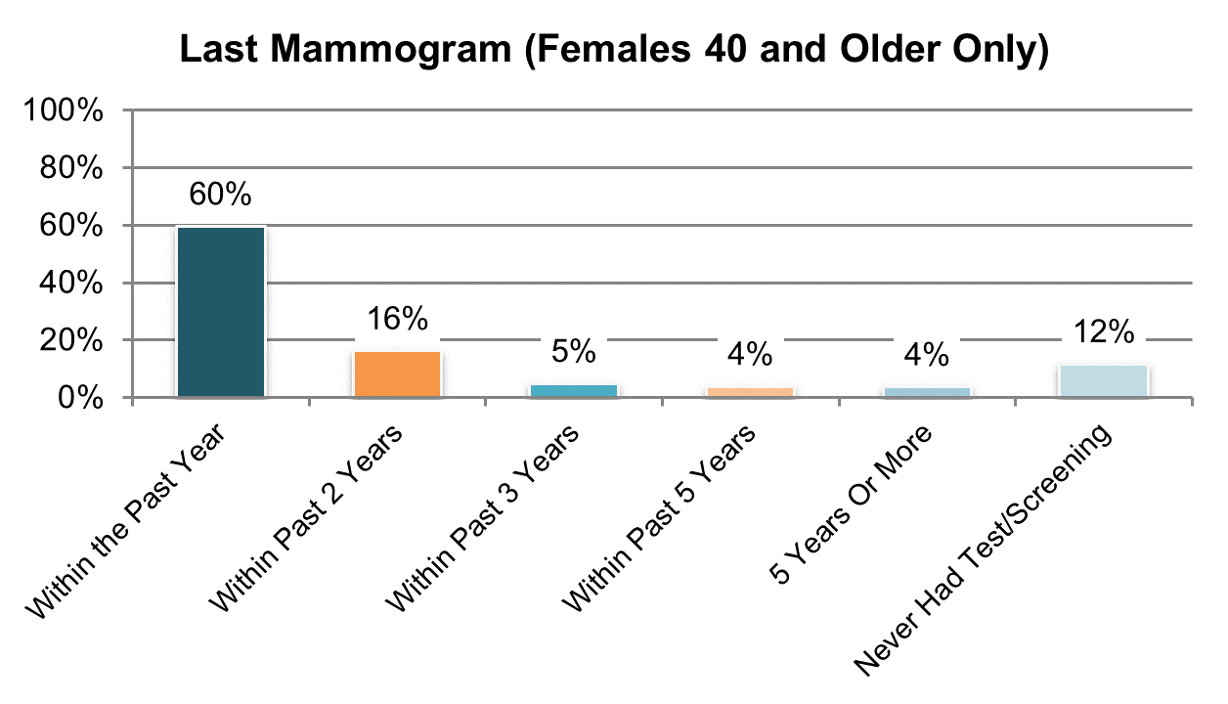

Table . Had a mammogram in the past two years (among women age 40 and over; ‘within the past two years or less’ responses; information comes from Background Information section)

|  |  |  |  |  |  |  |
| --- | --- | --- | --- | --- | --- | --- |
| State | Overall in State | N | ICF/IID and Other Institutional Settings | Community-based Group Residential Settings | Own Home | Parent’s or Relative’s Home |
| **Within Average Range** | | |  |  |  |  |
| KY ** | 93% | 45 | n/a | n/a | n/a | n/a |
| NV ** | 90% | 52 | n/a | 83% | 96% | n/a |
| IL ** | 88% | 59 | n/a | 94% | n/a | n/a |
| AL ** | 87% | 103 | n/a | 93% | 88% | 75% |
| SD ** | 87% | 67 | n/a | 88% | 86% | n/a |
| MO ** | 85% | 74 | n/a | 90% | 88% | n/a |
| TN ** | 85% | 94 | n/a | 88% | 83% | n/a |
| CT ** | 84% | 64 | n/a | 92% | n/a | n/a |
| GA ** | 84% | 67 | n/a | 76% | 90% | n/a |
| AR ** | 83% | 58 | 91% | n/a | n/a | n/a |
| LA ** | 82% | 61 | 87% | n/a | n/a | n/a |
| OH ** | 82% | 66 | n/a | n/a | n/a | n/a |
| MN ** | 80% | 70 | n/a | 70% | n/a | n/a |
| AZ ** | 80% | 25 | n/a | n/a | n/a | n/a |
| DE ** | 80% | 88 | n/a | 76% | n/a | n/a |
| NY ** | 79% | 87 | n/a | 81% | n/a | n/a |
| MA ** | 79% | 112 | n/a | 78% | n/a | n/a |
| VT ** | 78% | 55 | n/a | n/a | n/a | n/a |
| PA ** | 78% | 80 | n/a | 85% | n/a | n/a |
| RI ** | 76% | 55 | n/a | 87% | n/a | n/a |
| FL ** | 76% | 225 | n/a | 76% | 85% | 68% |
| ME ** | 75% | 83 | n/a | 68% | n/a | n/a |
| MS ** | 73% | 70 | n/a | 65% | 93% | 57% |
| WY ** | 72% | 53 | n/a | 72% | 81% | n/a |
| NC ** | 72% | 130 | 78% | 75% | n/a | 59% |
| VA ** | 71% | 109 | n/a | 73% | n/a | n/a |
| MI ** | 69% | 83 | n/a | 70% | 91% | n/a |
| OK ** | 65% | 80 | n/a | 69% | 64% | n/a |
| UT ** | 61% | 33 | n/a | n/a | n/a | n/a |
| IN ** | 60% | 173 | n/a | n/a | 78% | 48% |
| WA ** | 60% | 42 | n/a | n/a | 70% | n/a |
| KS ** | 59% | 34 | n/a | 57% | n/a | n/a |
| CO ** | 55% | 38 | n/a | n/a | n/a | n/a |
| HI ** | 53% | 62 | n/a | n/a | n/a | n/a |
| NCI Average | 61% | 9,276 | 89% | 65% | 52% | 49% |

**State had a large number of “don’t know” responses and missing data (at least 25%)

**Note:** The following states were not included in analysis due to low N (<20): DC and WI

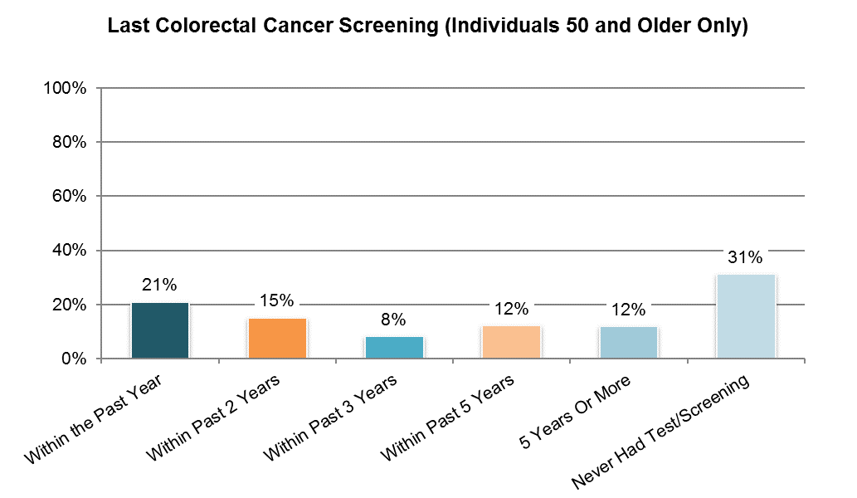

Table . Had a colorectal cancer screening in the past year (among people age 50 and over; ‘within the last year or less’ responses; information comes from Background Information section)

|  |  |  |  |  |  |  |
| --- | --- | --- | --- | --- | --- | --- |
| State | Overall in State | N | ICF/IID and Other Institutional Settings | Community-based Group Residential Settings | Own Home | Parent’s or Relative’s Home |
| **Within Average Range** | | |  |  |  |  |
| NV ** | 44% | 39 | n/a | 50% | n/a | n/a |
| KY ** | 36% | 47 | n/a | n/a | n/a | n/a |
| NY ** | 36% | 134 | n/a | 35% | n/a | n/a |
| PA ** | 36% | 73 | n/a | 38% | n/a | n/a |
| GA ** | 34% | 83 | n/a | 37% | 38% | n/a |
| DE ** | 27% | 79 | n/a | 29% | n/a | n/a |
| KS ** | 24% | 66 | n/a | 23% | n/a | n/a |
| AL ** | 24% | 83 | n/a | 24% | n/a | n/a |
| VA ** | 22% | 123 | n/a | 28% | n/a | n/a |
| WA ** | 22% | 69 | n/a | n/a | 28% | n/a |
| VT ** | 21% | 82 | n/a | n/a | n/a | n/a |
| OK | 20% | 115 | n/a | 16% | 28% | n/a |
| MS ** | 19% | 77 | n/a | 31% | 21% | n/a |
| NC ** | 19% | 173 | 19% | 13% | n/a | 17% |
| TN ** | 19% | 105 | n/a | 18% | 23% | n/a |
| IN ** | 19% | 178 | n/a | n/a | 25% | 14% |
| IL ** | 18% | 76 | n/a | 22% | n/a | n/a |
| UT ** | 18% | 38 | n/a | n/a | n/a | n/a |
| MI ** | 18% | 98 | n/a | 20% | 23% | n/a |
| FL ** | 18% | 262 | n/a | 23% | 17% | 14% |
| OH ** | 18% | 88 | 11% | 9% | n/a | n/a |
| CT ** | 18% | 91 | n/a | 20% | n/a | n/a |
| MO ** | 17% | 104 | n/a | 19% | 16% | n/a |
| LA ** | 17% | 70 | 13% | n/a | n/a | n/a |
| AR ** | 17% | 53 | 23% | n/a | n/a | n/a |
| MA ** | 17% | 142 | n/a | 18% | 10% | n/a |
| SD | 16% | 108 | n/a | 13% | 21% | n/a |
| RI ** | 15% | 81 | n/a | 13% | 13% | n/a |
| MN ** | 15% | 89 | n/a | 15% | n/a | n/a |
| WY ** | 14% | 56 | n/a | 17% | 19% | n/a |
| ME ** | 14% | 78 | n/a | 13% | n/a | n/a |
| CO ** | 12% | 33 | n/a | n/a | n/a | n/a |
| HI ** | 8% | 26 | n/a | n/a | n/a | n/a |
| NCI Average | 21% | 3,019 | 16% | 23% | 22% | 15% |

**State had a large number of “don’t know” responses and missing data (at least 25%)

**Note:** The following states were not included in analysis due to low N (<20): AZ, DC, WI

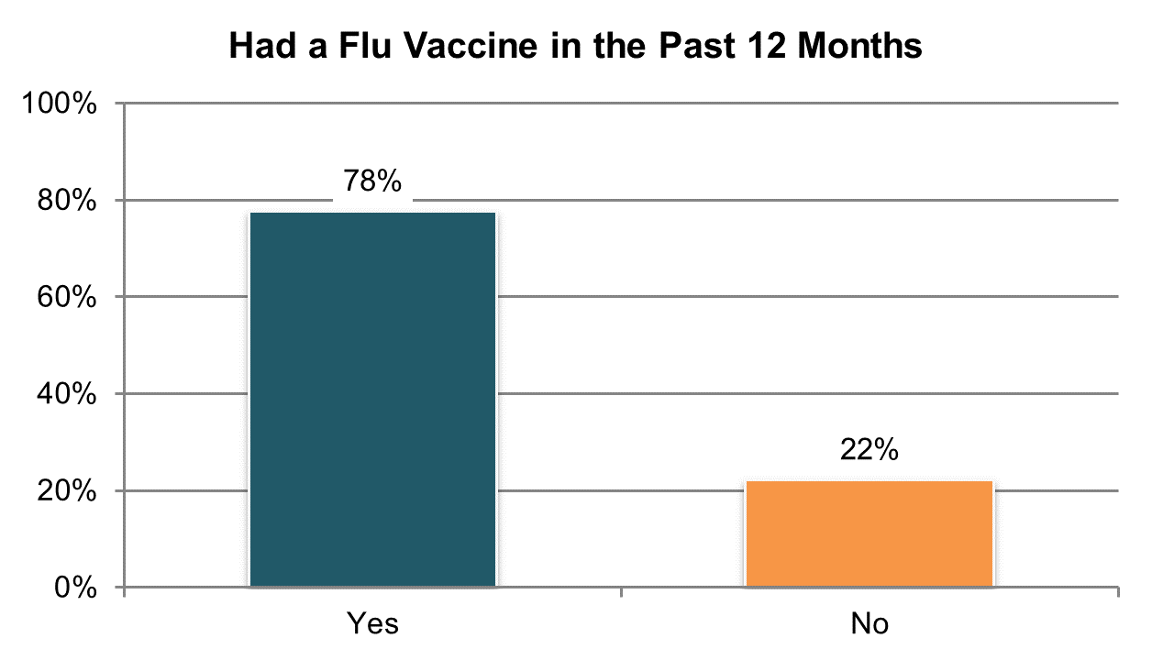

Table . Had a flu vaccine in the past year (within the last year or less responses; information comes from Background Information section)

|  |  |  |  |  |  |  |
| --- | --- | --- | --- | --- | --- | --- |
| State | Overall in State | N | ICF/IID and Other Institutional Settings | Community-based Group Residential Settings | Own Home | Parent’s or Relative’s Home |
| **Within Average Range** | | |  |  |  |  |
| MN ** | 100% | 142 | n/a | 100% | n/a | n/a |
| DE ** | 97% | 275 | n/a | 98% | n/a | n/a |
| SD | 93% | 346 | n/a | 94% | 93% | 89% |
| RI ** | 92% | 264 | n/a | 98% | 87% | 86% |
| CT ** | 90% | 201 | n/a | 94% | 100% | 61% |
| VA ** | 87% | 538 | 98% | 89% | 77% | 78% |
| UT ** | 86% | 218 | 96% | 95% | 86% | 70% |
| MO | 86% | 356 | n/a | 93% | 87% | 64% |
| IL ** | 84% | 237 | n/a | 93% | n/a | 56% |
| ME ** | 83% | 260 | n/a | 86% | 71% | 78% |
| MA | 81% | 375 | n/a | 87% | 76% | 70% |
| CO | 81% | 392 | n/a | 93% | 72% | 72% |
| AR ** | 81% | 301 | 92% | 83% | 72% | 79% |
| DC ** | 80% | 46 | n/a | n/a | n/a | n/a |
| AZ ** | 80% | 166 | n/a | 85% | n/a | 73% |
| LA ** | 80% | 266 | 99% | n/a | 54% | 66% |
| MS ** | 80% | 174 | n/a | 84% | 93% | 71% |
| TN ** | 80% | 344 | n/a | 86% | 82% | 68% |
| NY ** | 79% | 403 | 83% | 90% | 82% | 57% |
| KS ** | 78% | 283 | n/a | 86% | 84% | 56% |
| OH ** | 78% | 305 | 96% | 87% | 68% | 60% |
| MI ** | 77% | 303 | n/a | 87% | 72% | 63% |
| VT | 77% | 251 | n/a | n/a | 78% | 62% |
| NC ** | 75% | 614 | 99% | 82% | 57% | 63% |
| PA ** | 74% | 309 | 84% | 86% | 63% | 62% |
| WA | 74% | 395 | n/a | 97% | 76% | 65% |
| AL ** | 72% | 276 | n/a | 82% | 75% | 53% |
| KY ** | 72% | 229 | n/a | 84% | 59% | 62% |
| OK | 70% | 392 | n/a | 75% | 78% | 55% |
| GA ** | 69% | 338 | n/a | 74% | 65% | 65% |
| WY | 66% | 270 | n/a | 79% | 63% | 49% |
| IN | 60% | 793 | n/a | n/a | 63% | 58% |
| NV ** | 60% | 214 | n/a | 60% | 61% | 57% |
| FL | 52% | 1,316 | n/a | 67% | 52% | 45% |
| HI ** | 45% | 238 | n/a | 36% | n/a | 41% |
| NCI Average | 78% | 11,830 | 93% | 85% | 74% | 64% |

**State had a large number of “don’t know” responses and missing data (at least 25%)

**Note:** WI is not included in analysis due to low N (<20)

## Medications

### Medications are managed effectively and appropriately.

There is one Medications indicator collected using the Background Information section of the Adult Consumer Survey:

1. Proportion of people who take at least one medication for mood, anxiety, psychotic disorder, and/or behavioral challenges

In addition, NCI collects information on:

1. Proportion of people who were reported to take medication for at least one of the following: mood disorders, anxiety, psychotic disorders
2. Proportion of people who were reported to take medication for behavior challenges
3. Proportion of people reported to have a behavior plan
4. Proportion of people who take meds for behavior challenges who have a behavior plan

Tables 109 through 115 present the results for this core indicator. The corresponding chart shows un-collapsed averages.

All un-collapsed state data frequencies for these survey questions are displayed in Appendix D.

Important note on changes to the survey tool and analysis. In examining the results included in this section, we found that a number of states had a large amount of missing data for these questions. States for which 25% or more of their sample were missing data for specific questions are indicated with an asterisk. The quantity of missing data can be a result of several factors. We do not know, however, whether the data are missing systematically or randomly; for example, for a specific state, are the data missing across the board for those in a specific waiver? If so, the resulting data are not representative of the entire sample or population. As a result, we advise caution when examining data that are indicated as having high rates of “don’t know” responses.

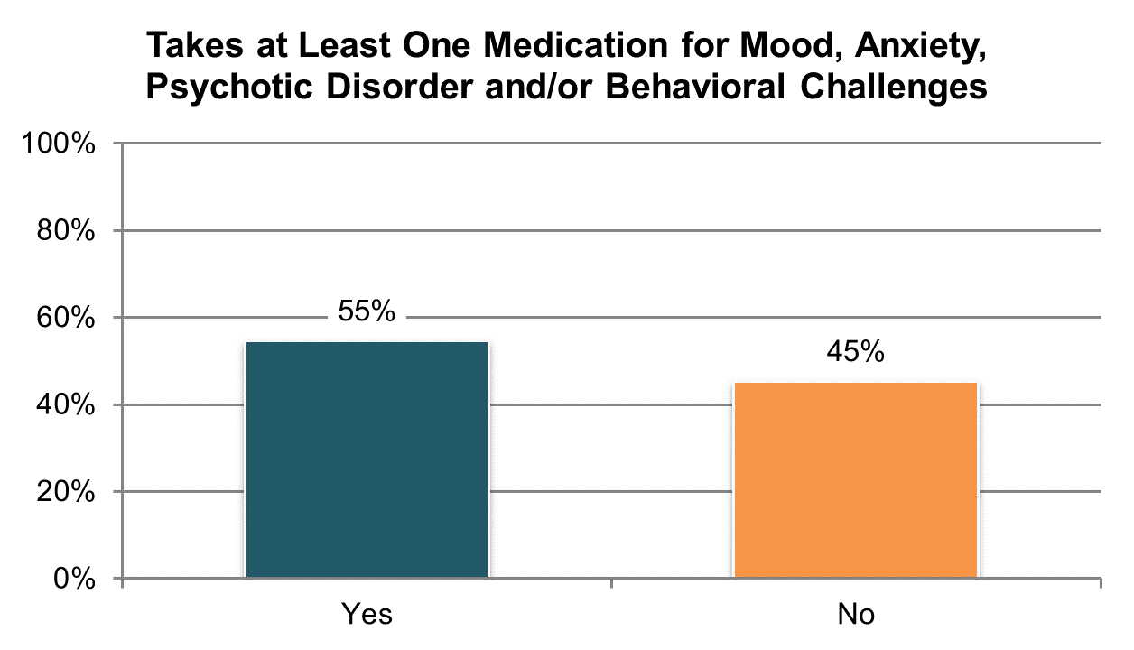

Table . Takes at least one medication for mood disorders, anxiety, psychotic disorders, and/or behavior (information comes from Background Information section)

|  |  |  |  |  |  |  |
| --- | --- | --- | --- | --- | --- | --- |
| State | Overall in State | N | ICF/IID and Other Institutional Settings | Community-based Group Residential Settings | Own Home | Parent’s or Relative’s Home |
| **Significantly Above Average** | | |  |  |  |  |
| MO | 70% | 393 | n/a | 69% | 78% | 29% |
| DE | 67% | 386 | n/a | 70% | 60% | n/a |
| VA | 66% | 764 | 58% | 79% | 78% | 44% |
| ME | 64% | 363 | n/a | 78% | 55% | 40% |
| TN | 63% | 424 | n/a | 76% | 70% | 36% |
| UT | 62% | 386 | 75% | 86% | 57% | 38% |
| **Within Average Range** | | |  |  |  |  |
| MA | 61% | 410 | n/a | 73% | 44% | 38% |
| RI ** | 61% | 331 | n/a | 85% | 71% | 31% |
| NV | 60% | 391 | n/a | 68% | 59% | 30% |
| OK | 60% | 400 | n/a | 70% | 69% | 38% |
| KY | 59% | 433 | n/a | 77% | 47% | 45% |
| MI | 59% | 422 | n/a | 74% | 57% | 42% |
| KS | 59% | 374 | n/a | 67% | 66% | 40% |
| AR | 59% | 378 | 66% | 51% | 68% | 37% |
| VT | 58% | 325 | n/a | 62% | 67% | 39% |
| WY | 55% | 306 | n/a | 73% | 54% | 24% |
| CO | 55% | 396 | n/a | 64% | 41% | 39% |
| NC | 54% | 798 | 50% | 70% | 51% | 43% |
| LA | 53% | 436 | 65% | n/a | 62% | 42% |
| NY | 53% | 474 | 65% | 66% | 40% | 34% |
| DC ** | 53% | 256 | 66% | 63% | 62% | 24% |
| IL | 53% | 394 | n/a | 67% | 52% | 36% |
| CT | 52% | 327 | n/a | 67% | 47% | 43% |
| OH | 52% | 570 | 72% | 73% | 66% | 31% |
| AL | 52% | 382 | n/a | 65% | 53% | 33% |
| GA | 51% | 455 | n/a | 79% | 54% | 39% |
| MN | 51% | 397 | 61% | 61% | 47% | 37% |
| PA | 50% | 611 | 46% | 77% | 40% | 37% |
| SD | 50% | 353 | n/a | 54% | 51% | 22% |
| MS | 47% | 350 | n/a | 55% | 62% | 34% |
| **Significantly Below Average** | | |  |  |  |  |
| WA | 46% | 399 | n/a | 67% | 62% | 30% |
| FL | 45% | 1,420 | n/a | 70% | 46% | 31% |
| IN | 41% | 816 | n/a | 55% | 41% | 40% |
| AZ | 40% | 451 | n/a | 64% | 49% | 30% |
| HI | 30% | 388 | n/a | 51% | n/a | 15% |
| NCI Average | 55% | 16,159 | 62% | 68% | 57% | 35% |

**State had a large number of “don’t know” responses and missing data (at least 25%)**; Note:** WI excluded due to low N (<20)

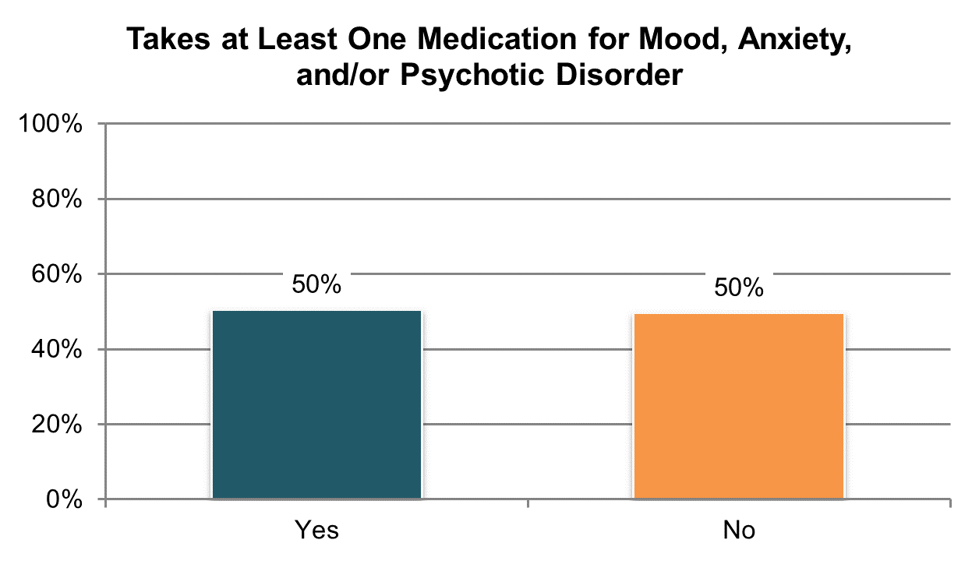

Table . Takes medication for at least one of the following: mood disorders, anxiety, or psychotic disorders (information comes from Background Information section

|  |  |  |  |  |  |  |
| --- | --- | --- | --- | --- | --- | --- |
| State | Overall in State | N | ICF/IID and Other Institutional Settings | Community-based Group Residential Settings | Own Home | Parent’s or Relative’s Home |
| **Significantly Above Average** | | |  |  |  |  |
| MO | 67% | 393 | n/a | 67% | 75% | 21% |
| VA | 61% | 774 | 52% | 74% | 70% | 39% |
| TN | 61% | 423 | n/a | 73% | 69% | 34% |
| DE | 61% | 389 | n/a | 62% | 60% | n/a |
| ME | 59% | 370 | n/a | 71% | 51% | 35% |
| UT | 59% | 391 | 75% | 82% | 57% | 36% |
| MA | 58% | 413 | n/a | 72% | 44% | 33% |
| **Within Average Range** | | |  |  |  |  |
| VT | 57% | 323 | n/a | 62% | 67% | 36% |
| RI ** | 56% | 335 | n/a | 80% | 68% | 28% |
| MI | 56% | 422 | n/a | 71% | 56% | 38% |
| NV | 56% | 389 | n/a | 62% | 57% | 28% |
| KY | 56% | 436 | n/a | 74% | 45% | 41% |
| AR | 55% | 382 | 59% | 50% | 66% | 36% |
| KS | 55% | 379 | n/a | 63% | 65% | 34% |
| OK | 55% | 400 | n/a | 66% | 67% | 29% |
| CO | 53% | 398 | n/a | 62% | 39% | 35% |
| WY | 52% | 308 | n/a | 68% | 53% | 21% |
| OH | 50% | 574 | 70% | 72% | 65% | 28% |
| AL | 49% | 381 | n/a | 63% | 51% | 30% |
| NY | 49% | 483 | 58% | 61% | 40% | 29% |
| LA | 49% | 437 | 61% | n/a | 59% | 35% |
| NC | 48% | 809 | 41% | 64% | 49% | 38% |
| SD | 48% | 356 | n/a | 52% | 48% | 22% |
| DC ** | 48% | 261 | 54% | 58% | 59% | 20% |
| IL | 47% | 399 | n/a | 60% | 52% | 31% |
| CT | 47% | 334 | n/a | 61% | 45% | 36% |
| PA | 46% | 621 | 43% | 73% | 37% | 33% |
| GA | 45% | 465 | n/a | 72% | 52% | 31% |
| MN | 45% | 397 | 57% | 52% | 39% | 33% |
| **Significantly Below Average** | | |  |  |  |  |
| WA | 43% | 402 | n/a | 55% | 59% | 28% |
| MS | 40% | 375 | n/a | 50% | 56% | 25% |
| FL | 40% | 1,424 | n/a | 61% | 43% | 27% |
| IN | 38% | 816 | n/a | 55% | 39% | 36% |
| AZ | 36% | 458 | n/a | 62% | 43% | 27% |
| HI | 18% | 397 | n/a | 30% | n/a | 10% |
| NCI Average | 50% | 16,314 | 57% | 64% | 54% | 31% |

**State had a large number of “don’t know” responses and missing data (at least 25%); **Note:** WI excluded due to low N (<20).

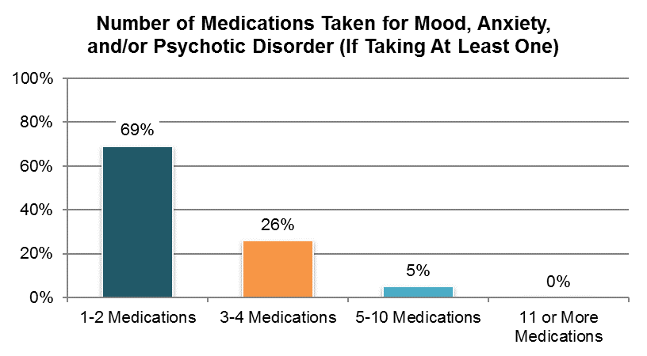

Table . Number of medications taken for at least one of the following: mood disorders, anxiety, or psychotic disorders (information comes from Background Information section)

|  |  |  |  |  |  |
| --- | --- | --- | --- | --- | --- |
| State | 1-2  Medications | 3-4 Medications | 5-10  Medications | 11 or More Medications | N |
| AL | 68% | 28% | 4% | 0% | 188 |
| AR | 66% | 30% | 3% | 0% | 202 |
| AZ | 63% | 30% | 7% | 0% | 151 |
| CO | 68% | 27% | 5% | 0% | 204 |
| CT | 76% | 21% | 3% | 0% | 149 |
| DC ** | 96% | 4% | 0% | 0% | 68 |
| DE | 72% | 22% | 5% | 0% | 203 |
| FL | 77% | 21% | 2% | 0% | 559 |
| GA | 70% | 21% | 9% | 0% | 208 |
| HI | 79% | 20% | 1% | 0% | 71 |
| IL | 78% | 20% | 2% | 0% | 183 |
| IN | 85% | 15% | 0% | 0% | 307 |
| KS | 66% | 30% | 4% | 0% | 206 |
| KY | 70% | 26% | 4% | 0% | 232 |
| LA | 66% | 28% | 5% | 1% | 209 |
| MA | 59% | 31% | 10% | 0% | 237 |
| ME | 69% | 25% | 6% | 1% | 189 |
| MI | 61% | 32% | 7% | 0% | 234 |
| MN | 68% | 25% | 7% | 1% | 169 |
| MO | 60% | 32% | 9% | 0% | 262 |
| MS | 78% | 16% | 6% | 0% | 134 |
| NC | 69% | 25% | 7% | 0% | 378 |
| NV | 61% | 29% | 9% | 1% | 216 |
| NY | 61% | 33% | 5% | 1% | 228 |
| OH | 70% | 21% | 9% | 0% | 267 |
| OK | 65% | 29% | 6% | 0% | 220 |
| PA | 66% | 30% | 5% | 0% | 277 |
| RI | 71% | 25% | 3% | 1% | 181 |
| SD | 62% | 30% | 8% | 0% | 169 |
| TN | 56% | 35% | 9% | 0% | 247 |
| UT | 63% | 32% | 5% | 0% | 222 |
| VA | 61% | 29% | 10% | 0% | 467 |
| VT | 68% | 25% | 7% | 0% | 182 |
| WA | 70% | 27% | 3% | 0% | 172 |
| WY | 73% | 25% | 3% | 0% | 158 |
| NCI Average | 69% | 26% | 5% | 0% | 7,749 |

**State had a large number of “don’t know” responses and missing data (at least 25%)

**Note:** WI excluded due to low N (<20)

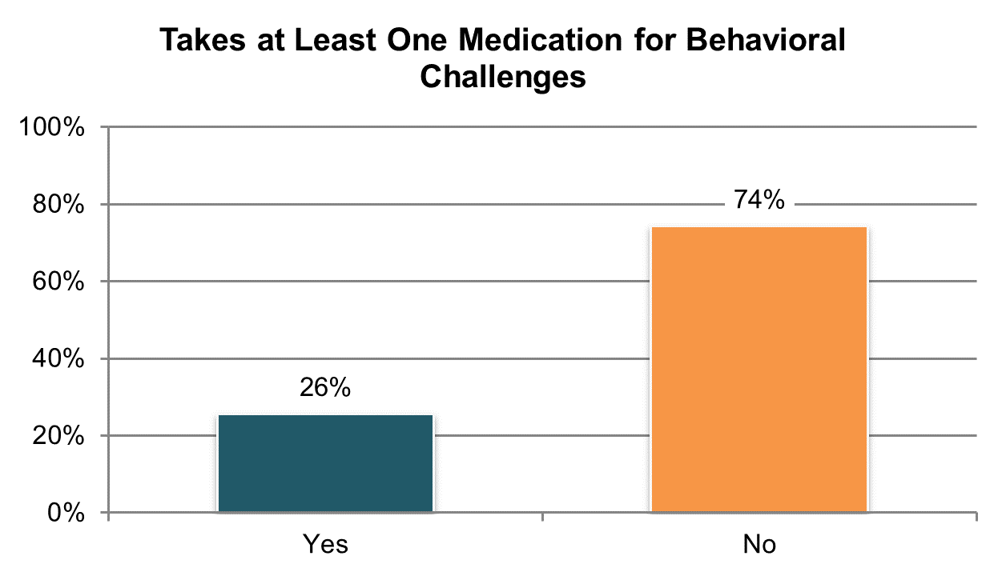

Table . Takes medication for behavior challenges (information comes from Background Information section)

|  |  |  |  |  |  |  |
| --- | --- | --- | --- | --- | --- | --- |
| State | Overall in State | N | ICF/IID and Other Institutional Settings | Community-based Group Residential Settings | Own Home | Parent’s or Relative’s Home |
| **Significantly Above Average** | | |  |  |  |  |
| DE | 47% | 371 | n/a | 49% | 41% | n/a |
| UT | 36% | 380 | 56% | 58% | 22% | 17% |
| RI ** | 35% | 330 | n/a | 59% | 20% | 14% |
| NV | 35% | 388 | n/a | 44% | 28% | 13% |
| AR | 34% | 374 | 43% | 29% | 37% | 21% |
| VA | 33% | 744 | 29% | 40% | 32% | 23% |
| MI | 33% | 419 | n/a | 48% | 28% | 21% |
| NY | 32% | 476 | 56% | 41% | 13% | 19% |
| NC | 31% | 799 | 38% | 43% | 18% | 23% |
| **Within Average Range** | | |  |  |  |  |
| DC ** | 33% | 238 | 48% | 41% | n/a | 13% |
| CT | 33% | 321 | n/a | 47% | 20% | 25% |
| KS | 32% | 368 | n/a | 38% | 34% | 19% |
| ME | 30% | 359 | n/a | 41% | 12% | 19% |
| MN | 30% | 393 | 29% | 37% | 24% | 21% |
| IL | 29% | 388 | n/a | 41% | 16% | 17% |
| TN | 29% | 420 | n/a | 31% | 38% | 13% |
| MO | 28% | 384 | n/a | 28% | 29% | 14% |
| AZ | 28% | 447 | n/a | 52% | 29% | 19% |
| LA | 27% | 435 | 43% | n/a | 25% | 17% |
| CO | 25% | 385 | n/a | 45% | 15% | 12% |
| VT | 22% | 324 | n/a | 33% | 19% | 11% |
| KY | 20% | 426 | n/a | 27% | 10% | 18% |
| **Significantly Below Average** | | |  |  |  |  |
| FL | 20% | 1,425 | n/a | 38% | 15% | 13% |
| PA | 20% | 599 | 24% | 32% | 9% | 15% |
| AL | 19% | 381 | n/a | 27% | 19% | 9% |
| MA | 19% | 409 | n/a | 25% | 4% | 14% |
| WY | 18% | 305 | n/a | 31% | 7% | 7% |
| OH | 17% | 563 | 36% | 23% | 17% | 9% |
| HI | 17% | 389 | n/a | 32% | n/a | 8% |
| GA | 15% | 461 | n/a | 25% | 17% | 12% |
| MS | 15% | 334 | n/a | 19% | 13% | 13% |
| IN | 15% | 814 | n/a | n/a | 12% | 16% |
| SD | 15% | 353 | n/a | 16% | 12% | 8% |
| WA | 14% | 402 | n/a | 23% | 18% | 9% |
| OK | 13% | 400 | n/a | 14% | 7% | 13% |
| NCI Average | 26% | 16,004 | 40% | 36% | 20% | 15% |

**State had a large number of “don’t know” responses and missing data (at least 25%); **Note:** WI excluded due to low N (<20).

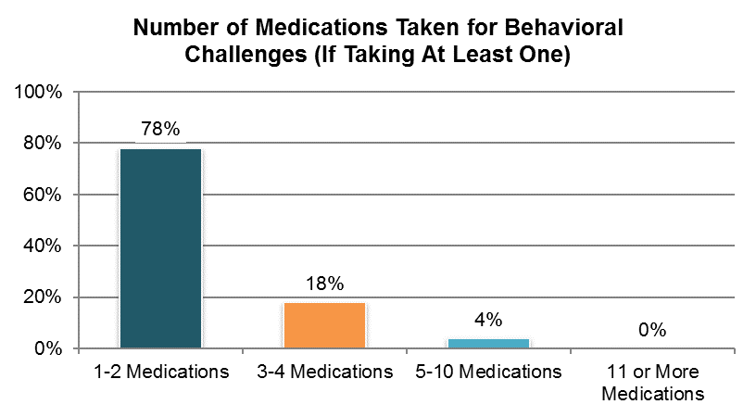

Table . Number of medications taken for behavior challenges (information comes from Background Information section)

|  |  |  |  |  |  |
| --- | --- | --- | --- | --- | --- |
| State | 1-2  Medications | 3-4 Medications | 5-10  Medications | 11 or More Medications | N |
| AL | 84% | 15% | 1% | 0% | 68 |
| AR | 66% | 30% | 4% | 0% | 122 |
| AZ | 73% | 20% | 7% | 0% | 111 |
| CO | 83% | 15% | 2% | 0% | 86 |
| CT | 81% | 17% | 3% | 0% | 103 |
| DC ** | 92% | 8% | 0% | 0% | 37 |
| DE | 80% | 18% | 3% | 0% | 142 |
| FL | 81% | 17% | 3% | 0% | 280 |
| GA | 77% | 21% | 1% | 0% | 70 |
| HI | 67% | 21% | 12% | 0% | 66 |
| IL | 83% | 15% | 3% | 0% | 110 |
| IN | 88% | 11% | 1% | 0% | 121 |
| KS | 80% | 18% | 2% | 0% | 114 |
| KY | 83% | 17% | 0% | 0% | 83 |
| LA | 77% | 19% | 4% | 0% | 112 |
| MA | 72% | 26% | 3% | 0% | 78 |
| ME | 80% | 14% | 6% | 0% | 90 |
| MI | 74% | 21% | 4% | 1% | 132 |
| MN | 87% | 6% | 5% | 1% | 111 |
| MO | 75% | 23% | 3% | 0% | 106 |
| MS | 80% | 16% | 4% | 0% | 45 |
| NC | 76% | 21% | 3% | 0% | 241 |
| NV | 62% | 33% | 5% | 0% | 132 |
| NY | 66% | 26% | 8% | 0% | 145 |
| OH | 75% | 19% | 6% | 0% | 88 |
| OK | 82% | 16% | 2% | 0% | 51 |
| PA | 80% | 16% | 4% | 0% | 105 |
| RI | 81% | 16% | 3% | 0% | 107 |
| SD | 76% | 22% | 2% | 0% | 51 |
| TN | 69% | 26% | 5% | 0% | 112 |
| UT | 73% | 22% | 5% | 0% | 133 |
| VA | 80% | 16% | 5% | 0% | 235 |
| VT | 77% | 16% | 7% | 0% | 69 |
| WA | 90% | 10% | 0% | 0% | 58 |
| WY | 87% | 11% | 2% | 0% | 53 |
| NCI Average | 78% | 18% | 4% | 0% | 3,767 |

**State had a large number of “don’t know” responses and missing data (at least 25%)

**Note:** WI excluded due to low N (<20)

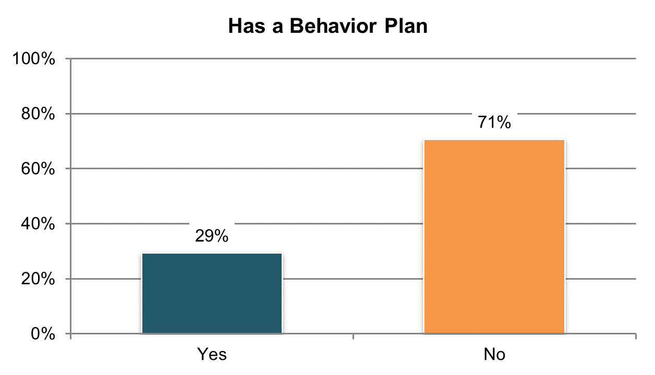

Table . Has a behavior plan (information comes from Background Information section) º

|  |  |  |  |  |  |  |
| --- | --- | --- | --- | --- | --- | --- |
| State | Overall in State | N | ICF/IID and Other Institutional Settings | Community-based Group Residential Settings | Own Home | Parent’s or Relative’s Home |
| **Significantly Above Average** | | |  |  |  |  |
| DE | 64% | 418 | n/a | 67% | 60% | n/a |
| DC ** | 58% | 218 | 80% | 67% | n/a | 30% |
| KS | 50% | 369 | n/a | 63% | 52% | 27% |
| NV | 50% | 395 | n/a | 66% | 41% | 9% |
| AR | 47% | 387 | 57% | 44% | 53% | 25% |
| CT | 42% | 338 | n/a | 76% | 25% | 14% |
| IL | 42% | 390 | n/a | 66% | 28% | 14% |
| UT | 41% | 400 | 54% | 81% | 21% | 11% |
| OK | 41% | 400 | n/a | 52% | 51% | 15% |
| CO | 39% | 397 | n/a | 60% | 22% | 10% |
| **Within Average Range** | | |  |  |  |  |
| VT | 36% | 326 | n/a | 62% | 27% | 14% |
| NY | 34% | 489 | 68% | 52% | 5% | 8% |
| RI ** | 33% | 349 | n/a | 61% | 16% | 11% |
| IN | 32% | 821 | n/a | 65% | 41% | 29% |
| PA | 30% | 605 | 43% | 63% | 14% | 14% |
| TN | 29% | 441 | n/a | 34% | 38% | 9% |
| KY | 27% | 448 | n/a | 40% | 25% | 14% |
| WY | 26% | 314 | n/a | 39% | 19% | 9% |
| MI | 25% | 423 | n/a | 39% | 29% | 10% |
| LA | 24% | 434 | 58% | n/a | 16% | 7% |
| **Significantly Below Average** | | |  |  |  |  |
| VA | 23% | 769 | 50% | 28% | 20% | 13% |
| WA | 23% | 403 | n/a | 52% | 45% | 2% |
| SD | 22% | 361 | n/a | 27% | 16% | 8% |
| NC | 20% | 809 | 46% | 29% | 5% | 8% |
| AZ | 19% | 459 | n/a | 60% | 15% | 5% |
| MA | 19% | 415 | n/a | 31% | 4% | 3% |
| AL | 19% | 384 | n/a | 28% | 24% | 4% |
| MO | 17% | 395 | n/a | 14% | 21% | 7% |
| FL | 15% | 1,430 | n/a | 35% | 8% | 7% |
| ME | 14% | 360 | n/a | 18% | 12% | 8% |
| HI | 13% | 401 | n/a | 18% | n/a | 8% |
| OH | 12% | 603 | 52% | 7% | 12% | 2% |
| GA | 7% | 471 | n/a | 19% | 10% | 1% |
| MS | 6% | 357 | n/a | 7% | 2% | 6% |
| NCI Average | 29% | 15,979 | 57% | 45% | 24% | 11% |

ºNew variable to reporting

**State had a large number of “don’t know” responses and missing data (at least 25%)

**Note:** MN and WI excluded due to low N (<20).

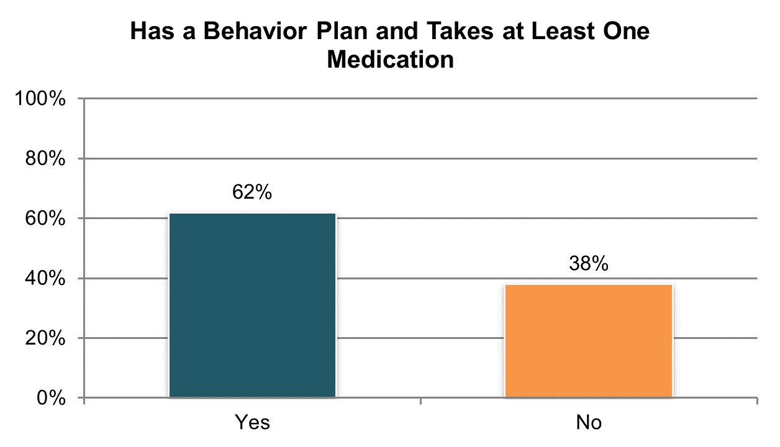

Table . Has a behavior plan (of those who take medication for a behavior challenge; information comes from Background Information section)

|  |  |  |  |  |  |  |
| --- | --- | --- | --- | --- | --- | --- |
| State | Overall in State | N | ICF/IID and Other Institutional Settings | Community-based Group Residential Settings | Own Home | Parent’s or Relative’s Home |
| **Significantly Above Average** | | |  |  |  |  |
| DE | 98% | 170 | n/a | 99% | n/a | n/a |
| DC ** | 94% | 77 | n/a | 98% | n/a | n/a |
| AR | 91% | 127 | 88% | n/a | 89% | n/a |
| NV | 88% | 133 | n/a | 94% | 83% | n/a |
| IL | 87% | 111 | n/a | 98% | n/a | 54% |
| KS | 83% | 116 | n/a | 95% | 76% | n/a |
| CO | 81% | 95 | n/a | 90% | n/a | n/a |
| CT | 81% | 104 | n/a | 100% | n/a | 46% |
| UT | 76% | 135 | n/a | 97% | n/a | 28% |
| NY | 74% | 151 | 96% | 86% | n/a | 31% |
| **Within Average Range** | | |  |  |  |  |
| VT | 73% | 71 | n/a | n/a | n/a | n/a |
| RI ** | 71% | 112 | n/a | 80% | n/a | n/a |
| PA | 67% | 115 | n/a | 89% | n/a | 38% |
| IN | 67% | 121 | n/a | n/a | 85% | 63% |
| TN | 63% | 119 | n/a | 61% | 69% | n/a |
| OK | 61% | 51 | n/a | 72% | n/a | n/a |
| SD | 61% | 51 | n/a | 60% | n/a | n/a |
| KY | 59% | 86 | n/a | 65% | n/a | 47% |
| AL | 59% | 71 | n/a | 64% | n/a | n/a |
| WY | 57% | 54 | n/a | 67% | n/a | n/a |
| AZ | 57% | 117 | n/a | 95% | n/a | 19% |
| MA | 55% | 76 | n/a | 68% | n/a | n/a |
| MI | 54% | 136 | n/a | 61% | 57% | 37% |
| LA | 54% | 116 | 85% | n/a | 37% | 18% |
| WA | 47% | 57 | n/a | n/a | 72% | n/a |
| HI | 47% | 66 | n/a | n/a | n/a | n/a |
| **Significantly Below Average** | | |  |  |  |  |
| FL | 51% | 281 | n/a | 68% | 29% | 32% |
| NC | 46% | 250 | 94% | 53% | n/a | 15% |
| VA | 41% | 243 | n/a | 43% | n/a | 27% |
| OH | 40% | 94 | 87% | n/a | 29% | 4% |
| MO | 34% | 104 | n/a | 28% | 41% | n/a |
| ME | 33% | 99 | n/a | 35% | n/a | n/a |
| GA | 32% | 71 | n/a | 45% | n/a | 7% |
| MS | 21% | 47 | n/a | n/a | n/a | n/a |
| NCI Average | 62% | 3,827 | 90% | 73% | 61% | 31% |

ºNew variable to reporting; **State had a large number of “don’t know” responses and missing data (at least 25%); **Note:** MN and WI excluded due to low N (<20).

## Wellness

### People are supported to maintain healthy habits.

There is one Wellness indicator composed of three items:

1. The proportion of people who maintain healthy habits in such areas as:
   1. Exercise
   2. Weight
   3. Smoking

Tables 116 through 118 present the results for these three core indicators.

The corresponding charts show un-collapsed averages.

All un-collapsed state data frequencies for these survey questions are displayed in Appendix D.

Important note on changes to the survey tool and analysis. In examining the results included in this section, we found that a number of states had a large amount of missing data for these questions. States for which 25% or more of their sample were missing data for specific questions are indicated with an asterisk. The quantity of missing data can be a result of several factors. We do not know, however, whether the data are missing systematically or randomly; for example, for a specific state, are the data missing across the board for those in a specific waiver? If so, the resulting data are not representative of the entire sample or population. As a result, we advise caution when examining data that are indicated as having high rates of “don’t know” responses.

One item, whether people take part in physical activity, was moved from the BI section (where information may be more likely to be obtained from state records or proxy respondents) to Section II (where information may come from the individual receiving services or a proxy respondent).

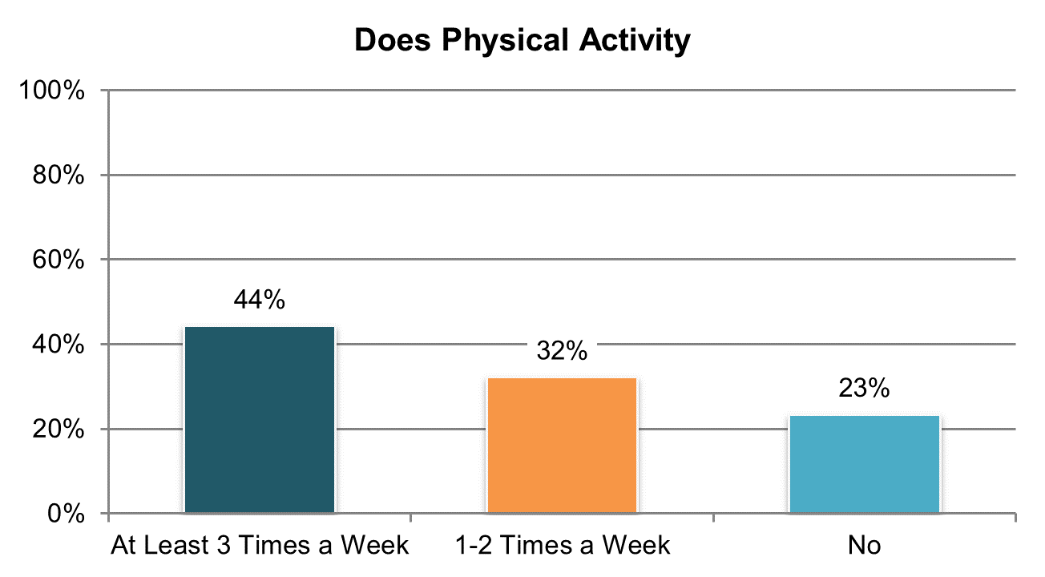

Table . Engages in physical activity (‘yes, regularly at least 3 times per week’ and ‘sometimes, 1 or 2 times per week’ responses; proxy responses allowed) ±

|  |  |  |  |  |  |  |
| --- | --- | --- | --- | --- | --- | --- |
| State | Overall in State | N | ICF/IID and Other Institutional Settings | Community-based Group Residential Settings | Own Home | Parent’s or Relative’s Home |
| **Significantly Above Average** | | |  |  |  |  |
| HI | 92% | 390 | n/a | 91% | n/a | 92% |
| DC | 88% | 389 | 89% | 90% | 81% | 87% |
| NV | 85% | 388 | n/a | 84% | 84% | 91% |
| UT | 83% | 385 | 92% | 85% | 75% | 83% |
| RI | 83% | 447 | n/a | 82% | 84% | 78% |
| MN | 83% | 400 | 75% | 86% | 82% | 82% |
| **Within Average Range** | | |  |  |  |  |
| ME | 81% | 383 | n/a | 74% | 95% | 81% |
| AZ | 80% | 462 | n/a | 77% | 82% | 81% |
| NC | 80% | 742 | 63% | 84% | 79% | 86% |
| AL | 80% | 378 | n/a | 79% | 80% | 81% |
| WY | 80% | 312 | n/a | 82% | 81% | 74% |
| WI | 80% | 404 | 66% | 85% | 85% | 79% |
| CT | 79% | 325 | 55% | 75% | 88% | 83% |
| MA | 79% | 410 | n/a | 74% | 79% | 89% |
| TN | 79% | 434 | n/a | 84% | 74% | 80% |
| OK | 78% | 395 | n/a | 78% | 76% | 81% |
| GA | 78% | 449 | n/a | 76% | 83% | 77% |
| WA | 77% | 392 | n/a | 90% | 81% | 76% |
| IL | 77% | 377 | n/a | 73% | 78% | 83% |
| CO | 77% | 402 | n/a | 67% | 92% | 71% |
| SD | 76% | 333 | n/a | 74% | 76% | 82% |
| VA | 76% | 800 | 68% | 80% | 60% | 73% |
| PA | 76% | 665 | 65% | 74% | 85% | 74% |
| LA | 75% | 423 | 75% | n/a | 79% | 73% |
| OH | 75% | 534 | 71% | 71% | 78% | 76% |
| MI | 75% | 429 | n/a | 68% | 86% | 75% |
| MS | 74% | 396 | n/a | 86% | 78% | 67% |
| IN | 73% | 814 | n/a | n/a | 72% | 73% |
| VT | 72% | 324 | n/a | 67% | 71% | 72% |
| NY | 72% | 483 | 79% | 65% | 83% | 73% |
| MO | 71% | 395 | n/a | 58% | 75% | 79% |
| AR | 71% | 373 | 70% | 65% | 74% | 67% |
| KS | 70% | 344 | n/a | 66% | 78% | 70% |
| **Significantly Below Average** | | |  |  |  |  |
| FL | 69% | 1,422 | n/a | 67% | 73% | 69% |
| DE | 67% | 366 | n/a | 67% | 85% | n/a |
| KY | 45% | 447 | n/a | 44% | 34% | 51% |
| NCI Average | 77% | 16,812 | 72% | 76% | 78% | 77% |

±Item changed from previous years – moved from BI section to Section II (see Appendix A)

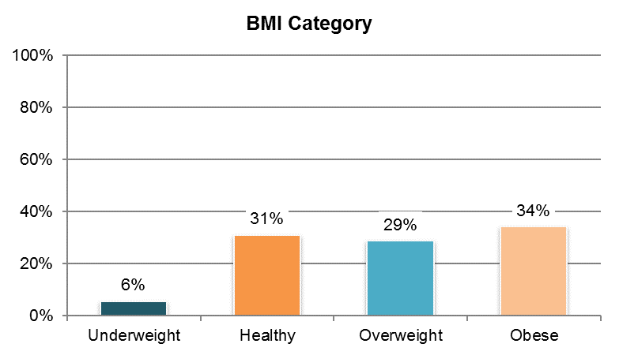

Table . BMI category (BMI calculated using data on weight and height; information comes from Background Information section)

|  |  |  |  |  |  |
| --- | --- | --- | --- | --- | --- |
| State | Underweight | Healthy | Overweight | Obese | N |
| AL | 3% | 25% | 27% | 45% | 368 |
| AR | 5% | 27% | 32% | 36% | 328 |
| AZ ** | 5% | 44% | 27% | 23% | 228 |
| CO | 6% | 32% | 32% | 31% | 392 |
| CT ** | 5% | 26% | 40% | 29% | 212 |
| DC | 7% | 33% | 30% | 29% | 312 |
| DE | 3% | 31% | 30% | 36% | 397 |
| FL | 8% | 35% | 31% | 26% | 1,206 |
| GA ** | 4% | 36% | 29% | 30% | 341 |
| HI | 6% | 32% | 29% | 33% | 382 |
| IL | 7% | 30% | 26% | 37% | 378 |
| IN | 5% | 29% | 27% | 39% | 781 |
| KS | 6% | 28% | 29% | 37% | 314 |
| KY | 7% | 26% | 24% | 42% | 434 |
| LA | 5% | 29% | 25% | 41% | 404 |
| MA | 4% | 33% | 29% | 34% | 411 |
| ME | 5% | 26% | 31% | 38% | 316 |
| MI | 6% | 29% | 31% | 34% | 379 |
| MN | 5% | 34% | 32% | 30% | 358 |
| MO | 5% | 31% | 29% | 35% | 366 |
| MS ** | 6% | 27% | 27% | 40% | 301 |
| NC | 8% | 31% | 28% | 32% | 713 |
| NV | 3% | 29% | 29% | 39% | 397 |
| NY | 5% | 34% | 32% | 30% | 476 |
| OH ** | 5% | 32% | 31% | 33% | 429 |
| OK | 9% | 33% | 25% | 33% | 400 |
| PA ** | 5% | 29% | 33% | 33% | 374 |
| RI ** | 7% | 33% | 28% | 32% | 358 |
| SD | 4% | 27% | 25% | 44% | 360 |
| TN | 4% | 29% | 30% | 37% | 404 |
| UT | 8% | 35% | 26% | 31% | 378 |
| VA ** | 6% | 33% | 26% | 35% | 645 |
| VT | 5% | 28% | 30% | 38% | 324 |
| WA | 6% | 36% | 27% | 31% | 379 |
| WY | 6% | 38% | 27% | 30% | 301 |
| NCI Average | 6% | 31% | 29% | 34% | 14,546 |

**State had a large number of “don’t know” responses and missing data (at least 25%)

**Note:** WI excluded due to low N (<20).

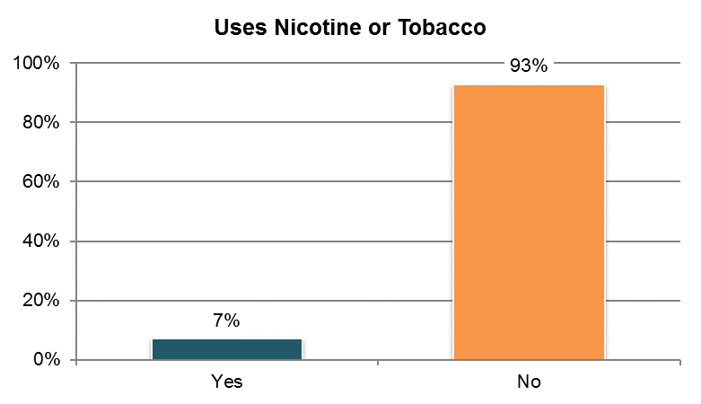

Table . Uses nicotine or tobacco products (information comes from Background Information section)

|  |  |  |  |  |  |  |
| --- | --- | --- | --- | --- | --- | --- |
| State | Overall in State | N | ICF/IID and Other Institutional Settings | Community-based Group Residential Settings | Own Home | Parent’s or Relative’s Home |
| **Significantly Above Average** | | |  |  |  |  |
| KY | 15% | 443 | n/a | 16% | 30% | 6% |
| **Within Average Range** | | |  |  |  |  |
| WY | 11% | 309 | n/a | 11% | 18% | 3% |
| TN | 10% | 437 | n/a | 11% | 13% | 4% |
| SD | 10% | 361 | n/a | 12% | 9% | 6% |
| OH | 9% | 567 | 5% | 10% | 20% | 5% |
| KS | 9% | 367 | n/a | 3% | 25% | 3% |
| LA | 9% | 382 | 15% | n/a | 12% | 4% |
| CO | 9% | 399 | n/a | 1% | 20% | 4% |
| NC | 8% | 793 | 2% | 12% | 22% | 6% |
| VT | 8% | 322 | n/a | 5% | 16% | 3% |
| PA | 8% | 586 | 2% | 8% | 24% | 3% |
| AR | 8% | 365 | 3% | 9% | 14% | 1% |
| MO | 8% | 394 | n/a | 4% | 10% | 5% |
| ME | 7% | 381 | n/a | 7% | 15% | 8% |
| DE | 7% | 412 | n/a | 6% | 20% | n/a |
| IL | 7% | 376 | n/a | 7% | 24% | 4% |
| NV | 7% | 387 | n/a | 8% | 9% | 0% |
| WA | 7% | 392 | n/a | 0% | 14% | 3% |
| MS | 7% | 397 | n/a | 9% | 9% | 4% |
| MN | 7% | 409 | 0% | 9% | 19% | 2% |
| OK | 6% | 400 | n/a | 9% | 11% | 0% |
| UT | 6% | 395 | 4% | 7% | 16% | 2% |
| VA | 5% | 750 | 2% | 7% | 8% | 4% |
| IN | 5% | 812 | n/a | 10% | 11% | 3% |
| AZ | 5% | 441 | n/a | 10% | 7% | 2% |
| NY | 5% | 488 | 2% | 4% | 15% | 2% |
| MA | 5% | 413 | n/a | 6% | 7% | 1% |
| CT | 4% | 334 | n/a | 5% | 6% | 2% |
| AL | 4% | 386 | n/a | 4% | 8% | 3% |
| MI | 4% | 420 | n/a | 5% | 7% | 1% |
| RI ** | 4% | 362 | n/a | 3% | 12% | 2% |
| **Significantly Below Average** | | |  |  |  |  |
| FL | 5% | 1,417 | n/a | 5% | 13% | 1% |
| GA | 4% | 468 | n/a | 7% | 10% | 1% |
| DC ** | 2% | 229 | 3% | 2% | n/a | 1% |
| HI | 2% | 293 | n/a | 3% | n/a | 0% |
| NCI Average | 7% | 16,087 | 4% | 7% | 14% | 3% |

**State had a large number of “don’t know” responses and missing data (at least 25%)

**Note:** WI excluded due to low N (<20).

## Respect and Rights

### People receive the same respect and protections as others in the community.

There are four Respect and Rights indicators:

1. The proportion of people whose basic rights are respected by others, including:
   1. Proportion of people who reported people always knock before entering home
   2. Proportion of people who report having a key to their home
   3. Proportion of people who reported people always knock before entering bedroom
   4. Proportion of people who report they can lock their bedroom
   5. Proportion of people who reported they could be alone at home with visitors
   6. Proportion of people who report that there are rules about having friends or visitors
   7. Proportion of people who reported people never read their mail without permission
   8. Proportion of people who reported they can use phone and internet without restriction
2. The proportion of people who have a place to be alone in the home
3. The proportion of people indicating that most support staff treat them with respect
4. The proportion of people who have participated in a self-advocacy group meeting, conference, or event
5. The proportion of people who report having voted

Tables 119 through 130 present items from the Respect and Rights sub-domain. The corresponding charts show un-collapsed averages.

All un-collapsed state data frequencies for these survey questions are displayed in Appendix D.

Important note on changes to the survey tool and analysis. Several questions in this section were moved from Section II (where information may come from the individual receiving services or a proxy respondent) to Section I (where only the person receiving services may respond).

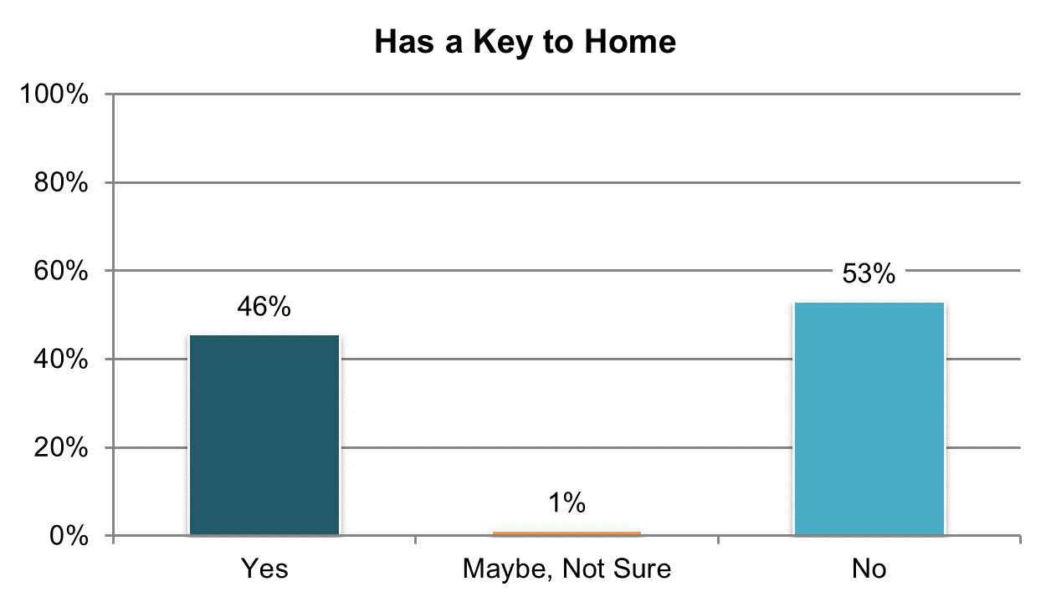

Table . Has a key to the home (‘yes’ responses only; proxy responses allowed) º

|  |  |  |  |  |  |  |
| --- | --- | --- | --- | --- | --- | --- |
| State | Overall in State | N | ICF/IID and Other Institutional Settings | Community-based Group Residential Settings | Own Home | Parent’s or Relative’s Home |
| **Significantly Above Average** | | |  |  |  |  |
| WI | 68% | 394 | 50% | 45% | 88% | 69% |
| SD | 64% | 318 | n/a | 40% | 95% | 50% |
| AZ | 64% | 461 | n/a | 24% | 91% | 77% |
| NV | 62% | 386 | n/a | 46% | 85% | 71% |
| WY | 61% | 310 | n/a | 36% | 91% | 64% |
| WA | 57% | 389 | n/a | 26% | 70% | 60% |
| GA | 56% | 411 | n/a | 28% | 88% | 58% |
| IN | 56% | 803 | n/a | n/a | 82% | 50% |
| **Within Average Range** | | |  |  |  |  |
| KS | 52% | 312 | n/a | 31% | 79% | 56% |
| RI | 51% | 442 | n/a | 24% | 87% | 58% |
| AL | 51% | 375 | n/a | 46% | 80% | 48% |
| OH | 50% | 511 | 6% | 40% | 69% | 59% |
| MS | 50% | 381 | n/a | 36% | 80% | 46% |
| LA | 49% | 397 | 12% | n/a | 84% | 52% |
| CO | 49% | 382 | n/a | 26% | 93% | 57% |
| DC | 47% | 356 | 17% | 52% | 62% | 43% |
| TN | 47% | 428 | n/a | 43% | 53% | 46% |
| MN | 47% | 380 | 28% | 35% | 94% | 49% |
| CT | 46% | 300 | n/a | 18% | 94% | 61% |
| FL | 46% | 1,331 | n/a | 21% | 88% | 44% |
| AR | 46% | 349 | 6% | 36% | 85% | 34% |
| PA | 42% | 641 | 8% | 22% | 90% | 46% |
| VT | 42% | 313 | n/a | 20% | 85% | 56% |
| MA | 41% | 402 | n/a | 23% | 91% | 60% |
| MO | 39% | 386 | n/a | 16% | 52% | 34% |
| ME | 39% | 377 | n/a | 22% | 83% | 58% |
| **Significantly Below Average** | | |  |  |  |  |
| NC | 37% | 719 | 5% | 30% | 93% | 45% |
| UT | 37% | 368 | 8% | 33% | 83% | 30% |
| MI | 33% | 421 | n/a | 5% | 67% | 50% |
| DE | 33% | 372 | n/a | 29% | 78% | n/a |
| HI | 33% | 354 | n/a | 10% | n/a | 45% |
| NY | 33% | 483 | 2% | 19% | 94% | 39% |
| IL | 31% | 365 | n/a | 11% | 84% | 47% |
| KY | 30% | 440 | n/a | 8% | 70% | 43% |
| OK | 28% | 397 | n/a | 22% | 58% | 20% |
| VA | 27% | 784 | 7% | 18% | 83% | 34% |
| NCI Average | 46% | 16,238 | 13% | 28% | 81% | 50% |

ºNew variable to reporting

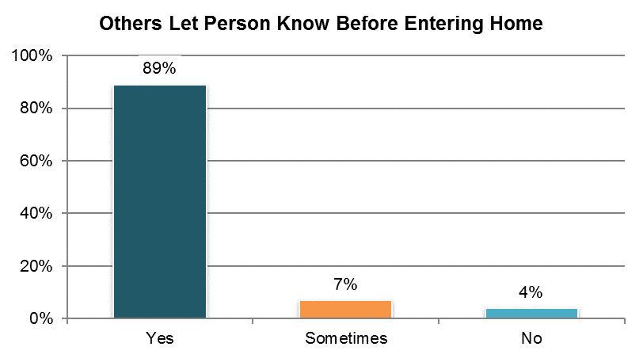

Table . Others let person know before entering home (‘yes’ responses only)

|  |  |  |  |  |  |  |
| --- | --- | --- | --- | --- | --- | --- |
| State | Overall in State | N | ICF/IID and Other Institutional Settings | Community-based Group Residential Settings | Own Home | Parent’s or Relative’s Home |
| **Significantly Above Average** | | |  |  |  |  |
| AZ | 98% | 417 | n/a | 97% | 95% | 98% |
| TN | 97% | 327 | n/a | 96% | 96% | 99% |
| IN | 95% | 555 | n/a | n/a | 96% | 96% |
| WA | 95% | 261 | n/a | n/a | 95% | 95% |
| KY | 94% | 298 | n/a | 89% | 95% | 97% |
| WI | 94% | 279 | 87% | 97% | 92% | 95% |
| FL | 92% | 838 | n/a | 87% | 93% | 93% |
| **Within Average Range** | | |  |  |  |  |
| MN | 93% | 248 | n/a | 93% | 94% | 93% |
| LA | 92% | 285 | 83% | n/a | 94% | 95% |
| OK | 92% | 210 | n/a | 93% | 87% | 92% |
| MS | 91% | 313 | n/a | 88% | 88% | 97% |
| OH | 91% | 383 | 77% | 89% | 90% | 94% |
| PA | 91% | 424 | n/a | 88% | 90% | 92% |
| MA | 91% | 306 | n/a | 88% | 94% | 96% |
| CO | 91% | 306 | n/a | 82% | 90% | 94% |
| NC | 90% | 427 | 68% | 93% | 92% | 95% |
| KS | 90% | 269 | n/a | 86% | 95% | 94% |
| AL | 90% | 331 | n/a | 88% | 100% | 89% |
| VA | 90% | 489 | 91% | 88% | 100% | 91% |
| RI | 89% | 342 | n/a | 93% | 90% | 90% |
| WY | 89% | 235 | n/a | 85% | 88% | 96% |
| CT | 88% | 242 | n/a | 87% | 92% | 91% |
| NV | 88% | 343 | n/a | 88% | 89% | 84% |
| DC | 88% | 193 | n/a | 94% | n/a | 92% |
| AR | 88% | 222 | 56% | 100% | 91% | 91% |
| MO | 88% | 260 | n/a | 75% | 91% | n/a |
| HI | 87% | 191 | n/a | 75% | n/a | 92% |
| IL | 87% | 257 | n/a | 81% | 87% | 94% |
| GA | 87% | 294 | n/a | 73% | 94% | 88% |
| VT | 85% | 269 | n/a | n/a | 89% | 81% |
| UT | 84% | 236 | n/a | 82% | 86% | 88% |
| SD | 84% | 283 | n/a | 79% | 89% | 91% |
| **Significantly Below Average** | | |  |  |  |  |
| NY | 82% | 306 | n/a | 77% | 92% | 83% |
| MI | 82% | 266 | n/a | 72% | 86% | 88% |
| ME | 77% | 274 | n/a | 72% | 86% | 77% |
| DE | 75% | 258 | n/a | 75% | 78% | n/a |
| NCI Average | 89% | 11,437 | 77% | 86% | 91% | 92% |

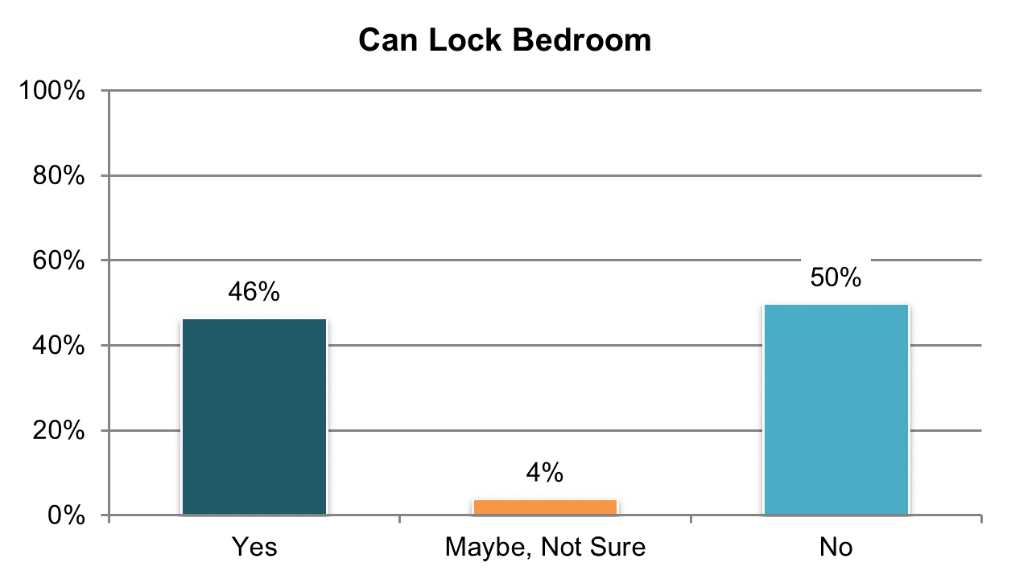

Table . Can lock bedroom if they want (‘yes’ responses only; proxy responses allowed) º

|  |  |  |  |  |  |  |
| --- | --- | --- | --- | --- | --- | --- |
| State | Overall in State | N | ICF/IID and Other Institutional Settings | Community-based Group Residential Settings | Own Home | Parent’s or Relative’s Home |
| **Significantly Above Average** | | |  |  |  |  |
| GA | 76% | 385 | n/a | 72% | 91% | 74% |
| AZ | 67% | 453 | n/a | 32% | 72% | 80% |
| FL | 66% | 1,317 | n/a | 56% | 80% | 67% |
| AL | 64% | 375 | n/a | 56% | 90% | 67% |
| MS | 62% | 379 | n/a | 80% | 70% | 50% |
| SD | 61% | 306 | n/a | 69% | 63% | 30% |
| NV | 58% | 340 | n/a | 55% | 67% | 56% |
| VA | 53% | 788 | 20% | 58% | 51% | 51% |
| **Within Average Range** | | |  |  |  |  |
| WY | 55% | 274 | n/a | 57% | 63% | 44% |
| TN | 53% | 418 | n/a | 52% | 53% | 54% |
| KY | 53% | 417 | n/a | 35% | 79% | 63% |
| AR | 49% | 365 | 19% | 94% | 65% | 44% |
| HI | 49% | 337 | n/a | 48% | n/a | 54% |
| KS | 47% | 277 | n/a | 46% | 62% | 35% |
| UT | 46% | 363 | 24% | 52% | 55% | 40% |
| NC | 46% | 698 | 21% | 52% | 77% | 45% |
| CT | 45% | 304 | 15% | 39% | 63% | 51% |
| IN | 45% | 782 | n/a | n/a | 65% | 39% |
| OH | 44% | 510 | 19% | 55% | 52% | 45% |
| CO | 44% | 376 | n/a | 28% | 64% | 45% |
| DE | 42% | 351 | n/a | 39% | 67% | n/a |
| MN | 42% | 383 | 26% | 45% | 64% | 36% |
| MO | 41% | 360 | n/a | 31% | 48% | 27% |
| **Significantly Below Average** | | |  |  |  |  |
| PA | 40% | 590 | 20% | 35% | 63% | 40% |
| RI | 39% | 414 | n/a | 29% | 53% | 42% |
| LA | 38% | 407 | 17% | n/a | 64% | 38% |
| ME | 38% | 349 | n/a | 43% | 38% | 25% |
| WI | 37% | 343 | 46% | 39% | 41% | 32% |
| OK | 37% | 395 | n/a | 44% | 46% | 22% |
| VT | 36% | 269 | n/a | n/a | 53% | 30% |
| WA | 35% | 358 | n/a | 30% | 50% | 28% |
| IL | 34% | 352 | n/a | 27% | 80% | 34% |
| MA | 33% | 378 | n/a | 29% | 59% | 34% |
| MI | 33% | 413 | n/a | 29% | 51% | 27% |
| NY | 32% | 464 | 6% | 27% | 62% | 37% |
| DC | 31% | 351 | 10% | 36% | n/a | 28% |
| NCI Average | 46% | 15,641 | 20% | 46% | 62% | 43% |

ºNew variable to reporting

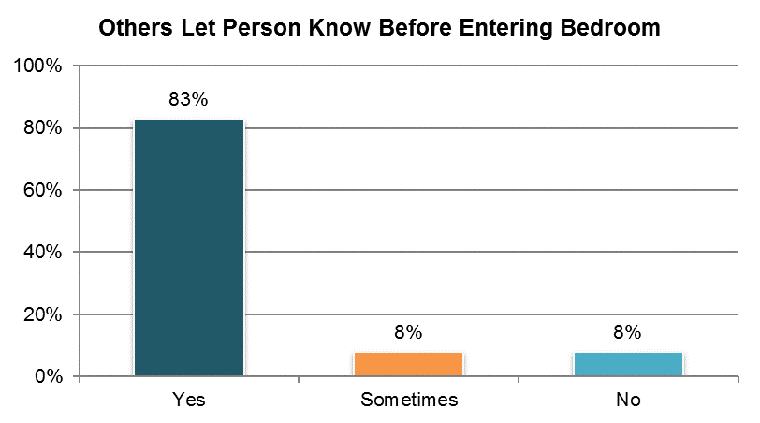

Table . Others let person know before entering bedroom (‘yes’ responses only)

|  |  |  |  |  |  |  |
| --- | --- | --- | --- | --- | --- | --- |
| State | Overall in State | N | ICF/IID and Other Institutional Settings | Community-based Group Residential Settings | Own Home | Parent’s or Relative’s Home |
| **Significantly Above Average** | | |  |  |  |  |
| AZ | 95% | 419 | n/a | 95% | 95% | 95% |
| KY | 94% | 292 | n/a | 91% | 98% | 95% |
| TN | 92% | 330 | n/a | 91% | 92% | 90% |
| CO | 90% | 292 | n/a | 89% | 94% | 83% |
| FL | 87% | 814 | n/a | 80% | 91% | 89% |
| **Within Average Range** | | |  |  |  |  |
| WA | 88% | 244 | n/a | n/a | 92% | 85% |
| WI | 88% | 274 | 87% | 85% | 88% | 87% |
| NV | 88% | 338 | n/a | 88% | 90% | 79% |
| GA | 87% | 296 | n/a | 87% | 93% | 84% |
| LA | 86% | 274 | 83% | n/a | 89% | 86% |
| WY | 85% | 226 | n/a | 83% | 91% | 78% |
| VA | 85% | 485 | 85% | 85% | 91% | 80% |
| DC | 85% | 186 | n/a | 91% | n/a | 85% |
| NC | 85% | 430 | 74% | 87% | 87% | 84% |
| PA | 85% | 403 | 91% | 86% | 87% | 82% |
| KS | 85% | 247 | n/a | 82% | 89% | 81% |
| MN | 85% | 239 | n/a | 85% | 91% | 83% |
| MA | 84% | 299 | n/a | 84% | 85% | 83% |
| AR | 84% | 218 | 86% | 100% | 86% | 78% |
| CT | 83% | 240 | n/a | 81% | 85% | 84% |
| IL | 83% | 242 | n/a | 85% | 80% | 81% |
| AL | 82% | 329 | n/a | 85% | 88% | 78% |
| MO | 82% | 249 | n/a | 76% | 84% | n/a |
| RI | 82% | 338 | n/a | 89% | 91% | 69% |
| SD | 81% | 269 | n/a | 75% | 88% | 80% |
| OH | 81% | 381 | 86% | 85% | 79% | 80% |
| MS | 80% | 290 | n/a | 81% | 81% | 79% |
| UT | 79% | 232 | n/a | 81% | 79% | 81% |
| OK | 79% | 201 | n/a | 87% | 80% | 63% |
| NY | 78% | 301 | n/a | 75% | 93% | 73% |
| MI | 77% | 253 | n/a | 74% | 90% | 65% |
| HI | 76% | 179 | n/a | 68% | n/a | 76% |
| VT | 76% | 241 | n/a | n/a | 88% | 75% |
| **Significantly Below Average** | | |  |  |  |  |
| IN | 78% | 525 | n/a | n/a | 88% | 74% |
| DE | 74% | 260 | n/a | 74% | 79% | n/a |
| ME | 73% | 267 | n/a | 78% | 75% | 58% |
| NCI Average | 83% | 11,103 | 85% | 84% | 88% | 80% |

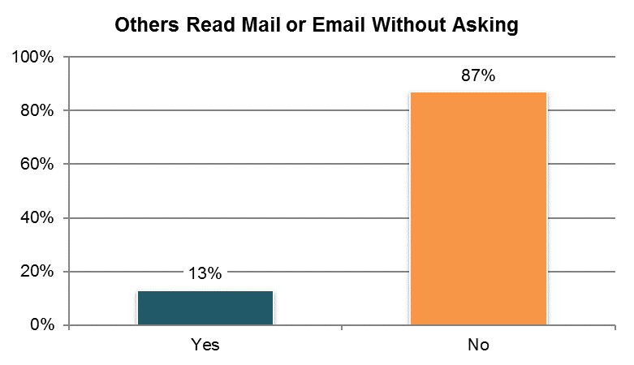

Table . Others read mail or email without asking first ±

|  |  |  |  |  |  |  |
| --- | --- | --- | --- | --- | --- | --- |
| State | Overall in State | N | ICF/IID and Other Institutional Settings | Community-based Group Residential Settings | Own Home | Parent’s or Relative’s Home |
| **Significantly Above Average** | | |  |  |  |  |
| DE | 28% | 205 | n/a | 29% | 11% | n/a |
| HI | 28% | 166 | n/a | 14% | n/a | 33% |
| RI | 24% | 316 | n/a | 22% | 19% | 24% |
| IL | 22% | 227 | n/a | 20% | 23% | 26% |
| **Within Average Range** | | |  |  |  |  |
| DC | 22% | 149 | n/a | 15% | n/a | 30% |
| UT | 21% | 212 | n/a | 23% | 12% | 21% |
| OK | 21% | 194 | n/a | 18% | 30% | 19% |
| CT | 19% | 213 | n/a | 19% | 12% | 24% |
| IN | 18% | 541 | n/a | n/a | 11% | 20% |
| AL | 17% | 293 | n/a | 14% | 11% | 24% |
| MO | 17% | 233 | n/a | 18% | 16% | n/a |
| OH | 16% | 352 | 25% | 17% | 14% | 18% |
| MI | 15% | 261 | n/a | 19% | 7% | 17% |
| WY | 15% | 209 | n/a | 16% | 14% | 15% |
| MA | 15% | 282 | n/a | 20% | 8% | 13% |
| VA | 14% | 450 | 28% | 14% | 12% | 12% |
| SD | 14% | 265 | n/a | 14% | 15% | 4% |
| NY | 13% | 265 | n/a | 15% | 3% | 19% |
| PA | 12% | 411 | n/a | 8% | 8% | 14% |
| NV | 12% | 319 | n/a | 13% | 9% | 16% |
| AR | 11% | 213 | 8% | 8% | 11% | 16% |
| KS | 11% | 239 | n/a | 12% | 4% | 15% |
| CO | 11% | 283 | n/a | 14% | 3% | 15% |
| MN | 9% | 236 | n/a | 6% | 4% | 19% |
| WI | 9% | 283 | 5% | 10% | 6% | 13% |
| GA | 9% | 273 | n/a | 18% | 5% | 6% |
| LA | 9% | 275 | 12% | n/a | 13% | 4% |
| **Significantly Below Average** | | |  |  |  |  |
| FL | 10% | 770 | n/a | 10% | 9% | 10% |
| NC | 8% | 371 | 3% | 4% | 5% | 14% |
| KY | 7% | 288 | n/a | 7% | 2% | 8% |
| MS | 7% | 274 | n/a | 6% | 5% | 7% |
| WA | 4% | 252 | n/a | n/a | 2% | 5% |
| ME | 3% | 266 | n/a | 3% | 0% | 10% |
| VT | 3% | 253 | n/a | n/a | 0% | 5% |
| AZ | 2% | 379 | n/a | 0% | 2% | 3% |
| TN | 2% | 289 | n/a | 1% | 1% | 2% |
| NCI Average | 13% | 10,507 | 13% | 13% | 9% | 15% |

±Item changed from previous years – question was moved from Section II to Section I (see Appendix A)

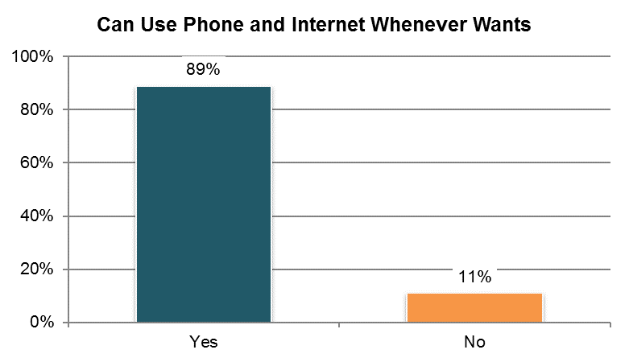

Table . Can use phone and internet whenever they want ±

|  |  |  |  |  |  |  |
| --- | --- | --- | --- | --- | --- | --- |
| State | Overall in State | N | ICF/IID and Other Institutional Settings | Community-based Group Residential Settings | Own Home | Parent’s or Relative’s Home |
| **Significantly Above Average** | | |  |  |  |  |
| WI | 97% | 276 | 95% | 100% | 99% | 94% |
| WA | 97% | 254 | n/a | n/a | 94% | 100% |
| OH | 95% | 358 | 100% | 95% | 93% | 96% |
| GA | 94% | 295 | n/a | 94% | 97% | 92% |
| MS | 94% | 276 | n/a | 92% | 94% | 94% |
| KS | 93% | 228 | n/a | 95% | 90% | 95% |
| IL | 93% | 239 | n/a | 93% | 100% | 92% |
| NV | 93% | 335 | n/a | 94% | 93% | 89% |
| **Within Average Range** | | |  |  |  |  |
| MI | 93% | 269 | n/a | 87% | 97% | 96% |
| AR | 91% | 221 | 93% | 88% | 97% | 81% |
| KY | 91% | 289 | n/a | 86% | 93% | 96% |
| MN | 90% | 242 | n/a | 87% | 96% | 92% |
| PA | 90% | 400 | 85% | 95% | 91% | 88% |
| NC | 90% | 406 | 97% | 84% | 98% | 90% |
| SD | 90% | 267 | n/a | 82% | 96% | 100% |
| CT | 90% | 224 | n/a | 81% | 96% | 94% |
| RI | 90% | 324 | n/a | 87% | 89% | 84% |
| VA | 89% | 482 | 94% | 86% | 97% | 92% |
| OK | 89% | 201 | n/a | 91% | 95% | 85% |
| IN | 89% | 532 | n/a | n/a | 97% | 86% |
| FL | 88% | 800 | n/a | 89% | 88% | 89% |
| MA | 88% | 303 | n/a | 88% | 96% | 85% |
| AL | 88% | 321 | n/a | 90% | 86% | 85% |
| UT | 88% | 230 | n/a | 85% | 96% | 85% |
| MO | 88% | 245 | n/a | 86% | 88% | n/a |
| NY | 87% | 270 | n/a | 86% | 98% | 81% |
| CO | 87% | 285 | n/a | 92% | 90% | 92% |
| TN | 87% | 300 | n/a | 93% | 85% | 79% |
| LA | 86% | 279 | 79% | n/a | 92% | 86% |
| DC | 86% | 166 | n/a | 78% | n/a | 88% |
| AZ | 84% | 402 | n/a | 78% | 77% | 87% |
| ME | 84% | 261 | n/a | 78% | 94% | 85% |
| WY | 83% | 220 | n/a | 71% | 93% | 87% |
| **Significantly Below Average** | | |  |  |  |  |
| VT | 80% | 238 | n/a | n/a | 91% | 84% |
| DE | 76% | 225 | n/a | 74% | 89% | n/a |
| HI | 75% | 172 | n/a | 58% | n/a | 77% |
| NCI Average | 89% | 10,835 | 92% | 86% | 93% | 89% |

±Item changed from previous years – question was moved from Section II to Section I (see Appendix A)

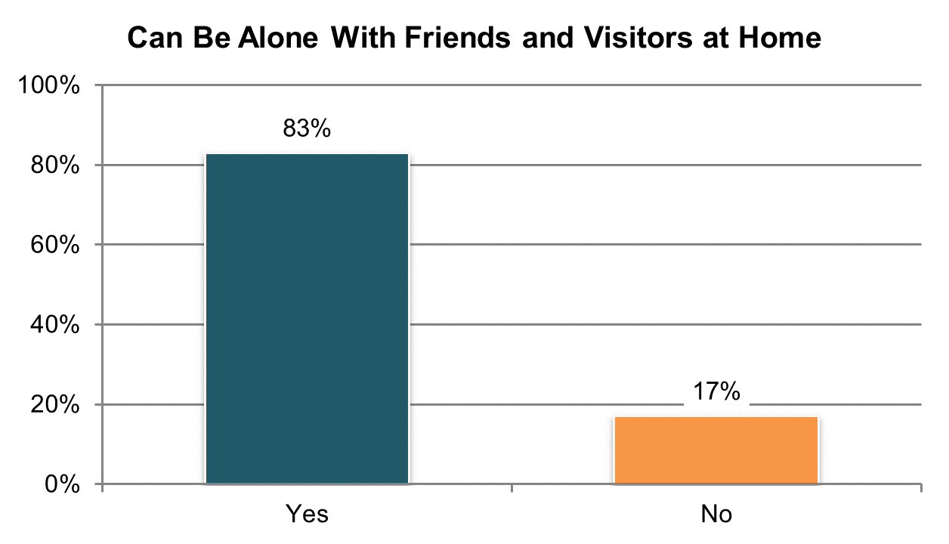

Table . Can be alone with visitors at home ±

|  |  |  |  |  |  |  |
| --- | --- | --- | --- | --- | --- | --- |
| State | Overall in State | N | ICF/IID and Other Institutional Settings | Community-based Group Residential Settings | Own Home | Parent’s or Relative’s Home |
| **Significantly Above Average** | | |  |  |  |  |
| WI | 92% | 270 | 96% | 90% | 97% | 89% |
| GA | 91% | 281 | n/a | 88% | 97% | 90% |
| KY | 91% | 293 | n/a | 86% | 98% | 94% |
| MS | 90% | 274 | n/a | 90% | 90% | 88% |
| VA | 89% | 456 | 100% | 85% | 97% | 92% |
| KS | 89% | 256 | n/a | 88% | 88% | 90% |
| AZ | 89% | 400 | n/a | 82% | 81% | 92% |
| PA | 88% | 379 | n/a | 83% | 95% | 90% |
| **Within Average Range** | | |  |  |  |  |
| MI | 88% | 257 | n/a | 83% | 92% | 90% |
| DC | 88% | 171 | n/a | 92% | n/a | 84% |
| SD | 88% | 275 | n/a | 85% | 92% | 93% |
| WA | 88% | 240 | n/a | n/a | 85% | 86% |
| TN | 87% | 319 | n/a | 86% | 90% | 85% |
| AR | 86% | 216 | 81% | 72% | 87% | 92% |
| IN | 84% | 519 | n/a | n/a | 91% | 82% |
| FL | 84% | 765 | n/a | 77% | 94% | 81% |
| AL | 84% | 302 | n/a | 82% | 93% | 83% |
| MO | 83% | 242 | n/a | 84% | 81% | n/a |
| UT | 83% | 235 | n/a | 80% | 91% | 83% |
| RI | 83% | 302 | n/a | 88% | 96% | 71% |
| OH | 83% | 358 | 88% | 82% | 80% | 84% |
| CO | 83% | 281 | n/a | 86% | 95% | 77% |
| WY | 82% | 208 | n/a | 72% | 93% | 79% |
| MA | 82% | 284 | n/a | 80% | 94% | 71% |
| CT | 81% | 227 | n/a | 80% | 90% | 76% |
| NV | 80% | 323 | n/a | 76% | 89% | 78% |
| ME | 80% | 224 | n/a | 75% | 91% | 82% |
| OK | 80% | 192 | n/a | 80% | 86% | 78% |
| NY | 79% | 277 | n/a | 77% | 93% | 73% |
| MN | 79% | 232 | n/a | 68% | 100% | 79% |
| IL | 78% | 231 | n/a | 80% | 90% | 72% |
| **Significantly Below Average** | | |  |  |  |  |
| NC | 75% | 383 | 78% | 75% | 93% | 66% |
| LA | 72% | 269 | 76% | n/a | 74% | 69% |
| VT | 72% | 177 | n/a | n/a | 90% | 69% |
| HI | 70% | 149 | n/a | 63% | n/a | 76% |
| DE | 64% | 201 | n/a | 60% | 83% | n/a |
| NCI Average | 83% | 10,468 | 86% | 80% | 90% | 82% |

±Item changed from previous years – question was moved from Section II to Section I (see Appendix A)

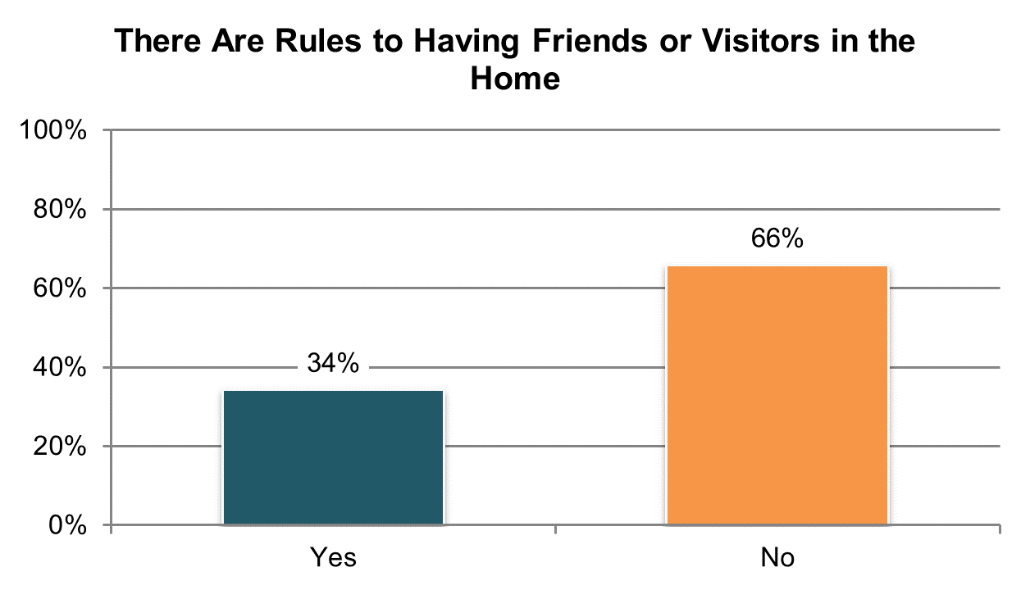

Table . There are rules to having friends or visitors at home º

|  |  |  |  |  |  |  |
| --- | --- | --- | --- | --- | --- | --- |
| State | Overall in State | N | ICF/IID and Other Institutional Settings | Community-based Group Residential Settings | Own Home | Parent’s or Relative’s Home |
| **Significantly Above Average** | | |  |  |  |  |
| AZ | 87% | 389 | n/a | 91% | 67% | 89% |
| NC | 51% | 345 | 52% | 63% | 30% | 54% |
| DE | 47% | 184 | n/a | 50% | 38% | n/a |
| NV | 47% | 318 | n/a | 61% | 29% | 37% |
| RI | 43% | 286 | n/a | 58% | 31% | 48% |
| **Within Average Range** | | |  |  |  |  |
| HI | 43% | 149 | n/a | 50% | n/a | 35% |
| OK | 43% | 188 | n/a | 47% | 38% | 38% |
| IL | 43% | 214 | n/a | 46% | 10% | 49% |
| CT | 43% | 207 | n/a | 51% | 21% | 47% |
| CO | 41% | 273 | n/a | 32% | 15% | 51% |
| WY | 41% | 209 | n/a | 54% | 30% | 39% |
| OH | 38% | 334 | 42% | 44% | 30% | 43% |
| NY | 37% | 273 | n/a | 43% | 13% | 46% |
| LA | 37% | 246 | 40% | n/a | 31% | 39% |
| MS | 36% | 258 | n/a | 39% | 35% | 33% |
| VT | 36% | 177 | n/a | n/a | 23% | 45% |
| AR | 36% | 211 | 54% | 41% | 33% | 38% |
| KY | 35% | 293 | n/a | 44% | 18% | 36% |
| DC | 34% | 158 | n/a | 29% | n/a | 33% |
| UT | 34% | 220 | n/a | 39% | 24% | 35% |
| MN | 33% | 227 | n/a | 46% | 11% | 27% |
| MI | 32% | 246 | n/a | 39% | 30% | 24% |
| VA | 30% | 412 | 15% | 37% | 19% | 26% |
| SD | 29% | 263 | n/a | 33% | 21% | 37% |
| MA | 28% | 276 | n/a | 33% | 14% | 28% |
| ME | 27% | 214 | n/a | 29% | 16% | 31% |
| MO | 26% | 222 | n/a | 24% | 27% | n/a |
| **Significantly Below Average** | | |  |  |  |  |
| IN | 27% | 503 | n/a | n/a | 20% | 29% |
| PA | 23% | 355 | n/a | 33% | 10% | 25% |
| WA | 21% | 230 | n/a | n/a | 17% | 27% |
| GA | 19% | 276 | n/a | 31% | 5% | 20% |
| FL | 19% | 738 | n/a | 30% | 8% | 19% |
| KS | 18% | 238 | n/a | 18% | 21% | 16% |
| WI | 17% | 262 | 22% | 34% | 10% | 18% |
| TN | 16% | 319 | n/a | 19% | 15% | 15% |
| AL | 15% | 300 | n/a | 17% | 10% | 16% |
| NCI Average | 34% | 10,013 | 37% | 41% | 23% | 35% |

ºNew variable to reporting

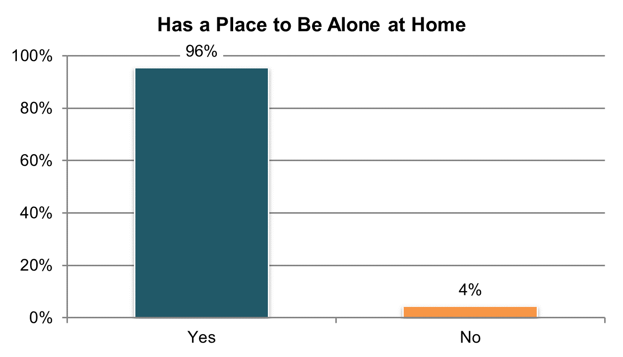

Table . Has a place to be alone at home ±

|  |  |  |  |  |  |  |
| --- | --- | --- | --- | --- | --- | --- |
| State | Overall in State | N | ICF/IID and Other Institutional Settings | Community-based Group Residential Settings | Own Home | Parent’s or Relative’s Home |
| **Significantly Above Average** | | |  |  |  |  |
| GA | 100% | 304 | n/a | 100% | 98% | 100% |
| AZ | 99% | 423 | n/a | 96% | 100% | 99% |
| MN | 99% | 251 | n/a | 98% | 100% | 100% |
| KS | 99% | 267 | n/a | 97% | 99% | 100% |
| CO | 98% | 307 | n/a | 100% | 97% | 98% |
| WA | 98% | 263 | n/a | n/a | 100% | 98% |
| IN | 98% | 575 | n/a | n/a | 96% | 98% |
| **Within Average Range** | | |  |  |  |  |
| WY | 98% | 236 | n/a | 99% | 97% | 98% |
| ME | 98% | 281 | n/a | 96% | 100% | 100% |
| NV | 97% | 349 | n/a | 96% | 100% | 93% |
| MO | 97% | 268 | n/a | 94% | 98% | 100% |
| WI | 97% | 288 | 91% | 100% | 97% | 98% |
| MA | 97% | 306 | n/a | 97% | 100% | 96% |
| CT | 97% | 246 | n/a | 98% | 98% | 97% |
| AL | 97% | 331 | n/a | 96% | 100% | 97% |
| FL | 97% | 856 | n/a | 94% | 99% | 97% |
| VT | 96% | 272 | n/a | n/a | 98% | 96% |
| TN | 96% | 335 | n/a | 95% | 98% | 96% |
| LA | 96% | 290 | 87% | n/a | 99% | 98% |
| PA | 96% | 434 | 76% | 97% | 97% | 97% |
| NC | 95% | 438 | 95% | 93% | 98% | 97% |
| AR | 95% | 225 | 90% | 100% | 95% | 94% |
| MS | 95% | 295 | n/a | 96% | 96% | 95% |
| IL | 95% | 256 | n/a | 92% | 100% | 96% |
| OH | 94% | 393 | 81% | 93% | 97% | 97% |
| MI | 94% | 285 | n/a | 89% | 100% | 98% |
| UT | 94% | 239 | n/a | 94% | 94% | 96% |
| SD | 94% | 286 | n/a | 93% | 96% | 94% |
| KY | 94% | 298 | n/a | 87% | 95% | 98% |
| RI | 93% | 346 | n/a | 95% | 92% | 92% |
| VA | 93% | 486 | 72% | 93% | 100% | 95% |
| DC | 93% | 185 | n/a | 97% | n/a | 80% |
| OK | 93% | 211 | n/a | 95% | 91% | 93% |
| NY | 91% | 300 | n/a | 88% | 98% | 91% |
| DE | 91% | 259 | n/a | 91% | 96% | n/a |
| **Significantly Below Average** | | |  |  |  |  |
| HI | 86% | 199 | n/a | 69% | n/a | 90% |
| NCI Average | 96% | 11,583 | 85% | 94% | 98% | 96% |

±Item changed from previous years – question rephrased (see Appendix A)

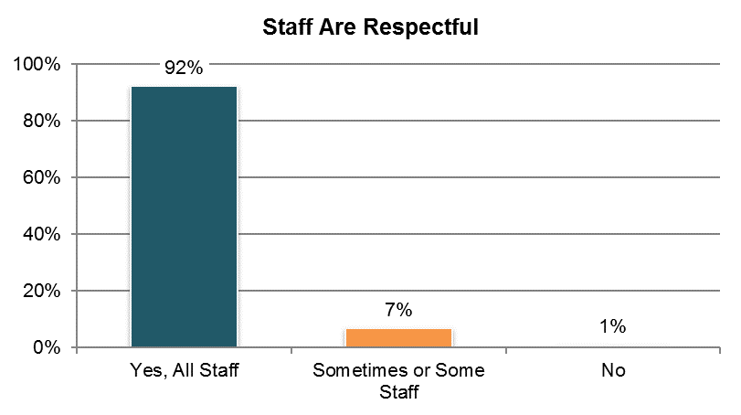

Table . Staff (at home, work, and/or day activity or program) are respectful (‘yes, all staff’ responses only) ±

|  |  |  |  |  |  |  |
| --- | --- | --- | --- | --- | --- | --- |
| State | Overall in State | N | ICF/IID and Other Institutional Settings | Community-based Group Residential Settings | Own Home | Parent’s or Relative’s Home |
| **Significantly Above Average** | | |  |  |  |  |
| TN | 99% | 329 | n/a | 99% | 98% | 100% |
| IN | 97% | 519 | n/a | n/a | 98% | 98% |
| LA | 96% | 256 | 94% | n/a | 97% | 96% |
| VA | 95% | 483 | 97% | 94% | 97% | 97% |
| PA | 95% | 347 | 90% | 92% | 96% | 98% |
| FL | 95% | 762 | n/a | 91% | 95% | 98% |
| **Within Average Range** | | |  |  |  |  |
| AR | 96% | 203 | 92% | 100% | 94% | 98% |
| AL | 95% | 317 | n/a | 93% | 98% | 98% |
| AZ | 95% | 313 | n/a | 94% | 80% | 97% |
| IL | 95% | 231 | n/a | 93% | 93% | 98% |
| GA | 95% | 305 | n/a | 91% | 94% | 98% |
| WA | 94% | 244 | n/a | n/a | 90% | 99% |
| CT | 94% | 229 | n/a | 91% | 96% | 96% |
| NC | 93% | 395 | 89% | 94% | 96% | 93% |
| MI | 93% | 227 | n/a | 91% | 97% | 95% |
| WI | 93% | 220 | 83% | 96% | 96% | 93% |
| KY | 93% | 284 | n/a | 84% | 95% | 99% |
| OH | 93% | 324 | 94% | 90% | 91% | 95% |
| RI | 93% | 321 | n/a | 91% | 92% | 95% |
| UT | 93% | 233 | n/a | 90% | 95% | 95% |
| HI | 92% | 182 | n/a | 83% | n/a | 94% |
| MN | 92% | 232 | n/a | 87% | 98% | 91% |
| NY | 92% | 265 | n/a | 88% | 93% | 94% |
| SD | 91% | 257 | n/a | 93% | 92% | 88% |
| DC | 91% | 167 | n/a | 97% | n/a | 92% |
| KS | 91% | 256 | n/a | 90% | 92% | 96% |
| OK | 90% | 188 | n/a | 91% | 90% | 92% |
| CO | 90% | 278 | n/a | 83% | 90% | 94% |
| MA | 90% | 283 | n/a | 88% | 89% | 94% |
| ME | 90% | 273 | n/a | 89% | 91% | 92% |
| NV | 89% | 323 | n/a | 85% | 91% | 95% |
| VT | 88% | 223 | n/a | n/a | 86% | 85% |
| MO | 87% | 256 | n/a | 80% | 89% | 90% |
| MS | 87% | 285 | n/a | 87% | 86% | 90% |
| WY | 87% | 212 | n/a | 75% | 89% | 98% |
| **Significantly Below Average** | | |  |  |  |  |
| DE | 79% | 225 | n/a | 78% | 79% | n/a |
| NCI Average | 92% | 10,447 | 91% | 90% | 93% | 95% |

±Item changed from previous years – question rephrased (see Appendix A)

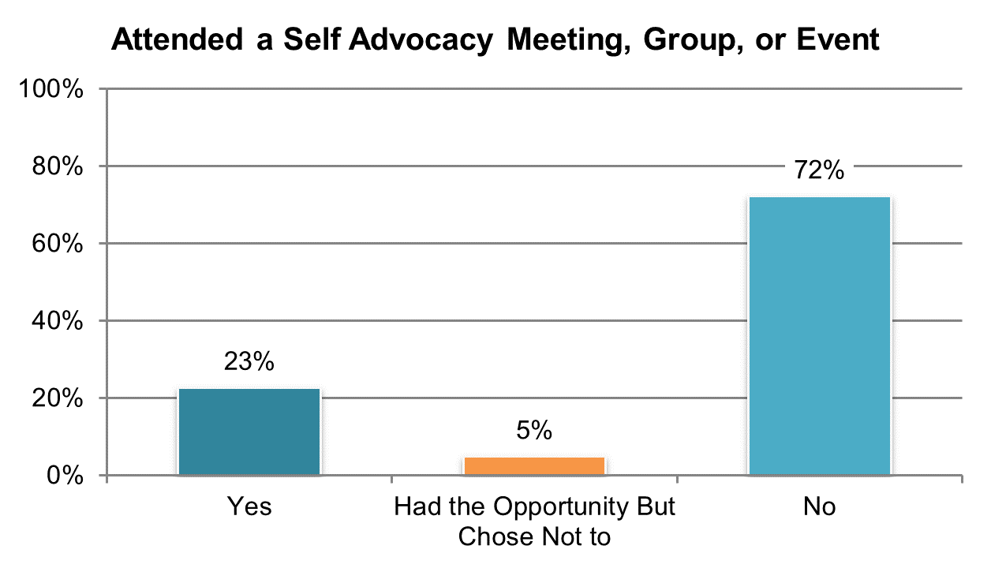

Table . Have attended a self-advocacy event or had opportunity but chose not to (‘yes’ and ‘had opportunity but chose not to’ responses; proxy responses allowed)

|  |  |  |  |  |  |  |
| --- | --- | --- | --- | --- | --- | --- |
| State | Overall in State | N | ICF/IID and Other Institutional Settings | Community-based Group Residential Settings | Own Home | Parent’s or Relative’s Home |
| **Significantly Above Average** | | |  |  |  |  |
| AL | 49% | 352 | n/a | 50% | 81% | 36% |
| SD | 45% | 314 | n/a | 51% | 42% | 35% |
| WY | 42% | 242 | n/a | 39% | 57% | 24% |
| HI | 40% | 351 | n/a | 55% | n/a | 42% |
| NC | 40% | 544 | 70% | 35% | 48% | 27% |
| CT | 40% | 284 | n/a | 37% | 48% | 41% |
| VT | 39% | 314 | n/a | 29% | 46% | 46% |
| MO | 37% | 321 | n/a | 28% | 42% | 38% |
| RI | 36% | 403 | n/a | 35% | 43% | 34% |
| **Within Average Range** | | |  |  |  |  |
| KS | 35% | 298 | n/a | 30% | 43% | 33% |
| IL | 31% | 226 | n/a | 27% | 52% | 31% |
| MN | 30% | 360 | 29% | 32% | 24% | 33% |
| UT | 30% | 354 | 84% | 29% | 31% | 22% |
| LA | 29% | 342 | 29% | n/a | 30% | 27% |
| MA | 28% | 345 | n/a | 30% | 28% | 23% |
| OH | 28% | 485 | 21% | 23% | 40% | 26% |
| ME | 27% | 358 | n/a | 30% | 37% | 22% |
| NV | 27% | 374 | n/a | 27% | 24% | 37% |
| MS | 25% | 316 | n/a | 25% | 25% | 30% |
| OK | 25% | 370 | n/a | 28% | 38% | 12% |
| VA | 25% | 661 | 19% | 27% | 45% | 19% |
| MI | 25% | 372 | n/a | 20% | 43% | 22% |
| WI | 24% | 385 | 6% | 16% | 31% | 24% |
| TN | 24% | 343 | n/a | 26% | 24% | 20% |
| AR | 23% | 270 | 24% | 32% | 27% | 14% |
| NY | 22% | 370 | 13% | 28% | 33% | 12% |
| **Significantly Below Average** | | |  |  |  |  |
| IN | 23% | 756 | n/a | n/a | 23% | 23% |
| CO | 21% | 382 | n/a | 17% | 21% | 25% |
| DC | 20% | 340 | 15% | 25% | 30% | 14% |
| WA | 20% | 374 | n/a | 14% | 26% | 16% |
| FL | 19% | 1,260 | n/a | 15% | 24% | 20% |
| GA | 17% | 369 | n/a | 16% | 14% | 20% |
| DE | 16% | 322 | n/a | 16% | 23% | n/a |
| KY | 15% | 362 | n/a | 17% | 17% | 14% |
| PA | 13% | 506 | 21% | 12% | 9% | 12% |
| AZ | 7% | 362 | n/a | 8% | 20% | 4% |
| NCI Average | 28% | 14,387 | 30% | 27% | 34% | 25% |

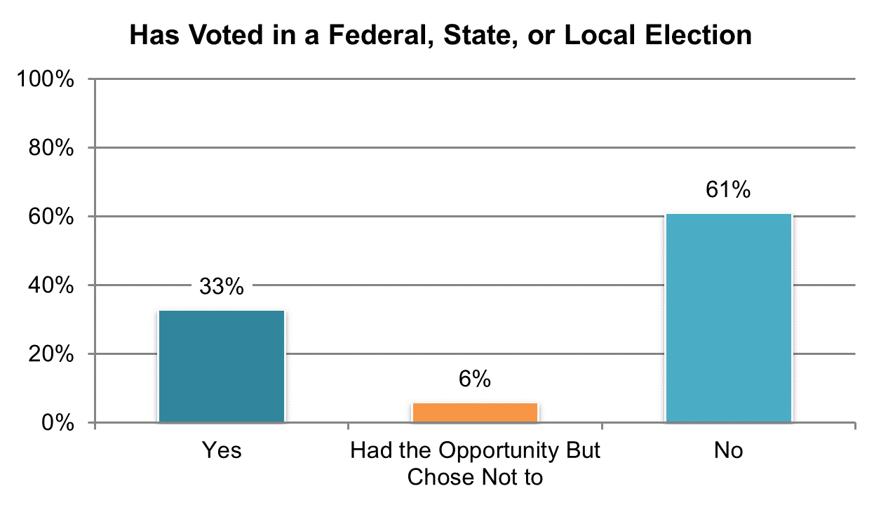

Table . Has ever voted in local, state, or federal election, or had the opportunity and chose not to (‘yes’ and ‘had opportunity to register to vote but chose not to’ responses; proxy responses allowed) º

|  |  |  |  |  |  |  |
| --- | --- | --- | --- | --- | --- | --- |
| State | Overall in State | N | ICF/IID and Other Institutional Settings | Community-based Group Residential Settings | Own Home | Parent’s or Relative’s Home |
| **Significantly Above Average** | | |  |  |  |  |
| NV | 61% | 371 | n/a | 60% | 66% | 60% |
| AL | 55% | 371 | n/a | 51% | 75% | 53% |
| KS | 51% | 298 | n/a | 49% | 62% | 49% |
| MS | 51% | 385 | n/a | 54% | 64% | 42% |
| MN | 50% | 394 | 36% | 45% | 77% | 53% |
| RI | 49% | 431 | n/a | 43% | 74% | 48% |
| CO | 49% | 396 | n/a | 36% | 70% | 48% |
| AZ | 48% | 456 | n/a | 43% | 43% | 51% |
| IL | 47% | 339 | n/a | 42% | 81% | 45% |
| LA | 47% | 392 | 42% | n/a | 57% | 45% |
| OH | 46% | 523 | 24% | 38% | 59% | 50% |
| MA | 46% | 387 | n/a | 43% | 67% | 49% |
| NC | 45% | 711 | 39% | 47% | 71% | 41% |
| **Within Average Range** | | |  |  |  |  |
| WI | 46% | 399 | 32% | 26% | 61% | 40% |
| SD | 42% | 324 | n/a | 32% | 52% | 41% |
| DE | 41% | 320 | n/a | 39% | 69% | n/a |
| PA | 41% | 646 | 22% | 38% | 65% | 40% |
| WY | 40% | 302 | n/a | 37% | 57% | 24% |
| CT | 40% | 311 | n/a | 25% | 75% | 44% |
| WA | 38% | 378 | n/a | 24% | 42% | 38% |
| ME | 37% | 357 | n/a | 34% | 57% | 32% |
| FL | 37% | 1,356 | n/a | 29% | 65% | 31% |
| VT | 37% | 308 | n/a | 25% | 52% | 38% |
| DC | 35% | 358 | 23% | 36% | 43% | 36% |
| MI | 34% | 408 | n/a | 22% | 56% | 32% |
| **Significantly Below Average** | | |  |  |  |  |
| VA | 32% | 778 | 31% | 31% | 61% | 25% |
| TN | 30% | 416 | n/a | 31% | 32% | 27% |
| IN | 30% | 814 | n/a | n/a | 46% | 25% |
| GA | 29% | 404 | n/a | 18% | 40% | 33% |
| NY | 29% | 461 | 8% | 27% | 59% | 26% |
| AR | 29% | 356 | 7% | 41% | 44% | 23% |
| UT | 28% | 370 | 21% | 31% | 43% | 20% |
| HI | 28% | 347 | n/a | 26% | n/a | 33% |
| MO | 20% | 385 | n/a | 13% | 24% | 13% |
| KY | 17% | 413 | n/a | 11% | 47% | 17% |
| OK | 14% | 382 | n/a | 14% | 25% | 6% |
| NCI Average | 39% | 16,047 | 26% | 34% | 57% | 37% |

ºNew variable to reporting

## Safety

### People are safe from abuse, neglect, and injury.

There are two Safety indicators:

1. The proportion of people who report that there are places where they feel afraid or scared
2. The proportion of people who report having someone to go to for help when they feel afraid

Table 131 and Table 132 present the results for the four survey items measuring these indicators. The corresponding charts show un-collapsed averages.

All un-collapsed state data frequencies for these survey questions are displayed in Appendix D.

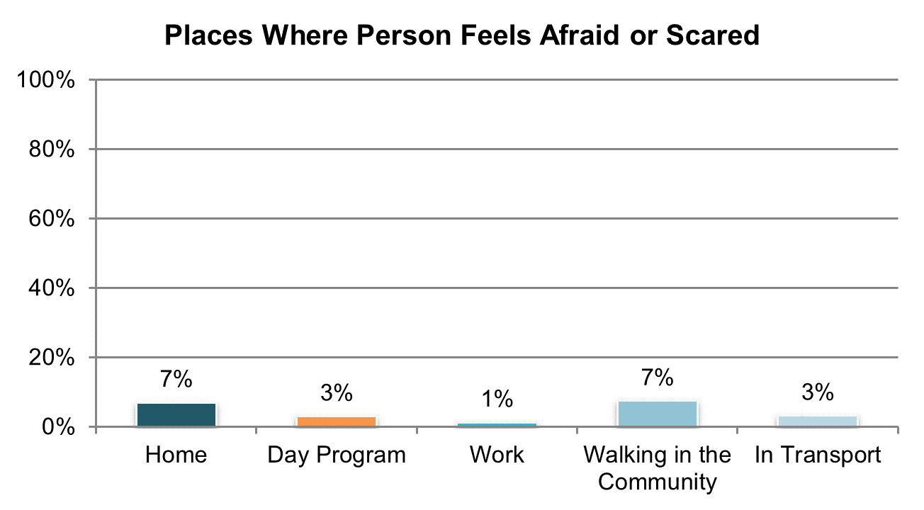

Table . There is at least one place where the person feels afraid or scared º

|  |  |  |  |  |  |  |
| --- | --- | --- | --- | --- | --- | --- |
| State | Overall in State | N | ICF/IID and Other Institutional Settings | Community-based Group Residential Settings | Own Home | Parent’s or Relative’s Home |
| **Significantly Above Average** | | |  |  |  |  |
| ME | 46% | 281 | n/a | 54% | 42% | 36% |
| WY | 35% | 222 | n/a | 40% | 30% | 38% |
| CO | 34% | 302 | n/a | 22% | 42% | 35% |
| AR | 34% | 217 | 41% | 36% | 28% | 37% |
| RI | 31% | 318 | n/a | 40% | 24% | 30% |
| **Within Average Range** | | |  |  |  |  |
| HI | 32% | 155 | n/a | 32% | n/a | 33% |
| KS | 30% | 222 | n/a | 29% | 32% | 27% |
| UT | 30% | 223 | n/a | 33% | 30% | 24% |
| MN | 30% | 247 | n/a | 34% | 30% | 27% |
| MA | 29% | 290 | n/a | 31% | 33% | 21% |
| IL | 28% | 246 | n/a | 25% | 33% | 31% |
| NV | 28% | 327 | n/a | 28% | 22% | 39% |
| VT | 27% | 261 | n/a | n/a | 35% | 28% |
| MI | 27% | 267 | n/a | 31% | 29% | 22% |
| NC | 27% | 423 | 25% | 22% | 29% | 29% |
| SD | 27% | 269 | n/a | 35% | 17% | 31% |
| DE | 26% | 251 | n/a | 25% | 41% | n/a |
| CT | 24% | 222 | n/a | 28% | 24% | 20% |
| OK | 23% | 206 | n/a | 22% | 22% | 29% |
| WI | 22% | 285 | 24% | 20% | 22% | 22% |
| OH | 21% | 377 | 17% | 24% | 24% | 18% |
| IN | 19% | 549 | n/a | n/a | 18% | 20% |
| PA | 19% | 413 | 20% | 17% | 20% | 20% |
| WA | 19% | 246 | n/a | n/a | 21% | 17% |
| VA | 19% | 462 | 16% | 19% | 24% | 18% |
| MS | 19% | 286 | n/a | 14% | 23% | 17% |
| DC | 18% | 191 | n/a | 18% | n/a | 20% |
| LA | 18% | 276 | 24% | n/a | 12% | 19% |
| NY | 18% | 290 | n/a | 21% | 23% | 13% |
| **Significantly Below Average** | | |  |  |  |  |
| MO | 16% | 251 | n/a | 11% | 20% | 0% |
| TN | 15% | 309 | n/a | 18% | 11% | 16% |
| FL | 14% | 812 | n/a | 15% | 18% | 11% |
| AZ | 13% | 415 | n/a | 12% | 14% | 14% |
| GA | 8% | 272 | n/a | 11% | 3% | 8% |
| KY | 8% | 213 | n/a | 12% | 0% | 9% |
| AL | 7% | 326 | n/a | 9% | 10% | 4% |
| NCI Average | 23% | 10,922 | 24% | 25% | 24% | 22% |

ºNew variable to reporting

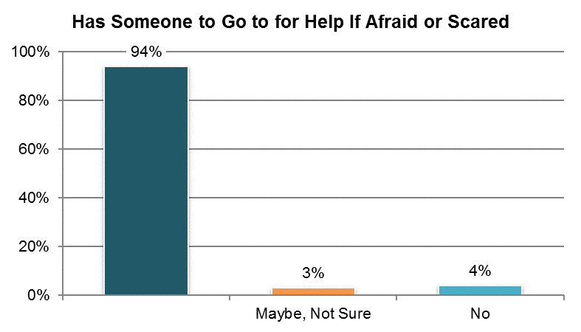

Table . Have someone to go to for help if they ever feel scared (‘yes’ responses only)

|  |  |  |  |  |  |  |
| --- | --- | --- | --- | --- | --- | --- |
| State | Overall in State | N | ICF/IID and Other Institutional Settings | Community-based Group Residential Settings | Own Home | Parent’s or Relative’s Home |
| **Significantly Above Average** | | |  |  |  |  |
| TN | 99% | 334 | n/a | 99% | 98% | 99% |
| KY | 99% | 298 | n/a | 98% | 100% | 99% |
| AL | 97% | 328 | n/a | 94% | 98% | 100% |
| **Within Average Range** | | |  |  |  |  |
| MO | 96% | 253 | n/a | 96% | 95% | n/a |
| OH | 96% | 379 | 94% | 96% | 95% | 97% |
| AZ | 96% | 420 | n/a | 91% | 93% | 97% |
| ME | 96% | 290 | n/a | 97% | 96% | 98% |
| WA | 96% | 259 | n/a | n/a | 96% | 98% |
| LA | 96% | 282 | 97% | n/a | 96% | 95% |
| GA | 96% | 295 | n/a | 92% | 97% | 96% |
| NC | 96% | 425 | 95% | 96% | 95% | 96% |
| MN | 95% | 247 | n/a | 97% | 92% | 96% |
| WI | 95% | 285 | 96% | 93% | 93% | 98% |
| IN | 95% | 560 | n/a | n/a | 95% | 95% |
| PA | 95% | 416 | n/a | 94% | 96% | 95% |
| FL | 95% | 838 | n/a | 94% | 96% | 94% |
| MA | 95% | 294 | n/a | 97% | 92% | 91% |
| VA | 94% | 488 | 88% | 95% | 94% | 95% |
| SD | 94% | 280 | n/a | 95% | 93% | 100% |
| OK | 94% | 209 | n/a | 96% | 89% | 96% |
| IL | 94% | 241 | n/a | 92% | 97% | 96% |
| UT | 94% | 238 | n/a | 97% | 93% | 91% |
| KS | 94% | 265 | n/a | 94% | 97% | 94% |
| CO | 93% | 299 | n/a | 100% | 91% | 88% |
| NV | 93% | 340 | n/a | 90% | 96% | 93% |
| CT | 92% | 238 | n/a | 90% | 92% | 93% |
| NY | 92% | 311 | n/a | 89% | 95% | 95% |
| DE | 92% | 250 | n/a | 93% | 86% | n/a |
| MS | 92% | 289 | n/a | 92% | 94% | 89% |
| RI | 92% | 344 | n/a | 88% | 92% | 93% |
| WY | 92% | 225 | n/a | 87% | 98% | 93% |
| AR | 91% | 220 | 86% | 100% | 92% | 85% |
| DC | 89% | 187 | n/a | 91% | n/a | 87% |
| VT | 89% | 265 | n/a | n/a | 94% | 85% |
| MI | 89% | 271 | n/a | 89% | 82% | 92% |
| HI | 88% | 195 | n/a | 85% | n/a | 88% |
| **NCI Average** | **94%** | **11358** | **93%** | **94%** | **94%** | **94%** |

1. NCI History and Activities

This section briefly describes the history of the National Core Indicators and NCI Surveys

# Overview of National Core Indicators

In December 1996, the National Association of State Directors of Developmental Disabilities Services (NASDDDS), in collaboration with the Human Services Research Institute (HSRI), launched the Core Indicators Project (CIP). The aim of the project was to support state developmental disabilities operating agencies in the development and implementation of performance and outcome indicators—and related data collection strategies—so that they could measure service delivery system performance. This effort, now called National Core Indicators (NCI), strives to provide states with valid and reliable tools to help improve system performance and better serve people with intellectual and developmental disabilities and their families. Moreover, NASDDDS’ active sponsorship of NCI facilitates pooled knowledge, expertise, and resources among the states.

In 1997, 15 states convened to discuss the scope and content of a potential performance measurement framework. Directors and staff from these 15 states worked to identify the major domains and sub-domains of performance, indicators, measures, and data sources. The original 61 indicators, developed through a consensus process, were intended to provide a system-level “snapshot” of how well each state was performing. The states were guided by a set of criteria that was designed to select indicators that were:

1. Measurable;
2. Related to issues the states had some ability to influence; and
3. Important to all individuals they served, regardless of level of disability or residential setting.

During this initial phase, data collection protocols were developed and field-tested, including a face-to-face Adult Consumer Survey (for individuals age 18 and older who were receiving services) and a mail-out Adult Family Survey (for families who have an adult family member living at home). Seven states volunteered to pilot test the indicators. Eight additional states served on the Steering Committee.

Since the initial field test, NCI has expanded its scope to include outcomes of services for children with intellectual and developmental disabilities and their families. In addition, NCI continues to develop and refine the indicators and expand state participation. For more information about NCI states, technical reports, and other resources, please visit <http://www.nationalcoreindicators.org>.

## State Participation

During the 2015-16 data collection cycle, 45 states, the District of Columbia, and 22 sub-state entities participated in NCI. State participation is entirely voluntary, and the participating states are shown in the chart below. Not all NCI member-states participate in all surveys in each year.

Figure 1. NCI State Participation

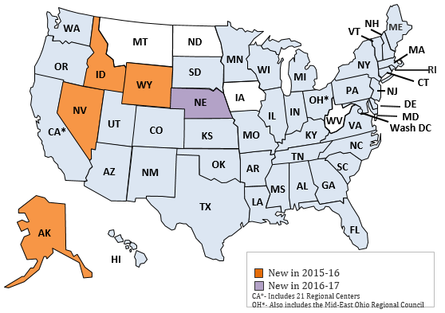

## The Core Indicators

The Core Indicators are the standard measures used across states to assess the outcomes of services provided to individuals and families. Indicators address key areas of concern, including employment, respect/rights, service planning, community inclusion, choice, and health and safety. An example of a Core Indicator would be, “The proportion of people who have a paid job in the community.” To see the entire list of Core Indicators, please visit <http://www.nationalcoreindicators.org/indicators>.

Each survey instrument is designed to measure certain Core Indicators. While most indicators correspond to a single survey question, a few refer to clusters of related questions. For example, the indicator that measures Community Inclusion (the proportion of people who regularly participate in everyday integrated activities in their communities) is measured by several survey questions that ask about several separate community activities.

The current set of performance indicators includes approximately 100 consumer, family, system, and health and safety outcomes—outcomes that are important to understanding the overall health of public developmental disabilities agencies. Indicators are organized across five broad domains: Individual Outcomes; Health, Welfare and Rights; Staff Stability and Competency; Family Outcomes; and System Performance. Each domain is broken down into sub-domains (see Figure 2). Four data sources are used to assess outcomes: the Adult Consumer Survey, three Family Surveys; NCI also produces a Staff Stability Survey (e.g., staff turnover).

The indicators have remained generally consistent over the last several years and thus can be used to analyze system-level trends over time. However, the NCI program is a dynamic effort that allows for measures to be added, dropped, or changed to reflect current and future priorities of participating states, so year-to-year comparisons should be made with caution.

The data collection tools used to gather indicator data are regularly refined and tested to ensure they remain valid, reliable, and applicable to current issues within the field. Details on the design and testing of this tool are provided in the next section of this report.

Figure 2 Adult Consumer Survey Indicators: Domains and Sub-Domains

|  |  |  |
| --- | --- | --- |
| **Domain** | **Sub-Domain** | **Concern Statement** |
| **Individual Outcomes** | Work | People have support to find and maintain community integrated employment. |
| Community Inclusion, Participation and Leisure | People have support to participate in everyday community activities and do things they like to do. |
| Choice and Decision-Making | People make choices about their lives and are actively engaged in planning their services and supports. |
| Self-direction | People have authority and are supported to direct and manage their own services. |
| Relationships | People have friends and relationships. |
| Satisfaction | People are satisfied with the services and supports they receive. |
| **Health, Welfare, and Rights** | Safety | People feel safe and free from fear. |
| Health | People secure needed health services. |
| Medications | Medications are managed effectively and appropriately. |
| Wellness | People are supported to maintain healthy habits. |
| Respect/Rights | People receive the same respect and protections as others in the community. |
| **System Performance** | Service Coordination | Service are accessible, responsive, and support the person's participation in service planning. |
| Access to Supports | People have access to quality supports. |

## How NCI Data Are Used

The Core Indicators provide information for quality management and are intended to be used in conjunction with other state data sources, such as risk management information, regional level performance data, results of provider monitoring processes, and administrative information gathered at the individual service coordination level. States typically use the indicator data to inform strategic planning, produce legislative reports, and prioritize quality improvement initiatives. Some states use NCI as a data source for supplemental performance measures in their home and community-based services (HCBS) waiver quality management systems and include the information in support of evidentiary reports to the Centers for Medicare & Medicaid Services (CMS). Many states share the indicator data with stakeholder groups such as Quality Councils and use the stakeholder feedback to help set priorities and establish policy direction. It is also important to note that states do not use the information to sanction service providers, nor do they use the results to remediate individual issues (unless specifically requested by the participant or required by law as in the case of suspected abuse, neglect, or mistreatment).

### Caution and Limitations

This report does not provide benchmarks for acceptable or unacceptable levels of performance. Rather, it is up to each state to decide whether its score or percentage is an acceptable performance level. States that fall into the “below average” tier on any scale or indicator are not necessarily underperforming; instead, this placement indicates only that the state’s scale score or indicator percentage is significantly lower than the average of all states—where “significantly” means “not due to chance.” The results tables throughout this report displays states’ scores relative to one another and show which states tend to have similar results. Notably, the difference between a “below average” state and the average across the other states may be very small, and it is up to public managers, policy-makers, and other stakeholders to decide whether a state’s result relative to the NCI Average suggests that changes or further investigation are necessary.

Moreover, the NCI Average should not be interpreted as defining “acceptable” levels of performance or satisfaction. Instead, it represents a multi-state “norm” that describes average levels of performance or satisfaction across the participating states. In some instances, there are few significant differences among the states; this denotes that most states are performing similarly. Instances in which several states’ results are especially high (statistically significantly above the average level) indicate the levels of performance or satisfaction achieved in those states might define a level of performance that may serve as a guidepost for other states.

Data from previous years are not presented in this report. Comparisons of results from year to year should be made with caution: even slight changes in wording or response options of certain questions may affect comparability of results from one year to the next; the mix of participating states differs slightly each year and may affect the NCI Averages; and states draw new samples each year rather than following the same group of individuals.

1. Methodology

This section describes the protocol for administering the Adult Consumer Survey, including sampling criteria, administration guidelines, and surveying procedures.

# Administration

A key principle of NCI is the importance of gathering information directly from service recipients. The indicators are meant to apply to all individuals receiving services from the state developmental disability agency, regardless of disability type, and NCI administration protocols dictate that every person selected into the sample be given an opportunity to respond (no one is prescreened or predetermined to be unable to respond). Moreover, survey questions should not be marked “not applicable” on the basis of a person’s level of ability.

Information for the Adult Consumer Survey Sections I and II are collected via a direct conversation with the person receiving services. Additionally, background information is primarily collected from the individual’s record. Section I questions, which pertain to personal experiences and require subjective responses, may only be answered by the individual receiving services. Section II of the survey—which consists of objective questions on the individual’s involvement in the community, their choices, respect and rights, and their access to services—allows for the use of “proxy” or other respondents who know the individual well (such as a family member or friend).

## Proxy Respondents

Studies have found that the greatest discrepancies between individual and proxy responses occur when the information being collected is subjective (i.e., related to how a person feels; proxies would be aware of the correct answers only if the individual had previously expressed his or her feelings)[4]. Questions relating to observable behaviors tend to have higher levels of agreement between individual and proxy. By excluding proxies, a large percentage of individuals (many of whom may be unable to respond) would be unrepresented in the data. Thus, the NCI project determined at the outset that proxy respondents would be used, though only for specific questions and only in situations where the individual him/herself either could not effectively communicate with the surveyor or chose to have a proxy respondent.

As mentioned, the use of proxy respondents for the NCI tool is limited to questions in Section II, which relates to observable and/or measurable items: Community Inclusion, Choices, some questions related to Respect/Rights, and Access to Needed Services. State records are also used to report objective data on an individual’s health status and exam history as well as employment status; this information is collected in the Background Section of the survey.

There are also ways to reduce discrepancies that may arise. First, it is important to make the questions as accessible as possible to increase participation by all individuals. NCI attempts to make the language in the Adult Consumer Survey as easy to understand as possible and the survey tool includes suggested rephrasing for questions to facilitate comprehension. Secondly, it is important to establish a set of standards for proxy respondents. NCI aims to increase the reliability of proxy responses by allowing only those people who know the individual well (family, friends, staff, etc.) to serve as proxy respondents. To avoid conflict, service coordinators are not allowed to respond as proxies. Further, if both the individual and a proxy respondent answer a question, the individual’s answer is recorded so long as his/her answer is deemed reliable by the surveyor. Surveyors also keep track of who responds to each question—the individual or the proxy—and the proxy’s relationship to the individual.

## Surveyor Training

States employ a variety of individuals to conduct the face-to-face meetings for the NCI Adult Consumer Survey. To avoid conflict, surveys cannot be administered by the individual’s service provider, relative, personal case manager, staff member, or other close contact. Given this constraint, states may use university students, state staff, private contractors, employees of advocacy organizations, and individuals with disabilities and their families to conduct the surveys.

Standardized training for surveyors is provided by HSRI and NASDDDS staff via on-site surveyor training to new states and states with a significant change in surveyor staffing as well as through refresher trainings (via webinar) for states that have previously participated. Trainings consist of a detailed review of the survey tool and an overview of general surveying techniques. Trainers are given a packet of standardized materials to be used at the on-site training sessions. In each state, one or more ‘Lead Trainers’ who are familiar with NCI survey administration may train additional surveyors using standard guidebook and materials developed by HSRI staff.

An additional session reviews the process for entering survey data in the Online Data Entry Survey Application (ODESA).

States are responsible for monitoring the fidelity of the survey administration and accomplish this through methods including survey shadowing (surveyors paired and review scoring after the session, supervisor observes one or more sessions), and meetings of surveyors to review questions that emerge as surveyors complete their first few surveys.

## Criteria for Exclusion of Responses

All individuals selected in the survey sample are given an opportunity to participate in a face-to-face meeting. There are no prescreening procedures. Exclusion of responses occurs at the time of data analysis by HSRI, based on the criteria described as follows. There is no threshold of questions that a respondent must answer for the survey to be considered complete. The total number of surveys used for analysis in 2015-16 was 17,682.

Surveys were excluded from analysis for Section I if:

1. The surveyor indicated that the individual receiving supports did not respond consistently to questions in Section I.
2. All answers to the Section I questions were either missing or marked as ‘N/A’ or ‘Don’t Know’.

Surveys were excluded from analysis for Section II if:

1. The individual receiving supports was marked as the respondent to all questions in Section II but Section I was deemed invalid (for one of the reasons above).

2) No questions were answered in Section II.

**Responses for Section I**

Only individuals receiving services may answer questions in Section I. As shown in Figure 3, among the entire 2015-16 sample the valid response rate to Section I was 70%; valid responses by state ranged from 50% to 91%.

### Responses for Section II

Section II allows for multiple respondents who know the individual well (e.g., family, friend, support worker) to provide answers. If an individual’s responses were excluded from Section I in the final analysis, responses from Section II were also excluded if the individual was the only respondent to Section II. For 2015-16, the valid response rate (proxies included) to Section II was 98%.

## Sampling

Each state is instructed to attempt to complete surveys with a random sample of individuals age 18 and over who are receiving at least one publicly funded service in addition to case management. A sample size of 400 guarantees valid comparisons to be made across states with a 95% confidence level and a margin of error of +/- 5%, no matter how large the service population size. A 95% confidence level and a margin of error of +/-5% is mandatory for each state’s sample to be included in this report. For states with smaller served populations, this total sample may be less than 400 to reach the 95% confidence level and 5% margin of error. Most states sample more than 400 individuals to account for refusals and surveys that may be deemed invalid. Figure 3 presents the number of surveys completed by state. A more detailed description of each state’s sampling strategy can be found in Appendix C.

|  |
| --- |
| Why do we ask states to collect 400 surveys?  When NCI asks states to pull a representative sample of 400 surveys, the aim is to compile a dataset that can provide a high level of statistical accuracy. The goal is to create a dataset that can be used to make accurate inferences about the entire population of people using public services in each state. To do this, we ask each participating state to pull a sample that reaches the 95% confidence level/5% margin of error threshold; for most states, this sample size is 400.  A sample size that reaches the 95% confidence level/5% margin of error threshold means that if you sampled that number of people from the same population several times, 95% of your responses would fall within 5% above or below the actual percentages. So using this sample size, we can assume relative accuracy. The larger the sample size, the smaller the margin of error and the greater the accuracy.  Statistical accuracy is largely a function of sample size. The larger the sample size, the greater the statistical accuracy of results (lower margin of error). However, gains in statistical accuracy are not proportional to increases in sample size. There are diminishing returns. For example, for a large total population, if the sample size increases by 100, and then by another 100, and then by another 100, the statistical accuracy might increase by 5%, then by 3%, then by 1%.  As a result, the 400 sample size gives a statistical accuracy of ±5% and is considered the most “cost effective” sample size for large scale surveys. Meaning, you could sample more people but the increase in statistical accuracy that those “extra” people would provide is minimal, and not worth the money.  To play around with this, we recommend you check out <http://www.raosoft.com/samplesize.html>. NCI requires a margin of error at most 5% and a 95% confidence level for the Adult Consumer Survey sample. As you increase the population size (in our case, this represents the service population), you’ll see that the recommended sample size does not increase proportionally.    <http://answersresearch.com/wp-content/uploads/2015/06/Answers-Research-Magic-400-062315.pdf> |

Figure 3. Valid Surveys and Response Rates by State: 2015-16

|  |  |  |  |  |
| --- | --- | --- | --- | --- |
| State | % Valid Answers to Section I | % Valid Answers to Section II | Number of Valid Surveys Completed | % of Total Sample Size (N) |
| AL | 84% | 96% | 399 | 2% |
| AR | 61% | 98% | 397 | 2% |
| AZ | 91% | 100% | 476 | 3% |
| CO | 75% | 100% | 411 | 2% |
| CT | 78% | 98% | 348 | 2% |
| DC | 50% | 99% | 401 | 2% |
| DE | 67% | 91% | 436 | 2% |
| FL | 62% | 99% | 1,457 | 8% |
| GA | 69% | 99% | 473 | 3% |
| HI | 51% | 99% | 401 | 2% |
| IL | 68% | 98% | 400 | 2% |
| IN | 72% | 99% | 830 | 5% |
| KS | 74% | 97% | 400 | 2% |
| KY | 67% | 100% | 456 | 3% |
| LA | 67% | 99% | 439 | 2% |
| MA | 77% | 99% | 422 | 2% |
| ME | 75% | 98% | 402 | 2% |
| MI | 68% | 100% | 435 | 2% |
| MN | 60% | 96% | 428 | 2% |
| MO | 70% | 100% | 400 | 2% |
| MS | 81% | 97% | 414 | 2% |
| NC | 56% | 99% | 823 | 5% |
| NV | 88% | 100% | 403 | 2% |
| NY | 65% | 99% | 497 | 3% |
| OH | 66% | 100% | 623 | 4% |
| OK | 54% | 100% | 400 | 2% |
| PA | 70% | 98% | 701 | 4% |
| RI | 72% | 97% | 506 | 3% |
| SD | 81% | 96% | 366 | 2% |
| TN | 77% | 99% | 447 | 3% |
| UT | 61% | 98% | 407 | 2% |
| VA | 63% | 100% | 818 | 5% |
| VT | 90% | 100% | 326 | 2% |
| WA | 69% | 99% | 406 | 2% |
| WI | 75% | 99% | 413 | 2% |
| WY | 78% | 99% | 321 | 2% |
| **Total** | **Average: 70%** | **Average: 98%** | Total: 17,682 | **100%** |

1. Data Analysis

This section explains the statistical methods used to analyze the Adult Consumer Survey data. It includes an explanation of how certain outcomes are “adjusted” for the purposes of making comparisons across states. This section also discusses scale construction and significance testing of results.

# Data Management and Analysis

HSRI coordinates the NCI data management and analysis. States enter data into the Online Data Entry Survey Application (ODESA) system[5]; HSRI staff subsequently download the data into a data file. This data file is then “cleaned” (reviewed for completeness and compliance with standard NCI formats) and invalid responses are eliminated. Files from individual states are then merged into a single file. The merged file from 2015-16 was used for all analyses in this report. NCI uses SPSS software for data analysis.

Below is a summary of the statistical procedures used to analyze the Adult Consumer Survey data.

## Outcome Adjustment

Outcome adjustment or “risk adjustment” is a statistical process used to control for differences in the individual characteristics of people who completed the NCI Survey across states. This procedure allows for more legitimate state comparisons by effectively “leveling the playing field.” This analysis helps account for the fact that states have different eligibility definitions for services and may have samples with different characteristics. Only those indicators that are likely to be affected by individual characteristics were adjusted (e.g., indicators in the Choice and Decision-Making sub-domain). For example, a person who is older and has more cognitive limitations may be less likely to choose where they live. On the other hand, such characteristics should not affect whether a person has friends or staff who are respectful.

The indicators are risk-adjusted using the following characteristics: age, level of intellectual disability, level of mobility, and whether any behavioral supports are needed to prevent self-injury, disruptive, or destructive behavior. Risk adjustment was only done on items in the Choice and Decision-Making sub-domain for this report. In prior years, Community Inclusion items were also risk-adjusted; however, due to the change in types of questions asked, those items are no longer adjusted. In this report, results for indicators that were adjusted are labeled as such, and unadjusted results for these indicators are presented in Appendix D.

Outcome adjustment for the indicators in the Choice and Decision-Making sub-domain was performed using logistic regression. This statistical analysis produces a predicted value that one would expect to observe given the individual’s characteristics. The state’s average observed rate (i.e., the state average prior to risk adjustment) was adjusted by the average predicted rate to produce the risk-adjusted rate. As a result of this procedure, state differences in adjusted values reflect true state differences rather than differences due to the demographic or characteristic makeup of state service populations.

## Scale Development

Scales are used to combine responses from multiple similar questions into one variable. In this way, we can measure an overarching concept rather than specific elements of the concept. For the Adult Consumer Survey, scales are used for the Choice and Decision-Making sub-domain and for Community Inclusion. To create a scale, statistical tests are required to ensure that the multiple items share common properties. Scales were created using factor analysis.

The Choice and Decision-Making sub-domain was divided into two scales: Life Decisions and Everyday Choices. These scales were created by averaging the items within those categories[6] for each individual. Higher scale scores represent higher levels of choice. These scales were also risk-adjusted.

The Community Inclusion scale was created by averaging the individual’s responses to four of the questions relating to whether people went out in the community for particular activities. Higher scale scores represent higher level of community participation as indicated by taking part in these activities in the community. The Community Inclusion scale was not risk-adjusted.

**Collapsing Data**

For many of the indicators in this report, only “yes” responses are analyzed and reported for state to state comparisons and significance testing. However, there are several indicators for which the “yes” response was collapsed with the middle response (for example, a “sometimes” response, or a “some input” response) to form the “yes” indicator category, which was then analyzed and subsequently reported. For example, for choice indicators, responses “person chose” and “person had some input” were collapsed into one “yes, person chose” category. For those indicators, the two responses were considered to be equally indicative of a positive outcome. Appendix B contains the collapsing and recoding rules for all indicators and risk adjustment variables.

## Significance Testing

In this report, for all non-adjusted items, each state’s indicator score was compared to the NCI Average (the average across all NCI states estimates) for that indicator. These comparisons were conducted using t-tests.

The t-test analyses determined whether each state’s percentage was:

1. Significantly higher than the other states’ average (NCI Average, average of averages);
2. Within the average range (i.e., not statistically different from the NCI Average); or
3. Significantly lower than the other states’ average.

A conservative cut-off point of p < 0.005 was used to determine significant differences. The placement of each state into one of these three groups is indicated in tables for each outcome.

**Please Note:** Statistical significance is influenced by the size of the state’s sample. Therefore, it is possible that a state with a lower percentage but a larger sample will be classified as significantly above average while a state with a somewhat higher percentage but a smaller sample will not.

1. Appendices

# Appendix A

## Survey Changes 2014-15 to 2015-16

| **2015-16** | | **2014-15** | | **Change Made** | **Note** |
| --- | --- | --- | --- | --- | --- |
| **Demographics** | | | | | |
| BI-3 | Zip code |  |  | New question; Added question that automatically gets recoded as an urban/rural designation in ODESA. Zip is not saved |  |
| BI-4 | Date of Birth | BI-3 | Date of birth | No change |  |
| BI-5 | Gender | BI-4 | Gender | No change |  |
| BI-6 | What is this person’s race and ethnicity? | BI-6 | What is this person’s race | In 2015-16 combined race and ethnicity |  |
| BI-7 | Does this person have a legal appointed guardian/conservator | BI-7 | Does this person have a legal appointed guardian? | In 2015-16 added response option for those under guardianship but not sure if limited or full |  |
| BI-8 | If this person has a legal/court-appointed guardian, what is the guardian’s relationship to the individual? |  |  | New question |  |
| BI-9 | Marital Status | BI-8 | Marital Status | No change |  |
| BI-10 | Is this person a parent? |  |  | New question |  |
| BI-10a | If the person has children under 18 years of age, does the child or children live with the person? |  |  | New question |  |
| BI-11 | Is this person diagnosed with an intellectual disability (ID)? | BI-9 | Is this person diagnosed with an intellectual disability (ID)? | No change |  |
| BI-11a | If yes, what level of ID? | BI-9a | If yes, what level of ID? | No change |  |
| BI-12 | What other conditions are noted in this person’s record? | BI-10 | What other disabilities are noted in this person’s record? | Changed word in question from “disabilities” to “conditions” |  |
| BI-12a | What health conditions are noted in this person’s record? | BI-10a | What health conditions are noted in this person’s record? | No change |  |
| BI-13 | What is this person’s primary language? | BI-11 | What is this person’s primary language? | No change |  |
| BI-14 | What is this person’s preferred means of communication? | BI-14 | What is this person’s primary means of expression? | In 2015-16, used “preferred means of communication” as opposed to “primary means of expression” |  |
| BI-15 | How would you describe this person’s mobility? | BI-13 | How would you describe this person’s mobility? | No change |  |
| BI-16 | Does this person have a primary care doctor or primary care practitioner? | BI-15 | Does this person have a primary care doctor or primary care doctor? | In 15-16 used term “practitioner” instead of “doctor” |  |
| BI-17 | When was his/her last complete annual physical exam? | BI-16 | When was his/her last complete annual physical exam? | No change |  |
| BI-18 | When was his/her last dentist exam? | BI-17 | When was his/her last dentist visit? | 2015-16: “exam” |  |
| BI-19 | When was the last time this person had an eye exam/vision screening? | BI-18 | When was the last time this person had an eye exam/vision screening? | No change |  |
| BI-20 | When was the last time this person had a hearing test? | BI-19 | When was the last time this person had a hearing test? | No change |  |
| BI-21 | During the past 12 months, has this person had a flu vaccination? | BI-20 | During the past 12 months has this person had a flu vaccination? | No change |  |
| BI-22 | How much does this person weigh? | BI-22 | How much does this person weigh? | No change |  |
| BI-23 | How tall is this person? | BI-23 | How tall is this person? | No change |  |
| BI-24 | Does this person use nicotine or tobacco products (e.g., cigarettes, e-cigarettes, chewing tobacco, etc.)? | BI-25 | Does this person smoke or chew tobacco? | The question was made more specific. |  |
| BI-25 | If female, when was her last pap test screening? | BI-26 | If female, when was her last pap test screening? | No change |  |
| BI-26 | If female, when was her last mammogram? | BI-27 | If female, when was her last mammogram? | No change |  |
| BI-27 | When was the last time this person had a screening for colorectal cancer? | BI-28 | When was the last time this person had a screening for colorectal cancer? | No change |  |
| BI-28 | If this person has a seizure disorder, how often do seizures occur? | BI-30 | If this person has seizures, how often do they occur? | Slight wording change |  |
| BI-29 | Does this person currently take medications to treat mood disorders, anxiety and/or psychotic disorders? | BI-31 | Does this person currently take medications to treat mood disorders, anxiety and/or psychotic disorders? | No change |  |
| BI-29a | If yes, how many medications to treat mood disorders, anxiety and/or psychotic disorders does this person take? | BI-31a | If yes, how many medications to treat mood disorders, anxiety and/or psychotic disorders does this person take? | No change |  |
| BI-30 | Does this person currently take medications for behavioral challenges? | BI-31b | Does this person currently take medications for behavioral challenges? | No change |  |
| BI-30a | If yes, how many medications to treat behavioral challenges does this person take? | BI-31c | If yes, how many medications to treat behavioral challenges does this person take? | No change |  |
| BI-31 | Does this person have a behavior plan? | BI-31d | Does this person have a behavior plan? | No change |  |
| BI-32 | How long has this person lived in his/her current home? | BI-33 | How long has this person lived in his/her current home? | No change |  |
| BI-33 | How would you characterize the place where this person lives? | BI-34 | How would you characterize the place where this person lives? | Response options changed |  |
| BI-33a | Is this person’s residence owned or controlled by a provider agency? |  |  | New question |  |
| BI-34 | If this person lives in an Intermediate Care Facility for persons with ID/DD, a specialized institutional facility, or a group home, is it publicly or privately operated? | BI-34a | If this person lives in an Intermediate Care Facility for persons with ID/DD, a specialized institutional facility or a group home, is it publicly or privately operated? | No change |  |
| BI-35 | Is this person named on the lease? |  |  | New question |  |
| BI-36 | Does this person own his or her own home? |  |  | New question |  |
| BI-37 | Has this person ever lived longer than a year in an institutional setting such as a nursing home or ICF? |  |  | New question |  |
| BI-38 | What amount of paid support does this person receive at home? | BI-36 | What amount of paid support does this person receive at home? | No change |  |
| BI-39-BI-43  Employment matrix |  | BI-37-BI-40 |  | Added BI-40: Paid small-group job in a community-based setting | This allowed people to report being involved in individual and group jobs separately. |
| BI-44 | Is community employment a goal in this person’s service plan? | BI-41 | Is community employment a goal in this person’s service plan? | No change |  |
| BI-45 | Is this person enrolled in school? | BI-42 | Is this person enrolled in the public school system? | Response options in 15-16 delineated the type of enrollment (high school, vocational school, college, etc.). Response options in 14-15 were yes/no |  |
| BI-46 | Does this person receive paid time off? | BI-45 | Does this person receive paid vacation and/or sick time at his/her job? | Wording changed |  |
| BI-47 | How long has this person been working at his/her current job? | BI-46 | How long has this person been working at his/her current job? | No change |  |
| BI-48 | Is this person self-employed? |  |  | Self-employment was included as a response option in question BI-47 (What type of job does this person have?) in 2014-15 |  |
| BI-49 | What type of job does this person have? | BI-47 | What type of job does this person have? | Response options differ |  |
| BI-50 | Which of the following services/supports funded by the state (or county) agency does this person receive? | BI-48 | Which of the following services/supports funded by the state (or county) agency does this person receive? | No change |  |
| BI-51 | Does this person receive either ICF-ID or Medicaid HCBS Waiver or State plan funding? | BI-48 | Does this person receive either ICF-ID or Medicaid HCBS Waiver or State plan funding? | Response options differ |  |
| BI-52 | Does this person currently receive Medicare? | BI-32 | Does this person currently receive Medicare? | No change |  |
| BI-53 | Is this person currently using a self-directed supports option? | BI-50 | Is this person currently using a self-directed supports option? | No change |  |
| BI-54 | If yes, who employs this person’s support workers? | BI-51 | If yes, who employs this person’s support workers? | No change |  |
| BI-55-BI-57-Behavioral support needs |  | BI-52-BI-54-Behavioral support needs |  | No change |  |
| **Questions not included in the 2015-16 ACS (that were included in the 2014-15 survey)**  Ethnicity  Overall health moved to Section II  Pneumonia Vaccine  Physical activity questions moved to Section II  How often does this person require medical care?  Who owns or leases where this person lives?  Funding for employment/day supports  Did this person work 10 out of the last 12 months in a community job? | | | | | |
| **2015-16** | | **2014-15** | | **Change Made** | **Note** |
| **Home** | | | | | |
| Q1-6 | Home | 9-14 | Home | Moved to beginning  Easier to understand, will typically begin with more positive response |  |
| 1 | Do you like your home or where you live? | 9 | Do you like your home or where you live? | No change |  |
| 2 | If In-between or No: What don’t you like about where you live? |  | | New question |  |
| 3 | Would you like to live somewhere else? | 10 | Would you like to live somewhere else? | No change |  |
| 4 | Do people let you know before they come into your home? | 12 | Do people let you know before they come into your home? | No change |  |
| 5 | Do people let you know before coming into your bedroom? | 13 | Do people let you know before coming into your bedroom? | No change |  |
| 6 | Do you have a place to be alone in your home? | 14 | Do you have enough privacy at home? | Modified  Easier to understand language | Comparisons to previous years’ data should be made with caution. |
| **Deleted or Replaced Questions - Home**  **11. Do you ever talk with your neighbors?** | | | | | |
| **Employment** | | | | | |
| Q7-13 | Employment/Day | 1-8 | Employment/Day | Moved to second sub-section  Helps ease into questions |  |
| 7 | Do you have a paid job in the community? | 1 | Do you have a paid job in the community? | No change |  |
| 8 | If No, ask: Would you like to have a job in the community? | 2 | If No, ask: Would you like to have a job in the community? | No change |  |
| 9 | Do you like working there? | 3 | Do you like working there? | No change |  |
| 10 | Would you like to work somewhere else? | 4 | Would you like to work somewhere else? | No change |  |
| 11 | Do you go to a program or workshop (program or center where other people with disabilities work)? | 5 | Do you go to a day program or do some other regularly scheduled activity during the day? | Modified  Specific to non-inclusive day activity (later ask about classes/other activities) | Parallel comparisons cannot be made from previous years' data. |
| 11a | Would you like to go more or less to the workshop (program or center) |  | | New question  Replaces former Q6. Helps determine level of satisfaction with activity and whether there are enough/too many hours devoted |  |
| 12 | Do you take classes, training, or do something to help you get a job or a better job? |  | | New question |  |
| 13 | Do you volunteer? | 8 | Do you do any volunteer work? | Modified  Deleted ‘work’ per state/interviewer suggestion |  |
| **Deleted or Rephrased Questions- Employment**  **6. Do you like going there/doing this activity?**  **7. Would you like to go somewhere else or do something else during the day?** | | | | | |
|  | | | | | |
| **Safety** | | | | | |
| 14 | Are there any places where you feel afraid or scared? |  | | Replaces former Q15-17. Question and response options changed to include more settings where people feel unsafe (e.g., during transport) | Comparisons to previous years’ data should be made with caution. |
| 15 | If you ever feel afraid, is there someone you can talk to? | 18 | If you ever feel afraid, is there someone you can talk to? | No change |  |
| **Deleted or Rephrased Questions - Safety**  **15. Are you ever afraid or scared when you are at home?**  **16. Are you ever afraid or scared when you are out in your neighborhood?**  **17. Are you ever afraid or scared at work or at your day program/other activity?** | | | | | |
| **Relationships** | | | | | |
| 16 | Do you have friends you like to talk to or do things with? | 19 | Do you have friends you like to talk to or do things with? | No change |  |
| 17 | Do you want more help to make or keep in contact with your friends? |  | | New Question  Gets at whether people have support to make/maintain relationships |  |
| 18 | Can you see your friends when you want to see them? | 21 | Can you see your friends when you want to see them? | No change |  |
| 19 | If no, why can’t you see your friends when you want to? |  | | New Question  Help states determine whether there are actionable issues (e.g., staff, transportation) |  |
| 20 | Do you have other ways of communicating with your friends when you cannot see them? |  | | New Question  Captures if people can keep in contact via technology |  |
| 21 | Can you go on a date if you want to? | 22 | Can you go on a date if you want to? | No change |  |
| 22 | Do you ever feel lonely? | 23 | Do you ever feel lonely? | No change |  |
| 23 | Can you see or communicate with your family when you want to? | 24 | Do you have family that you see? | Modified  Captures if people can keep in contact via technology; in particular, communication with family if the person does not live in the family home | Comparisons to previous years’ data should be made with caution. |
| **Deleted or Rephrased Questions - Relationships**  **20. Do you have a best friend, or someone you are really close to?**  **25. Can you see your family when you want to?**  **26. Can you help other people if you want to?** | | | | | |
| **Community Participation** | | | | | |
| Q24, 24a, 25 | Community Participation and Leisure |  |  | New Question  Builds on Community Inclusion (Section II); asks more subjective if people do what they want and when m and if people have enough to do |  |
| 24 | Are you able to go out and do the things you like to do? |  |  | New Question |  |
| 24a | Do you get to do the things you like to do as much as you like? |  |  | New Question |  |
| 25 | When you are at home, do you have enough things you like to do? (Do you have things to do so you are not bored at home?) |  |  | New Question |  |
| **Rights and Privacy** | | | | | |
| 26 | Do people read your mail or email without asking you first? | 64 | Do people read your mail or email without asking you first? | Moved to Section I  Determined that only individuals should answer | Comparisons to previous years’ data should be made with caution – specifically by looking only at surveys with a valid Section I and *only* answers given by the individual. |
| 27 | Can you be alone with friends or visitors at your home? | 65 | Can you be alone with friends or visitors at your home, or does someone have to be with you? | Moved to Section I  Determined that only individuals should answer | Comparisons to previous years’ data should be made with caution – specifically by looking only at surveys with a valid Section I and *only* answers given by the individual. |
| 27a | Are there rules about having friends or visitors in your home? |  | | New question  Gets at whether people can see friends *but* with rules/restrictions |  |
| 28 | Can you use the phone and Internet when you want to? | 66 | Can you use the phone and Internet when you want to? | Moved to Section I  Determined that only individuals should answer | Comparisons to previous years’ data should be made with caution – specifically by looking only at surveys with a valid Section I and *only* answers given by the individual. |
| **Satisfaction** | | | | | |
| 29 | Have you met your case manager/service coordinator? | 27 | Have you met your case manager/service coordinator? | No change |  |
| 30 | Does your case manager/service coordinator ask you what you want? | 30 | Does your case manager/service coordinator ask you what you want? | No change |  |
| 31 | Do you have a service plan? | 28 | Do you have a service plan? | No change |  |
| 32 | Did you take part in the last service planning meeting? | 29 | Did you help make your service plan? | Modified  Better reflects whether people take an active role in service planning | Comparisons to previous years’ data should be made with caution. |
| 33 | At the service planning meeting, did you know what was being talked about? |  | | New question  Determines whether preferred language was used and easy to understand terms. |  |
| 34 | Did the service planning meeting include the people you wanted to be there? |  | | New question  Determines whether person has the people/advocates desired as part of meeting |  |
| 35 | Were you able to choose the services that you get as part of your service plan? |  | | New question  Determines whether people are able to determine the services they want/need |  |
| 36 | Are you able to contact your case manager/service coordinator when you want to? | 32 | If you call and leave a message, does your case manager/service coordinator take a long time to call you back, or does s/he call back right away? | Modified  Easier to understand; more inclusive of various means to communicate (e.g., email) | Comparisons to previous years’ data should be made with caution. |
| 37 | Do you have staff who help you? | 33 | Do you have staff who help you? | No change |  |
| 38 | Do your staff treat you with respect? | 34 | Do your staff treat you with respect? | No change |  |
| 39 | Do your staff come and leave when they are supposed to? | 35 | Do your staff come when they are supposed to? | Modified  Added “and leave” |  |
| 40 | Do you have a way to get places you need to go (like work, appointments, etc.)? |  | | New question  Better gets at whether there is always transportation – specific to places person *needs* to go |  |
| 41 | Are you able to get places when you want to do something outside your home, like going out to see friends, for entertainment, or to do something fun? | 38 | When you want to go somewhere, do you always have a way to get there? | Modified  Better gets at whether there is always transportation – specific to places person *wants* to go | Comparisons to previous years’ data should be made with caution. |
| 42 | Are services and supports helping you to live a good life? |  | | New question |  |
| **Deleted or Rephrased Questions - Satisfaction**  **Q31. If you ask for something, does your case manager/service coordinator help you get what you need?** | | | | | |
| **Community Inclusion** | | | | | |
| Q44-50 | Community Inclusion | Q48-53 | Community Inclusion | Modified (all)  Now asks how many times a person went out, response options include frequency; still asks who the person typically goes with |  |
| 49 | Do you participate in community groups or other activities in your community? |  |  | New question  Helps get at whether people are integrated in their community |  |
| **Deleted or Rephrased Questions - Community Inclusion**  **53. In the past month, did you go out for exercise?** | | | | | |
| **Choice and Decision-Making** | | | | | |
| Q51-59 | Choice and Decision-Making | Q55-62 | Choice and Decision-Making | No changes |  |
| **Rights** | | | | | |
| 60 | Do you have a key to your home? |  | | New question | Crosswalks to new HCBS Regulation. |
| 61 | Can you lock your bedroom if you want to? |  | | New question | Crosswalks to new HCBS Regulation. |
| 62 | Have you ever participated in a self-advocacy group meeting, conference, or event? | 67 | Have you ever participated in a self-advocacy group meeting, conference, or event? | No change |  |
| 63 | Have you voted? |  | | New question  Helps get at citizenship and rights |  |
| **Access** | | | | | |
| 64 | Do you need any of these additional services? | 68b | If additional services are needed, please note type of service or support below | Modified  Combines former Q68 and Q68b | Comparisons to previous years’ data should be made with caution. |
| 65 | Do you feel your staff have the right training to meet your needs? | 69 | Do you feel your staff have the right training to meet your needs? | No change |  |
| **Deleted and Replaced Questions - Access**  **68. Do you get the services you need?** | | | | | |
| **Health and Wellness** | | | | | |
| 66 | Overall, how would you describe your health? | 70 | Overall, how would you describe your health? | No change |  |
| 67 | Do you exercise or do physical activity? |  | BI-24-24B | Moved from Background Information section.  Data are not typically found in records, will get more accurate information from individuals/proxies | Comparisons to previous years’ data should be made with caution. |
|  | | | | | |
| **Self-Directing Module** | | | | | |
| Q68-73 | Self-direction | Q39-44 | Self-direction | Moved to Section II open to anyone directing services (not just on a self-directing waiver)  Allows for more respondents to these questions; questions are only asked if the person responding takes part in directing services | Comparisons to previous years’ data should be made with caution – in particular, data compared to previous years should note that these data include any person using a self-directed option *and* questions are only asked to those who take part in directing services. |
| 68 | Do you participate in decisions about how to use your supports budget, hiring staff, or managing the services you get? |  | | New question  This question will determine if the section should be asked – if no, don’t know, or the person answering is staff, questions will not be asked |  |
| 69 | Who makes decisions about how your budget for services is used? |  | | New question  Determines all people who help make decisions including person, family, someone else |  |
| 70 | Do you hire and manage your staff? |  | | New question  Main tenet of self-direction |  |
| 71 | Can you make changes to your budget/services if you need to? | 41 | Can you make changes to your budget/services if you want to? | No change |  |
| 72 | Do you have enough help deciding how to use your budget/services? | 42 | Do you want more help deciding how to use your budget/services, or do you have enough help? | Modified  Clearer question | Comparisons to previous years’ data should be made with caution. |
| 73 | Do you get information about how much money is left in your budget/services? | 43 | Do you get information about how much money is left in your budget/services? | No change |  |
| 73a | If yes, is the information easy to understand? | 44 | If yes, is the information easy to understand? | No change |  |
| **Deleted and Replaced Questions - Self-Direction**  **39. Does someone talk with you about your budget and the services you can get?**  **40. Is there someone who helps you decide how to use your budget/services?** | | | | | |

# Appendix B

## Rules for Recoding and Combining Variables to Compute Core Indicators

|  |  |  |  |  |  |
| --- | --- | --- | --- | --- | --- |
| **Sub-Domain** | **Table label** | **Updated for 15-16** | **Variable name used in calculation** | **How its filtered** | **Tested for significance?** |
| **Demographics** | Urban/Rural | New for 15-16 | BIZIP | Don’t Know shown |  |
| Age (Variable used for risk adjustment) |  | AGE |  |  |
| Age Category | New for 15-16 | Age_categ *Categorical variable created for the following categories:*   * *18 thru 22* * *23 thru 34* * *35 thru 54* * *55 thru 74* * *75 and above.* * *Unknown* |  |  |
| Gender |  | GENDER |  |  |
| Marital Status |  | MARSTAT | Don’t Know shown |  |
| Person is a parent | New for 15-16 | PARENT15_1 PARENT15_2 PARENT15_3 PARENT15_99 | Don’t Know shown |  |
| Race | Race and ethnicity combined into one variable for 15-16 | RACE  *Categorical variable created using variables:*  *RACE151 RACE152 RACE153 RACE154 RACE155 RACE156 RACE157 RACE1599*  *“Two or more races” variable created by identifying the cases that have at least two races reported* | Don’t Know shown |  |
| Type of Residence | Categories changed for 15-16 | TYPEHOME15 | Don’t Know shown |  |
| Length of residence |  | RESIDLEN08 | Don’t Know shown |  |
| Persons residence owned or controlled by provider agency | New in 15-16 | CONTPROV15 | Don’t Know shown |  |
| Person named on lease | New in 15-16 | LEASE15 | Don’t Know shown |  |
| Person owns his or her own home | New in 15-16 | OWNHOME15 | Don’t Know shown |  |
| Diagnosis of ID |  | DIAGMR | Don’t Know shown |  |
| Level of ID (Variable used for risk adjustment) |  | LEVELMR08 | Unknown and unspecified shown; filtered for those with a diagnosis of ID (DIAGMR=2) |  |
| Other Disabilities | Categories changed for 15-16 | DXMIPDMD13 DXMIPDAD13 DXMIPDBC13 DXMIPDPD13 DXMIPDOTH13 DXAUTISM0813 DXCP13 DXBI13 DXNEURO13 DXCHEMDP13 DXDOWN0813 PRWISYND13 DXFETALALCH15 DXVISION15 DXHEARING15 DXNONE13 | Don’t Know included in denominators |  |
| Health variables | Categories changed for 15-16 | HCCARVAS HCDIAB HCCANCER HCHIBP HCHICHL HCDYSPH15 HCPRESULC HCALZHEIM15 | Don’t Know included in denominators |  |
| Preferred Means of Expression | Wording of question changed 15-16 | EXPRESS | Don’t Know shown |  |
| Language |  | LANGUAGE |  |  |
| Overall Health | NO LONGER IN DEMOGRAPHICS SECTION |  |  |  |
| Mobility (Variable used for risk adjustment) |  | MOBILITY08 | Don’t Know shown |  |
| Support to Manage Self Injurious Behavior (Variable used for risk adjustment) |  | SELFINJ08 | Don’t Know shown |  |
| Support to Manage Disruptive Behavior (Variable used for risk adjustment) |  | DISBEH08 | Don’t Know shown |  |
| Support to Manage Destructive Behavior (Variable used for risk adjustment) |  | UNCPBEH08 | Don’t Know shown |  |
|  | Guardianship | Categories changed 15-16 | LGLSTAT15 | Don’t Know shown |  |
| Relationship of guardian | New in 15-16 | GUARDRELAT15 | Don’t Know shown |  |
| Owns or leases home | NO LONGER IN SURVEY |  |  |  |
| **Choice and Decision-making** | Proportion of people who reported they chose or had some input in choosing where they live *if not living in the family home* (Adjusted Variable) |  | CHOSHOME2  *Recoded variable in which response options are collapsed into the following: 0 no 1 had at least some input* | Filtered for Section II (INVL_CR2_15=0) and for residence type (typehome08 not equal to 5 (parent or relatives home)  **Risk adjusted** |  |
| Proportion of people who reported they chose or had some input in choosing their roommates *if not living in the family home* (Adjusted Variable) |  | HOUSEMATES2  *Recoded variable in which response options are collapsed into the following: 0 no 1 had at least some input* | Filtered for Section II (INVL_CR2_15=0)  **Risk adjusted** |  |
| Proportion of people reported to have a job in the community and who reported they chose or had some input in choosing their job* (Adjusted Variable)  * reported for those who were determined to have a paid community job from Background section |  | CHOSJOB2  *Recoded variable in which response options are collapsed into the following: 0 no 1 had at least some input* | Filtered for Section II (INVL_CR2_15=0) and for PAIDCOMMJOB2=1  **Risk adjusted** |  |
| Proportion of people who reported they have a day program or activity and chose or had some input in choosing their day program or activity (Adjusted Variable) |  | CHOOSDAY2  *Recoded variable in which response options are collapsed into the following: 0 no 1 had at least some input* | Filtered for Section II (INVL_CR2_15=0)  **Risk adjusted** |  |
| Proportion of people who reported they choose or help decide their daily schedule (Adjusted Variable) |  | SCHEDULE2  *Recoded variable in which response options are collapsed into the following: 0 no 1 had at least some input* | Filtered for Section II (INVL_CR2_15=0)  **Risk adjusted** |  |
| Proportion of people who reported they choose or help decide how to spend free time (Adjusted Variable) |  | FREETIME2  *Recoded variable in which response options are collapsed into the following: 0 no 1 had at least some input* | Filtered for Section II (INVL_CR2_15=0)  **Risk adjusted** |  |
| Proportion of people who reported they chose or help decide what to buy with their spending money (Adjusted Variable) |  | CHOOSBUY2  *Recoded variable in which response options are collapsed into the following: 0 no 1 had at least some input* | Filtered for Section II (INVL_CR2_15=0)  **Risk adjusted** |  |
| Proportion of people who reported they chose or were aware they could request to change their case manager/service coordinator (“yes” and “no, but can change” responses) |  | CHOOSCM2  *Recoded variable in which response options are collapsed into the following: 0 no 1 had at least some input* | Filtered for Section II (INVL_CR2_15=0) | YES |
| Proportion of people who reported they chose or were aware they could request to change their staff (“yes” and “no, but can change” responses) |  | CHOOSSTAF2  *Recoded variable in which response options are collapsed into the following: 0 no 1 had at least some input* | Filtered for Section II (INVL_CR2_15=0)  **Risk adjusted** | YES |
| **Work** | Proportion of people who were reported to have a job in the community*  * reported for those who were determined to have a paid community job from Background section | Changed how asked and analyzed in 15-16 | PAIDCOMMJOB2  *Variable created indicating those who have at least one of the following marked “yes”*   1. *PAIDCOMMJOBIND15* 2. *PAIDCOMMJOBGRP15*   *Creates and makes DK missing* |  | YES |
| Proportion of people who were reported to have a job in the community by type of employment support*  * reported for those who were determined to have a paid community job from Background section | Changed how asked and analyzed in 15-16 | commwork_type_Individual  commwork_type_Group  Variables created to identify types of paid jobs in the community and whether public support is received for that job.  Variables created using  1) *PAIDCOMMJOBIND15 and PCJISERV15*  *2) PAIDCOMMJOBGRP15* | Filtered for PAIDCOMMJOB2=1 |  |
| Average number of bi-weekly hours by type of community employment support | Changed how asked and analyzed in 15-16 | Filter separately for commwork_type_Individual=1, commwork_type_Individual=2 and  commwork_type_Group=1  Then compare means with the variable PCJIHOURS15 or PCJGHOURS15 (for commwork_type_group=1) | Filtered for PAIDCOMMJOB2=1 |  |
| Average bi-weekly gross wages by type of community employment support | Changed how asked and analyzed in 15-16 | Filter separately for commwork_type_Individual=1, commwork_type_Individual=2 and  commwork_type_Group=1  Then compare means with the variable PCJIWAGES15 or PCJGWAGES15 (for commwork_type_group=1) | Filtered for PAIDCOMMJOB2=1 |  |
| Average bi-weekly hourly wage by type of community employment support | Changed how asked and analyzed in 15-16 | Filter separately for commwork_type_Individual=1, commwork_type_Individual=2 and  commwork_type_Group=1  Then compare means with the variable PCJIHWAGE or PCJGHWAGE (for commwork_type_group=1)  PCJIHWAGE and PCJGHWAGE were computed by dividing the wage in two week period by the wages earned in two week period | Filtered for PAIDCOMMJOB2=1 |  |
| Proportion of people who were reported to have a job in community employment who worked 10 of the past 12 months in community employment | No Longer in Survey |  |  |  |
| Average length of employment in current job for people who were reported to have a job in the community |  | Calculated variable using JOBYRS and JOBMOS to equal total months |  |  |
| Proportion of people who were reported to have a job in the community and received paid time off | Question changed in 15-16 | PDTIMEOFF2  *Recoded variable in which response options are collapsed into the following: 0 no 1 receives paid time off.* |  | YES |
| Proportion of people who were reported to have a job in the community in the four most common types of employment |  | JOBTYPE |  |  |
| Proportion of people who were reported not to have a job in the community and who reported they would like a job in the community* (“yes” responses only)  *reported for those who were determined to not have a community job from Background section |  | LIKEAJOB2  *Recoded variable in which response options are collapsed into the following: 0 no, in-between 1 yes.* | Filtered for PAIDCOMMJOB2=0 and Section I valid (INVL_CR1_15=0) | YES |
| Proportion of people who were reported to have community employment as a goal in their service plan |  | IEGOAL2  *Recoded variable in which response options are collapsed into the following: 0 no 1 integrated employment in service plan.* |  | YES |
| Proportion of people who report taking classes or training to help get a job, or get a better job | New for 15-16 | TRAINING2  *Recoded variable in which response options are collapsed into the following: 0 no 1 yes.* | Filtered for Section I (INVL_CR1_15=0) | yes |
| Proportion of people who reported going to a day program or regular activity |  | HAVEDAYACT2  *Recoded variable in which response options are collapsed into the following: 0 no 1 yes.* | Filtered for Section I (INVL_CR1_15=0) | YES |
| Proportion of people who reported doing volunteer work |  | VOLUNT2  *Recoded variable in which response options are collapsed into the following: 0 no 1 yes.* | Filtered for Section I (INVL_CR1_15=0) | YES |
| **Self-Directed Services**  **In 15-16 moved to Section II** | Proportion of people who were reported to be using a self-directed supports option |  | SELFDRCT2  *Recoded variable in which response options are collapsed into the following: 0 no 1 yes.* |  | YES |
| Proportion of people self-directing who reported they participate in decisions about using budget, hiring staff, or managing services (“yes” responses only) | New for 15-16 moved to Section II | BUDGDEC2  *Recoded variable in which response options are collapsed into the following: 0 no 1 yes.* | Filtered for Section 2 (INVL_CR2_15=0)and SELFDRCT2=1 | YES |
| Proportion of people self-directing who reported they make decisions about how budget for services is used | New for 15-16 moved to Section II | WHOBUDDEC2  *Recoded variable in which response options are collapsed into the following:*  *1 Individual mostly makes decisions, or has input but family friends also help with decisions*  *0 Someone else makes decisions.* | Filtered for BUDGDEC2=1 Section 2 (INVL_CR2_15=0) and SELFDRCT2=1 | YES |
| Proportion of people self-directing who reported they hire and manage their staff (“yes” responses only) | New for 15-16 moved to Section II | HIRESTAFF2  *Recoded variable in which response options are collapsed into the following: 1 Yes 0 No, maybe* | Filtered for BUDGDEC2=1 Section 2 (INVL_CR2_15=0) and SELFDRCT2=1 | YES |
| Proportion of people self-directing who reported they have enough help deciding how to use their budget/services (“yes” responses only) | New for 15-16 moved to Section II | ENUFHELP2  *Recoded variable in which response options are collapsed into the following: 1 Yes, have enough help 0 No, want more help or maybe, not sure.* | Filtered for BUDGDEC2=1 Section 2 (INVL_CR2_15=0) and SELFDRCT2=1 | YES |
| Proportion of people self-directing who reported they receive information about money that’s left in budget (“yes” responses only) | New for 15-16 moved to Section II | ENUFINFO2  *Recoded variable in which response options are collapsed into the following: 1 Yes 0 No, maybe, not sure.* | Filtered for BUDGDEC2=1 Section 2 (INVL_CR2_15=0) and SELFDRCT2=1 | YES |
| Proportion of people self-directing who report they get enough information about their budget/services and information is easy to understand (“yes” responses only) | New for 15-16 moved to Section II | INFOUNDERST2  *Recoded variable in which response options are collapsed into the following: 1 Yes 0 No, maybe, not sure.* | Filtered for BUDGDEC2=1 Section 2 (INVL_CR2_15=0) and SELFDRCT2=1 and ENUFINFO15=2 or ENUFINFO15=3 | YES |
| **Community Inclusion, Participation and Leisure (new name 15-16)** | Proportion of people who report being able to go out and do the things they like to do (yes responses only) | New in 15-16 | GOOUT2  *Recoded variable in which response options are collapsed into the following: 0 No, in-between 1 yes.* | Filtered for Section I (INVL_CR1_15=0) | YES |
| Proportion of people who report being able to go out and do the things they like to do enough (yes responses only) | New in 15-16 | GOOUTENOUGH2  *Recoded variable in which response options are collapsed into the following:* 0 No 1 Yes. | Filtered for Section I (INVL_CR1_15=0) | YES |
| Proportion of people who report that they have enough things to do at home (yes only) | New in 15-16 | HOMETODO2 *Recoded variable in which response options are collapsed into the following:*  0 Not enough, in the middle 1 Yes | Filtered for Section I (INVL_CR1_15=0) | YES |
| Proportion of people who reported going shopping at least once in the past month | Changed for 15-16 | SHOPPING15_2  *Recoded variable in which response options are collapsed into the following: 0 no, 0 times 1 at least once in past month.* | Filtered for Section II (INVL_CR2_15=0) | YES |
| Number of times people reported they went out shopping in the past month (Adjusted Variable) | No longer in report 15-16 |  |  |  |
| Proportion of people who reported going on errands at least once in the past month | Changed for 15-16 | ERRANDS15_2  *Recoded variable in which response options are collapsed into the following: 0 no, 0 times 1 at least once in past month.* | Filtered for Section II (INVL_CR2_15=0) | YES |
| Number of times people reported they went out on errands in the past month (Adjusted Variable) |  |  |  |  |
| Proportion of people who reported going out for entertainment at least once in the past month | Changed for 15-16 | ENTERTAN15_2  *Recoded variable in which response options are collapsed into the following: 0 no, 0 times 1 at least once in past month.* | Filtered for Section II (INVL_CR2_15=0) | YES |
| Number of times people reported they went out for entertainment in the past month (Adjusted Variable) | No longer in report 15-16 |  |  |  |
| Proportion of people who reported going out to eat at least once in the past month | Changed for 15-16 | EATOUT15_2  *Recoded variable in which response options are collapsed into the following: 0 no, 0 times 1 at least once in past month.* | Filtered for Section II (INVL_CR2_15=0) | YES |
| Number of times people reported they went out to eat in the past month (Adjusted Variable) | No longer in report 15-16 |  |  |  |
| Proportion of people who reported going to religious services or spiritual practice at least once in the past month | Changed for 15-16 | RELIGION15_2  *Recoded variable in which response options are collapsed into the following: 0 no, 0 times 1 at least once in past month.* | Filtered for Section II (INVL_CR2_15=0) | YES |
| Number of times people reported they went out to religious services in the past month (Adjusted Variable) | No longer in report 15-16 |  |  |  |
| In the past month, did you (did this person) go out for exercise? | No longer in report 15-16 |  |  |  |
| Number of times people reported they went out for exercise in the past month (Adjusted Variable) | No longer in report 15-16 |  |  |  |
| Proportion of people who reported participating in community groups (yes response only) | New 15-16 | Commact2  *Recoded variable in which response options are collapsed into the following:* 0 no 1 yes | Filtered for Section II (INVL_CR2_15=0) | YES |
| Proportion of people who reported having gone on vacation in the past year (yes only) |  | VACATION2  *Recoded variable in which response options are collapsed into the following:* 0 no 1 yes | Filtered for Section II (INVL_CR2_15=0) | YES |
| Number of times people reported they went on vacation in the past year (Adjusted Variable) | No longer in report 15-16 |  |  |  |
| **Relationships** | Proportion of people who reported they have friends who are not staff or family members (“yes, not staff or family” only) |  | HASFRNDS2  *Recoded variable in which response options are collapsed into the following: 0 no, only staff or family 1 yes, not staff or family.* | Filtered for Section I (INVL_CR1_15=0) | YES |
| Proportion of people who reported they have a best friend (may be staff or family) | No longer in survey 15-16 |  |  |  |
| Proportion of people who reported they have family they see and the support needed to see their family when they want to (“yes” responses only) |  | SEEFAMLY2  *Recoded variable in which response options are collapsed into the following:*  *0 no, sometimes 1 yes, whenever wants to, or chooses not to see family.* | Filtered for Section I (INVL_CR1_15=0) | YES |
| Proportion of people who reported they have friends (may be staff or family) and the support needed to see their friends when they want to (“yes” responses only) |  | SEEFRNDS2  *Recoded variable in which response options are collapsed into the following: 0 No, often unable to see friends, sometimes cannot see friends when wants 1 Yes.* | Filtered for Section I (INVL_CR1_15=0) | YES |
| Proportion of people who want more help to keep in contact with friends | New 15-16 | FRNDSHELP2  *Recoded variable in which response options are collapsed into the following: 0 No,  1 Yes, maybe.* | Filtered for Section I (INVL_CR1_15=0) | YES |
| Reasons why can’t see friends | New 15-16 | WHYSEEFRNDS15 | Filtered for Section I (INVL_CR1_15=0) |  |
| Proportion of people who reported they had other ways of communicating with friends (yes, but not often and yes, often responses) | New 15-16 | FRNDSCOMM2  *Recoded variable in which response options are collapsed into the following: 0 No, Sometimes  1 Yes* | Filtered for Section I (INVL_CR1_15=0) | YES |
| Proportion of people who reported they talk with their neighbors (yes, but not often and yes, often responses) | Not in survey 15-16 |  |  |  |
| Proportion of people who reported they can go on a date if they want to or can date with some restriction (“yes, can date” responses) | 15-16 Analyzed only the proportion of people who reported: “yes, or is married living with partner” | CANDATE2  *Recoded variable in which response options are collapsed into the following: 0 No, Yes but with restrictions  1 Yes or is married living with partner* | Filtered for Section I (INVL_CR1_15=0) | YES |
| Proportion of people who reported they feel lonely at least half the time (“often” responses) | 15-16 Analyzed only the proportion of people who say OFTEN | LONELY2_15  *Recoded variable in which response options are collapsed into the following: 0 no, not often, or sometimes 1 yes, often.* | Filtered for Section I (INVL_CR1_15=0) | YES |
| Proportion of people who reported they can help other people if they want to at least some of the time (“yes” responses only**)** | Not in survey 15-16 |  |  |  |
| **Satisfaction** | Proportion of people who reported they like their home (“yes” responses only) |  | LIKEHOME2  *Recoded variable in which response options are collapsed into the following: 0 no, in-between 1 yes.* | Filtered for Section I (INVL_CR1_15=0) | YES |
| Proportion of people who report disliking where they live for reasons indicated. | New 15-16 | DON’TLIKE15_1 DON’TLIKE15_2 DON’TLIKE15_3 DON’TLIKE15_4 DON’TLIKE15_5 DON’TLIKE15_6 DON’TLIKE15_7 DON’TLIKE15_10 DON’TLIKE15_11  DON’TLIKE15_99 | Filtered for Section I (INVL_CR1_15=0) |  |
| Proportion of people who reported they would like to live somewhere else (“yes” responses only) |  | HOMEELSE2  *Recoded variable in which response options are collapsed into the following: 0 no, in-between 1 yes.* | Filtered for Section I (INVL_CR1_15=0) | YES |
| Proportion of people who were reported to have a job in the community and who reported they like where they work (“yes” responses only) *  * reported for those who were determined to have a paid community job from Background section |  | LIKEJOB2  *Recoded variable in which response options are collapsed into the following: 0 no, in-between 1 yes.* | Filtered for Section I (INVL_CR1_15=0) and for PAIDCOMMJOB2=1 | YES |
| Proportion of people who were reported to have a job in the community and who reported they want to work somewhere else*(“yes” responses only) * reported for those who were determined to have a paid community job from Background section |  | JOBELSE2  *Recoded variable in which response options are collapsed into the following: 0 no, in-between 1 yes.* | Filtered for Section I (INVL_CR1_15=0) and for PAIDCOMMJOB2=1 | YES |
| Proportion of people who reported they attend a day program or activity and like their day program or activity (“yes” responses only) | Not in 15-16 survey |  |  |  |
| Proportion of people who reported they attend a day program or activity and want to go or do something different during the day (“yes” responses only) | Not in 15-16 survey |  |  |  |
| Proportion of people who reported that they want to go to their day program less (“less” responses only) | New 15-16 | LESSDAYACT2  *Recoded variable in which response options are collapsed into the following: 0 more, same 1 less.* | Filtered for Section I (INVL_CR1_15=0) and havedayact2=1 | YES |
|  | Proportion of people who reported that services and supports were helping them live a good life (“yes” responses only) | New 15-16 | GOODLIFE2  *Recoded variable in which response options are collapsed into the following: 0 No, in between 1 Yes.* | Filtered for Section I (INVL_CR1_15=0) | YES |
|  | Proportion of people who reported they met their service coordinator/case manager (“yes” responses only) |  | KNOWSCM082  *Recoded variable in which response options are collapsed into the following: 0 maybe, no 1 yes.* | Filtered for Section I (INVL_CR1_15=0) | YES |
| **Service Coordination** | Proportion of people who reported their service coordinator/case manager asks them what they want (“yes” responses only) |  | ASKIMPOR2  *Recoded variable in which response options are collapsed into the following: 0 sometimes, no 1 yes.* | Filtered for Section I (INVL_CR1_15=0) | YES |
| Proportion of people who reported their service coordinator/case manager helps them get what they need (“yes” responses only) | Not in survey 15-16 |  |  |  |
| Proportion of people who reported their service coordinator/case manager gets them back right away (”yes” responses only) | Question wording changed 15-16 | GETSBACK2  *Recoded variable in which response options are collapsed into the following: 0 No, sometimes 1 Yes.* | Filtered for Section I (INVL_CR1_15=0) | YES |
| Proportion of people who reported taking part in the last service planning meeting (“yes” responses only) | New in 15-16 | MSPLAN2  *Recoded variable in which response options are collapsed into the following: 0 No  1 Yes, or had option but chose not to.* | Filtered for Section I (INVL_CR1_15=0) | YES |
| Proportion of people who reported that they understood what was discussed in last service planning meeting (“yes” responses only) | New in 15-16 | PLANUNDRSTND2  *Recoded variable in which response options are collapsed into the following: 0 No, in-between 1 Yes.* | Filtered for Section I (INVL_CR1_15=0) | YES |
| Proportion of people who reported that service planning meeting included people the person wanted to be there (“yes” responses only) | New in 15-16 | PLANPEOPLE2  *Recoded variable in which response options are collapsed into the following: 0 No, in-between 1 Yes.* | Filtered for Section I (INVL_CR1_15=0) | YES |
| Proportion of people who reported that they were able to choose the services that were received as part of service plan (“yes” responses only) | New in 15-16 | PLANCHOOSE2  *Recoded variable in which response options are collapsed into the following:*  *0 No, had some input 1 Yes* | Filtered for Section I (INVL_CR1_15=0) | YES |
| Proportion of people who reported support workers come and leave when they are supposed to (“yes” responses only) |  | SWORKCOME2  *Recoded variable in which response options are collapsed into the following: 0 No, maybe not sure 1 Yes.* | Filtered for Section I (INVL_CR1_15=0) | YES |
| Proportion of people who reported they get the help they need to work out problems they have with their support workers (“yes” responses only) | Not in survey 15-16 |  |  |  |
| Proportion of people who reported they helped make their service plan (“yes” responses only) | Not in survey 15-16 |  |  |  |
| Proportion of people who reported they always they have a way to get places when they need to go somewhere (“yes” responses only) |  | TRANSPORT2  *Recoded variable in which response options are collapsed into the following: 0 No almost never, sometimes 1 Yes, almost always.* | Filtered for Section I (INVL_CR1_15=0) | YES |
| **Access** | Proportion of people who reported they always they have a way to get places when they want to do something for fun (“yes” responses only) | New 15-16 | GETPLACES2  *Recoded variable in which response options are collapsed into the following: 0 No almost never, sometimes 1 Yes, almost always.* |  |  |
| Proportion of people who use various types of transportation (multiple responses allowed) | Not in survey 15-16 |  |  |  |
| Proportion of people who reported their staff have adequate training to meet their needs (“yes” responses only) |  | STFTRN2  *Recoded variable in which response options are collapsed into the following: 1 yes 0 no, maybe.* | Filtered for Section II (INVL_CR2_15=0) | YES |
| Proportion of people who report getting the services they need | Not in survey 15-16 |  |  |  |
| Proportion of people who report needing additional services | Options and wordings changed 15-16 | ADDSERVEDSCCM ADDSERVEDRESFAM ADDSERVEDTR ADDSERVEDJOBS13 ADDSERVEDDAY ADDSERVEDEDU ADDSERVEDHC ADDSERVEDDC13 ADDSERVEDHOUS ADDSERVEDRES ADDSERVEDSOC ADDSERVEDCOMM ADDSERVEDENV ADDSERVEDBENE ADDSERVEDOTH | Filtered for Section II (INVL_CR2_15=0) |  |
| **Health** | Proportion of people who were reported to have a primary care practioner |  | PRIMDOC2_woDK  *Removes DK responses and Recoded variable in which response options are collapsed into the following: 0 doesnt have a primary doc 1 has a primary doc.* |  | YES |
| Proportion of people who were reported to be in poor health (“poor health” response only) |  | Health_poor  *Recoded variable in which  0 excellent or very good or fairly good  1 poor* | INVL_CR2_15=0 | YES |
| Proportion of people who were reported to have had a complete physical exam in the past year (“within the past year” responses) |  | physexam2  *Recoded variable in which response options are collapsed into the following: 0 not in past year 1 in past year.* | WI MS not included in 15-16 | YES |
| Proportion of people who were reported to have had a dental exam in the past year (“within the past year” or “within the past six months” responses) |  | dentvis2  *Recoded variable in which response options are collapsed into the following: 0 not in past year 1 in past year.* | WI not included for 15-16 | YES |
| Proportion of people who were reported to have had an eye exam in the past year (“within the past year” responses) |  | EYEEXAM2  *Recoded variable in which response options are collapsed into the following: 0 not in past year 1 in past year.* | WI not included for 15-16 | YES |
| Proportion of people who were reported to have had a hearing test in the past five years (“within the past five years” responses) |  | HEARTEST2  *Recoded variable in which response options are collapsed into the following: 0 not in the past 5 years 1 hearing test in the past 5 years.* | WI not included for 15-16 | YES |
| Proportion of women who were reported to have had a Pap test in the past three years (“within the past three years” or less responses) |  | PAPTEST2  *Recoded variable in which response options are collapsed into the following:*  *0 more than 3 years 1 in past 3 years.* | Filtered for GENDER=2  WI not included for 15-16 | YES |
| Proportion of women over 40 who were reported to have had a mammogram test in the past two years (“within the past two years” or “within past year” responses) |  | MAMMO2  *Recoded variable in which response options are collapsed into the following: 1 in last 2 years 0 more than 2 years.* | Filtered for GENDER=2 and AGE>=40  WI DC not included for 15-16 | YES |
| Proportion of people 50 or over who were reported to have had a colorectal cancer screening in the past year (“within the past year” responses) |  | CCSCREEN2  *Recoded variable in which response options are collapsed into the following: 1 in past year 0 more than 1 year.* | Filtered for AGE>=50  AZ DC WI not included 15-16 | YES |
| Proportion of people who were reported to have had a flu vaccine in the past year (“within the past year “responses) |  | FLUVACC2  *Recoded variable in which response options are collapsed into the following: 0 not in the past year 1 flu vaccine in the past year.* | WI not included in 15-16 | YES |
| Proportion of people who were reported to have had a pneumonia vaccine | Not in 15-16 |  |  |  |
| Proportion of people who take at least one med for mood disorder, anxiety, psychotic disorder, behavioral challenges |  | Totmeds  *Recoded variable using MEDS15 and MEDBEHAV 0 No meds 1 At least one kind.* | WI not included 15-16 | YES |
| Proportion of people who were reported to take medication for at least one of the following: mood disorders, anxiety, psychotic disorders** |  | meds_mood  *Recoded variable in which response options are collapsed into the following: 0 No meds for mood, anxiety, psychotic 1 Takes meds for mood, anxiety, psychotic.* | WI not included 15-16 | YES |
| **Wellness** | Number of meds taken for at least one of the following: mood disorders, anxiety, psychotic disorders |  | NUMMEDS | WI not included 15-16 |  |
| Proportion of people who were reported to take medication for behavior challenges** |  | meds_behav  *Recoded variable in which response options are collapsed into the following: 0 No meds for behavior challenges 1 Takes meds for behavior challenges.* | WI not included 15-16 | YES |
| Number of meds taken for behavior challenges |  | NUMBEMEDS | WI not included 15-16 |  |
| Proportion of people who were reported to engage in regular physical activity at least sometimes | Moved to section II for 15-16. | PhysAct_yes  *Recoded variable in which response options are collapsed into the following: 1 yes, regularly at least 3 times per week or sometimes 1 or 2 times per week 0 no.* | Filtered for Section II (INVL_CR2_15=0) | YES |
| Proportion of people in each BMI category |  | BMI_categ  BMI variable created using formula:  BMI=(Weight/(height in inches*height in inches))*703  Creates categories for BMI  1 underweight 2 normal 3 overweight 4 obese. | WI not included 15-16 |  |
| Proportion of people who were reported to chew or smoke tobacco** |  | TOBACCO2  *Recoded variable in which response options are collapsed into the following: 0 no 1 uses tobacco products.* | WI is N/A for 15-16 | YES |
| Proportion of people reported to have a behavior plan | New 15-16 | BehPlan_yes  *Recoded variable in which response options are collapsed into the following: 0 No 1 Yes.* | WI MN is N/A for 15-16 | YES |
| Proportion of people who take meds for behavior challenges who have a behavior plan | New 15-16 | BehPlan_yes  *Recoded variable in which response options are collapsed into the following: 0 No 1 Yes.* | Filtered for meds_behav=1 | YES |
|
|
| **Rights and Respect** | Proportion of people who reported people always knock before entering home (“yes” responses only) |  | ENTERHM2  *Recoded variable in which response options are collapsed into the following: 1 yes 0 sometimes, no.* | Filtered for Section I (INVL_CR1_15=0) | YES |
| Proportion of people who reported people always knock before entering bedroom (“yes” responses only) |  | ENTERBRM2  *Recoded variable in which response options are collapsed into the following: 1 yes 0 sometimes, no.* | Filtered for Section I (INVL_CR1_15=0) | YES |
| Proportion of people who reported they could be alone at home with visitors (“yes” responses only) | Moved to Section I in 15-16 | ALONEGST2  *Recoded variable in which response options are collapsed into the following: 1 yes 0 no.* | Filtered for Section 1 (INVL_CR1_15=0) | YES |
| Proportion of people who reported they have enough privacy at home |  | BEALONE2  *Recoded variable in which response options are collapsed into the following: 1 yes 0 no.* | Filtered for Section I (INVL_CR1_15=0) | YES |
| Proportion of people who reported people never read their mail without permission (“no” responses only) | Moved to Section I in 15-16 | MAILOPEN2  *Recoded variable in which response options are collapsed into the following: 1 yes 0 no.* | Filtered for Section 1 (INVL_CR1_15=0) | YES |
| Proportion of people who reported they can use phone and internet without restriction (“yes without restriction” response only) | Moved to Section I in 15-16 | USEPHONE2  *Recoded variable in which response options are collapsed into the following: 1 yes 0 no.* | Filtered for Section 1 (INVL_CR1_15=0) | YES |
| Proportion of people who have a place to be alone (can have time to self) (“yes” responses only) | New 15-16 | BEALONE2  *Recoded variable in which response options are collapsed into the following: 1 yes 0 no.* | Filtered for Section 1 (INVL_CR1_15=0) | YES |
| Proportion of people who reported their staff treat them with respect (“yes” responses only~~)~~ | Wording changed 15-16 | STAF2  *Recoded variable in which response options are collapsed into the following: 1 yes 0 no, sometimes, some staff.* | Filtered for Section I (INVL_CR1_15=0) | YES |
| Proportion of people who reported they have attended a self-advocacy event, or chose not to (“yes” and “chose not to” responses) |  | SELFADVO2  *Recoded variable in which response options are collapsed into the following: 0 no 1 had opportunity, yes.* | Filtered for Section II (INVL_CR2_15=0) | YES |
| Proportion of people who report having a key to their home (“yes” responses only~~)~~ | New 15-16 | KEY2  *Recoded variable in which response options are collapsed into the following: 1 Yes 0 No, maybe not sure.* | Filtered for Section II (INVL_CR2_15=0) | YES |
| Proportion of people who report they can lock their bedroom (“yes” responses only~~)~~ | New 15-16 | LOCK2  *Recoded variable in which response options are collapsed into the following: 1 Yes 0 No, maybe not sure.* | Filtered for Section II (INVL_CR2_15=0) | YES |
| Proportion of people who report having voted (“yes” and “had opportunity” only) | New 15-16 | VOTE2  *Recoded variable in which response options are collapsed into the following: 1 Yes or had opportunity to register to vote but chose not to 0 No.* | Filtered for Section II (INVL_CR2_15=0) | YES |
| Proportion of people who report that there are rules about having friends or visitors (“yes” responses only~~)~~ | New 15-16 | VISITRULES2  *Recoded variable in which response options are collapsed into the following: 0 No 1 Yes* | Filtered for Section I (INVL_CR1_15=0) | YES |
| Proportion of people who reported they never feel scared or afraid in their home** (no responses only) | Not in 15-16 survey |  |  |  |
| Proportion of people who reported they never feel scared or afraid in their neighborhood** (“no” responses only) | Not in 15-16 survey |  |  |  |
| Proportion of people who reported they never feel scared or afraid at their work or day program/regular activity** (“no” responses only) | Not in 15-16 survey |  |  |  |
| **Safety** | Proportion of people who report that there is at least one place where s/he feels afraid. | New 15-16 | Afraid_yes  *Recoded variable in which response options are collapsed into the following: 0 No 1 Yes, either in home, day program, work, community, transport, or other.* | Filtered for Section I (INVL_CR1_15=0) | YES |
| Proportion of people who reported they have someone to go to for help if they feel scared (“yes” responses only) |  | AFRAIDHELP2  *Recoded variable in which response options are collapsed into the following: 0 no, maybe 1 yes.* | Filtered for Section I (INVL_CR1_15=0) | YES |

# Appendix C Sampling Procedures

|  |  |  |  |  |
| --- | --- | --- | --- | --- |
|  | **SAMPLING AS REPORTED IN 2015-16 STATE WORK PLANS** | | | |
| **Sampling Description** | **Included Programs** | **Total Population in program (eligible for ACS)** | **Excluded Programs** |
| **AL** | Random sample from ~ 5,500 people receiving services through the ID and LAH Home and Community Based Services waivers. In addition, a selected sample of 30 individuals who have participated in a statewide planning pilot using Personal Outcome Measures (CQL) as the foundation for person-centered planning. | LAH 1915(c) Persons receiving supports and services in their own home or family home. | 569 | Non-waiver population |
| ID 1915(c) Persons receiving supports and services through contracted residential providers | 5,260 |
| **AR** | Stratified random sampling methodology (sample based on CM Provider.)  Each CM provider has at least 1 case selected. (There are ~ 100 providers)  ICF sample is pulled random sample. ICF system is separate. | 1915 HCB WAIVER (There are about 100 programs-including residential and non-residential) | 4,000+ |  |
| ICF-ID | 960 |
| **AZ** | Random pull from total service population | Long Term Care (LTC) 1115 Waiver | 28,070 |  |
| Non-LTC State only | 7,000 |
| **CO** | Colorado is using a stratified random sample of all adults 18 and over enrolled in the Developmental Disabilities Waiver, the Supported Living Services Waiver, or receiving Supported Living Services through state funding, who receive at least one service in addition to case management. The sample will be stratified by the data team at HCPF based on the total number of clients served by each of 21 agencies. | HCBS-DD 1915 (c): All adults age 18 and over, enrolled in HCBS-DD who receive at least one service other than case management. | 3,247 |  |
| HCBS-SLS 1915 (c): All adults age 18 and over, enrolled in HCBS-SLS who receive at least one service other than case management. | 2,769 |
| State-SLS State General Fund: All adults age 18 and over, enrolled in State-SLS who receive at least one service other than case management. | 642 |
| **CT** | CT DDS does a random sample pull from all individuals meeting the criteria of age 18 or over as of July 1, 2015 and receiving at least one funded service in addition to Case Management. | DDS Waiver Population HCBS 1915(c) Individuals in one of the four HCBS adult waivers DDS Manages including people in the Autism Waiver | 9,869 | People without case managers |
| All individuals meeting these criteria are pulled from CT central database (CAMRIS); the state then uses Excel to assign each a random number. The records are then sorted by that random number and the first 2,400 are used as the randomly selected survey participants, from which CT tries to interview at least 400. | Non-Waivered DDS Funding Individuals who are not enrolled in an HCBS waiver but are receiving at least one funded service in addition to Case Management |
| ICF are included. |
| **DC** | Sample of people who receive service coordination and at least one service. People must also affirmatively consent to participation in NCI. | HCBS Waiver: People who receive service coordination and at least one service | ~ 1,575 | State Plan Only Medicaid: People who receive service coordination and state plan services only |
| ICF-ID: People who receive service coordination and live in an ICF. | ~330 |
| **DE** | Sample was randomly pulled from list of individuals receiving services from the Delaware Division of Developmental Disabilities. Sample included HCBS waiver participants receiving case management services and individuals receiving Family Support Services, plus one other service | HCBS Waiver 1915(c): Adults age 21 and older who are receiving residential support services through the Home and Community Based Services Waiver. | 1,106 | HCBS receiving only FSS supports funded through HCBS 1915(c) |
| HCBS Waiver 1915(c): Adults age 21 and older who live at home and receive Family Support Services (FSS) AND participate in a Day Program funded through the HCBS. | ICF (4 people remain) |
| **FL** | Stratified random sample taken from all individuals age 18 and over receiving services through the iBudget HCBS waiver. Stratified by Support Coordinator (there are 800-900) and sample up to two individuals from each coordinator. | HCBS 1915(c) Waiver: Individuals with IDD (primarily ID, Cerebral Palsy, Spina Bifida, Prader Willi, and Autism) | ~30,000 | Non-waiver population |
| **GA** | Individuals receiving services through the NOW and COMP Home and Community Based Services or receiving State Funded Services are included in the population. A random sample of 480 individuals is selected from the population, stratified by region (regional samples are proportionate to regional representation in total population). | HCBS 1915(C) Federal IDD | 13,000 | Individuals who received the NCI interview within the 12 previous months are excluded. |
| State Funded State Individuals age 18 and over with IDD | 1,760 |
| **HI** | A random sample was drawn from the entire service population of adults over age 18 who receive at least one waiver service besides case management. | Developmental Disabilities Division HCBS 1915 (c) ID/DD | 2,354 |  |
| **IL** | A random sample of 400 adults selected from the entire population of adults participating in Illinois’ Adults with Developmental Disabilities Waiver. The selection of adults for the sample is completed by the Information Services department using a random number generator to assign numbers to all participants, placing the participants in numerical order, and selecting the first 400 names that appear. In addition, an additional 40 participants (numbers 401 – 440 on the randomly ordered list) have been selected for use as substitutes in the event that any of the original sample of 400 are unavailable or unwilling to participate. If substitutes are needed, they will be used in numerical order beginning at 401. | Adult waiver HCBS 1915 | 19,774 | State operated developmental centers funded by ICF/ID |
| ICF/DD ICF/ID |
| **IN** | The actual sample size will vary throughout the course of a year, as waiver participation changes with additions and departures from the waiver program. On a quarterly basis, Indiana calibrates the targeted sample size with actual waiver participation numbers and adjusts the sample size accordingly. The sample will be stratified by waiver population (Family Supports (FS) waiver, Community Integration and Habilitation (CIH) waiver populations, Money Follows the Person (MFP) waiver). Sample size for each waiver will be determined using a 95% confidence level and 5% margin of error threshold (based on population as of July 1, 2015). Sample is also proportional based on the total number of Individuals who reside in each BDDS District. The percentage of waiver participants by waiver type residing in each BDDS District shall be multiplied by the total number of targeted surveys to establish a proportioned sample population. | Family Supports Waiver (FSW) HCBS 1915(c) (capped waiver program). | 10,613 | Those selected for prior NCI survey in year prior from the potential pool of individuals |
| Community Integration & Habilitation Waiver (CIH) HCBS 1915(c) (uncapped waiver program). | 8,455 |
| Money Follows the Person-- Money Follows the Person Rebalancing Demonstration Grant | 99 |
| **KS** | The KDADS Fiscal Department pulls a random stratified sample of consumer names that consist of only those individuals who are on the IDD Waiver. KS stratifies the NCI-DD by the 26 Community Developmental Disability Organization (CDDO). KS uses unduplicated eligibility (DD=8,787 customers) to come up with a percent for each CDDO. KS then uses that percent to determine the strata. | IDD 1915 (c) waiver | 8,787 |  |
| **KY** | Stratified random sample by funding type | SCL 1915 (c) | 4,279 |  |
| Michelle P 1915 (c) | 4,577 |
| State general funds | 430 |
| MFP | 99 |
| ICF/IID | 368 |
| **LA** | Random sample of all adults, 18 years and older, receiving developmental disability services. This includes ICF/DD residents, HCBS waiver recipients, and adults receiving state-funded services. All names are placed in a single file and a random sample is selected. | New Opportunity, Children’s Choice, Residential Options, and Support Waivers Medicaid, HCBS waiver | 10,426 |  |
| Large & small, public & private ICF/DDs Medicaid, ICF/DD | 2,326 |
| Individual & Family Support State funding | 7,548 |
| **MA** | A random sample of all adults 22 and over receiving at least one service since November 2, 2015 in addition to service coordination/ case management. | State fund and Waiver Participants Total population numbers | 19,197 | ICF/ID  Autism Only—eligibility just changed. Small pool and in starter stage.  Praeder Willi  Psychiatric admissions  Incarcerated  Homeless    If enrolled exclusively in one of the following;  --Day Habilitation - Mass Health  --Transportation  --Assistive Technology-Contract  --Occupancy  --Stipends  --Financial Assistance  --Financial Assistance Administration  --Assistive Technology-MassHealth  --Financial Assistance - AWC |
| **ME** | Random selection of 1,000 consumers to produce a final sample of 400 surveys. | Case management (Medicaid): Medicaid State Plan Case Management is an entitlement for all persons who qualify for developmental services. Case management is not available to any other (adult) population. | 6,263 |  |
| Person needs to receive one other service in addition to Case Management services. |
| Sample selected from MaineCare DSS database |
| **MI** | Random sample of adults 18 and over. | BHDDA enrollment: State/DDI funding source: | 34,509 |  |
| Medicaid and non-Medicaid individuals receiving at least 3 services (service outside of case management, assessment, crisis and respite) |
| **MN** | The population includes any adult 18 years or over noted in state records as a person with developmental disabilities on a DD, or a long-term care screening document who also receives case management and at least one long-term service or support. This service could be a State Plan, or state grant service, or a service funded through a waiver. | Home Care only, State Plan funded: | 19,000 |  |
| Waivers (DD, TBI, CADI, CAC) 1915c | 34,500 |
| Support Grants, State funded: | 1,900 |
| ICF/DD, state plan funded: | 1,725 |
| **MO** | Random sample of the service population of adults over 18, enrolled in the Comprehensive Waiver, and receiving at least one service besides case management. Random sample is a statistically valid sample based upon the size of the total service population. | HCBS 1915(c) Comprehensive Waiver participants: | 8,000 | Support Wavier, Autism Waiver, Lopez Waiver, and Partnership for Hope Waiver HCBS 1915(c) |
| ICF/ID |
| DMH: General Revenue, PAC, SB40, etc. |
| **MS** | A random sample of 1,200 adults in the IDD Mississippi Medicaid Waiver MMIS Database. These adults will be 21 years or older, according to Mississippi’s definition of an “adult.” | IDD Waiver 1915c: | 2,002 | 1915i funded by Medicaid |
| State Funded-Only IDD |
| Persons living in ICF-IDD: funded through Medicaid/CMH State Funded |
| **NC** | Random samples of adults 18 and over who received at least one I/DD service other than case management were selected from within each of the State’s Local Management Entity-Managed Care Organization catchment areas and Developmental Treatment Centers. LME-MCO sample sizes were approximately proportional to their percentages of the state I/DD population served. Targeted sampling within Developmental Centers resulted in a final sample percentage of individuals served in these settings approximately three times the actual percentage. | ICF/ID and HCBS 1915b, 1915 b/c, 1915 c waivers | Approximately 20,000 |  |
| **NY** | Random sample of the entire service population of adults over 18 receiving at least one service besides case management. The sample includes people getting residential, day and family support services as well as people who are self-directing their services. | People receiving support through waivers and ICF/IID funding are included | 103,000 | Those receiving “light services” |
| **NV** | Using geographic stratification, 700 people will be included in sample pull. Stratified by region | SC + SLA funded through Medicaid and State general fund. Includes clients 18 years and over who are receiving service coordination plus supportive living arrangements. | 1,453 | Clients only receiving service coordination |
| SC + JDT funded through Medicaid and State general fund. Includes clients 18 years and over who are receiving service coordination plus jobs and day training | 1,592 | ICF--consumers housed in the 48 bed Intermediate Care Facility. |
| **OH** | The sample is pulled from the DODD data warehouse. Anyone over age 18 who is receiving at least one service in addition to case management (Case management and family support alone do not count as services) administered by county board, or lives in ICF, has the potential to be part of the random sample. | 1915 c waiver. Total number of people served: | 35,000 |  |
| ICF/ID, | 6,000 |
| **OK** | Representative random sample of 400 is pulled from state database of all adults receiving HCBS services in Oklahoma. - | In-Home Supports Waiver (IHSW); Community Waiver (CW)—including individuals recently transitioning from state-run institutions, individuals receiving residential support, and individuals not receiving residential supports; and Homeward Bound Waiver (HBW) | 5,102 |  |
| **PA** | PA uses a statewide random sample which is not stratified across 48 counties and county joinders. Individuals enrolled in waiver, base, and private and public ICF/ID funding are included in the sample. | Consolidated Waiver HCBS 1915(c) | 17,088 | People previously surveyed the prior year are not included in sample. |
| Person/Family Driven Supports (P/FDS) Waiver HCBS 1915(c) | 12,264 |
| Base Funding (State) | 12,620 |
| ICFs/ID | 2,913 |
| **RI** | Sample comes from Medicaid database. Stratified by the 9 agencies under the consent decree with percent of sample based on agency size, and the remaining agencies as a group | Adults served through BHDDH/DDD (Global Waiver (1115)) | Total population of both programs: 3,800 | ICFs (managed by Department of Health) |
| State plan |  |
| **SC** | SCDDSN will use a random sample of all adults 18 and over receiving at least one service (in addition to case management). The sample is drawn from the names included in the QIO Quality Assurance review of provider agencies. The QIO includes representation from each agency that is selected for review, but not each agency is reviewed each calendar year. Based on compliance scores. If they score over 75% in QA review (largely based on waiver reviews) they have 18-month review, if less, annual. ~ 75%-80% of state agencies are included in each NCI data cycle | Residential Services: HCB Waiver  1915(c) and State Funded: Residential services in a DDSN contracted residential setting. (The number in the State funded category will be limited.) | 10,980 | ICFs |
| Day and Employment Services HCB Waiver  (1915(c)) and State Funded: Day and Employment Services through a DDSN contracted provider. (The number in the State funded category will be limited.) |
| In-home supports: HCB Waiver  (1915(c)) and State Funded: In-home supports through a DDSN contracted provider. (The number in the State funded category will be limited.) |
| **SD** | Sample stratified by program | CHOICES HCBS 1915(c)  Adults who receive residential, day, employment, and case management services from any of the 19 service providers in South Dakota. | 2,600 | Those that participated in the Adult Consumer Survey the previous cycle were removed from the sample |
| Family Support 360 HCBS 1915(c): Adults who receive supports to continue living within the family home or to live independently.  Adults who receive supports to continue living within the family home or to live independently. | 340 |
| South Dakota Developmental Center (SDDC)  ICF/IID: Adults receiving institutional level of care at the only ICF/IID supporting adults in South Dakota. | 140 |
| Community Training Services (CTS) South Dakota State General Funds: Adults who are receiving State funded services and supports such as day and residential services | 300 |
| **TN** | A random sample, stratified by the three grand regions in Tennessee—East, Middle, and West—of adults receiving at least one waiver service through the Department of Intellectual & Developmental Disabilities. | Statewide Waiver 1915 (c)  Individuals must have diagnosis of ID, IQ 70 or below to meet eligibility (must also meet financial eligibility). Individuals supported have an array of service needs from employment to intensive medical and behavioral supports. | 4,900 | ICF/IID |
| Comprehensive Aggregate Cap (CAC) 1915 (c) Individuals must have diagnosis of ID, IQ 70 or below to meet eligibility (must also meet financial eligibility). Individuals supported have an array of service needs from employment to intensive medical and behavioral supports. | 1,821 |
| Self-Determination Waiver 1915 (c)  Individuals must have diagnosis of ID, IQ 70 or below to meet eligibility (must also meet financial eligibility). Individuals supported have an array of service needs. The same services are available in the SD waiver as the other two waivers; however, this waiver has a cost cap of $30,000 per year. | 1,155 |
| **UT** | Random sample of 450 adults age 18 and over who receive home and community based services and receive at least one service in addition to support coordination. Also pulls a random sample of 25 adults 18 and over at state operated immediate care facility; sample size for the ICF/ID is consistent with ~ 5% of UT total population of people served. Anticipates a 90% participation rate with face to face surveys. | HCBS 1915(c)/State Funded | ~5,300 | Those surveyed the previous year |
| Utah State Developmental Center State Operated ICF/ID | ~205 |
| **VA** | Medicaid waiver recipient data are received from the Department of Medical Assistance Services and sorted by zip code. A birthdate cutoff is selected and all people under age 18 are removed from the dataset. All people are divided into one of five health planning regions based on their zip code.  Sample is proportional: the number of people receiving services per region is determined and used to calculate target numbers for each health planning region. Data is randomly sorted within the appropriate health planning region. A sample double the target number is then selected to begin the data cycle. | ID Waiver C VA Intellectual Disability (ID) Waiver: Provides day support, personal assistance, prevocational, residential support, respite, supported employment, consumer directed services facilitation, assistive technology, companion services, crisis stabilization, crisis supervision, environmental mods, PERS, skilled nursing, therapeutic consultation, transition for individuals with ID | ~10,116 | EDCD 1915c |
| VA Elderly or Disabled w/Consumer Direction (0321.R03.00) |
| Provides adult day health care, personal assistance, respite care, consumer directed services facilitation, PERS, transition coordination |
| DD Waiver 1915c VA Individual & Family DD Support: Provides day support, in-home residential, personal care, prevocational, respite care, supported employment - group/individual, services facilitation, adult companion, assistive technology, crisis stabilization, crisis supervision, environmental mods, family/caregiver training, PERS, skilled nursing, therapeutic consultation, transition for individuals w/autism and DD | ~1,053 |
| DS Waiver 1915c VA Day Support HCBW for Persons w/ID: Provides day support, prevocational, supported employment for individuals w/ID ages 6 - no max age | ~300 |
| Community ICF/ID ICF/ID Intermediate Care Facilities for Individuals with Intellectual Disability (ICF/ID)  Provides comprehensive and individualized health care and rehabilitation services to individuals to promote their functional status and independence. | ~481 |
| Nursing Facility with Dx ICF - SNF | ~850 |
| State Training Center Residents ICF/ID Provides comprehensive and individualized health care and rehabilitation services to individuals to promote their functional status and independence. | ~480 |
| **VT** | VT used the complete list of adults age 18 and over receiving HCBS, who have received services for at least one year and who are out of high school, listed them by 10 providers and pulled a random sample of 14% at each agency. The exception is the smallest 2 agencies for which VT pulled a 20% sample. Of the 6 smaller agencies (including the supportive ISO that supports people self/family managing), VT picked 2 to participate this year (2 participated the first year and VT intends to have the last 2 participate next year | Developmental Disabilities Services | 2,354 |  |
| HCBS – Global Commitment for Health (1115) |
| Adults with developmental disabilities (ID and/or ASD) age 18 and over, in services for one year or more, no longer in high school. |
| **WA** | Randomized sample of all clients on all HCBS waivers. | CORE Waiver HCBS 1915(c)  The purpose of the Core Waiver it to provide an alternative to Intermediate Care Facility for the Intellectual Disability  (ICF/ID) placement for individuals who require residential habilitation services or live at home but are at immediate risk of out of home placement due to one or more of the following extraordinary needs.  • The individual has extreme and frequently occurring behavior challenges resulting in danger to health or safety or  • Has had 18 or more days of inpatient psychiatric care in the past 12 months or  • The individual lives in an ICF/ID and requests community placement or  • The person requires daily to weekly one-on-one support, supervision and 24-hour access to trained others to meet basic health and safety needs. | 4,519 | Personal Care State-only |
| ICF/IIDs funded through State General Fund, Federal, and local |
| The Developmental Disabilities Administration (DDA) operates four Residential Habilitation Centers (RHCs). The RHCs currently serve around 850 people, down from a census of more than 4,000 people in the early 1960s. The census varies as all facilities will admit some individuals for short-term care, treatment, or assessment.  Individuals who meet eligibility requirements:  • Are enrolled and eligible clients of DDA;  • Are 18 years of age or older;  • Meet Medicaid eligibility and need active treatment as defined in the Code of Federal Regulations;  • Who have a functional or intellectual disability that requires ICF/ID level of support and supervision; or  • Need 24 hour per day nursing level of care |
| Community Protection HCBS 1915(c)  The purpose of the Community Protection Waiver is to provide an alternative to ICF/ID placement for individuals who:  • Are at least 18 years of age, and  • Meet the criteria for ICF/ID level of care, and  • Live or are moving into the community, and  • Require 24-hour, on-site, awake staff supervision to ensure the safety of others, and  • Require therapies and other habilitation, and  • Are found by DDD to meet the criteria for an “individual with community protection issues.” | 426 |
| IFS Waiver HCBS 1915(c)  Services to individuals continuing to reside in their family home.  This waiver went live June 1, 2015. The sample was pulled before the waiver transition period. It is unlikely that individuals receiving services through this waiver will be included, but it is possible that someone could transition to this waiver during the survey cycle. Still in transition, no count at this time. | In transition – count unavailable |
| Basic Plus Waiver HCBS 1915(c) The goal of the Basic Plus Waiver is to support individuals (who require the level of care provided in an ICF/ID) who choose to live in their community. This is accomplished by coordination of natural supports, community resources/services. | 7,769 |
|
| **WI** | Wisconsin will sample Adult Waiver participants. Generates random sample. | HCBS Adult Waivers  (Family Care, PACE/Partnership, IRIS, Legacy Waivers Fed/State Adults with IDD/DD) | 26,000 | Children’s Waiver (all children’s waiver participants were excluded from the Adult Consumer Survey) |
| Adult Waivers Fed/State Physically Disabled and Frail Elders (does not meet target group) |
| ICF/ID residents whose care is paid by Fee for Service Medicaid (managed long-term care enrollees in Family Care and Partnership may reside in ICFs and were not explicitly excluded based on setting). |
| **WY** | In Wyoming, a participant is added to the Adult Waivers at the age of 21. The Division plans on oversampling adults, randomly selecting 500 adults to sample. | HCBS 1915(c) Adults with developmental disabilities (over the age of 21) and persons with Acquired Brain Injuries. | 1,793 | ICF Will not be surveyed |

# 

# Appendix D

## Un-collapsed and unadjusted data by state

## Choice and Decision-Making (unadjusted and un-collapsed)

Table . Level of choice in where they live *if not in the family home* (proxy responses allowed)

|  |  |  |  |  |
| --- | --- | --- | --- | --- |
| State | Person Chose | Person Had Some Input | Someone Else Chose | N |
| AL | 20% | 30% | 50% | 233 |
| AR | 28% | 21% | 51% | 267 |
| AZ | 37% | 39% | 24% | 160 |
| CO | 20% | 45% | 35% | 281 |
| CT | 19% | 25% | 55% | 191 |
| DC | 13% | 18% | 69% | 255 |
| DE | 17% | 34% | 50% | 307 |
| FL | 36% | 30% | 34% | 611 |
| GA | 38% | 36% | 27% | 199 |
| HI | 19% | 11% | 70% | 140 |
| IL | 18% | 38% | 43% | 208 |
| IN | 44% | 35% | 22% | 197 |
| KS | 30% | 43% | 27% | 271 |
| KY | 21% | 37% | 42% | 254 |
| LA | 24% | 27% | 49% | 209 |
| MA | 18% | 39% | 43% | 290 |
| ME | 28% | 29% | 44% | 277 |
| MI | 19% | 35% | 46% | 259 |
| MN | 19% | 37% | 44% | 245 |
| MO | 19% | 28% | 53% | 335 |
| MS | 32% | 24% | 43% | 196 |
| NC | 14% | 32% | 53% | 423 |
| NV | 32% | 30% | 38% | 320 |
| NY | 20% | 26% | 54% | 314 |
| OH | 25% | 29% | 47% | 306 |
| OK | 20% | 19% | 60% | 263 |
| PA | 31% | 25% | 45% | 321 |
| RI | 27% | 32% | 41% | 294 |
| SD | 33% | 34% | 32% | 293 |
| TN | 19% | 42% | 39% | 299 |
| UT | 28% | 30% | 42% | 223 |
| VA | 20% | 37% | 43% | 522 |
| VT | 27% | 26% | 47% | 236 |
| WA | 26% | 44% | 31% | 200 |
| WI | 26% | 36% | 38% | 204 |
| WY | 35% | 33% | 31% | 234 |
| NCI Average | 25% | 32% | 43% | 9,837 |

Table . Level of choice in choosing their roommates *if not in the family home* (proxy responses allowed)

|  |  |  |  |  |
| --- | --- | --- | --- | --- |
| State | Person Chose | Person Had Some Input | Someone Else Chose | N |
| AL | 18% | 24% | 59% | 234 |
| AR | 33% | 12% | 55% | 262 |
| AZ | 33% | 41% | 27% | 166 |
| CO | 25% | 34% | 42% | 276 |
| CT | 23% | 15% | 61% | 179 |
| DC | 12% | 14% | 74% | 250 |
| DE | 14% | 22% | 65% | 302 |
| FL | 40% | 20% | 40% | 611 |
| GA | 33% | 33% | 34% | 195 |
| HI | 9% | 11% | 79% | 116 |
| IL | 10% | 31% | 59% | 213 |
| IN | 56% | 20% | 24% | 195 |
| KS | 31% | 34% | 36% | 256 |
| KY | 18% | 15% | 67% | 249 |
| LA | 33% | 19% | 48% | 206 |
| MA | 15% | 24% | 61% | 283 |
| ME | 26% | 17% | 57% | 282 |
| MI | 13% | 24% | 63% | 251 |
| MN | 17% | 17% | 66% | 244 |
| MO | 20% | 25% | 55% | 329 |
| MS | 30% | 25% | 45% | 197 |
| NC | 13% | 17% | 71% | 419 |
| NV | 30% | 17% | 53% | 327 |
| NY | 19% | 15% | 66% | 313 |
| OH | 28% | 19% | 52% | 313 |
| OK | 30% | 13% | 57% | 263 |
| PA | 30% | 16% | 54% | 305 |
| RI | 27% | 20% | 53% | 288 |
| SD | 42% | 10% | 47% | 277 |
| TN | 26% | 30% | 43% | 296 |
| UT | 28% | 24% | 48% | 226 |
| VA | 11% | 21% | 69% | 515 |
| VT | 22% | 16% | 62% | 233 |
| WA | 34% | 35% | 31% | 207 |
| WI | 32% | 19% | 49% | 189 |
| WY | 35% | 23% | 42% | 209 |
| NCI Average | 25% | 21% | 53% | 9,676 |

Table . Level of choice in choosing where they work (among those with a job in the community; proxy responses allowed)

|  |  |  |  |  |
| --- | --- | --- | --- | --- |
| State | Person Chose | Person Had Some Input | Someone Else Chose | N |
| AL | 46% | 42% | 12% | 26 |
| AR | 62% | 33% | 5% | 21 |
| AZ | 57% | 30% | 13% | 61 |
| CO | 37% | 45% | 18% | 49 |
| CT | 29% | 45% | 26% | 116 |
| DC | n/a | n/a | n/a | n/a |
| DE | 39% | 29% | 31% | 51 |
| FL | 79% | 21% | 0% | 126 |
| GA | 68% | 25% | 7% | 71 |
| HI | n/a | n/a | n/a | n/a |
| IL | 59% | 31% | 10% | 29 |
| IN | 59% | 34% | 7% | 134 |
| KS | 69% | 31% | 0% | 45 |
| KY | 68% | 24% | 8% | 25 |
| LA | 63% | 27% | 10% | 49 |
| MA | 43% | 38% | 19% | 95 |
| ME | 41% | 44% | 15% | 71 |
| MI | 35% | 49% | 16% | 43 |
| MN | 34% | 43% | 23% | 160 |
| MO | 50% | 47% | 3% | 36 |
| MS | 38% | 38% | 24% | 58 |
| NC | 38% | 44% | 18% | 82 |
| NV | 52% | 34% | 14% | 58 |
| NY | 57% | 26% | 17% | 47 |
| OH | 62% | 30% | 8% | 100 |
| OK | 54% | 9% | 38% | 56 |
| PA | 57% | 37% | 6% | 68 |
| RI | 35% | 42% | 23% | 66 |
| SD | 51% | 41% | 8% | 114 |
| TN | 78% | 17% | 4% | 46 |
| UT | 50% | 41% | 9% | 64 |
| VA | 40% | 45% | 15% | 55 |
| VT | 22% | 60% | 17% | 129 |
| WA | 29% | 65% | 6% | 158 |
| WI | 30% | 53% | 17% | 53 |
| WY | 59% | 27% | 14% | 97 |
| NCI Average | 50% | 37% | 14% | 2,459 |

Table 137. Level of choice in choosing where they go during the day (among those with a day program or activity; proxy responses allowed)

|  |  |  |  |  |
| --- | --- | --- | --- | --- |
| State | Person Chose | Person Had Some Input | Someone Else Chose | N |
| AL | 29% | 33% | 37% | 350 |
| AR | 29% | 35% | 37% | 254 |
| AZ | 56% | 25% | 18% | 276 |
| CO | 26% | 36% | 38% | 301 |
| CT | 25% | 30% | 45% | 263 |
| DC | 15% | 25% | 60% | 338 |
| DE | 22% | 28% | 50% | 238 |
| FL | 47% | 34% | 19% | 999 |
| GA | 45% | 38% | 18% | 381 |
| HI | 41% | 19% | 39% | 365 |
| IL | 28% | 32% | 40% | 321 |
| IN | 35% | 29% | 36% | 527 |
| KS | 38% | 41% | 21% | 328 |
| KY | 30% | 37% | 33% | 380 |
| LA | 24% | 32% | 43% | 231 |
| MA | 24% | 37% | 39% | 325 |
| ME | 34% | 30% | 36% | 235 |
| MI | 32% | 32% | 36% | 292 |
| MN | 32% | 28% | 40% | 275 |
| MO | 35% | 35% | 30% | 247 |
| MS | 29% | 23% | 48% | 310 |
| NC | 17% | 40% | 42% | 558 |
| NV | 42% | 30% | 28% | 301 |
| NY | 24% | 31% | 45% | 397 |
| OH | 35% | 29% | 36% | 401 |
| OK | 22% | 20% | 58% | 152 |
| PA | 37% | 32% | 31% | 453 |
| RI | 33% | 38% | 28% | 418 |
| SD | 51% | 24% | 24% | 274 |
| TN | 44% | 30% | 26% | 271 |
| UT | 29% | 35% | 36% | 283 |
| VA | 20% | 42% | 38% | 577 |
| VT | 30% | 46% | 25% | 125 |
| WA | 45% | 41% | 14% | 236 |
| WI | 16% | 44% | 40% | 214 |
| WY | 44% | 28% | 29% | 269 |
| NCI Average | 32% | 33% | 35% | 12,165 |

Table . Level of choice of staff who help them at their home, job, or day program or activity (proxy responses allowed)

|  |  |  |  |  |
| --- | --- | --- | --- | --- |
| State | Person Chose | Person Had Some Input | Someone Else Chose | N |
| AL | 1% | 97% | 3% | 372 |
| AR | 18% | 56% | 26% | 370 |
| AZ | 8% | 76% | 15% | 370 |
| CO | 12% | 66% | 22% | 361 |
| CT | 13% | 45% | 42% | 295 |
| DC | 9% | 37% | 53% | 363 |
| DE | 10% | 41% | 49% | 353 |
| FL | 43% | 36% | 21% | 1283 |
| GA | 8% | 68% | 23% | 433 |
| HI | 29% | 32% | 39% | 363 |
| IL | 7% | 54% | 39% | 360 |
| IN | 29% | 56% | 15% | 739 |
| KS | 12% | 78% | 10% | 349 |
| KY | 10% | 14% | 75% | 419 |
| LA | 20% | 58% | 22% | 383 |
| MA | 22% | 40% | 38% | 377 |
| ME | 8% | 81% | 12% | 370 |
| MI | 21% | 38% | 42% | 349 |
| MN | 14% | 45% | 41% | 362 |
| MO | 16% | 55% | 29% | 383 |
| MS | 11% | 61% | 28% | 370 |
| NC | 16% | 44% | 41% | 693 |
| NV | 12% | 68% | 20% | 372 |
| NY | 7% | 60% | 33% | 422 |
| OH | 17% | 54% | 29% | 446 |
| OK | 12% | 58% | 29% | 363 |
| PA | 16% | 39% | 45% | 549 |
| RI | 15% | 54% | 30% | 424 |
| SD | 16% | 57% | 27% | 316 |
| TN | 12% | 84% | 4% | 425 |
| UT | 19% | 59% | 22% | 381 |
| VA | 10% | 46% | 44% | 760 |
| VT | 11% | 56% | 33% | 261 |
| WA | 24% | 58% | 18% | 375 |
| WI | 20% | 57% | 22% | 284 |
| WY | 33% | 30% | 37% | 291 |
| NCI Average | 16% | 54% | 30% | 15,386 |

Table . Level of choice in deciding their daily schedule (proxy responses allowed)

|  |  |  |  |  |
| --- | --- | --- | --- | --- |
| State | Person Chose | Person Had Some Input | Someone Else Chose | N |
| AL | 61% | 29% | 10% | 379 |
| AR | 48% | 31% | 21% | 382 |
| AZ | 78% | 11% | 11% | 468 |
| CO | 55% | 33% | 12% | 405 |
| CT | 41% | 36% | 23% | 319 |
| DC | 37% | 24% | 38% | 383 |
| DE | 49% | 29% | 23% | 364 |
| FL | 57% | 35% | 8% | 1,396 |
| GA | 65% | 31% | 4% | 443 |
| HI | 41% | 24% | 35% | 379 |
| IL | 45% | 37% | 19% | 375 |
| IN | 62% | 24% | 14% | 810 |
| KS | 54% | 35% | 11% | 353 |
| KY | 66% | 26% | 9% | 441 |
| LA | 46% | 31% | 23% | 424 |
| MA | 55% | 36% | 9% | 406 |
| ME | 60% | 33% | 7% | 375 |
| MI | 48% | 39% | 13% | 432 |
| MN | 54% | 27% | 18% | 402 |
| MO | 54% | 38% | 9% | 388 |
| MS | 55% | 22% | 23% | 399 |
| NC | 35% | 41% | 24% | 744 |
| NV | 63% | 29% | 9% | 390 |
| NY | 44% | 33% | 23% | 478 |
| OH | 54% | 29% | 17% | 538 |
| OK | 35% | 36% | 29% | 398 |
| PA | 56% | 31% | 13% | 658 |
| RI | 52% | 32% | 16% | 442 |
| SD | 65% | 21% | 14% | 333 |
| TN | 47% | 37% | 16% | 424 |
| UT | 48% | 42% | 10% | 382 |
| VA | 40% | 40% | 21% | 800 |
| VT | 61% | 27% | 12% | 320 |
| WA | 64% | 31% | 5% | 392 |
| WI | 52% | 34% | 15% | 399 |
| WY | 60% | 28% | 13% | 309 |
| NCI Average | 53% | 31% | 16% | 16,730 |

Table . Level of choice in deciding how to spend free time (proxy responses allowed)

|  |  |  |  |  |
| --- | --- | --- | --- | --- |
| State | Person Chose | Person Had Some Input | Someone Else Chose | N |
| AL | 79% | 18% | 4% | 379 |
| AR | 72% | 17% | 12% | 377 |
| AZ | 89% | 6% | 5% | 468 |
| CO | 75% | 20% | 5% | 404 |
| CT | 59% | 28% | 13% | 320 |
| DC | 49% | 27% | 24% | 375 |
| DE | 62% | 27% | 11% | 356 |
| FL | 65% | 30% | 5% | 1,405 |
| GA | 78% | 20% | 2% | 445 |
| HI | 59% | 20% | 22% | 368 |
| IL | 64% | 30% | 6% | 375 |
| IN | 78% | 16% | 7% | 809 |
| KS | 69% | 24% | 7% | 359 |
| KY | 71% | 23% | 6% | 434 |
| LA | 68% | 24% | 8% | 406 |
| MA | 68% | 26% | 5% | 409 |
| ME | 69% | 27% | 4% | 388 |
| MI | 63% | 31% | 6% | 426 |
| MN | 74% | 18% | 8% | 406 |
| MO | 69% | 28% | 3% | 389 |
| MS | 72% | 16% | 13% | 394 |
| NC | 56% | 34% | 10% | 743 |
| NV | 72% | 23% | 5% | 389 |
| NY | 58% | 27% | 16% | 481 |
| OH | 71% | 20% | 9% | 535 |
| OK | 71% | 18% | 10% | 397 |
| PA | 70% | 25% | 5% | 668 |
| RI | 58% | 35% | 7% | 446 |
| SD | 78% | 18% | 4% | 333 |
| TN | 81% | 15% | 4% | 432 |
| UT | 64% | 31% | 5% | 382 |
| VA | 67% | 25% | 8% | 799 |
| VT | 73% | 23% | 4% | 319 |
| WA | 76% | 20% | 4% | 392 |
| WI | 74% | 22% | 4% | 406 |
| WY | 74% | 20% | 6% | 311 |
| NCI Average | 69% | 23% | 8% | 16,725 |

Table . Level of choice in deciding what to buy with their money (proxy responses allowed)

|  |  |  |  |  |
| --- | --- | --- | --- | --- |
| State | Person Chose | Person Had Some Input | Someone Else Chose | N |
| AL | 80% | 12% | 8% | 377 |
| AR | 43% | 43% | 14% | 372 |
| AZ | 81% | 12% | 7% | 463 |
| CO | 55% | 33% | 11% | 398 |
| CT | 52% | 32% | 16% | 322 |
| DC | 42% | 25% | 33% | 372 |
| DE | 41% | 43% | 16% | 358 |
| FL | 45% | 41% | 14% | 1,398 |
| GA | 58% | 38% | 4% | 440 |
| HI | 60% | 23% | 16% | 332 |
| IL | 43% | 46% | 12% | 373 |
| IN | 58% | 30% | 12% | 806 |
| KS | 63% | 30% | 6% | 344 |
| KY | 69% | 24% | 7% | 441 |
| LA | 53% | 32% | 15% | 415 |
| MA | 54% | 36% | 10% | 404 |
| ME | 77% | 17% | 5% | 379 |
| MI | 47% | 41% | 13% | 426 |
| MN | 54% | 32% | 13% | 402 |
| MO | 52% | 40% | 8% | 390 |
| MS | 64% | 23% | 13% | 395 |
| NC | 46% | 42% | 11% | 737 |
| NV | 66% | 26% | 8% | 386 |
| NY | 48% | 31% | 21% | 484 |
| OH | 60% | 27% | 13% | 532 |
| OK | 49% | 31% | 20% | 394 |
| PA | 61% | 28% | 11% | 657 |
| RI | 55% | 36% | 9% | 446 |
| SD | 67% | 25% | 8% | 335 |
| TN | 51% | 36% | 14% | 428 |
| UT | 50% | 37% | 12% | 385 |
| VA | 50% | 37% | 13% | 799 |
| VT | 43% | 46% | 11% | 320 |
| WA | 55% | 35% | 11% | 390 |
| WI | 63% | 29% | 8% | 397 |
| WY | 64% | 28% | 9% | 311 |
| NCI Average | 56% | 32% | 12% | 16,608 |

Table . Level of choice in their case manager/service coordinator (proxy responses allowed)

|  |  |  |  |  |
| --- | --- | --- | --- | --- |
| State | Person Chose | Did Not Choose, But Can Change | Someone Else Chose | N |
| AL | 0% | 98% | 2% | 380 |
| AR | 4% | 78% | 17% | 366 |
| AZ | 2% | 84% | 14% | 466 |
| CO | 2% | 81% | 17% | 387 |
| CT | 5% | 48% | 48% | 296 |
| DC | 4% | 35% | 62% | 373 |
| DE | 5% | 24% | 72% | 305 |
| FL | 39% | 36% | 24% | 1,303 |
| GA | 5% | 59% | 35% | 426 |
| HI | 8% | 21% | 70% | 365 |
| IL | 2% | 64% | 35% | 369 |
| IN | 35% | 51% | 14% | 777 |
| KS | 19% | 69% | 12% | 356 |
| KY | 5% | 18% | 77% | 430 |
| LA | 4% | 74% | 22% | 396 |
| MA | 3% | 44% | 53% | 386 |
| ME | 11% | 79% | 10% | 367 |
| MI | 6% | 68% | 26% | 414 |
| MN | 3% | 58% | 38% | 372 |
| MO | 2% | 64% | 34% | 368 |
| MS | 4% | 68% | 27% | 362 |
| NC | 2% | 65% | 33% | 602 |
| NV | 7% | 83% | 10% | 374 |
| NY | 6% | 76% | 19% | 459 |
| OH | 11% | 66% | 22% | 513 |
| OK | 4% | 80% | 16% | 388 |
| PA | 6% | 43% | 51% | 626 |
| RI | 13% | 50% | 38% | 424 |
| SD | 18% | 61% | 20% | 324 |
| TN | 5% | 92% | 3% | 426 |
| UT | 37% | 36% | 27% | 358 |
| VA | 2% | 58% | 40% | 780 |
| VT | 5% | 73% | 22% | 308 |
| WA | 2% | 84% | 14% | 381 |
| WI | 10% | 77% | 13% | 383 |
| WY | 55% | 8% | 37% | 300 |
| NCI Average | 10% | 60% | 30% | 15,910 |

## Work (un-collapsed)

Table . Have a paid job in the community (among those with an individual and/or group supported; information comes from Background Information section)

|  |  |  |  |
| --- | --- | --- | --- |
| State | Yes | No | N |
| AL | 9% | 91% | 394 |
| AR | 7% | 93% | 354 |
| AZ | 15% | 85% | 451 |
| CO | 15% | 85% | 407 |
| CT | 42% | 58% | 319 |
| DC | 7% | 93% | 275 |
| DE | 16% | 84% | 401 |
| FL | 9% | 91% | 1,429 |
| GA | 18% | 82% | 461 |
| HI | 5% | 95% | 398 |
| IL | 9% | 91% | 352 |
| IN | 17% | 83% | 821 |
| KS | 15% | 85% | 368 |
| KY | 9% | 91% | 419 |
| LA | 15% | 85% | 427 |
| MA | 30% | 70% | 351 |
| ME | 24% | 76% | 374 |
| MI | 17% | 83% | 360 |
| MN | 41% | 59% | 402 |
| MO | 9% | 91% | 395 |
| MS | 17% | 83% | 370 |
| NC | 13% | 87% | 777 |
| NV | 15% | 85% | 399 |
| NY | 10% | 90% | 488 |
| OH | 24% | 76% | 556 |
| OK | 17% | 83% | 400 |
| PA | 16% | 84% | 549 |
| RI | 26% | 74% | 349 |
| SD | 38% | 62% | 361 |
| TN | 16% | 84% | 402 |
| UT | 19% | 81% | 398 |
| VA | 11% | 89% | 765 |
| VT | 42% | 58% | 325 |
| WA | 41% | 59% | 402 |
| WI | 15% | 85% | 383 |
| WY | 37% | 63% | 293 |
| NCI Average | 19% | 81% | 16,375 |

Table . Receives paid vacation and/or sick time at their job (among those with a paid job in the community; information comes from Background Information section)

|  |  |  |  |
| --- | --- | --- | --- |
| State | Yes | No | N |
| AL | 17% | 83% | 29 |
| AR | 12% | 88% | 25 |
| AZ | 29% | 71% | 49 |
| CO | 37% | 63% | 35 |
| CT | 57% | 43% | 77 |
| DC | n/a | n/a | n/a |
| DE | 25% | 75% | 40 |
| FL | 26% | 74% | 125 |
| GA | 25% | 75% | 76 |
| HI | n/a | n/a | n/a |
| IL | 44% | 56% | 25 |
| IN | 28% | 72% | 123 |
| KS | 30% | 70% | 44 |
| KY | 28% | 72% | 43 |
| LA | 9% | 91% | 44 |
| MA | 40% | 60% | 90 |
| ME | 16% | 84% | 73 |
| MI | 15% | 85% | 46 |
| MN | 34% | 66% | 156 |
| MO | 29% | 71% | 34 |
| MS | 11% | 89% | 47 |
| NC | 15% | 85% | 80 |
| NV | 31% | 69% | 75 |
| NY | 42% | 58% | 38 |
| OH | 40% | 60% | 106 |
| OK | 15% | 85% | 65 |
| PA | 28% | 72% | 43 |
| RI | 24% | 76% | 79 |
| SD | 20% | 80% | 126 |
| TN | 19% | 81% | 42 |
| UT | 20% | 80% | 50 |
| VA | 17% | 83% | 47 |
| VT | 11% | 89% | 125 |
| WA | 24% | 76% | 147 |
| WI | n/a | n/a | n/a |
| WY | 32% | 68% | 78 |
| NCI Average | 26% | 74% | 2,282 |

Table . Job industry (among those with a paid job in the community; information comes from Background Information section)

|  |  |  |  |  |  |  |
| --- | --- | --- | --- | --- | --- | --- |
| State | Food Industry | Building and Grounds | Personal Care Provider | Retail Job | Office Support | N |
| AL | 12% | 42% | 0% | 12% | 0% | 33 |
| AR | 38% | 31% | 0% | 0% | 3% | 29 |
| AZ | 14% | 29% | 0% | 14% | 3% | 65 |
| CO | 17% | 30% | 0% | 19% | 2% | 47 |
| CT | 10% | 29% | 1% | 15% | 7% | 98 |
| DC | n/a | n/a | n/a | n/a | n/a | n/a |
| DE | 21% | 43% | 0% | 6% | 4% | 53 |
| FL | 20% | 21% | 0% | 30% | 2% | 140 |
| GA | 21% | 33% | 0% | 29% | 2% | 83 |
| HI | 35% | 40% | 0% | 15% | 0% | 20 |
| IL | 21% | 12% | 0% | 21% | 3% | 33 |
| IN | 29% | 19% | 1% | 29% | 6% | 137 |
| KS | 29% | 31% | 0% | 14% | 0% | 51 |
| KY | 25% | 20% | 0% | 32% | 0% | 56 |
| LA | 21% | 40% | 0% | 14% | 4% | 52 |
| MA | 18% | 27% | 0% | 19% | 5% | 99 |
| ME | 21% | 28% | 0% | 25% | 7% | 87 |
| MI | 22% | 33% | 0% | 10% | 4% | 51 |
| MN | 13% | 25% | 1% | 12% | 4% | 163 |
| MO | 11% | 34% | 0% | 18% | 0% | 38 |
| MS | 36% | 36% | 0% | 12% | 2% | 58 |
| NC | 21% | 23% | 2% | 20% | 5% | 94 |
| NV | 7% | 47% | 0% | 11% | 3% | 90 |
| NY | 16% | 22% | 2% | 26% | 6% | 50 |
| OH | 16% | 31% | 0% | 14% | 6% | 130 |
| OK | 3% | 46% | 3% | 15% | 6% | 67 |
| PA | 28% | 14% | 4% | 20% | 3% | 74 |
| RI | 22% | 29% | 0% | 8% | 6% | 85 |
| SD | 24% | 36% | 2% | 10% | 2% | 135 |
| TN | 23% | 42% | 0% | 11% | 11% | 53 |
| UT | 23% | 35% | 2% | 9% | 2% | 57 |
| VA | 15% | 32% | 0% | 18% | 2% | 68 |
| VT | 11% | 27% | 0% | 28% | 6% | 131 |
| WA | 20% | 29% | 0% | 19% | 10% | 163 |
| WI | 14% | 27% | 0% | 19% | 14% | 63 |
| WY | 22% | 24% | 0% | 25% | 2% | 92 |
| NCI Average | 20% | 30% | 1% | 18% | 4% | 2,763 |

Table . Job industry, continued (among those with a paid job in the community; information comes from Background Information section)

|  |  |  |  |  |  |  |  |
| --- | --- | --- | --- | --- | --- | --- | --- |
| State | Farming, Fishing, Forestry | Construction or Repair | Assembly, Manufacturing, or Packaging | Materials Handling, Mail Distribution | Professional or Technical Job | Other | N |
| AL | 0% | 0% | 12% | 0% | 0% | 21% | 33 |
| AR | 0% | 0% | 0% | 0% | 0% | 28% | 29 |
| AZ | 2% | 0% | 8% | 2% | 2% | 28% | 65 |
| CO | 0% | 2% | 13% | 0% | 0% | 17% | 47 |
| CT | 0% | 0% | 16% | 6% | 0% | 15% | 98 |
| DC | n/a | n/a | n/a | n/a | n/a | n/a | n/a |
| DE | 0% | 0% | 8% | 0% | 0% | 19% | 53 |
| FL | 1% | 1% | 4% | 3% | 1% | 18% | 140 |
| GA | 1% | 0% | 4% | 0% | 1% | 10% | 83 |
| HI | 0% | 0% | 5% | 0% | 0% | 5% | 20 |
| IL | 0% | 0% | 18% | 0% | 0% | 24% | 33 |
| IN | 0% | 2% | 8% | 2% | 0% | 6% | 137 |
| KS | 0% | 0% | 4% | 2% | 0% | 20% | 51 |
| KY | 0% | 0% | 7% | 2% | 0% | 14% | 56 |
| LA | 2% | 0% | 4% | 2% | 0% | 14% | 52 |
| MA | 2% | 0% | 13% | 3% | 0% | 12% | 99 |
| ME | 0% | 1% | 5% | 1% | 0% | 13% | 87 |
| MI | 0% | 0% | 12% | 4% | 0% | 16% | 51 |
| MN | 1% | 0% | 30% | 6% | 1% | 9% | 163 |
| MO | 0% | 0% | 3% | 0% | 0% | 34% | 38 |
| MS | 0% | 0% | 0% | 0% | 0% | 14% | 58 |
| NC | 0% | 0% | 2% | 1% | 1% | 23% | 94 |
| NV | 2% | 0% | 12% | 1% | 1% | 16% | 90 |
| NY | 0% | 0% | 12% | 4% | 0% | 12% | 50 |
| OH | 3% | 0% | 12% | 3% | 0% | 15% | 130 |
| OK | 0% | 0% | 8% | 13% | 0% | 6% | 67 |
| PA | 0% | 0% | 10% | 1% | 0% | 20% | 74 |
| RI | 0% | 1% | 4% | 5% | 0% | 25% | 85 |
| SD | 0% | 0% | 8% | 4% | 0% | 15% | 135 |
| TN | 0% | 0% | 4% | 2% | 2% | 6% | 53 |
| UT | 0% | 2% | 14% | 0% | 0% | 14% | 57 |
| VA | 0% | 0% | 10% | 7% | 0% | 16% | 68 |
| VT | 2% | 0% | 8% | 5% | 0% | 15% | 131 |
| WA | 1% | 1% | 6% | 4% | 0% | 10% | 163 |
| WI | 0% | 2% | 5% | 0% | 0% | 19% | 63 |
| WY | 0% | 1% | 3% | 4% | 0% | 19% | 92 |
| NCI Average | 0% | 0% | 8% | 3% | 0% | 16% | 2,763 |

Table . Would like a job in the community (among those without a paid job in the community)

|  |  |  |  |  |
| --- | --- | --- | --- | --- |
| State | Yes | In-between | No | N |
| AL | 53% | 15% | 31% | 278 |
| AR | 59% | 6% | 35% | 108 |
| AZ | 7% | 1% | 93% | 269 |
| CO | 40% | 14% | 46% | 145 |
| CT | 38% | 12% | 50% | 74 |
| DC | 66% | 3% | 31% | 80 |
| DE | 73% | 4% | 23% | 165 |
| FL | 41% | 9% | 51% | 655 |
| GA | 49% | 11% | 39% | 194 |
| HI | 54% | 10% | 36% | 122 |
| IL | 50% | 9% | 41% | 150 |
| IN | 40% | 4% | 56% | 389 |
| KS | 39% | 13% | 48% | 159 |
| KY | 29% | 2% | 69% | 206 |
| LA | 40% | 8% | 52% | 142 |
| MA | 45% | 4% | 51% | 134 |
| ME | 61% | 10% | 29% | 150 |
| MI | 42% | 12% | 46% | 146 |
| MN | 52% | 4% | 44% | 79 |
| MO | 36% | 7% | 56% | 188 |
| MS | 50% | 6% | 44% | 161 |
| NC | 59% | 8% | 33% | 250 |
| NV | 46% | 12% | 41% | 241 |
| NY | 38% | 13% | 49% | 208 |
| OH | 42% | 6% | 51% | 177 |
| OK | 60% | 3% | 37% | 101 |
| PA | 35% | 3% | 62% | 215 |
| RI | 48% | 8% | 44% | 117 |
| SD | 51% | 13% | 36% | 109 |
| TN | 36% | 2% | 61% | 222 |
| UT | 56% | 5% | 39% | 125 |
| VA | 52% | 10% | 38% | 293 |
| VT | 52% | 10% | 38% | 140 |
| WA | 48% | 9% | 44% | 117 |
| WI | 41% | 9% | 50% | 141 |
| WY | 53% | 6% | 41% | 100 |
| NCI Average | 47% | 8% | 45% | 6,550 |

Table . Have community employment as a goal in their service plan (among those with a paid job in the community; information comes from Background Information section)

|  |  |  |  |
| --- | --- | --- | --- |
| State | Yes | No | N |
| AL | 28% | 72% | 384 |
| AR | 19% | 81% | 364 |
| AZ | 20% | 80% | 441 |
| CO | 30% | 70% | 398 |
| CT | 31% | 69% | 332 |
| DC | 48% | 52% | 183 |
| DE | 37% | 63% | 380 |
| FL | 19% | 81% | 1,408 |
| GA | 20% | 80% | 461 |
| HI | 16% | 84% | 392 |
| IL | 17% | 83% | 386 |
| IN | 21% | 79% | 796 |
| KS | 25% | 75% | 369 |
| KY | 22% | 78% | 437 |
| LA | 23% | 77% | 399 |
| MA | 27% | 73% | 403 |
| ME | 34% | 66% | 377 |
| MI | 26% | 74% | 417 |
| MN | 46% | 54% | 380 |
| MO | 15% | 85% | 393 |
| MS | 44% | 56% | 374 |
| NC | 19% | 81% | 797 |
| NV | 44% | 56% | 384 |
| NY | 21% | 79% | 476 |
| OH | 39% | 61% | 591 |
| OK | 33% | 67% | 400 |
| PA | 24% | 76% | 604 |
| RI | 69% | 31% | 340 |
| SD | 31% | 69% | 350 |
| TN | 29% | 71% | 417 |
| UT | 27% | 73% | 387 |
| VA | 23% | 77% | 763 |
| VT | 50% | 50% | 325 |
| WA | 59% | 41% | 398 |
| WI | 19% | 81% | 376 |
| WY | 36% | 64% | 304 |
| NCI Average | 30% | 70% | 16,386 |

Table . Takes classes to help get a job or get a better job

|  |  |  |  |
| --- | --- | --- | --- |
| State | Yes | No | N |
| AL | 38% | 62% | 331 |
| AR | 34% | 66% | 215 |
| AZ | 12% | 88% | 416 |
| CO | 20% | 80% | 295 |
| CT | 23% | 77% | 227 |
| DC | 34% | 66% | 190 |
| DE | 21% | 79% | 243 |
| FL | 29% | 71% | 827 |
| GA | 40% | 60% | 284 |
| HI | 32% | 68% | 189 |
| IL | 47% | 53% | 233 |
| IN | 21% | 79% | 558 |
| KS | 14% | 86% | 240 |
| KY | 12% | 88% | 288 |
| LA | 21% | 79% | 281 |
| MA | 29% | 71% | 296 |
| ME | 25% | 75% | 278 |
| MI | 31% | 69% | 275 |
| MN | 22% | 78% | 248 |
| MO | 10% | 90% | 247 |
| MS | 26% | 74% | 286 |
| NC | 27% | 73% | 423 |
| NV | 22% | 78% | 338 |
| NY | 17% | 83% | 296 |
| OH | 22% | 78% | 384 |
| OK | 22% | 78% | 195 |
| PA | 14% | 86% | 419 |
| RI | 24% | 76% | 341 |
| SD | 28% | 72% | 273 |
| TN | 17% | 83% | 330 |
| UT | 32% | 68% | 230 |
| VA | 18% | 82% | 462 |
| VT | 17% | 83% | 267 |
| WA | 12% | 88% | 262 |
| WI | 18% | 82% | 292 |
| WY | 18% | 82% | 234 |
| NCI Average | 24% | 76% | 11,193 |

Table . Attend a day program or regular activity

|  |  |  |  |
| --- | --- | --- | --- |
| State | Yes | No | N |
| AL | 93% | 7% | 331 |
| AR | 70% | 30% | 217 |
| AZ | 54% | 46% | 421 |
| CO | 63% | 37% | 305 |
| CT | 54% | 46% | 228 |
| DC | 0% | 100% | 195 |
| DE | 75% | 25% | 274 |
| FL | 44% | 56% | 852 |
| GA | 69% | 31% | 311 |
| HI | 72% | 28% | 199 |
| IL | 82% | 18% | 258 |
| IN | 56% | 44% | 578 |
| KS | 72% | 28% | 266 |
| KY | 74% | 26% | 299 |
| LA | 49% | 51% | 289 |
| MA | 70% | 30% | 310 |
| ME | 73% | 27% | 289 |
| MI | 56% | 44% | 286 |
| MN | 51% | 49% | 251 |
| MO | 45% | 55% | 273 |
| MS | 77% | 23% | 293 |
| NC | 61% | 39% | 437 |
| NV | 70% | 30% | 346 |
| NY | 63% | 37% | 309 |
| OH | 65% | 35% | 399 |
| OK | 32% | 68% | 210 |
| PA | 56% | 44% | 429 |
| RI | 70% | 30% | 344 |
| SD | 62% | 38% | 279 |
| TN | 45% | 55% | 334 |
| UT | 63% | 37% | 241 |
| VA | 69% | 31% | 502 |
| VT | 14% | 86% | 274 |
| WA | 10% | 90% | 266 |
| WI | 42% | 58% | 287 |
| WY | 49% | 51% | 237 |
| NCI Average | 57% | 43% | 11,619 |

Table . Volunteer

|  |  |  |  |
| --- | --- | --- | --- |
| State | Yes | No | N |
| AL | 38% | 62% | 331 |
| AR | 34% | 66% | 218 |
| AZ | 8% | 92% | 411 |
| CO | 33% | 67% | 299 |
| CT | 37% | 63% | 239 |
| DC | 40% | 60% | 190 |
| DE | 30% | 70% | 250 |
| FL | 23% | 77% | 838 |
| GA | 30% | 70% | 300 |
| HI | 49% | 51% | 196 |
| IL | 33% | 67% | 242 |
| IN | 38% | 62% | 576 |
| KS | 29% | 71% | 259 |
| KY | 15% | 85% | 292 |
| LA | 32% | 68% | 284 |
| MA | 39% | 61% | 298 |
| ME | 39% | 61% | 286 |
| MI | 30% | 70% | 275 |
| MN | 41% | 59% | 249 |
| MO | 27% | 73% | 267 |
| MS | 26% | 74% | 288 |
| NC | 34% | 66% | 425 |
| NV | 25% | 75% | 342 |
| NY | 29% | 71% | 309 |
| OH | 28% | 72% | 388 |
| OK | 28% | 72% | 210 |
| PA | 28% | 72% | 429 |
| RI | 33% | 67% | 347 |
| SD | 39% | 61% | 282 |
| TN | 23% | 77% | 332 |
| UT | 37% | 63% | 236 |
| VA | 40% | 60% | 479 |
| VT | 27% | 73% | 273 |
| WA | 29% | 71% | 265 |
| WI | 40% | 60% | 292 |
| WY | 32% | 68% | 237 |
| NCI Average | 32% | 68% | 11,434 |

## Self-Directed Supports (un-collapsed)

Table . Using a self-directed supports option (information comes from Background Information section)

|  |  |  |  |
| --- | --- | --- | --- |
| State | Yes | No | N |
| AL | 0% | 100% | 396 |
| AR | 0% | 100% | 363 |
| AZ | 0% | 100% | 471 |
| CO | 0% | 100% | 411 |
| CT | 9% | 91% | 339 |
| DC | 0% | 100% | 341 |
| DE | 0% | 100% | 436 |
| FL | 20% | 80% | 1,433 |
| GA | 3% | 97% | 468 |
| HI | 17% | 83% | 401 |
| IL | 32% | 68% | 386 |
| IN | 0% | 100% | 825 |
| KS | 20% | 80% | 378 |
| KY | 27% | 73% | 450 |
| LA | 3% | 97% | 435 |
| MA | 2% | 98% | 416 |
| ME | 0% | 100% | 386 |
| MI | 22% | 78% | 420 |
| MN | 7% | 93% | 428 |
| MO | 4% | 96% | 397 |
| MS | 0% | 100% | 414 |
| NC | 2% | 98% | 800 |
| NV | 0% | 100% | 400 |
| NY | 4% | 96% | 484 |
| OH | 3% | 97% | 574 |
| OK | 3% | 97% | 400 |
| PA | 14% | 86% | 611 |
| RI | 10% | 90% | 358 |
| SD | 6% | 94% | 354 |
| TN | 4% | 96% | 425 |
| UT | 23% | 77% | 407 |
| VA | 17% | 83% | 747 |
| VT | 12% | 88% | 326 |
| WA | 67% | 33% | 406 |
| WI | 33% | 67% | 304 |
| WY | 7% | 93% | 315 |
| NCI Average | 10% | 90% | 16,905 |

Table . People who decide or have input in making decisions for how budget for services is used (among those using a self-direction option and who participate in deciding how to use budget, hire staff or manage services; proxy responses allowed)

|  |  |  |  |  |  |
| --- | --- | --- | --- | --- | --- |
| State | Individual | Individual and Family or Friends | Family Member or Friend | Case Manager or Other State Employee | N |
| FL | 12% | 48% | 40% | 0% | 231 |
| HI | 7% | 14% | 75% | 4% | 28 |
| IL | 4% | 55% | 38% | 2% | 47 |
| KS | 13% | 50% | 33% | 3% | 30 |
| KY | 15% | 62% | 23% | 0% | 26 |
| MI | 20% | 43% | 30% | 0% | 44 |
| PA | 5% | 36% | 45% | 14% | 22 |
| RI | 0% | 43% | 35% | 22% | 23 |
| UT | 5% | 35% | 60% | 0% | 60 |
| WA | 14% | 44% | 38% | 4% | 214 |
| WI | 14% | 48% | 34% | 4% | 77 |
| AL | na | na | na | na | na |
| AR | na | na | na | na | na |
| AZ | na | na | na | na | na |
| CO | na | na | na | na | na |
| CT | na | na | na | na | na |
| DC | na | na | na | na | na |
| DE | na | na | na | na | na |
| GA | na | na | na | na | na |
| IN | na | na | na | na | na |
| LA | na | na | na | na | na |
| MA | na | na | na | na | na |
| ME | na | na | na | na | na |
| MN | na | na | na | na | na |
| MO | na | na | na | na | na |
| MS | na | na | na | na | na |
| NC | na | na | na | na | na |
| NV | na | na | na | na | na |
| NY | na | na | na | na | na |
| OH | na | na | na | na | na |
| OK | na | na | na | na | na |
| SD | na | na | na | na | na |
| TN | na | na | na | na | na |
| VA | na | na | na | na | na |
| VT | na | na | na | na | na |
| WY | na | na | na | na | na |
| NCI Average | 10% | 44% | 41% | 5% | 802 |

Table . Hires or manages staff (among those using a self-direction option and who participate in deciding how to use budget, hire staff, or manage services; proxy responses allowed)

|  |  |  |  |  |
| --- | --- | --- | --- | --- |
| State | Yes | Maybe, Not Sure | No | N |
| FL | 85% | 4% | 10% | 229 |
| HI | 93% | 4% | 4% | 28 |
| IL | 55% | 18% | 27% | 44 |
| KS | 67% | 22% | 11% | 27 |
| KY | 83% | 9% | 9% | 23 |
| MI | 71% | 7% | 21% | 42 |
| PA | 95% | 0% | 5% | 21 |
| RI | 64% | 18% | 18% | 22 |
| UT | 91% | 0% | 9% | 57 |
| WA | 73% | 6% | 21% | 204 |
| WI | 67% | 1% | 31% | 70 |
| AL | na | na | na | na |
| AR | na | na | na | na |
| AZ | na | na | na | na |
| CO | na | na | na | na |
| CT | na | na | na | na |
| DC | na | na | na | na |
| DE | na | na | na | na |
| GA | na | na | na | na |
| IN | na | na | na | na |
| LA | na | na | na | na |
| MA | na | na | na | na |
| ME | na | na | na | na |
| MN | na | na | na | na |
| MO | na | na | na | na |
| MS | na | na | na | na |
| NC | na | na | na | na |
| NV | na | na | na | na |
| NY | na | na | na | na |
| OH | na | na | na | na |
| OK | na | na | na | na |
| SD | na | na | na | na |
| TN | na | na | na | na |
| VA | na | na | na | na |
| VT | na | na | na | na |
| WY | na | na | na | na |
| NCI Average | 77% | 8% | 15% | 767 |

Table . Can make changes to individual budget/services if needed (among those using a self-direction option and who participate in deciding how to use budget, hire staff, or manage services; proxy responses allowed)

|  |  |  |  |  |
| --- | --- | --- | --- | --- |
| State | Yes | Maybe, Not Sure | No | N |
| FL | 92% | 5% | 3% | 229 |
| HI | 74% | 7% | 19% | 27 |
| IL | 64% | 29% | 7% | 45 |
| KS | 78% | 22% | 0% | 27 |
| KY | 88% | 8% | 4% | 24 |
| MI | 71% | 17% | 12% | 42 |
| RI | 74% | 22% | 4% | 23 |
| UT | 91% | 5% | 4% | 56 |
| WA | 87% | 13% | 1% | 200 |
| WI | 91% | 9% | 0% | 77 |
| WI | na | na | na | na |
| AL | na | na | na | na |
| AR | na | na | na | na |
| AZ | na | na | na | na |
| CO | na | na | na | na |
| CT | na | na | na | na |
| DC | na | na | na | na |
| DE | na | na | na | na |
| GA | na | na | na | na |
| IN | na | na | na | na |
| LA | na | na | na | na |
| MA | na | na | na | na |
| ME | na | na | na | na |
| MN | na | na | na | na |
| MO | na | na | na | na |
| MS | na | na | na | na |
| NC | na | na | na | na |
| NV | na | na | na | na |
| NY | na | na | na | na |
| OH | na | na | na | na |
| OK | na | na | na | na |
| SD | na | na | na | na |
| TN | na | na | na | na |
| VA | na | na | na | na |
| VT | na | na | na | na |
| WY | na | na | na | na |
| NCI Average | 81% | 14% | 5% | 750 |

Table . Has enough help deciding how to use their individual budget/services (among those using a self-direction option and who participate in deciding how to use budget, hire staff, or manage services; proxy responses allowed)

|  |  |  |  |  |
| --- | --- | --- | --- | --- |
| State | Yes | Maybe, Not Sure | No | N |
| FL | 96% | 3% | 1% | 231 |
| HI | 96% | 4% | 0% | 27 |
| IL | 87% | 13% | 0% | 46 |
| KS | 79% | 21% | 0% | 29 |
| KY | 84% | 12% | 4% | 25 |
| MI | 83% | 7% | 10% | 42 |
| PA | 95% | 5% | 0% | 21 |
| RI | 87% | 0% | 13% | 23 |
| UT | 91% | 9% | 0% | 58 |
| WA | 93% | 4% | 2% | 208 |
| WI | 93% | 3% | 4% | 74 |
| AL | na | na | na | na |
| AR | na | na | na | na |
| AZ | na | na | na | na |
| CO | na | na | na | na |
| CT | na | na | na | na |
| DC | na | na | na | na |
| DE | na | na | na | na |
| GA | na | na | na | na |
| IN | na | na | na | na |
| LA | na | na | na | na |
| MA | na | na | na | na |
| ME | na | na | na | na |
| MN | na | na | na | na |
| MO | na | na | na | na |
| MS | na | na | na | na |
| NC | na | na | na | na |
| NV | na | na | na | na |
| NY | na | na | na | na |
| OH | na | na | na | na |
| OK | na | na | na | na |
| SD | na | na | na | na |
| TN | na | na | na | na |
| VA | na | na | na | na |
| VT | na | na | na | na |
| WY | na | na | na | na |
| NCI Average | 90% | 7% | 3% | 784 |

Table . Gets enough information about how much money is left in budget/services (among those using a self-direction option and who participate in deciding how to use budget, hire staff, or manage services; proxy responses allowed)

|  |  |  |  |  |
| --- | --- | --- | --- | --- |
| State | Yes | Maybe, Not Sure | No | N |
| FL | 94% | 3% | 3% | 229 |
| HI | 58% | 4% | 38% | 26 |
| IL | 74% | 13% | 13% | 46 |
| KS | 79% | 7% | 14% | 28 |
| KY | 96% | 0% | 4% | 25 |
| MI | 74% | 10% | 15% | 39 |
| PA | 86% | 5% | 10% | 21 |
| RI | 78% | 0% | 22% | 23 |
| UT | 97% | 3% | 0% | 59 |
| WA | 68% | 22% | 10% | 182 |
| WI | 88% | 4% | 8% | 76 |
| AL | na | na | na | na |
| AR | na | na | na | na |
| AZ | na | na | na | na |
| CO | na | na | na | na |
| CT | na | na | na | na |
| DC | na | na | na | na |
| DE | na | na | na | na |
| GA | na | na | na | na |
| IN | na | na | na | na |
| LA | na | na | na | na |
| MA | na | na | na | na |
| ME | na | na | na | na |
| MN | na | na | na | na |
| MO | na | na | na | na |
| MS | na | na | na | na |
| NC | na | na | na | na |
| NV | na | na | na | na |
| NY | na | na | na | na |
| OH | na | na | na | na |
| OK | na | na | na | na |
| SD | na | na | na | na |
| TN | na | na | na | na |
| VA | na | na | na | na |
| VT | na | na | na | na |
| WY | na | na | na | na |
| NCI Average | 81% | 6% | 12% | 754 |

Table . Information received about budget/services is easy to understand (among those using a self-direction option and who participate in making decisions about how to use budget, hire staff, or manage services; proxy responses allowed)

|  |  |  |  |  |
| --- | --- | --- | --- | --- |
| State | Yes | Maybe, Not Sure | No | N |
| FL | 82% | 13% | 5% | 215 |
| IL | 70% | 27% | 3% | 37 |
| KS | 77% | 18% | 5% | 22 |
| KY | 92% | 8% | 0% | 24 |
| MI | 67% | 10% | 23% | 30 |
| UT | 75% | 17% | 8% | 59 |
| WA | 67% | 26% | 7% | 153 |
| WI | 75% | 13% | 12% | 68 |
| AL | na | na | na | na |
| AR | na | na | na | na |
| AZ | na | na | na | na |
| CO | na | na | na | na |
| CT | na | na | na | na |
| DC | na | na | na | na |
| DE | na | na | na | na |
| GA | na | na | na | na |
| HI | na | na | na | na |
| IN | na | na | na | na |
| LA | na | na | na | na |
| MA | na | na | na | na |
| ME | na | na | na | na |
| MN | na | na | na | na |
| MO | na | na | na | na |
| MS | na | na | na | na |
| NC | na | na | na | na |
| NV | na | na | na | na |
| NY | na | na | na | na |
| OH | na | na | na | na |
| OK | na | na | na | na |
| PA | na | na | na | na |
| RI | na | na | na | na |
| SD | na | na | na | na |
| TN | na | na | na | na |
| VA | na | na | na | na |
| VT | na | na | na | na |
| WY | na | na | na | na |
| NCI Average | 76% | 17% | 8% | 608 |

## Community Inclusion, Participation and Leisure (un-collapsed)

Table . Went out shopping at least once in the past month (proxy responses allowed)

|  |  |  |  |  |  |
| --- | --- | --- | --- | --- | --- |
| State | 0 times | 1-2 Times | 3-4 Times | More Than 5 Times | N |
| AL | 11% | 31% | 49% | 8% | 380 |
| AR | 16% | 23% | 29% | 32% | 376 |
| AZ | 6% | 71% | 9% | 14% | 469 |
| CO | 10% | 23% | 38% | 29% | 403 |
| CT | 10% | 33% | 27% | 30% | 322 |
| DC | 8% | 39% | 40% | 14% | 382 |
| DE | 14% | 40% | 29% | 17% | 354 |
| FL | 10% | 28% | 36% | 26% | 1,416 |
| GA | 5% | 45% | 33% | 17% | 441 |
| HI | 12% | 26% | 30% | 32% | 380 |
| IL | 9% | 42% | 35% | 14% | 377 |
| IN | 9% | 17% | 29% | 46% | 812 |
| KS | 8% | 20% | 41% | 30% | 362 |
| KY | 6% | 61% | 23% | 10% | 445 |
| LA | 16% | 28% | 29% | 27% | 421 |
| MA | 12% | 31% | 32% | 25% | 406 |
| ME | 5% | 14% | 22% | 59% | 391 |
| MI | 9% | 31% | 31% | 29% | 429 |
| MN | 8% | 26% | 40% | 26% | 401 |
| MO | 7% | 22% | 35% | 36% | 394 |
| MS | 9% | 30% | 42% | 20% | 394 |
| NC | 10% | 35% | 26% | 29% | 733 |
| NV | 6% | 25% | 34% | 35% | 382 |
| NY | 11% | 43% | 30% | 16% | 483 |
| OH | 11% | 33% | 27% | 29% | 532 |
| OK | 10% | 25% | 28% | 37% | 397 |
| PA | 8% | 33% | 33% | 25% | 660 |
| RI | 8% | 29% | 36% | 27% | 450 |
| SD | 7% | 30% | 48% | 16% | 326 |
| TN | 6% | 29% | 32% | 32% | 429 |
| UT | 12% | 26% | 40% | 23% | 380 |
| VA | 10% | 25% | 32% | 33% | 804 |
| VT | 8% | 17% | 21% | 53% | 319 |
| WA | 11% | 19% | 27% | 43% | 394 |
| WI | 17% | 29% | 28% | 26% | 405 |
| WY | 3% | 23% | 34% | 40% | 306 |
| NCI Average | 9% | 31% | 32% | 28% | 16,755 |

Table . Who person typically went out shopping with in the past month (proxy responses allowed)

|  |  |  |  |  |  |  |
| --- | --- | --- | --- | --- | --- | --- |
| State | Alone | Friends or Family | Housemates or Co-workers | Staff | Others | Don't know |
| AL | 1% | 48% | 34% | 57% | 2% | 1% |
| AR | 4% | 26% | 8% | 72% | 1% | 1% |
| AZ | 4% | 73% | 10% | 25% | 0% | 1% |
| CO | 15% | 47% | 20% | 52% | 0% | 0% |
| CT | 6% | 44% | 21% | 65% | 1% | 2% |
| DC | 5% | 24% | 17% | 74% | 0% | 3% |
| DE | 3% | 19% | 32% | 79% | 1% | 8% |
| FL | 8% | 52% | 17% | 52% | 0% | 2% |
| GA | 7% | 52% | 25% | 73% | 6% | 3% |
| HI | 4% | 46% | 1% | 65% | 14% | 4% |
| IL | 6% | 44% | 29% | 55% | 0% | 1% |
| IN | 5% | 67% | 0% | 53% | 1% | 1% |
| KS | 4% | 48% | 25% | 65% | 0% | 2% |
| KY | 3% | 49% | 3% | 65% | 0% | 1% |
| LA | 3% | 50% | 13% | 62% | 0% | 2% |
| MA | 9% | 31% | 25% | 64% | 0% | 2% |
| ME | 9% | 28% | 18% | 80% | 10% | 1% |
| MI | 12% | 49% | 26% | 58% | 1% | 0% |
| MN | 9% | 42% | 13% | 62% | 1% | 2% |
| MO | 3% | 22% | 40% | 88% | 1% | 1% |
| MS | 2% | 47% | 21% | 65% | 0% | 2% |
| NC | 5% | 46% | 17% | 68% | 1% | 1% |
| NV | 14% | 34% | 35% | 84% | 0% | 2% |
| NY | 7% | 35% | 27% | 61% | 1% | 1% |
| OH | 7% | 45% | 10% | 53% | 1% | 2% |
| OK | 0% | 34% | 19% | 71% | 0% | 1% |
| PA | 5% | 48% | 9% | 54% | 2% | 3% |
| RI | 5% | 42% | 22% | 69% | 1% | 3% |
| SD | 16% | 36% | 17% | 70% | 0% | 3% |
| TN | 1% | 31% | 36% | 78% | 0% | 2% |
| UT | 5% | 41% | 29% | 66% | 0% | 3% |
| VA | 3% | 42% | 38% | 69% | 1% | 1% |
| VT | 10% | 36% | 1% | 73% | 1% | 2% |
| WA | 13% | 54% | 9% | 51% | 0% | 0% |
| WI | 13% | 53% | 8% | 44% | 0% | 1% |
| WY | 11% | 42% | 19% | 75% | 2% | 3% |
| NCI Average | 7% | 42% | 19% | 64% | 1% | 2% |

Table . Went out on errands at least once in the past month (proxy responses allowed)

|  |  |  |  |  |  |
| --- | --- | --- | --- | --- | --- |
| State | 0 times | 1-2 Times | 3-4 Times | More Than 5 Times | N |
| AL | 11% | 74% | 14% | 1% | 374 |
| AR | 16% | 41% | 23% | 21% | 381 |
| AZ | 7% | 75% | 10% | 7% | 467 |
| CO | 6% | 42% | 33% | 19% | 401 |
| CT | 8% | 43% | 23% | 27% | 317 |
| DC | 14% | 68% | 14% | 4% | 367 |
| DE | 6% | 46% | 33% | 15% | 329 |
| FL | 16% | 46% | 26% | 12% | 1,411 |
| GA | 15% | 63% | 18% | 4% | 420 |
| HI | 25% | 47% | 15% | 12% | 323 |
| IL | 10% | 60% | 22% | 8% | 378 |
| IN | 13% | 40% | 24% | 24% | 803 |
| KS | 18% | 49% | 18% | 15% | 360 |
| KY | 8% | 63% | 24% | 4% | 447 |
| LA | 15% | 45% | 25% | 15% | 424 |
| MA | 9% | 45% | 28% | 19% | 401 |
| ME | 9% | 20% | 28% | 43% | 383 |
| MI | 12% | 45% | 26% | 16% | 427 |
| MN | 9% | 45% | 29% | 17% | 398 |
| MO | 13% | 38% | 23% | 26% | 392 |
| MS | 15% | 44% | 34% | 8% | 395 |
| NC | 15% | 43% | 22% | 19% | 725 |
| NV | 12% | 46% | 28% | 14% | 371 |
| NY | 11% | 53% | 26% | 10% | 484 |
| OH | 16% | 43% | 25% | 16% | 522 |
| OK | 6% | 32% | 26% | 36% | 398 |
| PA | 9% | 46% | 25% | 20% | 649 |
| RI | 7% | 46% | 27% | 20% | 441 |
| SD | 6% | 56% | 27% | 11% | 312 |
| TN | 7% | 53% | 22% | 18% | 429 |
| UT | 19% | 46% | 23% | 12% | 376 |
| VA | 15% | 47% | 22% | 16% | 804 |
| VT | 6% | 29% | 25% | 39% | 308 |
| WA | 8% | 33% | 31% | 28% | 393 |
| WI | 12% | 44% | 23% | 20% | 401 |
| WY | 9% | 40% | 20% | 30% | 299 |
| NCI Average | 12% | 47% | 24% | 17% | 16,510 |

Table . Who person typically went on errands with in the past month (proxy responses allowed)

|  |  |  |  |  |  |  |
| --- | --- | --- | --- | --- | --- | --- |
| State | Alone | Friends or Family | Housemates or Co-workers | Staff | Others | Don't know |
| AL | 1% | 41% | 19% | 56% | 0% | 2% |
| AR | 3% | 20% | 5% | 72% | 0% | 0% |
| AZ | 5% | 71% | 6% | 23% | 0% | 1% |
| CO | 14% | 44% | 15% | 54% | 0% | 1% |
| CT | 7% | 39% | 17% | 63% | 1% | 4% |
| DC | 8% | 23% | 3% | 63% | 0% | 7% |
| DE | 4% | 11% | 21% | 89% | 0% | 14% |
| FL | 5% | 48% | 12% | 46% | 0% | 2% |
| GA | 6% | 45% | 14% | 51% | 1% | 8% |
| HI | 4% | 46% | 0% | 37% | 1% | 19% |
| IL | 4% | 41% | 24% | 53% | 0% | 1% |
| IN | 5% | 65% | 0% | 37% | 0% | 2% |
| KS | 5% | 40% | 14% | 53% | 0% | 3% |
| KY | 3% | 47% | 3% | 61% | 0% | 1% |
| LA | 4% | 46% | 10% | 60% | 0% | 1% |
| MA | 11% | 28% | 17% | 64% | 1% | 3% |
| ME | 9% | 25% | 13% | 71% | 3% | 1% |
| MI | 12% | 45% | 17% | 55% | 0% | 1% |
| MN | 10% | 39% | 3% | 61% | 1% | 2% |
| MO | 4% | 15% | 32% | 81% | 0% | 1% |
| MS | 2% | 40% | 17% | 54% | 1% | 1% |
| NC | 4% | 41% | 12% | 61% | 1% | 3% |
| NV | 14% | 27% | 19% | 72% | 1% | 5% |
| NY | 11% | 31% | 17% | 58% | 1% | 1% |
| OH | 5% | 43% | 6% | 45% | 1% | 4% |
| OK | 1% | 33% | 17% | 74% | 0% | 0% |
| PA | 6% | 47% | 7% | 50% | 1% | 4% |
| RI | 7% | 37% | 15% | 66% | 2% | 4% |
| SD | 15% | 32% | 7% | 69% | 1% | 8% |
| TN | 0% | 29% | 28% | 78% | 0% | 2% |
| UT | 5% | 40% | 15% | 51% | 0% | 3% |
| VA | 3% | 36% | 16% | 61% | 0% | 1% |
| VT | 14% | 27% | 1% | 73% | 1% | 5% |
| WA | 15% | 55% | 5% | 50% | 0% | 1% |
| WI | 16% | 51% | 4% | 41% | 1% | 2% |
| WY | 13% | 37% | 12% | 64% | 2% | 5% |
| NCI Average | 7% | 39% | 12% | 59% | 1% | 3% |

Table . Went out for entertainment at least once in the past month (proxy responses allowed)

|  |  |  |  |  |  |
| --- | --- | --- | --- | --- | --- |
| State | 0 times | 1-2 Times | 3-4 Times | More Than 5 Times | N |
| AL | 28% | 42% | 20% | 10% | 373 |
| AR | 23% | 35% | 24% | 18% | 379 |
| AZ | 13% | 67% | 10% | 9% | 470 |
| CO | 24% | 34% | 27% | 15% | 404 |
| CT | 14% | 36% | 28% | 22% | 321 |
| DC | 11% | 42% | 32% | 15% | 385 |
| DE | 31% | 42% | 17% | 10% | 347 |
| FL | 22% | 32% | 27% | 19% | 1,411 |
| GA | 17% | 47% | 23% | 13% | 430 |
| HI | 31% | 36% | 23% | 9% | 372 |
| IL | 18% | 55% | 19% | 7% | 369 |
| IN | 29% | 26% | 20% | 26% | 814 |
| KS | 25% | 30% | 21% | 23% | 357 |
| KY | 14% | 56% | 25% | 5% | 443 |
| LA | 26% | 36% | 19% | 18% | 419 |
| MA | 23% | 35% | 23% | 19% | 402 |
| ME | 38% | 28% | 19% | 16% | 381 |
| MI | 23% | 40% | 21% | 16% | 430 |
| MN | 17% | 35% | 26% | 23% | 403 |
| MO | 24% | 32% | 19% | 25% | 394 |
| MS | 36% | 39% | 17% | 8% | 396 |
| NC | 24% | 38% | 23% | 16% | 736 |
| NV | 15% | 33% | 18% | 34% | 379 |
| NY | 34% | 42% | 17% | 8% | 483 |
| OH | 21% | 37% | 25% | 17% | 532 |
| OK | 18% | 26% | 26% | 30% | 394 |
| PA | 26% | 42% | 18% | 14% | 666 |
| RI | 17% | 36% | 26% | 21% | 443 |
| SD | 22% | 45% | 23% | 10% | 319 |
| TN | 15% | 33% | 24% | 29% | 433 |
| UT | 20% | 29% | 25% | 26% | 381 |
| VA | 22% | 35% | 25% | 18% | 797 |
| VT | 37% | 25% | 15% | 24% | 316 |
| WA | 24% | 34% | 20% | 22% | 397 |
| WI | 25% | 27% | 21% | 27% | 404 |
| WY | 21% | 35% | 18% | 27% | 308 |
| NCI Average | 23% | 37% | 22% | 18% | 16,688 |

Table . Who person typically went out for entertainment with in the past month (proxy responses allowed)

|  |  |  |  |  |  |  |
| --- | --- | --- | --- | --- | --- | --- |
| State | Alone | Friends or Family | Housemates or Co-workers | Staff | Others | Don't know |
| AL | 0% | 42% | 26% | 53% | 9% | 3% |
| AR | 3% | 24% | 11% | 66% | 0% | 1% |
| AZ | 4% | 68% | 10% | 22% | 0% | 1% |
| CO | 8% | 47% | 18% | 44% | 0% | 0% |
| CT | 6% | 42% | 21% | 56% | 1% | 2% |
| DC | 5% | 24% | 17% | 73% | 0% | 2% |
| DE | 2% | 18% | 32% | 61% | 1% | 9% |
| FL | 4% | 47% | 20% | 46% | 1% | 1% |
| GA | 7% | 49% | 23% | 63% | 7% | 5% |
| HI | 1% | 34% | 1% | 49% | 10% | 6% |
| IL | 2% | 42% | 29% | 51% | 0% | 3% |
| IN | 3% | 51% | 1% | 46% | 0% | 1% |
| KS | 2% | 46% | 26% | 49% | 0% | 4% |
| KY | 2% | 43% | 4% | 60% | 0% | 1% |
| LA | 4% | 46% | 14% | 56% | 0% | 2% |
| MA | 6% | 33% | 26% | 55% | 1% | 3% |
| ME | 3% | 22% | 9% | 48% | 7% | 2% |
| MI | 6% | 45% | 27% | 48% | 2% | 0% |
| MN | 4% | 47% | 16% | 49% | 1% | 1% |
| MO | 2% | 24% | 36% | 71% | 0% | 1% |
| MS | 2% | 31% | 19% | 43% | 1% | 1% |
| NC | 1% | 37% | 18% | 59% | 1% | 1% |
| NV | 14% | 39% | 45% | 69% | 1% | 3% |
| NY | 4% | 25% | 24% | 42% | 2% | 1% |
| OH | 5% | 42% | 14% | 49% | 2% | 2% |
| OK | 1% | 34% | 20% | 62% | 0% | 1% |
| PA | 3% | 41% | 10% | 43% | 1% | 3% |
| RI | 4% | 43% | 23% | 62% | 1% | 4% |
| SD | 8% | 42% | 15% | 54% | 0% | 5% |
| TN | 0% | 29% | 37% | 74% | 0% | 1% |
| UT | 1% | 41% | 31% | 59% | 1% | 2% |
| VA | 1% | 33% | 37% | 62% | 1% | 2% |
| VT | 6% | 30% | 2% | 46% | 1% | 3% |
| WA | 9% | 52% | 9% | 37% | 0% | 0% |
| WI | 6% | 56% | 14% | 37% | 1% | 2% |
| WY | 7% | 44% | 16% | 55% | 1% | 3% |
| NCI Average | 4% | 39% | 19% | 53% | 2% | 2% |

Table . Went out to eat at least once in the past month (proxy responses allowed)

|  |  |  |  |  |  |
| --- | --- | --- | --- | --- | --- |
| State | 0 times | 1-2 Times | 3-4 Times | More Than 5 Times | N |
| AL | 7% | 29% | 56% | 8% | 376 |
| AR | 18% | 28% | 21% | 34% | 379 |
| AZ | 17% | 62% | 12% | 9% | 468 |
| CO | 11% | 34% | 33% | 23% | 400 |
| CT | 11% | 32% | 26% | 31% | 322 |
| DC | 18% | 36% | 33% | 13% | 372 |
| DE | 18% | 37% | 33% | 11% | 347 |
| FL | 14% | 30% | 33% | 24% | 1,412 |
| GA | 4% | 40% | 41% | 16% | 445 |
| HI | 21% | 29% | 28% | 21% | 373 |
| IL | 7% | 50% | 28% | 14% | 372 |
| IN | 13% | 21% | 20% | 46% | 813 |
| KS | 11% | 24% | 36% | 29% | 362 |
| KY | 7% | 54% | 28% | 12% | 446 |
| LA | 17% | 29% | 29% | 25% | 405 |
| MA | 11% | 27% | 28% | 34% | 404 |
| ME | 15% | 21% | 27% | 38% | 390 |
| MI | 14% | 33% | 22% | 32% | 429 |
| MN | 14% | 34% | 28% | 25% | 404 |
| MO | 8% | 25% | 35% | 32% | 393 |
| MS | 14% | 39% | 28% | 19% | 395 |
| NC | 12% | 32% | 24% | 32% | 735 |
| NV | 14% | 33% | 24% | 28% | 374 |
| NY | 19% | 42% | 26% | 14% | 483 |
| OH | 13% | 36% | 29% | 23% | 533 |
| OK | 12% | 19% | 30% | 39% | 396 |
| PA | 13% | 36% | 29% | 21% | 658 |
| RI | 8% | 29% | 26% | 37% | 449 |
| SD | 11% | 37% | 33% | 19% | 326 |
| TN | 8% | 26% | 35% | 31% | 432 |
| UT | 13% | 34% | 33% | 20% | 382 |
| VA | 12% | 30% | 29% | 30% | 808 |
| VT | 11% | 28% | 23% | 38% | 318 |
| WA | 12% | 25% | 25% | 39% | 397 |
| WI | 16% | 31% | 25% | 28% | 403 |
| WY | 7% | 35% | 25% | 33% | 304 |
| NCI Average | 12% | 33% | 29% | 26% | 16,705 |

Table . Who person typically went out to eat with in the past month (proxy responses allowed)

|  |  |  |  |  |  |  |
| --- | --- | --- | --- | --- | --- | --- |
| State | Alone | Friends or Family | Housemates or Co-workers | Staff | Others | Don't know |
| AL | 1% | 53% | 37% | 65% | 9% | 2% |
| AR | 5% | 30% | 9% | 69% | 2% | 1% |
| AZ | 3% | 69% | 7% | 19% | 0% | 0% |
| CO | 13% | 59% | 23% | 52% | 1% | 1% |
| CT | 5% | 47% | 23% | 61% | 3% | 3% |
| DC | 6% | 26% | 9% | 64% | 0% | 5% |
| DE | 2% | 19% | 42% | 73% | 1% | 9% |
| FL | 5% | 57% | 21% | 47% | 1% | 1% |
| GA | 6% | 58% | 26% | 76% | 7% | 2% |
| HI | 4% | 44% | 1% | 53% | 8% | 5% |
| IL | 6% | 53% | 31% | 55% | 0% | 2% |
| IN | 3% | 71% | 1% | 50% | 0% | 1% |
| KS | 5% | 58% | 29% | 59% | 1% | 2% |
| KY | 3% | 48% | 4% | 64% | 1% | 1% |
| LA | 3% | 55% | 16% | 62% | 0% | 2% |
| MA | 6% | 40% | 29% | 64% | 1% | 2% |
| ME | 3% | 38% | 15% | 68% | 9% | 1% |
| MI | 11% | 56% | 30% | 50% | 1% | 1% |
| MN | 4% | 50% | 17% | 52% | 1% | 1% |
| MO | 4% | 35% | 41% | 83% | 1% | 1% |
| MS | 1% | 51% | 24% | 56% | 2% | 1% |
| NC | 3% | 51% | 21% | 66% | 1% | 1% |
| NV | 10% | 49% | 43% | 67% | 1% | 5% |
| NY | 8% | 35% | 28% | 54% | 2% | 1% |
| OH | 5% | 51% | 14% | 50% | 2% | 1% |
| OK | 0% | 37% | 24% | 68% | 0% | 1% |
| PA | 4% | 52% | 12% | 46% | 1% | 3% |
| RI | 7% | 50% | 23% | 70% | 1% | 2% |
| SD | 13% | 51% | 19% | 60% | 0% | 3% |
| TN | 0% | 34% | 37% | 78% | 0% | 1% |
| UT | 3% | 48% | 30% | 60% | 1% | 2% |
| VA | 1% | 45% | 41% | 68% | 1% | 1% |
| VT | 7% | 41% | 3% | 69% | 2% | 2% |
| WA | 13% | 64% | 10% | 42% | 1% | 0% |
| WI | 10% | 62% | 12% | 37% | 1% | 1% |
| WY | 8% | 53% | 21% | 69% | 4% | 3% |
| NCI Average | 5% | 48% | 21% | 60% | 2% | 2% |

Table . Went out to religious service or spiritual practice at least once in the past month (proxy responses allowed)

|  |  |  |  |  |  |
| --- | --- | --- | --- | --- | --- |
| State | 0 times | 1-2 Times | 3-4 Times | More Than 5 Times | N |
| AL | 30% | 12% | 56% | 2% | 372 |
| AR | 51% | 14% | 21% | 14% | 375 |
| AZ | 39% | 48% | 11% | 3% | 463 |
| CO | 61% | 12% | 20% | 7% | 403 |
| CT | 64% | 16% | 17% | 3% | 318 |
| DC | 32% | 20% | 44% | 4% | 352 |
| DE | 59% | 16% | 22% | 3% | 352 |
| FL | 53% | 14% | 27% | 5% | 1,412 |
| GA | 29% | 22% | 44% | 6% | 418 |
| HI | 48% | 10% | 38% | 3% | 326 |
| IL | 56% | 17% | 23% | 3% | 361 |
| IN | 50% | 9% | 25% | 16% | 819 |
| KS | 55% | 7% | 27% | 11% | 339 |
| KY | 56% | 21% | 18% | 5% | 434 |
| LA | 36% | 17% | 36% | 11% | 418 |
| MA | 63% | 15% | 19% | 4% | 393 |
| ME | 67% | 12% | 17% | 3% | 385 |
| MI | 55% | 17% | 22% | 5% | 428 |
| MN | 54% | 15% | 24% | 7% | 404 |
| MO | 52% | 14% | 27% | 6% | 387 |
| MS | 30% | 22% | 39% | 10% | 395 |
| NC | 34% | 24% | 31% | 11% | 727 |
| NV | 68% | 10% | 10% | 11% | 376 |
| NY | 70% | 12% | 15% | 3% | 481 |
| OH | 56% | 15% | 23% | 6% | 530 |
| OK | 49% | 10% | 29% | 12% | 398 |
| PA | 58% | 13% | 25% | 5% | 648 |
| RI | 59% | 15% | 18% | 7% | 432 |
| SD | 53% | 12% | 32% | 2% | 321 |
| TN | 41% | 19% | 34% | 6% | 424 |
| UT | 45% | 10% | 35% | 10% | 375 |
| VA | 49% | 17% | 27% | 8% | 800 |
| VT | 77% | 8% | 13% | 3% | 317 |
| WA | 64% | 7% | 24% | 5% | 395 |
| WI | 58% | 13% | 18% | 11% | 406 |
| WY | 63% | 9% | 20% | 7% | 311 |
| NCI Average | 52% | 15% | 26% | 7% | 16,495 |

Table . Who person typically went to religious service or spiritual practice with in the past month (proxy responses allowed)

|  |  |  |  |  |  |  |
| --- | --- | --- | --- | --- | --- | --- |
| State | Alone | Friends or Family | Housemates or Co-workers | Staff | Others | Don't know |
| AL | 2% | 38% | 16% | 33% | 1% | 3% |
| AR | 2% | 22% | 3% | 31% | 1% | 1% |
| AZ | 2% | 49% | 5% | 10% | 0% | 1% |
| CO | 5% | 24% | 8% | 12% | 1% | 0% |
| CT | 2% | 21% | 7% | 14% | 1% | 3% |
| DC | 7% | 24% | 9% | 42% | 1% | 11% |
| DE | 2% | 13% | 11% | 27% | 0% | 8% |
| FL | 4% | 33% | 9% | 14% | 0% | 2% |
| GA | 4% | 50% | 15% | 24% | 0% | 8% |
| HI | 2% | 37% | 1% | 15% | 1% | 18% |
| IL | 3% | 30% | 7% | 13% | 0% | 5% |
| IN | 4% | 43% | 0% | 8% | 1% | 0% |
| KS | 4% | 33% | 7% | 14% | 0% | 7% |
| KY | 3% | 30% | 3% | 17% | 0% | 4% |
| LA | 4% | 37% | 16% | 34% | 0% | 2% |
| MA | 3% | 19% | 6% | 18% | 1% | 4% |
| ME | 3% | 15% | 3% | 15% | 1% | 1% |
| MI | 5% | 32% | 10% | 14% | 1% | 0% |
| MN | 6% | 30% | 4% | 16% | 0% | 1% |
| MO | 2% | 24% | 15% | 31% | 0% | 2% |
| MS | 2% | 50% | 11% | 23% | 1% | 1% |
| NC | 3% | 37% | 15% | 33% | 1% | 3% |
| NV | 6% | 18% | 4% | 12% | 2% | 4% |
| NY | 3% | 14% | 7% | 14% | 0% | 1% |
| OH | 4% | 28% | 3% | 15% | 0% | 2% |
| OK | 1% | 24% | 10% | 31% | 0% | 0% |
| PA | 3% | 27% | 3% | 13% | 1% | 4% |
| RI | 3% | 26% | 4% | 15% | 1% | 6% |
| SD | 9% | 29% | 4% | 16% | 1% | 4% |
| TN | 1% | 30% | 14% | 38% | 0% | 3% |
| UT | 5% | 39% | 9% | 17% | 1% | 4% |
| VA | 2% | 27% | 15% | 28% | 1% | 2% |
| VT | 4% | 14% | 0% | 7% | 0% | 2% |
| WA | 4% | 29% | 3% | 8% | 0% | 0% |
| WI | 4% | 33% | 4% | 9% | 0% | 1% |
| WY | 4% | 24% | 3% | 12% | 1% | 1% |
| NCI Average | 3% | 29% | 7% | 19% | 1% | 3% |

Table . Participated in a community group in the past month (proxy responses allowed)

|  |  |  |  |
| --- | --- | --- | --- |
| State | Yes | No | N |
| AL | 22% | 78% | 369 |
| AR | 33% | 67% | 368 |
| AZ | 19% | 81% | 466 |
| CO | 29% | 71% | 402 |
| CT | 47% | 53% | 319 |
| DC | 29% | 71% | 338 |
| DE | 17% | 83% | 338 |
| FL | 47% | 53% | 1,399 |
| GA | 63% | 37% | 421 |
| HI | 62% | 38% | 356 |
| IL | 40% | 60% | 352 |
| IN | 34% | 66% | 807 |
| KS | 42% | 58% | 321 |
| KY | 16% | 84% | 426 |
| LA | 32% | 68% | 415 |
| MA | 38% | 62% | 388 |
| ME | 28% | 72% | 381 |
| MI | 36% | 64% | 423 |
| MN | 37% | 63% | 401 |
| MO | 45% | 55% | 385 |
| MS | 34% | 66% | 387 |
| NC | 41% | 59% | 722 |
| NV | 47% | 53% | 381 |
| NY | 23% | 77% | 478 |
| OH | 30% | 70% | 535 |
| OK | 36% | 64% | 397 |
| PA | 39% | 61% | 646 |
| RI | 36% | 64% | 436 |
| SD | 41% | 59% | 313 |
| TN | 37% | 63% | 428 |
| UT | 54% | 46% | 375 |
| VA | 42% | 58% | 790 |
| VT | 28% | 72% | 317 |
| WA | 49% | 51% | 395 |
| WI | 36% | 64% | 403 |
| WY | 38% | 62% | 305 |
| NCI Average | 37% | 63% | 16,383 |

Table . Who person typically participated in a community group with in the past month (proxy responses allowed)

|  |  |  |  |  |  |  |
| --- | --- | --- | --- | --- | --- | --- |
| State | Alone | Friends or Family | Housemates or Co-workers | Staff | Others | Don't know |
| AL | 1% | 16% | 4% | 10% | 1% | 3% |
| AR | 2% | 14% | 3% | 24% | 1% | 3% |
| AZ | 2% | 11% | 0% | 9% | 0% | 1% |
| CO | 3% | 19% | 6% | 16% | 1% | 2% |
| CT | 3% | 21% | 8% | 28% | 1% | 4% |
| DC | 4% | 9% | 2% | 20% | 1% | 14% |
| DE | 1% | 4% | 8% | 13% | 0% | 10% |
| FL | 4% | 29% | 11% | 23% | 2% | 2% |
| GA | 6% | 37% | 13% | 45% | 4% | 6% |
| HI | 0% | 24% | 2% | 48% | 1% | 11% |
| IL | 2% | 20% | 11% | 20% | 1% | 7% |
| IN | 4% | 22% | 0% | 17% | 0% | 1% |
| KS | 2% | 25% | 13% | 27% | 1% | 12% |
| KY | 2% | 10% | 1% | 8% | 0% | 5% |
| LA | 2% | 18% | 7% | 20% | 0% | 3% |
| MA | 3% | 15% | 10% | 25% | 0% | 6% |
| ME | 3% | 11% | 4% | 15% | 1% | 5% |
| MI | 5% | 18% | 12% | 20% | 2% | 2% |
| MN | 4% | 18% | 7% | 21% | 1% | 2% |
| MO | 2% | 19% | 18% | 38% | 1% | 1% |
| MS | 1% | 19% | 10% | 18% | 1% | 3% |
| NC | 2% | 22% | 6% | 26% | 1% | 3% |
| NV | 11% | 21% | 22% | 34% | 1% | 2% |
| NY | 4% | 8% | 7% | 13% | 1% | 1% |
| OH | 4% | 18% | 4% | 13% | 1% | 1% |
| OK | 1% | 18% | 8% | 23% | 1% | 1% |
| PA | 3% | 21% | 4% | 19% | 2% | 3% |
| RI | 3% | 17% | 7% | 26% | 1% | 5% |
| SD | 7% | 21% | 5% | 22% | 1% | 6% |
| TN | 0% | 12% | 14% | 30% | 1% | 2% |
| UT | 2% | 27% | 18% | 35% | 1% | 3% |
| VA | 2% | 17% | 16% | 30% | 1% | 3% |
| VT | 4% | 15% | 1% | 21% | 1% | 2% |
| WA | 11% | 34% | 6% | 20% | 1% | 0% |
| WI | 6% | 24% | 5% | 12% | 1% | 3% |
| WY | 5% | 19% | 6% | 21% | 3% | 4% |
| NCI Average | 3% | 19% | 8% | 22% | 1% | 4% |

Table . Went on vacation in the past year (proxy responses allowed)

|  |  |  |  |
| --- | --- | --- | --- |
| State | Yes | No | N |
| AL | 61% | 39% | 373 |
| AR | 53% | 47% | 371 |
| AZ | 76% | 24% | 470 |
| CO | 45% | 55% | 403 |
| CT | 47% | 53% | 319 |
| DC | 25% | 75% | 363 |
| DE | 64% | 36% | 364 |
| FL | 54% | 46% | 1,413 |
| GA | 64% | 36% | 419 |
| HI | 65% | 35% | 370 |
| IL | 55% | 45% | 365 |
| IN | 52% | 48% | 819 |
| KS | 54% | 46% | 345 |
| KY | 69% | 31% | 417 |
| LA | 58% | 42% | 417 |
| MA | 47% | 53% | 395 |
| ME | 43% | 57% | 385 |
| MI | 61% | 39% | 426 |
| MN | 42% | 58% | 403 |
| MO | 61% | 39% | 393 |
| MS | 55% | 45% | 391 |
| NC | 49% | 51% | 728 |
| NV | 58% | 42% | 371 |
| NY | 57% | 43% | 477 |
| OH | 56% | 44% | 527 |
| OK | 58% | 42% | 395 |
| PA | 56% | 44% | 657 |
| RI | 57% | 43% | 440 |
| SD | 52% | 48% | 319 |
| TN | 67% | 33% | 424 |
| UT | 45% | 55% | 377 |
| VA | 45% | 55% | 800 |
| VT | 42% | 58% | 322 |
| WA | 47% | 53% | 390 |
| WI | 48% | 52% | 404 |
| WY | 41% | 59% | 306 |
| NCI Average | 54% | 46% | 16,558 |

Table . Who person typically went on vacation with in the past year (proxy responses allowed)

|  |  |  |  |  |  |  |
| --- | --- | --- | --- | --- | --- | --- |
| State | Alone | Friends or Family | Housemates or Co-workers | Staff | Others | Don't know |
| AL | 1% | 27% | 8% | 15% | 3% | 3% |
| AR | 1% | 30% | 4% | 21% | 0% | 2% |
| AZ | 0% | 21% | 1% | 3% | 1% | 0% |
| CO | 3% | 41% | 8% | 16% | 1% | 0% |
| CT | 4% | 33% | 7% | 19% | 2% | 3% |
| DC | 1% | 22% | 18% | 56% | 0% | 8% |
| DE | 2% | 18% | 6% | 17% | 1% | 6% |
| FL | 2% | 37% | 6% | 9% | 0% | 2% |
| GA | 1% | 28% | 5% | 9% | 0% | 8% |
| HI | 1% | 30% | 0% | 6% | 1% | 6% |
| IL | 0% | 39% | 4% | 6% | 1% | 3% |
| IN | 1% | 44% | 0% | 5% | 0% | 0% |
| KS | 1% | 40% | 5% | 10% | 0% | 6% |
| KY | 0% | 23% | 1% | 10% | 0% | 6% |
| LA | 1% | 34% | 4% | 10% | 0% | 3% |
| MA | 5% | 28% | 11% | 23% | 2% | 2% |
| ME | 12% | 27% | 6% | 32% | 4% | 2% |
| MI | 1% | 30% | 5% | 9% | 1% | 1% |
| MN | 3% | 40% | 7% | 15% | 2% | 0% |
| MO | 0% | 22% | 14% | 21% | 2% | 1% |
| MS | 1% | 34% | 6% | 13% | 0% | 2% |
| NC | 0% | 39% | 8% | 16% | 1% | 2% |
| NV | 4% | 31% | 7% | 10% | 3% | 4% |
| NY | 1% | 23% | 9% | 18% | 2% | 2% |
| OH | 1% | 33% | 5% | 11% | 1% | 3% |
| OK | 1% | 31% | 4% | 18% | 0% | 1% |
| PA | 2% | 32% | 2% | 11% | 2% | 3% |
| RI | 1% | 29% | 4% | 15% | 1% | 5% |
| SD | 2% | 37% | 4% | 13% | 1% | 5% |
| TN | 1% | 23% | 6% | 13% | 0% | 3% |
| UT | 0% | 42% | 7% | 15% | 1% | 3% |
| VA | 2% | 32% | 16% | 25% | 1% | 2% |
| VT | 7% | 33% | 1% | 24% | 0% | 1% |
| WA | 1% | 47% | 2% | 8% | 1% | 1% |
| WI | 5% | 43% | 4% | 11% | 1% | 2% |
| WY | 5% | 45% | 6% | 16% | 2% | 3% |
| NCI Average | 2% | 32% | 6% | 15% | 1% | 3% |

Table . Able to go out and do the things like to do in the community

|  |  |  |  |  |
| --- | --- | --- | --- | --- |
| State | Yes | In-between | No | N |
| AL | 83% | 13% | 4% | 334 |
| AR | 91% | 7% | 1% | 219 |
| AZ | 93% | 6% | 1% | 412 |
| CO | 78% | 19% | 3% | 304 |
| CT | 89% | 8% | 2% | 244 |
| DC | 87% | 12% | 2% | 189 |
| DE | 70% | 23% | 7% | 232 |
| FL | 84% | 14% | 1% | 836 |
| GA | 90% | 9% | 1% | 299 |
| HI | 86% | 9% | 6% | 188 |
| IL | 85% | 13% | 2% | 252 |
| IN | 92% | 5% | 3% | 571 |
| KS | 84% | 13% | 3% | 255 |
| KY | 92% | 6% | 2% | 299 |
| LA | 86% | 12% | 2% | 287 |
| MA | 88% | 9% | 3% | 311 |
| ME | 80% | 18% | 2% | 280 |
| MI | 77% | 21% | 2% | 273 |
| MN | 89% | 8% | 2% | 251 |
| MO | 85% | 14% | 1% | 265 |
| MS | 79% | 15% | 6% | 283 |
| NC | 85% | 13% | 2% | 428 |
| NV | 81% | 15% | 4% | 339 |
| NY | 83% | 14% | 3% | 303 |
| OH | 89% | 9% | 2% | 386 |
| OK | 86% | 10% | 4% | 207 |
| PA | 92% | 6% | 2% | 432 |
| RI | 82% | 14% | 3% | 340 |
| SD | 82% | 14% | 4% | 285 |
| TN | 89% | 9% | 2% | 330 |
| UT | 88% | 10% | 2% | 243 |
| VA | 90% | 8% | 2% | 499 |
| VT | 65% | 29% | 5% | 252 |
| WA | 91% | 7% | 1% | 257 |
| WI | 78% | 19% | 3% | 285 |
| WY | 80% | 15% | 5% | 237 |
| NCI Average | 85% | 12% | 3% | 11,407 |

Table . Able to go out and do the things likes to do in the community as often as wants to

|  |  |  |  |
| --- | --- | --- | --- |
| State | Yes | No | N |
| AL | 59% | 41% | 319 |
| AR | 73% | 27% | 211 |
| AZ | 92% | 8% | 400 |
| CO | 73% | 27% | 282 |
| CT | 83% | 17% | 219 |
| DC | 76% | 24% | 182 |
| DE | 62% | 38% | 201 |
| FL | 79% | 21% | 791 |
| GA | 86% | 14% | 277 |
| HI | 72% | 28% | 148 |
| IL | 80% | 20% | 214 |
| IN | 78% | 22% | 526 |
| KS | 83% | 17% | 233 |
| KY | 91% | 9% | 287 |
| LA | 79% | 21% | 260 |
| MA | 79% | 21% | 279 |
| ME | 54% | 46% | 258 |
| MI | 70% | 30% | 250 |
| MN | 80% | 20% | 241 |
| MO | 76% | 24% | 250 |
| MS | 75% | 25% | 261 |
| NC | 76% | 24% | 402 |
| NV | 74% | 26% | 310 |
| NY | 77% | 23% | 281 |
| OH | 77% | 23% | 364 |
| OK | 76% | 24% | 192 |
| PA | 87% | 13% | 398 |
| RI | 76% | 24% | 309 |
| SD | 69% | 31% | 267 |
| TN | 85% | 15% | 314 |
| UT | 81% | 19% | 224 |
| VA | 80% | 20% | 469 |
| VT | 56% | 44% | 228 |
| WA | 85% | 15% | 248 |
| WI | 63% | 37% | 257 |
| WY | 73% | 27% | 201 |
| NCI Average | 76% | 24% | 10,553 |

Table . Has enough things to do when at home

|  |  |  |  |  |
| --- | --- | --- | --- | --- |
| State | Yes | In-between | No | N |
| AL | 77% | 13% | 10% | 328 |
| AR | 83% | 12% | 6% | 223 |
| AZ | 96% | 3% | 1% | 418 |
| CO | 87% | 11% | 2% | 307 |
| CT | 84% | 10% | 6% | 244 |
| DC | 78% | 13% | 9% | 190 |
| DE | 62% | 21% | 17% | 238 |
| FL | 84% | 12% | 3% | 837 |
| GA | 85% | 11% | 4% | 303 |
| HI | 71% | 18% | 11% | 193 |
| IL | 88% | 9% | 3% | 260 |
| IN | 92% | 4% | 3% | 574 |
| KS | 81% | 16% | 3% | 256 |
| KY | 89% | 8% | 3% | 299 |
| LA | 82% | 11% | 7% | 289 |
| MA | 83% | 13% | 4% | 304 |
| ME | 66% | 22% | 12% | 284 |
| MI | 78% | 18% | 4% | 278 |
| MN | 89% | 6% | 6% | 254 |
| MO | 86% | 10% | 3% | 265 |
| MS | 71% | 15% | 14% | 290 |
| NC | 85% | 10% | 5% | 432 |
| NV | 72% | 16% | 11% | 346 |
| NY | 81% | 11% | 8% | 307 |
| OH | 84% | 9% | 7% | 391 |
| OK | 79% | 13% | 8% | 210 |
| PA | 91% | 6% | 4% | 434 |
| RI | 80% | 13% | 7% | 349 |
| SD | 83% | 11% | 6% | 284 |
| TN | 91% | 5% | 4% | 333 |
| UT | 84% | 10% | 7% | 243 |
| VA | 87% | 7% | 6% | 501 |
| VT | 69% | 24% | 7% | 262 |
| WA | 92% | 4% | 5% | 264 |
| WI | 90% | 3% | 7% | 290 |
| WY | 79% | 14% | 7% | 234 |
| NCI Average | 82% | 11% | 6% | 11,514 |

## Relationships (un-collapsed)

Table . Have friends who are not staff or family members

|  |  |  |  |  |
| --- | --- | --- | --- | --- |
| State | Has Friends Who Are Not Staff or Family | All Friends Are Staff or Family | Does Not Have Friends | N |
| AL | 89% | 5% | 6% | 331 |
| AR | 78% | 14% | 9% | 221 |
| AZ | 67% | 30% | 3% | 422 |
| CO | 78% | 10% | 13% | 304 |
| CT | 74% | 22% | 4% | 245 |
| DC | 81% | 9% | 10% | 192 |
| DE | 68% | 23% | 9% | 253 |
| FL | 77% | 16% | 8% | 852 |
| GA | 84% | 10% | 6% | 307 |
| HI | 67% | 19% | 13% | 196 |
| IL | 82% | 9% | 9% | 260 |
| IN | 87% | 4% | 9% | 575 |
| KS | 74% | 17% | 9% | 258 |
| KY | 60% | 37% | 3% | 300 |
| LA | 81% | 9% | 11% | 292 |
| MA | 82% | 10% | 8% | 309 |
| ME | 88% | 4% | 8% | 285 |
| MI | 70% | 21% | 9% | 282 |
| MN | 83% | 11% | 6% | 246 |
| MO | 81% | 12% | 7% | 267 |
| MS | 81% | 13% | 6% | 290 |
| NC | 69% | 20% | 10% | 438 |
| NV | 71% | 15% | 14% | 345 |
| NY | 71% | 14% | 15% | 312 |
| OH | 79% | 15% | 6% | 392 |
| OK | 73% | 17% | 9% | 212 |
| PA | 74% | 13% | 13% | 438 |
| RI | 75% | 18% | 7% | 352 |
| SD | 83% | 12% | 5% | 281 |
| TN | 87% | 11% | 2% | 331 |
| UT | 70% | 22% | 8% | 239 |
| VA | 82% | 12% | 6% | 500 |
| VT | 71% | 10% | 19% | 268 |
| WA | 83% | 9% | 8% | 262 |
| WI | 80% | 7% | 12% | 291 |
| WY | 83% | 9% | 9% | 233 |
| NCI Average | 77% | 14% | 9% | 11,581 |

Table . Wants more help to meet or keep in contact with friends

|  |  |  |  |  |
| --- | --- | --- | --- | --- |
| State | Yes | Maybe, Not Sure | No | N |
| AL | 49% | 12% | 39% | 327 |
| AR | 38% | 7% | 55% | 216 |
| AZ | 14% | 2% | 84% | 418 |
| CO | 37% | 14% | 49% | 295 |
| CT | 45% | 8% | 47% | 239 |
| DC | 36% | 9% | 54% | 180 |
| DE | 45% | 4% | 51% | 220 |
| FL | 35% | 11% | 54% | 800 |
| GA | 27% | 16% | 57% | 282 |
| HI | 44% | 3% | 53% | 185 |
| IL | 25% | 6% | 69% | 251 |
| IN | 36% | 5% | 59% | 529 |
| KS | 32% | 9% | 60% | 240 |
| KY | 16% | 8% | 76% | 293 |
| LA | 35% | 12% | 53% | 288 |
| MA | 44% | 12% | 45% | 286 |
| ME | 34% | 6% | 59% | 270 |
| MI | 38% | 9% | 53% | 271 |
| MN | 39% | 8% | 53% | 241 |
| MO | 35% | 10% | 55% | 233 |
| MS | 40% | 3% | 56% | 280 |
| NC | 31% | 9% | 61% | 413 |
| NV | 58% | 7% | 35% | 333 |
| NY | 32% | 9% | 59% | 296 |
| OH | 37% | 5% | 59% | 374 |
| OK | 67% | 5% | 28% | 195 |
| PA | 25% | 4% | 72% | 388 |
| RI | 49% | 9% | 41% | 331 |
| SD | 46% | 8% | 47% | 270 |
| TN | 25% | 2% | 73% | 328 |
| UT | 52% | 5% | 43% | 220 |
| VA | 35% | 11% | 54% | 470 |
| VT | 34% | 12% | 54% | 242 |
| WA | 25% | 9% | 66% | 255 |
| WI | 30% | 4% | 66% | 274 |
| WY | 23% | 7% | 70% | 225 |
| NCI Average | 36% | 8% | 56% | 10,958 |

Table . Have friends (may be staff or family) and the support needed to see their friends when they want

|  |  |  |  |  |
| --- | --- | --- | --- | --- |
| State | Yes | Sometimes Can't See Friends | No, or Often Unable | N |
| AL | 74% | 24% | 2% | 316 |
| AR | 89% | 6% | 5% | 196 |
| AZ | 90% | 8% | 2% | 397 |
| CO | 72% | 21% | 7% | 259 |
| CT | 76% | 16% | 8% | 234 |
| DC | 77% | 14% | 9% | 168 |
| DE | 72% | 20% | 9% | 220 |
| FL | 79% | 17% | 4% | 760 |
| GA | 79% | 18% | 4% | 280 |
| HI | 80% | 7% | 13% | 166 |
| IL | 82% | 17% | 1% | 221 |
| IN | 80% | 14% | 6% | 523 |
| KS | 90% | 7% | 2% | 242 |
| KY | 88% | 9% | 3% | 285 |
| LA | 83% | 11% | 6% | 262 |
| MA | 82% | 12% | 5% | 282 |
| ME | 57% | 39% | 4% | 236 |
| MI | 78% | 17% | 5% | 246 |
| MN | 77% | 15% | 8% | 237 |
| MO | 82% | 14% | 4% | 233 |
| MS | 84% | 12% | 5% | 269 |
| NC | 81% | 13% | 6% | 372 |
| NV | 76% | 17% | 8% | 303 |
| NY | 83% | 14% | 4% | 253 |
| OH | 82% | 11% | 7% | 355 |
| OK | 77% | 17% | 6% | 188 |
| PA | 89% | 7% | 4% | 368 |
| RI | 78% | 15% | 7% | 317 |
| SD | 84% | 11% | 4% | 273 |
| TN | 89% | 9% | 2% | 328 |
| UT | 83% | 14% | 4% | 220 |
| VA | 85% | 10% | 5% | 445 |
| VT | 58% | 33% | 9% | 215 |
| WA | 82% | 14% | 4% | 243 |
| WI | 79% | 16% | 6% | 250 |
| WY | 82% | 14% | 5% | 212 |
| NCI Average | 80% | 15% | 5% | 10,374 |

Table . Reasons cannot always see friends

|  |  |  |  |  |  |  |  |
| --- | --- | --- | --- | --- | --- | --- | --- |
| State | Lack of Transportation | Lack of Staff | Rules and Restrictions | Cost | Difficulty Finding Time | Other | N |
| AL | 55% | 1% | 7% | 3% | 32% | 3% | 76 |
| AR | N/A | N/A | N/A | N/A | N/A | N/A | N/A |
| AZ | 32% | 6% | 32% | 3% | 6% | 21% | 34 |
| CO | 15% | 6% | 12% | 1% | 51% | 15% | 67 |
| CT | 27% | 24% | 16% | 2% | 9% | 22% | 45 |
| DC | 48% | 19% | 15% | 7% | 11% | 0% | 27 |
| DE | 20% | 12% | 27% | 2% | 31% | 8% | 51 |
| FL | 34% | 9% | 7% | 9% | 29% | 13% | 152 |
| GA | 58% | 13% | 6% | 4% | 15% | 4% | 48 |
| HI | 33% | 0% | 7% | 0% | 4% | 56% | 27 |
| IL | 39% | 13% | 9% | 9% | 9% | 22% | 23 |
| IN | 22% | 2% | 3% | 0% | 57% | 15% | 89 |
| KS | N/A | N/A | N/A | N/A | N/A | N/A | N/A |
| KY | 45% | 7% | 31% | 3% | 10% | 3% | 29 |
| LA | 16% | 9% | 14% | 0% | 23% | 39% | 44 |
| MA | 24% | 16% | 11% | 2% | 27% | 20% | 45 |
| ME | 35% | 10% | 4% | 1% | 26% | 23% | 91 |
| MI | 49% | 2% | 15% | 5% | 12% | 17% | 41 |
| MN | 34% | 8% | 6% | 6% | 34% | 12% | 50 |
| MO | 11% | 17% | 25% | 11% | 19% | 17% | 36 |
| MS | 34% | 5% | 3% | 3% | 34% | 21% | 38 |
| NC | 42% | 6% | 8% | 3% | 12% | 29% | 65 |
| NV | 28% | 4% | 14% | 5% | 28% | 20% | 74 |
| NY | 32% | 14% | 11% | 3% | 27% | 14% | 37 |
| OH | 36% | 9% | 7% | 2% | 26% | 21% | 58 |
| OK | 18% | 0% | 15% | 3% | 21% | 44% | 39 |
| PA | 25% | 14% | 8% | 3% | 11% | 39% | 36 |
| RI | 23% | 13% | 8% | 2% | 34% | 20% | 61 |
| SD | 30% | 19% | 16% | 8% | 14% | 14% | 37 |
| TN | 12% | 6% | 9% | 3% | 48% | 21% | 33 |
| UT | 29% | 9% | 17% | 3% | 26% | 17% | 35 |
| VA | 41% | 8% | 6% | 4% | 31% | 10% | 51 |
| VT | 35% | 1% | 2% | 1% | 49% | 11% | 81 |
| WA | 19% | 7% | 9% | 2% | 47% | 16% | 43 |
| WI | 40% | 4% | 0% | 4% | 32% | 20% | 50 |
| WY | 19% | 13% | 19% | 3% | 16% | 31% | 32 |
| NCI Average | 31% | 9% | 12% | 4% | 25% | 19% | 1,745 |

Table . Has other ways to communicate with friends when cannot see them

|  |  |  |  |  |
| --- | --- | --- | --- | --- |
| State | Yes | Sometimes | No | N |
| AL | 78% | 7% | 15% | 309 |
| AR | 85% | 5% | 10% | 196 |
| AZ | 78% | 9% | 13% | 393 |
| CO | 75% | 10% | 15% | 264 |
| CT | 81% | 8% | 10% | 220 |
| DC | 84% | 6% | 10% | 169 |
| DE | 80% | 5% | 16% | 219 |
| FL | 83% | 7% | 10% | 762 |
| GA | 84% | 7% | 9% | 269 |
| HI | 62% | 1% | 37% | 156 |
| IL | 81% | 6% | 13% | 211 |
| IN | 78% | 2% | 19% | 503 |
| KS | 81% | 10% | 9% | 233 |
| KY | 69% | 23% | 8% | 145 |
| LA | 89% | 3% | 8% | 235 |
| MA | 86% | 4% | 10% | 269 |
| ME | 78% | 6% | 17% | 247 |
| MI | 76% | 8% | 16% | 244 |
| MN | 82% | 3% | 15% | 237 |
| MO | 87% | 5% | 7% | 205 |
| MS | 85% | 7% | 8% | 270 |
| NC | 79% | 5% | 15% | 357 |
| NV | 84% | 6% | 9% | 299 |
| NY | 75% | 11% | 14% | 236 |
| OH | 82% | 3% | 15% | 355 |
| OK | 85% | 4% | 11% | 189 |
| PA | 81% | 3% | 17% | 320 |
| RI | 78% | 7% | 16% | 308 |
| SD | 88% | 3% | 9% | 267 |
| TN | 82% | 5% | 13% | 316 |
| UT | 80% | 5% | 15% | 212 |
| VA | 79% | 6% | 15% | 441 |
| VT | 67% | 9% | 24% | 208 |
| WA | 90% | 3% | 7% | 231 |
| WI | 84% | 4% | 12% | 243 |
| WY | 88% | 5% | 7% | 208 |
| NCI Average | 81% | 6% | 13% | 9,946 |

Table . Can see and communicate with their family when they want

|  |  |  |  |  |
| --- | --- | --- | --- | --- |
| State | Whenever Person Wants or Chooses Not to See Family | Sometimes | No | N |
| AL | 73% | 21% | 6% | 323 |
| AR | 88% | 10% | 2% | 212 |
| AZ | 96% | 2% | 2% | 413 |
| CO | 83% | 10% | 6% | 277 |
| CT | 90% | 9% | 1% | 229 |
| DC | 80% | 15% | 5% | 168 |
| DE | 79% | 16% | 5% | 222 |
| FL | 84% | 11% | 4% | 803 |
| GA | 90% | 9% | 2% | 290 |
| HI | 90% | 5% | 5% | 190 |
| IL | 85% | 12% | 2% | 241 |
| IN | 92% | 4% | 4% | 567 |
| KS | 93% | 5% | 2% | 244 |
| KY | 75% | 22% | 3% | 298 |
| LA | 86% | 11% | 3% | 284 |
| MA | 89% | 9% | 2% | 288 |
| ME | 61% | 30% | 9% | 237 |
| MI | 87% | 11% | 2% | 268 |
| MN | 94% | 5% | 1% | 238 |
| MO | 84% | 12% | 4% | 244 |
| MS | 86% | 11% | 3% | 278 |
| NC | 82% | 13% | 5% | 418 |
| NV | 88% | 10% | 2% | 323 |
| NY | 79% | 18% | 3% | 282 |
| OH | 91% | 7% | 2% | 367 |
| OK | 85% | 9% | 6% | 200 |
| PA | 93% | 5% | 1% | 353 |
| RI | 86% | 10% | 4% | 322 |
| SD | 85% | 10% | 5% | 280 |
| TN | 90% | 7% | 3% | 309 |
| UT | 86% | 9% | 5% | 237 |
| VA | 86% | 12% | 2% | 464 |
| VT | 70% | 19% | 11% | 246 |
| WA | 93% | 5% | 2% | 250 |
| WI | 88% | 8% | 4% | 278 |
| WY | 84% | 10% | 6% | 231 |
| NCI Average | 85% | 11% | 4% | 10,874 |

Table . Feel lonely at least half the time

|  |  |  |  |  |
| --- | --- | --- | --- | --- |
| State | Yes, Often | Sometimes | No, Not Often | N |
| AL | 14% | 38% | 48% | 326 |
| AR | 16% | 36% | 48% | 223 |
| AZ | 5% | 8% | 87% | 415 |
| CO | 16% | 35% | 49% | 302 |
| CT | 9% | 30% | 61% | 244 |
| DC | 12% | 40% | 48% | 191 |
| DE | 19% | 32% | 49% | 243 |
| FL | 8% | 29% | 63% | 824 |
| GA | 6% | 42% | 53% | 297 |
| HI | 15% | 26% | 59% | 188 |
| IL | 12% | 41% | 47% | 250 |
| IN | 12% | 24% | 64% | 563 |
| KS | 18% | 37% | 45% | 262 |
| KY | 5% | 31% | 64% | 298 |
| LA | 7% | 32% | 61% | 285 |
| MA | 13% | 34% | 53% | 293 |
| ME | 16% | 29% | 56% | 273 |
| MI | 12% | 32% | 56% | 277 |
| MN | 11% | 31% | 58% | 252 |
| MO | 9% | 29% | 62% | 259 |
| MS | 14% | 42% | 44% | 286 |
| NC | 10% | 37% | 53% | 430 |
| NV | 17% | 30% | 53% | 339 |
| NY | 9% | 36% | 54% | 307 |
| OH | 11% | 30% | 59% | 382 |
| OK | 11% | 32% | 57% | 209 |
| PA | 6% | 31% | 63% | 418 |
| RI | 14% | 32% | 55% | 339 |
| SD | 13% | 40% | 47% | 276 |
| TN | 7% | 27% | 66% | 331 |
| UT | 16% | 36% | 47% | 231 |
| VA | 8% | 31% | 61% | 472 |
| VT | 10% | 38% | 51% | 259 |
| WA | 11% | 33% | 56% | 257 |
| WI | 15% | 27% | 58% | 282 |
| WY | 14% | 39% | 47% | 233 |
| NCI Average | 12% | 33% | 56% | 11,316 |

Table . Can go on a date if they want or can date with some restriction

|  |  |  |  |  |
| --- | --- | --- | --- | --- |
| State | Can Date, Is Married, or Living With Partner | With Restrictions or Rules | No | N |
| AL | 79% | 3% | 18% | 312 |
| AR | 73% | 19% | 8% | 182 |
| AZ | 17% | 67% | 16% | 389 |
| CO | 74% | 11% | 15% | 243 |
| CT | 49% | 30% | 21% | 187 |
| DC | 66% | 15% | 19% | 175 |
| DE | 57% | 34% | 9% | 202 |
| FL | 79% | 9% | 12% | 639 |
| GA | 82% | 12% | 6% | 267 |
| HI | 52% | 16% | 32% | 146 |
| IL | 59% | 16% | 25% | 209 |
| IN | 71% | 9% | 20% | 461 |
| KS | 85% | 9% | 6% | 235 |
| KY | 58% | 27% | 15% | 233 |
| LA | 68% | 20% | 12% | 227 |
| MA | 77% | 12% | 12% | 252 |
| ME | 74% | 19% | 7% | 199 |
| MI | 76% | 13% | 11% | 230 |
| MN | 70% | 21% | 9% | 199 |
| MO | 77% | 14% | 9% | 202 |
| MS | 70% | 15% | 15% | 198 |
| NC | 56% | 30% | 14% | 373 |
| NV | 71% | 17% | 12% | 312 |
| NY | 69% | 14% | 17% | 213 |
| OH | 79% | 10% | 11% | 328 |
| OK | 68% | 13% | 19% | 192 |
| PA | 73% | 17% | 11% | 320 |
| RI | 68% | 15% | 17% | 302 |
| SD | 80% | 12% | 8% | 255 |
| TN | 85% | 8% | 8% | 253 |
| UT | 74% | 16% | 10% | 210 |
| VA | 58% | 19% | 23% | 398 |
| VT | 88% | 4% | 8% | 197 |
| WA | 87% | 6% | 7% | 184 |
| WI | 82% | 10% | 8% | 208 |
| WY | 72% | 18% | 10% | 213 |
| NCI Average | 70% | 17% | 13% | 9,345 |

## Satisfaction (un-collapsed)

Table . Like their home

|  |  |  |  |  |
| --- | --- | --- | --- | --- |
| State | Yes | In-between | No | N |
| AL | 89% | 5% | 6% | 334 |
| AR | 93% | 3% | 4% | 223 |
| AZ | 98% | 1% | 1% | 420 |
| CO | 86% | 9% | 4% | 308 |
| CT | 90% | 6% | 4% | 247 |
| DC | 88% | 7% | 5% | 195 |
| DE | 83% | 8% | 9% | 278 |
| FL | 91% | 7% | 2% | 872 |
| GA | 90% | 9% | 1% | 311 |
| HI | 94% | 3% | 3% | 200 |
| IL | 91% | 4% | 5% | 260 |
| IN | 97% | 2% | 1% | 587 |
| KS | 86% | 10% | 4% | 273 |
| KY | 89% | 7% | 4% | 301 |
| LA | 92% | 4% | 3% | 293 |
| MA | 86% | 7% | 7% | 314 |
| ME | 83% | 11% | 6% | 287 |
| MI | 89% | 6% | 5% | 287 |
| MN | 89% | 6% | 5% | 253 |
| MO | 85% | 8% | 6% | 274 |
| MS | 87% | 6% | 6% | 315 |
| NC | 90% | 7% | 3% | 448 |
| NV | 80% | 10% | 10% | 349 |
| NY | 86% | 7% | 7% | 323 |
| OH | 87% | 6% | 7% | 403 |
| OK | 93% | 3% | 4% | 212 |
| PA | 90% | 5% | 5% | 447 |
| RI | 91% | 6% | 4% | 350 |
| SD | 89% | 6% | 4% | 289 |
| TN | 93% | 4% | 3% | 336 |
| UT | 91% | 5% | 5% | 243 |
| VA | 91% | 6% | 3% | 508 |
| VT | 92% | 6% | 2% | 288 |
| WA | 86% | 9% | 4% | 267 |
| WI | 89% | 5% | 6% | 292 |
| WY | 86% | 11% | 3% | 236 |
| NCI Average | 89% | 6% | 4% | 11,823 |

Table . Reasons why person does not like home (categories are not mutually exclusive)

|  |  |  |  |  |  |
| --- | --- | --- | --- | --- | --- |
| State | Accessibility | Feels Unsafe in Neighborhood | Home Needs Repairs and Upkeep | Doesn't Feel Like Home | N |
| AL | 0% | 0% | 1% | 1% | 334 |
| AR | 0% | 0% | 1% | 1% | 223 |
| AZ | 1% | 0% | 0% | 0% | 421 |
| CO | 0% | 2% | 1% | 1% | 308 |
| CT | 0% | 0% | 0% | 0% | 249 |
| DC | 1% | 2% | 2% | 1% | 194 |
| DE | 1% | 3% | 1% | 4% | 277 |
| FL | 0% | 1% | 1% | 1% | 878 |
| GA | 0% | 1% | 0% | 0% | 310 |
| HI | 1% | 0% | 0% | 0% | 200 |
| IL | 0% | 2% | 0% | 1% | 262 |
| IN | 0% | 0% | 1% | 0% | 589 |
| KS | 0% | 0% | 0% | 1% | 280 |
| KY | 0% | 2% | 3% | 2% | 300 |
| LA | 0% | 2% | 1% | 2% | 293 |
| MA | 1% | 2% | 1% | 1% | 313 |
| ME | 0% | 1% | 1% | 2% | 287 |
| MI | 0% | 1% | 1% | 1% | 288 |
| MN | 0% | 1% | 1% | 3% | 256 |
| MO | 1% | 1% | 2% | 2% | 277 |
| MS | 1% | 2% | 1% | 3% | 335 |
| NC | 0% | 0% | 1% | 1% | 450 |
| NV | 2% | 1% | 0% | 3% | 310 |
| NY | 1% | 2% | 1% | 1% | 325 |
| OH | 1% | 1% | 1% | 1% | 403 |
| OK | 0% | 0% | 0% | 0% | 212 |
| PA | 1% | 1% | 1% | 0% | 453 |
| RI | 1% | 1% | 1% | 1% | 347 |
| SD | 0% | 1% | 1% | 2% | 290 |
| TN | 0% | 1% | 1% | 1% | 340 |
| UT | 1% | 2% | 2% | 2% | 244 |
| VA | 0% | 1% | 0% | 1% | 508 |
| VT | 0% | 0% | 0% | 1% | 293 |
| WA | 2% | 1% | 1% | 1% | 267 |
| WI | 1% | 0% | 1% | 1% | 296 |
| WY | 1% | 0% | 1% | 1% | 237 |
| NCI Average | 1% | 1% | 1% | 1% | 11,849 |

Table . Reasons why person does not like home, continued (categories are not mutually exclusive)

|  |  |  |  |  |  |  |
| --- | --- | --- | --- | --- | --- | --- |
| State | Problems With Roommates | Problems With Staff | Closer to Family or Friends | More Independence | Other | N |
| AL | 3% | 0% | 1% | 3% | 2% | 334 |
| AR | 1% | 0% | 2% | 1% | 3% | 223 |
| AZ | 0% | 1% | 0% | 0% | 1% | 421 |
| CO | 4% | 2% | 3% | 6% | 6% | 308 |
| CT | 1% | 1% | 2% | 3% | 4% | 249 |
| DC | 3% | 3% | 1% | 4% | 3% | 194 |
| DE | 8% | 6% | 3% | 4% | 1% | 277 |
| FL | 2% | 0% | 1% | 2% | 3% | 878 |
| GA | 0% | 1% | 2% | 2% | 4% | 310 |
| HI | 0% | 0% | 0% | 0% | 5% | 200 |
| IL | 3% | 0% | 2% | 2% | 2% | 262 |
| IN | 0% | 0% | 0% | 1% | 1% | 589 |
| KS | 2% | 1% | 2% | 4% | 5% | 280 |
| KY | 7% | 2% | 1% | 2% | 1% | 300 |
| LA | 1% | 1% | 3% | 2% | 1% | 293 |
| MA | 5% | 3% | 4% | 5% | 3% | 313 |
| ME | 5% | 2% | 5% | 4% | 5% | 287 |
| MI | 3% | 2% | 2% | 3% | 3% | 288 |
| MN | 5% | 4% | 2% | 4% | 4% | 256 |
| MO | 3% | 2% | 4% | 4% | 5% | 277 |
| MS | 3% | 2% | 4% | 2% | 3% | 335 |
| NC | 2% | 1% | 1% | 2% | 4% | 450 |
| NV | 5% | 3% | 2% | 7% | 10% | 310 |
| NY | 1% | 1% | 2% | 2% | 5% | 325 |
| OH | 2% | 1% | 2% | 2% | 6% | 403 |
| OK | 0% | 0% | 0% | 0% | 1% | 212 |
| PA | 1% | 1% | 1% | 2% | 3% | 453 |
| RI | 2% | 1% | 1% | 1% | 4% | 347 |
| SD | 3% | 2% | 3% | 2% | 3% | 290 |
| TN | 3% | 1% | 0% | 1% | 2% | 340 |
| UT | 2% | 1% | 2% | 1% | 2% | 244 |
| VA | 2% | 1% | 2% | 2% | 3% | 508 |
| VT | 1% | 1% | 1% | 2% | 2% | 293 |
| WA | 2% | 1% | 0% | 2% | 6% | 267 |
| WI | 2% | 1% | 2% | 4% | 5% | 296 |
| WY | 3% | 2% | 3% | 5% | 5% | 237 |
| NCI Average | 3% | 1% | 2% | 3% | 3% | 11,849 |

Table . Want to live somewhere else

|  |  |  |  |  |
| --- | --- | --- | --- | --- |
| State | Yes | In-between | No | N |
| AL | 28% | 4% | 68% | 329 |
| AR | 32% | 7% | 61% | 222 |
| AZ | 13% | 4% | 83% | 418 |
| CO | 20% | 17% | 63% | 304 |
| CT | 31% | 8% | 61% | 236 |
| DC | 32% | 8% | 59% | 189 |
| DE | 43% | 8% | 49% | 263 |
| FL | 23% | 10% | 68% | 856 |
| GA | 21% | 9% | 70% | 302 |
| HI | 23% | 3% | 73% | 196 |
| IL | 27% | 6% | 67% | 252 |
| IN | 21% | 4% | 75% | 560 |
| KS | 23% | 10% | 68% | 260 |
| KY | 19% | 3% | 78% | 297 |
| LA | 29% | 11% | 60% | 275 |
| MA | 26% | 11% | 63% | 301 |
| ME | 27% | 12% | 62% | 282 |
| MI | 29% | 7% | 64% | 281 |
| MN | 29% | 11% | 60% | 250 |
| MO | 28% | 7% | 64% | 269 |
| MS | 23% | 7% | 69% | 311 |
| NC | 28% | 9% | 64% | 433 |
| NV | 46% | 10% | 44% | 335 |
| NY | 20% | 8% | 72% | 317 |
| OH | 32% | 10% | 58% | 388 |
| OK | 31% | 9% | 60% | 206 |
| PA | 23% | 7% | 70% | 435 |
| RI | 27% | 12% | 62% | 338 |
| SD | 37% | 10% | 53% | 278 |
| TN | 17% | 3% | 80% | 332 |
| UT | 28% | 9% | 63% | 239 |
| VA | 25% | 7% | 68% | 482 |
| VT | 27% | 13% | 61% | 272 |
| WA | 22% | 19% | 59% | 258 |
| WI | 28% | 8% | 64% | 289 |
| WY | 26% | 13% | 61% | 237 |
| NCI Average | 27% | 9% | 65% | 11,492 |

Table . Have a paid job in the community and like where they work

|  |  |  |  |  |
| --- | --- | --- | --- | --- |
| State | Yes | In-between | No | N |
| AL | 100% | 0% | 0% | 28 |
| AR | 100% | 0% | 0% | 20 |
| AZ | 97% | 2% | 2% | 58 |
| CO | 91% | 9% | 0% | 47 |
| CT | 90% | 6% | 4% | 108 |
| DC | n/a | n/a | n/a | n/a |
| DE | 84% | 13% | 4% | 56 |
| FL | 89% | 11% | 0% | 122 |
| GA | 96% | 4% | 0% | 72 |
| HI | n/a | n/a | n/a | n/a |
| IL | 93% | 7% | 0% | 27 |
| IN | 95% | 4% | 2% | 131 |
| KS | 93% | 5% | 2% | 44 |
| KY | 96% | 4% | 0% | 27 |
| LA | 89% | 11% | 0% | 47 |
| MA | 91% | 6% | 3% | 89 |
| ME | 93% | 7% | 0% | 72 |
| MI | 87% | 10% | 3% | 31 |
| MN | 92% | 7% | 1% | 124 |
| MO | 94% | 3% | 3% | 36 |
| MS | 90% | 6% | 4% | 52 |
| NC | 93% | 5% | 1% | 76 |
| NV | 88% | 11% | 2% | 57 |
| NY | 96% | 2% | 2% | 48 |
| OH | 97% | 2% | 1% | 94 |
| OK | 96% | 4% | 0% | 50 |
| PA | 97% | 2% | 2% | 60 |
| RI | 93% | 5% | 2% | 57 |
| SD | 93% | 4% | 4% | 107 |
| TN | 89% | 11% | 0% | 47 |
| UT | 84% | 16% | 0% | 64 |
| VA | 86% | 10% | 4% | 51 |
| VT | 95% | 5% | 1% | 128 |
| WA | 91% | 4% | 4% | 138 |
| WI | 89% | 8% | 3% | 36 |
| WY | 91% | 5% | 3% | 91 |
| NCI Average | 92% | 6% | 2% | 2,295 |

Table . Have a paid job in the community and want to work somewhere else

|  |  |  |  |  |
| --- | --- | --- | --- | --- |
| State | Yes | In-between | No | N |
| AL | 41% | 7% | 52% | 27 |
| AR | 25% | 20% | 55% | 20 |
| AZ | 17% | 4% | 80% | 54 |
| CO | 28% | 15% | 57% | 46 |
| CT | 29% | 13% | 58% | 106 |
| DC | n/a | n/a | n/a | n/a |
| DE | 46% | 13% | 41% | 56 |
| FL | 19% | 11% | 70% | 122 |
| GA | 25% | 19% | 56% | 73 |
| HI | n/a | n/a | n/a | n/a |
| IL | 39% | 11% | 50% | 28 |
| IN | 21% | 6% | 73% | 124 |
| KS | 14% | 18% | 68% | 44 |
| KY | 11% | 0% | 89% | 27 |
| LA | 13% | 9% | 78% | 46 |
| MA | 36% | 10% | 55% | 84 |
| ME | 27% | 9% | 64% | 67 |
| MI | 35% | 6% | 58% | 31 |
| MN | 34% | 16% | 50% | 121 |
| MO | 12% | 18% | 71% | 34 |
| MS | 27% | 10% | 63% | 52 |
| NC | 24% | 16% | 59% | 74 |
| NV | 31% | 20% | 49% | 55 |
| NY | 27% | 9% | 64% | 44 |
| OH | 24% | 9% | 67% | 94 |
| OK | 23% | 19% | 58% | 48 |
| PA | 25% | 7% | 68% | 57 |
| RI | 32% | 12% | 56% | 57 |
| SD | 28% | 13% | 59% | 108 |
| TN | 22% | 4% | 73% | 45 |
| UT | 37% | 11% | 52% | 63 |
| VA | 33% | 10% | 57% | 49 |
| VT | 28% | 15% | 56% | 124 |
| WA | 20% | 19% | 61% | 136 |
| WI | 31% | 8% | 61% | 36 |
| WY | 28% | 14% | 58% | 90 |
| NCI Average | 27% | 12% | 61% | 2,242 |

Table . Attend a day program or workshop and wants to go less often

|  |  |  |  |  |
| --- | --- | --- | --- | --- |
| State | More | About the Same | Less | N |
| AL | 23% | 55% | 23% | 304 |
| AR | 28% | 53% | 19% | 134 |
| AZ | 8% | 88% | 4% | 218 |
| CO | 18% | 69% | 13% | 182 |
| CT | 38% | 51% | 11% | 99 |
| DE | 27% | 40% | 33% | 187 |
| FL | 12% | 74% | 14% | 354 |
| GA | 8% | 85% | 7% | 202 |
| HI | 27% | 60% | 13% | 128 |
| IL | 21% | 63% | 16% | 198 |
| IN | 22% | 66% | 11% | 303 |
| KS | 7% | 80% | 13% | 170 |
| KY | 5% | 75% | 20% | 215 |
| LA | 21% | 68% | 11% | 132 |
| MA | 22% | 60% | 18% | 194 |
| ME | 10% | 72% | 19% | 200 |
| MI | 27% | 62% | 11% | 140 |
| MN | 29% | 52% | 18% | 119 |
| MO | 18% | 70% | 12% | 108 |
| MS | 32% | 42% | 26% | 216 |
| NC | 24% | 67% | 9% | 243 |
| NV | 36% | 47% | 16% | 225 |
| NY | 19% | 75% | 5% | 166 |
| OH | 17% | 65% | 18% | 239 |
| OK | 24% | 54% | 22% | 63 |
| PA | 23% | 67% | 10% | 211 |
| RI | 25% | 55% | 20% | 222 |
| SD | 28% | 54% | 18% | 165 |
| TN | 21% | 66% | 13% | 148 |
| UT | 15% | 68% | 17% | 133 |
| VA | 14% | 71% | 14% | 312 |
| VT | 42% | 44% | 14% | 36 |
| WA | 52% | 39% | 9% | 23 |
| WI | 26% | 60% | 14% | 108 |
| WY | 24% | 55% | 22% | 102 |
| DC | n/a | n/a | n/a | n/a |
| NCI Average | 23% | 61% | 17% | 6,199 |

Table . Services and Supports help person live a good life

|  |  |  |  |  |
| --- | --- | --- | --- | --- |
| State | Yes | In-between | No | N |
| AL | 95% | 3% | 2% | 333 |
| AR | 93% | 5% | 2% | 225 |
| AZ | 97% | 2% | 1% | 416 |
| CO | 89% | 9% | 2% | 307 |
| CT | 93% | 7% | 1% | 241 |
| DC | 88% | 8% | 4% | 168 |
| DE | 87% | 8% | 5% | 230 |
| FL | 94% | 6% | 0% | 827 |
| GA | 92% | 8% | 0% | 300 |
| HI | 93% | 4% | 4% | 195 |
| IL | 94% | 6% | 0% | 254 |
| IN | 95% | 4% | 1% | 566 |
| KS | 90% | 8% | 1% | 252 |
| KY | 92% | 7% | 1% | 296 |
| LA | 91% | 8% | 1% | 283 |
| MA | 91% | 6% | 3% | 309 |
| ME | 85% | 13% | 1% | 280 |
| MI | 86% | 13% | 1% | 267 |
| MN | 91% | 7% | 2% | 250 |
| MO | 89% | 9% | 2% | 259 |
| MS | 91% | 7% | 2% | 292 |
| NC | 92% | 6% | 2% | 418 |
| NV | 91% | 7% | 2% | 346 |
| NY | 87% | 11% | 2% | 307 |
| OH | 90% | 7% | 3% | 384 |
| OK | 89% | 6% | 5% | 209 |
| PA | 92% | 6% | 2% | 423 |
| RI | 92% | 7% | 1% | 335 |
| SD | 92% | 6% | 2% | 282 |
| TN | 97% | 2% | 1% | 328 |
| UT | 94% | 5% | 1% | 239 |
| VA | 94% | 4% | 2% | 494 |
| VT | 87% | 11% | 2% | 254 |
| WA | 94% | 5% | 1% | 258 |
| WI | 88% | 10% | 3% | 289 |
| WY | 86% | 10% | 4% | 234 |
| NCI Average | 91% | 7% | 2% | 11,350 |

## Service Coordination (un-collapsed)

Table . Met their case manager/service coordinator

|  |  |  |  |  |
| --- | --- | --- | --- | --- |
| State | Yes | Maybe, Not Sure | No | N |
| AL | 97% | 2% | 1% | 334 |
| AR | 97% | 3% | 0% | 216 |
| AZ | 98% | 1% | 1% | 423 |
| CO | 93% | 5% | 2% | 303 |
| CT | 94% | 4% | 2% | 242 |
| DC | 95% | 2% | 4% | 185 |
| DE | 81% | 4% | 15% | 223 |
| FL | 99% | 1% | 0% | 857 |
| GA | 91% | 5% | 4% | 295 |
| HI | 96% | 1% | 4% | 199 |
| IL | 97% | 2% | 1% | 254 |
| IN | 96% | 2% | 2% | 576 |
| KS | 97% | 2% | 1% | 269 |
| KY | 97% | 1% | 2% | 300 |
| LA | 95% | 3% | 1% | 278 |
| MA | 94% | 2% | 4% | 309 |
| ME | 98% | 1% | 1% | 283 |
| MI | 97% | 1% | 2% | 283 |
| MN | 91% | 3% | 6% | 243 |
| MO | 98% | 1% | 1% | 266 |
| MS | 94% | 2% | 4% | 281 |
| NC | 96% | 2% | 3% | 353 |
| NV | 96% | 1% | 3% | 344 |
| NY | 97% | 1% | 2% | 313 |
| OH | 96% | 1% | 3% | 387 |
| OK | 90% | 1% | 9% | 209 |
| PA | 96% | 0% | 3% | 427 |
| RI | 91% | 6% | 3% | 336 |
| SD | 97% | 1% | 2% | 285 |
| TN | 99% | 0% | 1% | 325 |
| UT | 98% | 1% | 1% | 234 |
| VA | 95% | 4% | 1% | 493 |
| VT | 100% | 0% | 0% | 277 |
| WA | 87% | 2% | 11% | 264 |
| WI | 97% | 1% | 2% | 289 |
| WY | 100% | 0% | 0% | 234 |
| NCI Average | 95% | 2% | 3% | 11,389 |

Table . Case manager/service coordinator asks person what s/he want

|  |  |  |  |  |
| --- | --- | --- | --- | --- |
| State | Yes | Sometimes | No | N |
| AL | 94% | 4% | 2% | 324 |
| AR | 92% | 4% | 4% | 212 |
| AZ | 95% | 2% | 2% | 408 |
| CO | 88% | 9% | 4% | 280 |
| CT | 88% | 8% | 5% | 226 |
| DC | 82% | 13% | 5% | 167 |
| DE | 70% | 14% | 16% | 171 |
| FL | 95% | 4% | 1% | 818 |
| GA | 87% | 11% | 2% | 264 |
| HI | 86% | 3% | 11% | 180 |
| IL | 90% | 7% | 3% | 239 |
| IN | 95% | 3% | 2% | 533 |
| KS | 91% | 6% | 3% | 250 |
| KY | 92% | 6% | 2% | 291 |
| LA | 90% | 8% | 3% | 265 |
| MA | 85% | 9% | 6% | 282 |
| ME | 78% | 14% | 8% | 262 |
| MI | 84% | 13% | 3% | 265 |
| MN | 89% | 4% | 8% | 211 |
| MO | 86% | 12% | 2% | 247 |
| MS | 87% | 8% | 5% | 260 |
| NC | 87% | 10% | 4% | 324 |
| NV | 84% | 12% | 4% | 315 |
| NY | 87% | 9% | 4% | 303 |
| OH | 89% | 7% | 4% | 354 |
| OK | 85% | 8% | 7% | 179 |
| PA | 92% | 4% | 4% | 388 |
| RI | 86% | 11% | 3% | 302 |
| SD | 86% | 8% | 6% | 272 |
| TN | 98% | 2% | 0% | 319 |
| UT | 88% | 6% | 5% | 223 |
| VA | 89% | 7% | 3% | 466 |
| VT | 74% | 18% | 8% | 257 |
| WA | 93% | 5% | 2% | 222 |
| WI | 86% | 7% | 7% | 269 |
| WY | 92% | 4% | 4% | 228 |
| NCI Average | 88% | 8% | 4% | 10,576 |

Table . Able to contact case manager/service coordinator when wants

|  |  |  |  |  |
| --- | --- | --- | --- | --- |
| State | Yes | Sometimes | No | N |
| AL | 86% | 9% | 5% | 302 |
| AR | 90% | 6% | 4% | 214 |
| AZ | 96% | 1% | 3% | 410 |
| CO | 90% | 5% | 5% | 292 |
| CT | 85% | 9% | 6% | 226 |
| DC | 82% | 6% | 12% | 172 |
| DE | 61% | 9% | 29% | 179 |
| FL | 93% | 5% | 2% | 773 |
| GA | 87% | 4% | 9% | 219 |
| HI | 82% | 4% | 13% | 181 |
| IL | 86% | 11% | 3% | 235 |
| IN | 96% | 2% | 2% | 472 |
| KS | 86% | 12% | 2% | 230 |
| KY | 91% | 5% | 3% | 293 |
| LA | 93% | 5% | 2% | 260 |
| MA | 86% | 7% | 7% | 271 |
| ME | 90% | 5% | 6% | 196 |
| MI | 84% | 12% | 4% | 276 |
| MN | 87% | 4% | 9% | 222 |
| MO | 89% | 3% | 8% | 212 |
| MS | 88% | 4% | 8% | 265 |
| NC | 87% | 5% | 8% | 315 |
| NV | 76% | 13% | 11% | 336 |
| NY | 91% | 6% | 3% | 278 |
| OH | 91% | 7% | 2% | 353 |
| OK | 85% | 3% | 12% | 195 |
| PA | 88% | 3% | 8% | 321 |
| RI | 88% | 6% | 6% | 308 |
| SD | 88% | 8% | 4% | 278 |
| TN | 97% | 2% | 1% | 322 |
| UT | 88% | 5% | 6% | 217 |
| VA | 83% | 6% | 11% | 438 |
| VT | 73% | 15% | 12% | 203 |
| WA | 88% | 5% | 7% | 181 |
| WI | 91% | 4% | 5% | 278 |
| WY | 89% | 7% | 3% | 231 |
| NCI Average | 87% | 6% | 7% | 10,154 |

Table . Took part in last service planning meeting, or had the opportunity and chose not to

|  |  |  |  |  |
| --- | --- | --- | --- | --- |
| State | Yes | Had the Option But Chose Not to | No | N |
| AL | 99% | 1% | 0% | 324 |
| AR | 95% | 2% | 3% | 181 |
| AZ | 97% | 2% | 1% | 139 |
| CO | 98% | 1% | 1% | 278 |
| CT | 96% | 3% | 1% | 206 |
| DC | 96% | 2% | 2% | 174 |
| DE | 94% | 2% | 4% | 114 |
| FL | 99% | 0% | 1% | 771 |
| GA | 99% | 1% | 0% | 292 |
| HI | 97% | 3% | 1% | 178 |
| IL | 98% | 1% | 0% | 234 |
| IN | 98% | 2% | 0% | 503 |
| KS | 97% | 1% | 2% | 246 |
| KY | 97% | 3% | 0% | 280 |
| LA | 98% | 2% | 0% | 254 |
| MA | 98% | 1% | 1% | 287 |
| ME | 97% | 2% | 1% | 228 |
| MI | 96% | 3% | 1% | 229 |
| MN | 98% | 0% | 2% | 202 |
| MO | 95% | 4% | 1% | 238 |
| MS | 90% | 3% | 7% | 184 |
| NC | 97% | 1% | 2% | 333 |
| NV | 97% | 2% | 1% | 308 |
| NY | 98% | 1% | 1% | 286 |
| OH | 96% | 3% | 2% | 335 |
| OK | 94% | 6% | 1% | 181 |
| PA | 98% | 1% | 1% | 334 |
| RI | 97% | 2% | 1% | 299 |
| SD | 98% | 1% | 0% | 235 |
| TN | 94% | 2% | 4% | 325 |
| UT | 98% | 0% | 2% | 214 |
| VA | 98% | 2% | 0% | 434 |
| VT | 96% | 0% | 4% | 168 |
| WA | 98% | 2% | 0% | 250 |
| WI | 95% | 2% | 3% | 257 |
| WY | 97% | 2% | 1% | 221 |
| NCI Average | 97% | 2% | 1% | 9,722 |

Table . Understood what was talked about at last service planning meeting

|  |  |  |  |  |
| --- | --- | --- | --- | --- |
| State | Yes | In-between | No | N |
| AL | 93% | 5% | 2% | 317 |
| AR | 87% | 9% | 4% | 170 |
| AZ | 85% | 10% | 5% | 130 |
| CO | 71% | 23% | 6% | 271 |
| CT | 79% | 18% | 3% | 192 |
| DC | 80% | 15% | 5% | 167 |
| DE | 78% | 17% | 5% | 101 |
| FL | 90% | 7% | 3% | 751 |
| GA | 83% | 16% | 1% | 283 |
| HI | 80% | 9% | 10% | 169 |
| IL | 88% | 10% | 2% | 225 |
| IN | 86% | 10% | 5% | 484 |
| KS | 91% | 9% | 0% | 233 |
| KY | 93% | 5% | 2% | 268 |
| LA | 89% | 7% | 4% | 244 |
| MA | 88% | 10% | 3% | 271 |
| ME | 73% | 23% | 4% | 213 |
| MI | 79% | 17% | 4% | 214 |
| MN | 86% | 13% | 2% | 189 |
| MO | 83% | 15% | 2% | 213 |
| MS | 81% | 17% | 3% | 156 |
| NC | 84% | 14% | 2% | 311 |
| NV | 81% | 14% | 5% | 286 |
| NY | 91% | 7% | 2% | 273 |
| OH | 85% | 12% | 4% | 310 |
| OK | 71% | 16% | 12% | 161 |
| PA | 84% | 12% | 4% | 321 |
| RI | 77% | 18% | 4% | 273 |
| SD | 82% | 13% | 5% | 222 |
| TN | 89% | 9% | 2% | 302 |
| UT | 85% | 10% | 6% | 200 |
| VA | 83% | 12% | 5% | 406 |
| VT | 78% | 19% | 3% | 157 |
| WA | 85% | 13% | 3% | 240 |
| WI | 77% | 18% | 5% | 243 |
| WY | 84% | 12% | 4% | 206 |
| NCI Average | 83% | 13% | 4% | 9,172 |

Table . Last service planning meeting included people person wanted to be there

|  |  |  |  |  |
| --- | --- | --- | --- | --- |
| State | Yes | In-between | No | N |
| AL | 94% | 4% | 2% | 318 |
| AR | 91% | 5% | 4% | 172 |
| AZ | 89% | 4% | 7% | 133 |
| CO | 88% | 9% | 3% | 274 |
| CT | 96% | 3% | 1% | 204 |
| DC | 88% | 8% | 4% | 161 |
| DE | 79% | 10% | 10% | 106 |
| FL | 97% | 2% | 1% | 757 |
| GA | 97% | 3% | 0% | 282 |
| HI | 95% | 2% | 3% | 167 |
| IL | 93% | 3% | 3% | 231 |
| IN | 96% | 3% | 1% | 495 |
| KS | 97% | 2% | 1% | 239 |
| KY | 93% | 5% | 1% | 281 |
| LA | 94% | 4% | 2% | 243 |
| MA | 94% | 4% | 2% | 284 |
| ME | 92% | 4% | 4% | 220 |
| MI | 91% | 7% | 2% | 211 |
| MN | 93% | 2% | 4% | 202 |
| MO | 92% | 4% | 4% | 219 |
| MS | 86% | 7% | 8% | 168 |
| NC | 94% | 3% | 3% | 318 |
| NV | 88% | 8% | 4% | 303 |
| NY | 92% | 4% | 3% | 270 |
| OH | 93% | 5% | 2% | 324 |
| OK | 86% | 7% | 8% | 169 |
| PA | 96% | 2% | 2% | 322 |
| RI | 92% | 4% | 4% | 285 |
| SD | 93% | 5% | 2% | 242 |
| TN | 97% | 2% | 2% | 316 |
| UT | 91% | 6% | 3% | 211 |
| VA | 94% | 4% | 2% | 429 |
| VT | 88% | 8% | 4% | 155 |
| WA | 94% | 4% | 2% | 246 |
| WI | 95% | 3% | 2% | 253 |
| WY | 91% | 4% | 5% | 215 |
| NCI Average | 92% | 5% | 3% | 9,425 |

Table . Person was able to choose services they get as part of service plan

|  |  |  |  |  |
| --- | --- | --- | --- | --- |
| State | Yes | Had Some Input | No | N |
| AL | 72% | 11% | 17% | 319 |
| AR | 81% | 15% | 4% | 175 |
| AZ | 64% | 33% | 3% | 132 |
| CO | 63% | 34% | 3% | 273 |
| CT | 69% | 23% | 8% | 201 |
| DC | 79% | 17% | 4% | 163 |
| DE | 56% | 24% | 20% | 95 |
| FL | 89% | 10% | 1% | 759 |
| GA | 85% | 15% | 0% | 284 |
| HI | 82% | 9% | 9% | 168 |
| IL | 77% | 19% | 4% | 226 |
| IN | 91% | 8% | 1% | 490 |
| KS | 81% | 16% | 2% | 243 |
| KY | 93% | 7% | 1% | 280 |
| LA | 84% | 13% | 2% | 251 |
| MA | 71% | 25% | 5% | 273 |
| ME | 79% | 19% | 2% | 217 |
| MI | 72% | 23% | 5% | 219 |
| MN | 66% | 27% | 7% | 197 |
| MO | 72% | 21% | 7% | 208 |
| MS | 55% | 31% | 14% | 181 |
| NC | 70% | 24% | 6% | 308 |
| NV | 72% | 23% | 5% | 301 |
| NY | 78% | 17% | 5% | 271 |
| OH | 77% | 18% | 5% | 319 |
| OK | 67% | 16% | 17% | 167 |
| PA | 81% | 13% | 6% | 304 |
| RI | 73% | 23% | 5% | 288 |
| SD | 77% | 17% | 6% | 236 |
| TN | 88% | 11% | 1% | 321 |
| UT | 91% | 6% | 2% | 204 |
| VA | 86% | 9% | 5% | 430 |
| VT | 59% | 35% | 6% | 163 |
| WA | 74% | 23% | 2% | 231 |
| WI | 62% | 26% | 12% | 250 |
| WY | 74% | 20% | 6% | 213 |
| NCI Average | 75% | 19% | 6% | 9,360 |

Table . Staff show up and leave when they are supposed to

|  |  |  |  |  |
| --- | --- | --- | --- | --- |
| State | Yes | Maybe, Not Sure | No | N |
| AL | 98% | 1% | 1% | 313 |
| AR | 98% | 1% | 1% | 200 |
| AZ | 96% | 2% | 2% | 300 |
| CO | 89% | 8% | 3% | 267 |
| CT | 93% | 4% | 3% | 222 |
| DC | 94% | 3% | 3% | 163 |
| DE | 85% | 8% | 7% | 214 |
| FL | 96% | 3% | 1% | 746 |
| GA | 88% | 11% | 0% | 290 |
| HI | 87% | 9% | 4% | 178 |
| IL | 96% | 3% | 1% | 225 |
| IN | 96% | 3% | 2% | 500 |
| KS | 90% | 9% | 2% | 252 |
| KY | 94% | 5% | 1% | 283 |
| LA | 96% | 3% | 1% | 254 |
| MA | 87% | 11% | 2% | 263 |
| ME | 93% | 6% | 2% | 266 |
| MI | 90% | 7% | 3% | 218 |
| MN | 91% | 4% | 5% | 226 |
| MO | 91% | 6% | 3% | 250 |
| MS | 95% | 4% | 1% | 278 |
| NC | 92% | 6% | 2% | 380 |
| NV | 93% | 4% | 2% | 323 |
| NY | 92% | 7% | 2% | 255 |
| OH | 95% | 3% | 2% | 312 |
| OK | 95% | 2% | 3% | 185 |
| PA | 93% | 5% | 2% | 312 |
| RI | 87% | 9% | 3% | 295 |
| SD | 91% | 5% | 4% | 253 |
| TN | 99% | 1% | 0% | 326 |
| UT | 96% | 3% | 1% | 232 |
| VA | 95% | 3% | 2% | 460 |
| VT | 91% | 8% | 1% | 217 |
| WA | 95% | 3% | 2% | 237 |
| WI | 94% | 3% | 3% | 204 |
| WY | 88% | 8% | 4% | 215 |
| NCI Average | 93% | 5% | 2% | 10,114 |

## Access (un-collapsed)

Table . Has a way to get places needs to go

|  |  |  |  |  |
| --- | --- | --- | --- | --- |
| State | Yes, Almost Always | Sometimes | No, Almost Never | N |
| AL | 93% | 7% | 1% | 334 |
| AR | 98% | 2% | 0% | 226 |
| AZ | 95% | 5% | 0% | 417 |
| CO | 93% | 7% | 0% | 306 |
| CT | 96% | 4% | 0% | 240 |
| DC | 90% | 10% | 0% | 193 |
| DE | 93% | 7% | 0% | 228 |
| FL | 92% | 7% | 0% | 830 |
| GA | 81% | 18% | 1% | 301 |
| HI | 93% | 5% | 2% | 198 |
| IL | 92% | 7% | 2% | 255 |
| IN | 96% | 4% | 0% | 567 |
| KS | 90% | 9% | 0% | 266 |
| KY | 85% | 14% | 1% | 293 |
| LA | 94% | 6% | 0% | 289 |
| MA | 97% | 3% | 1% | 311 |
| ME | 94% | 6% | 0% | 280 |
| MI | 88% | 12% | 0% | 284 |
| MN | 96% | 4% | 1% | 253 |
| MO | 95% | 5% | 0% | 264 |
| MS | 91% | 8% | 1% | 295 |
| NC | 94% | 6% | 0% | 428 |
| NV | 89% | 9% | 2% | 344 |
| NY | 89% | 10% | 1% | 310 |
| OH | 96% | 4% | 1% | 390 |
| OK | 98% | 2% | 0% | 210 |
| PA | 94% | 5% | 0% | 435 |
| RI | 95% | 5% | 1% | 340 |
| SD | 92% | 7% | 1% | 277 |
| TN | 99% | 1% | 0% | 326 |
| UT | 90% | 9% | 1% | 234 |
| VA | 93% | 6% | 1% | 496 |
| VT | 92% | 7% | 1% | 269 |
| WA | 95% | 5% | 0% | 261 |
| WI | 93% | 6% | 1% | 294 |
| WY | 90% | 9% | 1% | 235 |
| NCI Average | 93% | 7% | 1% | 11,479 |

Table . Has a way to get places when wants to go outside of home

|  |  |  |  |  |
| --- | --- | --- | --- | --- |
| State | Yes, Almost Always | Sometimes | No, Almost Never | N |
| AL | 77% | 20% | 3% | 332 |
| AR | 92% | 6% | 2% | 225 |
| AZ | 91% | 9% | 1% | 424 |
| CO | 83% | 16% | 1% | 304 |
| CT | 85% | 13% | 2% | 241 |
| DC | 80% | 18% | 3% | 192 |
| DE | 71% | 22% | 7% | 219 |
| FL | 81% | 18% | 1% | 832 |
| GA | 74% | 24% | 2% | 293 |
| HI | 88% | 7% | 5% | 191 |
| IL | 80% | 17% | 3% | 250 |
| IN | 84% | 14% | 1% | 563 |
| KS | 82% | 16% | 2% | 264 |
| KY | 85% | 13% | 2% | 297 |
| LA | 86% | 13% | 1% | 289 |
| MA | 87% | 11% | 2% | 309 |
| ME | 73% | 25% | 2% | 264 |
| MI | 79% | 19% | 2% | 278 |
| MN | 91% | 8% | 1% | 253 |
| MO | 85% | 14% | 1% | 264 |
| MS | 75% | 20% | 5% | 291 |
| NC | 81% | 15% | 3% | 429 |
| NV | 74% | 22% | 4% | 339 |
| NY | 81% | 17% | 2% | 301 |
| OH | 87% | 10% | 3% | 388 |
| OK | 88% | 8% | 4% | 206 |
| PA | 93% | 7% | 1% | 432 |
| RI | 79% | 17% | 4% | 335 |
| SD | 80% | 17% | 3% | 281 |
| TN | 96% | 4% | 0% | 327 |
| UT | 82% | 16% | 2% | 239 |
| VA | 88% | 10% | 2% | 494 |
| VT | 67% | 27% | 7% | 254 |
| WA | 91% | 9% | 0% | 263 |
| WI | 80% | 16% | 4% | 289 |
| WY | 77% | 20% | 3% | 235 |
| NCI Average | 83% | 15% | 3% | 11,387 |

Table . Staff have adequate training to meet the person’s needs (proxy responses allowed)

|  |  |  |  |  |
| --- | --- | --- | --- | --- |
| State | Yes | Maybe, Not Sure | No | N |
| AL | 93% | 4% | 3% | 380 |
| AR | 96% | 3% | 2% | 375 |
| AZ | 92% | 5% | 3% | 472 |
| CO | 86% | 9% | 4% | 405 |
| CT | 92% | 4% | 4% | 324 |
| DC | 91% | 5% | 4% | 393 |
| DE | 81% | 7% | 11% | 314 |
| FL | 94% | 4% | 2% | 1,432 |
| GA | 87% | 12% | 1% | 446 |
| HI | 92% | 6% | 3% | 390 |
| IL | 93% | 6% | 1% | 375 |
| IN | 87% | 10% | 3% | 821 |
| KS | 92% | 7% | 1% | 361 |
| KY | 91% | 7% | 2% | 448 |
| LA | 94% | 4% | 2% | 424 |
| MA | 88% | 7% | 5% | 415 |
| ME | 91% | 7% | 2% | 380 |
| MI | 87% | 7% | 5% | 430 |
| MN | 92% | 6% | 2% | 407 |
| MO | 93% | 5% | 2% | 396 |
| MS | 90% | 5% | 5% | 400 |
| NC | 90% | 6% | 4% | 741 |
| NV | 83% | 11% | 6% | 397 |
| NY | 84% | 10% | 5% | 485 |
| OH | 91% | 5% | 5% | 542 |
| OK | 95% | 3% | 2% | 397 |
| PA | 93% | 5% | 3% | 674 |
| RI | 88% | 9% | 4% | 459 |
| SD | 91% | 5% | 3% | 340 |
| TN | 98% | 1% | 1% | 437 |
| UT | 94% | 4% | 2% | 389 |
| VA | 89% | 8% | 3% | 806 |
| VT | 87% | 10% | 3% | 325 |
| WA | 92% | 6% | 2% | 397 |
| WI | 86% | 8% | 6% | 403 |
| WY | 87% | 8% | 5% | 308 |
| NCI Average | 90% | 6% | 3% | 16,888 |

Table . Additional services needed (categories are not mutually exclusive; proxy responses allowed)

|  |  |  |  |  |  |  |  |
| --- | --- | --- | --- | --- | --- | --- | --- |
| State | Service Coordination, Case Management | Respite or Family Support | Transport-ation | Job Assistance | Day Services (Not Employment) | Education | Health Care Coordination |
| AL | 1% | 3% | 27% | 59% | 1% | 14% | 3% |
| AR | 2% | 7% | 6% | 13% | 3% | 13% | 3% |
| AZ | 5% | 20% | 26% | 20% | 9% | 26% | 11% |
| CO | 20% | 28% | 35% | 30% | 18% | 27% | 15% |
| CT | 15% | 24% | 37% | 24% | 21% | 28% | 16% |
| DC | 3% | 6% | 26% | 31% | 5% | 28% | 6% |
| DE | 38% | 22% | 24% | 50% | 20% | 42% | 18% |
| FL | 3% | 13% | 14% | 18% | 8% | 9% | 5% |
| GA | 11% | 12% | 26% | 21% | 3% | 14% | 11% |
| HI | 4% | 21% | 23% | 11% | 5% | 14% | 4% |
| IL | 5% | 5% | 12% | 16% | 4% | 9% | 5% |
| IN | 1% | 22% | 21% | 11% | 10% | 15% | 6% |
| KS | 45% | 7% | 33% | 21% | 36% | 14% | 44% |
| KY | 3% | 9% | 20% | 22% | 9% | 11% | 5% |
| LA | 2% | 8% | 11% | 25% | 4% | 19% | 7% |
| MA | 11% | 16% | 15% | 19% | 12% | 15% | 7% |
| ME | 3% | 11% | 15% | 34% | 5% | 20% | 2% |
| MI | 7% | 16% | 31% | 33% | 22% | 33% | 10% |
| MN | 26% | 23% | 44% | 36% | 23% | 35% | 17% |
| MO | 6% | 6% | 16% | 31% | 11% | 24% | 10% |
| MS | 13% | 28% | 34% | 25% | 15% | 40% | 18% |
| NC | 15% | 27% | 23% | 26% | 14% | 32% | 13% |
| NV | 28% | 26% | 49% | 37% | 30% | 35% | 33% |
| NY | 24% | 14% | 33% | 19% | 15% | 21% | 30% |
| OH | 20% | 14% | 31% | 32% | 23% | 36% | 15% |
| OK | 16% | 16% | 34% | 18% | 13% | 30% | 5% |
| PA | 6% | 18% | 22% | 16% | 12% | 18% | 6% |
| RI | 19% | 19% | 38% | 43% | 23% | 38% | 22% |
| SD | 29% | 14% | 51% | 33% | 19% | 25% | 25% |
| TN | 6% | 11% | 8% | 27% | 2% | 22% | 2% |
| UT | 6% | 10% | 13% | 16% | 8% | 19% | 7% |
| VA | 8% | 19% | 19% | 21% | 13% | 18% | 9% |
| VT | 13% | 23% | 22% | 29% | 35% | 11% | 3% |
| WA | 15% | 25% | 25% | 26% | 16% | 18% | 13% |
| WI | 17% | 17% | 42% | 20% | 14% | 27% | 14% |
| WY | 32% | 13% | 29% | 30% | 21% | 17% | 22% |
| NCI Average | 13% | 16% | 26% | 26% | 14% | 23% | 12% |

Table . Additional services needed, continued (categories are not mutually exclusive; proxy responses allowed)

|  |  |  |  |  |  |  |  |  |
| --- | --- | --- | --- | --- | --- | --- | --- | --- |
| State | Dental Care Coordination | Housing Assistance | Residential Support Services | Social or Relationship | Communication Technology | Environmental Adaptations | Benefits Information | Other |
| AL | 2% | 29% | 8% | 37% | 4% | 5% | 2% | 9% |
| AR | 12% | 6% | 2% | 14% | 8% | 7% | 2% | 54% |
| AZ | 16% | 14% | 9% | 19% | 16% | 11% | 12% | 35% |
| CO | 13% | 12% | 13% | 32% | 16% | 11% | 17% | 14% |
| CT | 14% | 14% | 22% | 31% | 19% | 11% | 13% | 19% |
| DC | 9% | 16% | 5% | 18% | 17% | 5% | 1% | 22% |
| DE | 18% | 23% | 15% | 44% | 21% | 4% | 5% | 9% |
| FL | 17% | 4% | 5% | 19% | 7% | 8% | 2% | 32% |
| GA | 26% | 8% | 15% | 8% | 9% | 0% | 2% | 12% |
| HI | 14% | 11% | 2% | 6% | 9% | 4% | 7% | 50% |
| IL | 5% | 8% | 5% | 12% | 7% | 3% | 2% | 55% |
| IN | 5% | 7% | 17% | 16% | 9% | 6% | 4% | 33% |
| KS | 42% | 7% | 36% | 20% | 5% | 7% | 27% | 13% |
| KY | 3% | 22% | 5% | 17% | 8% | 5% | 7% | 14% |
| LA | 16% | 18% | 6% | 20% | 8% | 13% | 4% | 39% |
| MA | 8% | 10% | 12% | 20% | 11% | 5% | 9% | 39% |
| ME | 7% | 12% | 4% | 31% | 15% | 4% | 1% | 48% |
| MI | 21% | 17% | 21% | 33% | 17% | 7% | 7% | 8% |
| MN | 21% | 24% | 16% | 30% | 17% | 17% | 18% | 4% |
| MO | 19% | 14% | 8% | 23% | 14% | 11% | 8% | 20% |
| MS | 28% | 10% | 15% | 22% | 20% | 22% | 29% | 8% |
| NC | 16% | 11% | 13% | 26% | 21% | 15% | 7% | 36% |
| NV | 46% | 36% | 23% | 42% | 20% | 9% | 23% | 27% |
| NY | 27% | 18% | 9% | 36% | 12% | 5% | 30% | 18% |
| OH | 17% | 21% | 14% | 28% | 22% | 13% | 15% | 23% |
| OK | 6% | 10% | 10% | 15% | 18% | 18% | 10% | 45% |
| PA | 8% | 13% | 9% | 18% | 11% | 9% | 5% | 26% |
| RI | 19% | 23% | 21% | 42% | 27% | 18% | 21% | 22% |
| SD | 27% | 23% | 31% | 25% | 29% | 12% | 29% | 6% |
| TN | 1% | 12% | 4% | 21% | 18% | 8% | 3% | 53% |
| UT | 16% | 7% | 7% | 15% | 9% | 9% | 5% | 38% |
| VA | 36% | 7% | 10% | 18% | 22% | 14% | 4% | 20% |
| VT | 3% | 9% | 1% | 28% | 4% | 1% | 1% | 25% |
| WA | 18% | 11% | 9% | 21% | 12% | 10% | 8% | 17% |
| WI | 24% | 17% | 19% | 29% | 12% | 19% | 23% | 23% |
| WY | 20% | 16% | 24% | 18% | 13% | 5% | 8% | 25% |
| NCI Average | 17% | 14% | 12% | 24% | 14% | 9% | 10% | 26% |

## Health (un-collapsed)

Table . Have a primary care doctor or primary care practitioner (information comes from Background Information section)

|  |  |  |  |
| --- | --- | --- | --- |
| State | Yes | No | N |
| AL | 99% | 1% | 393 |
| AR | 97% | 3% | 390 |
| AZ | 97% | 3% | 463 |
| CO | 96% | 4% | 405 |
| CT | 98% | 2% | 341 |
| DC | 100% | 0% | 346 |
| DE | 99% | 1% | 424 |
| FL | 98% | 2% | 1,442 |
| GA | 98% | 2% | 462 |
| HI | 99% | 1% | 395 |
| IL | 97% | 3% | 393 |
| IN | 98% | 2% | 827 |
| KS | 99% | 1% | 371 |
| KY | 98% | 2% | 450 |
| LA | 97% | 3% | 433 |
| MA | 99% | 1% | 417 |
| ME | 98% | 2% | 397 |
| MI | 97% | 3% | 431 |
| MN | 99% | 1% | 409 |
| MO | 99% | 1% | 398 |
| MS | 97% | 3% | 395 |
| NC | 98% | 2% | 817 |
| NV | 99% | 1% | 393 |
| NY | 98% | 2% | 497 |
| OH | 97% | 3% | 593 |
| OK | 99% | 1% | 400 |
| PA | 97% | 3% | 627 |
| RI | 99% | 1% | 375 |
| SD | 99% | 1% | 362 |
| TN | 96% | 4% | 435 |
| UT | 97% | 3% | 386 |
| VA | 98% | 2% | 778 |
| VT | 98% | 2% | 326 |
| WA | 99% | 1% | 401 |
| WI | 100% | 0% | 391 |
| WY | 98% | 2% | 313 |
| NCI Average | 98% | 2% | 17,076 |

Table . Overall health (proxy responses allowed)

|  |  |  |  |  |  |
| --- | --- | --- | --- | --- | --- |
| State | Excellent | Very Good | Fairly Good | Poor | N |
| AL | 17% | 60% | 23% | 1% | 376 |
| AR | 19% | 43% | 35% | 3% | 368 |
| AZ | 8% | 30% | 59% | 3% | 465 |
| CO | 13% | 56% | 29% | 3% | 404 |
| CT | 27% | 53% | 19% | 1% | 323 |
| DC | 31% | 49% | 18% | 2% | 390 |
| DE | 25% | 47% | 25% | 3% | 372 |
| FL | 18% | 51% | 27% | 3% | 1,420 |
| GA | 17% | 59% | 23% | 1% | 447 |
| HI | 26% | 45% | 27% | 2% | 374 |
| IL | 17% | 46% | 35% | 2% | 368 |
| IN | 17% | 54% | 26% | 3% | 815 |
| KS | 18% | 41% | 38% | 4% | 353 |
| KY | 4% | 44% | 46% | 7% | 443 |
| LA | 23% | 47% | 27% | 3% | 423 |
| MA | 22% | 49% | 27% | 2% | 408 |
| ME | 22% | 50% | 25% | 3% | 376 |
| MI | 18% | 48% | 31% | 3% | 427 |
| MN | 21% | 50% | 24% | 4% | 403 |
| MO | 14% | 54% | 28% | 4% | 388 |
| MS | 13% | 49% | 32% | 5% | 397 |
| NC | 18% | 49% | 31% | 2% | 739 |
| NV | 26% | 48% | 24% | 3% | 393 |
| NY | 16% | 47% | 35% | 1% | 483 |
| OH | 19% | 46% | 31% | 5% | 537 |
| OK | 20% | 50% | 26% | 4% | 397 |
| PA | 21% | 51% | 26% | 2% | 660 |
| RI | 21% | 49% | 28% | 2% | 449 |
| SD | 28% | 43% | 26% | 4% | 334 |
| TN | 16% | 52% | 28% | 4% | 433 |
| UT | 20% | 49% | 28% | 3% | 387 |
| VA | 21% | 47% | 29% | 3% | 806 |
| VT | 26% | 45% | 25% | 4% | 321 |
| WA | 18% | 46% | 34% | 3% | 396 |
| WI | 14% | 48% | 34% | 4% | 403 |
| WY | 20% | 43% | 32% | 5% | 303 |
| NCI Average | 19% | 48% | 30% | 3% | 16,781 |

Table . Had a complete physical exam in the past year (information comes from Background Information section)

|  |  |  |  |
| --- | --- | --- | --- |
| State | Past Year | One Year or More | N |
| AL | 93% | 7% | 392 |
| AR | 97% | 3% | 377 |
| AZ | 81% | 19% | 365 |
| CO | 89% | 11% | 387 |
| CT | 95% | 5% | 316 |
| DC | 83% | 17% | 268 |
| DE | 84% | 16% | 398 |
| FL | 94% | 6% | 1,438 |
| GA | 89% | 11% | 454 |
| HI | 76% | 24% | 396 |
| IL | 86% | 14% | 372 |
| IN | 90% | 10% | 809 |
| KS | 81% | 19% | 363 |
| KY | 88% | 12% | 412 |
| LA | 94% | 6% | 409 |
| MA | 93% | 7% | 406 |
| ME | 95% | 5% | 388 |
| MI | 90% | 10% | 397 |
| MN | 64% | 36% | 386 |
| MO | 96% | 4% | 391 |
| MS | n/a | n/a | n/a |
| NC | 93% | 7% | 774 |
| NV | 91% | 9% | 383 |
| NY | 90% | 10% | 487 |
| OH | 85% | 15% | 498 |
| OK | 97% | 3% | 400 |
| PA | 92% | 8% | 604 |
| RI | 88% | 12% | 319 |
| SD | 95% | 5% | 353 |
| TN | 93% | 7% | 432 |
| UT | 90% | 10% | 361 |
| VA | 86% | 14% | 749 |
| VT | 88% | 12% | 316 |
| WA | 86% | 14% | 395 |
| WI | n/a | n/a | n/a |
| WY | 80% | 20% | 314 |
| NCI Average | 89% | 11% | 15,509 |

Table . Had a dental exam in the past year (information comes from Background Information section)

|  |  |  |  |  |
| --- | --- | --- | --- | --- |
| State | Within Last Six Months | Within the Past Year | One Year or More | N |
| AL | 50% | 32% | 19% | 345 |
| AR | 55% | 31% | 13% | 318 |
| AZ | 42% | 33% | 25% | 313 |
| CO | 24% | 47% | 29% | 384 |
| CT | 59% | 35% | 5% | 300 |
| DC | 17% | 69% | 14% | 249 |
| DE | 29% | 60% | 11% | 390 |
| FL | 42% | 38% | 20% | 1,404 |
| GA | 32% | 45% | 23% | 402 |
| HI | 25% | 31% | 44% | 319 |
| IL | 42% | 37% | 20% | 327 |
| IN | 58% | 27% | 15% | 795 |
| KS | 48% | 33% | 20% | 312 |
| KY | 33% | 50% | 16% | 363 |
| LA | 46% | 29% | 25% | 357 |
| MA | 58% | 34% | 7% | 401 |
| ME | 44% | 36% | 21% | 369 |
| MI | 39% | 34% | 26% | 341 |
| MN | 59% | 14% | 27% | 396 |
| MO | 51% | 35% | 14% | 374 |
| MS | 21% | 43% | 36% | 258 |
| NC | 57% | 29% | 15% | 739 |
| NV | 46% | 33% | 21% | 345 |
| NY | 62% | 28% | 9% | 457 |
| OH | 32% | 48% | 20% | 419 |
| OK | 60% | 27% | 14% | 388 |
| PA | 49% | 35% | 17% | 528 |
| RI | 49% | 39% | 12% | 247 |
| SD | 83% | 14% | 3% | 346 |
| TN | 67% | 23% | 11% | 409 |
| UT | 34% | 45% | 20% | 318 |
| VA | 40% | 32% | 28% | 645 |
| VT | 63% | 23% | 14% | 295 |
| WA | 58% | 20% | 22% | 399 |
| WI | n/a | n/a | n/a | n/a |
| WY | 36% | 40% | 24% | 306 |
| NCI Average | 46% | 35% | 19% | 14,558 |

Table . Had an eye exam in the past year (information comes from Background Information section)

|  |  |  |  |  |  |  |  |
| --- | --- | --- | --- | --- | --- | --- | --- |
| State | Within the Past Year | Within Past 2 Years | Within Past 3 Years | Within Past 5 Years | 5 Years Or More | Never Had Test/Screening | N |
| AL | 49% | 33% | 10% | 4% | 4% | 0% | 313 |
| AR | 70% | 15% | 5% | 2% | 6% | 2% | 285 |
| AZ | 61% | 20% | 8% | 4% | 7% | 1% | 226 |
| CO | 41% | 39% | 11% | 7% | 1% | 0% | 335 |
| CT | 59% | 32% | 7% | 1% | 0% | 0% | 231 |
| DC | 76% | 20% | 2% | 1% | 0% | 0% | 187 |
| DE | 64% | 30% | 5% | 1% | 0% | 0% | 351 |
| FL | 54% | 25% | 6% | 4% | 8% | 3% | 1,342 |
| GA | 64% | 19% | 5% | 3% | 6% | 3% | 306 |
| HI | 50% | 25% | 7% | 3% | 5% | 10% | 282 |
| IL | 73% | 18% | 4% | 3% | 3% | 0% | 298 |
| IN | 51% | 27% | 5% | 4% | 7% | 5% | 772 |
| KS | 59% | 28% | 4% | 3% | 6% | 0% | 282 |
| KY | 69% | 16% | 5% | 4% | 4% | 1% | 304 |
| LA | 61% | 16% | 5% | 5% | 10% | 4% | 329 |
| MA | 61% | 24% | 6% | 3% | 4% | 1% | 376 |
| ME | 39% | 36% | 15% | 6% | 3% | 1% | 356 |
| MI | 48% | 27% | 8% | 3% | 9% | 5% | 293 |
| MN | 56% | 23% | 7% | 5% | 8% | 0% | 351 |
| MO | 67% | 26% | 3% | 1% | 3% | 1% | 375 |
| MS | 58% | 29% | 2% | 3% | 7% | 1% | 195 |
| NC | 50% | 26% | 8% | 4% | 9% | 4% | 647 |
| NV | 72% | 18% | 3% | 2% | 1% | 5% | 307 |
| NY | 69% | 22% | 3% | 2% | 3% | 0% | 450 |
| OH | 53% | 33% | 5% | 4% | 3% | 2% | 393 |
| OK | 66% | 12% | 4% | 2% | 10% | 6% | 385 |
| PA | 69% | 22% | 4% | 1% | 4% | 1% | 454 |
| RI | 58% | 32% | 4% | 1% | 4% | 0% | 235 |
| SD | 71% | 23% | 3% | 1% | 1% | 0% | 346 |
| TN | 80% | 15% | 2% | 1% | 2% | 0% | 396 |
| UT | 49% | 25% | 7% | 5% | 9% | 4% | 202 |
| VA | 53% | 22% | 6% | 4% | 11% | 4% | 467 |
| VT | 54% | 31% | 6% | 4% | 5% | 1% | 250 |
| WA | 49% | 19% | 7% | 3% | 11% | 10% | 346 |
| WI | n/a | n/a | n/a | n/a | n/a | n/a | n/a |
| WY | 57% | 33% | 5% | 1% | 3% | 0% | 297 |
| NCI Average | 59% | 25% | 6% | 3% | 5% | 2% | 12,964 |

Table . Had a hearing test in the past five years (information comes from Background Information section)

|  |  |  |  |  |
| --- | --- | --- | --- | --- |
| State | Within Past 5 Years | 5 Years Or More | Never Had Test/Screening | N |
| AL | 65% | 19% | 15% | 168 |
| AR | 69% | 24% | 7% | 217 |
| AZ | 70% | 24% | 6% | 162 |
| CO | 99% | 1% | 0% | 77 |
| CT | 76% | 18% | 6% | 152 |
| DC | 98% | 2% | 0% | 156 |
| DE | 73% | 26% | 1% | 111 |
| FL | 48% | 40% | 12% | 1,125 |
| GA | 61% | 18% | 21% | 218 |
| HI | 71% | 8% | 21% | 231 |
| IL | 78% | 19% | 3% | 210 |
| IN | 32% | 45% | 24% | 698 |
| KS | 46% | 41% | 13% | 149 |
| KY | 56% | 37% | 7% | 179 |
| LA | 56% | 30% | 14% | 251 |
| MA | 61% | 21% | 18% | 318 |
| ME | 47% | 33% | 21% | 190 |
| MI | 48% | 30% | 22% | 224 |
| MN | 63% | 37% | 0% | 230 |
| MO | 55% | 19% | 27% | 249 |
| MS | 46% | 41% | 13% | 144 |
| NC | 50% | 35% | 15% | 485 |
| NV | 58% | 7% | 35% | 151 |
| NY | 77% | 18% | 5% | 395 |
| OH | 61% | 27% | 12% | 242 |
| OK | 42% | 29% | 29% | 375 |
| PA | 86% | 9% | 4% | 310 |
| RI | 58% | 33% | 9% | 150 |
| SD | 49% | 42% | 10% | 278 |
| TN | 91% | 7% | 2% | 354 |
| UT | 56% | 35% | 10% | 133 |
| VA | 46% | 34% | 20% | 282 |
| VT | 59% | 29% | 12% | 181 |
| WA | 31% | 43% | 26% | 284 |
| WI | n/a | n/a | n/a | n/a |
| WY | 38% | 37% | 25% | 197 |
| NCI Average | 61% | 26% | 13% | 9,276 |

Table . Had a Pap test in the past three years (among women; information comes from Background Information section)

|  |  |  |  |  |  |  |  |
| --- | --- | --- | --- | --- | --- | --- | --- |
| State | Within the Past Year | Within Past 2 Years | Within Past 3 Years | Within Past 5 Years | 5 Years or More | Never Had Test/ Screening | N |
| AL | 59% | 12% | 6% | 3% | 8% | 12% | 147 |
| AR | 57% | 12% | 3% | 5% | 7% | 16% | 115 |
| AZ | 49% | 9% | 12% | 0% | 7% | 23% | 57 |
| CO | 26% | 22% | 7% | 13% | 9% | 22% | 54 |
| CT | 48% | 27% | 5% | 4% | 4% | 11% | 92 |
| DC | 76% | 18% | 6% | 0% | 0% | 0% | 34 |
| DE | 62% | 22% | 8% | 3% | 3% | 2% | 124 |
| FL | 39% | 11% | 6% | 3% | 8% | 34% | 541 |
| GA | 60% | 19% | 3% | 1% | 7% | 9% | 116 |
| HI | 23% | 20% | 6% | 6% | 14% | 31% | 110 |
| IL | 40% | 21% | 7% | 5% | 11% | 16% | 85 |
| IN | 23% | 10% | 7% | 5% | 12% | 44% | 308 |
| KS | 23% | 23% | 5% | 10% | 8% | 30% | 77 |
| KY | 52% | 16% | 6% | 4% | 7% | 14% | 97 |
| LA | 51% | 17% | 5% | 5% | 3% | 19% | 111 |
| MA | 30% | 18% | 7% | 11% | 17% | 16% | 149 |
| ME | 25% | 20% | 9% | 8% | 18% | 19% | 108 |
| MI | 34% | 14% | 9% | 4% | 13% | 26% | 120 |
| MN | 18% | 26% | 10% | 12% | 34% | 0% | 102 |
| MO | 30% | 18% | 10% | 6% | 15% | 20% | 119 |
| MS | 41% | 30% | 10% | 2% | 3% | 14% | 145 |
| NC | 40% | 10% | 6% | 6% | 10% | 28% | 247 |
| NV | 58% | 19% | 6% | 3% | 4% | 11% | 102 |
| NY | 56% | 20% | 3% | 5% | 3% | 13% | 158 |
| OH | 40% | 14% | 13% | 5% | 8% | 19% | 118 |
| OK | 32% | 9% | 5% | 4% | 10% | 39% | 170 |
| PA | 56% | 18% | 3% | 6% | 7% | 10% | 135 |
| RI | 35% | 24% | 2% | 2% | 12% | 23% | 82 |
| SD | 27% | 20% | 13% | 6% | 24% | 9% | 128 |
| TN | 41% | 20% | 11% | 9% | 7% | 13% | 103 |
| UT | 25% | 17% | 7% | 10% | 10% | 32% | 60 |
| VA | 38% | 13% | 8% | 4% | 8% | 29% | 182 |
| VT | 30% | 18% | 9% | 8% | 9% | 25% | 99 |
| WA | 27% | 17% | 6% | 4% | 6% | 40% | 114 |
| WI | n/a | n/a | n/a | n/a | n/a | n/a | n/a |
| WY | 39% | 20% | 4% | 4% | 7% | 27% | 105 |
| NCI Average | 40% | 18% | 7% | 5% | 9% | 20% | 4,614 |

Table . Had a mammogram test in the past two years (among women age 40 and over; (information comes from Background Information section)

|  |  |  |  |  |  |  |  |
| --- | --- | --- | --- | --- | --- | --- | --- |
| State | Within the Past Year | Within Past 2 Years | Within Past 3 Years | Within Past 5 Years | 5 Years or More | Never Had Test/Screening | N |
| AL | 68% | 19% | 5% | 3% | 2% | 3% | 103 |
| AR | 81% | 2% | 0% | 2% | 3% | 12% | 58 |
| AZ | 56% | 24% | 8% | 4% | 0% | 8% | 25 |
| CO | 24% | 32% | 11% | 21% | 3% | 11% | 38 |
| CT | 63% | 22% | 2% | 5% | 2% | 8% | 64 |
| DC | n/a | n/a | n/a | n/a | n/a | n/a | n/a |
| DE | 58% | 22% | 8% | 7% | 2% | 3% | 88 |
| FL | 60% | 16% | 2% | 3% | 5% | 15% | 225 |
| GA | 72% | 12% | 0% | 0% | 1% | 15% | 67 |
| HI | 24% | 29% | 6% | 11% | 6% | 23% | 62 |
| IL | 66% | 22% | 3% | 2% | 3% | 3% | 59 |
| IN | 49% | 12% | 3% | 4% | 6% | 27% | 173 |
| KS | 50% | 9% | 9% | 9% | 9% | 15% | 34 |
| KY | 80% | 13% | 0% | 0% | 2% | 4% | 45 |
| LA | 72% | 10% | 0% | 0% | 2% | 16% | 61 |
| MA | 70% | 9% | 9% | 1% | 7% | 4% | 112 |
| ME | 52% | 23% | 6% | 6% | 4% | 10% | 83 |
| MI | 53% | 16% | 5% | 4% | 4% | 19% | 83 |
| MN | 71% | 9% | 6% | 7% | 7% | 0% | 70 |
| MO | 70% | 15% | 0% | 1% | 3% | 11% | 74 |
| MS | 46% | 27% | 4% | 1% | 4% | 17% | 70 |
| NC | 61% | 11% | 8% | 2% | 3% | 15% | 130 |
| NV | 73% | 17% | 2% | 0% | 2% | 6% | 52 |
| NY | 67% | 13% | 2% | 6% | 3% | 9% | 87 |
| OH | 73% | 9% | 3% | 5% | 0% | 11% | 66 |
| OK | 61% | 4% | 4% | 4% | 4% | 24% | 80 |
| PA | 61% | 16% | 6% | 4% | 8% | 5% | 80 |
| RI | 55% | 22% | 7% | 2% | 11% | 4% | 55 |
| SD | 69% | 18% | 4% | 0% | 3% | 6% | 67 |
| TN | 69% | 16% | 4% | 2% | 2% | 6% | 94 |
| UT | 33% | 27% | 9% | 6% | 0% | 24% | 33 |
| VA | 49% | 22% | 4% | 6% | 6% | 15% | 109 |
| VT | 62% | 16% | 13% | 2% | 4% | 4% | 55 |
| WA | 52% | 7% | 7% | 2% | 0% | 31% | 42 |
| WI | n/a | n/a | n/a | n/a | n/a | n/a | n/a |
| WY | 58% | 13% | 6% | 2% | 6% | 15% | 53 |
| NCI Average | 60% | 16% | 5% | 4% | 4% | 12% | 2,597 |

Table Had a colorectal cancer screening in past year (among people age 50 and over; comes from Background Information section)

|  |  |  |  |  |  |  |  |
| --- | --- | --- | --- | --- | --- | --- | --- |
| State | Within the Past Year | Within Past 2 Years | Within Past 3 Years | Within Past 5 Years | 5 Years or More | Never Had Test/Screening | N |
| AL | 24% | 11% | 10% | 10% | 14% | 31% | 83 |
| AR | 17% | 19% | 9% | 15% | 15% | 25% | 53 |
| AZ | n/a | n/a | n/a | n/a | n/a | n/a | n/a |
| CO | 12% | 24% | 15% | 18% | 15% | 15% | 33 |
| CT | 18% | 21% | 11% | 18% | 24% | 9% | 91 |
| DC | n/a | n/a | n/a | n/a | n/a | n/a | n/a |
| DE | 27% | 25% | 9% | 18% | 16% | 5% | 79 |
| FL | 18% | 18% | 7% | 12% | 9% | 36% | 262 |
| GA | 34% | 16% | 0% | 1% | 4% | 46% | 83 |
| HI | 8% | 4% | 8% | 4% | 0% | 77% | 26 |
| IL | 18% | 14% | 9% | 13% | 9% | 36% | 76 |
| IN | 19% | 8% | 7% | 7% | 8% | 51% | 178 |
| KS | 24% | 20% | 5% | 8% | 11% | 33% | 66 |
| KY | 36% | 17% | 4% | 6% | 6% | 30% | 47 |
| LA | 17% | 13% | 6% | 11% | 10% | 43% | 70 |
| MA | 17% | 17% | 9% | 17% | 23% | 18% | 142 |
| ME | 14% | 8% | 10% | 21% | 15% | 32% | 78 |
| MI | 18% | 23% | 8% | 10% | 4% | 36% | 98 |
| MN | 15% | 13% | 13% | 26% | 33% | 0% | 89 |
| MO | 17% | 17% | 10% | 17% | 13% | 25% | 104 |
| MS | 19% | 19% | 6% | 3% | 8% | 44% | 77 |
| NC | 19% | 17% | 11% | 18% | 13% | 23% | 173 |
| NV | 44% | 3% | 5% | 3% | 3% | 44% | 39 |
| NY | 36% | 19% | 3% | 15% | 14% | 13% | 134 |
| OH | 18% | 16% | 7% | 7% | 23% | 30% | 88 |
| OK | 20% | 8% | 8% | 7% | 5% | 52% | 115 |
| PA | 36% | 8% | 7% | 19% | 10% | 21% | 73 |
| RI | 15% | 19% | 17% | 10% | 19% | 21% | 81 |
| SD | 16% | 9% | 11% | 20% | 16% | 28% | 108 |
| TN | 19% | 24% | 10% | 19% | 9% | 19% | 105 |
| UT | 18% | 18% | 5% | 13% | 13% | 32% | 38 |
| VA | 22% | 12% | 11% | 9% | 6% | 41% | 123 |
| VT | 21% | 13% | 7% | 15% | 13% | 30% | 82 |
| WA | 22% | 7% | 9% | 6% | 12% | 45% | 69 |
| WI | n/a | n/a | n/a | n/a | n/a | n/a | n/a |
| WY | 14% | 20% | 5% | 9% | 5% | 46% | 56 |
| NCI Average | 21% | 15% | 8% | 12% | 12% | 31% | 3,019 |

Table . Had a flu vaccine in the past year (information comes from Background Information section)

|  |  |  |  |
| --- | --- | --- | --- |
| State | Yes | No | N |
| AL | 72% | 28% | 276 |
| AR | 81% | 19% | 301 |
| AZ | 80% | 20% | 166 |
| CO | 81% | 19% | 392 |
| CT | 90% | 10% | 201 |
| DC | 80% | 20% | 46 |
| DE | 97% | 3% | 275 |
| FL | 52% | 48% | 1,316 |
| GA | 69% | 31% | 338 |
| HI | 45% | 55% | 238 |
| IL | 84% | 16% | 237 |
| IN | 60% | 40% | 793 |
| KS | 78% | 22% | 283 |
| KY | 72% | 28% | 229 |
| LA | 80% | 20% | 266 |
| MA | 81% | 19% | 375 |
| ME | 83% | 17% | 260 |
| MI | 77% | 23% | 303 |
| MN | 100% | 0% | 142 |
| MO | 86% | 14% | 356 |
| MS | 80% | 20% | 174 |
| NC | 75% | 25% | 614 |
| NV | 60% | 40% | 214 |
| NY | 79% | 21% | 403 |
| OH | 78% | 22% | 305 |
| OK | 70% | 30% | 392 |
| PA | 74% | 26% | 309 |
| RI | 92% | 8% | 264 |
| SD | 93% | 7% | 346 |
| TN | 80% | 20% | 344 |
| UT | 86% | 14% | 218 |
| VA | 87% | 13% | 538 |
| VT | 77% | 23% | 251 |
| WA | 74% | 26% | 395 |
| WI | n/a | n/a | n/a |
| WY | 66% | 34% | 270 |
| NCI Average | 78% | 22% | 11,830 |

## Medications (un-collapsed)

Table . Takes at least one medication for behavior, mood disorders, anxiety, and/or psychotic disorders (information comes from Background Information section)

|  |  |  |  |
| --- | --- | --- | --- |
| State | Yes | No | N |
| AL | 52% | 48% | 382 |
| AR | 59% | 41% | 378 |
| AZ | 40% | 60% | 451 |
| CO | 55% | 45% | 396 |
| CT | 52% | 48% | 327 |
| DC | 53% | 47% | 256 |
| DE | 67% | 33% | 386 |
| FL | 45% | 55% | 1,420 |
| GA | 51% | 49% | 455 |
| HI | 30% | 70% | 388 |
| IL | 53% | 47% | 394 |
| IN | 41% | 59% | 816 |
| KS | 59% | 41% | 374 |
| KY | 59% | 41% | 433 |
| LA | 53% | 47% | 436 |
| MA | 61% | 39% | 410 |
| ME | 64% | 36% | 363 |
| MI | 59% | 41% | 422 |
| MN | 51% | 49% | 397 |
| MO | 70% | 30% | 393 |
| MS | 47% | 53% | 350 |
| NC | 54% | 46% | 798 |
| NV | 60% | 40% | 391 |
| NY | 53% | 47% | 474 |
| OH | 52% | 48% | 570 |
| OK | 60% | 40% | 400 |
| PA | 50% | 50% | 611 |
| RI | 61% | 39% | 331 |
| SD | 50% | 50% | 353 |
| TN | 63% | 37% | 424 |
| UT | 62% | 38% | 386 |
| VA | 66% | 34% | 764 |
| VT | 58% | 42% | 325 |
| WA | 46% | 54% | 399 |
| WI | n/a | na | n/a |
| WY | 55% | 45% | 306 |
| NCI Average | 55% | 45% | 16,159 |

Table . Take medication for at least one of the following: mood disorders, anxiety, or psychotic disorders (information comes from Background Information section)

|  |  |  |  |
| --- | --- | --- | --- |
| State | Yes | No | N |
| AL | 49% | 51% | 381 |
| AR | 55% | 45% | 382 |
| AZ | 36% | 64% | 458 |
| CO | 53% | 47% | 398 |
| CT | 47% | 53% | 334 |
| DC | 48% | 52% | 261 |
| DE | 61% | 39% | 389 |
| FL | 40% | 60% | 1,424 |
| GA | 45% | 55% | 465 |
| HI | 18% | 82% | 397 |
| IL | 47% | 53% | 399 |
| IN | 38% | 62% | 816 |
| KS | 55% | 45% | 379 |
| KY | 56% | 44% | 436 |
| LA | 49% | 51% | 437 |
| MA | 58% | 42% | 413 |
| ME | 59% | 41% | 370 |
| MI | 56% | 44% | 422 |
| MN | 45% | 55% | 397 |
| MO | 67% | 33% | 393 |
| MS | 40% | 60% | 375 |
| NC | 48% | 52% | 809 |
| NV | 56% | 44% | 389 |
| NY | 49% | 51% | 483 |
| OH | 50% | 50% | 574 |
| OK | 55% | 45% | 400 |
| PA | 46% | 54% | 621 |
| RI | 56% | 44% | 335 |
| SD | 48% | 52% | 356 |
| TN | 61% | 39% | 423 |
| UT | 59% | 41% | 391 |
| VA | 61% | 39% | 774 |
| VT | 57% | 43% | 323 |
| WA | 43% | 57% | 402 |
| WI | n/a | n/a | n/a |
| WY | 52% | 48% | 308 |
| NCI Average | 50% | 50% | 16,314 |

Table . Number of medications taken for at least one of the following: mood disorders, anxiety, or psychotic disorders (information comes from Background Information section)

|  |  |  |  |  |  |
| --- | --- | --- | --- | --- | --- |
| State | 1-2 Medications | 3-4 Medications | 5-10 Medications | 11 or More Medications | N |
| AL | 68% | 28% | 4% | 0% | 188 |
| AR | 66% | 30% | 3% | 0% | 202 |
| AZ | 63% | 30% | 7% | 0% | 151 |
| CO | 68% | 27% | 5% | 0% | 204 |
| CT | 76% | 21% | 3% | 0% | 149 |
| DC | 96% | 4% | 0% | 0% | 68 |
| DE | 72% | 22% | 5% | 0% | 203 |
| FL | 77% | 21% | 2% | 0% | 559 |
| GA | 70% | 21% | 9% | 0% | 208 |
| HI | 79% | 20% | 1% | 0% | 71 |
| IL | 78% | 20% | 2% | 0% | 183 |
| IN | 85% | 15% | 0% | 0% | 307 |
| KS | 66% | 30% | 4% | 0% | 206 |
| KY | 70% | 26% | 4% | 0% | 232 |
| LA | 66% | 28% | 5% | 1% | 209 |
| MA | 59% | 31% | 10% | 0% | 237 |
| ME | 69% | 25% | 6% | 1% | 189 |
| MI | 61% | 32% | 7% | 0% | 234 |
| MN | 68% | 25% | 7% | 1% | 169 |
| MO | 60% | 32% | 9% | 0% | 262 |
| MS | 78% | 16% | 6% | 0% | 134 |
| NC | 69% | 25% | 7% | 0% | 378 |
| NV | 61% | 29% | 9% | 1% | 216 |
| NY | 61% | 33% | 5% | 1% | 228 |
| OH | 70% | 21% | 9% | 0% | 267 |
| OK | 65% | 29% | 6% | 0% | 220 |
| PA | 66% | 30% | 5% | 0% | 277 |
| RI | 71% | 25% | 3% | 1% | 181 |
| SD | 62% | 30% | 8% | 0% | 169 |
| TN | 56% | 35% | 9% | 0% | 247 |
| UT | 63% | 32% | 5% | 0% | 222 |
| VA | 61% | 29% | 10% | 0% | 467 |
| VT | 68% | 25% | 7% | 0% | 182 |
| WA | 70% | 27% | 3% | 0% | 172 |
| WI | 73% | 25% | 3% | 0% | 158 |
| WY | n/a | n/a | n/a | n/a | n/a |
| NCI Average | 69% | 26% | 5% | 0% | 7,749 |

Table . Take medication for behavior challenges (information comes from Background Information section)

|  |  |  |  |
| --- | --- | --- | --- |
| State | Yes | No | N |
| AL | 19% | 81% | 381 |
| AR | 34% | 66% | 374 |
| AZ | 28% | 72% | 447 |
| CO | 25% | 75% | 385 |
| CT | 33% | 67% | 321 |
| DC | 33% | 67% | 238 |
| DE | 47% | 53% | 371 |
| FL | 20% | 80% | 1,425 |
| GA | 15% | 85% | 461 |
| HI | 17% | 83% | 389 |
| IL | 29% | 71% | 388 |
| IN | 15% | 85% | 814 |
| KS | 32% | 68% | 368 |
| KY | 20% | 80% | 426 |
| LA | 27% | 73% | 435 |
| MA | 19% | 81% | 409 |
| ME | 30% | 70% | 359 |
| MI | 33% | 67% | 419 |
| MN | 30% | 70% | 393 |
| MO | 28% | 72% | 384 |
| MS | 15% | 85% | 334 |
| NC | 31% | 69% | 799 |
| NV | 35% | 65% | 388 |
| NY | 32% | 68% | 476 |
| OH | 17% | 83% | 563 |
| OK | 13% | 87% | 400 |
| PA | 20% | 80% | 599 |
| RI | 35% | 65% | 330 |
| SD | 15% | 85% | 353 |
| TN | 29% | 71% | 420 |
| UT | 36% | 64% | 380 |
| VA | 33% | 67% | 744 |
| VT | 22% | 78% | 324 |
| WA | 14% | 86% | 402 |
| WI | n/a | n/a | n/a |
| WY | 18% | 82% | 305 |
| NCI Average | 26% | 74% | 16,004 |

Table . Number of medications taken for at least one of the following behavior challenges (information comes from Background Information section)

|  |  |  |  |  |  |
| --- | --- | --- | --- | --- | --- |
| State | 1-2 Medications | 3-4 Medications | 5-10 Medications | 11 or More Medications | N |
| AL | 84% | 15% | 1% | 0% | 68 |
| AR | 66% | 30% | 4% | 0% | 122 |
| AZ | 73% | 20% | 7% | 0% | 111 |
| CO | 83% | 15% | 2% | 0% | 86 |
| CT | 81% | 17% | 3% | 0% | 103 |
| DC | 92% | 8% | 0% | 0% | 37 |
| DE | 80% | 18% | 3% | 0% | 142 |
| FL | 81% | 17% | 3% | 0% | 280 |
| GA | 77% | 21% | 1% | 0% | 70 |
| HI | 67% | 21% | 12% | 0% | 66 |
| IL | 83% | 15% | 3% | 0% | 110 |
| IN | 88% | 11% | 1% | 0% | 121 |
| KS | 80% | 18% | 2% | 0% | 114 |
| KY | 83% | 17% | 0% | 0% | 83 |
| LA | 77% | 19% | 4% | 0% | 112 |
| MA | 72% | 26% | 3% | 0% | 78 |
| ME | 80% | 14% | 6% | 0% | 90 |
| MI | 74% | 21% | 4% | 1% | 132 |
| MN | 87% | 6% | 5% | 1% | 111 |
| MO | 75% | 23% | 3% | 0% | 106 |
| MS | 80% | 16% | 4% | 0% | 45 |
| NC | 76% | 21% | 3% | 0% | 241 |
| NV | 62% | 33% | 5% | 0% | 132 |
| NY | 66% | 26% | 8% | 0% | 145 |
| OH | 75% | 19% | 6% | 0% | 88 |
| OK | 82% | 16% | 2% | 0% | 51 |
| PA | 80% | 16% | 4% | 0% | 105 |
| RI | 81% | 16% | 3% | 0% | 107 |
| SD | 76% | 22% | 2% | 0% | 51 |
| TN | 69% | 26% | 5% | 0% | 112 |
| UT | 73% | 22% | 5% | 0% | 133 |
| VA | 80% | 16% | 5% | 0% | 235 |
| VT | 77% | 16% | 7% | 0% | 69 |
| WA | 90% | 10% | 0% | 0% | 58 |
| WI | 87% | 11% | 2% | 0% | 53 |
| WY | n/a | n/a | n/a | n/a | n/a |
| NCI Average | 78% | 18% | 4% | 0% | 3,767 |

Table . Has a behavior plan (information comes from Background Information section)

|  |  |  |  |
| --- | --- | --- | --- |
| State | Yes | No | N |
| AL | 19% | 81% | 384 |
| AR | 47% | 53% | 387 |
| AZ | 19% | 81% | 459 |
| CO | 39% | 61% | 397 |
| CT | 42% | 58% | 338 |
| DC | 58% | 42% | 218 |
| DE | 64% | 36% | 418 |
| FL | 15% | 85% | 1,430 |
| GA | 7% | 93% | 471 |
| HI | 13% | 87% | 401 |
| IL | 42% | 58% | 390 |
| IN | 32% | 68% | 821 |
| KS | 50% | 50% | 369 |
| KY | 27% | 73% | 448 |
| LA | 24% | 76% | 434 |
| MA | 19% | 81% | 415 |
| ME | 14% | 86% | 360 |
| MI | 25% | 75% | 423 |
| MN | n/a | n/a | n/a |
| MO | 17% | 83% | 395 |
| MS | 6% | 94% | 357 |
| NC | 20% | 80% | 809 |
| NV | 50% | 50% | 395 |
| NY | 34% | 66% | 489 |
| OH | 12% | 88% | 603 |
| OK | 41% | 59% | 400 |
| PA | 30% | 70% | 605 |
| RI | 33% | 67% | 349 |
| SD | 22% | 78% | 361 |
| TN | 29% | 71% | 441 |
| UT | 41% | 59% | 400 |
| VA | 23% | 77% | 769 |
| VT | 36% | 64% | 326 |
| WA | 23% | 77% | 403 |
| WI | n/a | n/a | n/a |
| WY | 26% | 74% | 314 |
| NCI Average | 29% | 71% | 15,979 |

Table . Has a behavior plan (of those who take medication for a behavior challenge); information comes from Background Information section)

|  |  |  |  |
| --- | --- | --- | --- |
| State | Yes | No | N |
| AL | 98% | 2% | 170 |
| AR | 94% | 6% | 77 |
| AZ | 91% | 9% | 127 |
| CO | 88% | 12% | 133 |
| CT | 87% | 13% | 111 |
| DC | 83% | 17% | 116 |
| DE | 81% | 19% | 95 |
| FL | 81% | 19% | 104 |
| GA | 76% | 24% | 135 |
| HI | 74% | 26% | 151 |
| IL | 73% | 27% | 71 |
| IN | 71% | 29% | 112 |
| KS | 67% | 33% | 115 |
| KY | 67% | 33% | 121 |
| LA | 63% | 37% | 119 |
| MA | 61% | 39% | 51 |
| ME | 61% | 39% | 51 |
| MI | 59% | 41% | 86 |
| MN | 59% | 41% | 71 |
| MO | 57% | 43% | 54 |
| MS | 57% | 43% | 117 |
| NC | 55% | 45% | 76 |
| NV | 54% | 46% | 136 |
| NY | 54% | 46% | 116 |
| OH | 47% | 53% | 57 |
| OK | 47% | 53% | 66 |
| PA | 51% | 49% | 281 |
| RI | 46% | 54% | 250 |
| SD | 41% | 59% | 243 |
| TN | 40% | 60% | 94 |
| UT | 34% | 66% | 104 |
| VA | 33% | 67% | 99 |
| VT | 32% | 68% | 71 |
| WA | 21% | 79% | 47 |
| WI | n/a | n/a | n/a |
| WY | n/a | n/a | n/a |
| NCI Average | 62% | 38% | 3,827 |

## Wellness (un-collapsed)

Table . Engage in physical activity (proxy respondents were allowed)

|  |  |  |  |  |
| --- | --- | --- | --- | --- |
| State | At Least 3 Times a Week | 1-2 Times a Week | No | N |
| AL | 34% | 46% | 20% | 378 |
| AR | 40% | 31% | 29% | 373 |
| AZ | 21% | 59% | 20% | 462 |
| CO | 41% | 36% | 23% | 402 |
| CT | 47% | 33% | 21% | 325 |
| DC | 55% | 33% | 12% | 389 |
| DE | 39% | 29% | 33% | 366 |
| FL | 35% | 34% | 31% | 1,422 |
| GA | 39% | 39% | 22% | 449 |
| HI | 83% | 8% | 8% | 390 |
| IL | 41% | 37% | 23% | 377 |
| IN | 35% | 38% | 27% | 814 |
| KS | 39% | 31% | 30% | 344 |
| KY | 13% | 32% | 55% | 447 |
| LA | 43% | 32% | 25% | 423 |
| MA | 46% | 33% | 21% | 410 |
| ME | 52% | 29% | 19% | 383 |
| MI | 39% | 35% | 25% | 429 |
| MN | 55% | 28% | 17% | 400 |
| MO | 42% | 29% | 29% | 395 |
| MS | 44% | 31% | 26% | 396 |
| NC | 51% | 29% | 20% | 742 |
| NV | 54% | 30% | 15% | 388 |
| NY | 36% | 36% | 28% | 483 |
| OH | 46% | 30% | 25% | 534 |
| OK | 50% | 28% | 22% | 395 |
| PA | 42% | 34% | 24% | 665 |
| RI | 50% | 33% | 17% | 447 |
| SD | 47% | 29% | 24% | 333 |
| TN | 45% | 34% | 21% | 434 |
| UT | 54% | 29% | 17% | 385 |
| VA | 43% | 33% | 24% | 800 |
| VT | 48% | 25% | 28% | 324 |
| WA | 48% | 29% | 23% | 392 |
| WI | 51% | 28% | 20% | 404 |
| WY | 46% | 34% | 20% | 312 |
| NCI Average | 44% | 32% | 23% | 16,812 |

Table . BMI category (BMI is calculated using person’s height and weight; information comes from Background Information section)

|  |  |  |  |  |  |
| --- | --- | --- | --- | --- | --- |
| State | Underweight | Average | Overweight | Obese | N |
| AL | 3% | 25% | 27% | 45% | 368 |
| AR | 5% | 27% | 32% | 36% | 328 |
| AZ | 5% | 44% | 27% | 23% | 228 |
| CO | 6% | 32% | 32% | 31% | 392 |
| CT | 5% | 26% | 40% | 29% | 212 |
| DC | 7% | 33% | 30% | 29% | 312 |
| DE | 3% | 31% | 30% | 36% | 397 |
| FL | 8% | 35% | 31% | 26% | 1,206 |
| GA | 4% | 36% | 29% | 30% | 341 |
| HI | 6% | 32% | 29% | 33% | 382 |
| IL | 7% | 30% | 26% | 37% | 378 |
| IN | 5% | 29% | 27% | 39% | 781 |
| KS | 6% | 28% | 29% | 37% | 314 |
| KY | 7% | 26% | 24% | 42% | 434 |
| LA | 5% | 29% | 25% | 41% | 404 |
| MA | 4% | 33% | 29% | 34% | 411 |
| ME | 5% | 26% | 31% | 38% | 316 |
| MI | 6% | 29% | 31% | 34% | 379 |
| MN | 5% | 34% | 32% | 30% | 358 |
| MO | 5% | 31% | 29% | 35% | 366 |
| MS | 6% | 27% | 27% | 40% | 301 |
| NC | 8% | 31% | 28% | 32% | 713 |
| NV | 3% | 29% | 29% | 39% | 397 |
| NY | 5% | 34% | 32% | 30% | 476 |
| OH | 5% | 32% | 31% | 33% | 429 |
| OK | 9% | 33% | 25% | 33% | 400 |
| PA | 5% | 29% | 33% | 33% | 374 |
| RI | 7% | 33% | 28% | 32% | 358 |
| SD | 4% | 27% | 25% | 44% | 360 |
| TN | 4% | 29% | 30% | 37% | 404 |
| UT | 8% | 35% | 26% | 31% | 378 |
| VA | 6% | 33% | 26% | 35% | 645 |
| VT | 5% | 28% | 30% | 38% | 324 |
| WA | 6% | 36% | 27% | 31% | 379 |
| WI | 6% | 38% | 27% | 30% | 301 |
| WY | n/a | n/a | n/a | n/a | n/a |
| NCI Average | 6% | 31% | 29% | 34% | 14,546 |

Table . Chew or smoke tobacco (information comes from Background Information section)

|  |  |  |  |
| --- | --- | --- | --- |
| State | Yes | No | N |
| AL | 4% | 96% | 386 |
| AR | 8% | 92% | 365 |
| AZ | 5% | 95% | 441 |
| CO | 9% | 91% | 399 |
| CT | 4% | 96% | 334 |
| DC | 2% | 98% | 229 |
| DE | 7% | 93% | 412 |
| FL | 5% | 95% | 1,417 |
| GA | 4% | 96% | 468 |
| HI | 2% | 98% | 293 |
| IL | 7% | 93% | 376 |
| IN | 5% | 95% | 812 |
| KS | 9% | 91% | 367 |
| KY | 15% | 85% | 443 |
| LA | 9% | 91% | 382 |
| MA | 5% | 95% | 413 |
| ME | 7% | 93% | 381 |
| MI | 4% | 96% | 420 |
| MN | 7% | 93% | 409 |
| MO | 8% | 92% | 394 |
| MS | 7% | 93% | 397 |
| NC | 8% | 92% | 793 |
| NV | 7% | 93% | 387 |
| NY | 5% | 95% | 488 |
| OH | 9% | 91% | 567 |
| OK | 6% | 94% | 400 |
| PA | 8% | 92% | 586 |
| RI | 4% | 96% | 362 |
| SD | 10% | 90% | 361 |
| TN | 10% | 90% | 437 |
| UT | 6% | 94% | 395 |
| VA | 5% | 95% | 750 |
| VT | 8% | 92% | 322 |
| WA | 7% | 93% | 392 |
| WI | n/a | n/a | n/a |
| WY | 11% | 89% | 309 |
| NCI Average | 7% | 93% | 16,087 |

## Respect and Rights (un-collapsed)

Table . Has a key to the home (proxy responses allowed)

|  |  |  |  |  |
| --- | --- | --- | --- | --- |
| State | Yes | Maybe, Not Sure | No | N |
| AL | 51% | 2% | 47% | 375 |
| AR | 46% | 1% | 54% | 349 |
| AZ | 64% | 0% | 36% | 461 |
| CO | 49% | 1% | 51% | 382 |
| CT | 46% | 2% | 52% | 300 |
| DC | 47% | 1% | 51% | 356 |
| DE | 33% | 1% | 66% | 372 |
| FL | 46% | 1% | 53% | 1,331 |
| GA | 56% | 2% | 42% | 411 |
| HI | 33% | 2% | 65% | 354 |
| IL | 31% | 0% | 69% | 365 |
| IN | 56% | 0% | 44% | 803 |
| KS | 52% | 8% | 41% | 312 |
| KY | 30% | 2% | 68% | 440 |
| LA | 49% | 1% | 49% | 397 |
| MA | 41% | 0% | 58% | 402 |
| ME | 39% | 1% | 60% | 377 |
| MI | 33% | 1% | 65% | 421 |
| MN | 47% | 1% | 52% | 380 |
| MO | 39% | 1% | 60% | 386 |
| MS | 50% | 0% | 50% | 381 |
| NC | 37% | 1% | 62% | 719 |
| NV | 62% | 3% | 35% | 386 |
| NY | 33% | 1% | 66% | 483 |
| OH | 50% | 1% | 49% | 511 |
| OK | 28% | 0% | 72% | 397 |
| PA | 42% | 1% | 56% | 641 |
| RI | 51% | 1% | 48% | 442 |
| SD | 64% | 0% | 35% | 318 |
| TN | 47% | 1% | 52% | 428 |
| UT | 37% | 1% | 62% | 368 |
| VA | 27% | 1% | 72% | 784 |
| VT | 42% | 0% | 58% | 313 |
| WA | 57% | 1% | 42% | 389 |
| WI | 68% | 1% | 31% | 394 |
| WY | 61% | 2% | 37% | 310 |
| NCI Average | 46% | 1% | 53% | 16,238 |

Table . People always ask before entering home

|  |  |  |  |  |
| --- | --- | --- | --- | --- |
| State | Yes | Sometimes | No | N |
| AL | 90% | 5% | 5% | 331 |
| AR | 88% | 7% | 5% | 222 |
| AZ | 98% | 1% | 1% | 417 |
| CO | 91% | 8% | 2% | 306 |
| CT | 88% | 8% | 3% | 242 |
| DC | 88% | 7% | 5% | 193 |
| DE | 75% | 19% | 6% | 258 |
| FL | 92% | 5% | 3% | 838 |
| GA | 87% | 12% | 1% | 294 |
| HI | 87% | 4% | 9% | 191 |
| IL | 87% | 9% | 4% | 257 |
| IN | 95% | 3% | 2% | 555 |
| KS | 90% | 7% | 3% | 269 |
| KY | 94% | 4% | 2% | 298 |
| LA | 92% | 4% | 4% | 285 |
| MA | 91% | 5% | 4% | 306 |
| ME | 77% | 18% | 6% | 274 |
| MI | 82% | 13% | 6% | 266 |
| MN | 93% | 6% | 2% | 248 |
| MO | 88% | 8% | 4% | 260 |
| MS | 91% | 7% | 2% | 313 |
| NC | 90% | 5% | 5% | 427 |
| NV | 88% | 7% | 4% | 343 |
| NY | 82% | 12% | 6% | 306 |
| OH | 91% | 3% | 7% | 383 |
| OK | 92% | 5% | 3% | 210 |
| PA | 91% | 6% | 4% | 424 |
| RI | 89% | 8% | 3% | 342 |
| SD | 84% | 9% | 7% | 283 |
| TN | 97% | 2% | 1% | 327 |
| UT | 84% | 11% | 5% | 236 |
| VA | 90% | 6% | 5% | 489 |
| VT | 85% | 9% | 6% | 269 |
| WA | 95% | 4% | 1% | 261 |
| WI | 94% | 3% | 3% | 279 |
| WY | 89% | 8% | 3% | 235 |
| NCI Average | 89% | 7% | 4% | 11,437 |

Table . Can lock bedroom (proxy responses allowed)

|  |  |  |  |  |
| --- | --- | --- | --- | --- |
| State | Yes | Maybe, Not Sure | No | N |
| AL | 64% | 6% | 30% | 375 |
| AR | 49% | 3% | 48% | 365 |
| AZ | 67% | 3% | 31% | 453 |
| CO | 44% | 6% | 51% | 376 |
| CT | 45% | 3% | 52% | 304 |
| DC | 31% | 4% | 65% | 351 |
| DE | 42% | 3% | 55% | 351 |
| FL | 66% | 5% | 29% | 1,317 |
| GA | 76% | 5% | 19% | 385 |
| HI | 49% | 6% | 45% | 337 |
| IL | 34% | 4% | 62% | 352 |
| IN | 45% | 3% | 52% | 782 |
| KS | 47% | 12% | 42% | 277 |
| KY | 53% | 5% | 42% | 417 |
| LA | 38% | 5% | 57% | 407 |
| MA | 33% | 1% | 65% | 378 |
| ME | 38% | 3% | 59% | 349 |
| MI | 33% | 4% | 63% | 413 |
| MN | 42% | 2% | 56% | 383 |
| MO | 41% | 3% | 56% | 360 |
| MS | 62% | 2% | 36% | 379 |
| NC | 46% | 4% | 51% | 698 |
| NV | 58% | 4% | 38% | 340 |
| NY | 32% | 5% | 63% | 464 |
| OH | 44% | 4% | 52% | 510 |
| OK | 37% | 2% | 62% | 395 |
| PA | 40% | 5% | 55% | 590 |
| RI | 39% | 3% | 57% | 414 |
| SD | 61% | 4% | 35% | 306 |
| TN | 53% | 5% | 42% | 418 |
| UT | 46% | 2% | 52% | 363 |
| VA | 53% | 3% | 44% | 788 |
| VT | 36% | 3% | 61% | 269 |
| WA | 35% | 2% | 63% | 358 |
| WI | 37% | 4% | 59% | 343 |
| WY | 55% | 3% | 42% | 274 |
| NCI Average | 46% | 4% | 50% | 15,641 |

Table . People always ask before entering bedroom

|  |  |  |  |  |
| --- | --- | --- | --- | --- |
| State | Yes | Sometimes | No | N |
| AL | 82% | 6% | 11% | 329 |
| AR | 84% | 7% | 9% | 218 |
| AZ | 95% | 2% | 3% | 419 |
| CO | 90% | 6% | 4% | 292 |
| CT | 83% | 11% | 6% | 240 |
| DC | 85% | 8% | 7% | 186 |
| DE | 74% | 13% | 13% | 260 |
| FL | 87% | 7% | 6% | 814 |
| GA | 87% | 10% | 3% | 296 |
| HI | 76% | 5% | 19% | 179 |
| IL | 83% | 8% | 9% | 242 |
| IN | 78% | 8% | 14% | 525 |
| KS | 85% | 9% | 7% | 247 |
| KY | 94% | 3% | 3% | 292 |
| LA | 86% | 5% | 9% | 274 |
| MA | 84% | 8% | 7% | 299 |
| ME | 73% | 15% | 12% | 267 |
| MI | 77% | 13% | 10% | 253 |
| MN | 85% | 9% | 6% | 239 |
| MO | 82% | 8% | 10% | 249 |
| MS | 80% | 13% | 7% | 290 |
| NC | 85% | 8% | 7% | 430 |
| NV | 88% | 6% | 6% | 338 |
| NY | 78% | 17% | 5% | 301 |
| OH | 81% | 7% | 12% | 381 |
| OK | 79% | 9% | 12% | 201 |
| PA | 85% | 7% | 8% | 403 |
| RI | 82% | 8% | 10% | 338 |
| SD | 81% | 8% | 10% | 269 |
| TN | 92% | 6% | 2% | 330 |
| UT | 79% | 9% | 12% | 232 |
| VA | 85% | 7% | 8% | 485 |
| VT | 76% | 10% | 15% | 241 |
| WA | 88% | 9% | 3% | 244 |
| WI | 88% | 7% | 5% | 274 |
| WY | 85% | 8% | 7% | 226 |
| NCI Average | 83% | 8% | 8% | 11,103 |

Table . Others read mail or email without asking

|  |  |  |  |
| --- | --- | --- | --- |
| State | Yes | No | N |
| AL | 17% | 83% | 293 |
| AR | 11% | 89% | 213 |
| AZ | 2% | 98% | 379 |
| CO | 11% | 89% | 283 |
| CT | 19% | 81% | 213 |
| DC | 22% | 78% | 149 |
| DE | 28% | 72% | 205 |
| FL | 10% | 90% | 770 |
| GA | 9% | 91% | 273 |
| HI | 28% | 72% | 166 |
| IL | 22% | 78% | 227 |
| IN | 18% | 82% | 541 |
| KS | 11% | 89% | 239 |
| KY | 7% | 93% | 288 |
| LA | 9% | 91% | 275 |
| MA | 15% | 85% | 282 |
| ME | 3% | 97% | 266 |
| MI | 15% | 85% | 261 |
| MN | 9% | 91% | 236 |
| MO | 17% | 83% | 233 |
| MS | 7% | 93% | 274 |
| NC | 8% | 92% | 371 |
| NV | 12% | 88% | 319 |
| NY | 13% | 87% | 265 |
| OH | 16% | 84% | 352 |
| OK | 21% | 79% | 194 |
| PA | 12% | 88% | 411 |
| RI | 24% | 76% | 316 |
| SD | 14% | 86% | 265 |
| TN | 2% | 98% | 289 |
| UT | 21% | 79% | 212 |
| VA | 14% | 86% | 450 |
| VT | 3% | 97% | 253 |
| WA | 4% | 96% | 252 |
| WI | 9% | 91% | 283 |
| WY | 15% | 85% | 209 |
| NCI Average | 13% | 87% | 10,507 |

Table . Can use phone and internet whenever wants

|  |  |  |  |
| --- | --- | --- | --- |
| State | Yes | No | N |
| AL | 88% | 12% | 321 |
| AR | 91% | 9% | 221 |
| AZ | 84% | 16% | 402 |
| CO | 87% | 13% | 285 |
| CT | 90% | 10% | 224 |
| DC | 86% | 14% | 166 |
| DE | 76% | 24% | 225 |
| FL | 89% | 12% | 800 |
| GA | 94% | 6% | 295 |
| HI | 75% | 25% | 172 |
| IL | 93% | 7% | 239 |
| IN | 89% | 11% | 532 |
| KS | 93% | 7% | 228 |
| KY | 91% | 9% | 289 |
| LA | 86% | 14% | 279 |
| MA | 88% | 12% | 303 |
| ME | 84% | 16% | 261 |
| MI | 93% | 7% | 269 |
| MN | 90% | 10% | 242 |
| MO | 88% | 12% | 245 |
| MS | 94% | 6% | 276 |
| NC | 90% | 10% | 406 |
| NV | 93% | 7% | 335 |
| NY | 87% | 13% | 270 |
| OH | 95% | 5% | 358 |
| OK | 89% | 11% | 201 |
| PA | 90% | 10% | 400 |
| RI | 90% | 10% | 324 |
| SD | 90% | 10% | 267 |
| TN | 87% | 13% | 300 |
| UT | 88% | 12% | 230 |
| VA | 89% | 11% | 482 |
| VT | 80% | 20% | 238 |
| WA | 97% | 3% | 254 |
| WI | 97% | 3% | 276 |
| WY | 83% | 17% | 220 |
| NCI Average | 89% | 11% | 10,835 |

Table . Can be alone with friends and visitors at home

|  |  |  |  |
| --- | --- | --- | --- |
| State | Yes | No | N |
| AL | 84% | 16% | 302 |
| AR | 86% | 14% | 216 |
| AZ | 89% | 12% | 400 |
| CO | 83% | 17% | 281 |
| CT | 81% | 19% | 227 |
| DC | 88% | 12% | 171 |
| DE | 64% | 36% | 201 |
| FL | 84% | 16% | 765 |
| GA | 91% | 9% | 281 |
| HI | 70% | 30% | 149 |
| IL | 78% | 22% | 231 |
| IN | 84% | 16% | 519 |
| KS | 89% | 11% | 256 |
| KY | 91% | 9% | 293 |
| LA | 72% | 28% | 269 |
| MA | 82% | 18% | 284 |
| ME | 80% | 20% | 224 |
| MI | 88% | 12% | 257 |
| MN | 79% | 21% | 232 |
| MO | 83% | 17% | 242 |
| MS | 90% | 10% | 274 |
| NC | 75% | 25% | 383 |
| NV | 80% | 20% | 323 |
| NY | 79% | 21% | 277 |
| OH | 83% | 17% | 358 |
| OK | 80% | 20% | 192 |
| PA | 88% | 12% | 379 |
| RI | 83% | 17% | 302 |
| SD | 88% | 12% | 275 |
| TN | 87% | 13% | 319 |
| UT | 83% | 17% | 235 |
| VA | 89% | 11% | 456 |
| VT | 72% | 28% | 177 |
| WA | 88% | 13% | 240 |
| WI | 92% | 8% | 270 |
| WY | 82% | 18% | 208 |
| NCI Average | 83% | 17% | 10,468 |

Table . There are rules against having friends and visitors at home

|  |  |  |  |
| --- | --- | --- | --- |
| State | Yes | No | N |
| AL | 15% | 85% | 300 |
| AR | 36% | 64% | 211 |
| AZ | 87% | 13% | 389 |
| CO | 41% | 59% | 273 |
| CT | 43% | 57% | 207 |
| DC | 34% | 66% | 158 |
| DE | 47% | 53% | 184 |
| FL | 19% | 81% | 738 |
| GA | 19% | 81% | 276 |
| HI | 43% | 57% | 149 |
| IL | 43% | 57% | 214 |
| IN | 27% | 73% | 503 |
| KS | 18% | 82% | 238 |
| KY | 35% | 65% | 293 |
| LA | 37% | 63% | 246 |
| MA | 28% | 72% | 276 |
| ME | 27% | 73% | 214 |
| MI | 32% | 68% | 246 |
| MN | 33% | 67% | 227 |
| MO | 26% | 74% | 222 |
| MS | 36% | 64% | 258 |
| NC | 51% | 49% | 345 |
| NV | 47% | 53% | 318 |
| NY | 37% | 63% | 273 |
| OH | 38% | 62% | 334 |
| OK | 43% | 57% | 188 |
| PA | 23% | 77% | 355 |
| RI | 43% | 57% | 286 |
| SD | 29% | 71% | 263 |
| TN | 16% | 84% | 319 |
| UT | 34% | 66% | 220 |
| VA | 30% | 70% | 412 |
| VT | 36% | 64% | 177 |
| WA | 21% | 79% | 230 |
| WI | 17% | 83% | 262 |
| WY | 41% | 59% | 209 |
| NCI Average | 34% | 66% | 10,013 |

Table . Has a place to be alone

|  |  |  |  |
| --- | --- | --- | --- |
| State | Yes | No | N |
| AL | 97% | 3% | 331 |
| AR | 95% | 5% | 225 |
| AZ | 99% | 1% | 423 |
| CO | 98% | 2% | 307 |
| CT | 97% | 3% | 246 |
| DC | 93% | 7% | 185 |
| DE | 91% | 9% | 259 |
| FL | 97% | 3% | 856 |
| GA | 100% | 0% | 304 |
| HI | 86% | 14% | 199 |
| IL | 95% | 5% | 256 |
| IN | 98% | 2% | 575 |
| KS | 99% | 1% | 267 |
| KY | 94% | 6% | 298 |
| LA | 96% | 4% | 290 |
| MA | 97% | 3% | 306 |
| ME | 98% | 2% | 281 |
| MI | 94% | 6% | 285 |
| MN | 99% | 1% | 251 |
| MO | 97% | 3% | 268 |
| MS | 95% | 5% | 295 |
| NC | 95% | 5% | 438 |
| NV | 97% | 3% | 349 |
| NY | 91% | 9% | 300 |
| OH | 94% | 6% | 393 |
| OK | 93% | 7% | 211 |
| PA | 96% | 4% | 434 |
| RI | 93% | 7% | 346 |
| SD | 94% | 6% | 286 |
| TN | 96% | 4% | 335 |
| UT | 94% | 6% | 239 |
| VA | 93% | 7% | 486 |
| VT | 96% | 4% | 272 |
| WA | 98% | 2% | 263 |
| WI | 97% | 3% | 288 |
| WY | 98% | 2% | 236 |
| NCI Average | 96% | 4% | 11,583 |

Table . Staff (at home, work, and/or day activity or program) are respectful

|  |  |  |  |  |
| --- | --- | --- | --- | --- |
| State | Yes | Sometimes or Some Staff | No | N |
| AL | 95% | 4% | 0% | 317 |
| AR | 96% | 2% | 1% | 203 |
| AZ | 95% | 4% | 1% | 313 |
| CO | 90% | 9% | 1% | 278 |
| CT | 94% | 5% | 1% | 229 |
| DC | 91% | 6% | 3% | 167 |
| DE | 79% | 19% | 2% | 225 |
| FL | 95% | 4% | 1% | 762 |
| GA | 95% | 5% | 0% | 305 |
| HI | 92% | 5% | 3% | 182 |
| IL | 95% | 5% | 0% | 231 |
| IN | 97% | 2% | 0% | 519 |
| KS | 91% | 8% | 1% | 256 |
| KY | 93% | 6% | 1% | 284 |
| LA | 96% | 3% | 1% | 256 |
| MA | 90% | 10% | 1% | 283 |
| ME | 90% | 10% | 0% | 273 |
| MI | 93% | 6% | 0% | 227 |
| MN | 92% | 8% | 0% | 232 |
| MO | 87% | 13% | 0% | 256 |
| MS | 87% | 12% | 1% | 285 |
| NC | 93% | 6% | 1% | 395 |
| NV | 89% | 11% | 1% | 323 |
| NY | 92% | 7% | 1% | 265 |
| OH | 93% | 6% | 1% | 324 |
| OK | 90% | 9% | 1% | 188 |
| PA | 95% | 4% | 0% | 347 |
| RI | 93% | 7% | 1% | 321 |
| SD | 91% | 7% | 2% | 257 |
| TN | 99% | 1% | 0% | 329 |
| UT | 93% | 7% | 0% | 233 |
| VA | 95% | 4% | 0% | 483 |
| VT | 88% | 11% | 1% | 223 |
| WA | 94% | 5% | 1% | 244 |
| WI | 93% | 6% | 0% | 220 |
| WY | 87% | 10% | 3% | 212 |
| NCI Average | 92% | 7% | 1% | 10,447 |

Table . Have attended a self-advocacy event or chose not to (proxy responses allowed)

|  |  |  |  |  |
| --- | --- | --- | --- | --- |
| State | Yes | Had the Opportunity But Chose Not to | No | N |
| AL | 38% | 12% | 51% | 352 |
| AR | 20% | 2% | 77% | 270 |
| AZ | 6% | 1% | 93% | 362 |
| CO | 16% | 5% | 79% | 382 |
| CT | 34% | 6% | 60% | 284 |
| DC | 19% | 1% | 80% | 340 |
| DE | 14% | 2% | 84% | 322 |
| FL | 16% | 3% | 81% | 1,260 |
| GA | 11% | 6% | 83% | 369 |
| HI | 38% | 2% | 60% | 351 |
| IL | 27% | 4% | 69% | 226 |
| IN | 22% | 1% | 77% | 756 |
| KS | 25% | 10% | 65% | 298 |
| KY | 10% | 6% | 85% | 362 |
| LA | 24% | 4% | 71% | 342 |
| MA | 22% | 6% | 72% | 345 |
| ME | 26% | 1% | 73% | 358 |
| MI | 20% | 5% | 75% | 372 |
| MN | 26% | 4% | 70% | 360 |
| MO | 21% | 17% | 63% | 321 |
| MS | 24% | 2% | 75% | 316 |
| NC | 35% | 6% | 60% | 544 |
| NV | 22% | 5% | 73% | 374 |
| NY | 16% | 6% | 78% | 370 |
| OH | 22% | 6% | 72% | 485 |
| OK | 23% | 2% | 75% | 370 |
| PA | 12% | 1% | 87% | 506 |
| RI | 27% | 10% | 64% | 403 |
| SD | 39% | 6% | 55% | 314 |
| TN | 17% | 6% | 76% | 343 |
| UT | 23% | 7% | 70% | 354 |
| VA | 21% | 5% | 75% | 661 |
| VT | 32% | 7% | 61% | 314 |
| WA | 16% | 4% | 80% | 374 |
| WI | 22% | 2% | 76% | 385 |
| WY | 37% | 5% | 58% | 242 |
| NCI Average | 23% | 5% | 72% | 14,387 |

Table . Has ever voted in local, state, or federal election, or had the opportunity and chose not (proxy responses allowed)

|  |  |  |  |  |
| --- | --- | --- | --- | --- |
| State | Yes | Had the Opportunity But Chose Not to | No | N |
| AL | 49% | 6% | 45% | 371 |
| AR | 26% | 3% | 71% | 356 |
| AZ | 47% | 1% | 52% | 456 |
| CO | 42% | 8% | 51% | 396 |
| CT | 33% | 6% | 60% | 311 |
| DC | 33% | 2% | 65% | 358 |
| DE | 34% | 7% | 59% | 320 |
| FL | 32% | 5% | 63% | 1,356 |
| GA | 21% | 8% | 71% | 404 |
| HI | 23% | 5% | 72% | 347 |
| IL | 39% | 8% | 53% | 339 |
| IN | 28% | 2% | 70% | 814 |
| KS | 31% | 20% | 49% | 298 |
| KY | 15% | 2% | 83% | 413 |
| LA | 45% | 2% | 53% | 392 |
| MA | 38% | 9% | 54% | 387 |
| ME | 36% | 1% | 63% | 357 |
| MI | 30% | 4% | 66% | 408 |
| MN | 45% | 5% | 50% | 394 |
| MO | 16% | 5% | 80% | 385 |
| MS | 46% | 5% | 49% | 385 |
| NC | 37% | 8% | 55% | 711 |
| NV | 34% | 27% | 39% | 371 |
| NY | 21% | 8% | 71% | 461 |
| OH | 37% | 9% | 54% | 523 |
| OK | 14% | 0% | 86% | 382 |
| PA | 30% | 11% | 59% | 646 |
| RI | 42% | 8% | 51% | 431 |
| SD | 37% | 5% | 58% | 324 |
| TN | 25% | 5% | 70% | 416 |
| UT | 26% | 2% | 72% | 370 |
| VA | 27% | 5% | 68% | 778 |
| VT | 36% | 1% | 63% | 308 |
| WA | 35% | 3% | 62% | 378 |
| WI | 38% | 7% | 54% | 399 |
| WY | 34% | 5% | 60% | 302 |
| NCI Average | 33% | 6% | 61% | 16,047 |

## Safety (un-collapsed)

Table . There is at least one place where the person feels afraid or scared

|  |  |  |  |  |  |  |
| --- | --- | --- | --- | --- | --- | --- |
| State | Home | Day Program | Work | Walking in the Community | In Transport | N |
| AL | 3% | 2% | 0% | 2% | 0% | 334 |
| AR | 14% | 7% | 3% | 13% | 4% | 224 |
| AZ | 2% | 2% | 1% | 4% | 6% | 425 |
| CO | 8% | 5% | 2% | 18% | 8% | 308 |
| CT | 7% | 2% | 2% | 6% | 4% | 246 |
| DC | 3% | 0% | 0% | 10% | 4% | 194 |
| DE | 12% | 4% | 2% | 6% | 3% | 266 |
| FL | 3% | 1% | 0% | 3% | 1% | 859 |
| GA | 3% | 2% | 1% | 1% | 1% | 292 |
| HI | 4% | 2% | 0% | 8% | 1% | 171 |
| IL | 10% | 9% | 1% | 14% | 4% | 255 |
| IN | 3% | 1% | 2% | 5% | 2% | 581 |
| KS | 15% | 8% | 2% | 13% | 2% | 262 |
| KY | 1% | 1% | 0% | 3% | 1% | 298 |
| LA | 6% | 2% | 1% | 5% | 1% | 289 |
| MA | 10% | 4% | 2% | 10% | 6% | 316 |
| ME | 20% | 9% | 2% | 16% | 8% | 282 |
| MI | 7% | 2% | 2% | 10% | 3% | 284 |
| MN | 5% | 4% | 1% | 10% | 8% | 254 |
| MO | 5% | 1% | 0% | 4% | 2% | 276 |
| MS | 5% | 2% | 2% | 7% | 2% | 295 |
| NC | 8% | 2% | 1% | 6% | 2% | 442 |
| NV | 8% | 1% | 3% | 10% | 4% | 346 |
| NY | 4% | 2% | 1% | 7% | 4% | 304 |
| OH | 6% | 3% | 2% | 7% | 3% | 398 |
| OK | 6% | 0% | 2% | 3% | 3% | 213 |
| PA | 6% | 1% | 1% | 6% | 1% | 442 |
| RI | 12% | 7% | 1% | 15% | 8% | 336 |
| SD | 11% | 3% | 2% | 10% | 3% | 282 |
| TN | 6% | 4% | 1% | 2% | 1% | 323 |
| UT | 12% | 8% | 3% | 6% | 5% | 238 |
| VA | 7% | 4% | 0% | 3% | 3% | 506 |
| VT | 9% | 0% | 0% | 6% | 1% | 289 |
| WA | 3% | 0% | 0% | 5% | 3% | 264 |
| WI | 2% | 2% | 3% | 7% | 3% | 296 |
| WY | 10% | 3% | 0% | 8% | 2% | 235 |
| NCI Average | 7% | 3% | 1% | 7% | 3% | 11,625 |

Table . Have someone to go to for help if they ever feel scared

|  |  |  |  |  |
| --- | --- | --- | --- | --- |
| State | Yes | Maybe, Not Sure | No | N |
| AL | 97% | 2% | 2% | 328 |
| AR | 91% | 4% | 5% | 220 |
| AZ | 96% | 1% | 3% | 420 |
| CO | 93% | 4% | 3% | 299 |
| CT | 92% | 3% | 5% | 238 |
| DC | 89% | 2% | 9% | 187 |
| DE | 92% | 2% | 6% | 250 |
| FL | 95% | 2% | 3% | 838 |
| GA | 96% | 1% | 3% | 295 |
| HI | 88% | 1% | 12% | 195 |
| IL | 94% | 3% | 2% | 241 |
| IN | 95% | 1% | 4% | 560 |
| KS | 94% | 3% | 3% | 265 |
| KY | 99% | 1% | 0% | 298 |
| LA | 96% | 1% | 3% | 282 |
| MA | 95% | 1% | 4% | 294 |
| ME | 96% | 2% | 2% | 290 |
| MI | 89% | 8% | 3% | 271 |
| MN | 95% | 1% | 4% | 247 |
| MO | 96% | 2% | 2% | 253 |
| MS | 92% | 2% | 6% | 289 |
| NC | 96% | 2% | 2% | 425 |
| NV | 93% | 2% | 5% | 340 |
| NY | 92% | 5% | 3% | 311 |
| OH | 96% | 2% | 2% | 379 |
| OK | 94% | 0% | 5% | 209 |
| PA | 95% | 1% | 4% | 416 |
| RI | 92% | 3% | 5% | 344 |
| SD | 94% | 2% | 4% | 280 |
| TN | 99% | 0% | 1% | 334 |
| UT | 94% | 2% | 4% | 238 |
| VA | 94% | 4% | 1% | 488 |
| VT | 89% | 8% | 3% | 265 |
| WA | 96% | 2% | 2% | 259 |
| WI | 95% | 1% | 4% | 285 |
| WY | 92% | 5% | 4% | 225 |
| NCI Average | 94% | 3% | 4% | 11,358 |

1. See Appendix A for how questions are collapsed and Appendix D for un-collapsed data by state
2. A miscoding of residential types for was identified by WI just prior to publication of this report. A portion of those in ICF categories should have been categorized in ‘Group Residential Setting’ in 2015-2016.
3. Outcome adjustment or “risk adjustment” is a statistical process used to control for differences in the individual characteristics of people who completed the NCI Survey across states. For a more robust description of risk adjustment see ‘Outcome Adjustment’ on page 220.
4. Magaziner, Jay, Sheryl Zimmerman, Ann L. Gruber-Baldini, J. Richard Hebel, and Kathleen M. Fox. "Proxy Reporting in Five Areas of Functional Status Comparison with Self-Reports and Observations of Performance." American Journal of Epidemiology 146.5 (1997): 418-28.
5. Beginning in 2013-14, all states are required to enter NCI data into ODESA.
6. Indicators used for scales are listed in the corresponding sections.